ROSSERVER Engineering Notebook

This notebook contains the technical details of the Brandies Research Technology Innovation ROSServer Project. This project is designed to allow Brandeis community members to program ROS robots virtually, especially important in COVID contingencies.

5/5/2020 1:08 PM Jacob Smith: Tim and I are working on setting up a remote log on ROS server so Brandeis community members can learn ROS from home.

We made this [wishlist](https://www.amazon.com/hz/wishlist/dl/invite/gRIaMbJ?ref_=wl_share). And I found these stepper motor designs [1](https://www.thingiverse.com/thing:3117251) [2](https://www.thingiverse.com/thing:3805732) [3](https://www.thingiverse.com/thing:2778904) [4](https://www.thingiverse.com/thing:2779252). I have ROS textbook and made a [repository](https://github.com/BrandeisMakerLab/ROSServer) to hold our work for this project.

5/15/2020 4:17 PM: I am preparing examples for the ROS robots components. This should probably be a separate repository.

For the obstacle avoidance sensor, it works as a digital input (VCC-5V, GND-GND,OUT Digital 7), same digital input program as usual

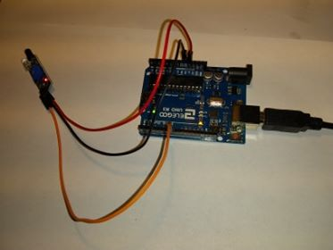

APDS 9960 Gesture sensor

Using [Sparkfun](https://github.com/sparkfun/APDS-9960_RGB_and_Gesture_Sensor) example and [this](https://www.youtube.com/watch?v=XFy8X_ohmQ8) reference video

Haven’t gotten examples to work, could be because the sensor isn’t soldered

5/16/2020 2:15 AM: I am using my [Lavfin Smart Car](https://www.amazon.com/gp/product/B07JN46YSW/ref=ppx_yo_dt_b_asin_title_o03_s01?ie=UTF8&psc=1) as a test platform for the ROS robot components. I wrote the motors example to get the robot driving, and will now test the obstacle avoidance senosrs on the robot.

Using four sensors because there’s only enough digital input ports for four.

Port 13 can’t be used as a digital input, don’t know why

Replaced not working sensor

|  |  |
| --- | --- |
| **Digital Port** | **Purpose** |
| **0** |  |
| **1** |  |
| **2** | TOP LEFTAVOID |
| **3** | BOTTOMRIGHTAVOID |
| **4** | dir1PinL |
| **5** | dir2PinL |
| **6** | dir1PinR |
| **7** | dir2PinR |
| **8** | speedPinL |
| **9** | speedPinR |
| **10** |  |
| **11** | BOTTOMLEFTAVOID |
| **12** | TOPLEFTAVOID |
| **13** | EXTERNAL LED |

5/16/2020 6:08 PM: I wrote a simple navigation program to use the obstacle avoidance sensor to allow the robot to drive around a cardboard environment. It doesn’t take advantage of all 4 sensors because ethe robot only needs the forward sensors, but it shows that they can be used to inform he robot’s motion.

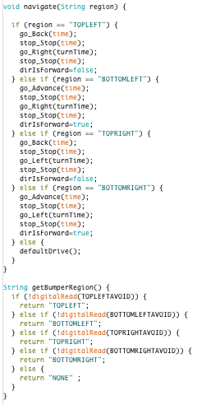

5/20/20 11:16 AM Jacob Smith: I got APDS9960 sensor working, proximity, ambient interrupt, and color sensor examples work well. Using sparkfun APDS library <https://github.com/sparkfun/SparkFun_APDS-9960_Sensor_Arduino_Library>. I tested the color sensor with card stock paper of different colors (pale) and index cards of differnet colors (bright) with the sensor about 1.5 cm from color facing table no extra light. Below is testing setup and results. Results show that sensor is most sensitive to red color levels, then somewhat sensitive for green levels and not sensitive to blue levels. 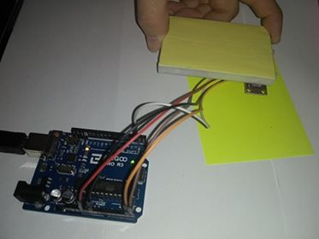

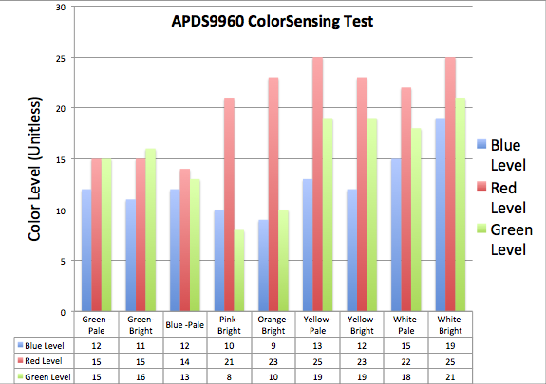

**Color Sensor use:** Wiring (Sensor to Arduino): GND🡪GND, VCC🡪3.3V,SDA🡪Analog 4,SCL🡪Analog5, INT🡪Digital2

Use Sparkfun Library <https://github.com/sparkfun/SparkFun_APDS-9960_Sensor_Arduino_Library>

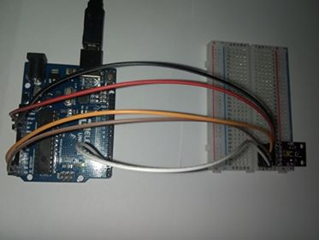

**Stepper Motor (28byj with driver)**

Wiring (Driver to Arduino) -🡪GND,+🡪5V,IN1🡪Digital 8,IN2🡪 Digital 9,IN3🡪 Digital 10,IN4🡪 Digital 11

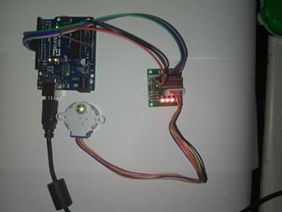

Use library https://github.com/arduino-libraries/Stepper

Also writing example sketch

5/21/2020 11:27 AM: Example sketch is here, I got the moto to go backwards by switching pins 2 and 3 in program [forum post](https://forum.arduino.cc/index.php?topic=549927.0)

Stepper move example sketch

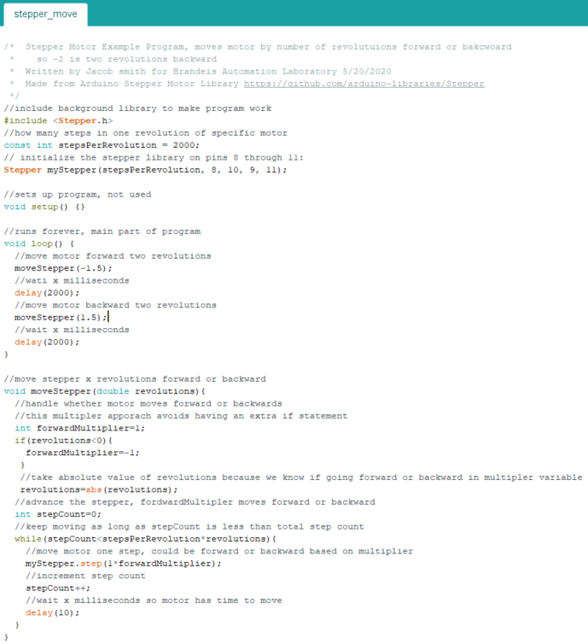

ROS Serial Documentation

[Github repo](https://github.com/ros-drivers/rosserial)

[Wiki](http://wiki.ros.org/action/fullsearch/rosserial_arduino?action=fullsearch&context=180&value=linkto%3A%22rosserial_arduino%22)

ESP ROS documentation

[ESPROS Repo](https://github.com/dabmake/ESPROS)

[Huckster tutorial](https://www.hackster.io/khasreto/run-rosserial-over-the-internet-with-esp32-0615f5)

[Hadabot Tutorial](https://blog.hadabot.com/set-up-esp32-microcontroller-for-ros2-robotics.html)

[Medium Tutorial](https://medium.com/@e850506/ros-serial-with-esp-32-246248cb6bac)

5/27/2020 12:26 PM Jacob Smith: I got the EPS32 example working [tutorial](https://randomnerdtutorials.com/installing-the-esp32-board-in-arduino-ide-windows-instructions/) [troubleshooting guide](https://randomnerdtutorials.com/esp32-troubleshooting-guide/)

ESP32 [SimpleWifi Server](https://github.com/espressif/arduino-esp32/blob/master/libraries/WiFi/examples/SimpleWiFiServer/SimpleWiFiServer.ino) example program works, I can interact with ESp over wifi.

I used [Wifi Scan](https://github.com/espressif/arduino-esp32/blob/master/libraries/WiFi/examples/WiFiScan/WiFiScan.ino) program to find the SSID of my network and make sure it was detected

[This](https://microcontrollerslab.com/accessing-esp32-web-server-anywhere-world-esp8266/) could be used to allow esp32 to eb accessed from anywhere, not tested

10:15 PM [AccelStepper Library](http://www.airspayce.com/mikem/arduino/AccelStepper/) (not tested)

2:36 AM: I used the speedControl example program of the stepper library to see what actual speeds resulted from setting speed. For example, how long does the wheel take to complete a revolution when the speed is set to 15? The two charts below show my findings for the 28byj motor. Namely that the maximum speed is 4.2 seconds per revolution, and from 5.2 to 20 seconds per revolution a trendline can be used to convert from speed setting to actual speed, and from 20 seconds on a less reliable trendline can make the same conversion. The problem for slow speeds is that they are integer settings 1,2, or 3 so there isn’t a way to have speed setting 1.5 with the Stepper library. Note: when I took these measurements, I recorded the time for 3 revolutions and then divided by 3 in the data shown.

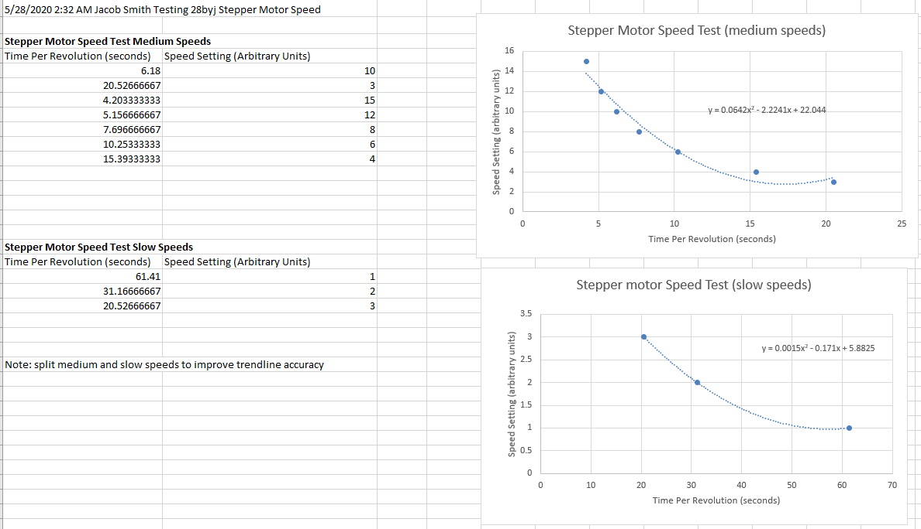

I then used these trendlines to create the below getSpeed function, which returns the speed setting for the stepper motor based on the desired speed in seconds per revolution.

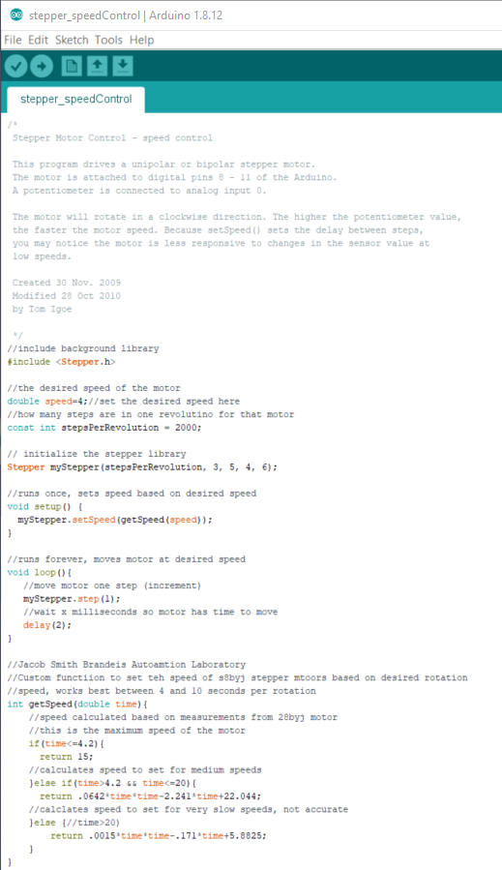

Finally, I tested that function below, entering the desired time and timing how long the wheel actually took to complete one revolution.

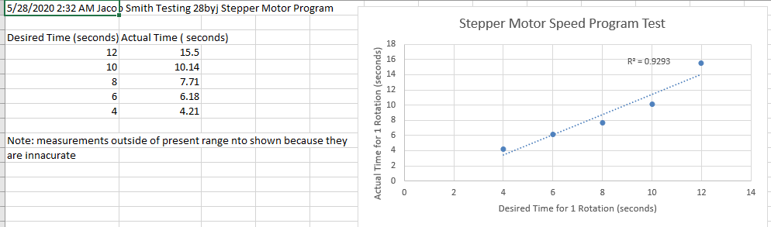

In conclusion, I have a somewhat accurate way to control the speed of the stepper motors, especially for speeds between 4.2 and 12 seconds per revolution.

5/29/2020 3:33 PM: I am working on running ROS from my linux hard drive. This requires installing a driver for the wifi chip on linux. Can’t access linux files from windows [source](https://www.howtogeek.com/112888/3-ways-to-access-your-linux-partitions-from-windows/) how to access windows files from linux [source](https://askubuntu.com/questions/433591/how-can-i-access-windows-files-from-ubuntu) [2](https://www.wikihow.com/Access-Windows-Files-in-Ubuntu) [3](https://www.quora.com/How-do-I-access-Windows-files-from-Ubuntu). Driver [1](https://www.intel.com/content/www/us/en/support/articles/000005511/network-and-i-o/wireless-networking.html) [2](https://medium.com/devstudio/how-to-install-wifi-driver-of-rtl8723be-in-ubuntu-18-04-1c031e2baf5) 3 My wifi chip doesn’t work with TKP wifi [source](https://ubuntuforums.org/showthread.php?t=2400595&page=2&s=d935a59fdcfc1d16b226f1f16547d534) Ubutnu 18.04 should work [source](https://www.reddit.com/r/Ubuntu/comments/ba79op/how_to_manually_install_a_driver_for_intel/) Ubuntu 18.04.3

6/3/2020 4:31 PM: [Link](https://www.birdbraintechnologies.com/remote-robots/) for Remote robotics

Wiring Diagram for ESp 32 Robot

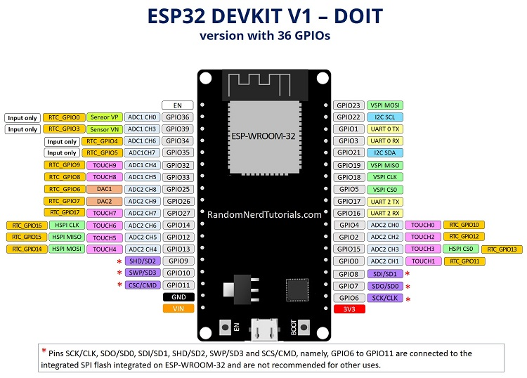

Wiring

GPIO 32=Front Left Obstacle

GPIO 34=Front Right Obstacle

Using [this](https://randomnerdtutorials.com/esp32-i2c-communication-arduino-ide/) link to find 12c devices to get color sensor working, I was able to detect the color sensor 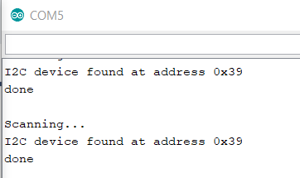

The Position Code Nov 29 2019 Answer to [this forum](https://github.com/espressif/arduino-esp32/issues/2501) was the solution to my EPS32 only connecting every other upload

6/10/2020 3:51 PM Jacob Smith: Last week, I presented the ESP32 Website demonstration, where the robot can drive forward, backward, display what color it is on and whether something is in front of it using bumpers. While I could refine this example by using the odometry calculations I made and stopping the connection issues with the website, the main goal is setting up ROS.

These links represent third party applications to use ROS with an ESP32 [1](https://blog.hadabot.com/ros2-esp32-to-control-motor-driver-using-web-browser.html') [2](https://www.hackster.io/khasreto/run-rosserial-over-the-internet-with-esp32-0615f5)

These links are low level example programs [1](https://github.com/ros-drivers/rosserial/tree/noetic-devel/rosserial_arduino/src/ros_lib) [ESP32SupportFor1](https://github.com/ros-drivers/rosserial/pull/345) [TutorialFor1](http://wiki.ros.org/action/fullsearch/rosserial_arduino?action=fullsearch&context=180&value=linkto%3A%22rosserial_arduino%22') [HelloWorldFor1](https://medium.com/@e850506/ros-serial-with-esp-32-246248cb6bac)

Also see website programming link [here](https://slack-redir.net/link?url=https%3A%2F%2Fwww.birdbraintechnologies.com%2Froboticsathome%2F)

6/17/2020 12:19 AM Working on installing ROS on ym windows computer because the linux version hasn’t worked yet.

I am getting error:

“Docker Desktop requires Windows 10 Pro/Enterprise (15063+) or Windows 10 Home (19018+).”

A workaround for this error that worked for me <https://itnext.io/install-docker-on-windows-10-home-d8e621997c1d>

<https://github.com/docker/for-win/issues/2367>

cd "C:\Program Files\Docker\Docker"  
./DockerCli.exe -SwitchDaemon  
try this

I’m getting 3 errors in docker

Docker machine "default" does not exist. Use "docker-machine ls" to list machines. Use "docker-machine create" to add a new one.

error during connect: Get http://%2F%2F.%2Fpipe%2Fdocker_engine/v1.40/version: open //./pipe/docker_engine: The system cannot find the file specified. In the default daemon configuration on Windows, the docker client must be run elevated to connect. This error may also indicate that the docker daemon is not running.

Error with pre-create check: "This computer is running Hyper-V. VirtualBox won't boot a 64bits VM when Hyper-V is activated. Either use Hyper-V as a driver, or disable the Hyper-V hypervisor. (To skip this check, use --virtualbox-no-vtx-check)"

<https://stackoverflow.com/questions/40459280/docker-cannot-start-on-windows>

<https://software.intel.com/content/www/us/en/develop/documentation/intel-system-studio-docker-install/top/windows/windows-troubleshoot-docker-for-windows.html>

<https://www.mydatahack.com/resolving-docker-deamon-is-not-running-error-from-command-prompt/>

<https://stackoverflow.com/questions/39966083/docker-machine-no-machine-name-no-default-exists>