# REGIONAL DATA – WASHINGTON COUNTY

**Summary and Location**

Washington County is comprised of 458 square miles and is centrally located between Baltimore and Washington, D.C. The Pennsylvania State line serves as its northernmost boundary, and the county is bounded on the east by Frederick County, on the west by Allegany County, and on the south by the Potomac River, which divides Maryland from West Virginia.

Washington County is included in the Hagerstown-[Martinsburg](http://en.wikipedia.org/wiki/Martinsburg,_West_Virginia), MD-[WV](http://en.wikipedia.org/wiki/West_Virginia) [Metropolitan Statistical Area](http://en.wikipedia.org/wiki/Hagerstown_metropolitan_area), which is also included in the [Washington](http://en.wikipedia.org/wiki/Washington,_D.C.)-[Baltimore](http://en.wikipedia.org/wiki/Baltimore)-[Arlington](http://en.wikipedia.org/wiki/Arlington_County,_Virginia), DC-MD-[VA](http://en.wikipedia.org/wiki/Virginia)-WV-[PA](http://en.wikipedia.org/wiki/Pennsylvania) [Combined Statistical Area](http://en.wikipedia.org/wiki/Washington_metropolitan_area).

**Regional Map - (Washington County Highlighted in Green)**

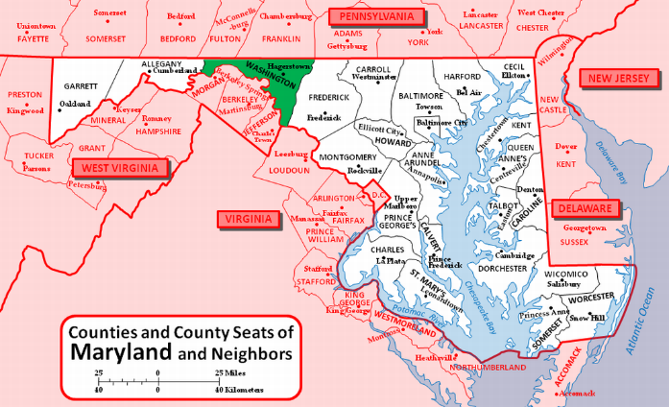

**Transportation & Linkages**

The intersection of Interstates 70 and 81 provides easy market access and efficient movement of goods. Baltimore is approximately one hour and 20 minutes via Interstate Route 70. From Hagerstown, major employment areas in the Washington metropolitan area are approximately a one-hour drive.

The Washington County Regional Airport is a fully instrumented airfield with two airlines offering daily commuter service to major destinations. Local bus service is provided by Washington County Commuter, and Amtrak service is provided Monday through Friday by MARC service from Martinsburg.

**Washington County Map**

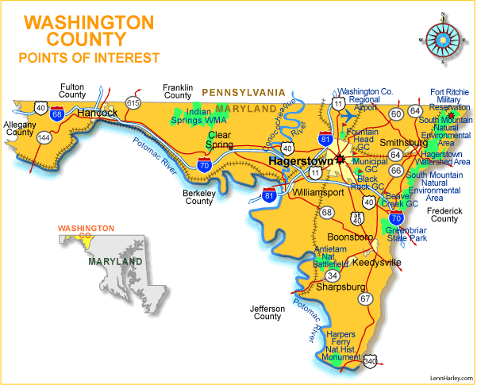

**Population**

Washington County is the eleventh largest county in Maryland by population From 2000 to 2010, Washington County experienced a 11.75% increase in population while the State of Maryland’s total population increased by 9% during the same time period. That trend in population growth appears to have slowed during the last decade. As of the census of 2010, there were 147,430 people and 55,960 households residing in the county. The population was 322 people per square mile. The 2020 Census reflects an increase to 154,705 people, representing a 4.9% increase during that ten-year period.

Below is a chart showing the estimated population growth for the municipalities in Washington County, from the 2010 U.S. Census to 2021:

|  |  |  |  |  |
| --- | --- | --- | --- | --- |
| **City/Town** | **Population per 2010 Census** | **Estimated Population as of 2021** | **Estimated Growth since 2010** | **Estimated Percent Increase** |
| Boonsboro | 3,336 | 3,791 | 455 | 13.6% |
| Clear Spring | 358 | 366 | 1 | 2.2% |
| Funkstown | 904 | 867 | -37 | -4.0% |
| Hagerstown | 39,662 | 40,030 | 368 | 0.9% |
| Hancock | 1,545 | 1,523 | -22 | -1.4% |
| Keedysville | 1,152 | 1,233 | 81 | 7.0% |
| Sharpsburg | 705 | 643 | -62 | -8.8% |
| Smithsburg | 2,975 | 2,964 | -11 | -0.4% |
| Williamsport | 2,137 | 2,081 | -56 | -2.6% |

Source: U.S. Census Bureau and www.worldpopulationreview.com

**Income**

The median household income from 2017 to 2021 in Washington County was $67,349. The per capita income for the same time period was $33,682. Approximately 14.5% of the population was at or below the poverty level.

SOURCES: U.S. Census Bureau

**Washington County Government**

Washington County is run by a Board of County Commissioner and a county administrator. Currently, Rob Slocum serves as the Administrator. Current commissioners include: John Barr, President; Jeffrey A. Cline, Vice-President; Derek Harvey, Wayne K. Keefer, and Randall E. Wagner.

**Labor & Employment**

Washington County is the hub of the regional economy and draws its workforce from counties within the Maryland/Pennsylvania/West Virginia tristate region.

As you can see below, the rate of unemployment in Washington County has decreased steadily since 2012 until 2020 which saw a significant increase due to the Covid-19 pandemic. It dropped again in 2021 and 2022.

|  |  |  |  |  |
| --- | --- | --- | --- | --- |
| **Washington County Labor Force Estimates** | | | | |
| **YEAR** | **Labor Force** | **Employment** | **Unemployment** | **Rate** |
| 2021 | 72,870 | 61,592 | 3,326 | 5.4% |
| 2020 | 72,701 | 60,287 | 4,100 | 6.8% |
| 2019 | 74,945 | 64,775 | 3,147 | 4.2% |
| 2018 | 74,742 | 65,707 | 3,249 | 4.3% |
| 2017 | 75,294 | 66,602 | 3,521 | 4.5% |
| 2016 | 76,939 | 66,955 | 3,750 | 4.9% |
| 2015 | 76,834 | 67,164 | 4,318 | 5.6% |
| 2014 | 76,372 | 66,684 | 4,931 | 6.5% |
| 2013 | 77,168 | 66,777 | 5,675 | 7.4% |
| 2012 | 77,165 | 66,551 | 6,046 | 7.8% |

The following charts reflect the civilian labor force and unemployment trends in Washington County over the last thirty years (source: The Federal Reserve St. Louis):

The following chart highlights employment and payrolls by industry within Washington County – representing the labor force working in Washington County regardless of where they live (in or out of county). Based on information collected since 2012 and through 2020, the following table shows most categories of employment in Washington County[1]:

Areas of private sector decline includes financial activities and information, the result of continuing consolidation in each of these industries. The following page presents a chart that reflects the top 20 employers in Washington County.

(source: Commerce.maryland.gov/Documents/ResearchDocument/WashingtonBef.pdf)

|  |  |  |
| --- | --- | --- |
| Company | Product/Service | Employment |
|  |  |  |
| Meritus Health | Medical services | 2,740 |
| Fiserv | Credit card processing | 2,322 |
| Citi | Credit card processing | 2,100 |
| Volvo Group | Diesel Engines & transmissions | 1,517 |
| Hagerstown Community College | Higher Education | 890 |
| The Bowman Group | Hotels management and logistics | 746 |
| FedEx Ground | Mail & package delivery services | 705 |
| Staples | Office supplies distribution & retailing | 597 |
| Merkle Response Management Group | Data entry and fulfillment | 545 |
| Amazon | Retail | 500 |
| Arc of Washington County | Medical and social services | 500 |
| Direct Mail Processors | Data entry and fulfillment | 500 |
| Walmart/Sams Club | Consumer goods | 485 |
| Brook Lane Health Services | Medical services | 485 |
| Lehigh Phoenix | Printed book covers | 360 |
| A.C.&T. | Convenient stores, gas stations | 350 |
| Dot Foods | Food distribution | 312 |
| Sierra Nevada | Aircraft maintenance | 335 |
| JLG Industries | Aerial work platforms | 300 |
| Home Depot | Home improvement products distribution & retailing | 296 |

**Education**

Public: More than 22,000 students are enrolled in Washington County Public Schools as of September 30, 2022. Forty-six school facilities, administered by nearly 3,222 employees, make WCPS the third largest employer (including non-private employers) in Washington County. The public-school system is comprised of following:

|  |  |
| --- | --- |
| *Schools* | *Qty* |
| Elementary Schools | 26 |
| Middle Schools | 7 |
| High Schools | 9 |
| Special Programs | 4 |
|  |  |

Private: There are 39 private schools (including pre-k and nursery) teaching over 2,200 students.

**Higher Education**

Hagerstown Community College (HCC), founded in 1946, offers more than 100 programs of study for university transfer or for immediate career preparation, as well as continuing education courses and adult basic education. Associate degrees, certificates and letters of recognition are awarded, including degrees and certificates in biotechnology, alternative energy technology, and cyber security. HCC’s business incubator, the Technical Innovation Center, is the largest, most comprehensive technology-based business incubator in Western Maryland. It provides space and other services and amenities to entrepreneurs, start-ups, and existing companies. Its facilities consist of office space, open manufacturing space, conference rooms, and 4,000 square feet of biotech research labs. The college recently opened a five-story, 65,000 sq. ft. Science, Technology, Engineering, and Math (STEM) building and renovated the Kepler Theater, with the addition of the Performing and Visual Arts Education Center.

Barr Construction Institute, education division of Associated Builders and Contractors, Inc., offers professional management education and industrial, commercial and apprenticeship and craft trades training. Construction and maintenance training is recognized by the U.S. Department of Labor, Bureau of Apprenticeship & Training, and is accredited by the National Center of Construction Education and Research (affiliate of the University of Florida).

Kaplan University-Hagerstown (KU-H), a private institution founded in 1938, offers four bachelor degree, 12 associate degree and three certificate programs in the areas of business, allied health, criminal justice, paralegal studies, graphic design, human services and information technology. Online and traditional, on campus courses are available.

Pittsburgh Institute of Aeronautics (PIA), recognized as a premier training school for aviation maintenance since 1929, opened its newest location at the Hagerstown Regional Airport in Spring 2011. Students take a 16-month diploma program and become eligible to test for the FAA’s Airframe and Power Plant Certification test.

*University System of Maryland at Hagerstown* (USMH), is a regional higher education center offering more than 20 undergraduate and graduate degree programs in one convenient location in downtown Hagerstown. Six Maryland universities offer select programs in the state-of-the-art facility. Many programs, such as nursing, education, social work and health information management, are chosen because they meet area workforce demand. Partner institutions include Coppin State University (CSU); Frostburg State University (FSU); Salisbury

University (SU); Towson University (TU); University of Maryland, College Park (UM); and the University of Maryland University College (UMUC).

1. Maryland Department of Labor, 2021 statistics.