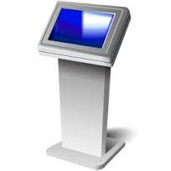 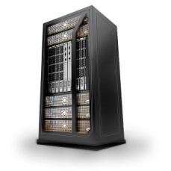  

This is just an overview of my idea for our project. This is just to show an overview of all the requirements.

Access

* The application shall be secure.
* The user should be able to access the application from kiosk or web.
* Will the system generate credential to the user?

Application

* The system must not allow the user to gaming the system.
* Some users may not be disciplined, the input must be validated.

Database

* data will be hosted in the clouds

Technology Requirements

* Java

-Object Model

-Exception

-Threads

-Design Patterns

* Data Transfer

-XML (which I'd used in previous assignments)

-JSON (learning)

* Database

-RDMS

-Open source

-Crossed platform

* Front End (web-based)

-HTML5

-JavaScript

-CSS

* Server

-JSP

-JEE

* GUI

-JavaFx

-Swing

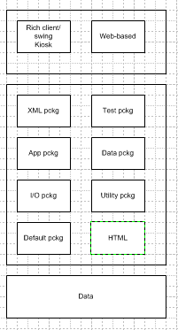

Question:

1. Will the user require login credential?
2. Which age group will be using the system
3. Admin credential necessary?