Space game artwork request

About the game
This is an online 2 player videogame. Each player is given a base where it can send ships from and needs to destroy the other player’s base.
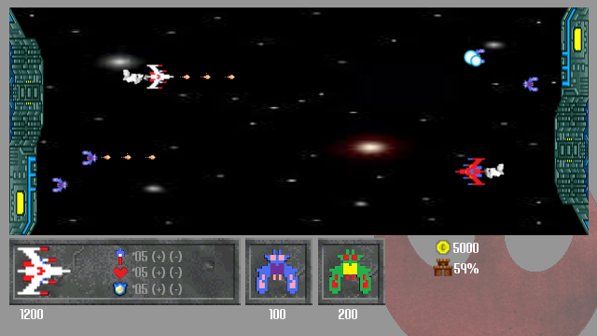
Illustration 1: Game mockup
There is a main ship, that is controlled by the player. As well as that, it can send other ships and upgrade the defence on the base. In order to do all this the player needs to get money, either by destroying ships or by adding some money creating upgrades to the bases.

About the work
I’ll need the artist to decide on an art style and produce enough assets to populate the videogame world.
I’ve attached some screenshots of different games with a possible art style as a guideline, but the artist should not be limited to those. As part of this work, the concept of the game may vary, at the artist’s discretion, the theme could change from space to war or the bases could be represented as planets, etc. After he/she has come up with an artstyle we can discuss it over a mockup. This might not be ok the first time, so a number of iterations should be expected on this initial task.
Once the style is agreed upon, the next task will be to produce the assets as detailed in the Item list section. This item list may be subject to changes, to be agreed before deciding on the final budget.
As this is a game in development, most probably there will be subsequent independent requests. For example, the assets in the item list cover a basic scene with some upgrades. In case the game progresses correctly I might need to get some more for another stage, or even some work done for the menues/GUI. All this would be commisioned separately.

Item list
- Main player ship:
  - Will need at least 2 main ships. In the game mockup those are the white and red ships. Both ships should have several visible upgrades, both in fire power and defence. The differences may be as small as a simple color change or different factions (aliens/humans or machines/animals). It would also be helpful to have a simple way of showing damages.
- Auxiliary ships:
  - The auxiliary ships will not be controlled by the player, so they will not be as big/powerful as the main ship. I’ll need at least 2 different types for each faction. The differences between factions will be equivalent to the differences between the main ships.
- Player base
  - The player base is the place where the ships are sent from, and the place that must be guarded. In the mockup those are the green structures at the sides. Depending on the art direction the base can be swapped for a planet, a building or a tree, for example. The requirement is that it must be able to spawn the ships and that they will be placed at the sides of the screen.
- Background
  - A background should be designed according to the theme. It may have some moving elements, but those will not be affecting the gameplay.
- Smoke/shoot effects
  - Some missiles, smoke particles and explosions must be designed. They don’t need to be animated, as the animation will be done by me in-game.
So in total this will be 2 factions with 1 main ship, at least 2 different auxiliary ships and a base each as well as some general effects and a background.

Payment
The price will be set by the artist. It can be divided across the project. For example I can pay 20% of it after agreeing on the art style and the rest of it once every asset is delivered.
The price set will not vary over the course of the work. In case we agree on getting more assets produced those will be dealed separately.

License
This is a subject that can be discussed when deciding on a price. At least I require the rights to use the art as part of the described videogame and subsequent videogames I might produce, to use it as a part of an advertisement for the game and to charge for any game that uses the assets.
The artist will be entitled to appear in the credits of the game, along with any logo/contact information he/she wants to add.
Depending on the price I will not mind if the artist also keeps ownership of the assets so they can be included on a portfolio or even used in any other medium through a creative commons license.

Art styles
Some art styles follow as an inspiration for the artist. Any of these would be valid results of the required work.
