**Database Project Proposal**

Jack Murray

Peter Willis

Noah Kramer

Braeden Hecht

**Brief Project Summary**: Build a database containing movies. Users will be able to query the database to get information including listing movies with a particular actor or director, movies released years, or of a particular rating and more.

**Tentative Business Rules and Restrictions:**

* At least one director
* Must have a release year
* Must have at least one genre
* Must have a production studio
* Rating must be between 0 and 5
* Every person must have a birthdate

**ER diagram**

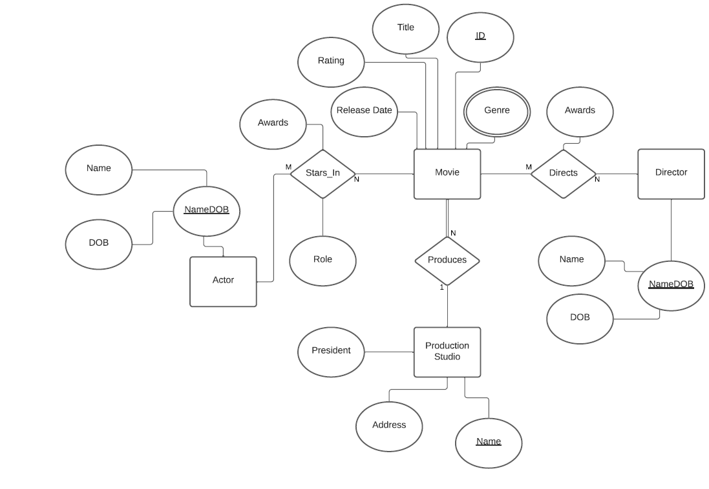

**Schema**

