Monitor 54321
320 Gb HD 98765
32 Gb USB Key 24680
Laser Printer 35791
Microphone 65789
i5-580 processor 43543
MSI Video Card 76543
ASUS Motherboard 55544
End of Transaction 10101

Refund e00000

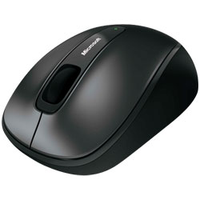Mouse24.99

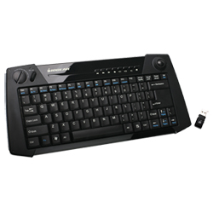keyboard61.99

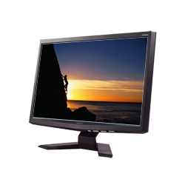Monitor 164.99
320 Gb HD 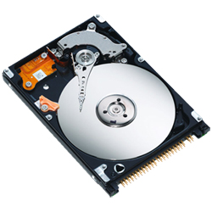54.99
32 Gb USB Key 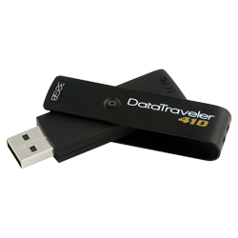99.97
Laser Printer  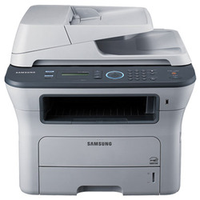249.99
Microphone  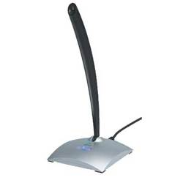45.99
i5-580 processor  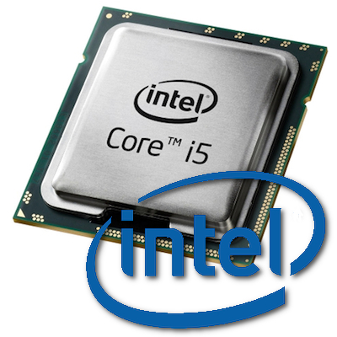 266.00
MSI Video Card  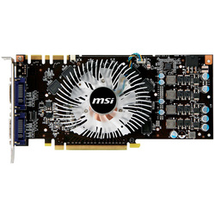159.97
ASUS Motherboard  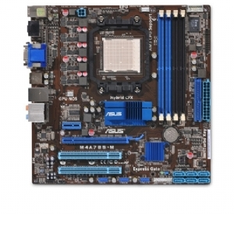78.97
End of Transaction 

Refund 

