Lab 4 Stepper Motor Finite State Machine
This laboratory assignment accompanies the book, Embedded Systems: Real-Time Interfacing to ARM Cortex M Microcontrollers, ISBN-13: 978-1463590154, by Jonathan W. Valvano, copyright © 2013.

Goals • To interface a stepper motor,
• To implement background processing with periodic interrupts,
• To develop a linked command structure.

Review • Valvano Section 1.4 about open collector logic,
• Valvano Section 3.5 about abstraction, linked lists and FSM’s,
• Valvano Section 4.7.2, about stepper motor interfacing

Starter files • PointerTrafficLight_1968.zip PeriodicTimer0AInts_1968.zip and
• Lab4_Artist.sch

Background
Stepper motors are popular with digital control systems because they can be used in an open loop manner with predictable responses. Such applications include positioning heads in disk drives, adjusting fuel mixtures in automobiles, and controlling articulating joints in robotics. In this lab, you will control a stepper motor using a finite state machine. The finite state machine must be implemented as a linked data structure. Four switches will allow the operator to control the motor. A background periodic interrupt using Periodic timer will perform inputs from the switches and outputs to the stepper motor coils. The worm gear on the motor, as shown in Figure 4.1, produces a linear motion as the stepper motor turns. It takes 24 full-steps to complete one rotation of the shaft and 200 full-steps to move the worm gear from one end to the other. If you step the motor too far in either direction, the worm gear will disengage and you will have to manually re-engage the worm gear. The periodic timer module must be written at a low level, like the book, without calling StellarisWare driver code. Other code (OLED, GPIO, and PLL) can use StellarisWare driver code.

Requirements document
1. Overview
1.1. Objectives: Why are we doing this project? What is the purpose?
The objectives of this project are to design, build and test a stepper motor controller. Educationally, students are learning how to interface a stepper motor, how to design with finite state machines, and how to perform state machine input/output in the background.

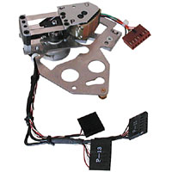
Figure 4.1. Stepper motor with worm gear, CAT# EX-82, http://www.allelectronics.com.

1.2. Process: How will the project be developed?
The project will be developed using the LM3S1968 board. There will be three switches that the operator will use to control the motor. The system will be built on a solderless breadboard and run on the usual USB power. The system may use the on board switches or off-board switches. A hardware/software interface will be designed that allows software to control the stepper motor. There will be at least three hardware/software modules: switch input, motor output, and the finite state machine. The process will be to design and test each module independently from the other modules. After each module is tested, the system will be built and tested.

1.3. Roles and Responsibilities: Who will do what? Who are the clients?
EE445L students are the engineers and the TA is the client. Students are expected to make minor modifications to this document in order to clarify exactly what they plan to build. Students are allowed to divide responsibilities of the project however they wish, but, at the time of demonstration, both students are expected to understand all aspects of the design.

1.4. Interactions with Existing Systems: How will it fit in?
The system will use the LM3S1968 board, a solderless breadboard, and the stepper motor shown in Figure 4.1. The wiring connector for the stepper motor is described in the PCB Artist file Lab4_Artist.sch and in Figure 4.2. It will be powered using the USB cable. You may use a +5V power from the lab bench, but please do not power the motors with a voltage above +5V.
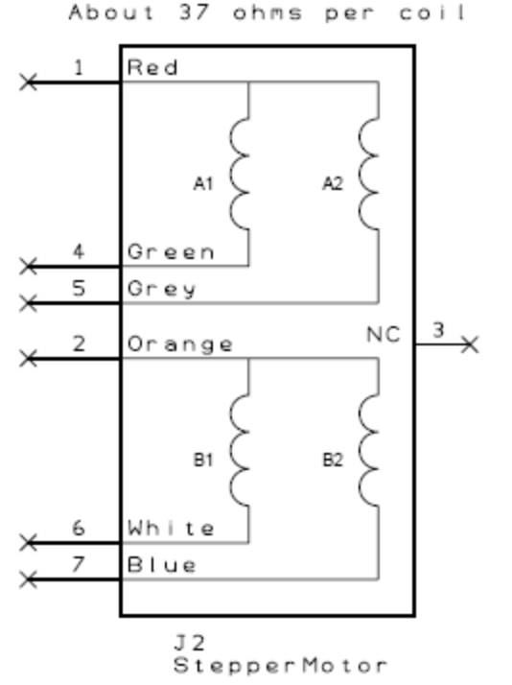
Figure 4.2. The EX-82 stepper motor has unipolar configuration with four+5V 37-Ω coils (see the starter file Lab4_Artist.sch ).

1.5. Terminology: Define terms used in the document.
For the terms Moore FSM, abstraction, board support package, back emf, holding torque, and jerk, see textbook for definitions. A full step is defined as the change occurring after one output using the full step sequence {5,6,10,9}. CW stands for clockwise. CCW stands for counterclockwise.

1.6. Security: How will intellectual property be managed?
The system may include software from StellarisWare and from the book. No software written for this project may be transmitted, viewed, or communicated with any other EE445L student past, present, or future (other than the lab partner of course). It is the responsibility of the team to keep its EE445L lab solutions secure.

2. Function Description
2.1. Functionality: What will the system do precisely?
If all buttons are released, then the motor should stop. If switch 1 is pressed, spin slowly in one direction as long as switch 1 continues to be pressed (note to students: you should extend this sentence to specify the speed). If switch 2 is pressed, spin slowly in the other direction as long as switch 2 continues to be pressed (note to students: you should extend this sentence to specify the speed). If switch 1 and 2 are both pressed, the motor should continuously oscillate as fast as possible back and forth. The amplitude of this oscillation will be 8 steps. In other words, output the sequence {CW, CW, CW, CW, CW, CW, CW, CW, CCW, CCW, CCW, CCW, CCW, CCW, CCW, CCW} over and over as long as both switch 1 and 2 continue to be pressed (note to students: you should extend this sentence to specify the oscillation rate). If switch 3 is pressed then released, then step once in one direction (note to students: you should edit this sentence to define which direction it steps). Any other combination (e.g., 1+3, 2+3, 1+2+3) should be ignored. You may assume the operator (you or the TA) will release the switches when it reaches the end of the worm gear. (Note to students: if you use the internal switches you could rename the switches Up Down Left Right or Select to match the switches you use)
There will be a 1-1 mapping from the FSM graph and the C data structure. There is a delay for each state, which is saved in the FSM structure. The motor output is always one of these values 5, 6, 10, or 9. The motor moves such that the output never skips from 5 to 10, 10 to 5, 6 to 9, or 9 to 6. There are about 20 to 30 states (note to students: you can place your FSM graphs here). The FSM runs in the background using periodic interrupts. The foreground (main) initializes the FSM, then executes for(;;){} do nothing loop. The maximum time to execute one instance of the ISR is xxxx (note to students: replace the xxxx with performance measure of your solution).

2.2. Scope: List the phases and what will be delivered in each phase.
Phase 1 is the preparation; phase 2 is the demonstration; and phase 3 is the lab report. Details can be found in the lab manual.

2.3. Prototypes: How will intermediate progress be demonstrated?
A prototype system running on the LM3S1968 board and solderless breadboard will be demonstrated. Progress will be judged by the preparation, demonstration and lab report.

2.4. Performance: Define the measures and describe how they will be determined.
The system will be judged by three qualitative measures. First, the software modules must be easy to understand and well-organized. Second, the system must employ a finite state machine running in the background. There should be a clear and obvious abstraction, separating what the machine does (the FSM state diagram) from how the machine works (the software ISR). Backward jumps in the ISR are not allowed. Third, all software will be judged according to style guidelines. Software must follow the style described in Section 3.3 of the book (note to students: you may edit this sentence to define a different style format). There are three quantitative measures. First, the speed of oscillations will be measured, with an attempt to make it oscillate as fast as possible. Second, the maximum time to run one instance of the ISR will be recorded. Third, you will measure power supply current to run the system. There is no particular need to minimize current in this system.

2.5. Usability: Describe the interfaces. Be quantitative if possible.
There will be three switch inputs. The stepper motor will operate under no load conditions,

2.6. Safety: Explain any safety requirements and how they will be measured.
Stepper motors draw current even when not moving. For simple edit compile download changes you can leave the motor powered. However, for longer edit sessions, disconnect the +5V power to the motor. For example, when developing software that does not involve the motor: 1) Disconnect the USB cable; 2) Disconnect the +5V power to the protoboard/motor; 3) Reconnect the USB cable; 4) Edit/debug software. When developing software that does involve the motor: 1) Disconnect the USB cable; 2) Edit and compile software; 3) Reconnect the USB cable; 4) Download/debug software. Connecting or disconnecting wires on the protoboard while power is applied may damage the board.

3. Deliverables
3.1. Reports: How will the system be described?
A lab report described below is due by the due date listed in the syllabus. This report includes the final requirements document.

3.2. Audits: How will the clients evaluate progress?
The preparation is due at the beginning of the lab period on the date listed in the syllabus.

3.3. Outcomes: What are the deliverables? How do we know when it is done?
There are three deliverables: preparation, demonstration, and report. (Note to students: you should remove all notes to students in your final requirements document).

Preparation (do this before your lab period)
1) Copy and paste the requirements document from the lab manual. Edit it to reflect your design.

2) With an ohmmeter, measure the resistance of one coil. Apply +5V across the coil and simultaneously measure using both a voltmeter and a current-meter the voltage and current required to activate one coil of your stepper motor. Do this before your lab period, without any connections to the LM3S board. Design the hardware interface between the LM3S, and prepare a circuit diagram labeling all resistors and diodes. The pin out for the stepper is shown in Figure 4.2. Include pin numbers and resistor/capacitor types and tolerances. Be sure the interface circuit (e.g., 2N2222 or L293) you select can sink enough current to activate the coil. In particular, verify the driver can supply (I_{CE} or I_{OL}) the required current for the stepper motor. Make sure you have all the parts you need before lab starts. This interface will require four 1N914 snubber diodes. If do not properly connect the diodes, the back EMF will destroy your board.

3) Design the machine by first drawing the finite state graph. A “syntax-error-free” version of the software is required as preparation. This will be checked off by the TA at the beginning of the lab period. You are required to do your editing before lab. The debugging will be done during lab. Document clearly the operation of the routines. The periodic interrupt-driven background thread will execute the finite state machine, while the foreground thread initializes the system then does nothing. Figure 4.3 shows the data flow graph of the stepper motor controller.

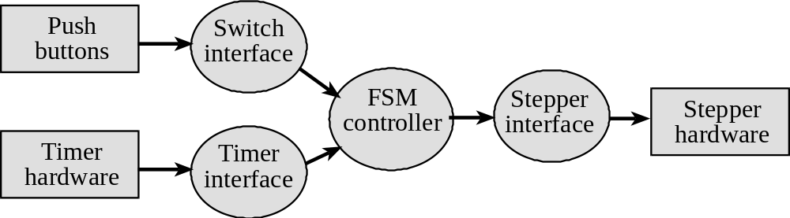
Figure 4.3. Data flows from the timer and the switches to the stepper motor.

Figure 4.4 shows a possible call graph of the system. Dividing the system into modules allows for concurrent development and eases the reuse of code.
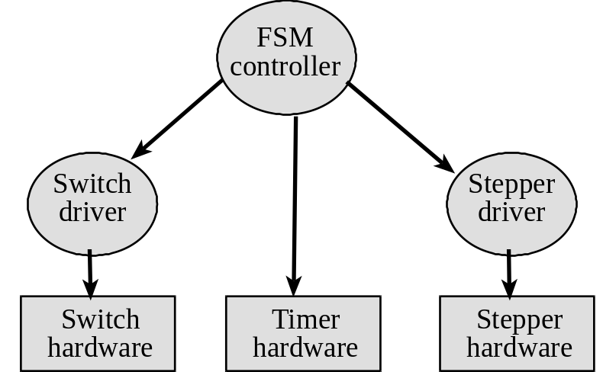
Figure 4.4. A call graph showing the three modules used by the stepper controller.

A switch device driver means you create switch.h and switch.c files, separating mechanisms (how it works) from policies (what it does). Similarly, make stepper.h and stepper.c files. Design the software in a manner that makes it easier to understand, debug, modify and reuse in other projects. Design the system in a manner that would allow you to reassign the pin connections of the interface (e.g., moving I/O from one port to another), by making changes to switch.c and stepper.c without requiring modifications to main.c switch.h or stepper.h.

Procedure (do this during your lab period)
1) Make sure your TA checks your hardware diagram before connecting it to the LM3S. We do not have extra boards, so if you fry your board, you may not be able to finish. First build the digital interface on a separate protoboard from the LM3S, as shown in Figure 4.5. Use switches as inputs for the stepper interface. You should be able to generate the 5,6,10,9 sequence with your fingers. Using a scope, look at the voltages across the coils to verify the diodes are properly eliminating the back EMF. The very fast turn-off times of the digital transistors can easily produce 100 to 200 volts of back EMF, so please test the hardware before connecting it to the LM3S.
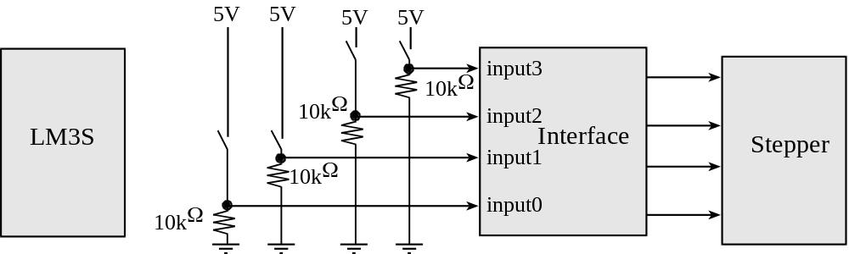
Figure 4.5. Hardware test procedure, microcontroller not connected at all.

2) The switches will eventually be replaced by microcontroller outputs, as shown in Figure 4.6. Once you are sure the hardware is operating properly, run a simple software function that rotates the motor at a slow but constant velocity to verify the hardware/software interface. In particular, debug the switch and motor drivers separately.
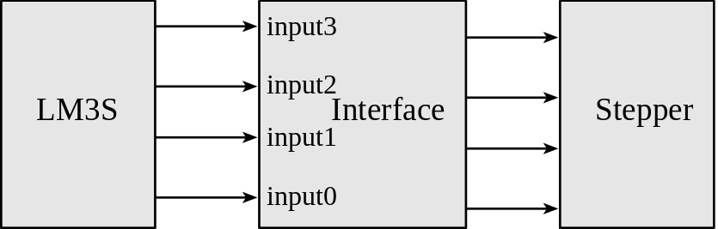
Figure 4.6. Hardware block diagram.

3) Debug the FSM software. To determine the fastest rate the motor can vibrate back and forth (CW for 8 steps and CCW for 8 steps), experimentally test the system at smaller and smaller delays between steps. You will be able to vibrate more quickly using a non-uniform time delay between steps. In particular, you want to minimize jerk. Measure the maximum time to execute the ISR.

4) Remove the USB cable and carefully power your stepper motor system using a lab power supply directly to the +5V pin on the board. Set the voltage to +5V and measure the required current to run the stepper controller system. Take a measurement with and without the motor spinning. Double check the positive and negative connections before turning it on. If you are at all unsure about this measurement ask your TA for help.

Deliverables (exact components of the lab report)
A) Objectives (final requirements document)
B) Hardware Design (PCB Artist printout)
stepper motor interface, showing all external components
switch interfaces, showing all external components
C) Software Design (upload your files to Blackboard as instructed by your TA)
Draw figures illustrating the major data structures used, e.g., the finite state graph
If you organized the system different than Figure 4.3 and 4.4, then draw its data flow and call graphs
D) Measurement Data
Prep 2) Give the voltage, current, and resistance measurements
Specify the fastest rate the motor can vibrate back and forth
Specify the maximum time to execute once instance of the ISR
Measurements of current required to run the system, with and without the motor spinning
E) Analysis and Discussion (give short 1 or two sentence answers to these questions)
1) What is jerk? How is it minimized?
2) Draw an electrical circuit model for one stepper motor coil, and explain the components.
3) Explain what parameters were important for choosing a motor drive interface chip (e.g., L293 or 2N2222). How does your circuit satisfy these parameters?
4) What happens to the current when a mechanical load is applied to the shaft? Why?
5) It the motor is spinning at a constant rate, give a definition of electrical power in terms of parameters of this lab? Research mechanical power. Give a definition of mechanical power. Are the two related?

Checkout (show this to the TA)
You should be able to demonstrate correct operation of the stepper motor system. Be prepared to describe how your stepper interface works. Explain how your system handles the switch bounce. Demonstrate debugging features that allow you to visualize the software behavior.

A software and report files must be uploaded as instructed by your TA.

Hints
1. Be sure the interface driver (e.g., the 2N2222 or L293) has an I_{CE} or I_{OL} large enough to deliver the needed coil current. Although many steppers will operate at voltages less than the rated voltage, the torque is much better when using the proper voltage. Remember to actually measure the coil current rather than dividing voltage by resistance.
2. Be sure to put an appropriate delay between each step to prevent the motor from stalling.
3. The USB +5V regulated supply is specified to 500 mA total current. Your motor requires almost all of this current. To prevent the USB from disconnecting you, do not leave the system plugged in too long. Even while stopped the stepper draws current
4. See the data sheets and materials on stepper motors at
http://users.ece.utexas.edu/~valvano/DataSheets/
2N2222.pdf L293.pdf
1N914.pdf B3F-1059.pdf , B3F-switch.pdf
Stepper.pdf
StepperBasic.pdf StepperDriveBasic.pdf
StepperHalfstep.pdf StepperMicrostep.pdf
StepperSelection.pdf Stepper_ST.pdf

5. Do not use 32-bit timer mode. The 32-bit timer mode creates an error (hardware bug) in the ADC triggering. Refer to the errata http://users.ece.utexas.edu/~valvano/EE345L/Labs/Fall2011/LM3S1968errata.pdf.

