Lab 10 Z-B-Fone
This laboratory assignment accompanies the book, Embedded Systems: Real-Time Interfacing to Arm Cortex M Microcontrollers, ISBN-13: 978-1463590154, by Jonathan W. Valvano, copyright © 2012.
Goals
- Develop debugging techniques for transmitter (Tx) and receiver (Rx) systems,
- Use FIFOs and other data structures to implement communication,
- Implement a voice communication system between two microcontrollers via an IEEE 802.15.4 – ZigBee wireless module.
- Sound recording using an ADC, an audio amp, and an electret microphone
- Sound playback using a DAC, an audio amp, and a speaker (Lab 5)
Review
- Valvano Section 3.7 FIFO Queues
- Valvano Sections 3.4.4, 4.9, and 5.6 UART
- Valvano Section 10.2.5 and Example 10.4 on microphone interfacing and sound input/output
- Valvano Chapter 11 on communication systems
- http://users.ece.utexas.edu/~valvano/EE345L/Labs/Fall2011/XBeeManual.pdf
- http://users.ece.utexas.edu/~valvano/EE345L/Labs/Fall2011/Zigbeeinfo.pdf
Starter files
  - UART2_1968.zip – serial communication using interrupts
  - Your Lab5 DAC and speaker system

Background
ZigBee is the commercial name given to devices that communicate wirelessly employing the IEEE 802.15.4 standard. A wireless personal area network (WPAN) is a computer network used for communication among computer devices close to one person or one device. The This standard is intended to provide relatively slow, i.e., less than 250 kb/s, low power, short range, i.e., 10 to 75m, and low cost wireless communication for remote control and process automation applications. ZigBee components offer long battery life and the ability to operate in large ad hoc mesh networks. They typically operate in the 2.4 GHz Industrial-Scientific-Medical (ISM) unlicensed band that is shared with Wi-Fi (IEEE 802.11) and Bluetooth (IEEE 802.15.1) communications. The IEEE 802.15.4 standard describes how information is represented via radio frequency signals, i.e., the physical or PHY layer, and how communications are formatted and controlled, i.e., the media access control or MAC layer. Communication requirements beyond the PHY and MAC, e.g., flow control, error recovery, and routing, remain to be implemented within the application employing the ZigBee communication.
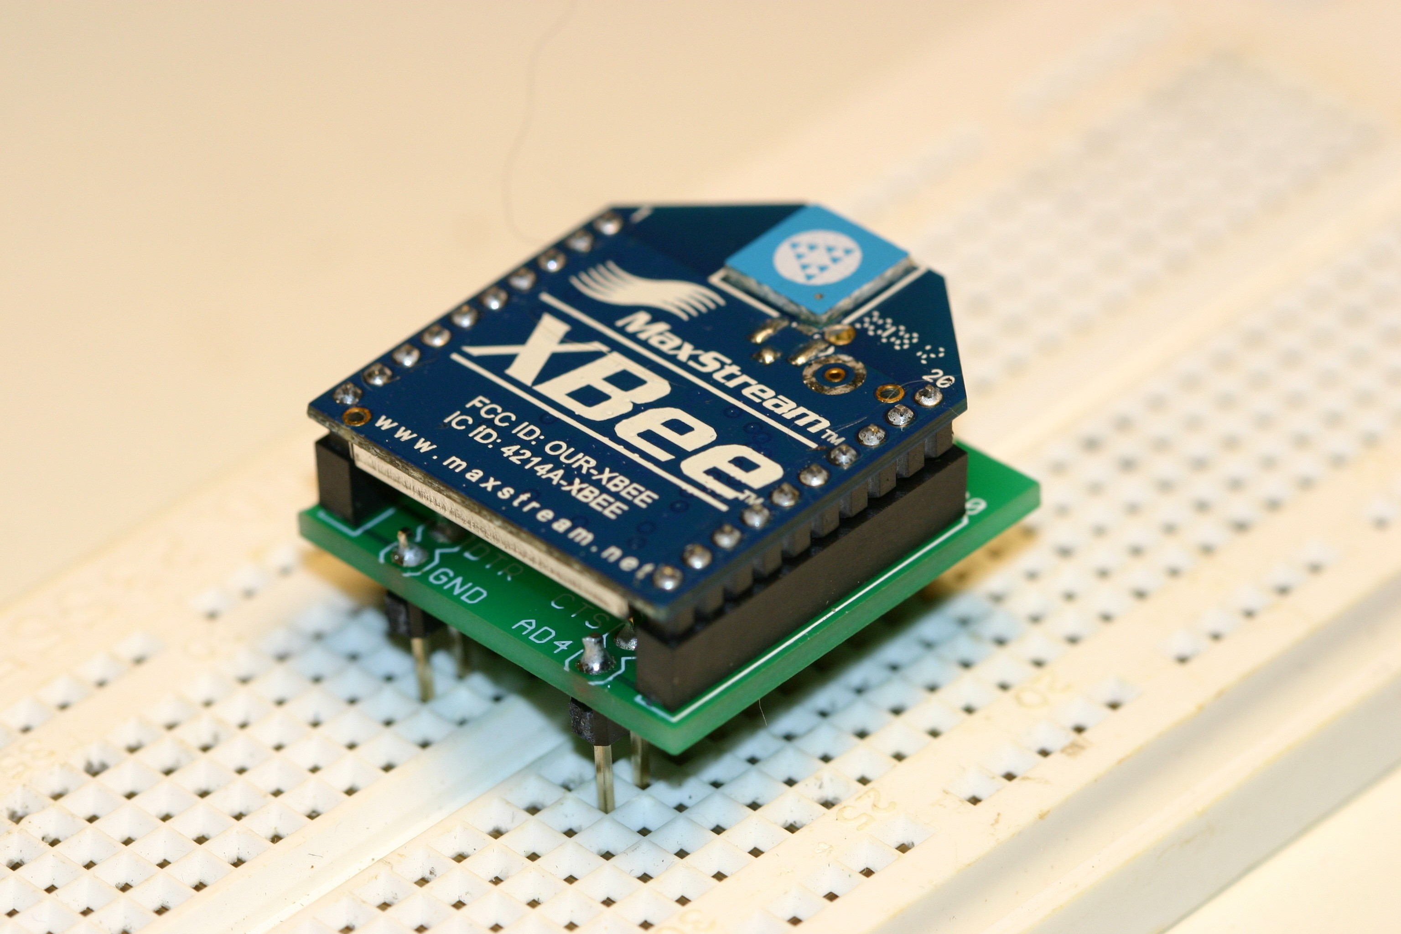
Figure 10.1. The MaxStream XBee module employs ZigBee to communicate serial data.

Ordering Information www.sparkfun.com
XBee 1mW ZigBee Module, Sparkfun No. WRL-08664, $22.95
XBee Module Breakout Board, Sparkfun No. BOB-08276, $2.95
Two 2mm 10-pin XBee Sockets, Sparkfun No. PRT-08272, $1.00*2
0.1" 40-pin Break Away Header, Sparkfun No. PRT-00116, $2.50

Specifications
This lab will implement simplex audio communication between two microcontrollers. The telephone system will communicate via a ZigBee wireless link. Two partnerships (four students) will implement the communication link; one partnership will construct a system capable of talking and the other partnership will construct a system capable of listening. In order to collaborate, the two teams will need to decide (protocol used by the TA/professor system)
1. Transmit and receive IDs (ID=1 and ID=2 are reserved for the professor systems)
2. Audio input/output sampling rates (e.g., 4000 samples per second),
3. Message format (e.g., audio data transmitted as raw 8-bit signed data sent in 100 byte packets),
3. How begin talking (e.g., transfer data while talk button held, play to speaker all received data)
If there is a group of 5 or 6 students, then that group must implement bidirectional communication (either half duplex or full duplex).

To stream data at 4000 bytes/sec, you will need to increase the baud rate from the default value of 9600 to 115200 bits/sec. The transmission rate is also limited by other wireless traffic, RF signal strength and noise. The fundamental limit is 250,000 bits/sec. One possible flow of data is as follows
- A person holds a request to talk button. Audio data will be sent as long as the button is pushed.
- When the talk button is held, the computer samples ADC data at 4000 Hz, and scales the audio data into 8-bit signed numbers. The computer sends multiple frames as it streams data from its microphone to the speaker on the other phone. Each data packet has 100 8-bit signed data samples. This operation calls XBee_CreateTxFrame to create an API1 frame and XBee_SendTxFrame to send it.
- When a computer receives an API 81 frame, it spools the data into a FIFO, streaming its data to its DAC at 4000 Hz. If the receive data flow runs out of data, output to the DAC is halted until more data arrives.

The UART1 module (the one interfaced to the XBee) must be written at a low level, like the book, without calling StellarisWare driver code. Other code (OLED, SSI, ADC, GPIO, timer, and PLL) can use StellarisWare driver code. It is possible support full duplex communication (audio in both directions at the same time); but only simplex is required for this lab.

Interfaces
The talk system consists of a LM3S1968, a microphone, a microphone amp, an ADC, a talk button, and an XBee module. The listen system consists of a LM3S1968, a DAC, a speaker amp, a speaker and an XBee module. Each microcontroller has an XBee module interfaced through a UART port. The default or initial baud rate of the XBee is 9600 bits/sec. The default format is 1 start bit, 8 data bits, no parity bit, and 1 stop bit. Both the talker and listener systems will use UART1 to communicate with the XBee.

XBee Module Driver
- Public Functions
XBee_Init – initialize the XBee module
The XBee module is controlled by a series of ‘AT’ commands. (This command set was originally developed to control asynchronous telephone modems and was developed by the Hayes Company. The AT prefix was an abbreviation for ‘ATtention.’) This routine sets the 16-bit module identifier of both the transmitter and receiver modules using the ‘MY’ and ‘DL’ AT command suffixes. This routine also conditions the module to operate in Application Programming Interface (API) mode 1. When operating in this mode, the module accepts data to be transmitted as structured frames rather than as a transparent serial communication device and it permits to the transmitter to automatically be notified if the receiver correctly received the transmission. In this protocol, all message characters are ASCII characters. E.g., A is letter ‘A’ or $41. Numbers are also in ASCII, as hex numbers. For example the number 79 is $4F and transmitted as ASCII ‘4’ ($34), ASCII ‘F’ ($46). The ASCII character <CR> is the carriage return (13 or $0D) and is used to terminate an AT command. The space is optional between the command and the parameter.

LM3S to XBee XBee response to LM3S Meaning
X wait 1.1s +++ wait 1.1s OK<CR> Enter command mode
ATDL4F<CR> wait 20ms OK<CR> Sets destination address to 79
ATDH0<CR> wait 20ms OK<CR> Sets destination high address to 0
ATMY4E<CR> wait 20ms OK<CR> Sets my address to 78
ATAP1<CR> wait 20ms OK<CR> API mode 1 (sends/receive packets)
ATBD7<CR> wait 20ms OK<CR> 115200 bits/sec baud rate
ATCN<CR> wait 20ms OK<CR> Ends command mode
Some of the default parameters are channel (CH=12), PAN (ID= 0x3332 or 13106) destination high address (DH=0) The default baud rate (BD=3) is 9600 bits/sec. ATBD6<CR> would create 57600 bits/sec. A change in baud rate goes into effect after the ATCN command.

XBee_CreateTxFrame – create an API frame
This routine creates an API transmit data frame consisting of a start delimiter, frame length, frame data, and checksum fields. The frame data field contains destination address and transmission options information. Increment the Frame Id (byte 5 in the figure at the bottom page 57) from 1 to 255, and then back to 1 again.

XBee_SendTxFrame – send an API frame
This routine transmits the API transmit data frame to the XBee module via UART1. The following figure shows a TxFrame message measured at the input of the XBee, pin 3 Din. The ID is a sequential number from 1 to 255, and then back to 1 again. It is used by the XBee to order the packets at the receiver. Setting ID equal to zero will disable the acknowledge message (a bad thing to do). We will not use options (Opt=0). The checksum is the bottom 8 bits of the calculation $FF-($01+$FD+$00+$02+$00+$48+$65) = $52.
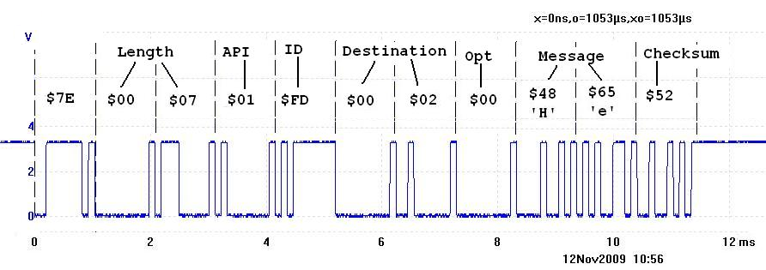
Figure 10.2. Transmit API frame type $01 used to send data (at 9600 bps, you will be 115200).

XBee_TxStatus – determine transmit status
When the XBee module transmits an API transmit data frame it will receive an acknowledgement from the destination module if the frame was received without errors. The status of the transmission will be sent to the LM3S1968 via an API transmit status frame. This routine returns a ‘1’ if the transmission was successful and a ‘0’ otherwise. The following figure shows a response the XBee returns after the transmitter sends a TxFrame that was properly received by the other computer, measured on XBee pin 2 Dout.
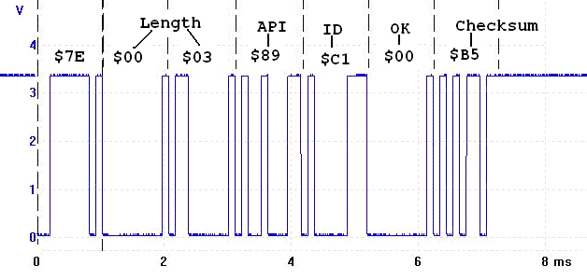
Figure 10.3. Transmit status API frame type $89 used to acknowledge message (at 9600 bps, you will be 115200).

- Private Functions
sendATCommand – sends an AT command repeatedly until it receives a reply that it was correctly received
This routine receives the various parameters associated with an AT command as input then transmits the formatted command to the XBee module. After a blind-cycle delay, the routine checks if the command has been successfully received by determining if the module has returned the ‘OK’ character string.

UART1 Design
The system initializes communication with UART1 to affect communication with the XBee module. Microphone data recorded using the ADC must be buffered (e.g., microphone buffer). A microphone buffer is required because the ADC is sampled at a fixed rate, while XBee packets are sent periodically. Similarly speaker data must be buffered (e.g., speaker FIFO), because data arrives in packets and is output to the DAC at a fixed rate. Both transmission and reception UART channels should be interrupt driven. API type 89 frames received at the listener should cause data to be put in a speaker FIFO. When the XBee module receives an API data frame it sends a message to the LM3S1968. Figure 10.4 shows one such message frame as measured at XBee pin 2 Dout. RSSI is the signal strength.

Periodic events at the audio sampling frequency
If the talk button is pressed ADC samples are scaled to 8 bits and put into a microphone buffer. After 100 samples, an API frame is created and sent. On the listener, if there is data in the speaker FIFO, this periodic task will remove one sample, scale it back to 12 bits, and output it to its DAC.
Your team is free to change any and all specifications as long as the system behaves like a telephone.
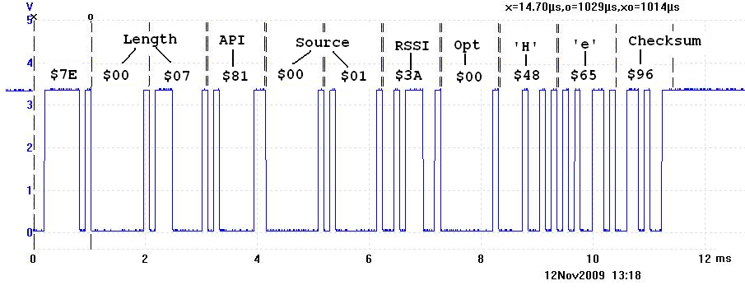
Figure 10.4. Receive API frame type $81 used to receive data (at 9600 bps, you will be 115200).

Preparation
Part a) Produce a schematic for your system, including interfaces to the microphone, speaker and XBee. Your schematic should illustrate all connections; have labels for all chips and their pin numbers, and values for all passive components.

Part b) Develop the XBee.h and XBee.c device driver files.

Part c) Write simple main programs you can use to test your device.

Procedure
Part a) Connect the XBee module to the LM3S1968. When not plugged into a protoboard, keep the XBee plugged into its static-protecting foam.

Part b) Debug the system in a bottom up manner. Write simple main programs to test the low-level functionality of the interface. Please test the microphone and speaker interfaces separately. When testing the XBee you can send a simple incrementing sequence of data and verify all data are properly received in order. Add appropriate debugging instruments such as profiles and dumps. Connect unused pins from both devices to a single logic analyzer and record a thread profile (which program runs when) as a stream of data is passed from the transmitter to the receiver (there should be signals from both computers).

Part c) Write a main program and periodic ISR that implements both the talking and listening features. One team implements talking the other implements listening.

Part d) The goal in this section is to measure effective bandwidth of your channel. We know the sampling rate is fixed (e.g., 2000 samples per second). What we do not know is the effective number of bits. Remove the microphone and replace it with a sine wave generator at a fixed frequency (your choice of frequency). Stream the data into the ADC, across the network, and to the DAC. Use a spectrum analyzer to measure the frequency spectrum of the DAC output. If the system were perfect the measured spectrum would just include just DC and 100 Hz with no other frequencies. Because of noise there will be DC (ignore this because it is not important), 100 Hz (signal) and other frequencies (noise). Measure the signal to noise ratio (like Figure 8.35 in the book). For example, if the ratio of signal to noise is X is dB, we calculate the effective number of bits using the relation X = 20 log₁₀(2^{n}). The effective bandwidth is 2000×n in bits/sec. Figure 10.5 shows a recorded wave at the speaker output with a 100 Hz wave at the input.
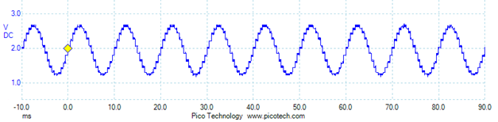
Figure 10.5. 100 Hz wave at the input and the signal measured on the DAC output.
Figure 10.6 plots the spectrum of this signal. Notice the -4 dB signal at 100 Hz, and the -40 dB noises away from 100 Hz. For this system the signal to noise ratio is 36 dB. 36 = 20 log₁₀(2^{n}) means n = 6 bits. For this system we are transmitting 6 bits at 2000 times/sec = 12000 bits/sec (well below the 250,000 channel rate of the XBee).
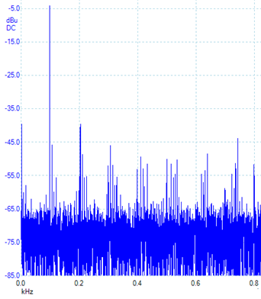
Figure 10.6. 100 Hz wave at the input and the signal measured on the DAC output.

Part e) The goal in this section is to measure maximum range of your system. Using the same test procedure developed in part c) find the maximum distance where the system performs reliable communication.

Deliverables (exact components of the lab report)
- Objectives (1/2 page maximum)
- Hardware Design
Talker and Listener schematics
- Software Design (a hardcopy software printout is due at the time of demonstration)
Hardcopy of your Talker and Listener system software
- Measurement Data
Estimate the maximum bandwidth of your XBee wireless link.
Estimate the range of your XBee wireless link.
- Analysis and Discussion (1 page maximum)
F) Make a list of the all the tasks completed and specify which members completed which tasks.

Checkout
Demonstrate that audio from the talker computer can be communicated to the speaker on the listener. Teams are allowed to share software within the group, but expect all members to contribute. During checkout you will need to explain exactly how each member contributed.
Upload your software and lab report, as instructed by your TA.

Hints
0) If the XBee stops operating, I suggest you power-cycle the module (turn off power, then restore power). A particular problem occurs when the software running on the receiver microcontroller is reset while the rest of the system is still running. When the software attempts to initialize the XBee, the XBee might still be receiving data from the transmitter, since of course the transmitter system is unaffected by the receiver microcontroller being reset. The receiver software is looking for a short string ending with the characters “OK\r” in response to the “X” and “+++” commands. However, the software in the receiver will hang at this point if the incoming data is text from the transmitter. To fix this, either briefly shut off the transmitter system until the receiver system initializes correctly or power-cycle the receiver.

1) Adapt code from the UART2 (UART2 means interrupt driven and does not refer to the specific UART port on the microcontroller) starter files to implement the required interrupt-driven UART1 interfaces.

2) Be careful to flush all data out of the XBee when receiving messages and receiving responses. One way to flush the XBee is to read all the characters that exist until there is no more data from the XBee for more than 12 bit times.

3) The following TxFrame was sent from the Transmitter system to the XBee. It was ignored by the XBee. Why?
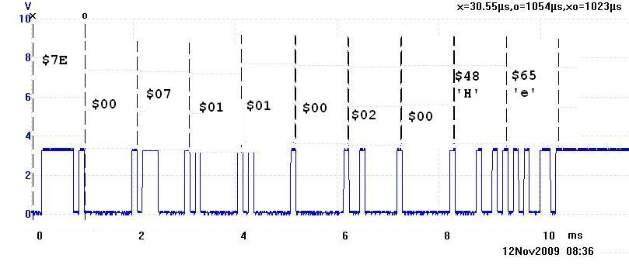
Figure 10.5. A bad transmit API frame (at 9600 bps).

4) There is an operational system (called the professor system) with which you can test your system. The professor system is both a talker and a listener and operates at an audio frequency of 2000 Hz. To test your system make your ID =2. The professor system has ID=1. If you push its talk button on the professor system, it will send audio data to ID=2. If you are ID=2 and send audio data to ID=1, then it will be played on its speaker. Once you are done testing your system with the professor system, please do not continue to use ID=1 or ID=2, so other students can use the professor system for testing.

5) Read Section 12.2.2 of the LM3S1968 data sheet about how to set the baud rate. In particular, there are four possible sequences to update the baud-rate registers. One does not simply set the UART1_IBRD_R and UART1_FBRD_R. This process is also explained in the 12.5 Register Description section.

6) I suggest you measure the actual bit time on the serial output of your XBee. At 57600 bps ("ATBD6\r"), I measured the bit time generated by the XBee to be 17μs, which is an equivalent baud rate of 58824 bits/sec. At 115200 bps ("ATBD7\r"), I measured the bit time generated by the XBee to be 9μs, which is an equivalent baud rate of 111,111 bits/sec.

