**Project Chimy’s – Use Case Diagram & Use Case Specifications**

**Use Case Diagram:**

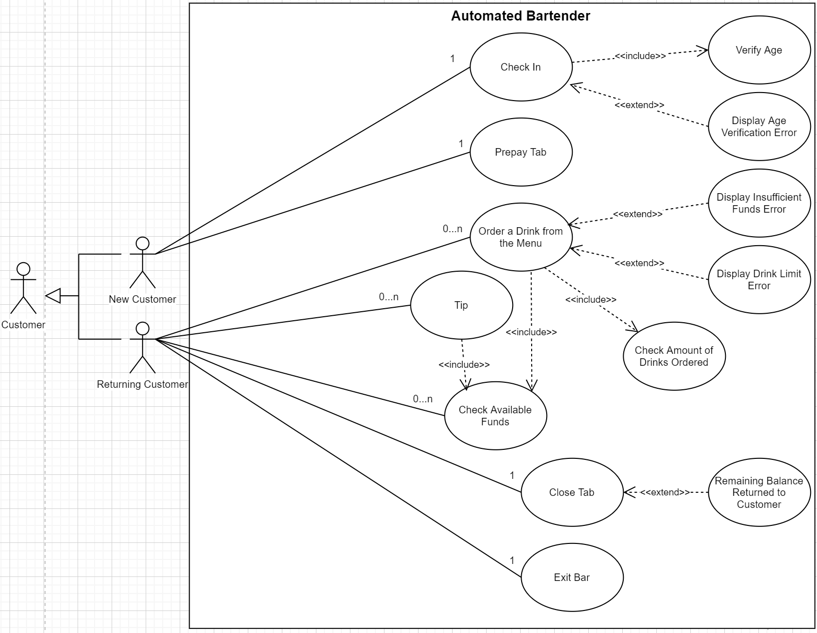

**Use Case Specifications:**

**Use Case Name:** Check In

**Use Case Description:** Allows a user to check with the automated bartender. This use case will always verify that the user is at least 21 years of age before they are allowed access to the automated bartender. If they are not at least 21 years of age, they will not be allowed access.

**Actors:**

* New Customer

**Triggers:**

* The user wishes to gain access to the automated bartender

**Pre-conditions:**

* The automated bartender is operational
* The user attempting to enter has proof that they are at least 21 years of age

**Post-conditions:**

* The user now has access to the automated bartender and its features

**Normal Flow:**

1. The user approaches the automated bartender and requests entry
2. The user verifies that they are of age to gain access to the automated bartender
3. They are allowed access to the automated bartender

**Use Case Name:** Prepay Tab

**Use Case Description:** Allows a user to prepay their tab by paying whatever amount they desire

**Actors:**

* New Customer

**Triggers:**

* The user wishes to prepay for their tab

**Pre-conditions:**

* The automated bartender is operational
* The user wishes to buy drinks
* The user has money to spend

**Post-conditions:**

* The user can now buy drinks

**Normal Flow:**

1. The user has been allowed access to the automated bartender
2. The user can prepay their tab
3. The user can now begin to order drinks

**Use Case Name:** Order a Drink from the Menu

**Use Case Description:** Allows a user to browse a menu and order drinks. The bartender keeps track of the prepaid balance and the amount of drinks the user has ordered. If the user has insufficient funds for another drink or they have reached their drink limit, the user will be denied another drink.

**Actors:**

* Returning Customer

**Triggers:**

* The user wishes to order a drink

**Pre-conditions:**

* The automated bartender is operational
* The user has enough funds for a drink
* The user has not reached their drink limit

**Post-conditions:**

* The user can leave a tip if they please
* The user can order another drink if they have not reached their limit and their balance has enough funds

**Normal Flow:**

1. The user selects a drink from the menu
2. The user has an option to tip

**Use Case Name:** Tip

**Use Case Description:** Allows the user to leave a tip if they wish to do so and ensures they have enough funds to leave the tip amount.

**Actors:**

* Returning Customer

**Triggers:**

* The user wishes to leave a tip

**Pre-conditions:**

* The automated bartender is operational
* The user has enough funds to leave a tip

**Post-conditions:**

* The user’s balance is updated

**Normal Flow:**

1. The user has just ordered a drink and has chosen to leave a tip
2. The user decides how much tip money will be left

**Use Case Name:** Check Available Funds

**Use Case Description:** Allows the user to check the current balance of their prepaid tab at any time

**Actors:**

* Returning Customer

**Triggers:**

* The user wishes to view the balance remaining of their prepaid tab

**Pre-conditions:**

* The automated bartender is operational
* The user wishes to view the current balance of their prepaid tab

**Post-conditions:**

* The user now knows their remaining balance

**Normal Flow:**

1. The user requests to see the current balance of their prepaid tab
2. The user is presented their current balance

**Use Case Name:** Close Tab

**Use Case Description:** Allows the user to close their tab at any time and will be returned any amount of money that remained in their balance, if any money remained at all.

**Actors:**

* Returning Customer

**Triggers:**

* The user wishes to close their tab

**Pre-conditions:**

* The automated bartender is operational
* The user is done ordering drinks or has run out of money

**Post-conditions:**

* The user no longer has a tab open or a balance

**Normal Flow:**

1. The user requests to close their tab
2. The user receives the money they did not spend from their prepaid tab
3. The tab is closed

**Use Case Name:** Exit Bar

**Use Case Description:** Allows the user to “exit the bar” i.e. ends their session with the automated bartender.

**Actors:**

* Returning Customer

**Triggers:**

* The user wishes to end their session with the automated bartender

**Pre-conditions:**

* The automated bartender is operational
* The user has paid their tab

**Post-conditions:**

* The user has been served drinks

**Normal Flow:**

1. The user ends their session with the automated bartender