John Sommers

SDEV 300 7381

17 April 2023

Sommers Lab 5 Test Cases

Pylint results:  
I earned a 9.64/10 using pylint. At first, I had some issues with missing docstrings and wrong import order, but I rectified these issues easily. The issues that remain here are the ones from last week in addition to the one that is more of a suggestion it seems because it says “consider”.

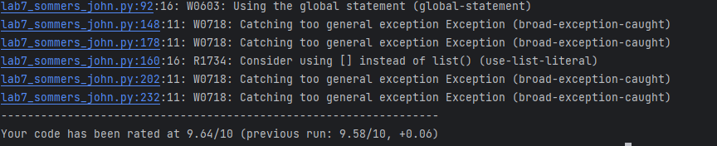

Test Cases:

|  |  |  |  |  |
| --- | --- | --- | --- | --- |
| Test # & Requirement Tested | How Tested | Expected Output | Acual Results | Pass (Y/N)? |
| 1. | Navigated to the password update form, and used previously established credentials to update the password. Restarted the application and then logged in with the new credentials. | The password update form works as intended and updates the user password. | As expected  (See screenshots) | Yes |
| 2. Autentecation Functions | Attempted to input a password that is commonly used (password) when using the registration form. | An error message prompting the user to not use a common password. | As expected  (See screenshots) | Yes |
| 3. A logger that logs all incorrect logins. | Intentionally tried to log in with wrong credentials. | Verified that this event was logged to the log file by opening the log file. | As expected | Yes |

Test Case 1:

Test Case 2:

Test Case 3:

Part 2: Password Stuff

1. This SDEV 300 class has some strage requests.

Morse Code

1. So this is base 64. Now I know.

Self explanatory.

1. --- Begin Key ----

I am so clever. No one could possibly figure this out.

--- End Key ---  
+14 ROT Cypher