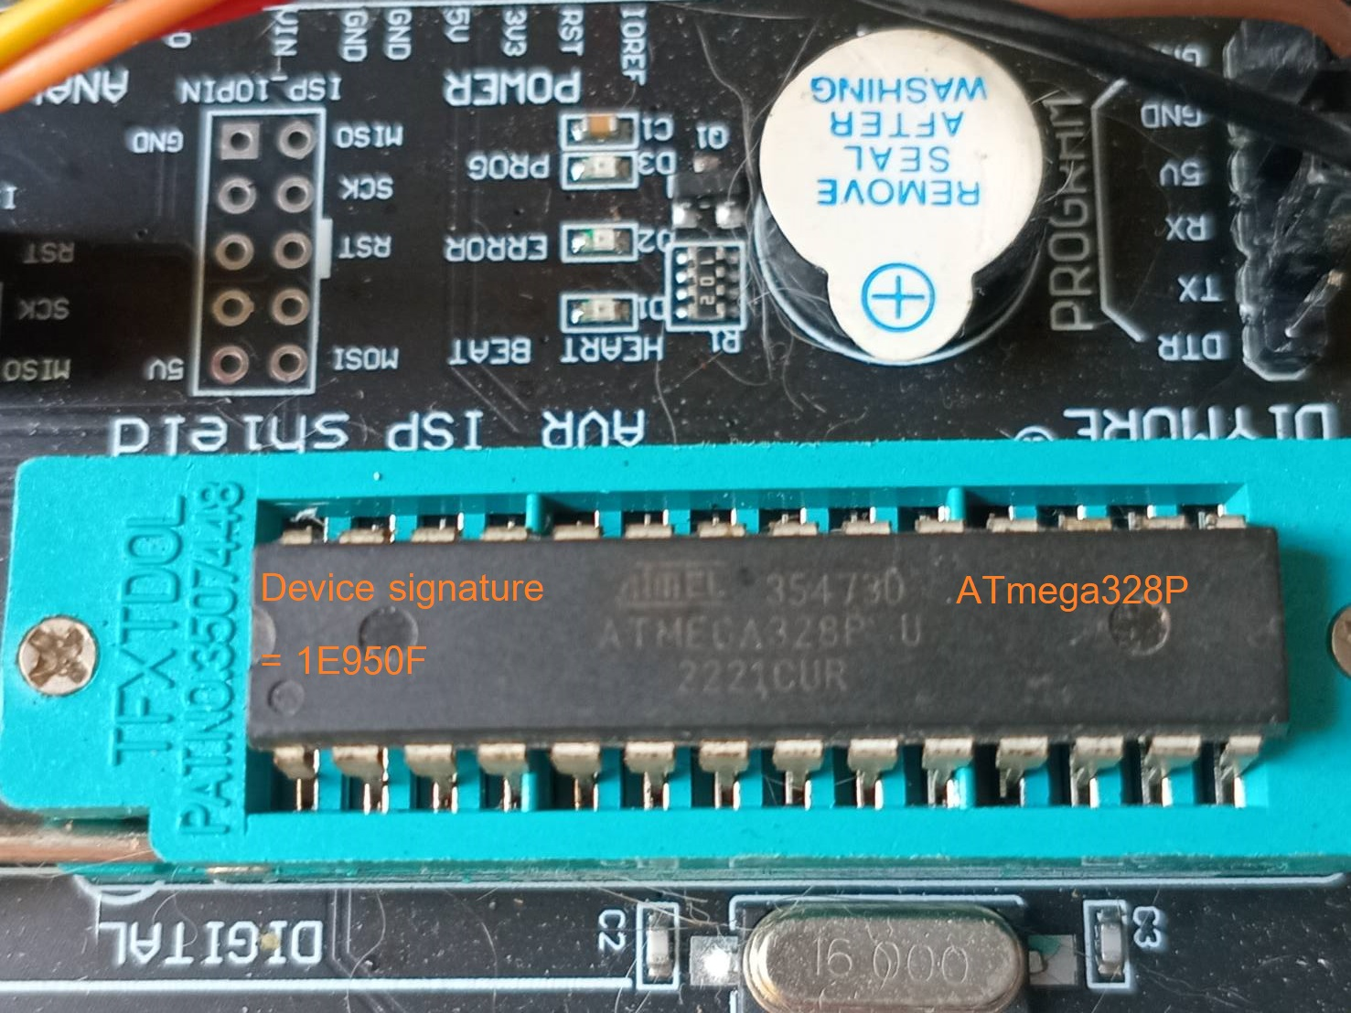
Arduino UNO with USBASP

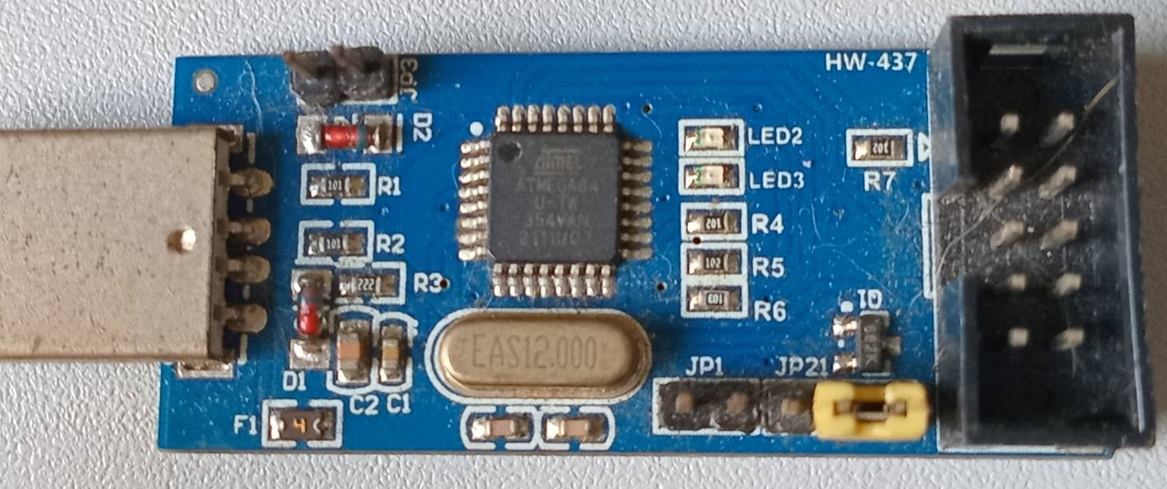
USBASP jumper setting for 5V.

UnoReadSerial.ino

/*
ATmega328P Device signature = 1e950f = 1E950F
*/

int pushButton = 2; // digital pin 2 has a pushbutton attached to it. Give it a name:

void setup() {
pinMode(LED_BUILTIN, OUTPUT); // initialize digital pin LED_BUILTIN as an output.
pinMode(7, OUTPUT); pinMode(8, OUTPUT); pinMode(9, OUTPUT);
Serial.begin(9600); // initialize serial communication at 9600 bits per second:
pinMode(pushButton, INPUT); // make the pushbutton's pin an input:
}

void loop() {
int buttonState = digitalRead(pushButton); // read the input pin:
Serial.println(buttonState); // print out the state of the button:
delay(1); // delay in between reads for stability
digitalWrite(LED_BUILTIN, HIGH); delay(200); digitalWrite(LED_BUILTIN, LOW); delay(200);
digitalWrite(7, HIGH); delay(200); digitalWrite(7, LOW); delay(200);
digitalWrite(8, HIGH); delay(200); digitalWrite(8, LOW); delay(200);
digitalWrite(9, HIGH); delay(200); digitalWrite(9, LOW); delay(200);
}

