CA

Question 1

Test 1)

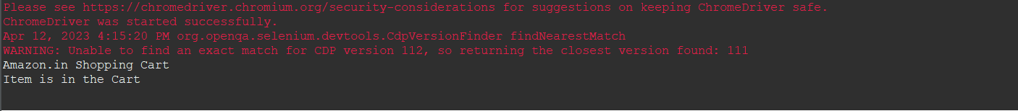

package com_selenium_test1.CA_Test1;

import org.openqa.selenium.By;

import org.openqa.selenium.WebDriver;

import org.openqa.selenium.chrome.ChromeDriver;

import org.openqa.selenium.chrome.ChromeOptions;

import io.github.bonigarcia.wdm.WebDriverManager;

public class Test1

{

public static void main( String[] args ) throws InterruptedException

{

WebDriverManager.chromedriver().setup();

ChromeOptions co=new ChromeOptions();

co.addArguments("--remote-allow-origins=*");

WebDriver driver=new ChromeDriver(co);

driver.manage().window().maximize();

driver.get("https://www.amazon.in/gp/product/B09FXM3WDR/ref=ox_sc_act_title_1?smid=A14CZOWI0VEHLG&psc=1");

driver.findElement(By.id("add-to-cart-button")).submit();

String cartTitle = driver.getTitle();

System.out.println(cartTitle);

if (cartTitle.equals("Amazon.in Shopping Cart")) {

System.out.println("Item is in the Cart");

} else {

System.out.println("Item is NOT in the Cart");

}

}

}

Testcase 2)

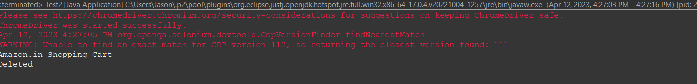

package com_selenium_test1.CA_Test1;

import org.openqa.selenium.By;

import org.openqa.selenium.WebDriver;

import org.openqa.selenium.WebElement;

import org.openqa.selenium.chrome.ChromeDriver;

import org.openqa.selenium.chrome.ChromeOptions;

import io.github.bonigarcia.wdm.WebDriverManager;

public class Test2 {

public static void main( String[] args ) throws InterruptedException

{

WebDriverManager.chromedriver().setup();

ChromeOptions co=new ChromeOptions();

co.addArguments("--remote-allow-origins=*");

WebDriver driver=new ChromeDriver(co);

driver.manage().window().maximize();

driver.get("https://www.amazon.in/gp/product/B09FXM3WDR/ref=ox_sc_act_title_1?smid=A14CZOWI0VEHLG&psc=1");

driver.findElement(By.id("add-to-cart-button")).submit();

driver.get("https://www.amazon.in/gp/cart/view.html?ref_=nav_cart");

driver.findElement(By.cssSelector("[value='Delete']")).click();

String t=driver.getTitle();

System.out.println(t);

Strings=driver.findElement(By.xpath("/html/body/div[1]/div[2]/div[3]/div[5]/div/div[2]/div[1]/div/div[1]/div/h1")).getText();

if(t.equals("Shopping Cart")) {

System.out.println("Deleted");

}

}

}

TestCase 3)

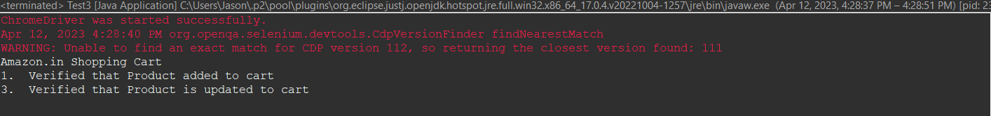

package com_selenium_test1.CA_Test1;

import java.util.List;

import org.openqa.selenium.By;

import org.openqa.selenium.JavascriptExecutor;

import org.openqa.selenium.WebDriver;

import org.openqa.selenium.WebElement;

import org.openqa.selenium.chrome.ChromeDriver;

import org.openqa.selenium.chrome.ChromeOptions;

import org.openqa.selenium.edge.EdgeDriver;

import org.openqa.selenium.interactions.Actions;

import org.openqa.selenium.support.ui.Select;

import dev.failsafe.internal.util.Assert;

import io.github.bonigarcia.wdm.WebDriverManager;

public class Test3 {

public static void main( String[] args ) throws InterruptedException

{

WebDriverManager.chromedriver().setup();

ChromeOptions co=new ChromeOptions();

co.addArguments("--remote-allow-origins=*");

WebDriver driver=new ChromeDriver(co);

driver.manage().window().maximize();

driver.get("https://www.amazon.in/gp/product/B09FXM3WDR/ref=ox_sc_act_title_1?smid=A14CZOWI0VEHLG&psc=1");

driver.findElement(By.id("add-to-cart-button")).submit();

String t=driver.getTitle();

System.out.println(t);

String cart=driver.findElement(By.xpath("//*[@id=\"NATC_SMART_WAGON_CONF_MSG_SUCCESS\"]/span")).getText();

if(cart.equals("Added to cart"));

System.out.println("1. Verified that Product added to cart ");

driver.navigate().back();

WebElement sort1=driver.findElement(By.xpath("/html/body/div[2]/div[2]/div[5]/div[3]/div[1]/div[3]/div/div[1]/div/div[1]/div/div/div[2]/div/div[2]/div/form/div/div/div[28]/div/div/div/span/div/div/span/select"));

sort1.click();

Select select=new Select(sort1);

select.selectByIndex(1);

String drop=driver.findElement(By.xpath("//*[@id=\"quantity\"]")).getText();

if(drop.equals("2"));

System.out.println("3. Verified that Product is updated to cart ");

}

}

Testcase 4)

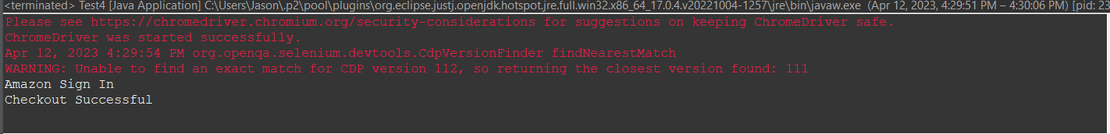

package com_selenium_test1.CA_Test1;

import org.openqa.selenium.By;

import org.openqa.selenium.WebDriver;

import org.openqa.selenium.chrome.ChromeDriver;

import org.openqa.selenium.chrome.ChromeOptions;

import io.github.bonigarcia.wdm.WebDriverManager;

public class Test4

{

public static void main( String[] args ) throws InterruptedException

{

WebDriverManager.chromedriver().setup();

ChromeOptions co=new ChromeOptions();

co.addArguments("--remote-allow-origins=*");

WebDriver driver=new ChromeDriver(co);

driver.manage().window().maximize();

driver.get("https://www.amazon.in/gp/product/B09FXM3WDR/ref=ox_sc_act_title_1?smid=A14CZOWI0VEHLG&psc=1");

driver.findElement(By.id("add-to-cart-button")).submit();

driver.get("https://www.amazon.in/gp/cart/view.html?ref_=nav_cart");

driver.findElement(By.name("proceedToRetailCheckout")).submit();

String t=driver.getTitle();

System.out.println(t);

if(t.equals("Amazon Sign In")) {

System.out.println("Checkout Successful");

}

}

}

Question2:

package com.selenium.test2.selenium1;

import java.util.List;

import org.openqa.selenium.By;

import org.openqa.selenium.JavascriptExecutor;

import org.openqa.selenium.Keys;

import org.openqa.selenium.WebDriver;

import org.openqa.selenium.WebElement;

import org.openqa.selenium.chrome.ChromeDriver;

import org.openqa.selenium.chrome.ChromeOptions;

import io.github.bonigarcia.wdm.WebDriverManager;

public class CA1_Q2_2

{

public static void main( String[] args ) throws InterruptedException

{

WebDriverManager.chromedriver().setup();

ChromeOptions co=new ChromeOptions();

co.addArguments("--remote-allow-origins=*");

WebDriver driver=new ChromeDriver(co);

driver.get("https://www.amazon.in/");

driver.manage().window().maximize();

String actualTitle=driver.getTitle();

System.out.println("Page title is : " + driver.getTitle());

String expectedTitle = "Online Shopping site in India: Shop Online for Mobiles, Books, Watches, Shoes and More - Amazon.in";

if(actualTitle.equalsIgnoreCase(expectedTitle))

System.out.println("Title Matched");

else

System.out.println("Title didn't match");

WebElement txt1=driver.findElement(By.id("twotabsearchtextbox"));

txt1.sendKeys("Watch");

driver.findElement(By.id("twotabsearchtextbox")).sendKeys(Keys.ENTER);

JavascriptExecutor js=(JavascriptExecutor) driver;

js.executeScript("window.scrollBy(0,1000)","");

List<WebElement> l1=driver.findElements(By.xpath("//h5[@class='s-line-clamp-1']"));

for(WebElement link:l1)

{

System.out.println(link.getText());

}

js.executeScript("window.scrollBy(0,1000)","");

List<WebElement> l2=driver.findElements(By.xpath("//h5[@class='s-line-clamp-1']"));

for(WebElement link:l2)

{

System.out.println(link.getText());

}

}

}

Question3:

3.1:

package com.selenium.testing.selenium65;

import org.openqa.selenium.By;

import org.openqa.selenium.JavascriptExecutor;

import org.openqa.selenium.WebDriver;

import org.openqa.selenium.WebElement;

import org.openqa.selenium.chrome.ChromeDriver;

import org.openqa.selenium.chrome.ChromeOptions;

import org.openqa.selenium.support.ui.Select;

import io.github.bonigarcia.wdm.WebDriverManager;

public class Q1 {

public static void main( String[] args ) throws InterruptedException

{

WebDriverManager.chromedriver().setup();

ChromeOptions co=new ChromeOptions();

co.addArguments("--remote-allow-origins=*");

WebDriver driver=new ChromeDriver(co);

//WebDriver driver=new EdgeDriver();

//open link and maximize

driver.get("https://www.amazon.in/gp/your-account/order-history?ref_=ya_d_c_yo");

driver.manage().window().maximize();

JavascriptExecutor js=(JavascriptExecutor) driver;

//js.executeScript("window.scrollBy(0,1000)","");

String url1="https://www.amazon.in/gp/your-account/order-history?ref_=ya_d_c_yo";

String url2="";

url2=driver.getCurrentUrl();

if(url1.equals(url2))

System.out.println("Correct");

    }

}

3.2:

package com.selenium.testing.selenium65;

import org.openqa.selenium.By;

import org.openqa.selenium.JavascriptExecutor;

import org.openqa.selenium.WebDriver;

import org.openqa.selenium.WebElement;

import org.openqa.selenium.chrome.ChromeDriver;

import org.openqa.selenium.chrome.ChromeOptions;

import org.openqa.selenium.support.ui.Select;

import io.github.bonigarcia.wdm.WebDriverManager;

public class Q1 {

public static void main( String[] args ) throws InterruptedException

{

WebDriverManager.chromedriver().setup();

ChromeOptions co=new ChromeOptions();

co.addArguments("--remote-allow-origins=*");

WebDriver driver=new ChromeDriver(co);

//WebDriver driver=new EdgeDriver();

//open link and maximize

driver.get("https://www.amazon.in/gp/your-account/order-history?ref_=ya_d_c_yo");

driver.manage().window().maximize();

JavascriptExecutor js=(JavascriptExecutor) driver;

//js.executeScript("window.scrollBy(0,1000)","");

String url1="https://www.amazon.in/gp/your-account/order-history?ref_=ya_d_c_yo";

String url2="";

url2=driver.getCurrentUrl();

if(url1.equals(url2))

System.out.println("Correct");

    }

}