Design and Development of an Intelligent Real-Time Traffic Flow Prediction and Congestion Analysis System Using Long Short-Term Memory (LSTM) Deep Learning Networks
A PROJECT REPORT

Submitted by
EVARENCE BESKI.M (212922104016)
JOHNSON.Y(212922104025)

In partial fulfilment for the award of the degree
of
BACHELOR OF ENGINEERING
in
COMPUTER SCIENCE AND ENGINEERING


St. JOSEPH COLLEGE OF ENGINEERING, SRIPERUMBUDUR

ANNA UNIVERSITY: CHENNAI 600025
MAY 2026

ANNA UNIVERSITY: CHENNAI 600 025

BONAFIDE CERTIFICATE
Certified that this project report “DESIGN AND DEVELOPMENT OF AN INTELLIGENT REAL-TIME TRAFFIC FLOW PREDICTION AND CONGESTION ANALYSIS SYSTEM USING LONG SHORT-TERM MEMORY (LSTM) DEEP LEARNING NETWORKS”is the bonafide work of EVARENCE BESKI.M (212922104016), JOHNSON.Y(212922104025) who carried out the project work under my supervision.

SIGNATURE
Ms. A. SUNITHA
SUPERVISOR
Department of Computer Science and Engineering.
St. Joseph College of Engineering, Sriperumbudur, Chennai- 602117.
SIGNATURE
Dr. M. NAVANEETHA KRISHNAN
HEAD OF THE DEPARTMENT
Department of Computer Science and Engineering.
St. Joseph College of Engineering, Sriperumbudur, Chennai- 60211
Submitted for the Bachelor of Engineering Degree Viva- Voce held at
St. Joseph College of Engineering on

INTERNAL EXAMINER _{EXTERNAL EXAMINER}
ACKNOWLEDGEMENT

We are very grateful and gifted in taking up this opportunity to thank the
Lord Almighty for showering his unlimited blessings upon us.
We take this occasion to express our respect and thanks to Rev. Fr. Dr. J. E. Arul Raj, Founder and Chairman and Rev. Sr. S. Gnanaselvam DMI, Managing Trustee, for facilitating us to do our project successfully.
We take this opportunity to thank our administrator Rev. Fr. I.SENGOL, MMI
MMI, for his kind and encouraging guidance. We wish to eloquent our genuine thanks to Principal Dr. T. Manuel Raj M. Tech., Ph.D.,MBA.,Ph.D(R&D).,CE., for his support and guidance.
We express our deep sense of gratitude to HOD & Project Co-Ordinator Ms. A. Sunitha M.E, (Ph.d), and Supervisor Dr. M. Navaneetha Krishnan, M.E., Ph.D., for his scintillating discussions and encouragement towards our project work.
It is pleasure to acknowledge our indebtedness to all the Staff Members of our department who aided us ingeniously to bring our project as effective one. Our special thanks to Non-Teaching Staffs for extending the Lab facilities.
We thank our family members and friends for their honorable support.

ABSTRACT
Traffic congestion has become a major problem in urban areas due to the rapid increase in the number of vehicles and population growth. Accurate traffic flow prediction is essential for intelligent transportation systems and effective traffic management. The proposed project, titled “Design and Development of an Intelligent Real-Time Traffic Flow Prediction and Congestion Analysis System Using Long Short-Term Memory (LSTM) Deep Learning Networks,” aims to predict traffic flow and analyze congestion levels using deep learning techniques.
The system uses historical traffic data containing attributes such as temperature, rainfall, snowfall, weather conditions, and traffic volume. The dataset is preprocessed by handling missing values, encoding categorical features, and normalizing numerical data. Feature selection is performed to identify the most relevant attributes affecting traffic flow. The processed data is then converted into time-series format and trained using the Long Short-Term Memory (LSTM) model.
The LSTM algorithm is highly suitable for traffic prediction because it can learn sequential dependencies and long-term patterns in time-series data. The trained model predicts future traffic flow and classifies congestion levels into low, medium, and high categories. The results are visualized using graphs and charts for better interpretation.
The proposed system provides improved prediction accuracy and efficient congestion analysis compared to traditional traffic prediction methods.

TABLE OF CONTENTS
CHAPTER | TITLE | PAGE NO
1 | ABSTRACT,  LIST OF FIGURES,  LIST OF ABBEREVIATION, INTRODUCTION | IV, VIII, X, 1
 | 1.1 OVERVIEW | 1
 | 1.2 OBJECTIVE | 3
2 | LITERATURE SURVEY | 5
3 | FEASIBILITY STUDY | 9
 | 3.1 EXISTING SYSTEM | 9
 | 3.1.1 EXISTING SYSTEM WORKFLOW | 11
 | 3.1.2 DISADVANTAGES | 13
 | 3.2 PROPOSED SYSTEM | 16
 | 3.2.1 ADVANTAGES | 18
 | 3.3 SYSTEM REQUIREMENT | 21
 | 3.3.1 HARDWARE REQUIREMENT | 21
 | 3.3.2 SOFTWARE REQUIREMENT | 21
 | 3.4 SOFTWARE PLATEFORM | 22
 | 3.4.1 PYTHON | 22
 | 3.4.2 JUPYTER& ANACONDA | 23
 | 3.4.3 OPERATING SYSTEM | 24
 | 3.4.4 PROCESSOR | 24
4 | SYSTEM DESIGN | 27
 | 4.1 SYSTEM ARCHITECTURE | 28
 | 4.2 DESCRIPTION | 29
 | 4.3 DATASET | 31
 | 4.4 DATA PRE-PROCESSING | 33
 | 4.5 FEATURE SELECTION | 34
 | 4.6 TRAIN SET | 34
 | 4.7 TEST SET | 35
 | 4.8 MODEL EVALUATION | 35
 | 4.9 PREDICTION | 36
5 | UML DIAGRAM | 36
 | 5.1 USE CASE DIAGRAM | 36
 | 5.2 CLASS DIAGRAM | 38
 | 5.3 SEQUENCE DIAGRAM | 39
 | 5.4 ACTIVITY DIAGRAM | 40
 | 5.5 COMPONANT DIAGRAM | 41
6 | IMPLEMENTATION | 51
 | 6.1 IMPLEMENTATION OVERVIEW | 51
 | 6.2 ALGORITHM SELECTION | 53
 | 6.3 DATA LOADING AND INITIAL ANALYSIS | 54
 | 6.4 EXPLORATORY DATA ANALYSIS (EDA) | 55
 | 6.5 DATA PROCESSING | 55
 | 6.6 FEATURE SELECTION | 56
 | 6.7 TIME SERIES CONVERSATION | 56
 | 6.8 LSTM Model Design | 57
 | 6.9 MODEL TRAINING | 58
 | 6.10 HYPERPARAMETER TUNING  6.11 MODEL EVALUATION  6.12 REAL-TIME PREDICTION  6.13 CONGESTION ANALYSIS  6.14 VISUALIZATION OF RESULTS  6.15 SYSTEM INTEGRATION  6.16 PERFORMANCE ANALYSIS  6.17 SUMMARY | 58  60  61  62  65  53  54  67  67
7 | RESULTS | 64
8 | CONCLUSION | 66
9 | FUTURE ENHANCEMENT | 67
 | APPENDIX A | 68
 | APPENDIX B | 77
 | REFERENCES | 82

FIGURE | NAME | PAGE NO
3.1 | Existing System of Workflow | 11
3.2 | Existing system Dataset | 12
4.1 | Existing System Diagram | 28
4.2 | Data Set | 32
4.3 | Null Values Checking | 33
4.4 | Dropping Null Values | 34
4.5 | Feature Selection | 35
4.6 | Use Case diagram | 38
4.7 | Class Diagram | 39
4.8 | Sequence diagram | 41
4.9 | Activity diagram | 42
4.10 | Component Diagram | 49
5.1 | Block Diagram | 45
5.2 | Data Set | 46
5.3 | Data Pre-Processing 1 | 47
List of Figures

  - Data Pre-Processing 2 48
  - Feature Selection 49
  - Model Building 50
  - Train the LSTM Building 59
  - Model Accuracy 60
  - Traffic Prediction 61
  - Result 72
  - Index Page 70
  - Traffic Data Input Screen-1 71
  - Traffic Data Input Screen-2 72
  - Traffic Data Input Screen-3 73
  - Predict the Traffic Value for Next hour 74

CHAPTER 1
INTRODUCTION

1.1 Overview
Traffic congestion has become one of the most critical challenges faced by modern urban environments. With the rapid increase in population and the growing number of vehicles on the road, managing traffic efficiently has become a complex task for city planners and transportation authorities.
Congestion not only leads to increased travel time but also results in higher fuel consumption, environmental pollution, and economic losses. Therefore, developing intelligent systems that can predict traffic flow accurately in real time is essential for improving the overall efficiency of transportation systems.
In recent years, Intelligent Transportation Systems (ITS) have gained significant attention as a solution to traffic-related issues. These systems integrate advanced technologies such as data analytics, machine learning, and communication systems to monitor, analyze, and control traffic conditions.
One of the key components of ITS is traffic flow prediction, which helps in forecasting future traffic conditions based on historical and real-time data. Accurate traffic prediction enables better route planning, congestion management, and decision-making for both commuters and authorities. Traditional traffic prediction methods, including statistical models like Auto-Regressive Integrated Moving Average (ARIMA) and classical machine learning techniques such as Linear Regression and Support Vector Machines (SVM), have been widely used in the past. However, these methods have several limitations when dealing with complex and dynamic traffic data.
1
Traffic patterns are highly non-linear and influenced by various temporal factors such as time of day, day of the week, and unexpected events. Conventional models often fail to capture these long-term dependencies and temporal variations effectively, resulting in lower prediction accuracy.
To overcome these limitations, deep learning techniques have emerged as powerful tools for time-series forecasting problems. Among these techniques, Long Short-Term Memory (LSTM) networks, a special type of Recurrent Neural Network (RNN), have shown remarkable performance in modeling sequential data.
LSTM networks are specifically designed to capture long-term dependencies by maintaining memory over extended time intervals. This capability makes them highly suitable for traffic flow prediction, where past traffic patterns significantly influence future conditions.
The proposed project focuses on the design and development of an intelligent real-time traffic flow prediction and congestion analysis system using LSTM deep learning networks.
The system utilizes historical traffic data, which is preprocessed and transformed into a suitable format for training the LSTM model.
The trained model learns the underlying temporal patterns in the data and predicts future traffic flow values for short-term intervals. This real-time prediction capability enables proactive traffic management and reduces congestion-related issues.
In addition to traffic prediction, the system also performs congestion analysis by classifying traffic different levels.This classification is based on predefined thresholds applied to the predicted traffic values.
2
The results are then visualized using graphs and dashboards, providing a clear and intuitive understanding of traffic conditions. Such visualization helps users and authorities to make informed decisions regarding route selection and traffic control measures.
The proposed system is designed to be scalable and adaptable to different traffic environments. It can be extended to incorporate real-time data from sensors, cameras, and Internet of Things (IoT) devices, making it suitable for smart city applications.
Furthermore, the use of deep learning ensures improved prediction accuracy compared to traditional methods, thereby enhancing the reliability of the system.
Overall, this project aims to contribute to the development of intelligent and efficient traffic management solutions by leveraging the capabilities of LSTM-based deep learning models.
By providing accurate real-time traffic predictions and congestion analysis, the system can play a vital role in reducing traffic congestion, improving road safety, and enhancing the quality of urban life.

3
1.2 Objective
The primary objective of this project is to design and develop an intelligent real-time traffic flow prediction and congestion analysis system using Long Short-Term Memory (LSTM) deep learning networks. The system aims to accurately forecast short-term traffic conditions by analyzing historical time-series traffic data and identifying underlying temporal patterns.
By leveraging the capabilities of LSTM models, the project seeks to improve prediction accuracy compared to traditional statistical and machine learning approaches.
Another key objective is to perform congestion analysis by classifying predicted traffic flow into different levels such as low, medium, and high congestion. This classification helps in understanding traffic conditions more effectively and supports better decision-making for route planning and traffic management.
The system is also intended to provide a user-friendly visualization of predicted traffic data through graphs and dashboards, enabling easy interpretation of results.
Furthermore, the project aims to develop a scalable and efficient model that can be extended to real-time applications in intelligent transportation systems and smart city environments.
By integrating advanced deep learning techniques, the system contributes to reducing traffic congestion, improving travel efficiency, and enhancing overall transportation management.

4
CHATPER 2
LITERATURE SURVEY
Recent studies in traffic flow prediction have focused on improving accuracy using advanced deep learning techniques.
Hybrid models such as CNN-GRU-LSTM have been proposed to capture both spatial and temporal traffic patterns, achieving higher prediction performance in complex urban environments. Similarly, optimization-based approaches like Genetic Algorithm-enhanced RNN models have been introduced to improve model efficiency by selecting optimal parameters.
In addition, several research works highlight the effectiveness of Long Short-Term Memory (LSTM) networks in handling time-series traffic data due to their ability to capture long-term dependencies. Despite these advancements, challenges such as high computational complexity and the need for large datasets still exist.
These studies motivate the development of an efficient LSTM-based traffic prediction system with improved performance and reduced complexity.
TITLE 1: Optimizing Traffic Speed Prediction Using a Multi-Objective Genetic Algorithm-Enhanced RNN for Intelligent Transportation Systems in 2025
Authors: C. Swetha Priya and F. Sagayaraj Francis
This research paper presents an advanced approach for traffic speed prediction by integrating a Multi-Objective Genetic Algorithm with a Recurrent Neural Network (RNN). The proposed model focuses on optimizing the performance of tuning its parameters using evolutionary techniques.
5
The study demonstrates that the hybrid approach significantly improves prediction accuracy compared to conventional RNN models.
The main advantage of this approach lies in its ability to optimize model parameters dynamically, reducing manual intervention and enhancing overall performance. It is particularly useful in complex traffic environments where multiple influencing factors must be considered simultaneously.
However, the model introduces increased computational complexity due to the integration of genetic algorithms, which can lead to longer training times. Additionally, careful parameter selection is required to achieve optimal results. Despite these challenges, the proposed method provides a robust framework for accurate and optimized traffic speed prediction.

TITLE 2: Performance and Improvement of Deep Learning Algorithms Based on LSTM in Traffic Flow Prediction in 2025
Authors: Wei Xu, Eric Blancaflor, Mideth Abisado
This paper focuses on evaluating the performance of Long Short-Term Memory (LSTM) networks in traffic flow prediction and proposes improvements to enhance their accuracy. The authors analyze how LSTM models effectively capture temporal dependencies in traffic data and compare their performance with traditional prediction techniques.
The study highlights the importance of model tuning, data preprocessing, and feature selection in achieving better forecasting results.

6
One of the key advantages of LSTM-based models is their ability to learn long-term dependencies, making them highly suitable for time-series data such as traffic flow. The improved model provides higher accuracy and stability, especially in dynamic traffic conditions.
However, the performance of LSTM models depends heavily on the availability of large and high-quality datasets. Training deep learning models can also be time-consuming and computationally expensive. Despite these limitations, the study confirms that LSTM remains a powerful and reliable approach for traffic flow prediction.
TITLE 3: A Novel CNN-GRU-LSTM Based Deep Learning Model for Accurate Traffic Prediction in 2025
Authors: Vandana Singh, Sudip Kumar Sahana, Vandana Bhattacharjee
This research paper introduces a hybrid deep learning model that combines Convolutional Neural Networks (CNN), Gated Recurrent Units (GRU), and Long Short-Term Memory (LSTM) networks for accurate traffic prediction. The model leverages CNN to extract spatial features from traffic data, while GRU and LSTM capture temporal dependencies.
By integrating these three models, the proposed approach aims to improve prediction accuracy and handle complex traffic scenarios more effectively. The results indicate that the hybrid model performs better than individual models in terms of accuracy and robustness. The main advantage of this approach is its ability to capture both spatial and temporal patterns in traffic data, leading to improved prediction performance. It is particularly effective in urban environments with highly dynamic traffic conditions.
7
However, the model is computationally intensive and requires significant resources for training and implementation. The complexity of combining multiple deep learning techniques also makes it harder to implement compared to simpler models.
Nevertheless, the proposed hybrid framework provides a highly accurate and advanced solution for traffic prediction tasks.

8
CHATPER 3
FEASIBILITY STUDY
The feasibility study evaluates the practicality and effectiveness of the proposed traffic flow prediction system. From a technical perspective, the system is feasible as it utilizes widely available tools such as Python, TensorFlow, and standard datasets for implementation. The computational requirements are manageable, especially with the support of platforms like Google Colab for model training. From an economic standpoint, the project is cost-effective since it primarily relies on open-source software and publicly available datasets, minimizing development expenses. Operational feasibility is also achieved as the system is user-friendly and can be easily understood and used for traffic analysis and prediction. Overall, the proposed system is feasible in terms of technical implementation, cost, and usability, making it suitable for real-world applications in intelligent transportation systems.
3.1 Existing System
The existing traffic flow prediction systems primarily rely on traditional statistical methods and basic machine learning algorithms to forecast traffic conditions. Common approaches include models such as Auto-Regressive Integrated Moving Average (ARIMA), Linear Regression, and Support Vector Machines (SVM). These techniques are effective for simple and linear data patterns; however, they face significant limitations when applied to complex and dynamic traffic environments. Traffic data is inherently non-linear and time-dependent, influenced by various factors such as peak hours, weather conditions, and unexpected events.

9
Traditional models often fail to capture these temporal dependencies accurately. Furthermore, most existing systems lack the ability to process large volumes of real-time data efficiently. As a result, their prediction accuracy decreases, especially during high-traffic conditions. Another major limitation is the inability to learn long-term dependencies in sequential data, which is crucial for accurate traffic forecasting. These systems also require manual feature engineering and parameter tuning, making them less adaptable to changing traffic patterns.
In addition, many existing models do not provide effective congestion analysis or visualization features, limiting their practical usability in intelligent transportation systems. Due to these drawbacks, there is a need for more advanced and intelligent approaches that can handle complex traffic patterns and provide accurate real-time predictions.

10
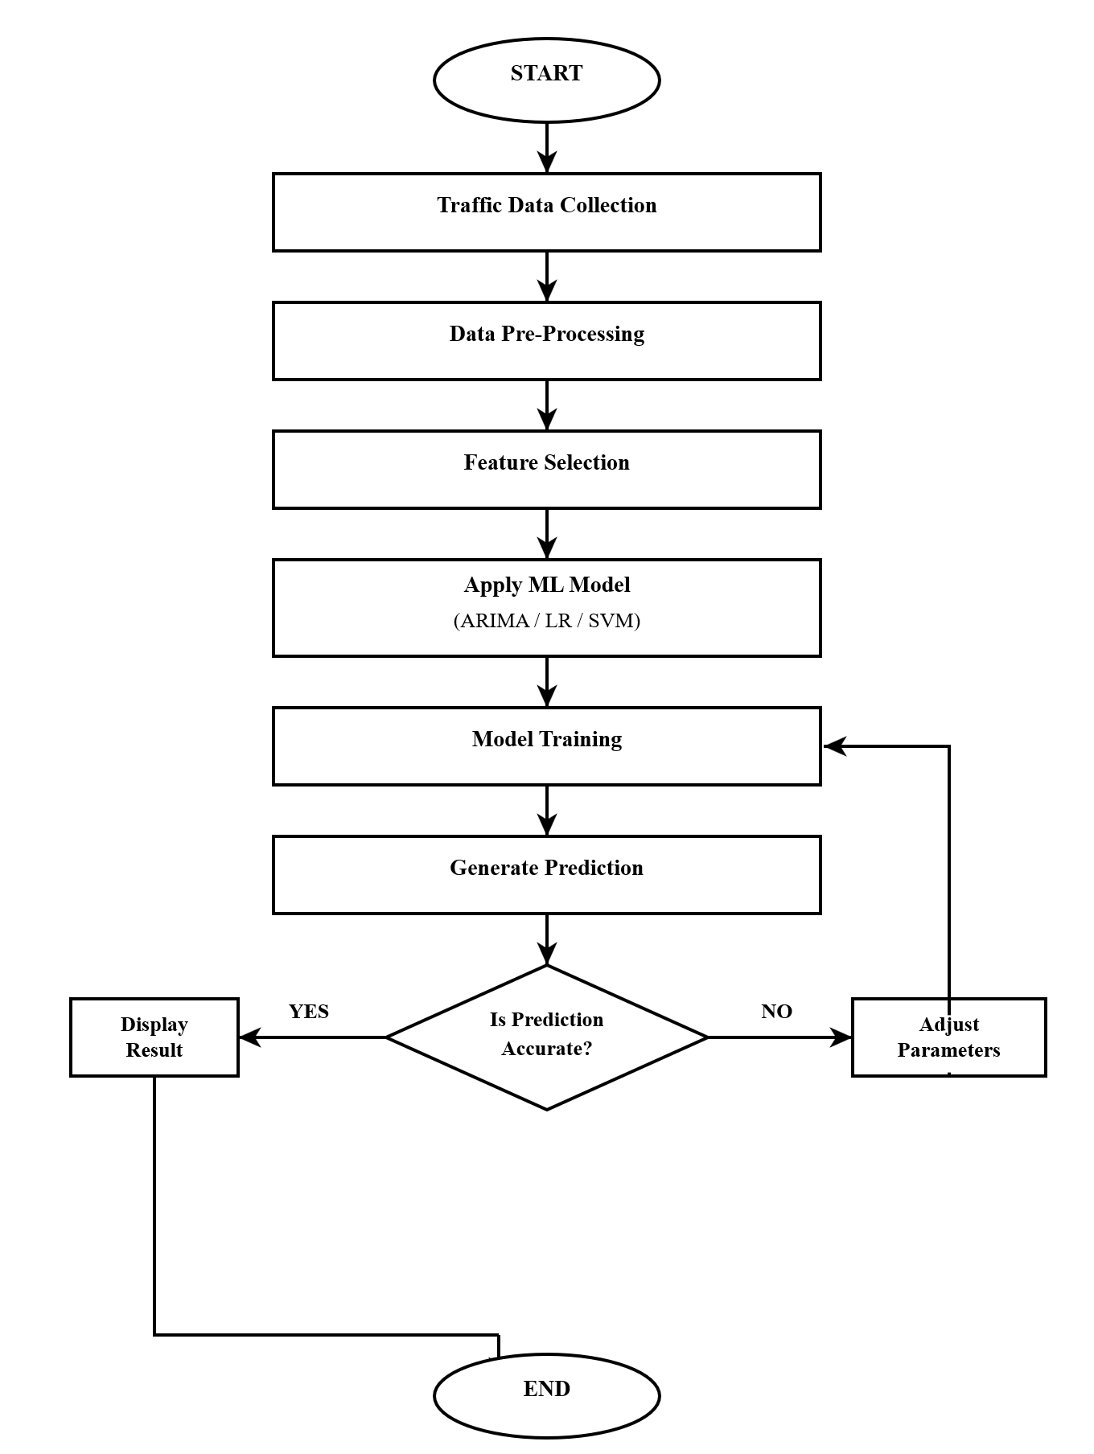
Figure 3.1 Existing System Workflow
Existing System Workflow:
The existing traffic prediction system collects historical traffic data from sensors and transportation databases. The collected data is preprocessed and analyzed using traditional machine learning or statistical methods. The system then predicts future traffic flow based on previously observed patterns. Finally, the predicted results are displayed for traffic monitoring and management purposes.

11
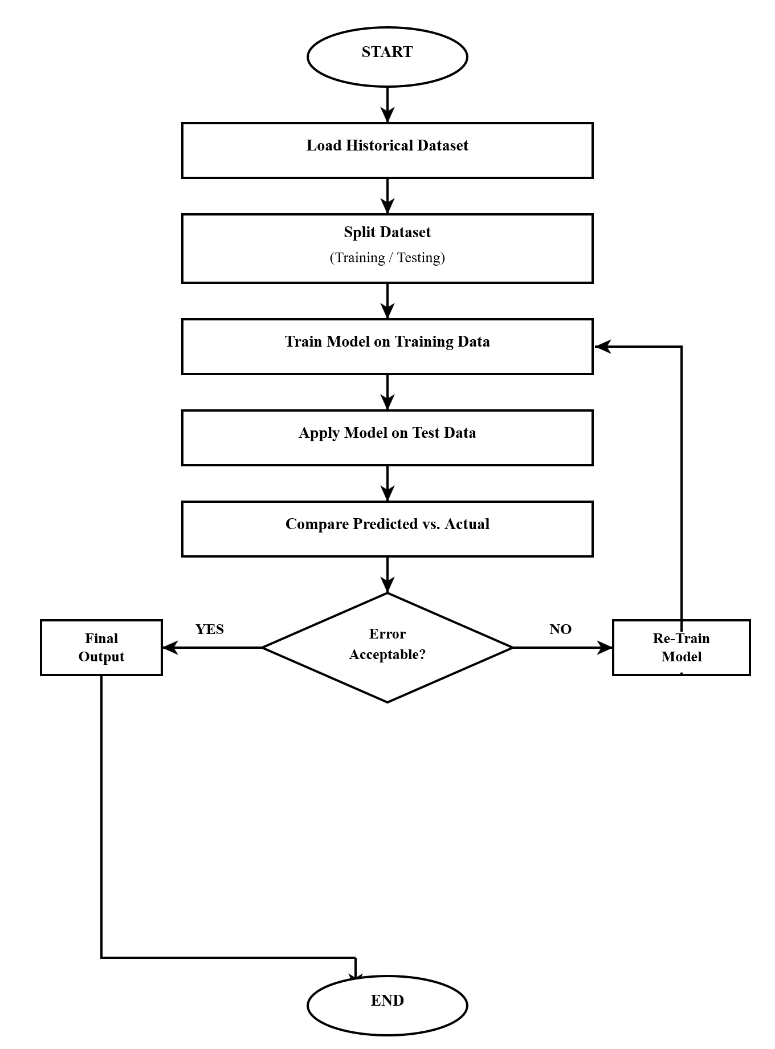
Figure 3.2 Existing System Train Data Flow

Existing System Train Data Flow:
In the existing system, historical traffic data is first loaded and cleaned to remove inconsistencies. The processed data is divided into training and testing datasets for model learning. Traditional algorithms are trained using the training dataset to identify traffic patterns. The trained model then generates traffic predictions based on input data.

12
3.1.2 Disadvantages
- The existing traffic flow prediction systems, which are primarily based on traditional statistical and machine learning approaches, suffer from several limitations that affect their overall performance and reliability.
- One of the major disadvantages is their inability to effectively handle the non-linear and dynamic nature of traffic data.
- Traffic patterns are highly complex and influenced by multiple factors such as time of day, weather conditions, road incidents, and varying traffic volumes.
- Traditional models like ARIMA and Linear Regression assume linear relationships within the data, which leads to inaccurate predictions when dealing with real-world traffic scenarios.
- Another significant drawback of existing systems is their inability to capture long-term temporal dependencies in time-series data.
- Traffic conditions at a particular time are often influenced by past patterns over extended periods. However, conventional models lack the memory mechanism required to learn and retain such dependencies.
- As a result, these models fail to provide accurate predictions, especially during peak hours or sudden traffic fluctuations.
- This limitation reduces the effectiveness of traffic management and decision-making processes.
- Existing machine learning models also require extensive manual feature engineering.
This not only increases the development effort but also introduces the possibility of human error.

13
- Additionally, these models often require frequent parameter tuning to maintain performance, making them less adaptable to changing traffic conditions.
- Another major issue is the lack of scalability in traditional systems.
- With the rapid growth of urban populations and the increasing number of vehicles, the volume of traffic data has grown significantly.
- Many existing models are not designed to handle large-scale datasets efficiently, leading to increased computational time and reduced performance.
- This makes it difficult to implement these systems in real-time traffic prediction scenarios.
- Furthermore, most existing systems are not capable of processing real-time data effectively.
- They rely heavily on historical data and fail to incorporate real-time updates, which are crucial for accurate traffic prediction.
- The absence of real-time processing limits the system’s ability to respond to sudden changes such as accidents, roadblocks, or unexpected congestion. This results in delayed or inaccurate predictions, affecting the overall efficiency of the transportation system.
- In addition, existing models often lack proper congestion analysis and classification mechanisms. While they may predict traffic flow values, they do not provide meaningful insights into congestion levels such as low, medium, or high traffic conditions.
- This limits their usability for practical applications, as users and authorities require clear and actionable information for decision-making. The absence of effective visualization tools further reduces the usability of these systems.
14
- Another disadvantage is the lower prediction accuracy achieved by traditional methods when compared to modern deep learning approaches.
- As traffic data becomes more complex, the performance of conventional models deteriorates, leading to unreliable results.
- This can negatively impact route planning, traffic control, and overall transportation management.
- Finally, the integration of these systems into intelligent transportation environments is limited due to their lack of adaptability and flexibility.
- They are not designed to work seamlessly with modern technologies such as IoT devices, smart sensors, and real-time monitoring systems. This restricts their application in smart city initiatives and advanced traffic management solutions.
- In summary, the existing traffic prediction systems face multiple challenges, including poor handling of non-linear data, inability to capture long-term dependencies, lack of scalability, absence of real-time processing, and limited analytical capabilities.
- These limitations highlight the need for more advanced and intelligent models, such as deep learning-based approaches, to improve traffic prediction accuracy and efficiency.

15
3.2 Proposed System
The proposed system introduces an intelligent and efficient approach for real-time traffic flow prediction and congestion analysis using Long Short-Term Memory (LSTM) deep learning networks.
Unlike traditional statistical and machine learning models, the proposed system is designed to effectively handle the non-linear and time-dependent nature of traffic data.
By leveraging the capabilities of LSTM, the system can learn complex temporal patterns and dependencies present in historical traffic data, thereby improving the accuracy of traffic predictions.
The system begins with the collection of traffic data from various sources such as publicly available datasets, sensors, or application programming interfaces.
This data typically includes traffic volume, speed, and time-related information, which are essential for analyzing traffic patterns. The collected data is then processed through a data preprocessing module, where missing values are handled, inconsistencies are removed, and the data is normalized to ensure better model performance. Proper preprocessing plays a crucial role in improving the quality of input data and enhancing the overall efficiency of the system.
Following preprocessing, the data is transformed into a suitable format through feature engineering techniques. The time-series nature of traffic data is preserved by converting it into sequences that can be effectively processed by the LSTM model.

16
The core component of the proposed system is the LSTM-based prediction model. LSTM networks are specifically designed to capture long-term dependencies in sequential data through their memory cells and gating mechanisms. These features enable the model to retain important information from past traffic patterns and use it to predict future traffic flow accurately. The model is trained using historical data and optimized using suitable performance metrics such as Root Mean Square Error (RMSE) and Mean Absolute Error (MAE). This training process allows the model to learn complex traffic behavior and improve its prediction capability over time.
Once the model is trained, it is used to perform real-time traffic flow prediction. The system generates short-term forecasts for upcoming time intervals, which can be used for proactive traffic management.
In addition to prediction, the system includes a congestion analysis module that classifies traffic conditions into different levels such as low, medium, and high congestion. This classification is based on predefined threshold values applied to the predicted traffic data, providing meaningful insights into traffic conditions.
The results of the prediction and congestion analysis are presented through a user-friendly visualization interface. Graphs and charts are used to display actual and predicted traffic values, enabling easy interpretation of the results. This visualization helps users, commuters, and traffic authorities to make informed decisions regarding route selection and traffic management strategies.
Furthermore, the proposed system is scalable and can be integrated with real-time data sources such as IoT sensors and smart traffic monitoring systems. This makes.

17
Overall, the proposed system offers improved accuracy, better adaptability, and enhanced performance compared to existing methods, making it a reliable solution for modern traffic management challenges.
3.2.1 Advantages
- The proposed LSTM-based traffic flow prediction and congestion analysis system offers several advantages over traditional statistical and machine learning approaches.
- One of the primary advantages is its ability to effectively capture long-term temporal dependencies present in traffic data.
- Traffic flow is inherently time-dependent, and past traffic patterns significantly influence future conditions.
- The Long Short-Term Memory (LSTM) network is specifically designed with memory cells and gating mechanisms that allow it to retain important information over extended time periods.
- This capability enables the model to produce more accurate and reliable predictions compared to conventional models that lack such memory features.
- Another significant advantage of the proposed system is its ability to handle non-linear and complex traffic patterns.
- Real-world traffic data is influenced by various dynamic factors such as peak
- hours, road conditions, weather variations, and unexpected events.
- Traditional models often assume linear relationships, which limits their effectiveness in such scenarios.
- In contrast, the LSTM-based approach can learn complex non-linear relationships within the data, resulting in improved prediction accuracy.

18
- The proposed system also reduces the need for extensive manual feature engineering.
- Unlike traditional machine learning models that require careful selection and transformation of input features, LSTM networks can automatically learn relevant features from raw time-series data.
- This not only simplifies the development process but also reduces the chances of human error. Additionally, the system is capable of adapting to new data patterns without requiring frequent manual adjustments, making it more efficient and flexible.
- Another important advantage is the system’s capability to perform real-time traffic prediction. By utilizing trained LSTM models, the system can generate short-term forecasts quickly, enabling proactive traffic management.
- This real-time prediction helps in reducing congestion by allowing commuters and authorities to make timely decisions, such as choosing alternative routes or implementing traffic control measures.
- The ability to respond to changing traffic conditions in real time enhances the overall efficiency of transportation systems.
- The integration of congestion analysis within the proposed system further enhances its usefulness. In addition to predicting traffic flow values, the system classifies traffic conditions into different levels such as low, medium, and high congestion.
- This classification provides clear and actionable insights, making it easier for users to understand traffic conditions without interpreting complex numerical data.

19
- The inclusion of visualization tools such as graphs and dashboards improves user interaction and supports better decision-making.
- Scalability is another key advantage of the proposed system.
- The model can be extended to handle large-scale datasets and can be integrated with real-time data sources such as sensors and Internet of Things (IoT) devices.
- This makes the system suitable for deployment in smart city environments and advanced intelligent transportation systems.
- The use of deep learning techniques ensures that the system remains effective even as the volume and complexity of traffic data increase.
- Finally, the proposed system provides higher prediction accuracy and reliability compared to existing methods.
- By combining advanced data preprocessing, feature engineering, and LSTM-based modeling, the system delivers consistent and improved performance.
- This leads to better traffic management, reduced congestion, and enhanced travel efficiency.
- Overall, the proposed system offers a comprehensive and intelligent solution for modern traffic prediction challenges, making it a valuable contribution to the field of intelligent transportation systems.

20
3.3 System Requirements
3.3.1 Hardware System Requirements
Processor : Intel Core i5 / i7
Speed : 2.9 GHz or above
RAM : 4 GB (Minimum), 8 GB Recommended
Cores : Dual Core / Quad Core
Hard Disk : 1 TB (Minimum)
Input Devices : Keyboard, Mouse
Output Devices : Monitor

3.3.2 Software System Requirements
Coding Language : Python
Software : Jupyter Notebook, Anaconda
Operating System : Windows
Libraries : NumPy, Pandas, Matplotlib, TensorFlow / Keras

21
3.4 Software Plaftfrom
The proposed system is developed using Python as the primary programming language due to its simplicity, flexibility, and strong support for data analysis and deep learning applications. Python provides a wide range of libraries such as NumPy and Pandas for data manipulation, Matplotlib for data visualization, and TensorFlow/Keras for building and training the LSTM model. These libraries enable efficient handling of large datasets and simplify the implementation of complex algorithms.
The development environment includes Jupyter Notebook and Anaconda, which provide an interactive and user-friendly platform for coding, testing, and visualization. Jupyter Notebook allows step-by-step execution of code and easy debugging, while Anaconda helps in managing libraries and dependencies effectively. The system can be executed on standard operating systems such as Windows, making it highly portable and accessible. Overall, the software platform supports efficient development, testing, and deployment of the proposed traffic prediction system.
3.4.1 Python
Python is a high-level, interpreted programming language widely used for software development, data analysis, and artificial intelligence applications. It is known for its simplicity, readability, and ease of use, making it an ideal choice for developing complex systems such as traffic flow prediction models. Python supports multiple programming paradigms, including procedural, object-oriented, and functional programming, which provides flexibility in designing and implementing applications.

22
In the proposed system, libraries such as NumPy and Pandas are used for efficient data manipulation and preprocessing. NumPy provides support for numerical operations and array handling, while Pandas offers powerful data structures like DataFrames for organizing and analyzing large datasets. These libraries simplify tasks such as data cleaning, normalization, and transformation, which are essential for preparing traffic data for model training. For visualization purposes, Python provides libraries such as Matplotlib, which helps in generating graphs and charts to represent traffic patterns and prediction results. Visualization plays a crucial role in understanding data trends and evaluating model performance. By plotting actual and predicted traffic values, users can easily interpret the effectiveness of the proposed system.
Python also supports advanced deep learning frameworks such as TensorFlow and Keras, which are used for building and training the Long Short-Term Memory (LSTM) model in this project. TensorFlow is an open-source platform developed for machine learning applications, while Keras provides a high-level interface that simplifies the process of designing neural networks. These frameworks enable the implementation of complex deep learning architectures with minimal effort and provide efficient tools for training, testing, and optimizing models.
Another important feature of Python is its compatibility with various development environments such as Jupyter Notebook and Anaconda. Jupyter Notebook provides an interactive platform where code can be written, executed, and visualized in a step-by-step manner. This is particularly useful for debugging and experimenting with different models.

23
Python is also highly portable and can run on different operating systems such as Windows, Linux, and macOS. This cross-platform compatibility makes it suitable for a wide range of applications and environments. Additionally, Python has a large and active community, which provides extensive documentation and support, making it easier for developers to learn and implement new concepts. In the context of the proposed traffic flow prediction system, Python plays a vital role in integrating all components, from data preprocessing to model development and result visualization. Its simplicity, powerful libraries, and strong community support make it an ideal choice for implementing intelligent and scalable systems. Overall, Python provides a robust and efficient platform for developing the LSTM-based traffic prediction model and achieving the objectives of the project.
3.4.2 Jupyter And Anaconda Prompt
Jupyter Notebook and Anaconda Prompt are important tools used in the development and execution of the proposed traffic flow prediction system. Jupyter Notebook is an open-source web-based application that allows users to write, execute, and visualize code in an interactive environment. It supports step-by-step execution, which is highly useful for data analysis, debugging, and testing machine learning models. In this project, Jupyter Notebook is used for implementing the LSTM model, performing data preprocessing, and visualizing traffic prediction results through graphs and charts. Its user-friendly interface makes it easier to understand the workflow and analyze outputs effectively.
Anaconda Prompt is a command-line interface provided by the Anaconda distribution, which is used for managing Python environments and installing required libraries.

24
Anaconda also helps in creating isolated environments, ensuring that different projects can run without dependency conflicts. The integration of Jupyter Notebook with Anaconda provides a powerful and efficient platform for developing, testing, and deploying machine learning and deep learning applications.
3.4.3 Operating System
The operating system plays a crucial role in managing hardware resources and providing a platform for executing software applications. The proposed traffic flow prediction system is compatible with widely used operating systems such as Windows, Linux, and macOS. These operating systems support Python and its associated libraries, making them suitable for developing and running deep learning models. Windows is commonly used due to its user-friendly interface, while Linux provides better performance and flexibility for advanced users. The operating system ensures smooth execution of development tools like Jupyter Notebook and Anaconda, enabling efficient implementation of the system. Overall, the use of a compatible and stable operating system ensures reliability and ease of development.
3.4.4 Processor
The processor is an essential hardware component responsible for executing instructions and performing computational tasks in the system. For the proposed project, a processor such as Intel Core i5 or i7 is recommended to handle data processing and model training efficiently. The processor should operate at a speed of around 2.9 GHz or higher to ensure smooth execution of deep learning operations.

25
Multi-core processors are preferred as they allow parallel processing, which improves performance during data preprocessing and model training. A powerful processor enhances the overall speed and efficiency of the system, reducing execution time and enabling faster prediction results.

26
CHAPTER 4
SYSTEM DESIGN
The system design describes the overall structure and workflow of the proposed traffic flow prediction and congestion analysis system. It defines how different modules interact with each other to process traffic data and generate accurate predictions. The system is designed in a modular approach, where each module performs a specific function such as data collection, preprocessing, feature engineering, model training, prediction, and congestion analysis. This modular design improves the efficiency, scalability, and maintainability of the system. The process begins with the collection of traffic data from various sources such as datasets or sensors. The collected data is then passed through a preprocessing module, where it is cleaned, normalized, and prepared for further analysis. After preprocessing, feature engineering techniques are applied to convert the data into a time-series format suitable for the LSTM model. The processed data is then used to train the LSTM model, which learns the underlying temporal patterns in the traffic data.
Once the model is trained, it is used to predict future traffic flow values in real time. The predicted values are further analyzed in the congestion analysis module, where traffic conditions are classified into different levels such as low, medium, and high congestion. Finally, the results are displayed through a visualization interface using graphs and charts, making it easier for users to understand traffic conditions.
Overall, the system design ensures a smooth flow of data between modules and provides an efficient framework for accurate traffic prediction and analysis.

27

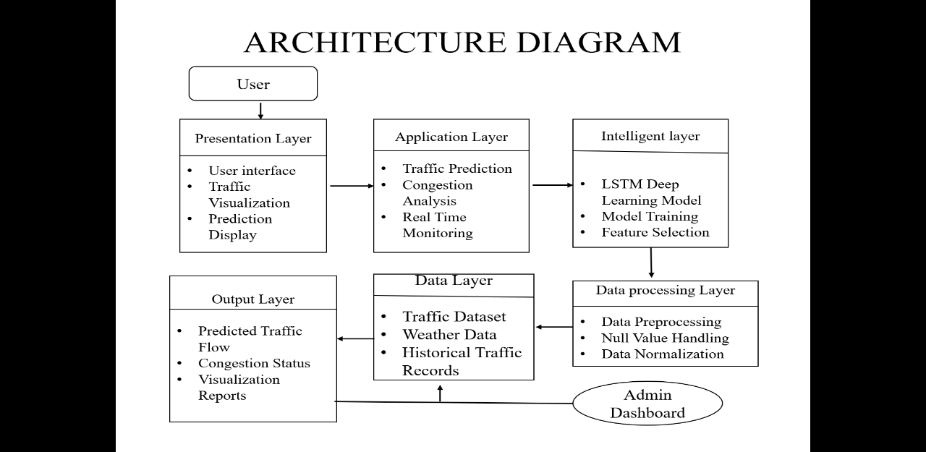

Figure 4.1 System Design Diagram

System Design Diagram:
The system design describes the overall structure and workflow of the proposed traffic flow prediction and congestion analysis system. It defines how different modules interact with each other to process traffic data and generate accurate predictions. The system is designed in a modular approach, where each module performs a specific function such as data collection, preprocessing, feature engineering, model training, prediction, and congestion analysis. This modular design improves the efficiency, scalability, and maintainability of the system.

28
The dataset is time-series in nature, making it suitable for LSTM-based prediction. The traffic_volume column is used as the target variable, while other attributes are used as input features. This dataset helps in analyzing traffic behavior under different weather and time conditions. It provides a strong foundation for training and testing the proposed model
4.2 DESCRIPTION
The proposed system for real-time traffic flow prediction and congestion analysis is designed to efficiently process traffic data and generate accurate forecasting results using Long Short-Term Memory (LSTM) deep learning networks. The system follows a structured and modular approach, where each module performs a specific task in the overall workflow. This ensures better organization, scalability, and ease of implementation.
The system begins with the data collection module, where traffic-related data is gathered from datasets or external sources such as sensors or APIs. This data includes important parameters like traffic volume, time intervals, and vehicle flow. The collected raw data is then passed to the data preprocessing module, where it is cleaned by removing missing values, handling inconsistencies, and normalizing the data to improve model performance.
The traffic_volume column is the target variable used for prediction, while the remaining attributes are used as input features to improve prediction accuracy. Categorical variables such as weather_main and weather_description are encoded into numerical format during preprocessing to make them suitable for machine learning models.

29
After preprocessing, the data is transformed in the feature engineering module, where it is converted into time-series sequences suitable for LSTM model input.
This step is crucial as LSTM networks require sequential data to learn temporal patterns effectively. The dataset is then divided into training and testing sets to evaluate the performance of the model.
The core of the system is the LSTM model module, where deep learning techniques are applied to learn patterns from historical traffic data. The model is trained using the prepared dataset and optimized using performance metrics such as Mean Absolute Error (MAE) and Root Mean Square Error (RMSE). Once trained, the model is capable of predicting future traffic flow based on learned patterns.The traffic prediction module uses the trained LSTM model to forecast short-term traffic conditions.
These predictions help in understanding future traffic trends and support proactive decision-making. Following this, the congestion analysis module classifies the predicted traffic flow into different levels such as low, medium, and high congestion based on predefined threshold values.
Finally, the system includes a visualization module, which presents the results in the form of graphs and charts. This helps users easily interpret traffic patterns and congestion levels. The visual output enhances the usability of the system by providing clear and understandable insights into traffic conditions.

30
4.2.1 Dataset Description
The dataset used in this project is a real-world traffic flow dataset consisting of 48,204 records and 9 attributes .It is used for training and testing the LSTM-based traffic prediction model. The dataset contains both numerical and categorical features that represent different weather and traffic conditions affecting vehicle flow.
The attributes in the dataset include holiday, temperature (temp), rainfall in the last 1 hour (rain_1h), snowfall in the last 1 hour (snow_1h), cloud coverage (clouds_all), weather main type (weather_main), weather description (weather_description), date_time, and traffic_volume. These features play an important role in analyzing traffic behavior under different environmental and temporal conditions. The date_time attribute represents the time-based sequence of traffic data, which is essential for time-series analysis using LSTM networks.
The traffic_volume column is the target variable used for prediction, while the remaining attributes are used as input features to improve prediction accuracy. Categorical variables such as weather_main and weather_description are encoded into numerical format during preprocessing to make them suitable for machine learning models.
Overall, this dataset provides a rich combination of temporal, environmental, and traffic-related information, making it highly suitable for real-time traffic flow prediction and congestion analysis using deep learning techniques.

31
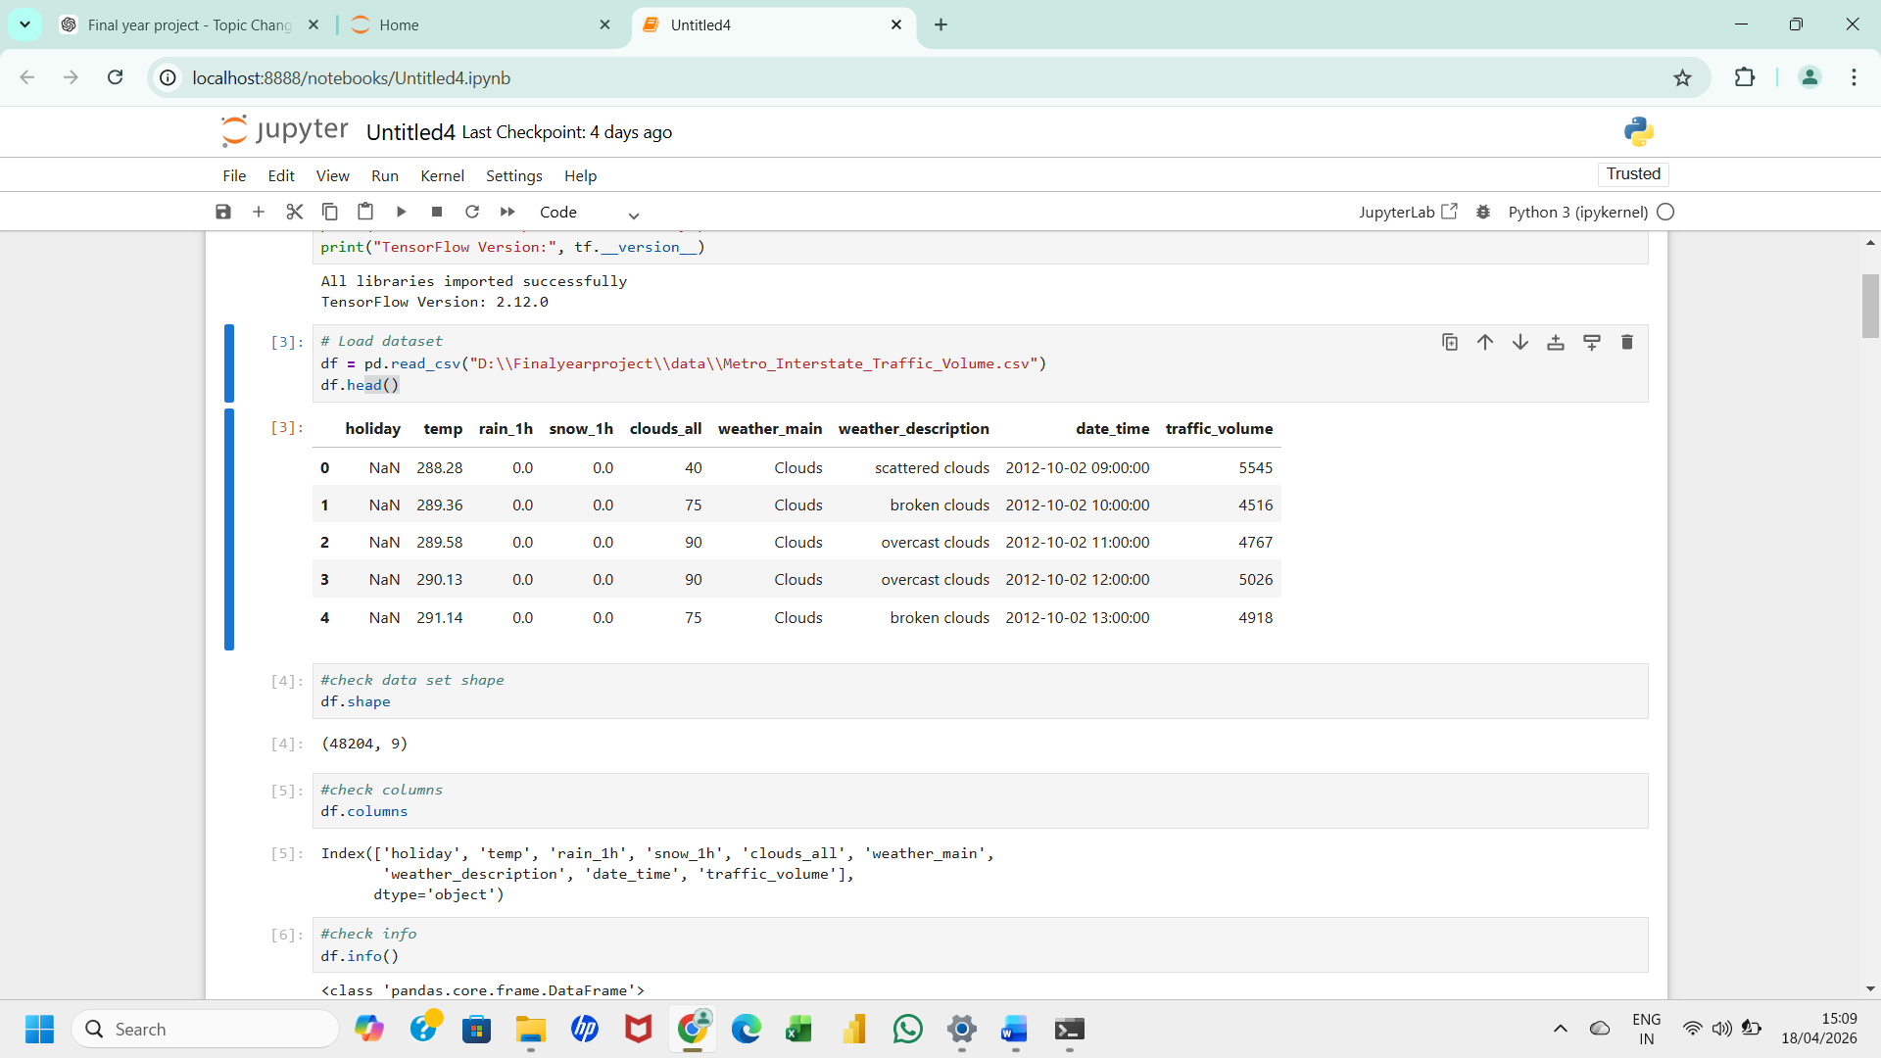
Figure 4.2 Data Set
Data Set:
The dataset used in the project contains traffic-related attributes such as temperature, rainfall, snowfall, weather conditions, date_time, and traffic_volume. It consists of 48,204 records with 9 features collected for traffic flow analysis. The dataset is used for training and testing the LSTM model. It provides historical traffic information required for prediction.
4.2.2 DATA PRE-PROCESSING
Data preprocessing is an essential step in the proposed traffic flow prediction system, as it improves the quality of the dataset and enhances the performance of the LSTM model temperature, rainfall, snowfall, and traffic volume are either removed or filled techniques to maintain data consistency.
The categorical attributes such as weather_main and weather_description are converted into numerical format using encoding techniques, making them suitable for deep learning models.
32

This transformation ensures that the model can interpret and learn from categorical data effectively. Additionally, the dataset is normalized to bring all features into a common scale, which helps in improving the convergence speed and accuracy of the LSTM model. The date_time attribute is also processed to extract meaningful time-based features, which are then used to convert the dataset into a time-series format. This step is crucial for capturing temporal dependencies in traffic flow data. Overall, data preprocessing ensures that the dataset is clean, structured, and suitable for accurate traffic prediction and congestion analysis.
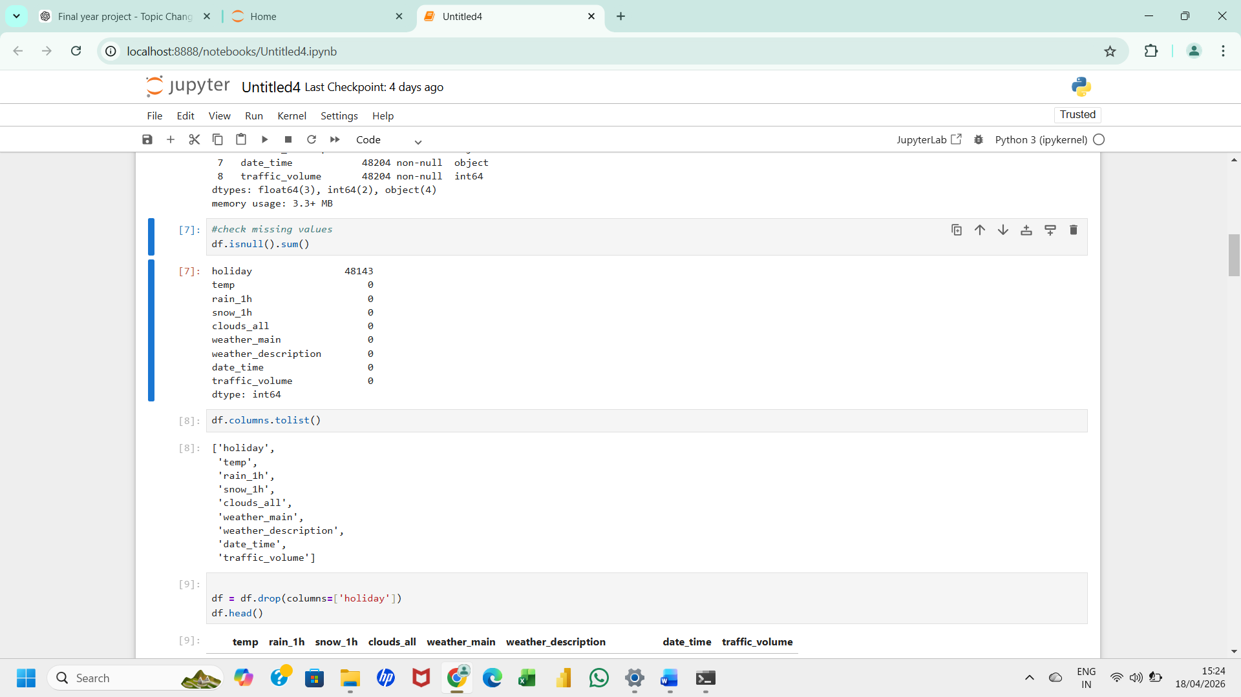

Figure 4.3 Null Values Checking
Null Values Checking:
Null values checking is performed to identify missing or incomplete data in the dataset. Functions such as isnull() and sum() are used to detect missing values in each column. Identifying null values is important because incomplete data affects model performance. This process ensures data quality before preprocessing.

33
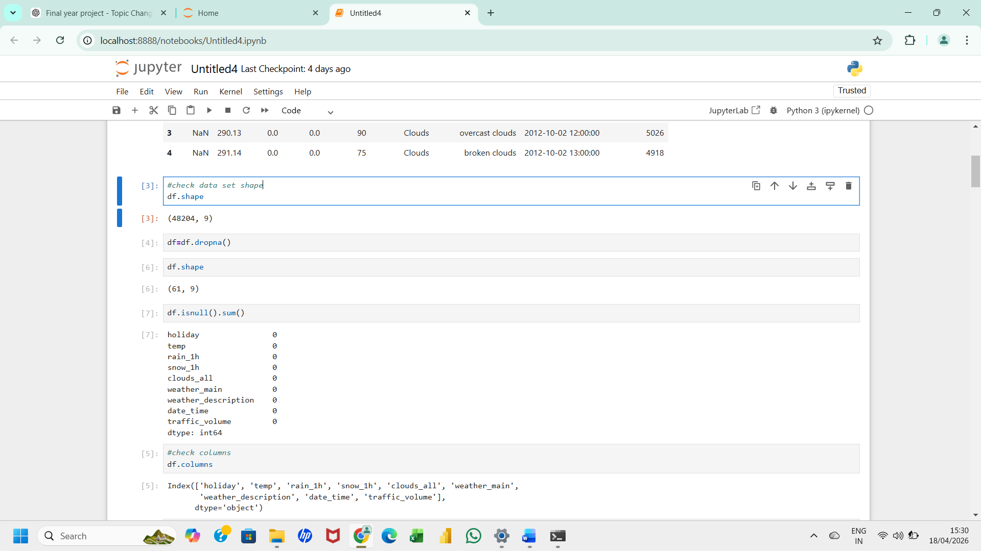

Figure 4.4 Dropping Null Values
Dropping Null Values:
After identifying missing values, unnecessary or incomplete records are removed from the dataset. Dropping null values helps in maintaining data consistency and improving model accuracy. This process prevents errors during training and prediction. Clean data improves the overall reliability of the system.
4.2.3.Feature Selection
Feature selection is an important step in the proposed traffic flow prediction system, where relevant attributes are identified from the dataset to improve model performance. In this project, features such as temperature, rainfall, snowfall, cloud coverage, weather conditions, and time-based attributes are selected as input variables. These features have a direct impact on traffic flow and help in understanding traffic behavior under different environmental conditions. The target variable used for prediction is traffic_volume, which represents the number of vehicles at a given time.
34
Irrelevant or redundant features are removed to reduce complexity and improve computational efficiency. Categorical features like weather_main and weather_description are converted into numerical form using encoding techniques. Proper feature selection helps in reducing noise in the dataset and enhances the accuracy of the LSTM model. This process ensures that only the most relevant information is used for training, leading to better prediction and congestion analysis results.
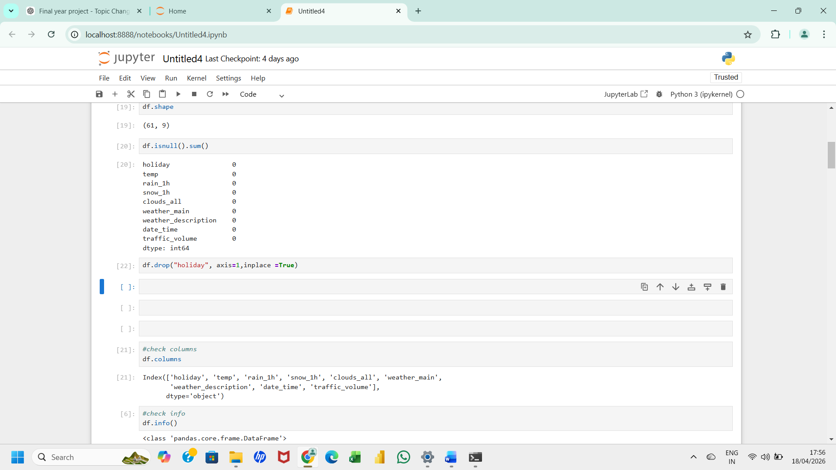
Figure 4.5 Feature Selection
Feature selection:
it is performed to identify important attributes affecting traffic flow prediction. Features such as temperature, rainfall, snowfall, cloud coverage, and weather conditions are selected. Irrelevant features are removed to reduce complexity and improve computational efficiency. Proper feature selection enhances prediction accuracy.
4.2.4 Test Set
The test set is a portion of the dataset that is used to evaluate the performance of the trained LSTM model. In this project, the dataset is divided into training and testing sets after preprocessing. The test set contains unseen data that is not used during model training, ensuring an unbiased evaluation. It helps in checking how well the model performs on new and real-world traffic data. The test data includes features such as weather conditions, time attributes, and traffic volume. By comparing predicted values with actual values in the test set, the accuracy of the model is determined.
35
4.2.5 Train Set
The train set is the major portion of the dataset used to train the LSTM model in the proposed system. It contains historical traffic data along with various features such as temperature, rainfall, snowfall, and weather conditions. The model learns patterns and relationships between input features and traffic volume using this data. During training, the LSTM network adjusts its internal weights to minimize prediction errors. The train set helps the model understand temporal dependencies in traffic flow data. A larger training dataset improves the model’s ability to generalize and make accurate predictions. Proper training ensures that the system performs efficiently during real-time traffic prediction tasks.
4.2.6 Model Evaluation
Model evaluation is performed to measure the performance and accuracy of the trained LSTM model. In this project, evaluation metrics such as Mean Absolute Error (MAE) and Root Mean Square Error (RMSE) are used. These metrics help in analyzing the difference between predicted and actual traffic values. A lower error value indicates better model performance.The evaluation is carried out using the test dataset, which contains unseen traffic data. Graphical representations such as loss curves and prediction plots are used to visualize performance. Model evaluation ensures that the proposed system is reliable, accurate, and suitable for real-time traffic flow prediction.
4.2.7 Prediction
Prediction is the final step in the proposed traffic flow system, where the trained LSTM model is used to forecast future traffic conditions. The model takes input features such as weather conditions, time, and previous traffic data to generate predictions. The output represents the expected traffic volume for future time intervals.
36
These predictions help in understanding traffic patterns and planning routes efficiently. The predicted values are further used for congestion analysis, where traffic is classified into low, medium, or high levels. Visualization tools such as graphs are used to display predicted results clearly. This prediction module enables real-time traffic monitoring and supports intelligent transportation decision-making.
4.3 UML Diagram
4.3.1 Use Case Diagram
The use case diagram represents the interaction between the user and the proposed traffic flow prediction system. In this system, the primary actor is the user, who interacts with the application to perform various operations such as viewing traffic data, predicting traffic flow, and analyzing congestion levels. The system takes input traffic data and processes it using the LSTM model to generate predictions. The user can access the predicted traffic information and visualize the results through graphs and charts. Another important functionality is congestion analysis, where the system classifies traffic conditions into low, medium, and high levels based on predicted values. This diagram helps in understanding the overall functionality of the system and how different features are accessed by the user in a simplified manner.

37
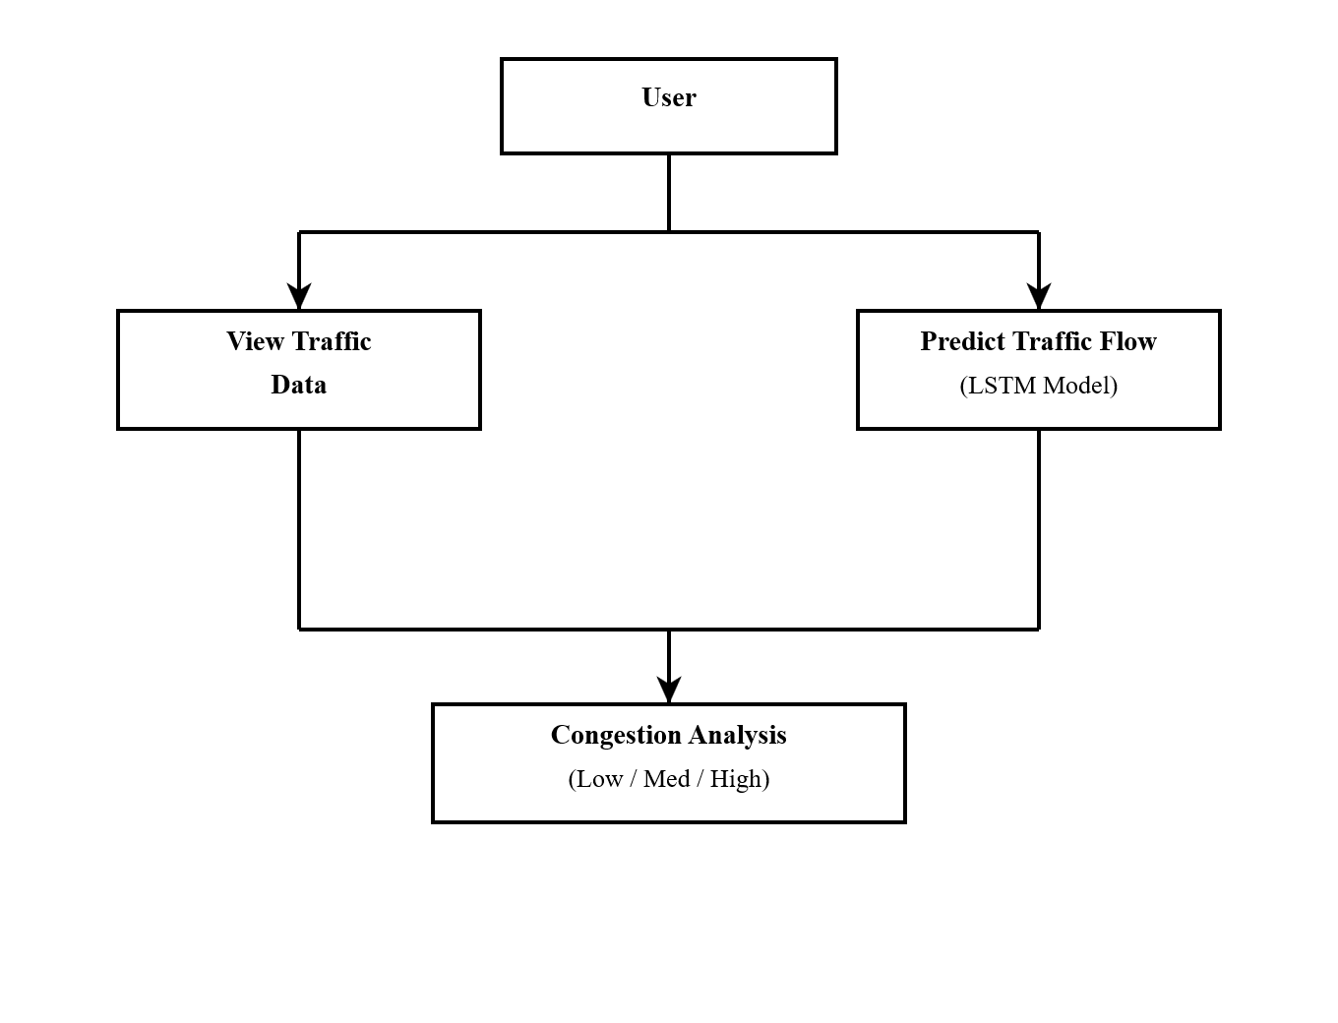
Figure 4.6 Use Case Diagram
Use Case Diagram:
The use case diagram represents the interaction between users and the proposed system. It shows functionalities such as data input, traffic prediction, congestion analysis, and result visualization. The diagram helps in understanding system requirements and user interactions. It provides a high-level view of the system behavior.

38
4.3.2 Class Diagram
The class diagram represents the static structure of the proposed system by showing the classes, attributes, and methods involved in traffic flow prediction. weather conditions, and traffic volume.
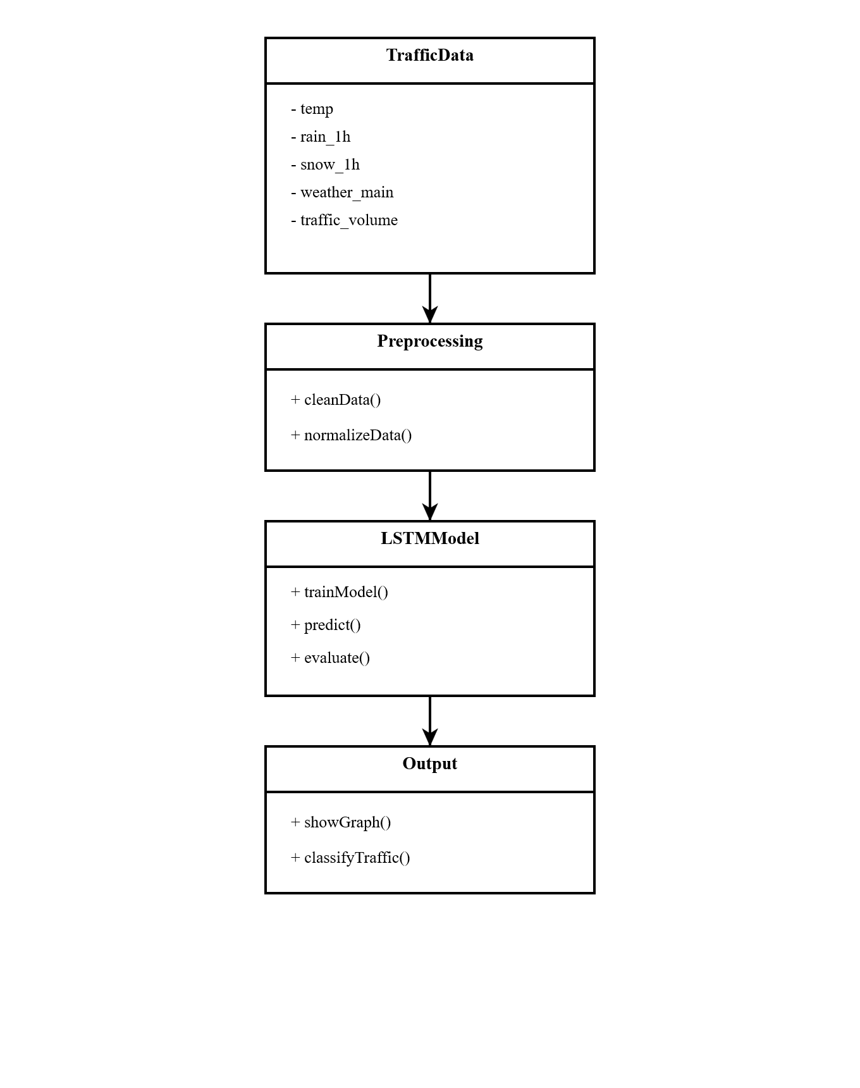
Figure 4.7 Class Diagram

39
Class Diagram:
The class diagram represents the static structure of the system using classes, attributes, and methods. It describes relationships between modules such as dataset handling, preprocessing, model training, and prediction. The diagram helps in understanding object-oriented system design. It also improves system organization and maintainability.
4.3.3 Sequence Diagram
The sequence diagram illustrates the step-by-step interaction between different components of the system over time. Initially, the user sends a request to the system for traffic prediction. The system retrieves traffic data from the dataset and forwards it to the preprocessing module for cleaning and normalization. The processed data is then passed to the LSTM model for training and prediction. The model generates future traffic flow values, which are then sent to the congestion analysis module for classification. Finally, the system displays the predicted results to the user in the form of graphs and visual outputs. This diagram clearly shows the order of operations and communication between system components.

40
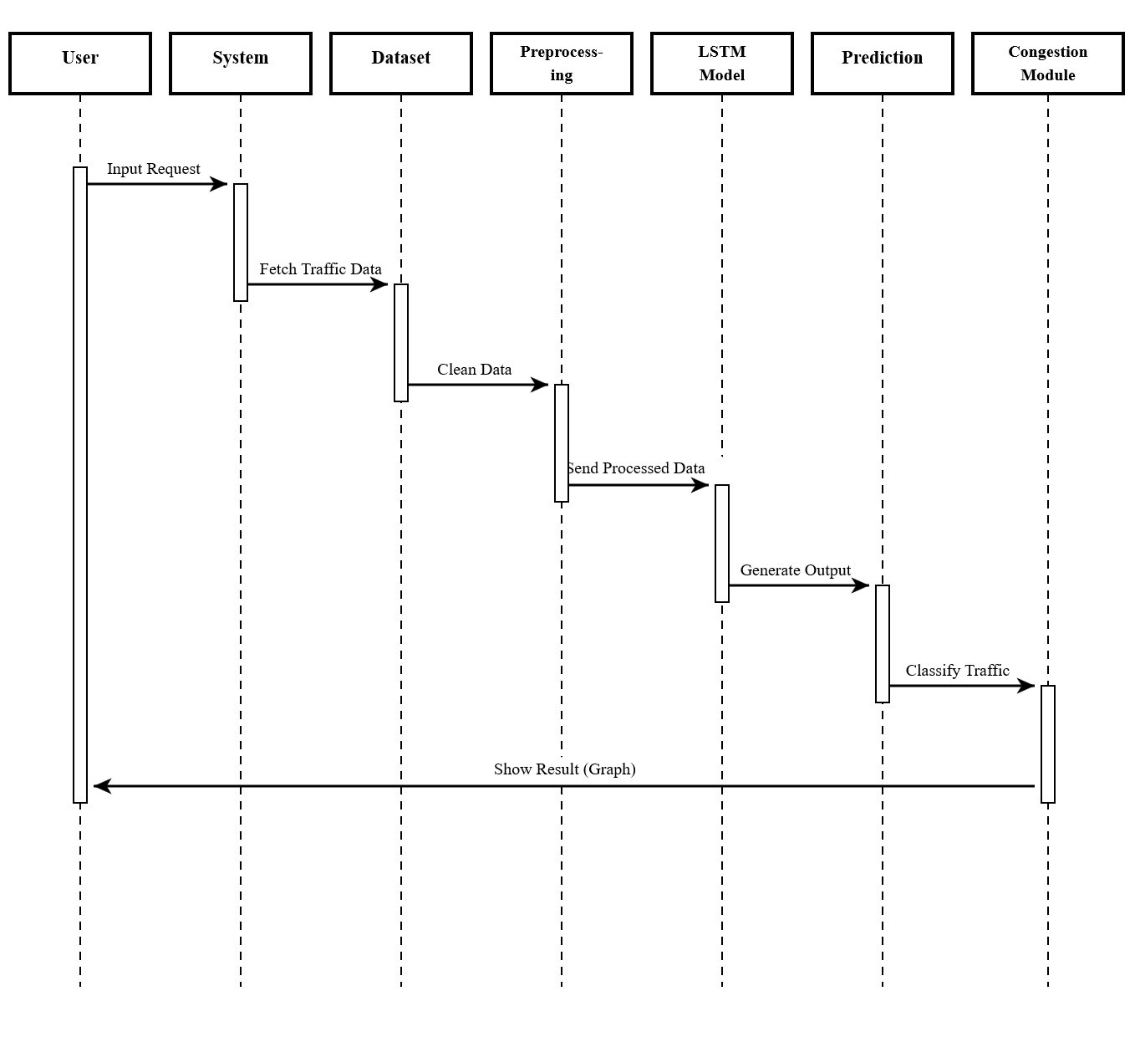
Figure 4.8 Sequence Diagram
Sequence Diagram:
The sequence diagram illustrates the flow of interactions between system components over time. It shows the sequence of operations such as data loading, preprocessing, model training, prediction, and result generation. The diagram helps in understanding communication between modules. It provides a dynamic view of system execution.

41
4.3.4 Activity Diagram
The activity diagram represents the workflow of the proposed traffic prediction system from start to end. The process begins with collecting traffic data from various sources such as datasets or sensors. The data is then preprocessed by removing missing values and normalizing attributes. After preprocessing, feature selection is performed to extract relevant attributes for the LSTM model. The model is then trained using historical data and used to predict future traffic flow. The predicted results are passed to the congestion analysis module, where traffic levels are classified. Finally, the results are displayed to the user through visualization tools. This diagram helps in understanding the sequential flow of activities in the system.
Start

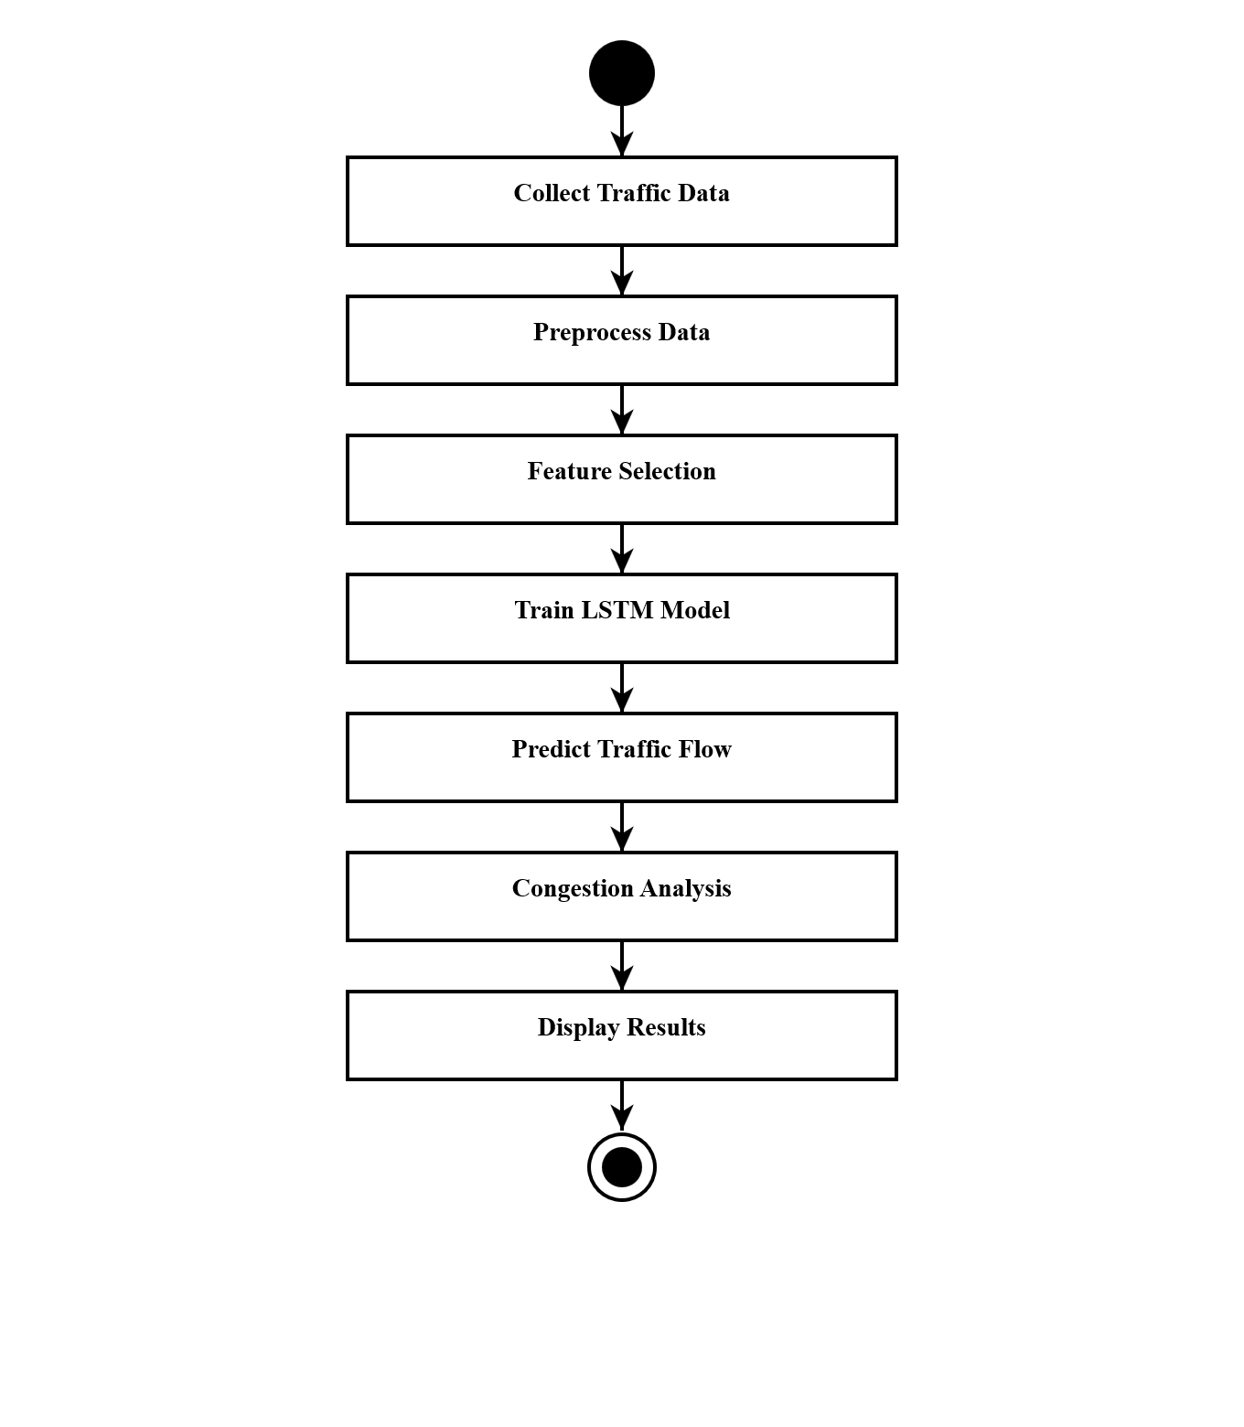
End

Figure 4.9 Activity Diagram
42
Activity Diagram:
The activity diagram represents the workflow of the proposed traffic prediction system. It describes the sequence of activities from dataset loading to prediction and congestion analysis. Decision-making and process flow are clearly represented in the diagram. It helps in understanding overall system functionality.
4.3.5 Component Diagram
The component diagram shows the physical structure of the proposed system and how different components interact with each other. The main components include the User Interface, Prediction Module, LSTM Model Engine, Data Processing Unit, and Traffic Dataset. The user interface allows users to interact with the system and view results. The prediction module handles traffic forecasting using the trained LSTM model. The data processing unit is responsible for preprocessing and feature engineering tasks. The LSTM model engine performs training and prediction operations. All these components work together to ensure smooth execution of the system.
Component Diagram:
The component diagram represents the physical components and modules of the system. It includes components such as dataset module, preprocessing module, LSTM model, prediction module, congestion analysis module, and visualization module. The diagram shows how components interact with each other. It helps in understanding system architecture and integration.

43
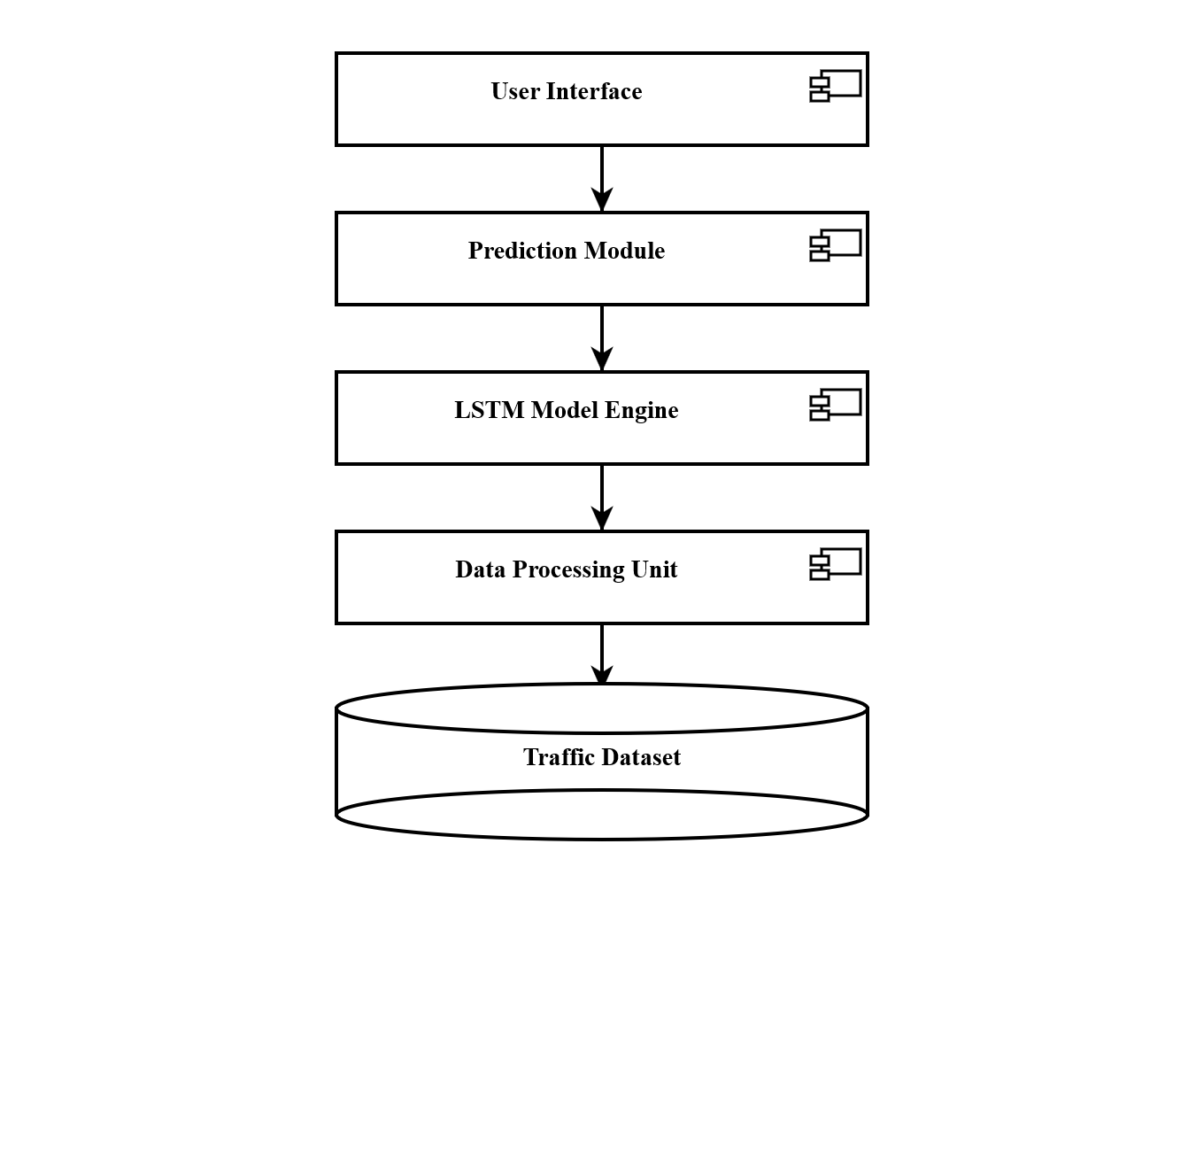
Figure 4.10 Component Diagram

44
CHAPTER 5
MODULES AND DESCRIPTION
The proposed system for real-time traffic flow prediction and congestion analysis is divided into several functional modules to ensure structured development and efficient processing. Each module performs a specific task and contributes to the overall performance of the system.
The Data Collection Module is responsible for gathering traffic-related data from datasets or external sources. This includes attributes such as temperature, rainfall, snowfall, weather conditions, and traffic volume. The collected data forms the base for further processing and analysis.
The Data Preprocessing Module cleans and prepares the raw data for model training. It handles missing values, removes inconsistencies, and normalizes the dataset. This module ensures that the data is in a suitable format for the LSTM model.
The Feature Selection Module identifies the most relevant attributes that influence traffic flow. It reduces unnecessary data complexity and improves model accuracy by selecting important features such as weather conditions and time-based factors.
The LSTM Model Module is the core component of the system. It is responsible for training the Long Short-Term Memory network using historical traffic data. This module learns temporal patterns and predicts future traffic flow based on past trends.
The Prediction Module uses the trained LSTM model to forecast real-time traffic conditions. It generates output values representing expected traffic volume for future time intervals.
45
The Congestion Analysis Module classifies the predicted traffic into different levels such as low, medium, and high congestion. This helps in understanding traffic intensity and supports better decision-making.
The Visualization Module displays the results using graphs and charts, making it easier for users to interpret traffic patterns and predictions effectively.
5.1 Dataset
The dataset used in this project is a real-world traffic flow dataset containing 48,204 records with 9 attributes. It includes features such as holiday, temperature, rainfall, snowfall, cloud coverage, weather conditions, date_time, and traffic_volume. The dataset is time-series in nature, making it suitable for LSTM-based prediction. The traffic_volume column is used as the target variable, while other attributes are used as input features. This dataset helps in analyzing traffic behavior under different weather and time conditions. It provides a strong foundation for training and testing the proposed model.

Figure 5.1 Data Set

46
Dataset:
The dataset used in the proposed system contains traffic-related information such as temperature, rainfall, snowfall, weather conditions, date_time, and traffic_volume. It consists of 48,204 records with 9 attributes used for traffic analysis and prediction. The dataset provides historical traffic information required for training the LSTM model. It acts as the primary source for learning traffic flow patterns.
5.2 Data Pre-Processing
Data preprocessing is performed to clean and transform raw traffic data into a suitable format for model training. Missing values are handled using appropriate techniques, and inconsistent data entries are removed. Categorical variables such as weather_main and weather_description are converted into numerical values using encoding g methods. Numerical features are normalized to improve model performance and reduce bias. The date_time attribute is processed to extract time-based patterns. This step ensures that the dataset is clean, structured, and ready for LSTM input.

Figure 5.2 Pre-Processing 1

47
Pre-Processing 1:
Pre-Processing 1 involves initial data cleaning and handling of missing values in the dataset. Null values and inconsistent records are identified and removed to improve data quality. Categorical features such as weather conditions are converted into numerical format using encoding techniques. This step ensures that the dataset is structured and suitable for further processing.

Figure 5.3 Pre-Processing 2
Pre-Processing 2:
Pre-Processing 2 focuses on normalization and time-series conversion of the dataset. Numerical features are scaled into a uniform range to improve model performance and convergence speed. The date_time attribute is processed to maintain sequential order in the data. The dataset is then converted into sequences using a sliding window technique for LSTM training.

48
5.3 Feature Selection
Feature selection is used to identify the most relevant attributes that influence traffic flow prediction. Important features such as temperature, rainfall, snowfall, cloud coverage, weather conditions, and time-related variables are selected. The target variable is traffic_volume, which represents vehicle density at a given time. Irrelevant or redundant features are removed to reduce complexity. This improves model efficiency and reduces computation time. Proper feature selection enhances prediction accuracy and helps the LSTM model focus on meaningful data patterns.

Figure 5.4 Feature Selection
Feature selection:
It is performed to identify the most important attributes influencing traffic prediction. Features such as temperature, rainfall, snowfall, cloud coverage, and weather conditions are selected for model training. Irrelevant or redundant features are removed to reduce complexity and improve efficiency. This step enhances model accuracy and reduces computation time.
5.4 Algorithm Selection
The Long Short-Term Memory (LSTM) algorithm is selected for this project due to its ability to handle time-series data effectively. LSTM is a type of Recurrent Neural Network (RNN) that can learn long-term dependencies in sequential data.

49
It is suitable for traffic prediction because traffic patterns depend on previous time intervals. LSTM uses memory cells and gates to control information flow, improving prediction accuracy. Compared to traditional models, LSTM provides better performance in handling complex and non-linear traffic data.
5.5 Model Building
Model building involves designing and training the LSTM neural network using the processed dataset. The input data is divided into training and testing sets. The LSTM model is constructed using layers such as input layer, hidden layers, and output layer. The model is trained using historical traffic data to learn patterns and relationships. Optimization techniques are applied to reduce prediction error. After training, the model is used to predict future traffic flow values. This trained model forms the core of the proposed system.
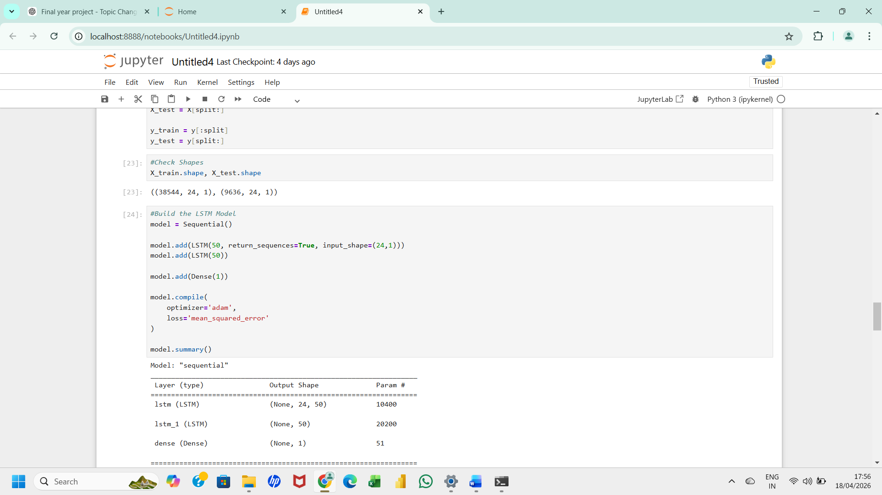

Figure 5.5 Model Building

50
Model Building:
The model building phase involves constructing the LSTM deep learning architecture using Keras and TensorFlow libraries. The model consists of input layers, LSTM layers, dropout layers, and dense output layers. The architecture is designed to capture sequential dependencies in traffic data. Proper model design improves prediction accuracy and stability.

51
CHAPTER 6
IMPLEMENTATION
6.1 IMPLEMENTATION OVERVIEW
The implementation phase is the practical execution of the proposed real-time traffic flow prediction and congestion analysis system. It converts the system design into a working model using Python programming language and deep learning frameworks such as TensorFlow and Keras. The system is implemented in a modular structure to ensure better organization, maintainability, and scalability. The main objective of the implementation is to develop an intelligent system that can predict traffic flow accurately using historical time-series data. The Long Short-Term Memory (LSTM) algorithm is used as the core model due to its ability to learn sequential dependencies and long-term patterns in data. Traffic flow is highly dynamic and depends on previous time intervals, making LSTM highly suitable.
The system supports real-time prediction and congestion analysis, which makes it applicable for smart city and intelligent transportation systems. Python libraries such as Pandas, NumPy, Matplotlib, and TensorFlow are used for data processing, model building, training, and visualization. Jupyter Notebook is used as the development environment for step-by-step execution and debugging.
Overall, the implementation ensures accurate prediction, efficient processing, and real-time analysis of traffic conditions.

52
6.2 Algorithm Implementation
The proposed system uses the Long Short-Term Memory (LSTM) algorithm for real-time traffic flow prediction and congestion analysis. LSTM is a type of Recurrent Neural Network (RNN) that is capable of learning long-term dependencies in sequential data. It is highly suitable for traffic prediction because traffic patterns depend on previous time intervals and historical behavior.
The implementation of the LSTM algorithm in this project is carried out in a structured manner as follows:
Algorithm Steps
Step 1: Data Collection
Load the traffic dataset containing attributes such as temperature, rainfall, snowfall, weather conditions, date_time, and traffic_volume.
Step 2: Data Preprocessing
Handle missing values, encode categorical variables, and normalize numerical data to improve model performance.
Step 3: Time-Series Conversion
Convert dataset into sequential format using sliding window technique where previous time steps are used to predict the next value.
Step 4: Train-Test Split
Split the dataset into training set and testing set to evaluate model performance.
Step 5: Model Initialization
Initialize the LSTM model using Keras Sequential API.

53
Step 6: Model Architecture
Add layers such as:
- Input Layer
- LSTM Layers
- Dropout Layers
- Dense Output Layer
Step 7: Model Compilation
Compile the model using:
- Optimizer: Adam
- Loss Function: Mean Squared Error (MSE)
Step 8: Model Training
Train the model using training data for multiple epochs to learn traffic patterns.
Step 9: Model Evaluation
Evaluate performance using metrics such as Mean Absolute Error (MAE) and Root Mean Square Error (RMSE).
Step 10: Prediction and Output
Use the trained model to predict future traffic flow and classify congestion levels.
6.3 DATASET LOADING AND INITIAL ANALYSIS
The dataset is loaded into the Python environment using the Pandas library. It contains 48,204 records and 9 attributes including holiday, temperature, rainfall, snowfall, cloud coverage, weather conditions.

54
The dataset is structured in tabular format and represents real-world traffic behavior under different environmental conditions. After loading the dataset, initial analysis is performed using functions such as head(), info(), and describe() to understand data distribution, data types, and missing values. This helps in identifying inconsistencies in the dataset.
Missing values, if present, are handled using appropriate imputation techniques such as mean or median replacement. Data types are also corrected to ensure compatibility with machine learning algorithms. The dataset is then verified to ensure it is clean, complete, and ready for preprocessing.
This step is very important because the quality of input data directly affects model accuracy and performance.
6.4 EXPLORATORY DATA ANALYSIS (EDA)
Exploratory Data Analysis is performed to understand hidden patterns and relationships in the traffic dataset. Visualization tools such as Matplotlib and Seaborn are used to analyze data distribution and trends.
Traffic volume is plotted against time to identify peak and non-peak hours. It is observed that traffic is higher during specific time intervals such as morning and evening rush hours. Weather conditions are also analyzed to understand their impact on traffic flow.
For example, rainy and snowy conditions generally lead to higher congestion levels. Cloud coverage and temperature also influence traffic behavior indirectly. These insights help in selecting important features for model training.
EDA plays a crucial role in understanding data behavior before applying machine learning algorithms, ensuring better model accuracy.

55
Visualization tools such as Matplotlib and Seaborn are used to analyze data distribution and trends.
6.5 DATA PREPROCESSING
Data preprocessing is a critical step in preparing raw data for machine learning. The dataset contains missing values, categorical variables, and different data scales, which must be processed before training.
Missing values are handled using statistical methods such as mean or median imputation. Categorical variables like weather_main and weather_description are converted into numerical format using encoding techniques such as label encoding or one-hot encoding.
Numerical features such as temperature, rainfall, and snowfall are normalized using scaling techniques to bring all values into a common range. This improves model convergence and accuracy.
The date_time column is converted into a structured time-series format to preserve chronological order.
6.6 FEATURE SELECTION
Feature selection is performed to identify the most relevant attributes that influence traffic flow prediction. Not all features in the dataset contribute equally to pred iction accuracy, so irrelevant features are removed.
Important features selected include temperature, rainfall, snowfall, cloud coverage, weather conditions, and time-based attributes. These features have a direct or indirect impact on traffic behavior.

56
The target variable is traffic_volume, which represents the number of vehicles at a given time. Selecting the correct features reduces model complexity and improves computational efficiency.
Feature selection also helps in reducing noise in the dataset and improves the overall performance of the LSTM model by focusing only on meaningful inputs.
6.7 TIME SERIES CONVERSION
Since LSTM is designed for sequential data, the dataset is converted into time-series format.
A sliding window technique is used to create sequences of past observations.
For example, the previous 10 time steps are used as input to predict the next traffic volume value. This helps the model understand temporal dependencies in traffic flow data.
The sequence creation ensures that the model learns patterns such as daily traffic cycles, rush hours, and seasonal variations. Maintaining proper chronological order is essential for accurate prediction. This transformation is one of the most important steps in preparing data for LSTM-based deep learning models.

57
6.8 LSTM MODEL DESIGN
The LSTM model is designed using a deep neural network architecture consisting of multiple layers. It includes input layer, LSTM layers, dropout layers,
The LSTM layers are responsible for learning sequential patterns in traffic data. The dropout layers help in preventing overfitting by randomly disabling neurons during training. The dense layer produces final output predictions.
The model uses the Adam optimizer for efficient learning and Mean Squared Error (MSE) as the loss function. Activation functions like ReLU and linear activation are used to improve learning capability.
This architecture ensures that the model captures both short-term and long-term dependencies in traffic data effectively.
6.9 MODEL TRAINING
The model is trained using historical traffic data over multiple epochs. During training, the model learns relationships between input features and traffic volume. Backpropagation is used to update weights and minimize error. Batch processing is used to divide data into smaller groups for efficient computation.
Validation data is used to monitor performance and prevent overfitting. As training progresses, the loss value decreases gradually, indicating improved learning.
Proper training ensures that the model generalizes well to unseen data and provides accurate predictions.

58
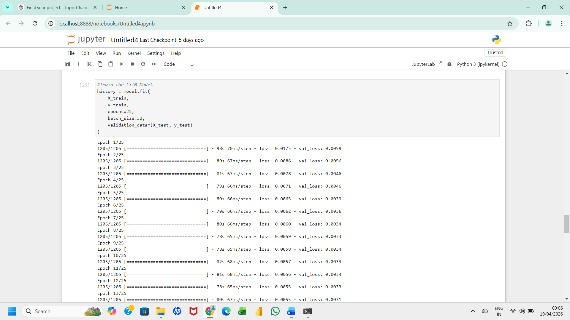
Figure 6.1 Train the LSTM model
Train the LSTM model:
The LSTM model is trained using historical traffic data over multiple epochs. During training, the model learns traffic patterns by adjusting internal weights using backpropagation. Training data is fed into the model in batches for efficient computation. The training process continues until the prediction error is minimized.

59
Hyperparameter tuning is performed to optimize model performance. Key parameters such as learning rate, batch size, number of epochs, and dropout rate are carefully adjusted. A lower learning rate ensures stable convergence, while an optimal batch size improves training efficiency. Dropout helps in reducing overfitting and improving generalization. Proper tuning of hyperparameters significantly enhances model accuracy and reduces prediction error. This step is essential for achieving optimal performance in deep learning models.
6.11 MODEL EVALUATION
The trained model is evaluated using test data that contains unseen traffic records. Performance is measured using Mean Absolute Error (MAE) and Root Mean Square Error (RMSE). Lower error values indicate higher prediction accuracy. The predicted values are compared with actual values using graphs for better analysis. A close match between predicted and actual values indicates that the model is performing well. This evaluation ensures the reliability and efficiency of the system.
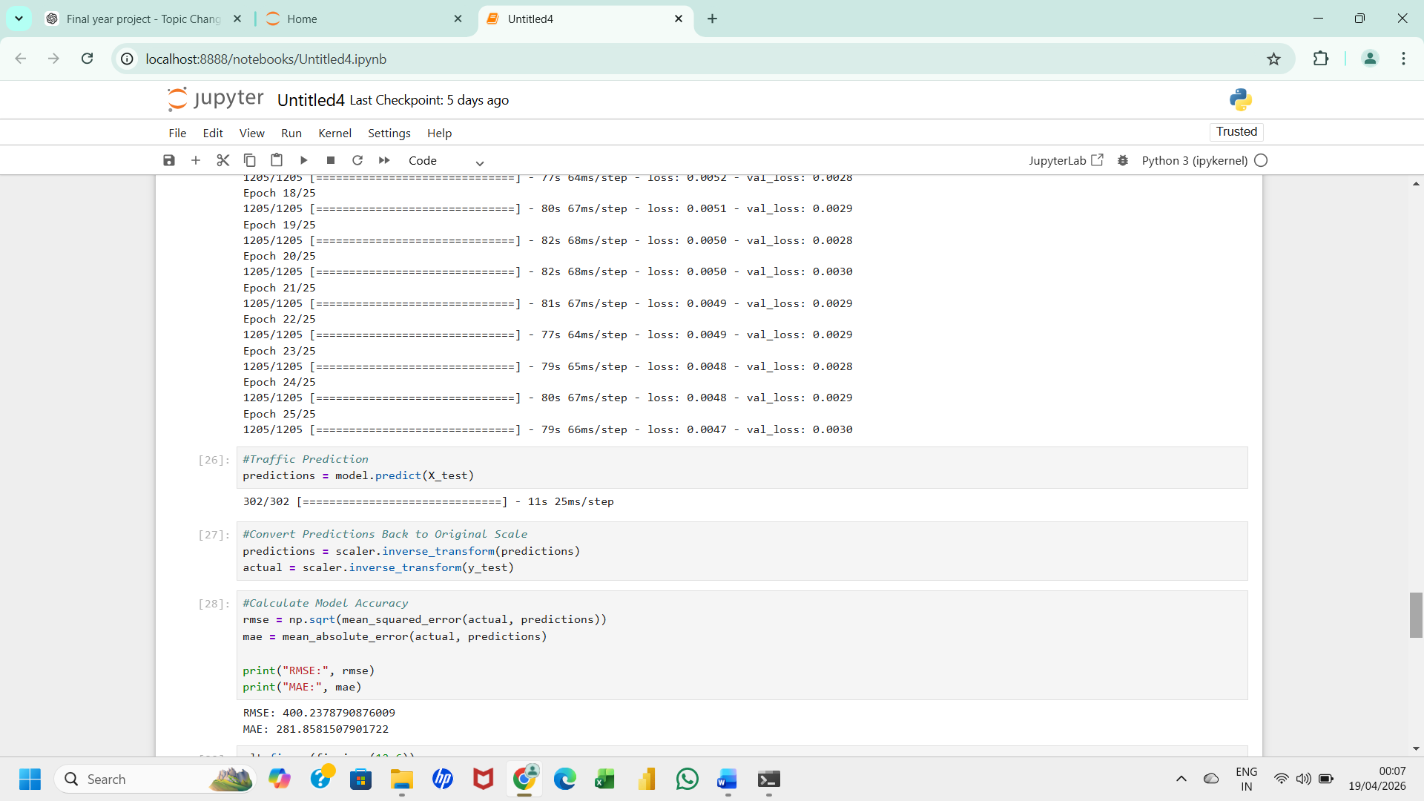
Figure 6.2 Model Accuracy

60
Model Accuracy :
The accuracy of the model is evaluated using performance metrics such as Mean Absolute Error (MAE) and Root Mean Square Error (RMSE). Lower error values indicate better prediction accuracy. The predicted values are compared with actual traffic values to analyze model performance. High accuracy confirms the effectiveness of the LSTM model
6.12 REAL-TIME PREDICTION
The trained LSTM model is used for real-time prediction by feeding new traffic data into the system. The model processes incoming data and predicts future traffic flow. This enables continuous monitoring of traffic conditions and helps in proactive decision-making. The system can also be integrated with IoT-based traffic sensors for live data input.Real-time prediction makes the system useful for traffic management authorities and smart city applications.

Figure 6.3 Traffic Prediction
Traffic Prediction :
Traffic prediction is performed using the trained LSTM model. The system analyzes historical traffic patterns and predicts future traffic flow values in real time. The predicted values help in understanding future congestion conditions. This supports intelligent transportation systems and traffic management applications.

61
6.13 CONGESTION ANALYSIS
The congestion analysis module is a critical component of the proposed real-time traffic flow prediction system. After the LSTM model generates predicted traffic volume values, these numerical outputs alone are not sufficient for practical usage. Therefore, congestion analysis is performed to convert raw predicted values into meaningful traffic conditions that can be easily interpreted by users, traffic authorities, and intelligent transportation systems. The main objective of this module is to classify traffic conditions based on predicted traffic volume into different congestion levels. This conversion helps in transforming complex numerical outputs into simple categorical information that supports quick decision-making. The system is designed to identify three major congestion levels: Low Congestion, Medium Congestion, and High Congestion.
Low congestion represents a situation where traffic flow is smooth and vehicle density is minimal. In this condition, roads are relatively free, and vehicles can move without significant delay. Medium congestion represents moderate traffic conditions where vehicle density increases and minor delays may occur. High congestion represents heavy traffic conditions where vehicle movement becomes slow due to high density of vehicles, often leading to traffic jams. The classification of congestion levels is performed using threshold-based logic. These threshold values are derived from historical dataset analysis, where traffic volume distribution is studied carefully. Based on statistical analysis, boundary values are defined to categorize traffic flow into different congestion levels. This ensures that classification is realistic and closely matches real-world traffic behaviour.

62
For example, if the predicted traffic volume is below a certain lower threshold, it is classified as low congestion. If it falls between lower and upper thresholds, it is classified as medium congestion. If it exceeds the upper threshold, it is classified as high congestion. This simple yet effective approach makes the system highly interpretable.
The congestion analysis module plays a major role in intelligent transportation systems because it provides actionable insights rather than just numerical predictions.
Traffic authorities can use this information for route planning, signal optimization, and emergency traffic management. For example, if high congestion is predicted, alternative routes can be suggested to reduce traffic load on main roads. This module also supports smart city applications where real-time traffic monitoring is required. By continuously analyzing predicted traffic values, the system can provide dynamic updates about road conditions.
This helps in reducing travel time, fuel consumption, and overall traffic congestion in urban areas.Another important aspect of congestion analysis is its integration with real-time prediction systems. As new traffic data is continuously fed into the LSTM model, predictions are updated dynamically. The congestion module immediately processes these updated predictions and provides real-time congestion status. This ensures that the system remains responsive to changing traffic conditions. From a technical perspective, the congestion analysis module is implemented using simple conditional logic after prediction generation.

63
However, its impact on the overall system is significant because it converts machine learning output into human-understandable results. This improves usability and makes the system practical for real-world deployment.
The effectiveness of congestion analysis depends on the accuracy of the LSTM prediction model. Since the LSTM model captures sequential patterns in traffic data, the predicted values are highly reliable. As a result, congestion classification also becomes accurate and meaningful.
In addition, visualization techniques are often combined with congestion analysis to improve interpretation. Color-coded graphs or bar charts are used to represent different congestion levels. For example, green represents low congestion, yellow represents medium congestion, and red represents high congestion. This visual representation enhances user understanding and allows quick decision-making.
Overall, the congestion analysis module acts as a bridge between machine learning predictions and real-world traffic management applications. It simplifies complex outputs and provides meaningful insights that can be directly used for traffic control and planning.
In conclusion, the congestion analysis module significantly enhances the usability of the proposed system by converting predicted traffic values into structured categories. It ensures that the system is not only technically accurate but also practically useful for real-time traffic management and intelligent transportation systems.

64
6.14 VISUALIZATION OF RESULTS
Visualization of results is an important phase in the proposed real-time traffic flow prediction and congestion analysis system. After the LSTM model generates predictions and the congestion analysis module classifies traffic conditions, the results are represented in graphical form for better understanding and interpretation. Visualization plays a key role in converting complex numerical outputs into meaningful visual patterns that can be easily analyzed by users, researchers, and traffic management authorities.
The primary objective of visualization is to present actual traffic values, predicted traffic values, and congestion levels in a clear and understandable format. Since traffic data is time-dependent and highly dynamic, graphical representation helps in identifying trends, patterns, and anomalies in traffic flow. This improves decision-making and supports intelligent transportation systems.
In this system, Python libraries such as Matplotlib and Seaborn are used for visualization. These libraries provide powerful tools for creating line graphs, bar charts, scatter plots, and comparative graphs. Each visualization technique is used for a specific purpose depending on the type of analysis required.
One of the most important visualizations is the actual vs predicted traffic flow graph. In this graph, the actual traffic volume values from the dataset are plotted against the predicted values generated by the LSTM model. This comparison helps in evaluating how accurately the model is able to follow real-world traffic patterns. If the predicted curve closely matches the actual curve, it indicates that the model has learned the traffic behavior effectively.

65
In addition to this, scatter plots are used to analyze the relationship between different features such as temperature, rainfall, and traffic volume. These plots help in understanding how environmental factors influence traffic behavior. For example, it can be observed that adverse weather conditions often lead to increased traffic congestion.
Visualization also helps in identifying model performance issues. If there is a large gap between actual and predicted values in the graph, it indicates that the model needs improvement. On the other hand, a close alignment between both curves indicates high model accuracy and good generalization capability.
Another important aspect of visualization is real-time display of traffic conditions. In real-time applications, updated predictions can be continuously visualized to show current traffic status. This helps users make quick decisions such as choosing alternative routes or avoiding congested areas. This feature is highly useful in smart city and intelligent transportation systems.
The visualization module also enhances system usability. Instead of presenting raw data, graphs and charts make the system more user-friendly and interpretable. Even non-technical users can easily understand traffic patterns and congestion levels through visual representation.
From a technical perspective, visualization is implemented using Python plotting functions. Data from the model output is passed into visualization functions, which generate graphs dynamically. These graphs can be saved, exported, or displayed in real-time dashboards.

66
6.16 SUMMARY
The implementation chapter of the proposed real-time traffic flow prediction and congestion analysis system represents the complete development process of the system from raw data handling to final output generation.
This system is designed using Python programming language and deep learning techniques, specifically the Long Short-Term Memory (LSTM) model, to achieve accurate traffic prediction and effective congestion analysis.
The overall implementation is carried out in a structured and modular manner to ensure clarity, scalability, and ease of maintenance in accordance with Anna University standards.
The system begins with dataset loading, where traffic-related data containing attributes such as temperature, rainfall, snowfall, weather conditions, and traffic volume is imported into the environment. This dataset is then carefully analyzed to understand its structure, distribution, and completeness.
Missing values and inconsistencies are handled during preprocessing to ensure data quality. This step is crucial because the accuracy of the machine learning model depends heavily on the quality of input data.
After preprocessing, feature selection is performed to identify the most relevant attributes influencing traffic flow. Irrelevant features are removed to reduce complexity and improve computational efficiency.

67
The selected features are then transformed into a time-series format, which is essential for LSTM-based learning. The sliding window technique is used to create sequences, enabling the model to learn temporal dependencies in traffic patterns.
The core of the system is the LSTM model, which is designed to capture both short-term and long-term dependencies in sequential traffic data.
The model consists of multiple layers including LSTM layers, dropout layers, and dense output layers. The dropout layers help prevent overfitting, while the dense layer produces the final prediction output.
The model is compiled using the Adam optimizer and Mean Squared Error (MSE) loss function, which ensures efficient learning and accurate predictions. During the training phase, the model is trained using historical traffic data over multiple epochs. The training process involves continuous weight adjustment using backpropagation to minimize error. Validation data is used to monitor performance and ensure that the model does not overfit. As training progresses, the loss value decreases steadily, indicating improved learning capability and better model performance.
Once training is completed, the model is evaluated using test data. Performance metrics such as Mean Absolute Error (MAE) and Root Mean Square Error (RMSE) are used to measure prediction accuracy.
Lower error values indicate higher accuracy and reliability of the system. The predicted values are also compared with actual values using graphical visualization, which helps in assessing model performance visually.

68
After prediction, the congestion analysis module classifies traffic flow into three categories: low congestion, medium congestion, and high congestion. This classification is based on threshold values derived from historical traffic data analysis. This step converts numerical predictions into meaningful traffic conditions that can be easily understood by users and traffic management systems.
The visualization module plays an important role in presenting results in a graphical format. Line graphs, bar charts, and comparison plots are used to represent actual vs predicted traffic flow and congestion levels.
Visualization improves interpretability and helps in identifying traffic patterns such as peak hours and congestion trends. It also enhances system usability for non-technical users.
The system is designed to support real-time traffic prediction, where new data can be continuously fed into the model to generate updated predictions.
This makes the system suitable for smart city applications and intelligent transportation systems. Real-time prediction helps in dynamic traffic management and decision-making.

69
Overall, the implementation of the system demonstrates a complete end-to-end workflow from data collection to prediction and congestion analysis.
The use of LSTM improves accuracy by effectively capturing sequential patterns in traffic data. The modular design ensures flexibility, scalability, and easy maintenance.
In conclusion, the proposed system provides an efficient and reliable solution for traffic flow prediction and congestion analysis. It successfully integrates machine learning techniques with real-time data processing to support intelligent transportation systems.
The system not only predicts traffic flow accurately but also provides meaningful insights for better traffic management and planning.

70
CHAPTER 7
RESULTS

The results of the proposed real-time traffic flow prediction and congestion analysis system demonstrate the effectiveness of the Long Short-Term Memory (LSTM) model in forecasting traffic conditions. The model was trained using historical traffic data and tested on unseen data to evaluate its performance. The prediction results show that the model is capable of capturing temporal patterns in traffic flow and producing accurate forecasts.
The performance of the model is evaluated using metrics such as Mean Absolute Error (MAE) and Root Mean Square Error (RMSE). The obtained results indicate that the error values are minimal, which confirms the accuracy and reliability of the LSTM model. The predicted traffic values are very close to the actual traffic values, demonstrating the model’s ability to generalize well on new data.
Graphical representations are used to visualize the results. The comparison between actual and predicted traffic volume is plotted using line graphs. These graphs clearly show that the predicted values closely follow the trend of actual traffic data, indicating good model performance. The results confirm that the proposed system can effectively predict traffic flow in real-time scenarios.

71
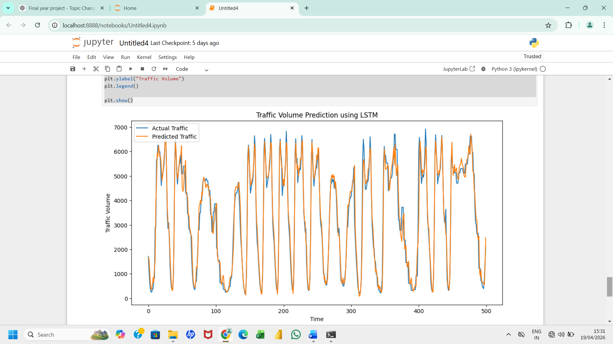
Figure 7.1 Result
Result:
The final result displays predicted traffic flow and congestion levels using graphical visualization techniques. Actual and predicted values are compared using line graphs and charts. The results demonstrate that the proposed LSTM model provides accurate and reliable traffic prediction. The system effectively supports congestion analysis and real-time traffic monitoring.

72
CHAPTER 8
CONCLUSION
The proposed real-time traffic flow prediction and congestion analysis system using LSTM deep learning networks successfully addresses the challenges of predicting complex traffic patterns. The system effectively utilizes historical traffic data and temporal dependencies to generate accurate predictions. The implementation of the LSTM model improves prediction accuracy compared to traditional methods. The system also performs congestion analysis by classifying traffic into different levels, providing meaningful insights for decision-making. Visualization of results further enhances the usability and understanding of traffic conditions. The overall performance of the system demonstrates its reliability and efficiency in handling real-time traffic scenarios. Hence, the proposed solution can be effectively used in intelligent transportation systems to reduce congestion and improve traffic management.

73
CHAPTER 9
FUTURE ENHANCEMENT
The proposed real-time traffic flow prediction and congestion analysis system using LSTM deep learning networks can be further enhanced in several ways to improve its performance and applicability. One of the major future improvements is the integration of real-time data from sensors, GPS devices, and Internet of Things (IoT) technologies. This will enable the system to provide more accurate and dynamic traffic predictions based on live traffic conditions.

74

APPENDIX A:
SOURCE CODE
Importing Libraries
import numpy as np
import pandas as pd
import matplotlib.pyplot as plt
from sklearn.preprocessing import MinMaxScaler
from sklearn.metrics import mean_squared_error, mean_absolute_error
import tensorflow as tf
from tensorflow.keras.models import Sequential
from tensorflow.keras.layers import LSTM, Dense
LOADING DATASET
data = pd.read_csv('traffic.csv')
data.head()
DATA PREPROCESSING
# Handle missing values
data.fillna(method='ffill', inplace=True)
#check data set shape
df.shape

75
df=df.dropna()
df.shape
df.drop("holiday", axis=1,inplace =True)
#check info
df.info()
#check missing values
df.isnull().sum()
df.columns.tolist()

df = df.drop(columns=['holiday'])
df.head()
#Convert date_time to Datetime
df['date_time'] = pd.to_datetime(df['date_time'])
#Sort by Time
df = df.sort_values('date_time')
#Set date_time as Index
df.set_index('date_time', inplace=True)
#Extract Only traffic_volume(Core Model)
traffic_data = df[['traffic_volume']]

76
traffic_data.head()
import matplotlib.pyplot as plt

plt.figure(figsize=(12,5))
plt.plot(traffic_data, color='blue')
plt.title("Traffic Volume Over Time")
plt.xlabel("Date")
plt.ylabel("Traffic Volume")
plt.show()
from sklearn.preprocessing import MinMaxScaler
scaler = MinMaxScaler(feature_range=(0,1))
scaled_data = scaler.fit_transform(traffic_data)
scaled_data[:5]
scaled_data = scaler.fit_transform(traffic_data)
def create_sequences(data, window_size=24):
X = []
y = []
for i in range(len(data) - window_size):
X.append(data[i:i+window_size])
y.append(data[i+window_size])

77
return np.array(X), np.array(y)
X, y = create_sequences(scaled_data, 24)
X.shape, y.shape
#Train Test Split
split = int(0.8 * len(X))

X_train = X[:split]
X_test = X[split:]

y_train = y[:split]
y_test = y[split:]
#Check Shapes
X_train.shape, X_test.shape
#Build the LSTM Model
model = Sequential()
model.add(LSTM(50, return_sequences=True, input_shape=(24,1)))
model.add(LSTM(50))

model.add(Dense(1))

78
model.compile(
optimizer='adam',
loss='mean_squared_error'
)
model.summary()
#Train the LSTM Model
history = model.fit(
X_train,
y_train,
epochs=25,
batch_size=32,
validation_data=(X_test, y_test)
)
#Traffic Prediction
predictions = model.predict(X_test)
#Convert Predictions Back to Original Scale
predictions = scaler.inverse_transform(predictions)
actual = scaler.inverse_transform(y_test)
#Calculate Model Accuracy
rmse = np.sqrt(mean_squared_error(actual, predictions))

79
mae = mean_absolute_error(actual, predictions)
print("RMSE:", rmse)
print("MAE:", mae)
plt.figure(figsize=(12,6))
plt.plot(actual[:500], label="Actual Traffic")
plt.plot(predictions[:500], label="Predicted Traffic")

plt.title("Traffic Volume Prediction using LSTM")
plt.xlabel("Time")
plt.ylabel("Traffic Volume")
plt.legend()

plt.show()
model.save("traffic_lstm_model.keras")

app.py
import streamlit as st
import numpy as np

80
import pickle
import tensorflow as tf
# Rebuild model
model = tf.keras.Sequential([
tf.keras.layers.Input(shape=(24, 1)),
tf.keras.layers.LSTM(50, return_sequences=True),
tf.keras.layers.LSTM(50),
tf.keras.layers.Dense(1)
])
# Load weights
model.load_weights(r"C:\Users\js280\traffic_lstm_model.h5")
# Load scaler
with open(r"C:\Users\js280\scaler.pkl", "rb") as f:
scaler = pickle.load(f)
# UI
st.title("Traffic Volume Prediction using LSTM")
st.write("Enter last 24 hours traffic data")

81
input_data = []
for i in range(24):
val = st.number_input(f"Hour {i+1}", min_value=0.0, step=1.0)
input_data.append(val)

if st.button("Predict"):
input_array = np.array(input_data).reshape(-1, 1)
input_scaled = scaler.transform(input_array)
input_scaled = input_scaled.reshape(1, 24, 1)

prediction = model.predict(input_scaled)
predicted_value = scaler.inverse_transform(prediction)

st.success(f"Predicted Traffic: {int(predicted_value[0][0])}")

82
APPENDIX B
SCREENSHOTS

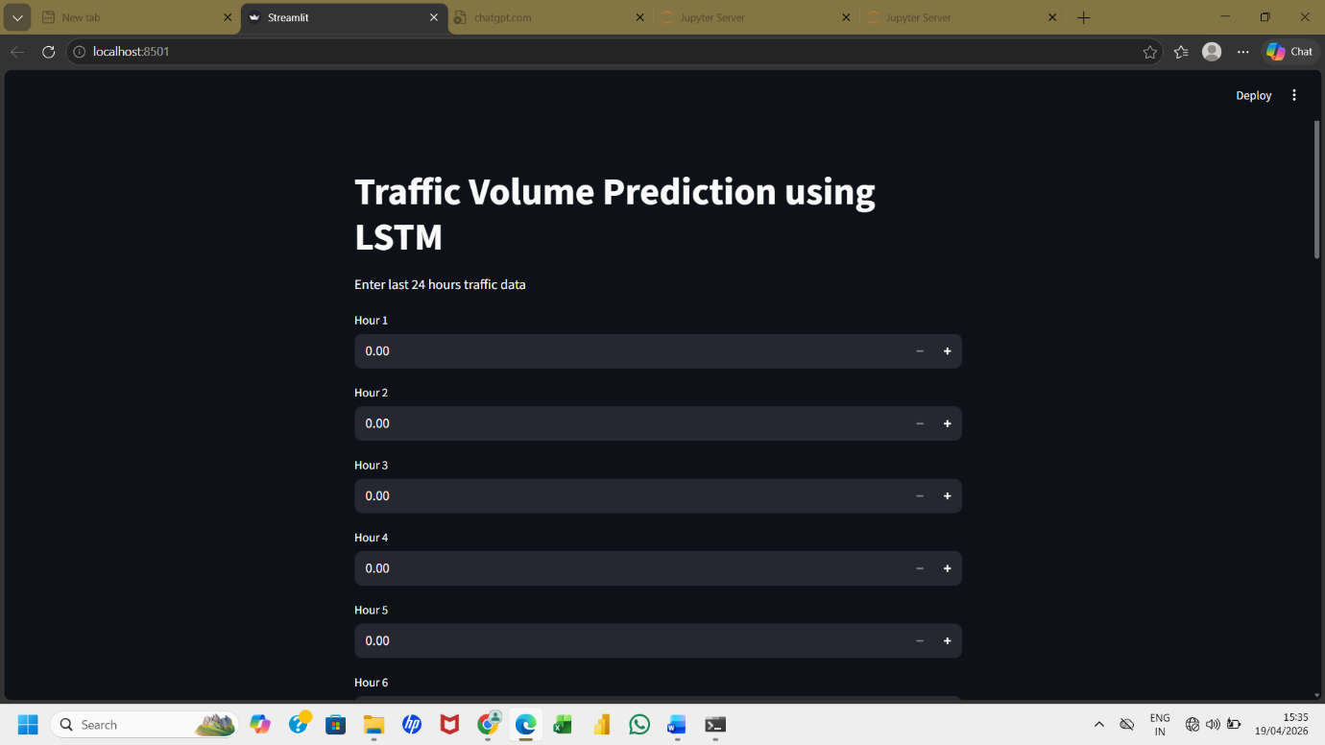
Figure 10.1 Index page

83
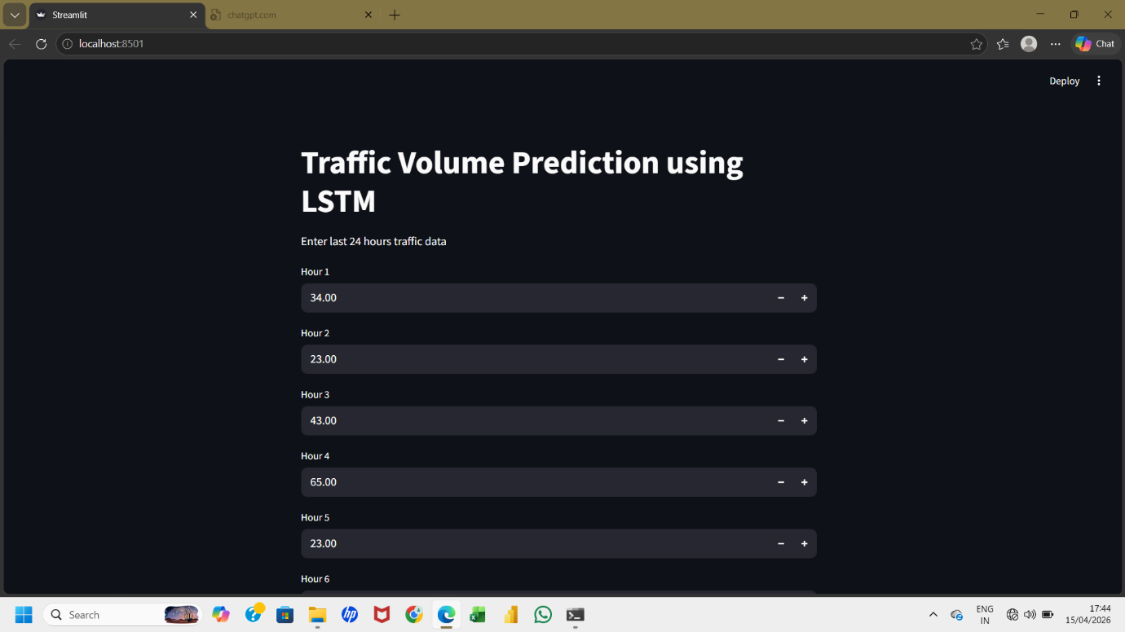
Figure 10.2 Traffic Data Input Screen-1

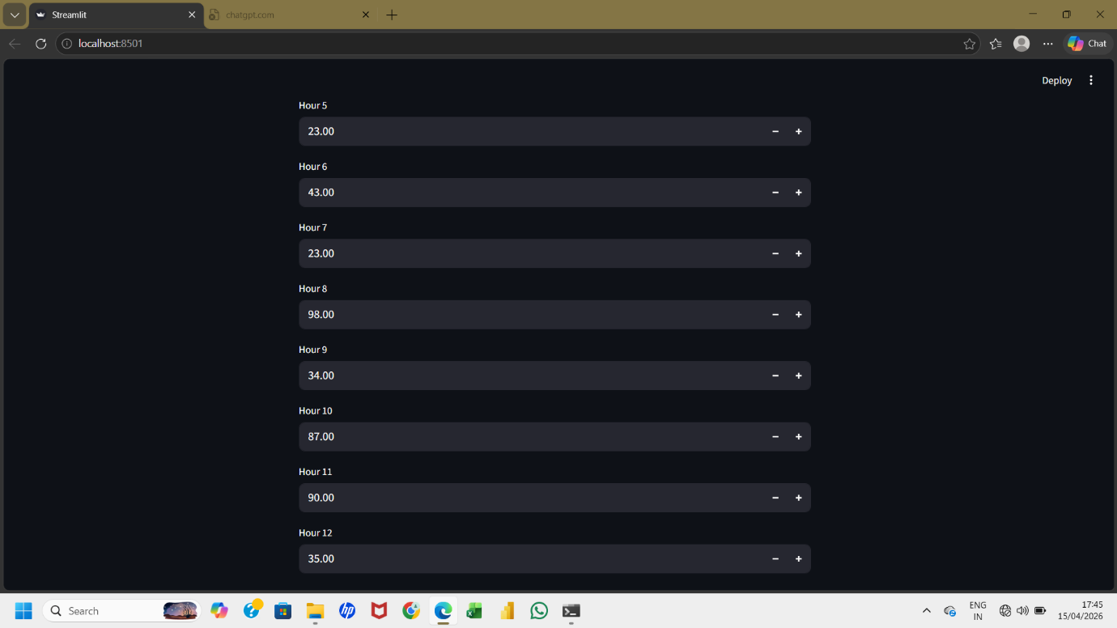
Figure 10.3 Traffic Data Input Screen-2

84

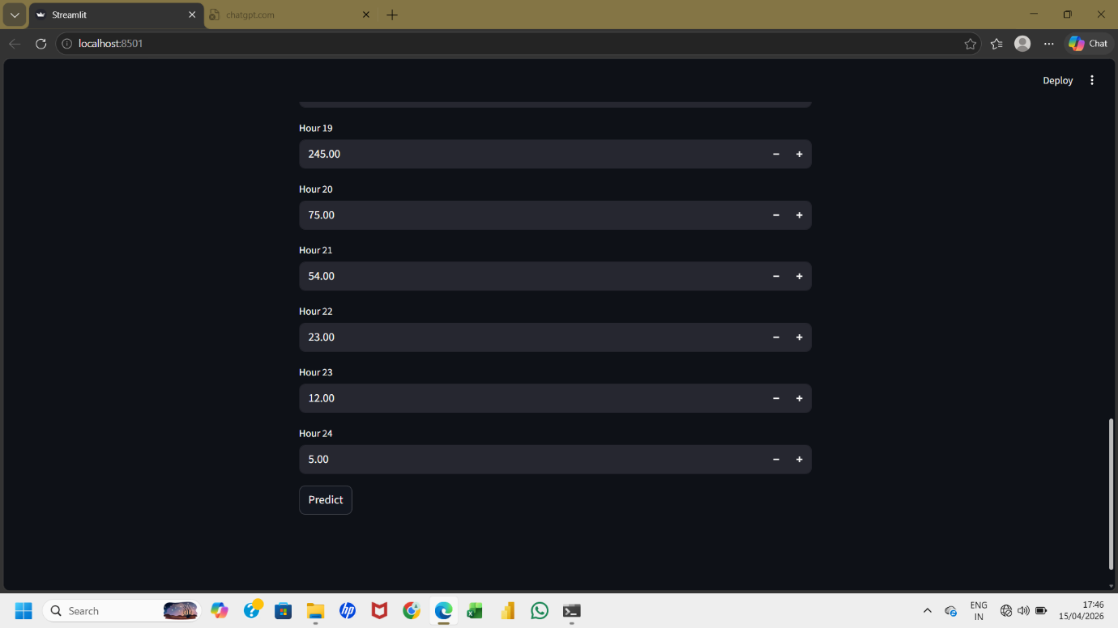
Figure 10.3 Traffic Data Input Screen-3

85

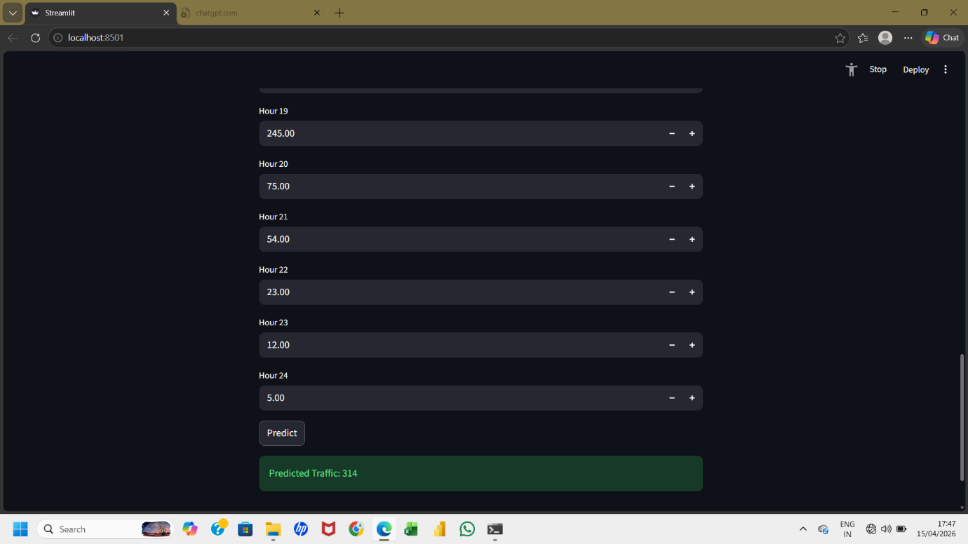
Figure 10.4 Predict the Traffic Value for Next hour

86

CHAPTER 10
REFERENCES
- C. Swetha Priya and F. Sagayaraj Francis, “Optimizing Traffic Speed Prediction Using a Multi-Objective Genetic Algorithm-Enhanced RNN for Intelligent Transportation Systems,” Journal of Intelligent Transportation Systems, 2024.
- Wei Xu, Eric Blancaflor, and Mideth Abisado, “Performance and Improvement of Deep Learning Algorithms Based on LSTM in Traffic Flow Prediction,” International Journal of Advanced Computer Science and Applications, 2024.
- Vandana Singh, Sudip Kumar Sahana, and Vandana Bhattacharjee, “A Novel CNN-GRU-LSTM Based Deep Learning Model for Accurate Traffic Prediction,” Journal of Big Data Analytics, 2024.
- Hochreiter, S., and Schmidhuber, J., “Long Short-Term Memory,” Neural Computation, vol. 9, no. 8, pp. 1735–1780, 1997.
- Goodfellow, I., Bengio, Y., and Courville, A., Deep Learning, MIT Press, 2016.
- LeCun, Y., Bengio, Y., and Hinton, G., “Deep Learning,” Nature, vol. 521, pp. 436–444, 2015.
- Brownlee, J., “Deep Learning for Time Series Forecasting,” Machine Learning Mastery, 2018.
- Chollet, F., Deep Learning with Python, Manning Publications, 2017.

87
- Graves, A., Supervised Sequence Labelling with Recurrent Neural Networks, Springer, 2012.
- Zhang, J., Zheng, Y., and Qi, D., “Deep Spatio-Temporal Residual Networks for Citywide Crowd Flows Prediction,” AAAI Conference, 2017.
- Lv, Y., Duan, Y., Kang, W., Li, Z., and Wang, F., “Traffic Flow Prediction with Big Data: A Deep Learning Approach,” IEEE Transactions on Intelligent Transportation Systems, 2015.
- Ma, X., Tao, Z., Wang, Y., Yu, H., and Wang, Y., “Long Short-Term Memory Neural Network for Traffic Speed Prediction Using Remote Microwave Sensor Data,” Transportation Research Part C, 2015.
- Yu, B., Yin, H., and Zhu, Z., “Spatio-Temporal Graph Convolutional Networks: A Deep Learning Framework for Traffic Forecasting,” IJCAI, 2018.
- Li, Y., Yu, R., Shahabi, C., and Liu, Y., “Diffusion Convolutional Recurrent Neural Network: Data-Driven Traffic Forecasting,” ICLR, 2018.
- Wang, J., Chen, R., and He, Z., “Traffic Speed Prediction for Urban Transportation Network: A Path Based Deep Learning Approach,” Transportation Research Part C, 2019.
- TensorFlow Documentation, “An End-to-End Open Source Machine Learning Platform,” Available: https://www.tensorflow.org
- Keras Documentation, “High-Level Neural Networks API,” Available: https://keras.io

88
- Pedregosa, F., et al., “Scikit-learn: Machine Learning in Python,” Journal of Machine Learning Research, 2011.
- McKinney, W., “Data Structures for Statistical Computing in Python,” Proceedings of the Python in Science Conference, 2010.
- Hunter, J.D., “Matplotlib: A 2D Graphics Environment,” Computing in Science & Engineering, 2007.
- NumPy Documentation, “Numerical Python Library,” Available: https://numpy.org
- Pandas Documentation, “Python Data Analysis Library,” Available: https://pandas.pydata.org
- Jupyter Documentation, “Interactive Computing Environment,” Available: https://jupyter.org
- Anaconda Documentation, “Data Science Platform and Package Manager,” Available: https://www.anaconda.com
- Kaggle Dataset, “Metro Interstate Traffic Volume Dataset,” Available: https://www.kaggle.com
- OpenStreetMap Contributors, “Traffic and Road Network Data,” Available: https://www.openstreetmap.org
- Government of India, “Intelligent Transportation Systems in Smart Cities,” Ministry of Road Transport and Highways, 2022.
- World Bank, “Urban Transport and Traffic Management Systems,” 2021.

89

