NGUYEN HOANG TAI – FULL STACK SOFTWARE ENGINEER
Mobile number: 0704469237
Email: nguyenhoangtai2k@gmail.com
GitHub: https://github.com/jsonmasker
Docker: https://hub.docker.com/u/jsonmasker
YouTube: https://www.youtube.com/@JsonMasker

INTRODUCTION
Hello everyone, my name is Nguyen Hoang Tai, but you can call me Json Masker that’s my nickname, and I love it. I’m a proficient software engineer with over 5 years of experience in developing web applications. I started working with the .NET framework when I was a student, and since then I’ve continued to build projects and share my work on GitHub and YouTube. I’m passionate about my field, I enjoy learning new technologies, and I especially love sharing my knowledge with others.
BACKGROUND
- Majoring in: Software Technology.
- School: Can Tho University of Technology.

TECHNICAL SKILLS
- Programming Languages: C#, JavaScript, Python.
- Markup Languages: HTML.
- Style Languages: CSS (Sass).
- Frameworks/Platforms: Asp.Net core MVC, Asp.Net Core API, Entity Framework, Angular, jQuery, Bootstrap, SignalR.
- Database Management Systems: SQL Server, My SQL, MongoDB, Weaviate (Vector database).
+ SQL Server: Store procedure, View, Trigger, Link Server, Job.
- AI Technologies: Ollama, ChatGPT.
- Design Patterns: Singleton pattern, Abstract pattern, Factory pattern, Observer pattern, DI pattern, CQRS pattern, …
- DevOps: Configure DEV and PROD environment, Manage GitHub, Public an ASP.NET CORE to IIS, Docker Engine.

SOFT SKILLS
- Problem-solving.
- Research new technology.
- Teamwork.
- Presentation on technology or personal finance topics.
- English skills: reading, writing, listening, speaking.

HOBBIES:
- Reading: Personal Finance Books, Self Development Books, Technology Document.
- Visiting the coffee shops.
- Enjoying food.

PERSONALITIES:
- Honest.
- Responsible.
- Friendly.
- Hardworking and eager to learn.

My Projects:

Project name: Lulusia Kingdom.  Team size: 3.  Position: Team Leader.  Project type: personal.  Architectures: Microservices, Client Server.  Description: Develop an application that connects all utility services in the urban area to serve the residents living there.  Modules: Chatbot, Restaurant, Coffee-shop, Lipstick-shop, Survey, …  Links: https://lulusia.com/ , https://lulusia.vn/ , https://silkway.vn/ | 08/24 - Now.
Job description:
- Build project architecture.
- Design web UI.
- Planning and division of work.
- Programming languages: C#, JavaScript, HTML, SCSS, Python, Dart.
- Frameworks: Angular, Asp.Net Core API, Asp.Net Core MVC, Entity Framework, Identity Framework, Flutter.
- Libraries: Bootstrap, jQuery, QR Code, MailKit, Ollama, ng-zorro, Core UI …
- Database management systems: SQL Server, MongoDB, Weaviate.
Project Architecture Overview.

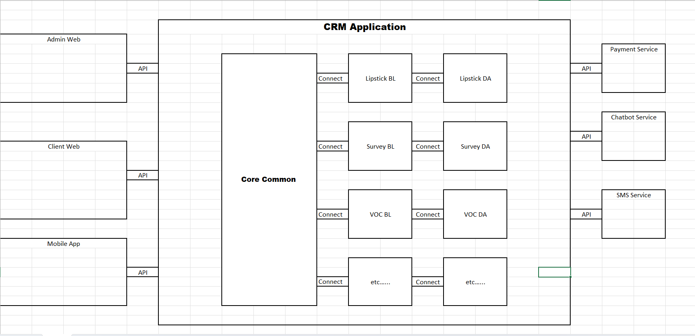
Image 1: Overview of the project architecture.

Chatbot Project Architecture Overview.
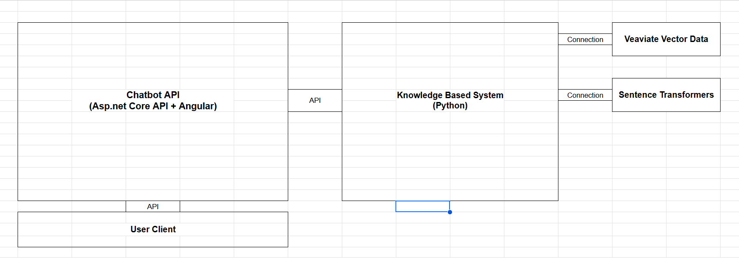
Image 2: Overview of the Chatbot project architecture.

Project name: Tenant Management App.  Company name: THISO  Team size: 3.  Position: Team Leader.  Architectures: Client Server. | 10/25 – Now.
Job description:
- Build project architecture.
- Design web UI.
- Planning and division of work.
- Programming languages: C#, JavaScript, HTML, SCSS.
- Frameworks: Angular, Asp.Net Core API, Entity Framework, Identity Framework.
- Libraries: ng-zorro, Core UI …
- Database management systems: SQL Server, MongoDB.

Project name: CRM Application.  Company name: THISO  Team size: 3.  Position: Team Leader.  Architectures: Microservices, Client Server.  Modules: Parking Central Data, Survey, Voice of Customers, Contractor Management at Thiskyhall, …  Links: https://adminportal.thiso.vn/ , https://contractor.thiskyhall.vn/ , https://voc.thiso.vn/ , … | 06/24 – 02/25.
Job description:
- Build project architecture.
- Design web UI.
- Planning and division of work.
- Link server and data synchronization.
- Programming languages: C#, JavaScript, HTML, SCSS.
- Frameworks: Angular, Asp.Net Core API, Asp.Net Core MVC, Entity Framework, Identity Framework.
- Libraries: Bootstrap, Auto Mapper, QR Coder, jQuery …
- Database management systems: SQL Server, MongoDB.

Project name: Visitor Management Application.  Company name: THISO  Team size: 2.  Position: Team Leader.  Architectures: Monolithic.  Links: https://inoutoffice.thiso.vn/ | 04/24 – 06/25.
Job description:
- Build project architecture.
- Design web UI.
- Website development.
- Programming languages: C#, JavaScript, HTML, SCSS.
- Frameworks: Asp.Net Core MVC, Entity Framework, Identity Framework.
- Libraries: Bootstrap, Auto Mapper, QR Code, MailKit, jQuery …
- Database management systems: SQL Server.

Project name: Restaurant Audit App.  Company name: MS-APPTECH  Team size: 4.  Position: .Net developer.  Architectures: Client Server. | 11/23 – 12/23.
Job description:
- Front-end development.
- Programming languages: C#, JavaScript, HTML, SCSS.
- Frameworks: Asp.Net Core MVC.
- Libraries: Bootstrap, jQuery …
- Database management systems: SQL Server.

Project name: Thiso Mall Sala Website.  Company name: MS-APPTECH  Team size: 4.  Position: .Net developer.  Architectures: Microservices.  Links: https://thisomallsala.vn/ | 08/23 – 10/ 23.
Job description:
- Front-end development.
- Programming languages: C#, JavaScript, HTML, SCSS.
- Frameworks: Asp.Net Core API, Asp.Net Core MVC, Dapper.
- Libraries: Bootstrap, Auto Mapper, jQuery …
- Database management systems: SQL Server, MongoDB.

Project name: Selling Course Online App.  Company name: FPT  Team size: 5.  Position: .Net Fresher.  Architectures: Client Server. | 03/23 – 08/23.
Job description:
- Build project architecture.
- Front-end development.
- Programming languages: C#, JavaScript, HTML, CSS.
- Frameworks: ReactJS, Asp.Net Core API, Entity Framework, Identity Framework.
- Database management systems: SQL Server.

Project name: Facilities Management App.  Team size: 4.  Position: ReactJS Developer.  Project type: Thesis.  Architectures: Client Server. | 06/22 – 11/22.
Job description:
- Front-end development.
- Programming languages: C#, JavaScript, HTML, SCSS.
- Frameworks: ReactJS, Asp.Net Core API, Entity Framework, Identity Framework.
- Database management systems: SQL Server, MongoDB.

