**WorkshopPLUS – Power Automate – Power User 1 Day**

Module 2 - Labs

Follow along steps

Contents

1. Use Approval flows to send and manage approvals 3

2. Use HTML option in mail actions (SharePoint) 11

3. Power Automate Approvals and Email with Options 14

# Use Approval flows to send and manage approvals

​

1. Open <https://flow.microsoft.com> and login with your account
2. Click **My Flows**
3. Create new Flow using “**Automated cloud flow**” option

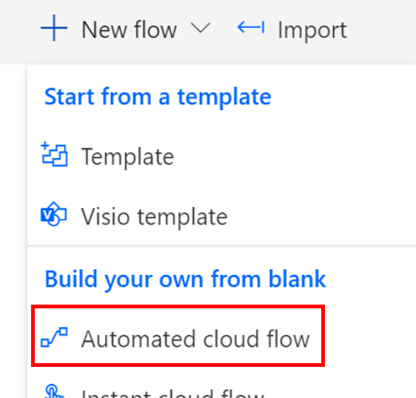

1. Name it “**Carlist Approval**“​, choose “**When an item is created**” (SharePoint) and click **Create**

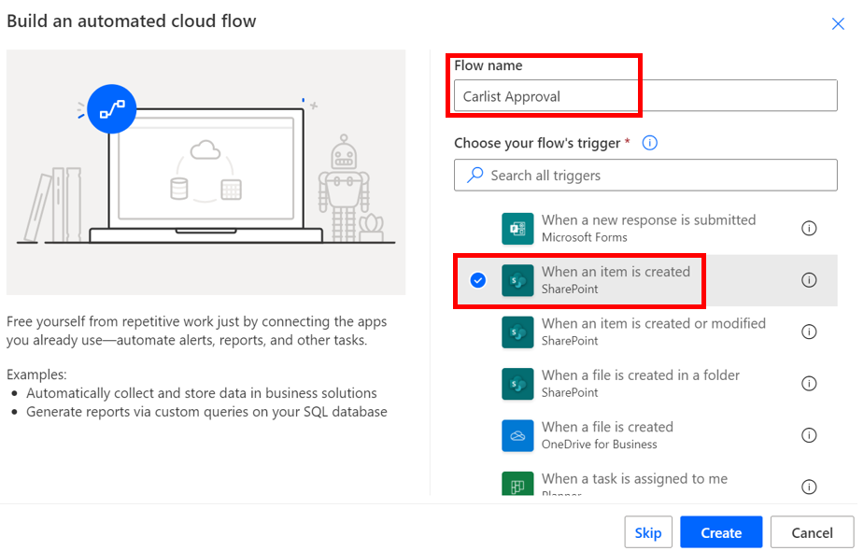

1. ​In Site Address, click on dropdown to select **FlowTraining** site and in List Name select **CarsList**

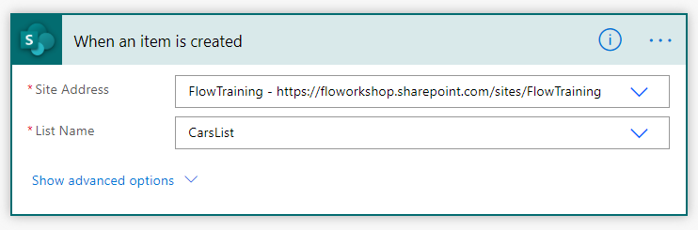

1. Click **New Step**, type **Approval** and then select **Start and wait for an approval**

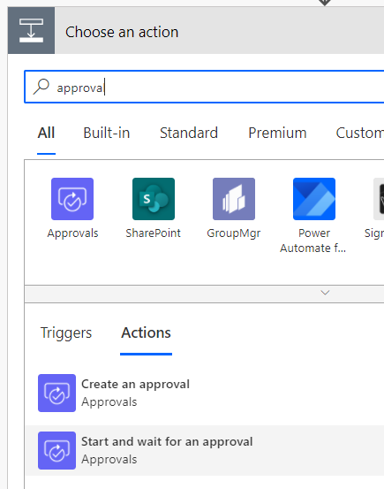

1. Set action settings as below using Dynamic content from “**When an item is created**” trigger
   * Title: **[Title]** (dynamic content from “When an item is created”)
   * Assigned to: *Your O365 account*
   * Details: **[Created by Display Name]** at **[Created]** (dynamic content from “When an item is created”)
   * Item link: **[Link to item]** (dynamic content from “When an item is created”)
   * Item link description: **[Name]** (dynamic content from “When an item is created”)

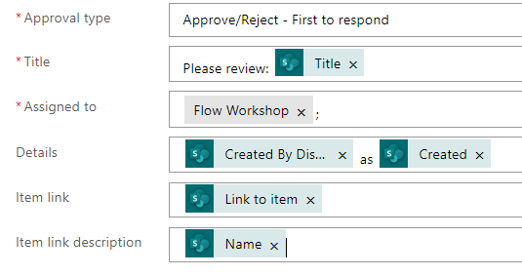 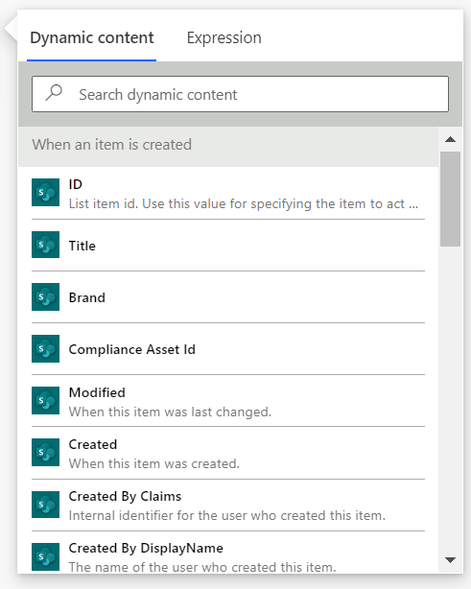

1. Click New Step and select **Condition**

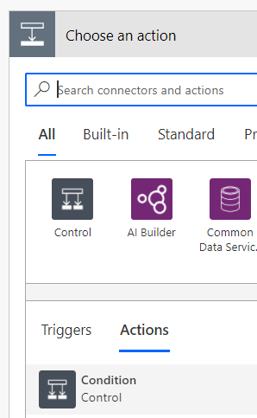

1. Choose **Outcome** from “**Start and wait for an approval**” action’s dynamic content

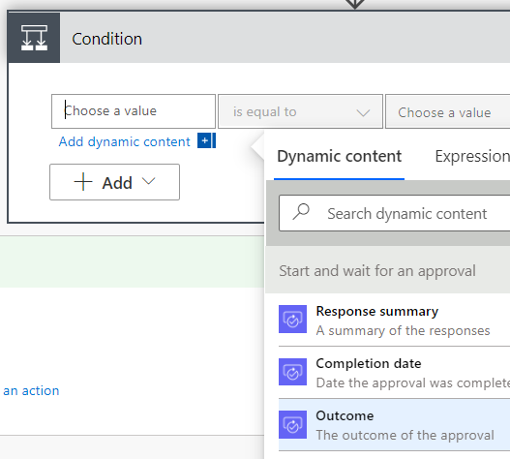

1. Set condition like below



1. Add new step “**Send an email (V2)**” action to condition’s “**If yes**” branch

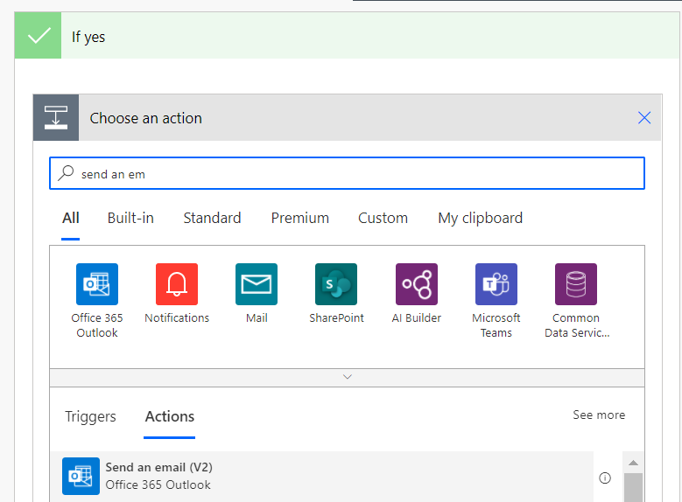

1. Add following text and dynamic content for action settings

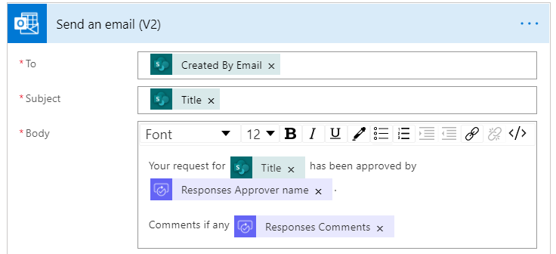

**Notice** that when you select “**Responses Approver Name**” from the dynamic content Flow will automatically add **Apply to each** step to your Flow because we are referencing collection type of parameters which will cause looping values of the collection even if there is just one item

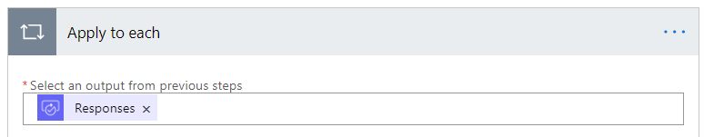

1. Click Send an email (V2) action’s three dots menu and click **Copy to my clipboard (preview)** option

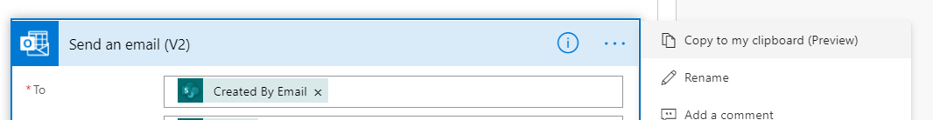

1. Add new step to “**If no**” branch, click **My Clipboard** and select copied **Send an email (V2)** action

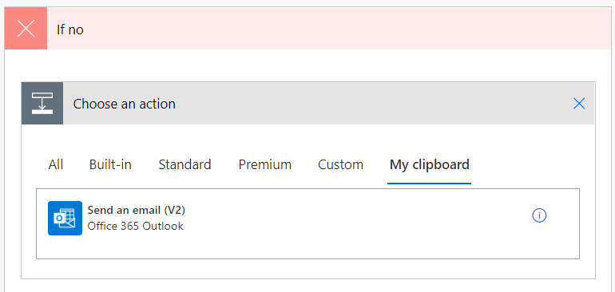

1. Change the email subject and body texts like below and **remove** wrong **responder/displayName** and **comments** dynamic content fields

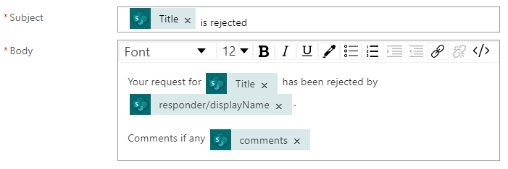

1. Add correct dynamic content fields **Responses Approver Name** and **Responses Comments**

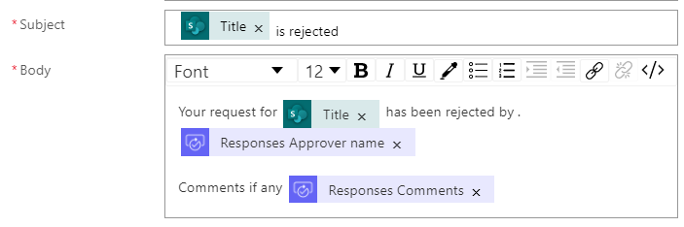

1. Flow should now look like below. Take a minute to review the logic of this Flow

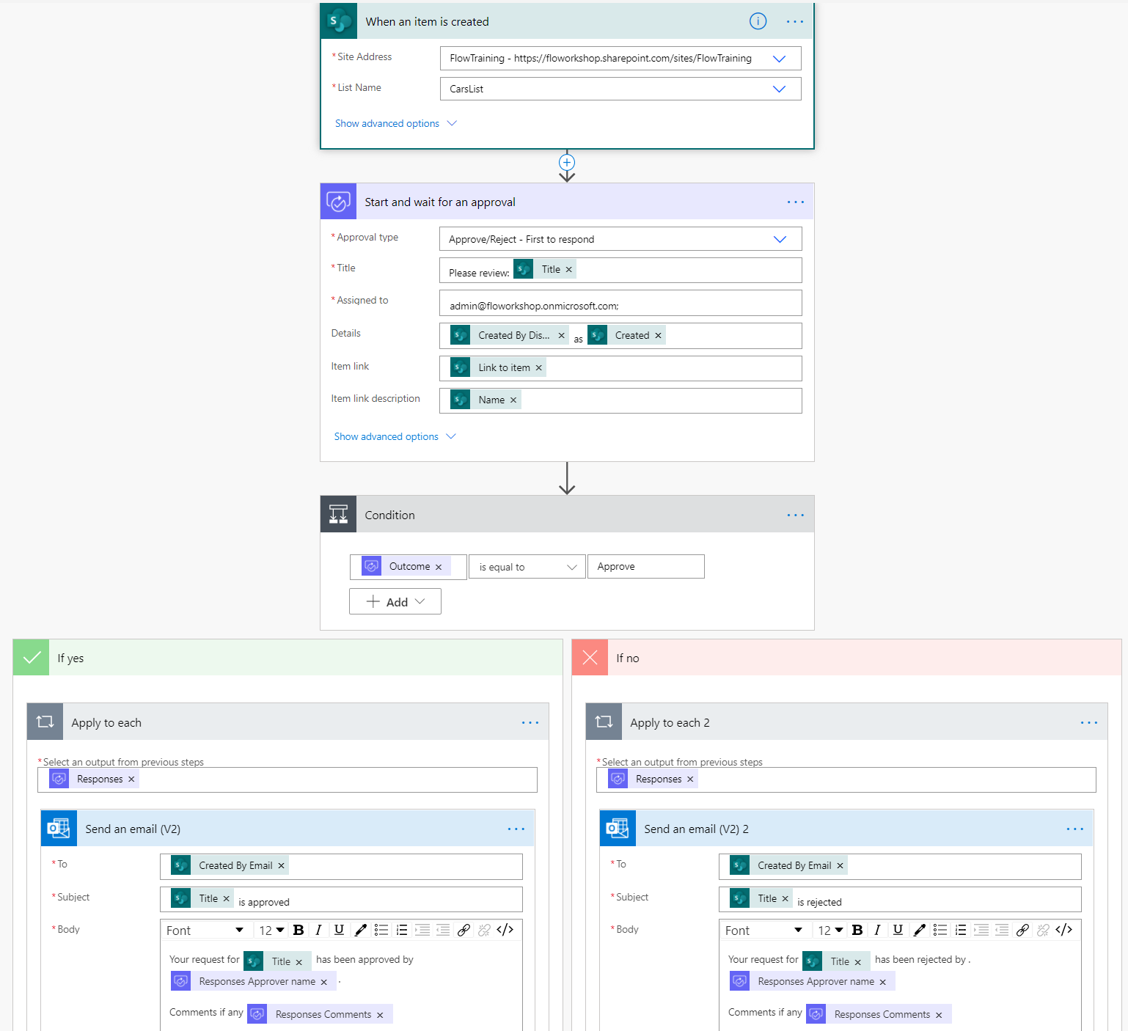

Now you are ready to test the Flow​

​

1. First click **Flow Checker** at top right to ensure no errors and all required fields have been filled out​

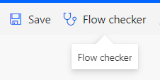

​

1. Click **Save**​

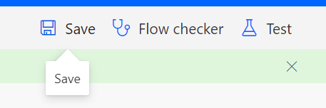

1. Click **Test** and select **Manually**

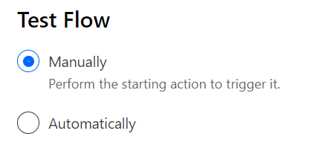

1. Go to **FlowTraining** SharePoint site https://**YOURTENANTNAME**[.sharepoint.com/sites/FlowTraining](https://smartk88.sharepoint.com/sites/FlowTraining)
2. Open CarsList and add new item to the list   ​

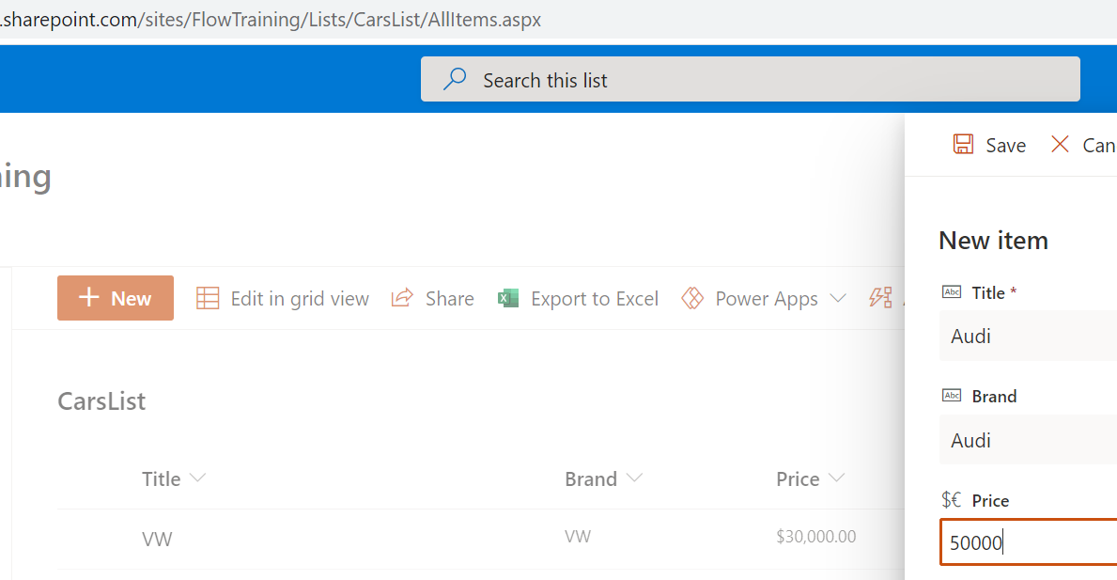

1. Come back to Flow and check that it is triggered. At this point you should be waiting for approval

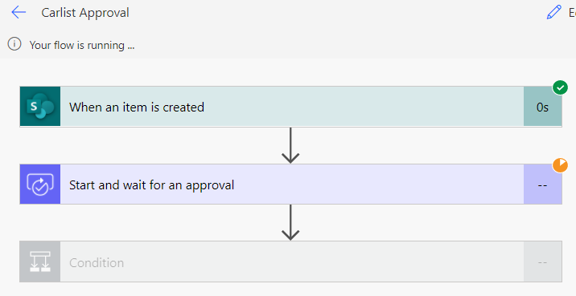

1. Open your mail at <https://outlook.office.com>in another tab of the browser and approve the new item in the list that you just created​

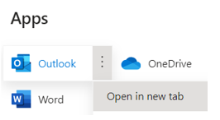

1. Approve the new item you just created to CarsList. Notice that there is also a link to SharePoint list item in the Approval email

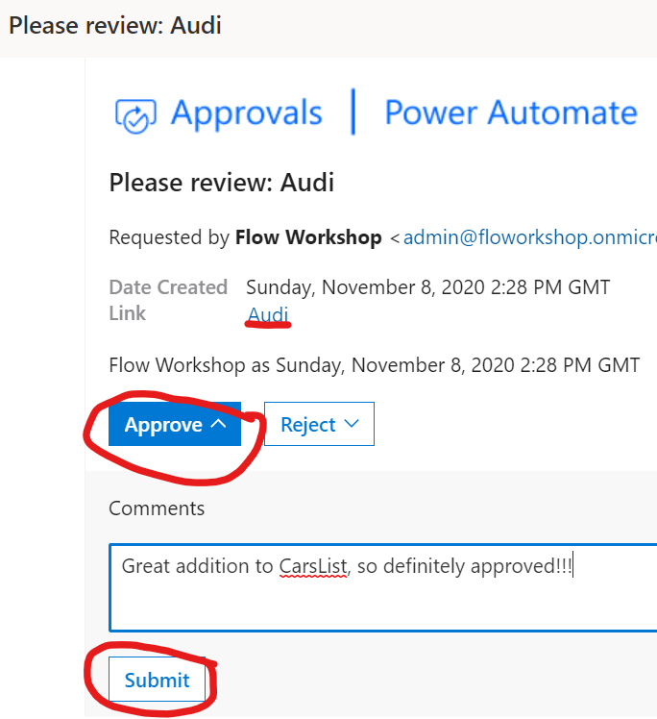

1. You should receive an email notifying you that the item has been approved

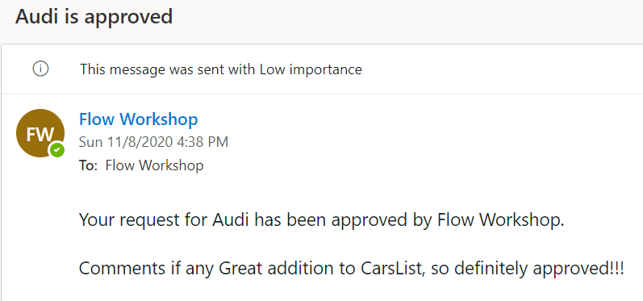

1. Go back to Flow and you should see that Flow was triggered successfully

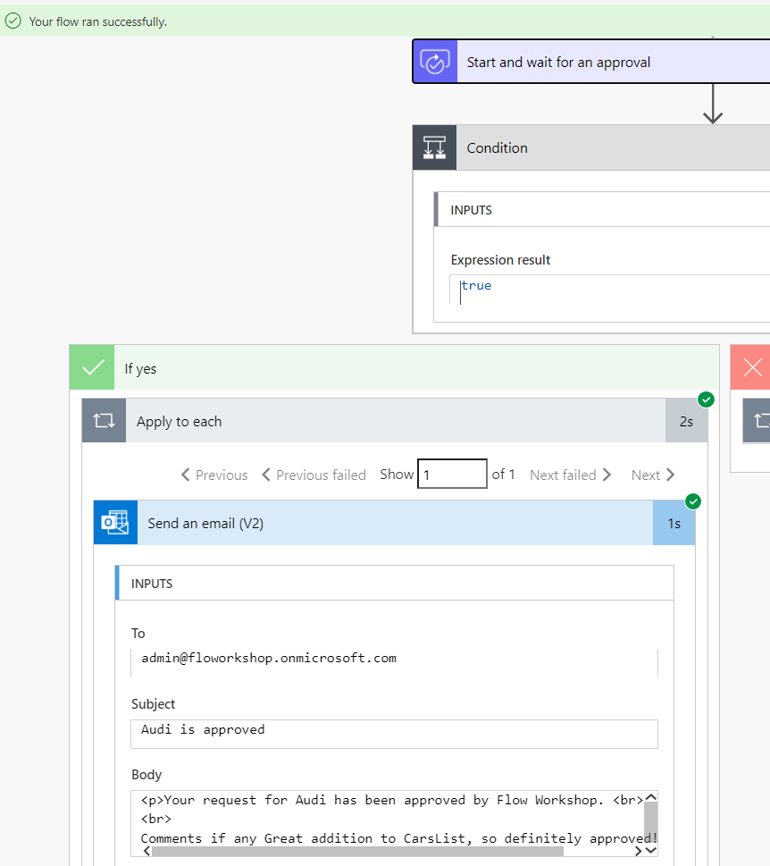

1. You can test the same by rejecting the approval and if you want test the approval in Flow **Action items**

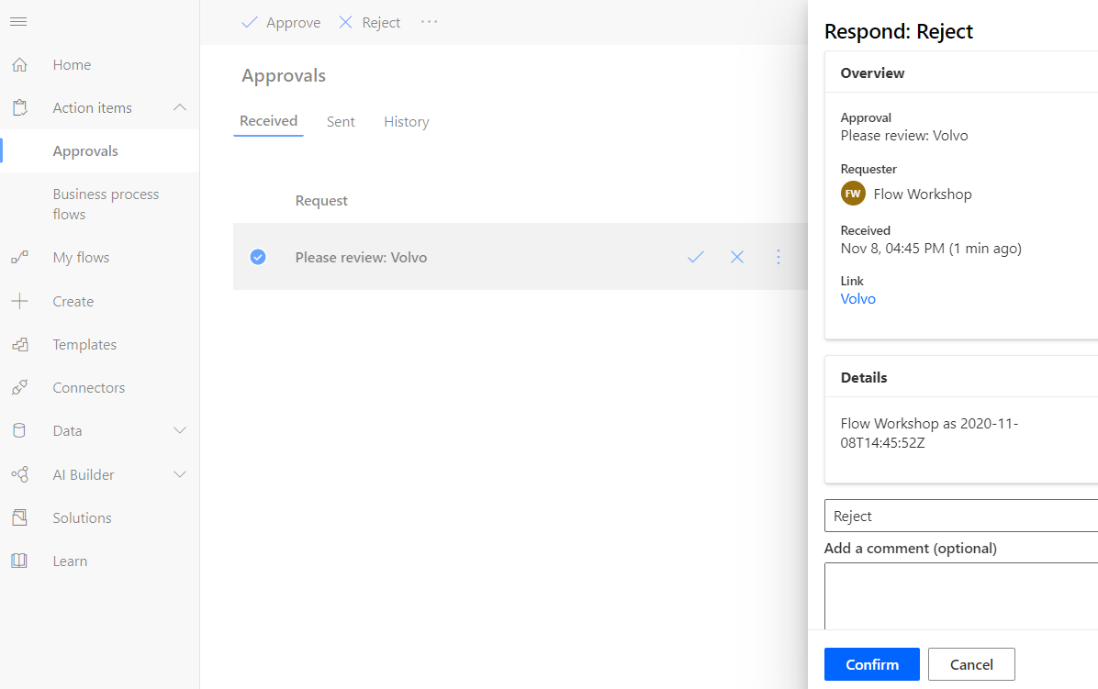

​

**Documentation** : <https://docs.microsoft.com/en-us/flow/modern-approvals>

# Use HTML option in mail actions (SharePoint)

1. Open <https://flow.microsoft.com> and login with your account
2. Click **My Flows**
3. Create new Flow using “**Automated cloud flow**” option



1. Name it “**HTML Email**“​, choose “**When an item is created**” (SharePoint) and click **Create**

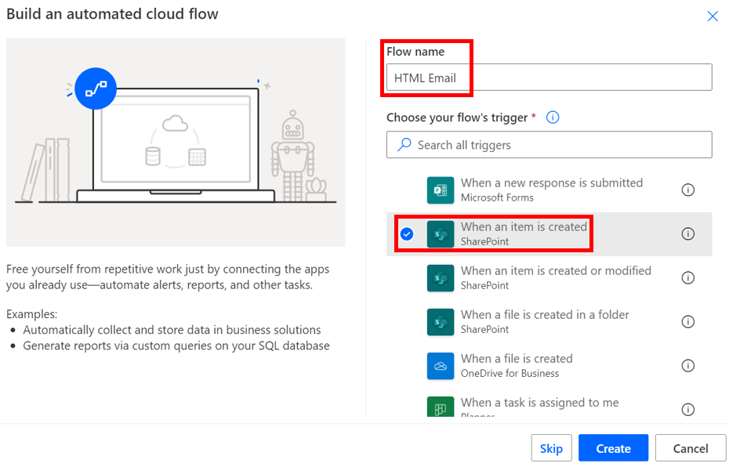

1. ​In Site Address, click on dropdown to select **FlowTraining** site and enter custom value **Documents** to List Name

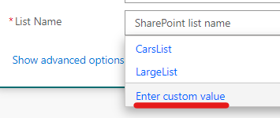

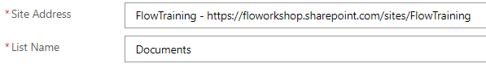

1. Add new step and select “Send an email (V2)” action

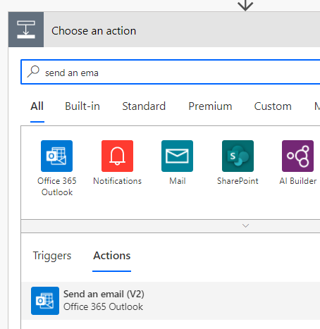

1. Configure **Send an email** action using following values
   * To: *Your O365 email address*
   * Subject: “**HTML email from SharePoint**”
   * Body -> open the code view by clicking “**</>**” button

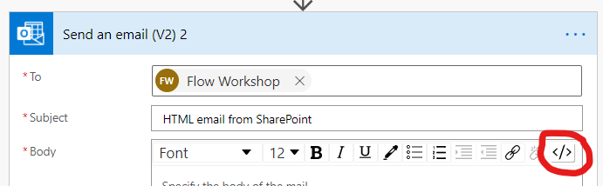

* + Add following HTML code snippet to body field and replace all red text with dynamic content values **Created By DisplayName** and **Link to item** like below:

**Dear [Created by DisplayName]</br>​**

**Here is the document you created:​</br>**

**Title: [Name]</br>**

**<a href="[Link to Item]" alt="[Name]"​>[Name]</a>​**

**</br></br>**

 ​ **Link to file: [Link to Item]**

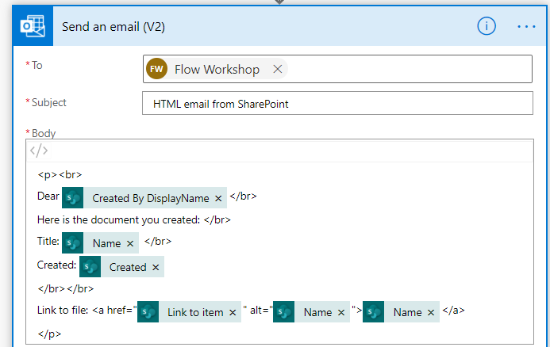

1. Save the flow



1. Test the flow by browsing to **Documents** library of your **FlowTraining** site
2. Create new file to document library

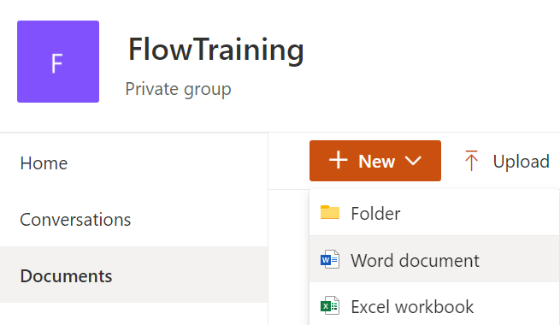

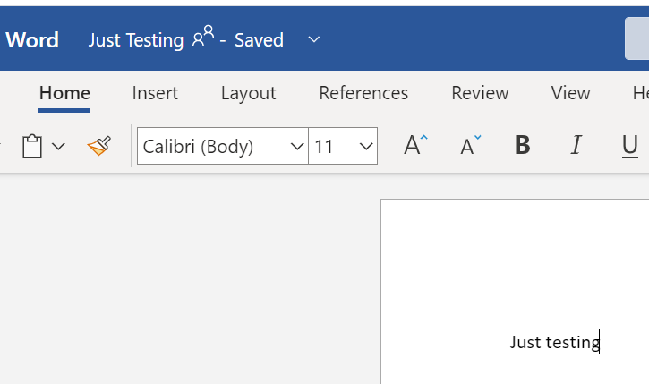

1. Open your O365 Outlook mail and in few seconds you should receive email from Flow

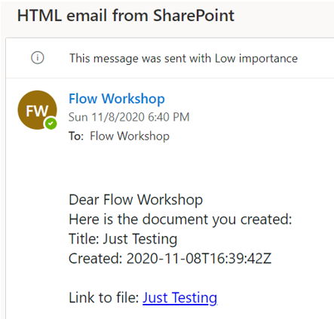

# Power Automate Approvals and Email with Options

​

1. Open <https://flow.microsoft.com> and login with your account
2. Click **My Flows**
3. Create new Flow using “**Instant cloud flow**” option

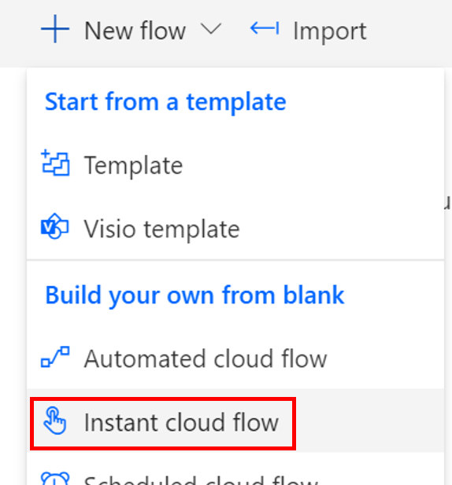

1. Name it “**Approval**“​ and choose “**Manually trigger a flow**”

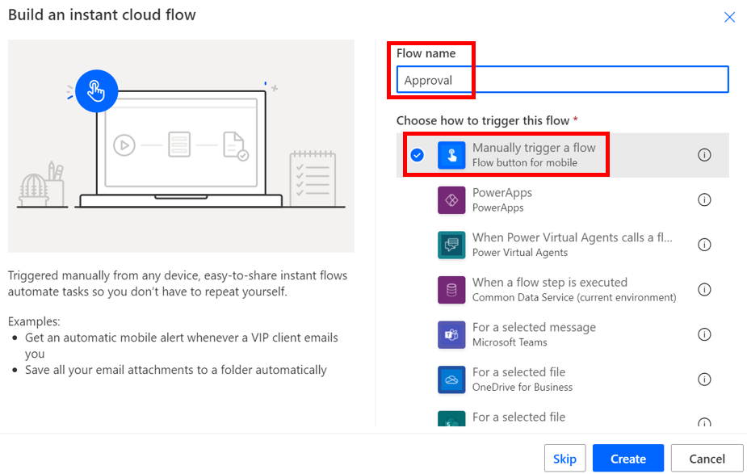

1. Create new Step – "​**Start and wait for an approval**"​
   * Approval type: **Approve/Reject – First to respond**
   * Title: **Approval**
   * Assigned To: *Your O365 account email address*
   * Details:​ **# This is a H1 header  -  Please Approve​**

**## This is a H2 header​**

**​**

**- Item 1​**

**- Item 2​**

**- Item 3​**

**Link: [Microsoft Flow](https://flow.microsoft.com)​**

* + Item link: [https://](https://yourtenantname.sharepoint.com/sites/FlowTraining/Shared%20Documents/DeptHome.jpg)**YOURTENANTNAME**[.sharepoint.com/sites/FlowTraining/Shared%20Documents/DeptHome.jpg](https://yourtenantname.sharepoint.com/sites/FlowTraining/Shared%20Documents/DeptHome.jpg)
  + Item link description: **Picture of a house**

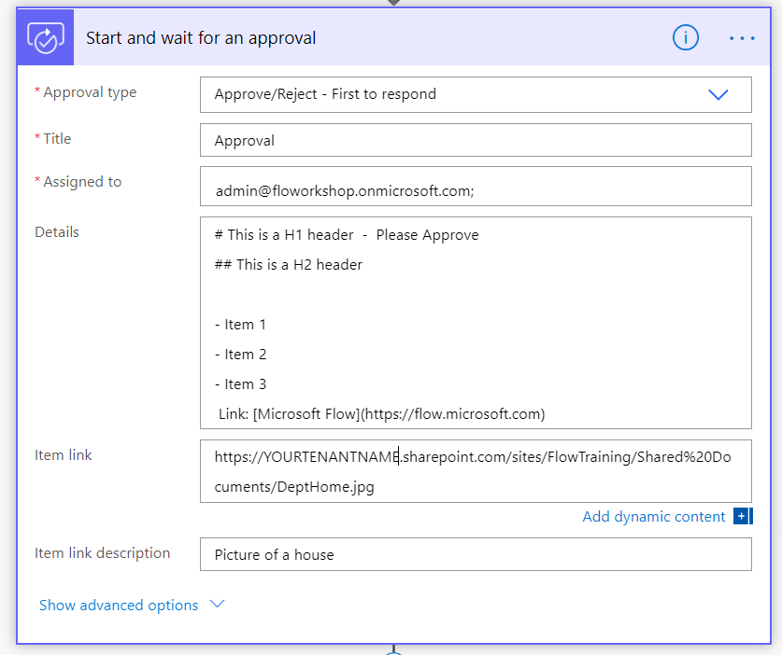

1. Click **Save**​



1. Click **Test** and select **Manually**



1. Open Outlook or Flow Approvals to see and approve/reject the request. Also test links in the approval message

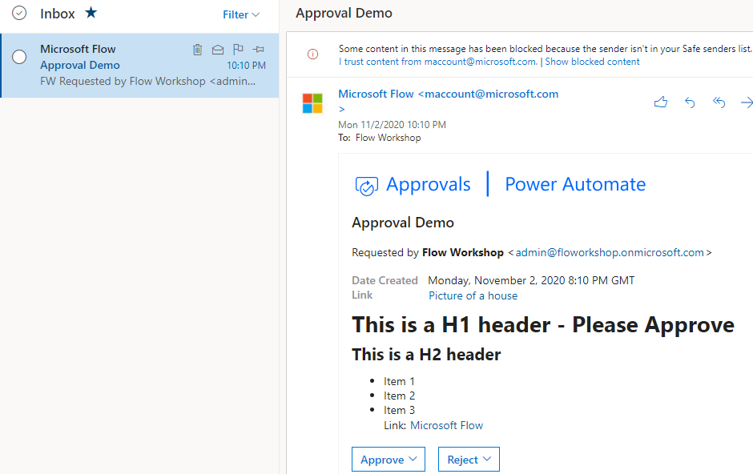

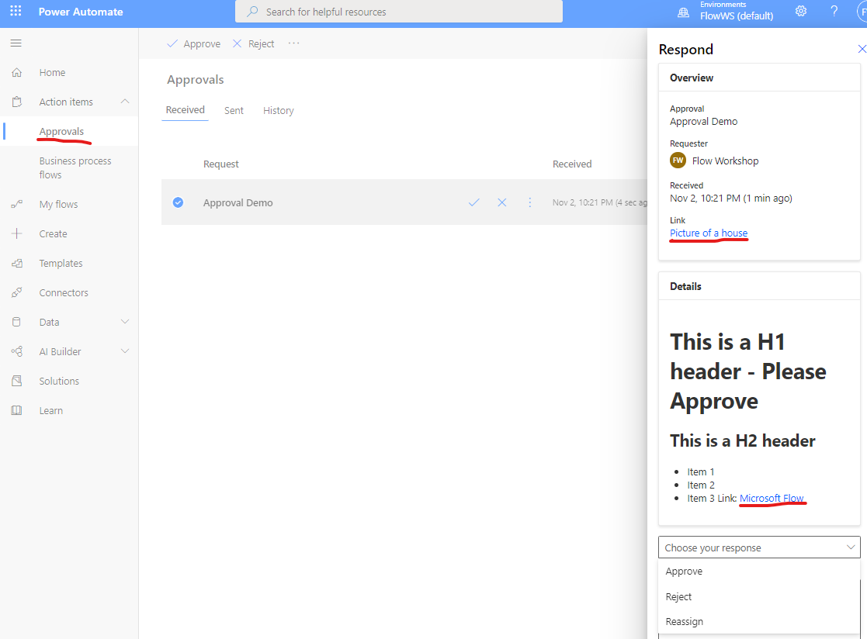

1. Add new action "**Send email with options**"​

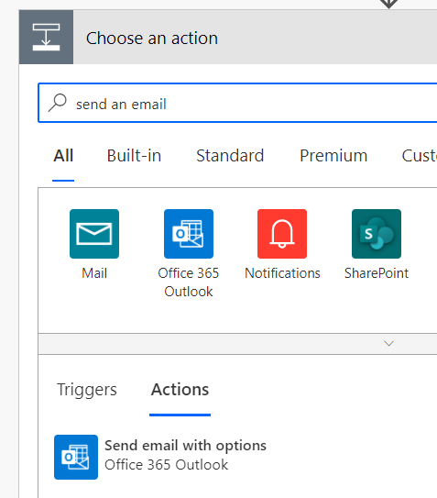

1. Configure action with following parameters
   * To: *Your O365 account email address* ​
   * Subject: **Approval 2**
   * User Options: **Approve, Reject**
   * Body:​

​

**<h1>This is H1 header</h1></br>​**

**<h2>This is H2 header</h2></br>​**

**</br>​**

**Body text​**

**</br>​**

**link : <a href='https://flow.microsoft.com'>Microsoft Flow</a>​**

**</br>​**

**Resize Picture: ​**

**</br>​**

**<img src="https://YOURTENANTNAME.sharepoint.com/sites/FlowTraining/Shared%20Documents/DeptHome.jpg" alt="Hoverover text" style="width:200px;height:120px;"></br>​**

* Use only HTML message: **Yes**

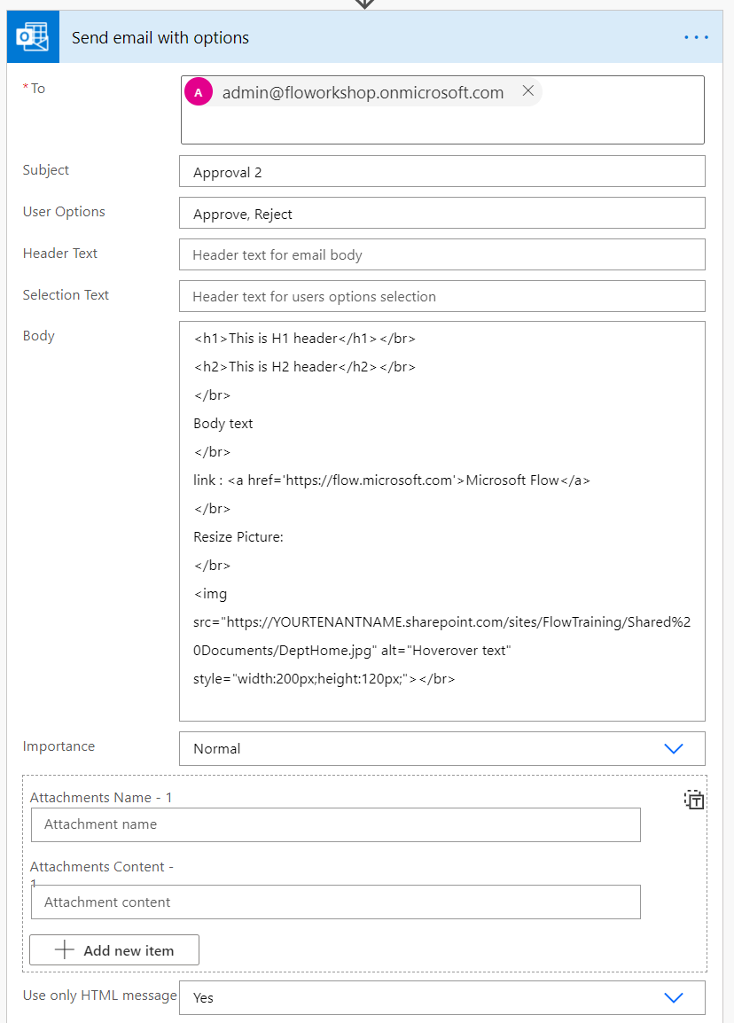

1. Click **Save**​



1. Click **Test** and select **Manually**



1. Approve / Reject the Approval task and select either Approve or Reject in email send by **Send an email with options** action
2. See the value of **SelectedOption** which should be the choice you selected

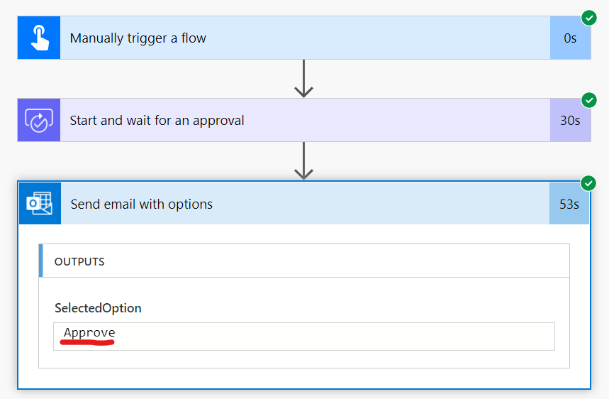

**Documentation :** <https://docs.microsoft.com/en-us/flow/approvals-markdown-support>​