**WorkshopPLUS – Power Automate – Power User 1 Day**

Module 3 - Labs

Follow along steps

Contents

1. Flow and SharePoint Integration 3

2. Working with SharePoint lists 7

3. Query SharePoint lists and libraries 10

4. Copy files 12

5. Use variables (flow internal variables) 16

6. Data operations 19

# Working with SharePoint lists

1. Create new Flow using “**Instant cloud flow**” option

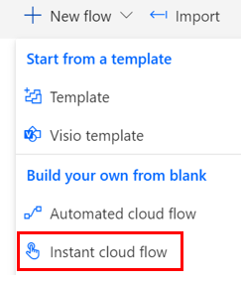

1. Name it “**List Items**“​ and choose “**Manually trigger a flow**”

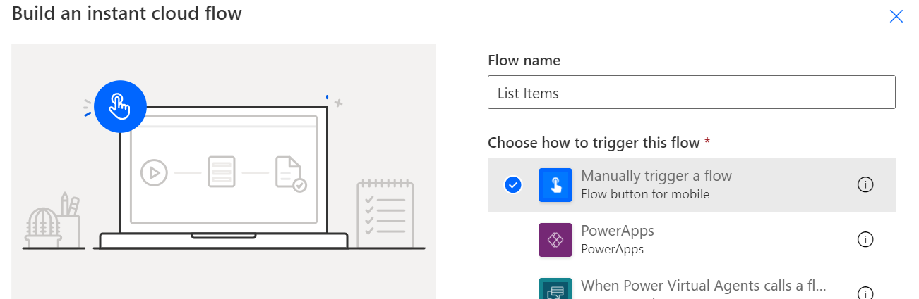

1. Add action “**Get items**” (SharePoint)
   * Site Address: **FlowTraining**
   * List Name: **LargeList**
   * Limit Entries to Folder: **/** (without this ‘query limitation’ you will receive warning in Flow Checker)

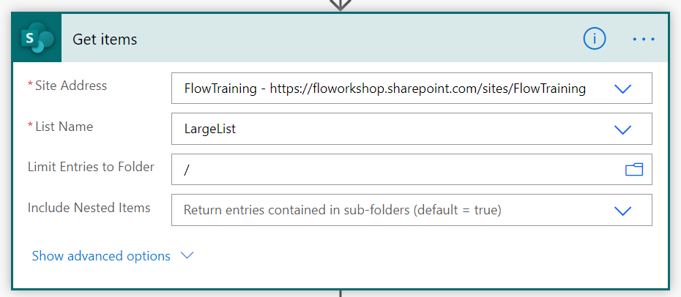

1. Add **Compose** action with expression “**length(body('Get_items')?['value'])”**

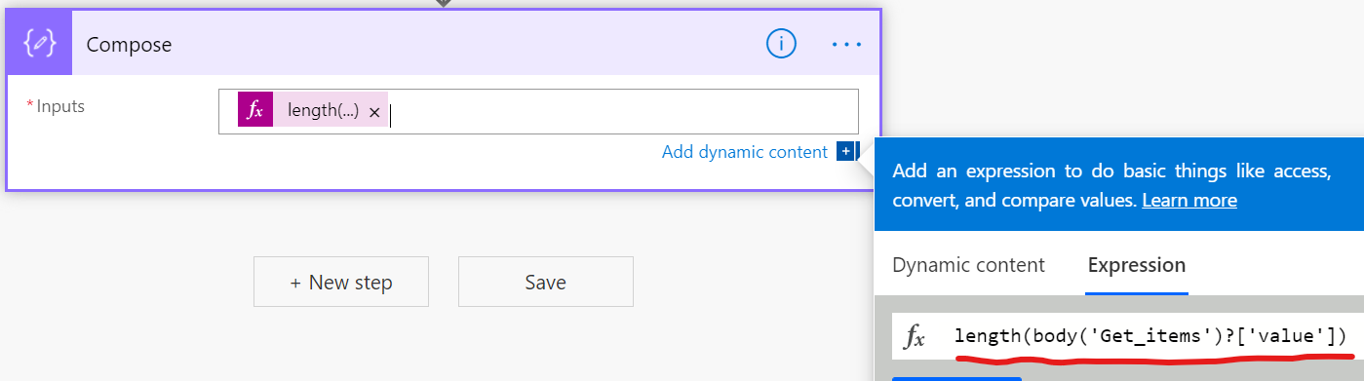

1. Click **Save**​

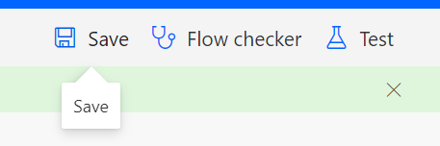

1. Click **Test** and select **Manually**

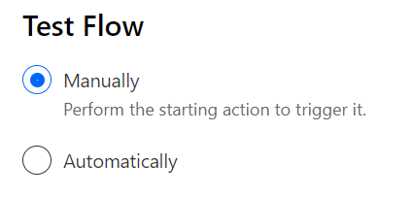

1. Check the value of the Compose action which should be **100** even that list contains thousands of items. Get items action returns only 100 items by default but that can be changed in by setting “Top Count” value which can be maximum **5000** (SharePoint list view threshold)

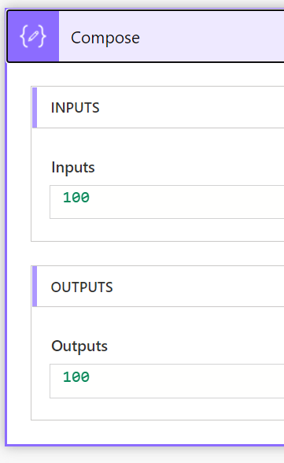 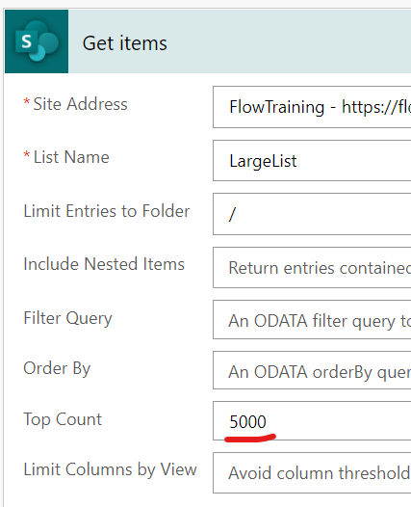

1. Test with Top Count 5000 and 5001 and see what happens

# Query SharePoint lists and libraries

1. Create new Flow using “**Instant cloud flow**” option



1. Name it “**SharePoint List Query**“​ and choose “**Manually trigger a flow**”

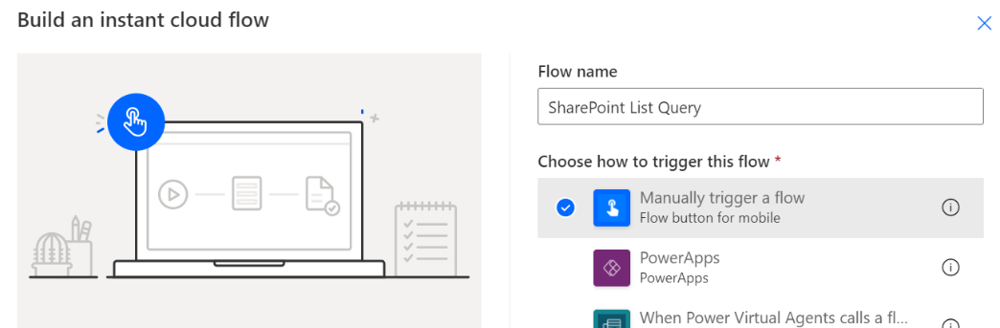

1. Create new Step - "**Get items​**" (SharePoint)
   * Site Address: **FlowTraining**​
   * List Name: **CarsList**
   * Filter query: **Brand eq** "**VW**"

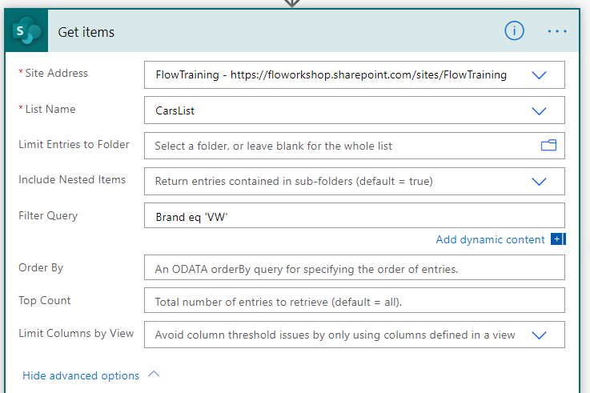

1. Click **Save**​

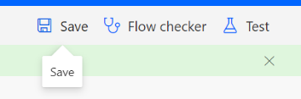

1. Click **Test** and select **Manually**



1. Flow run should fail. Why? … because we used double quotes in filter and correct way is to use single quotes

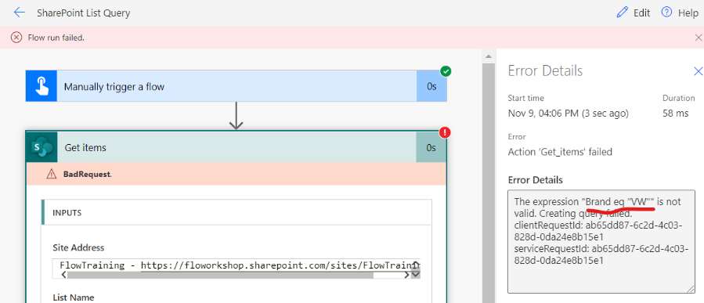

1. Fix the query like this **Brand eq ‘VW’** and test again  
   Also remember that the field name is case sensitive !!!

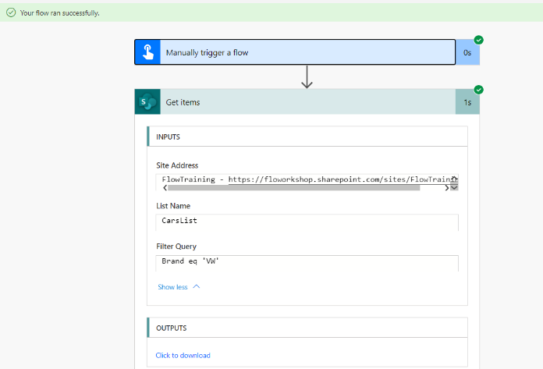

**Documentation:**<https://docs.microsoft.com/en-us/sharepoint/dev/sp-add-ins/use-odata-query-operations-in-sharepoint-rest-requests>

# Copy files

1. Create new Flow using “**Instant cloud flow**” option



1. Name it “**Copy files**“​ and choose “**Manually trigger a flow**”

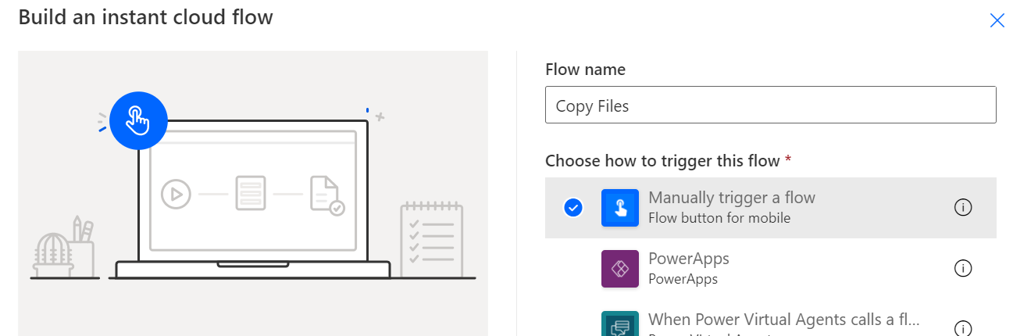

1. Create new Step - "**Get files (properties only)​**" (SharePoint)
   * Site Address: **FlowTraining**​
   * Library Name: **Documents**
   * Limit Entries to Folder: **/**
   * Include Nested Items: **No**

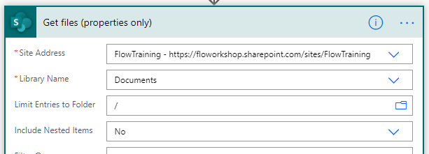

1. Create new step **Condition** and set condition to **IsFolder** “is equal to” **false** (Boolean value in this case **false** need to be all **lowercase**!)

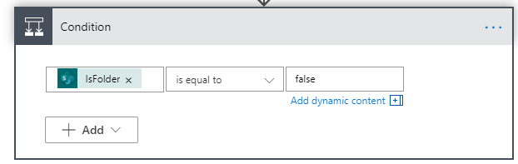

**Notice** that **Apply to each** loop will be automatically added as we are working with collection of files and there could be more than 1 file to copy

1. Create new Step - "**Copy file**" to “**If yes**” branch
   * Site Address: **FlowTraining**​
   * File to Copy: **[Identifier]** (Dynamic content)
   * Destination Site Address: **FlowTraining**
   * Destination Folder: **/copydocuments**
   * If another file is already there: **Replace**

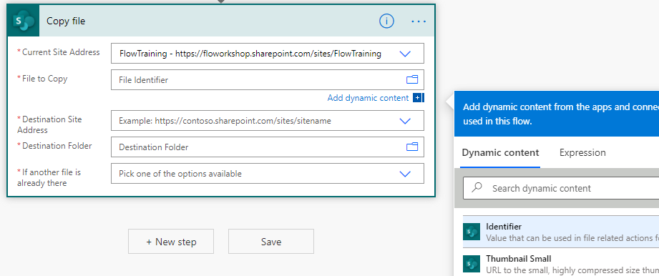

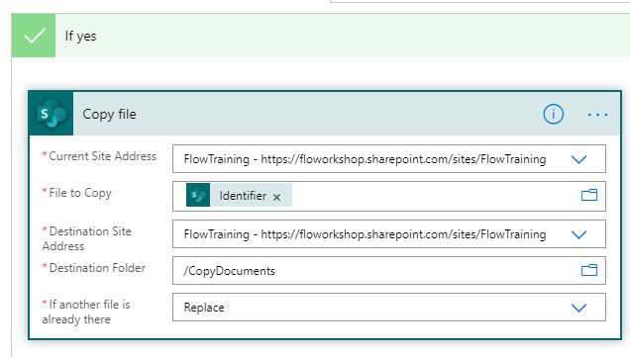

1. After you have configured previous step the Flow should look like below

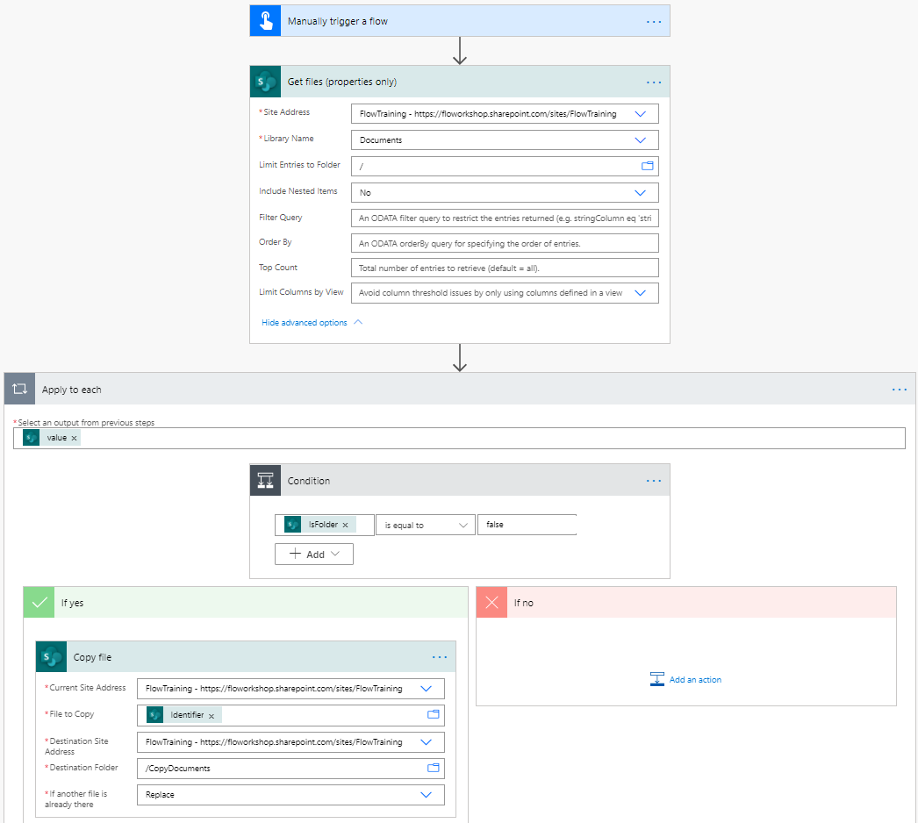

1. Save and test the flow



1. Go to **CopyDocuments** library in **FlowTraining** SharePoint site and verify that all documents in root of the Documents library are copied

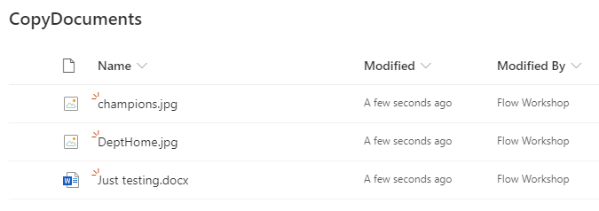

# Use variables (flow internal variables)

1. Create new Flow using “**Instant cloud flow**” option



1. Name it “**Use variables**“​ and choose “**Manually trigger a flow**”

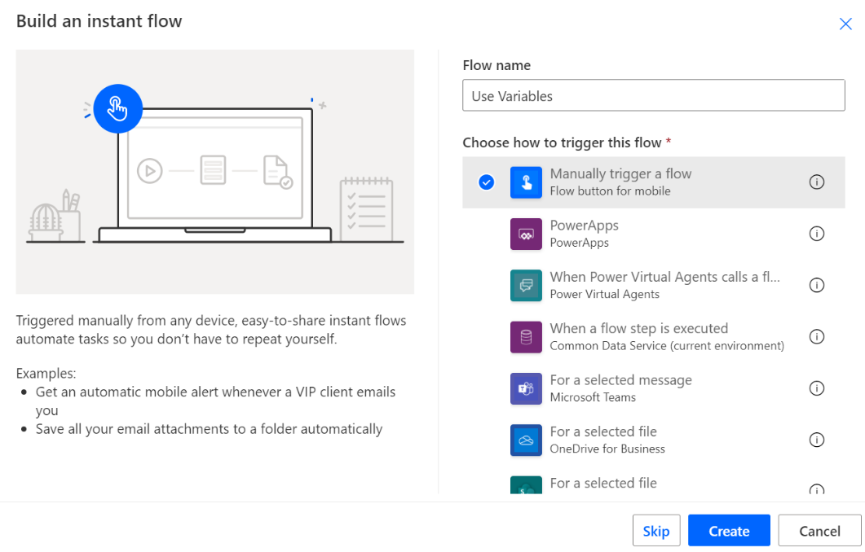

1. Add new step “**Initialize variable**”
   * Name: **Cars**
   * Type: **Array**​

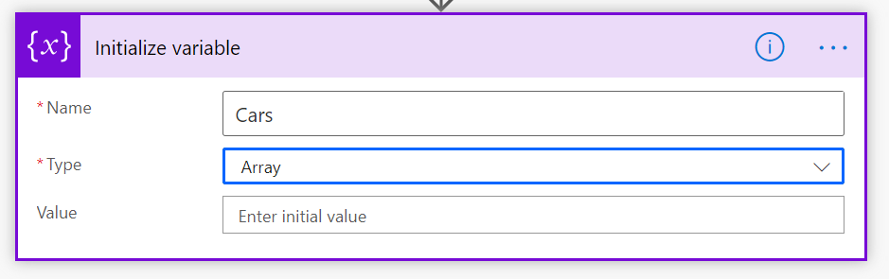

1. Create new Step - "**Get items​**" (SharePoint)
   * Site Address: **FlowTraining**​
   * Library Name: **CarsList**
   * Limit Entries to Folder: **/**

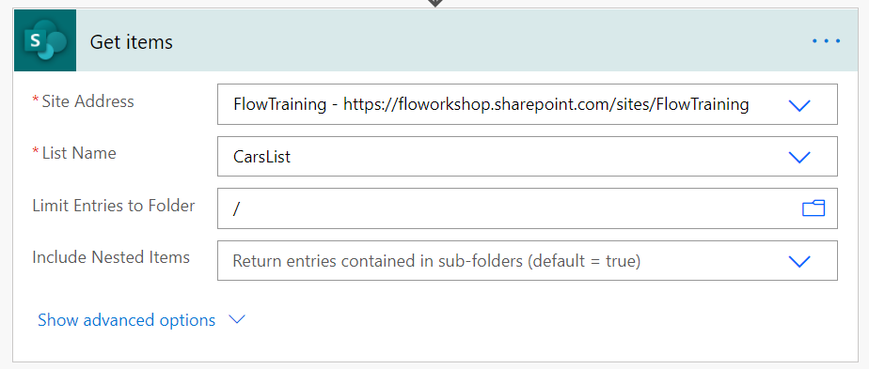

1. Add new step “**Append to array variable**”
   * Name: **Cars**
   * Value: **[Title]** (Dynamic content “Title” from previous step)
   * **Notice** that Apply to each is automatically added when you select Title dynamic content from previous step

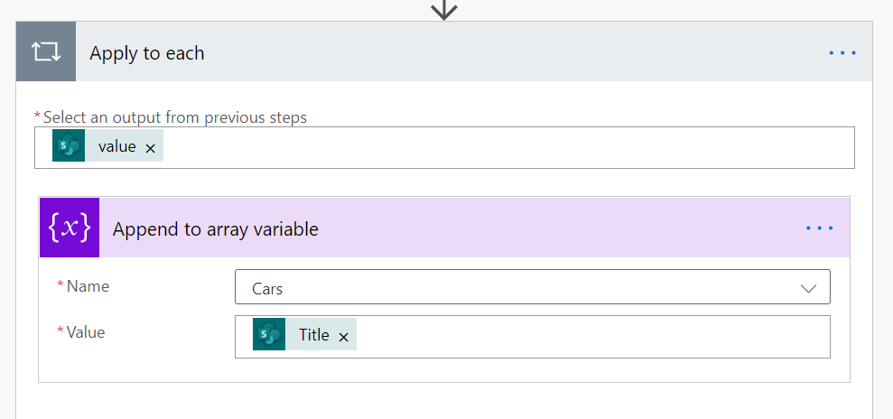

1. Add new step “**Send an email (V2)**” after the Apply to each
   * To: *Your O365 account email address*
   * Subject: **Cars List**
   * Body: **variables(‘Cars’)**

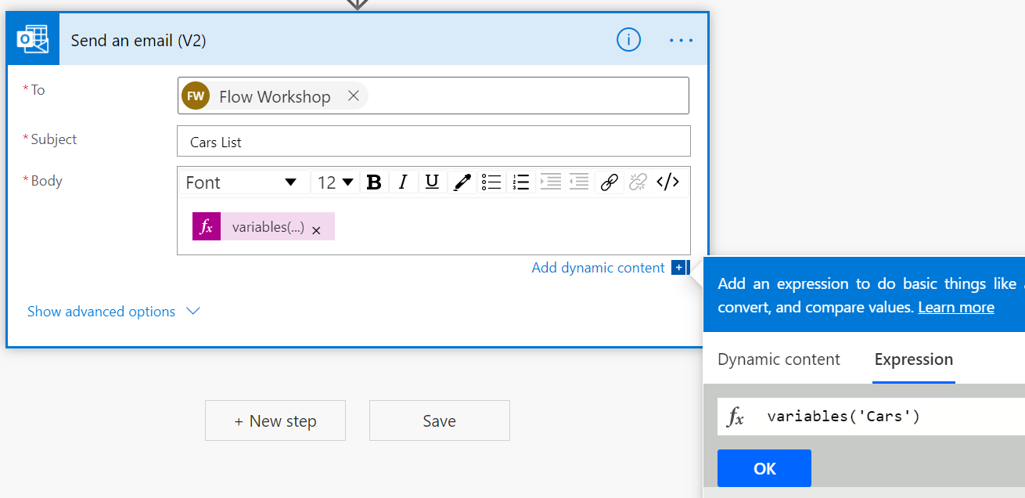

1. Save and test the Flow



1. Open <https://outlook.office.com> and you should see email sent by your Flow including list of all cars (title) in **CarsList**

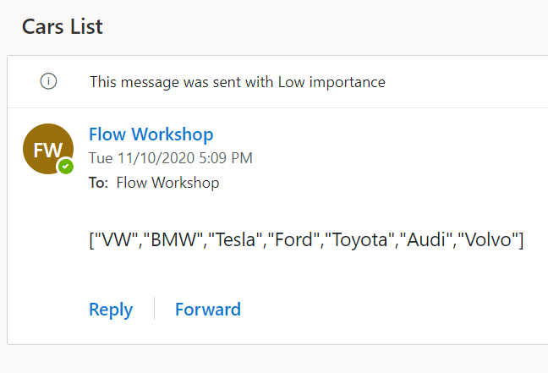

# Data operations

​

1. Create new Flow using “**Instant cloud flow**” option



1. Name it “**Data operations**“​ and choose “**Manually trigger a flow**”

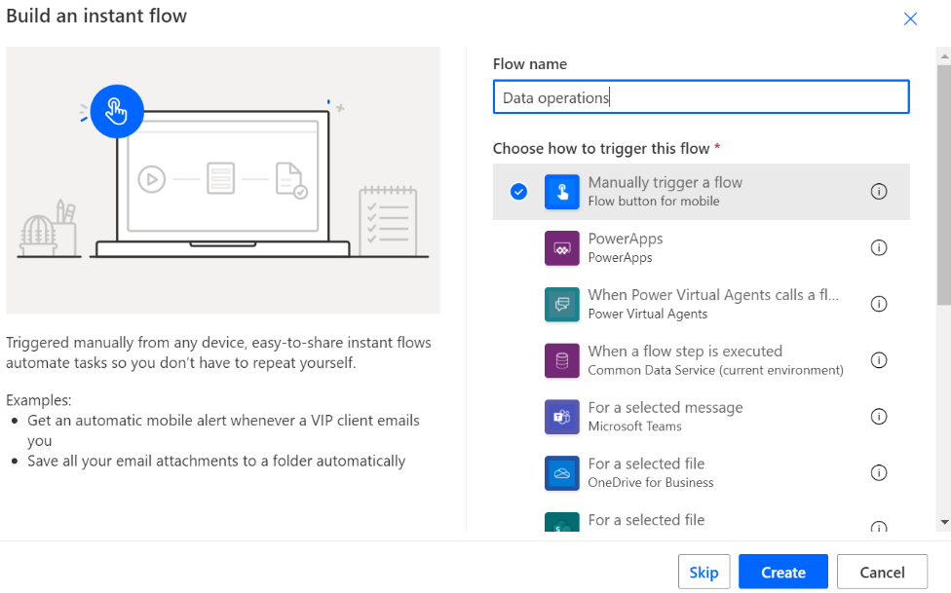

1. Create new Step - "**Get Items (SharePoint)​”**
   * Site Address: **FlowTraining**​
   * List Name: **CarsList**
   * Limit Entries to Folder: **/**

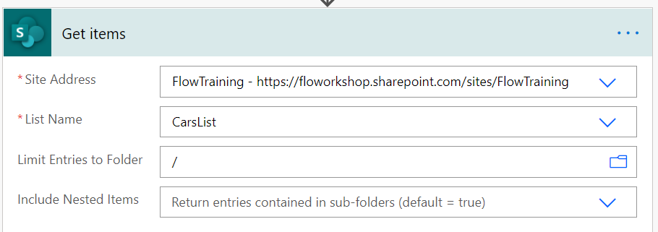

1. Create a new step – “**Parse JSON (Data Operations)**”
   * Select **Body** dynamic property from previous action
   * Paste following schema to **Schema** field

{

    "type": "object",

    "properties": {

        "value": {

            "type": "array",

            "items": {

                "type": "object",

                "properties": {

                    "Brand": {

                        "type": "string"

                    },

                    "Price": {

                        "type": "integer"

                    }

                }

            }

        }

    }

}

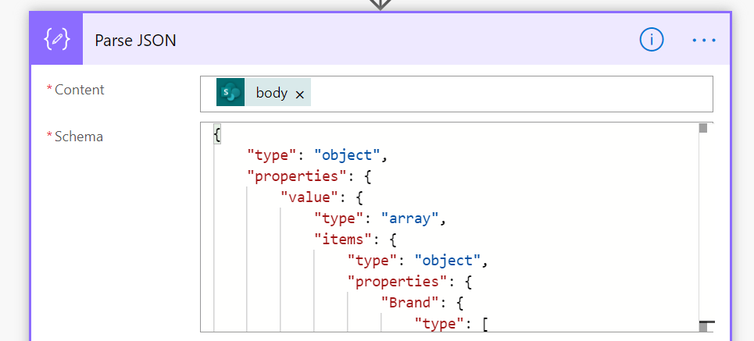

1. Create a new step – “**Create CSV table (Data Operations)**”
   * In **From** add dynamic content – **value** from “**Parse JSON**”

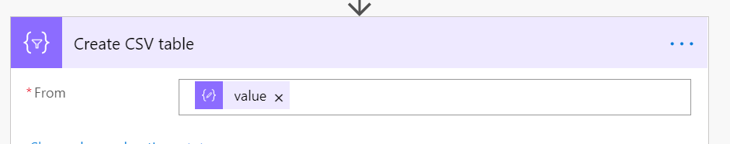

1. Create a new step – “**Select (Data Operations)**”​
   * In **From** add dynamic content – **value** from “**Parse JSON**”​
   * Add e new key **Brand** and in value, add dynamic content – **Brand** from “**Parse JSON**”**​**
   * Add e new key **Name** and in value, add dynamic content – **Title** from “**Parse JSON**”

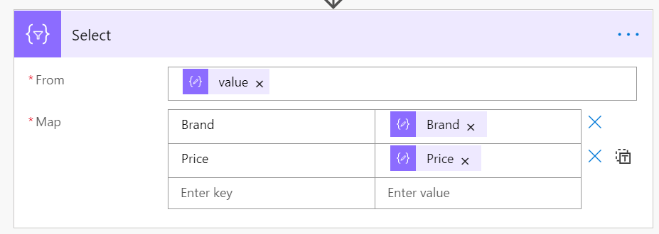

1. Create a new step – “**Create HTML table (Data Operations)**”​
   * In **From** add dynamic content – **Output** from **Select**​

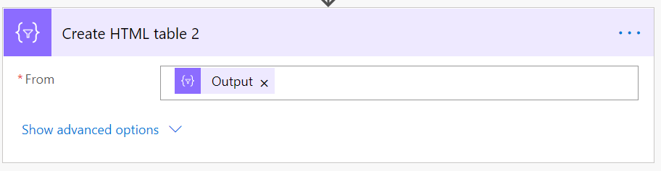

1. Create a new step – “**Filter (Data Operations)**”​
   * In **From** add Dynamic content – **Output** from **Select**
   * In “**Choose value**” add expression – “**item()?['Brand']”**
   * Select “**is equal to**”​ and add **VW** to value​

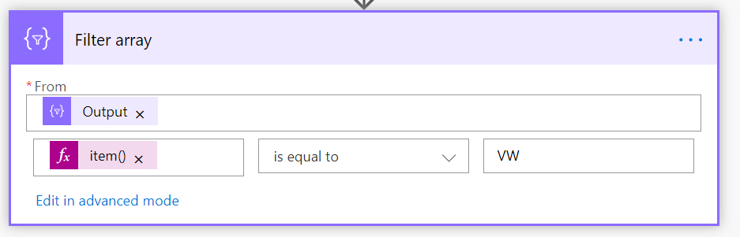

1. Save and test the Flow​



# Flow and SharePoint Integration

1. Open **FlowTraining** site and login with your account

[**https://YOURTENANTNAME.sharepoint.com/sites/FlowTraining**](https://YOURTENANTNAME.sharepoint.com/sites/FlowTraining)

1. Create Team for the site by clicking “**Create a Team**” on bottom left corner if not already created

1. Go to Site Content and click **CarsList**
2. Create new Flow by clicking Automate > Power Automate > **Create a flow**

1. Select “**Post a message to Microsoft Teams for selected item**” from template selection panel

1. Press Continue to confirm required SharePoint and Teams connections

1. Trigger of the Flow will be SharePoint “**For a selected item**” and you can see that **Site address** and **List name** parameters are already populated automatically

1. ​For a “**Post message**” action set
   * Team: **FlowTraining**
   * Channel: **General**

1. Save the Flow and move back to SharePoint **CarsList**
2. Select 1 item and open **Automate** menu where you now should have the Flow you just created available to be executed

1. Click the “**Post a message to Microsoft Teams for selected item**” you will see the Flow launch panel on the right side of the page. On first run you will see the list of connections the Flow has and sign-in status for each of them. Click **Continue**

1. Provide a message which you want to post to a selected Teams channel and press **Run flow**

1. Open <https://teams.microsoft.com> on browser and go to that Teams channel to verify that your message is posted

1. Click the name of the car brand you selected to see that you are directed to that item in SharePoint list

