**WorkshopPLUS – Power Automate – Power User 1 Day**

Module 4 - Labs

Follow along steps

Contents

1. Start a flow in when a Form is submitted 3

2. Start a flow in PowerApps 8

3. Error handling 14

# Start a flow in when a Form is submitted

1. Go to <https://forms.office.com> and create a new Form called **FlowTraining**

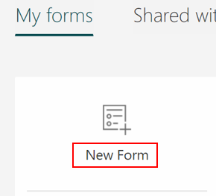

1. Name the form “**Flow Training**” and add 1 **Choice** question and **File upload** like below. **Note** that the form is automatically saved



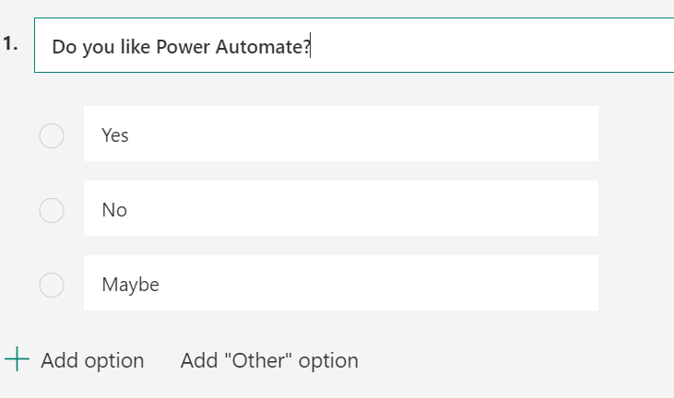

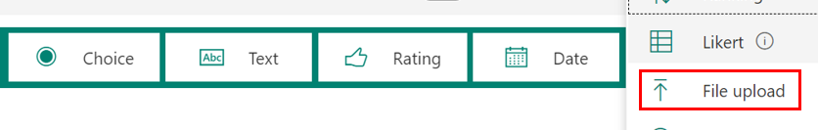

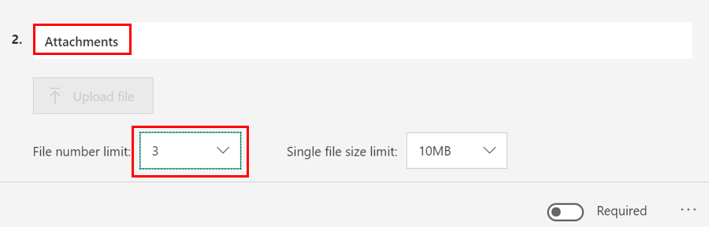

1. Go to <https://flow.microsoft.com> and create new Flow using “**Automated cloud flow**”

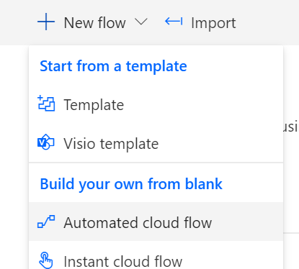

1. Name it “**Start Flow when Form is submitted**“​ and choose “**When a new response is submitted**” (Microsoft Forms)

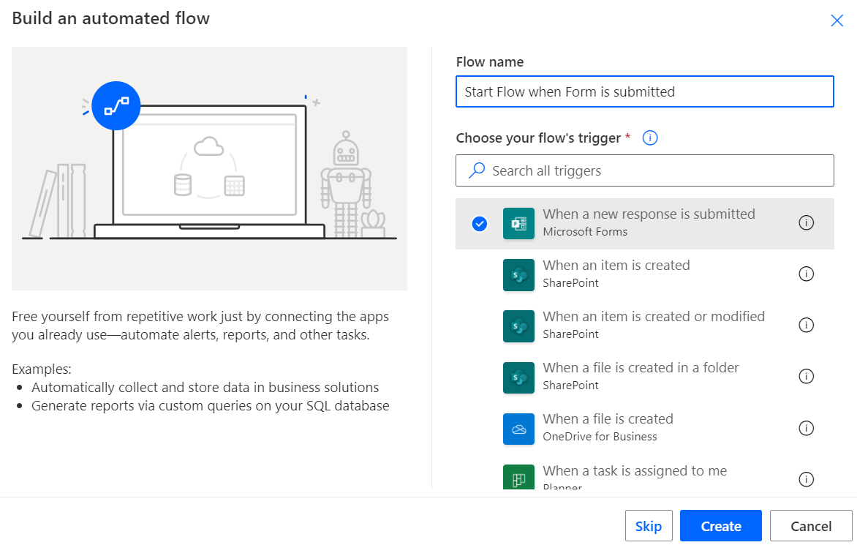

1. Set Flow Id to “**Flow Training**” to trigger

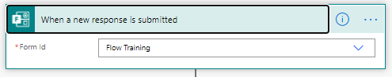

1. Create new step “**Get response details**”
   * Form Id: **Flow Training**​
   * Response Id: [**Response Id]** (dynamic content from trigger)

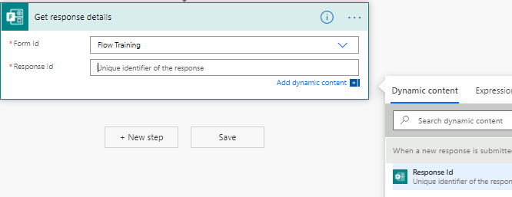

1. Create new step “**Create item**” (SharePoint)
   * Site Address: **FlowTraining**
   * List Name: “**Forms Responses**”
   * Title: **[Responders’ Email]** (dynamic content from Get response detail)
   * Question: **[Do you like Power Automate?]** (dynamic content from Get response detail)
   * Submissions Time: **[Submission time]** (dynamic content from Get response detail)

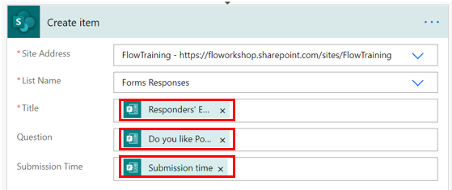

1. Create new step “**Parse JSON**”
   * Content: [Attachments] (dynamic content from Get response details)
   * Schema: **{**

**"type": "array",**

**"items": {**

**"type": "object",**

**"properties": {**

**"name": {**

**"type": "string"**

**},**

**"link": {**

**"type": "string"**

**},**

**"id": {**

**"type": "string"**

**}**

**}**

**}**

**}**

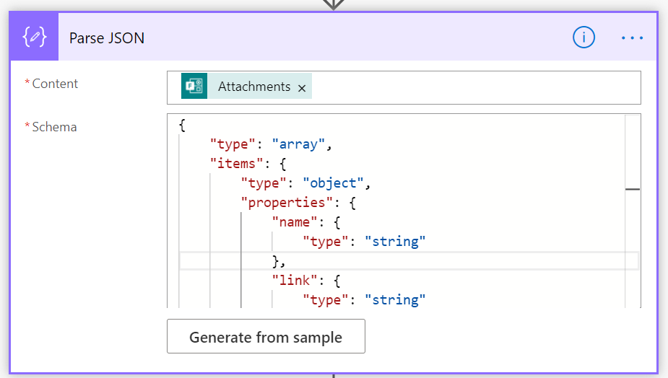

1. Create new step “**Get file content**” (OneDrive for Business)
   * Id: **[Id]** (dynamic property from Parse JSON)

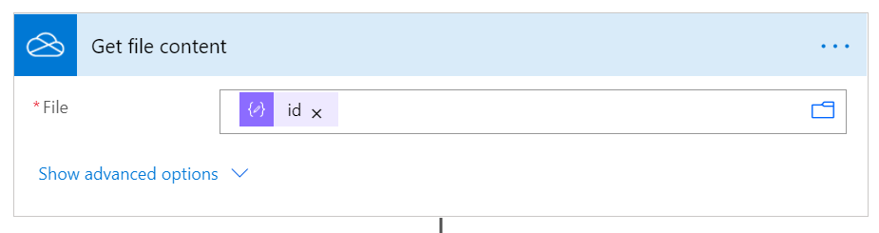

**NOTE**, **Apply to each** step is automatically added after this as Parse JSON output is an array of files

1. Add new action “**Add attachment**” (SharePoint) after “Get file content” action inside “Apply to each” loop
   * Site Address: **FlowTraining**
   * List Name: “**Forms Responses**”
   * Id: **[Id]** (dynamic content from Create item)
   * File Name: **[name]** (dynamic content from Parse JSON)
   * File Content: **[File content]** (dynamic content from Get file content)

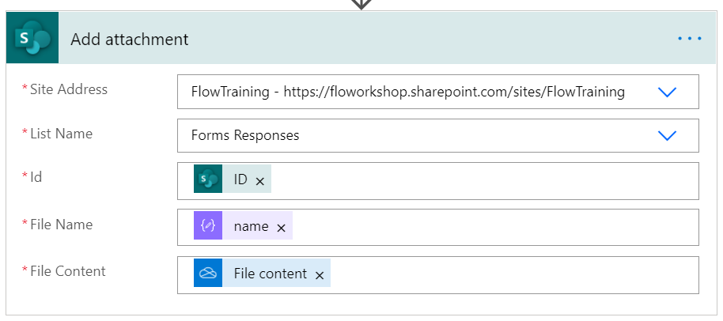

1. Save the flow and go back to Flow Training form
2. Open form in Preview and submit few answers with file uploads

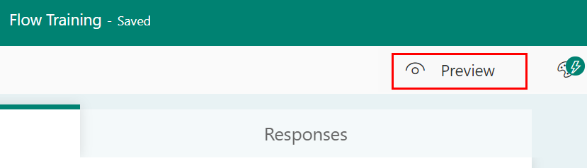

As configured you can attach max 3 files and following file types

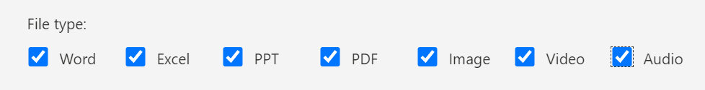

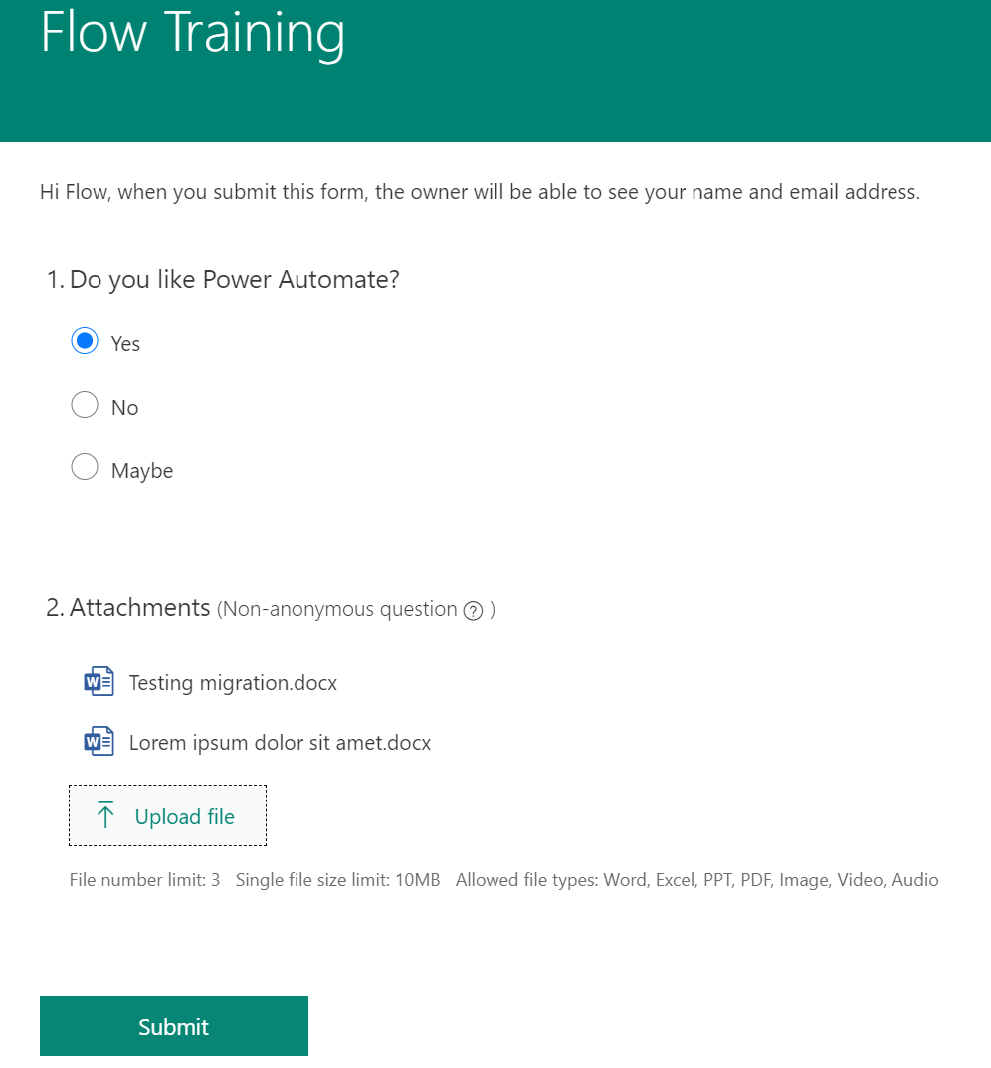

1. Open **Forms Responses** list in **FlowTraining** site and you should see information about submitted Form including attachments

<https://YOURTENANTNAME.sharepoint.com/sites/FlowTraining/Lists/Forms%20Responses>

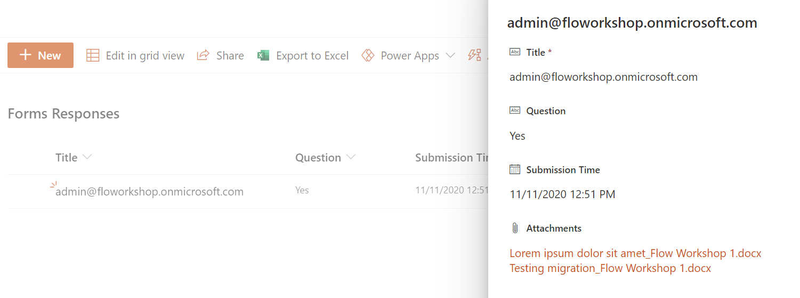

# Start a flow in PowerApps

1. Create new Flow using “**Instant cloud flow**” option

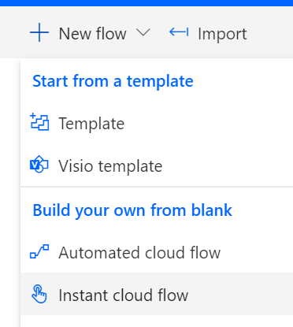

1. Name it “**PowerApp Car Rating**“​ and choose “**PowerApps**”

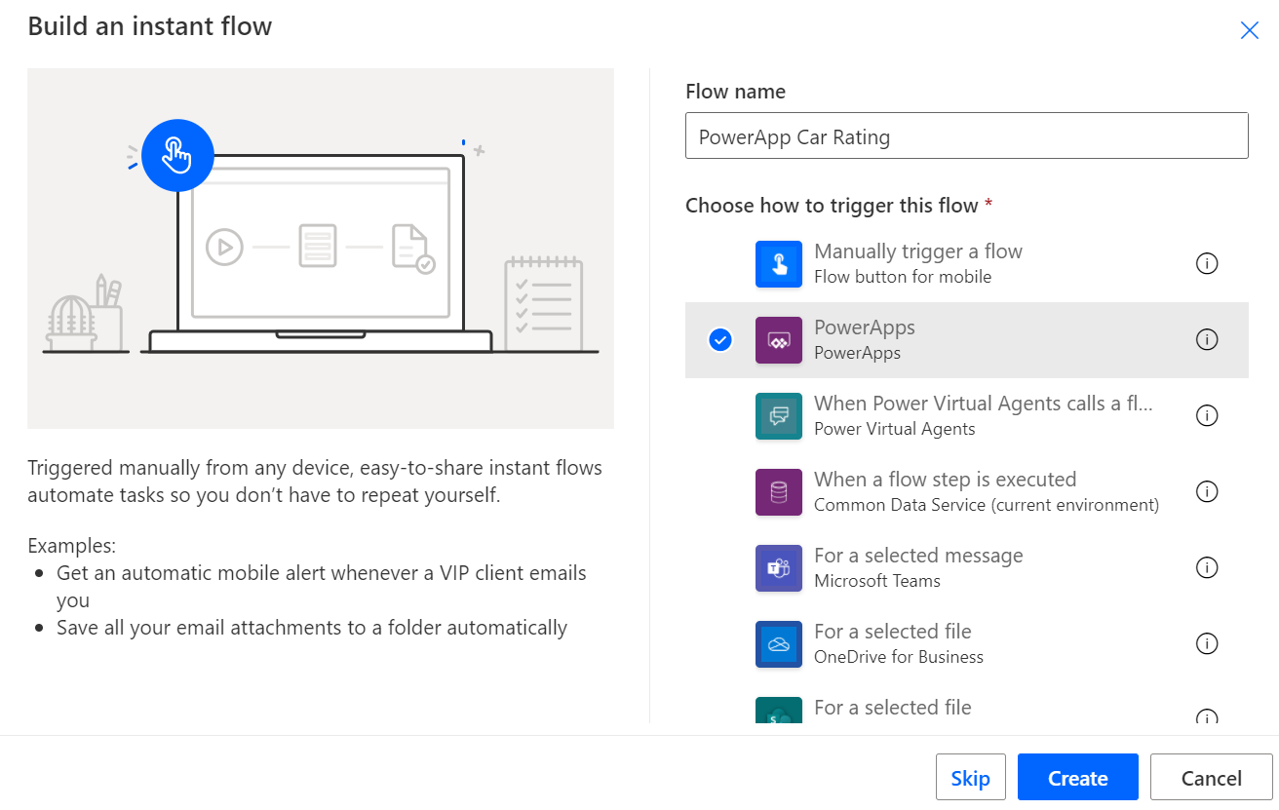

1. Add new step “**Initialize variable**”
   * Name: **Rating**
   * Type: **String**

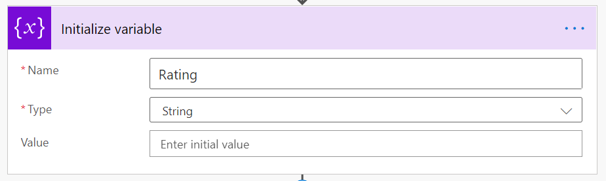

1. Add new step “**Compose**” and rename it to “**Compose Car Brand**”
   * Inputs: **Ask in PowerApps** (dynamic content)

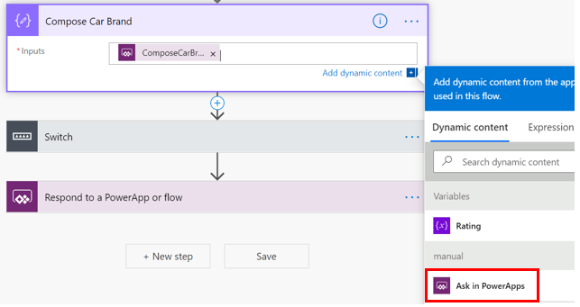

1. Add new step “**Switch**” (Control)
   * On: **[Outputs]** (dynamic content from Compose)
   * Case: **BMW**

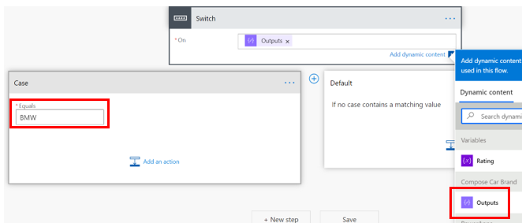

1. Add add action “**Set variable**” to **Case** branch of the Switch step
   * Name:**Rating**
   * Value:**EXCELLENT**

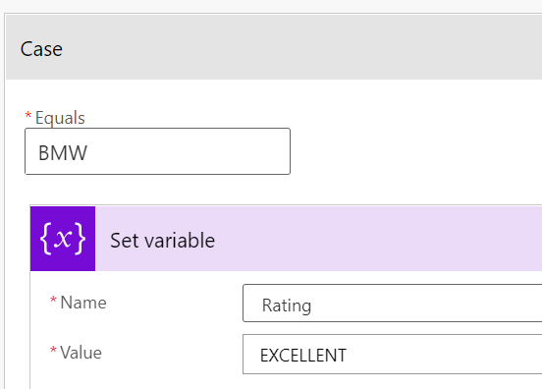

1. Add new step “**Set variable**” to **Default** branch of the Switch step
   * Name:**Rating**
   * Value:**OK**

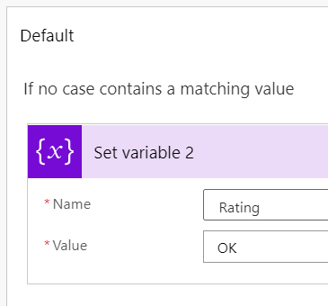

1. Add new step “**Respond to a PowerApp or Flow**”
   * Rating: **[Rating]** (variable)

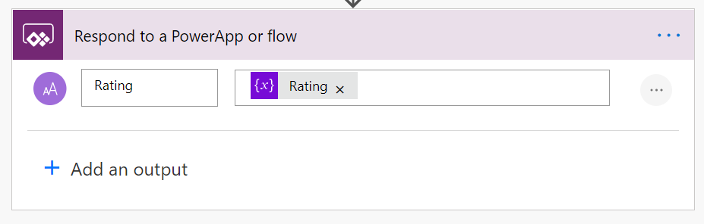

1. At this point Flow should look like below

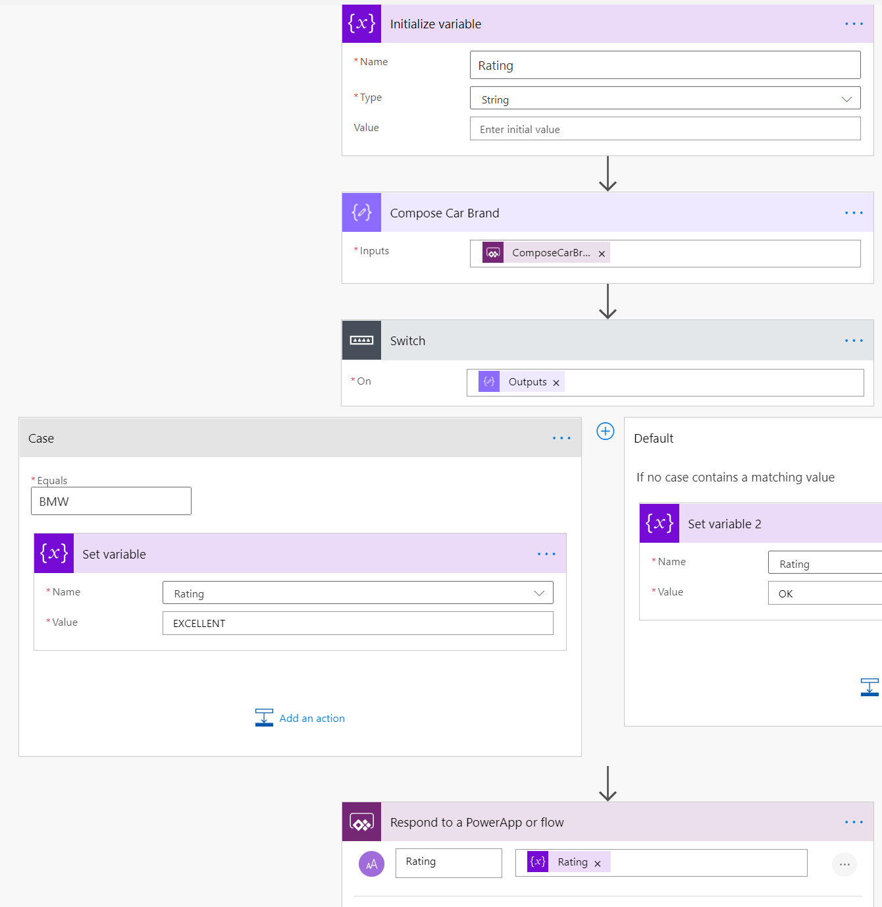

1. Open <https://make.powerapps.com> and sign-in using your O365 account
2. Create new “**Canvas App from blank**”

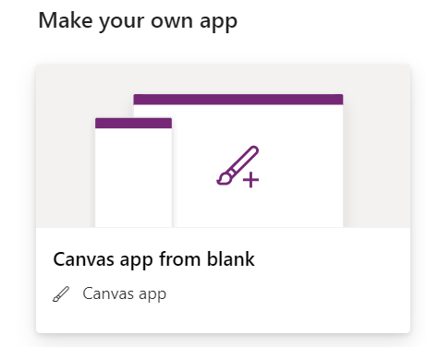

1. Name app as “**Car Rating App**” and select **Tablet** format

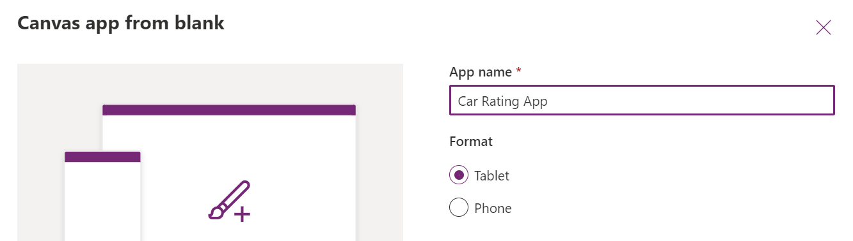

1. Add following controls to screen
   * Text label: Text=”**Car Model**”
   * Text input
   * Button: Text=”**Submit**”
   * Text label: Text=””

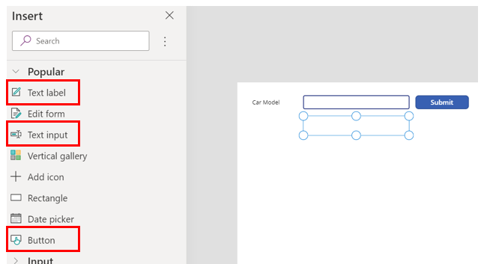

1. Select button control and from **Action** menu click **Power Automate**. Select **PowerApp Car Rating** Flow you created

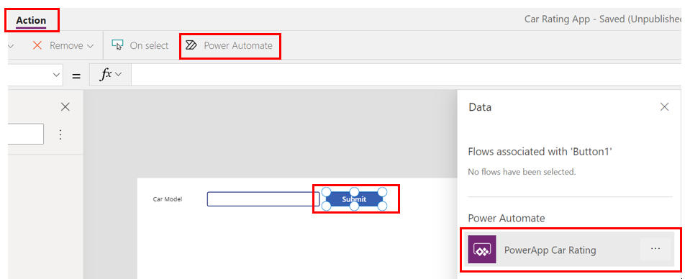

1. Set button’s **OnSelect** event like below which will create variable **ResponseFromFlow** and assigns value returned from the Flow to this variable

Set(ResponseFromFlow, PowerAppCarRating.Run(TextInput1.Text))

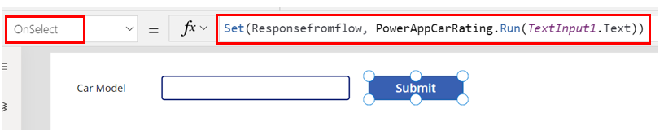

1. Select the second Text label and set its Text property to **ResponseFromFlow.rating**

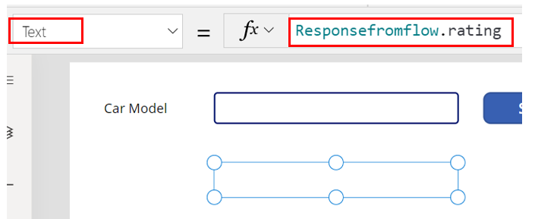

1. Test the App by clicking Play button on top right corner

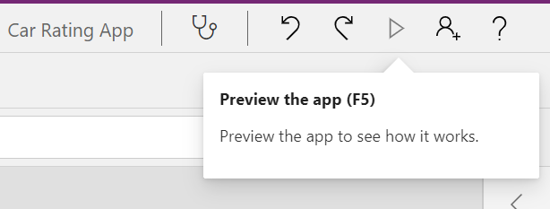

1. Type BMW to text input field and press **Submit.** You should see the following result after the call to Flow is done and it has responded to app with **Rating** value

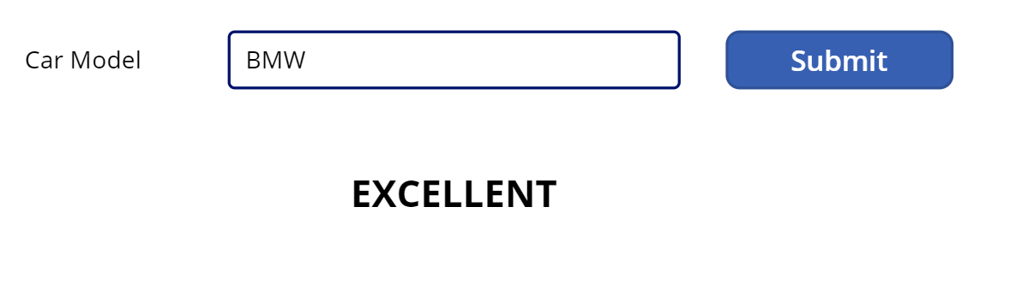

Test with other car brands as well to see the results

<https://docs.microsoft.com/en-us/powerapps/using-logic-flows>

# Error handling

1. Create new Flow using “**Instant cloud flow**” option

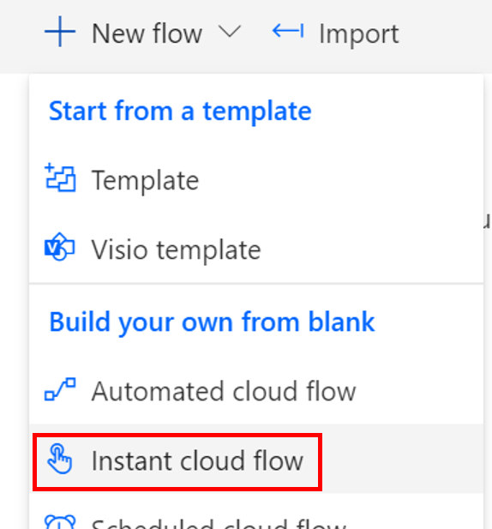

1. Name it “**Error handling**“​ and choose “**Manually trigger a flow**”

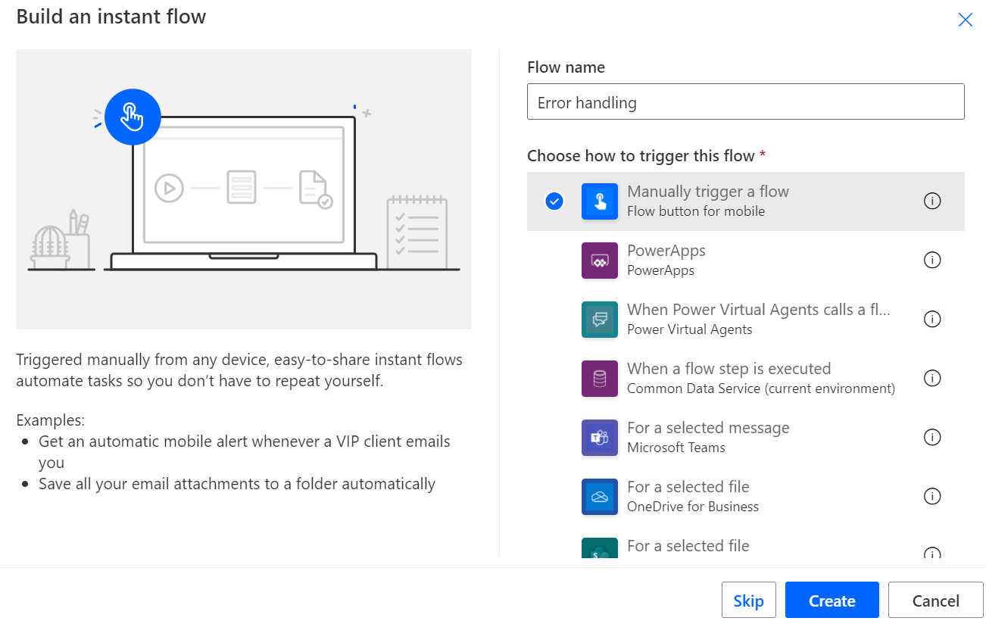

1. Add new step “**Approval**” and select “**Start and wait for an approval**”
   * Approval type: “**Approve/Reject – First to respond**”
   * Title: **Configure run after approval**
   * Assigned to: *Your O365 account*
   * Click **…** and select **Settings**
   * Set Timeout: **PT1M** (1 minute)

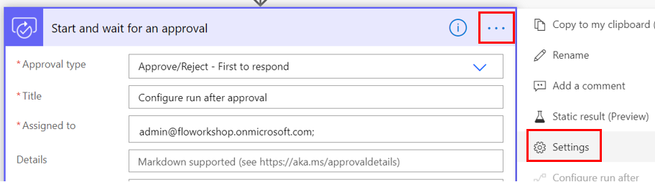

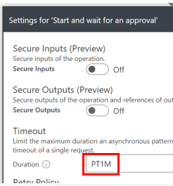

1. Add new step “**Send an email (V2)**”
   * To: *Your O365 email address*
   * Subject: **The approval flow has timed out**
   * Body: **[Title]** (Dynamic content from Approval)
   * Click **…** and select **Rename** and rename action to “**Send an email – Timed Out**”

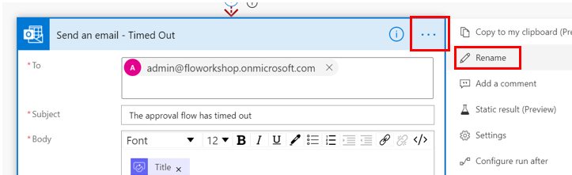

* + Click **…** again and select **Configure run after** and select only “**has timed out**”

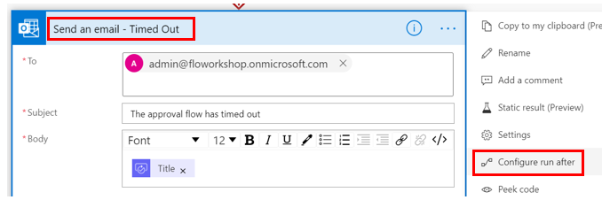

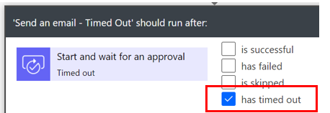

1. Add new step “**Send an email (V2)**”
   * To: *Your O365 email address*
   * Subject: **The approval flow has completed**
   * Body: **[Title]** (Dynamic content from Approval)
   * Click **…** and select **Rename** and rename action to “**Send an email – Completed**”
   * Click **…** again and select **Configure run after** and select only “**is skipped**”

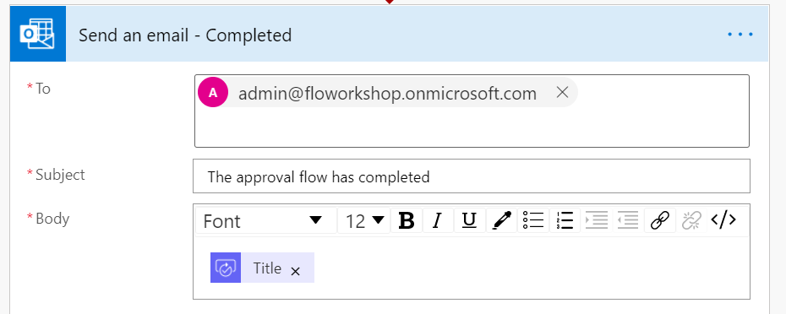

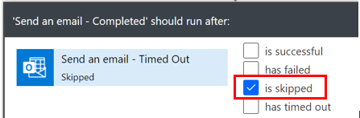

1. Save the Flow
2. Test Flow 2 times
   * Run Flow and wait until execution is finished in about 1 minute. You should see approval email sent to your O365 email but **do not** approve/reject it as we want that approval step will timeout. After that “**Send an email – Timed Out**” step is executed and because of run after configuration the “**Send an email – Completed**” is not

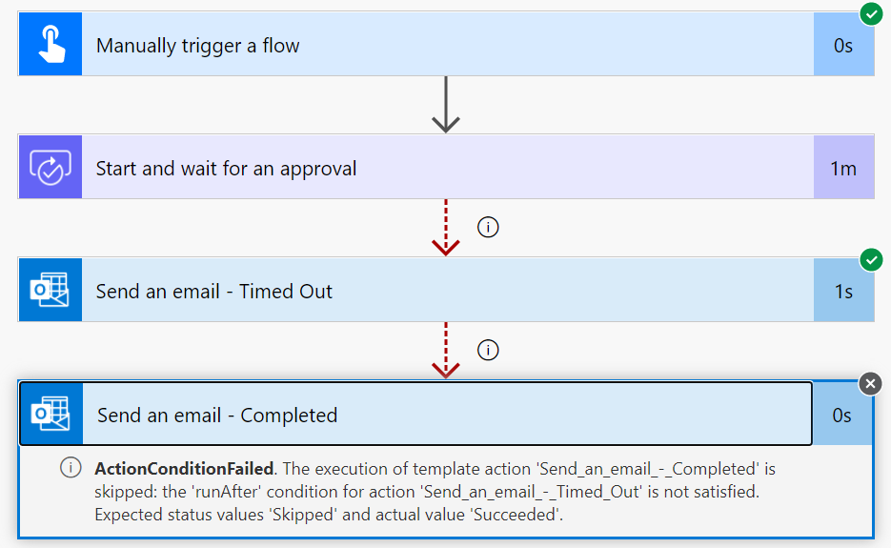

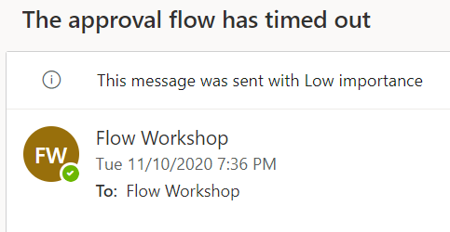

* + Run Flow again but this time approve/reject the approval sent to your O365 email. After that “**Send an email – Timed Out**” step will be skipped and “**Send an email – Completed**” is executed because of run after configuration

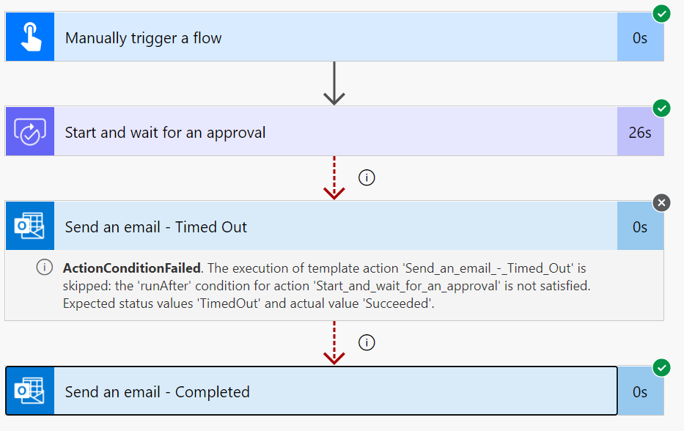

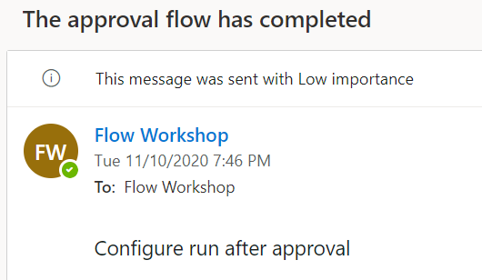

​

​

​

***NOTE: sometimes the approval email is very slow (5-10 minutes)***​