**Ordoñez, Juan Agustin**

**Rocamora, Eunace**

**BSIT MI 181**

**Wireframe, Mockup, & Prototype**

Image result for minesweeper bomb png black and white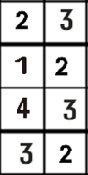Image result for minesweeper bomb png black and whiteImage result for minesweeper bomb png black and whiteImage result for minesweeper bomb png black and whiteImage result for minesweeper bomb png black and whiteImage result for minesweeper bomb png black and whiteImage result for minesweeper bomb png black and whiteImage result for minesweeper bomb png black and whiteImage result for minesweeper bomb png black and whiteImage result for minesweeper bomb png black and whiteImage result for minesweeper bomb png black and whiteImage result for minesweeper bomb png black and whiteImage result for minesweeper bomb png black and whiteImage result for minesweeper bomb png black and whiteImage result for minesweeper bomb png black and whiteImage result for minesweeper bomb png black and whiteImage result for minesweeper bomb png black and whiteImage result for minesweeper bomb png black and whiteImage result for minesweeper bomb png black and white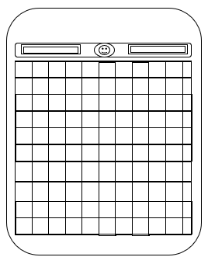Wireframe



After playing the game, the application will either tell the user if they won or they lose.

If the user selects on either “Start New Game” or “Load Saved Game”, the application will lead him to the main user interface of the application.

Once the user launches the application, this is the first interface the user will encounter. The program will give three selections to the user, “Start New Game”, “Load Saved Game”, and “View Highest Score”

YOU LOSE :<

View Highest Score

Load Saved Game

Start New Game

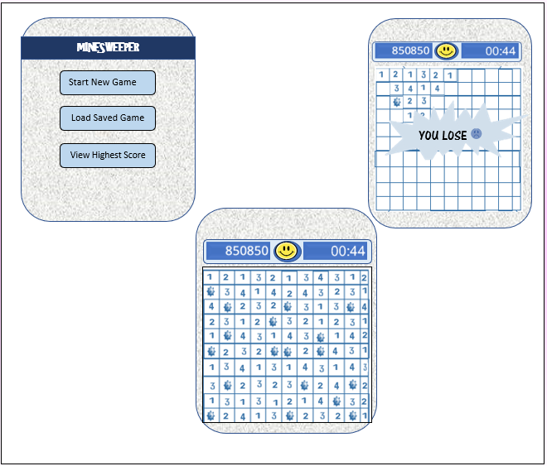Mockup

After playing the game, the application will either tell the user if they won or they lose.

If the user selects on either “Start New Game” or “Load Saved Game”, the application will lead him to the main user interface of the application.

Once the user launches the application, this is the first interface the user will encounter. The program will give three selections to the user, “Start New Game”, “Load Saved Game”, and “View Highest Score”

Prototype

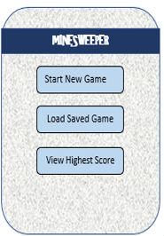

**Minesweeper** is a single-player puzzle video game. The objective of the game is to **clear a rectangular board containing hidden "mines" or bombs without detonating any of them.**

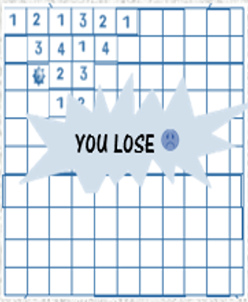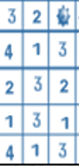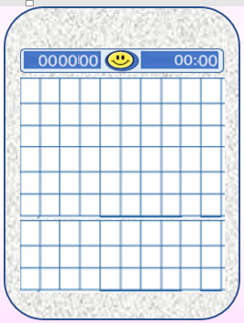0



**If the user tapped a box that contains a bomb, it will produce a pop-up message stating “You Lose” and if the user taps the okay button it will go back to the main screen.**

**Score**

**User**

**Time**

**When the user click the start new game, the game will start that will produce the following screen..**

**If the user tapped “Load Saved Game”, it will just load the ‘left’ game of the user.**

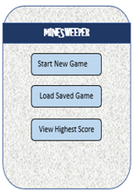

**If the user tapped “View Highest Score”, it will produce the highest score that is saved in the application.**

**Best Miner’s Score:**