Hardware/Software Codesign Lab 3

Student Name: Jose Sotelo

Student ID: 013969681

1. Follow the Lab 3 manual finish Lab 3.
2. Copy and paste the following information to the end of this document and submit this document:
3. Block diagram for your hardware platform.

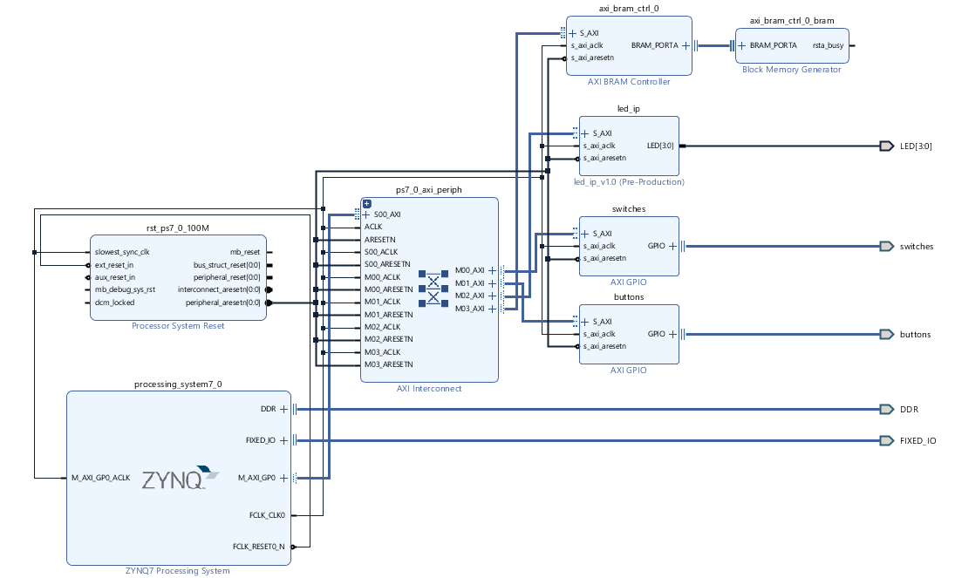

1. peripheral memory map

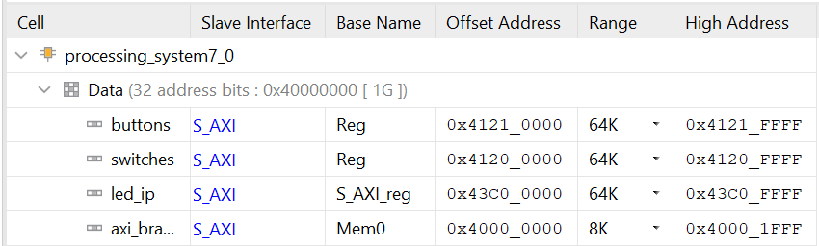

1. system.hdf: highlight information for the custom IP added and BRAM and BRAM controller.

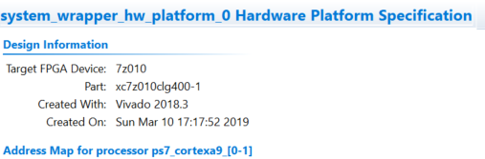

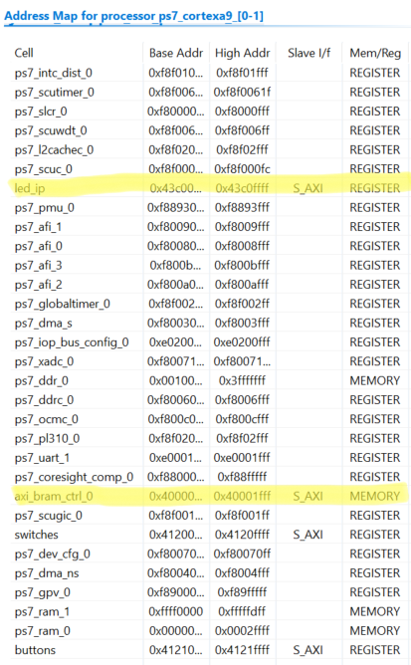

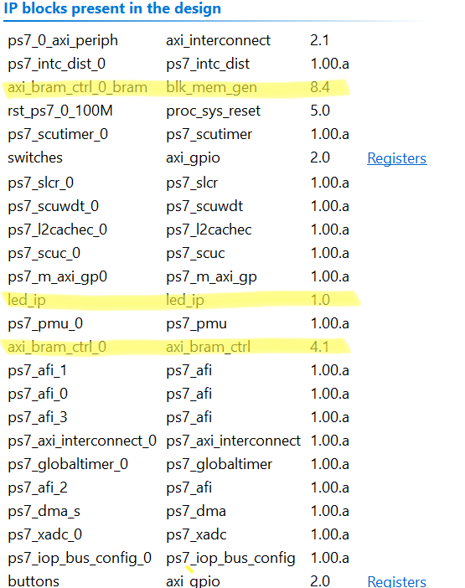

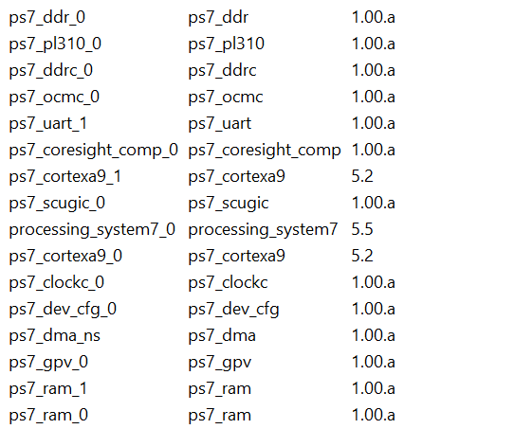

1. Pin assignment for the four LEDs

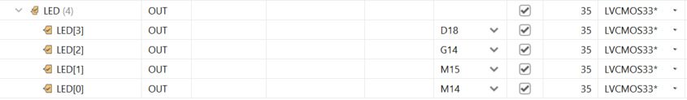

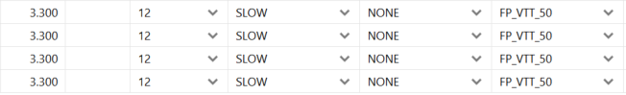

1. Answer the following question:
2. Which register in the custom IP is used to control the leds? Can we use a different one? Show the modified code to use a different register to control the leds.

No, we cannot use a different register. The registers used in the custom IP to control the LEDs are S_axi read and write registers.

1. Can we move the instantiation of lab3_user_logic from led_ip_v1_0_S_AXI.v to led_ip_v1_0, why or why not?

No, we could not instantiate lab3_user_logic to led_ip_v1_0_S_AXI.v to led_ip_v1_0.v because of hierarchical design using Verilog. The top module is led_ip_v1_0.v and the bottom to modules are led_ip_v1_0_S_AXI and lab3_user_logic .