**Welcome to the CSS syntax problem set!**

The purpose of this problem set is to get you familiar with the CSS syntax and practice using different CSS properties. As you go through each exercise, recall the things you learned in the previous lesson. If you get stuck, remember that you can use references and developer tools to help you out.

After you've completed the problem set, you should feel more confident when adding style to your webpages and you'll be ready to learn new techniques to improve your front-end web development process.

**CSS References**

* Mozilla Developer Network - [**CSS Reference**](https://developer.mozilla.org/en-US/docs/Web/CSS/Reference)
* css-tricks.com - [**CSS Almanac**](https://css-tricks.com/almanac/)

# Style an Image

For your first quiz, I want you to take this black and white image of a kitten and add some style to it.



Aww, isn't it cute! 🐱

I'll give you the image and the HTML, and it will be your job to add the style. But, you won't be adding just any style. Instead, you will need to use properties for border, cursor, and box-shadow to produce the following result.

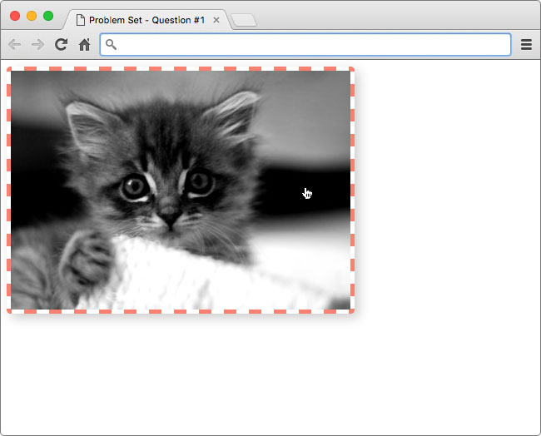

Hint: The color of the border is salmon (#fa8072)

### Border

If you've ever used a table in a word processor or spreedsheet, then you should be familiar with borders. With CSS, you can add a border to just about anything. There are a ton of different options for customizing borders like style, width, and color! Click [**here**](https://developer.mozilla.org/en-US/docs/Web/CSS/border) to learn more.

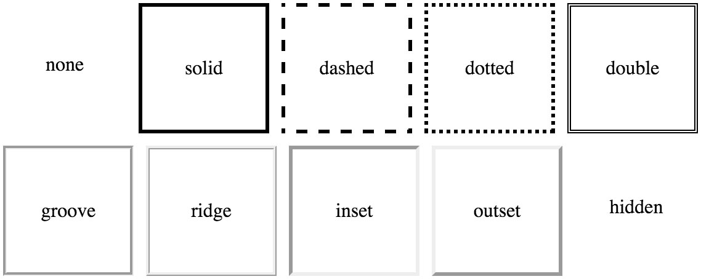

An example of the different border styles you can achieve with CSS

### Cursor

It's possible you've never noticed your cursor change when viewing a website because it's so subtle. But, changing the cursor can be extremely helpful when trying to communicate things to the user. For example, if a user hovers over a link, changing the cursor to a pointer let's the user know the link can be clicked.

cursor example

A normal button on the left, and the same button while a mouse is hovering over it on the right

For most situations your browser automatically changes the cursor, but you can use the cursor property to override its behavior. See [**this demo**](https://css-tricks.com/almanac/properties/c/cursor/) of all the different cursors in action! Obvisouly, this property only applies to users with a mouse 😉 .

### Box-Shadow



Use shadows to add a sense of depth to images

The box-shadow property is relatively new to the world of CSS. You can use it to add a shadow to an element. If you want to try experimenting with box-shadows, check out this [**box-shadow generator**](http://www.cssmatic.com/box-shadow) from CSSmatic.

### How to Complete this Quiz

Edit index.html in the Udacity classroom to replicate the same styling seen in the solution image.

Here's what I added to .kitten-image :

.kitten-image {

border: 5px dashed salmon;

border-radius: 5px;

cursor: pointer;

box-shadow: 5px 5px 20px #ccc;

}

The properties border and border-radius were used to create the border seen in the image. However, you could have split the border property into border-width, border-style, and border-color. My solution is just using the [**shorthand**](https://developer.mozilla.org/en-US/docs/Web/CSS/Shorthand_properties)version instead.

The cursor property was used to change the mouse cursor from its default setting to the pointing finger.

Finally, I added the property box-shadow to produce the drop shadow behind the image.

Here's the before and after:





I've already written the **selector** portion of the code, you just need to fill in the styles.

.kitten-image {

*/* add CSS here */*

}

Click "Skip to Quiz" when you're ready to start.

### Image Credit

* 'Kitten' by [**Nicolas Suzor**](https://www.flickr.com/photos/nicsuzor/) via Flickr, Creative Commons.

[**Start Quiz**](https://classroom.udacity.com/nanodegrees/nd001/parts/aabd87fc-6edf-4818-a911-15dfa9cabcb8/modules/4d4626ff-de39-4af7-9cf1-a26774ee022c/lessons/7323812069/concepts/71153997690923)

# Style the Font

For this quiz, you'll experiment with styling font using the "udacity" text below.

text image

This text looks pretty boring!

Just like the previous quiz, I'll give you the HTML and it will be your job to add the style. You'll need to use properties related to font and text to produce the following result.

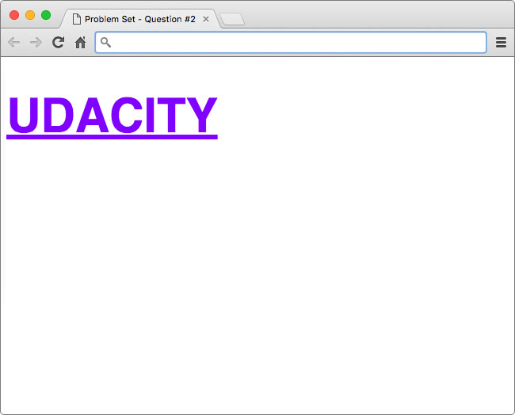

Hint: The font color is a shade of purple (*#8001ff*)

## Fonts

When using fonts on the web, you must first consider what fonts are available to your users. Every operating system, be it Windows, OS X, or Linux, comes with a set of pre-installed fonts that you can use for customizing your website. For a complete list of "web-safe" fonts, follow this [**link**](http://www.cssfontstack.com/).

The way it works is fairly simple. When using the font-family property, you specify the font(s) you want to use in your HTML.

font-family: font1, font2, font3, ...;

Then, the browser, starting from left to right, looks at the font(s) you've specified and checks to see if it can render the text using the font(s) you've provided. If it can't use the first font, then the browser moves to the next font, and so-on.

The purpose for specifying multiple fonts is because not all fonts are available on every operating system. So, specifying multiple, similar fonts ensures users have a consistent experience regardless of the operating system they are using.



Arial vs. Helvetica comparison

In the solution, I specified font-family: Helvetica, Arial, sans-serif;. Therefore, the browser first tries to render the font Helvetica. On Macs this works because Helvetica is a standard font packaged with the operating system. However, on Windows and Linux machines, it is possible (not likely) that those operating systems do not have support for the Helvetica font by default, so the browser would then try to use Arial. If Arial doesn't exist, then the browser will use whatever sans-serif font is available.

## Custom Fonts

It is also possible to use custom fonts on the web. If you want to go ahead and start experimenting, you can check out [**Google Fonts**](https://www.google.com/fonts) to see some open-source web fonts in action! With custom web fonts, it's not as important to specify multiple fonts like seen above; however, it is still smart to specify at least one backup font in case your custom font doesn't load.

## How to Complete this Quiz

Edit index.html in the Udacity classroom to replicate the same styling seen in the solution image.



Again, I've helped you out by writing the **selector** with an empty declaration block to put your changes. You're welcome 😉 .

.udacity-text {

*/* add CSS here */*

}

When you're ready, click "Skip to Quiz" to get started.

[**Start Quiz**](https://classroom.udacity.com/nanodegrees/nd001/parts/aabd87fc-6edf-4818-a911-15dfa9cabcb8/modules/4d4626ff-de39-4af7-9cf1-a26774ee022c/lessons/7323812069/concepts/71213796920923)

## Instructions

Replicate the same styling seen in the Udacity text below.

Hint: The font color is a shade of purple (#8001ff)

**[[](https://classroom.udacity.com/nanodegrees/nd001/parts/aabd87fc-6edf-4818-a911-15dfa9cabcb8/modules/4d4626ff-de39-4af7-9cf1-a26774ee022c/lessons/7323812069/concepts/71213796920923)](https://classroom.udacity.com/nanodegrees/nd001/parts/aabd87fc-6edf-4818-a911-15dfa9cabcb8/modules/4d4626ff-de39-4af7-9cf1-a26774ee022c/lessons/7323812069/concepts/71213796920923)**

Here's my answer:

.udacity-text {

font-family: Helvetica, Arial, sans-serif;

font-size: 60px;

text-transform: uppercase;

text-decoration: underline;

color: #8001ff;

}

The font-family property is used to change the font to Helvetica, Arial, or the default sans-serif font installed on the operating system.

Next, the font-size property is used to increase the size of the font to be larger and the text-transform and text-decoration properties are used to capitalize and underline the text.

Finally, color is used to change the color to the shade of purple you see in the solution image below.

Check out the before and after:



[**View IntroBack to Quiz**](https://classroom.udacity.com/nanodegrees/nd001/parts/aabd87fc-6edf-4818-a911-15dfa9cabcb8/modules/4d4626ff-de39-4af7-9cf1-a26774ee022c/lessons/7323812069/concepts/71213796920923)

## Instructions

Replicate the same styling seen in the Udacity text below.

Hint: The font color is a shade of purple (#8001ff)

**[[](https://classroom.udacity.com/nanodegrees/nd001/parts/aabd87fc-6edf-4818-a911-15dfa9cabcb8/modules/4d4626ff-de39-4af7-9cf1-a26774ee022c/lessons/7323812069/concepts/71213796920923)](https://classroom.udacity.com/nanodegrees/nd001/parts/aabd87fc-6edf-4818-a911-15dfa9cabcb8/modules/4d4626ff-de39-4af7-9cf1-a26774ee022c/lessons/7323812069/concepts/71213796920923)**

**Writing Selectors**

At this point, you should be familiar with the basic structure of a CSS statement. Every CSS statement is made up of a **selector** and a **declaration block**. The selector tells the browser what HTML element we want to style and the declaration block tells the browser what styles need to be applied to that HTML.

**[[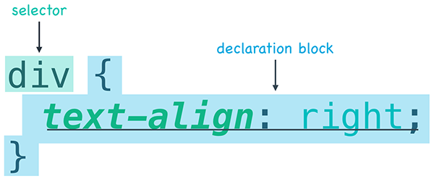](https://classroom.udacity.com/nanodegrees/nd001/parts/aabd87fc-6edf-4818-a911-15dfa9cabcb8/modules/4d4626ff-de39-4af7-9cf1-a26774ee022c/lessons/7323812069/concepts/209f562f-6314-4354-a629-ba76d971b1f3)](https://classroom.udacity.com/nanodegrees/nd001/parts/aabd87fc-6edf-4818-a911-15dfa9cabcb8/modules/4d4626ff-de39-4af7-9cf1-a26774ee022c/lessons/7323812069/concepts/209f562f-6314-4354-a629-ba76d971b1f3)**

**[The basic structure of a CSS statement](https://classroom.udacity.com/nanodegrees/nd001/parts/aabd87fc-6edf-4818-a911-15dfa9cabcb8/modules/4d4626ff-de39-4af7-9cf1-a26774ee022c/lessons/7323812069/concepts/209f562f-6314-4354-a629-ba76d971b1f3)**

For this exercise, I want you to focus exclusively on the selector part of a CSS statement. To do this, I've created a webpage that is lacking style. The webpage already has ids and classes added to the HTML, but it's missing the right selectors to add the style.

<div id="menu">

<h1 class="item">Chicken Clay Pot</h1>

<img src="img/clay-pot.jpg" alt="clay pot" class="picture">

<p class="description">Crispy rice baked in clay pot topped with chicken and vegetables</p>

</div>

*/* missing id */* {

text-align: center;

}

*/* missing class */* {

color: red;

}

*/* missing class */* {

border-radius: 5px;

}

*/* missing class */* {

font-style: italic;

}

It's your job to download the webpage and fill-in the missing selectors. If you do it right, your webpage should end up looking like this...

**[[](https://classroom.udacity.com/nanodegrees/nd001/parts/aabd87fc-6edf-4818-a911-15dfa9cabcb8/modules/4d4626ff-de39-4af7-9cf1-a26774ee022c/lessons/7323812069/concepts/209f562f-6314-4354-a629-ba76d971b1f3)](https://classroom.udacity.com/nanodegrees/nd001/parts/aabd87fc-6edf-4818-a911-15dfa9cabcb8/modules/4d4626ff-de39-4af7-9cf1-a26774ee022c/lessons/7323812069/concepts/209f562f-6314-4354-a629-ba76d971b1f3)**

**[Your corrected CSS should cause your site to render like this.](https://classroom.udacity.com/nanodegrees/nd001/parts/aabd87fc-6edf-4818-a911-15dfa9cabcb8/modules/4d4626ff-de39-4af7-9cf1-a26774ee022c/lessons/7323812069/concepts/209f562f-6314-4354-a629-ba76d971b1f3)**

**How to Complete this Exercise**

1. Open the index.html file in your Workspace below.
2. Edit index.html and add the missing id and class selectors within the <style> tags.
3. When you've successfully added the correct selectors, your site should look like the picture. Click over to solution.html to see how I did it.

**Using Attributes**

Using selectors is the fastest and most efficient way to add style to your HTML. At this point, you've only practiced using **tag**, **id**, and **class** selectors, but there are actually other types of selectors. If you want to read ahead, check out the following links.

* [**MDN's Selectors**](https://developer.mozilla.org/en-US/docs/Web/Guide/CSS/Getting_started/Selectors)
* [**How CSS Selectors Work**](https://css-tricks.com/how-css-selectors-work/)

We'll explore these more in later lessons.

Now it's time to put your knowledge of **attributes** to the test. For this quiz, I've created you a simple to-do list in HTML and written the CSS to make it stylized 😃 .

**[[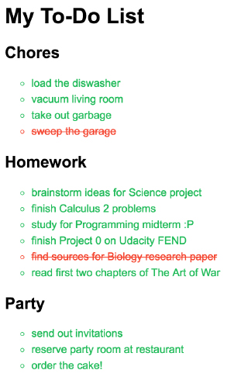](https://classroom.udacity.com/nanodegrees/nd001/parts/aabd87fc-6edf-4818-a911-15dfa9cabcb8/modules/4d4626ff-de39-4af7-9cf1-a26774ee022c/lessons/7323812069/concepts/44d47bb0-4716-45ce-a57c-07aaf6a6a33b)](https://classroom.udacity.com/nanodegrees/nd001/parts/aabd87fc-6edf-4818-a911-15dfa9cabcb8/modules/4d4626ff-de39-4af7-9cf1-a26774ee022c/lessons/7323812069/concepts/44d47bb0-4716-45ce-a57c-07aaf6a6a33b)**

**[Haven't you already finished project 0 for FEND?](https://classroom.udacity.com/nanodegrees/nd001/parts/aabd87fc-6edf-4818-a911-15dfa9cabcb8/modules/4d4626ff-de39-4af7-9cf1-a26774ee022c/lessons/7323812069/concepts/44d47bb0-4716-45ce-a57c-07aaf6a6a33b)**

However, in the HTML you'll see that some **id** and **class** attributes are missing from the HTML. To complete the exercise, add the correct **id** and **class** attributes to the HTML to reproduce the to-do list below.

**How to Complete this Exercise**

1. Edit index.html in the Workspace on the next page reproduce the solution image.
2. You will need to add the correct **id** and **class** attributes to the HTML elements to reproduce solution image.
3. Click over to solution.html when you're finished to see how I did it.

**[[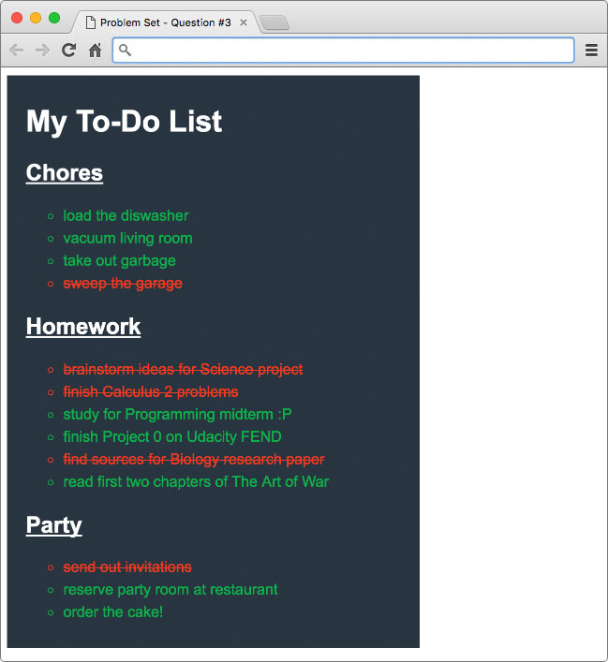](https://classroom.udacity.com/nanodegrees/nd001/parts/aabd87fc-6edf-4818-a911-15dfa9cabcb8/modules/4d4626ff-de39-4af7-9cf1-a26774ee022c/lessons/7323812069/concepts/44d47bb0-4716-45ce-a57c-07aaf6a6a33b)](https://classroom.udacity.com/nanodegrees/nd001/parts/aabd87fc-6edf-4818-a911-15dfa9cabcb8/modules/4d4626ff-de39-4af7-9cf1-a26774ee022c/lessons/7323812069/concepts/44d47bb0-4716-45ce-a57c-07aaf6a6a33b)**

**Slack Card**

[**Slack**](http://slack.com/) is a popular chat platform.

A Slack channel usually shows a list of names and their messages. If you click on someone's name, you'll see a card pop up that looks something like this:

**[[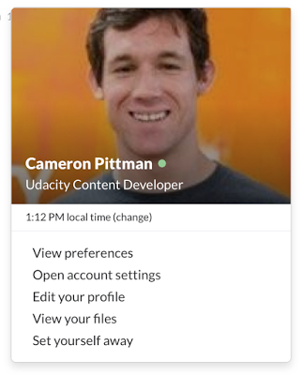](https://classroom.udacity.com/nanodegrees/nd001/parts/aabd87fc-6edf-4818-a911-15dfa9cabcb8/modules/4d4626ff-de39-4af7-9cf1-a26774ee022c/lessons/7323812069/concepts/056881b6-9429-4d6e-87d2-3da1f8da1bcf)](https://classroom.udacity.com/nanodegrees/nd001/parts/aabd87fc-6edf-4818-a911-15dfa9cabcb8/modules/4d4626ff-de39-4af7-9cf1-a26774ee022c/lessons/7323812069/concepts/056881b6-9429-4d6e-87d2-3da1f8da1bcf)**

Cameron's profile card looks great, but [**this one**](http://udacity.github.io/fend/lessons/L3/problem-set/07-slack-card/index.html) does not.

For this excercise, we've given you the code for that site in your own workspace. Your goal is to make it look more like a Slack profile card.

Here are some things to consider fixing:

1. The buttons are very blocky. Change the CSS so that they have rounded corners of 4px.
2. There seems to be a typo in the top part of the card. I don't know what a 'Stufent' is, but that's probably not the word you want.
3. The font for the buttons doesn't match the rest of the card. Find a way to make the font the same.
4. We've provided a placeholder image (in svg format) for you. Set the placeholder as the background for the top of the card.
5. Change the cursor to be a hand pointer instead of an arrow over the buttons.
6. Have other ideas for how to change the card? Try them out! This is *your* workspace!

*Note: the buttons at the bottom of the page have the class* profile-action*.*

You'll need to do [**some**](https://classroom.udacity.com/nanodegrees/nd001/parts/aabd87fc-6edf-4818-a911-15dfa9cabcb8/modules/4d4626ff-de39-4af7-9cf1-a26774ee022c/lessons/7323812069/concepts/056881b6-9429-4d6e-87d2-3da1f8da1bcf) [**research**](https://classroom.udacity.com/nanodegrees/nd001/parts/aabd87fc-6edf-4818-a911-15dfa9cabcb8/modules/4d4626ff-de39-4af7-9cf1-a26774ee022c/lessons/7323812069/concepts/056881b6-9429-4d6e-87d2-3da1f8da1bcf) for this quiz. There are at **least two new CSS properties** that you'll need to look up.

Here are a couple of sites that you might find useful: [**CSS Tricks**](https://css-tricks.com/almanac/) [**MDN CSS Reference**](https://developer.mozilla.org/en-US/docs/Web/CSS/Reference)

**How to Complete this Exercise**

1. Open the Workspace on the next page.
2. Make the necessary changes to the code to get that Slack card working correctly.
3. You can see how I did it in the solution.html file after you've finished.

Have fun!

# Udacity Site Header

Time for some more CSS practice.

Start by taking a look at any page on Udacity (like the one below).

**[[](https://classroom.udacity.com/nanodegrees/nd001/parts/aabd87fc-6edf-4818-a911-15dfa9cabcb8/modules/4d4626ff-de39-4af7-9cf1-a26774ee022c/lessons/7323812069/concepts/6ba2ae5a-39dd-4de8-824a-c280bf7671c1)](https://classroom.udacity.com/nanodegrees/nd001/parts/aabd87fc-6edf-4818-a911-15dfa9cabcb8/modules/4d4626ff-de39-4af7-9cf1-a26774ee022c/lessons/7323812069/concepts/6ba2ae5a-39dd-4de8-824a-c280bf7671c1)**

**[Udacity blog as of April 2016](https://classroom.udacity.com/nanodegrees/nd001/parts/aabd87fc-6edf-4818-a911-15dfa9cabcb8/modules/4d4626ff-de39-4af7-9cf1-a26774ee022c/lessons/7323812069/concepts/6ba2ae5a-39dd-4de8-824a-c280bf7671c1)**

Notice the header bar at the top of the page.

**[[](https://classroom.udacity.com/nanodegrees/nd001/parts/aabd87fc-6edf-4818-a911-15dfa9cabcb8/modules/4d4626ff-de39-4af7-9cf1-a26774ee022c/lessons/7323812069/concepts/6ba2ae5a-39dd-4de8-824a-c280bf7671c1)](https://classroom.udacity.com/nanodegrees/nd001/parts/aabd87fc-6edf-4818-a911-15dfa9cabcb8/modules/4d4626ff-de39-4af7-9cf1-a26774ee022c/lessons/7323812069/concepts/6ba2ae5a-39dd-4de8-824a-c280bf7671c1)**

In the workspace on the next page, we've started working to get the header to look right, but there are still a few more steps to making it look like it's supposed to.

We've added a few <!-- TODO: --> comments to the page. Go through them one at a time, and make the necessary changes to the CSS. When you're done, take a look at the solution.html file to see how I did it.

# What is a Stylesheet?

In the next exercise, you'll be working with a stylesheet. So what is a stylesheet and why is it important? Well, consider the following question...

What if you wanted to use the same CSS on more than one webpage?

You could just copy all of your CSS from one file and paste it into another, but that seems like a lot of extra work and doesn't scale very well. What if you decide to make changes later? You'd have to change every copy of the CSS!

There's got to be a better way...

**[[](https://classroom.udacity.com/nanodegrees/nd001/parts/aabd87fc-6edf-4818-a911-15dfa9cabcb8/modules/4d4626ff-de39-4af7-9cf1-a26774ee022c/lessons/7323812069/concepts/74240073020923)](https://classroom.udacity.com/nanodegrees/nd001/parts/aabd87fc-6edf-4818-a911-15dfa9cabcb8/modules/4d4626ff-de39-4af7-9cf1-a26774ee022c/lessons/7323812069/concepts/74240073020923)**

**[There's got to be a better way meme](https://classroom.udacity.com/nanodegrees/nd001/parts/aabd87fc-6edf-4818-a911-15dfa9cabcb8/modules/4d4626ff-de39-4af7-9cf1-a26774ee022c/lessons/7323812069/concepts/74240073020923)**

While the process described above works, it's not recommended. Instead, the preferred method is to write your CSS in a file called a **stylesheet** and then link to that file in your HTML.

**[[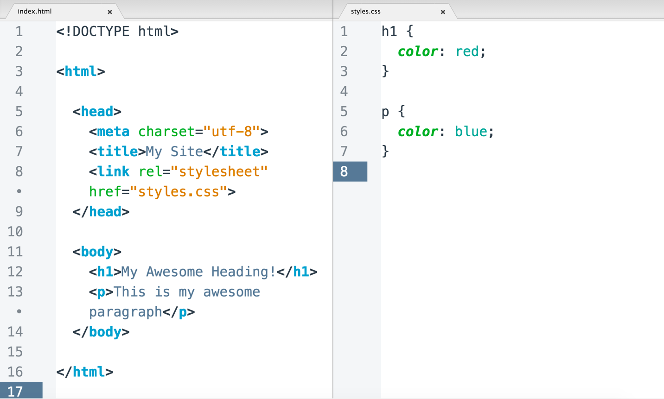](https://classroom.udacity.com/nanodegrees/nd001/parts/aabd87fc-6edf-4818-a911-15dfa9cabcb8/modules/4d4626ff-de39-4af7-9cf1-a26774ee022c/lessons/7323812069/concepts/74240073020923)](https://classroom.udacity.com/nanodegrees/nd001/parts/aabd87fc-6edf-4818-a911-15dfa9cabcb8/modules/4d4626ff-de39-4af7-9cf1-a26774ee022c/lessons/7323812069/concepts/74240073020923)**

**[Example HTML Document and CSS Stylesheet](https://classroom.udacity.com/nanodegrees/nd001/parts/aabd87fc-6edf-4818-a911-15dfa9cabcb8/modules/4d4626ff-de39-4af7-9cf1-a26774ee022c/lessons/7323812069/concepts/74240073020923)**

## Stylesheets

A stylesheet is a file containing the code that describes how elements on your webpage should be displayed.

**[[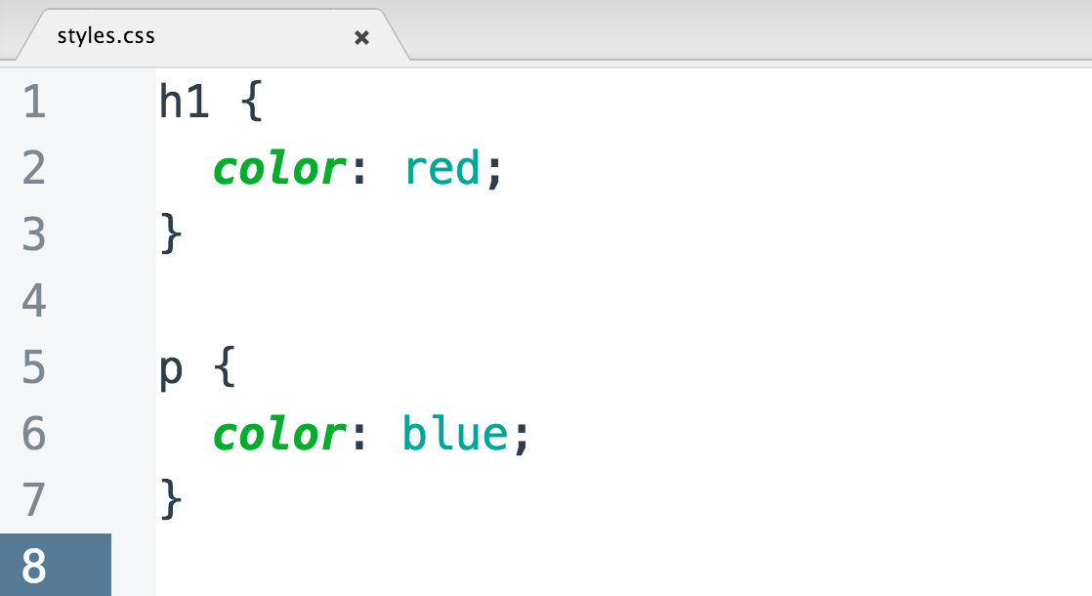](https://classroom.udacity.com/nanodegrees/nd001/parts/aabd87fc-6edf-4818-a911-15dfa9cabcb8/modules/4d4626ff-de39-4af7-9cf1-a26774ee022c/lessons/7323812069/concepts/74240073020923)](https://classroom.udacity.com/nanodegrees/nd001/parts/aabd87fc-6edf-4818-a911-15dfa9cabcb8/modules/4d4626ff-de39-4af7-9cf1-a26774ee022c/lessons/7323812069/concepts/74240073020923)**

**[Example CSS File](https://classroom.udacity.com/nanodegrees/nd001/parts/aabd87fc-6edf-4818-a911-15dfa9cabcb8/modules/4d4626ff-de39-4af7-9cf1-a26774ee022c/lessons/7323812069/concepts/74240073020923)**

This is no different than what you've been doing before, except the CSS lives in a different file... and you don't have to use the <style> tags anymore. To create a stylesheet, simply add a new file to your project, write some CSS, and save it as name-of-stylesheet.css.

## How to Link to a Stylesheet

Before your webpage can use the stylesheet, you need to link to it. To do this, you'll need to create a <link> to your stylesheet in your HTML. To create a link, simply type the following inside the <head> of your HTML.

<link href="path-to-stylesheet/stylesheet.css" rel="stylesheet">

The href attribute specifies the **path** to the linked resource (you can link to other resources besides stylesheets, more on this later) and the rel attribute names the **relationship** between the resource and your document. In this case, the relationship is a stylesheet. When you're done, it will look something like this...

<head>

<title>My Webpage</title>

*<!-- ... -->*

<link href="path-to-stylesheet/stylesheet.css" rel="stylesheet">

*<!-- ... -->*

</head>

# Link to a Stylesheet

For this exercise, you'll be linking a stylesheet to a familiar webpage from this lesson.

**[[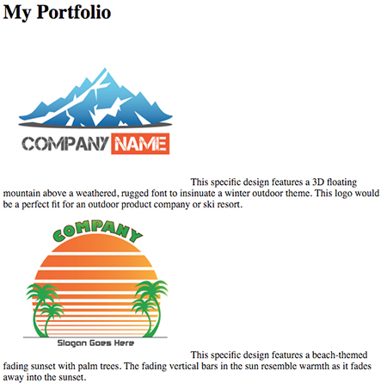](https://classroom.udacity.com/nanodegrees/nd001/parts/aabd87fc-6edf-4818-a911-15dfa9cabcb8/modules/4d4626ff-de39-4af7-9cf1-a26774ee022c/lessons/7323812069/concepts/b9defa86-d4f8-414e-8064-fa11d3d95e33)](https://classroom.udacity.com/nanodegrees/nd001/parts/aabd87fc-6edf-4818-a911-15dfa9cabcb8/modules/4d4626ff-de39-4af7-9cf1-a26774ee022c/lessons/7323812069/concepts/b9defa86-d4f8-414e-8064-fa11d3d95e33)**

**[Do you remember this webpage from the very first video in this lesson?](https://classroom.udacity.com/nanodegrees/nd001/parts/aabd87fc-6edf-4818-a911-15dfa9cabcb8/modules/4d4626ff-de39-4af7-9cf1-a26774ee022c/lessons/7323812069/concepts/b9defa86-d4f8-414e-8064-fa11d3d95e33)**

I've already provided you with the HTML and CSS in the downloadables section. It's your job to download the files and connect the **stylesheet** to the webpage.

<html>

<head>

<title>Link to a Stylesheet Quiz</title>

*<!-- add link here -->*

</head>

<body>

*<!-- ... -->*

</body>

</html>

In the download, styles.css (the stylesheet) is conviently tucked away in a folder called css. So, you will need to draw upon your knowledge of paths in order to correctly link the stylesheet to the HTML. If you've done everything correctly, your **link** should be formatted like...

<link href="path-to-stylesheet/stylesheet.css" rel="stylesheet">

## How to Complete this Exercise

1. Go into the workspace on this page
2. Edit the index.html file by adding a link to the missing stylesheet.
3. View index.html in the browser to see if the stylesheet was applied.
4. Take a look at the solution.html file in the workspace to see how I did it.