



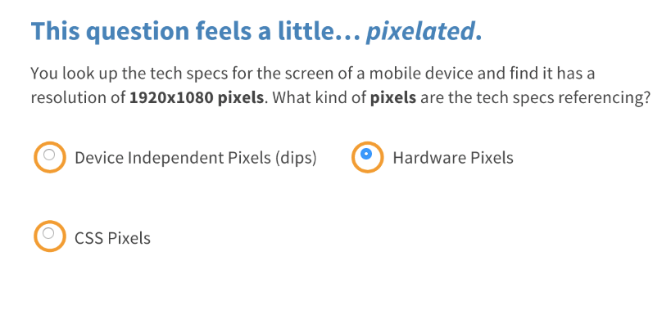

Correct! Tech specs will refer to the number of hardware pixels.

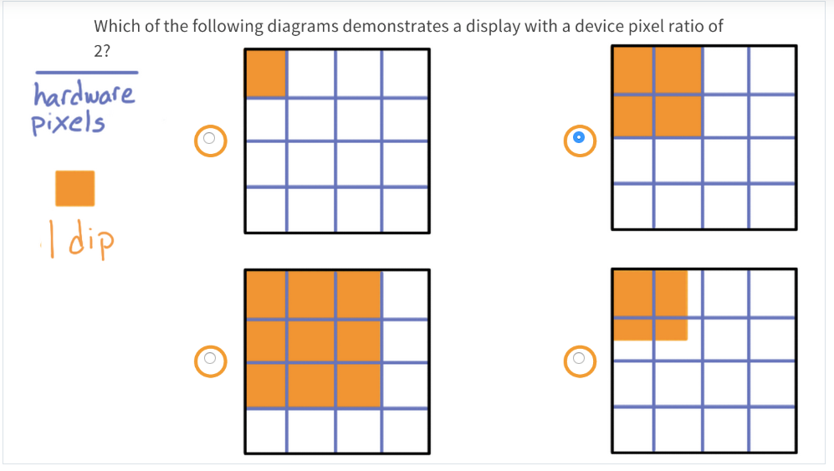

Great job! With one dip for every two hardware pixels, the device pixel ratio is 2!

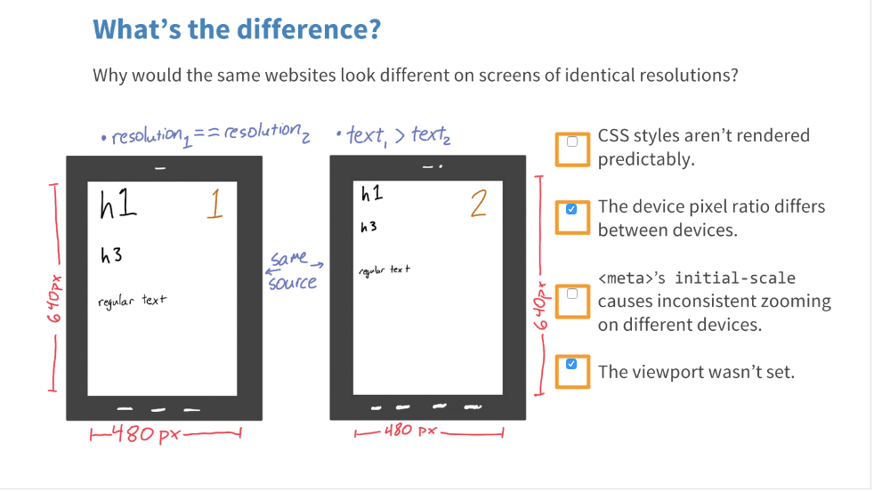

Great job! The viewport and the device pixel ratio are both likely causes for the differences between devices.

In other words, divide the number of hardware pixels by the DPR to find the number of CSS pixels.

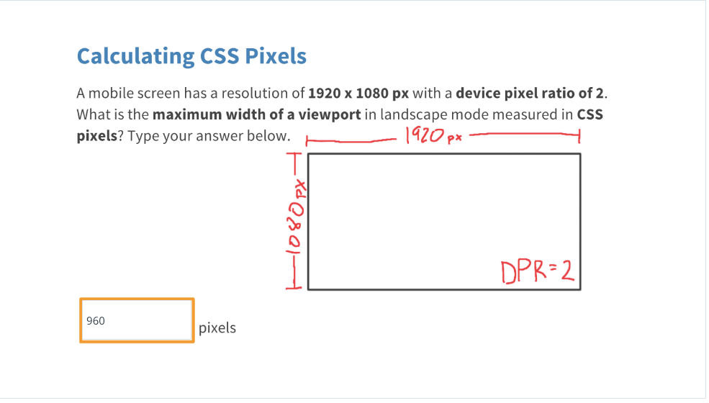

Right! Divide 1920px by 2 and you get a viewport width of 960 CSS pixels.

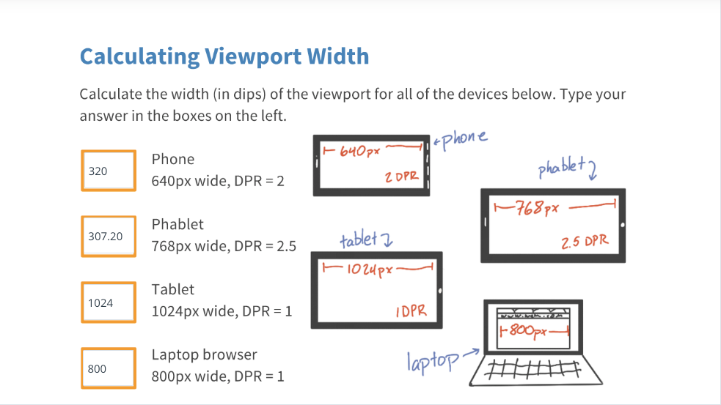







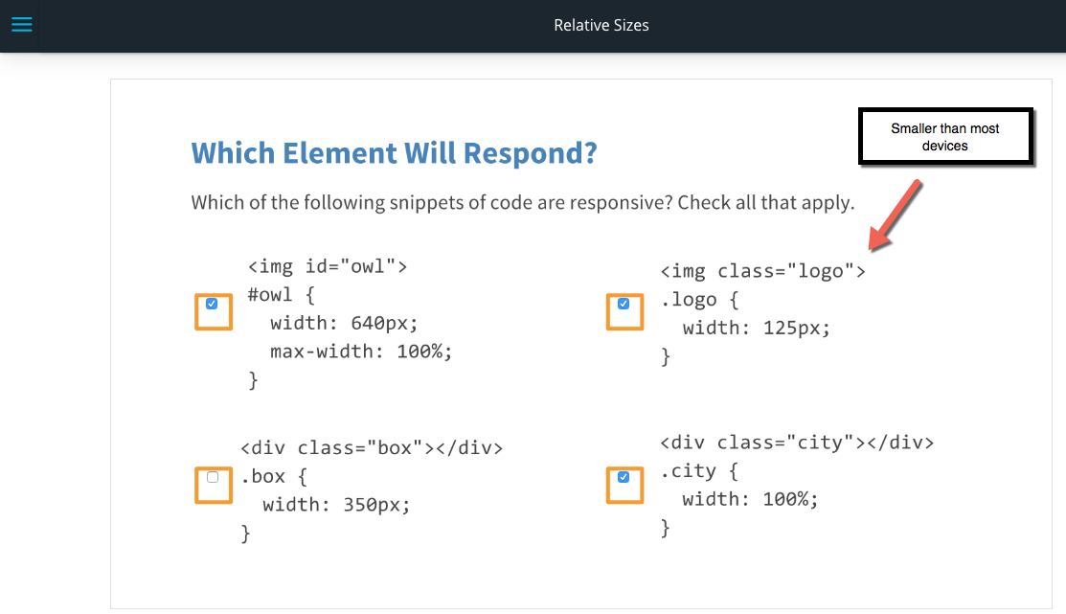

**Your answer must be proper CSS!**

Need some help writing CSS? Check out [**this big list of CSS properties**](http://www.w3.org/community/webed/wiki/CSS/Properties)

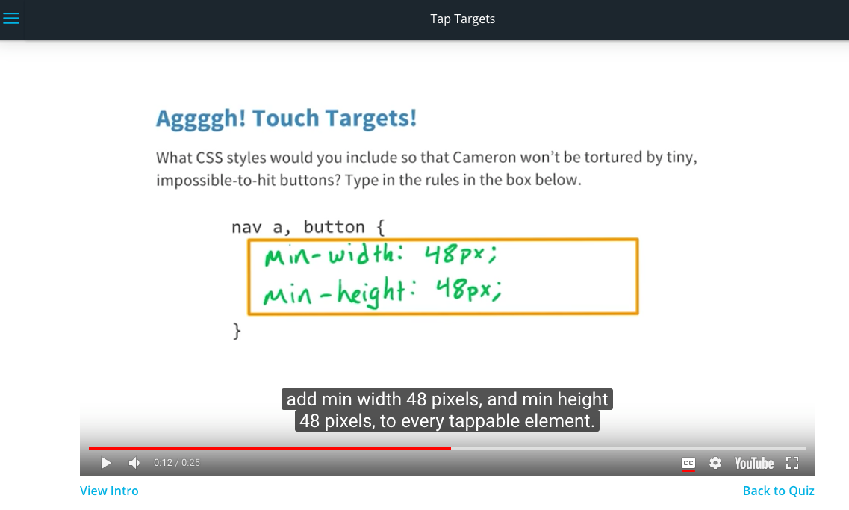





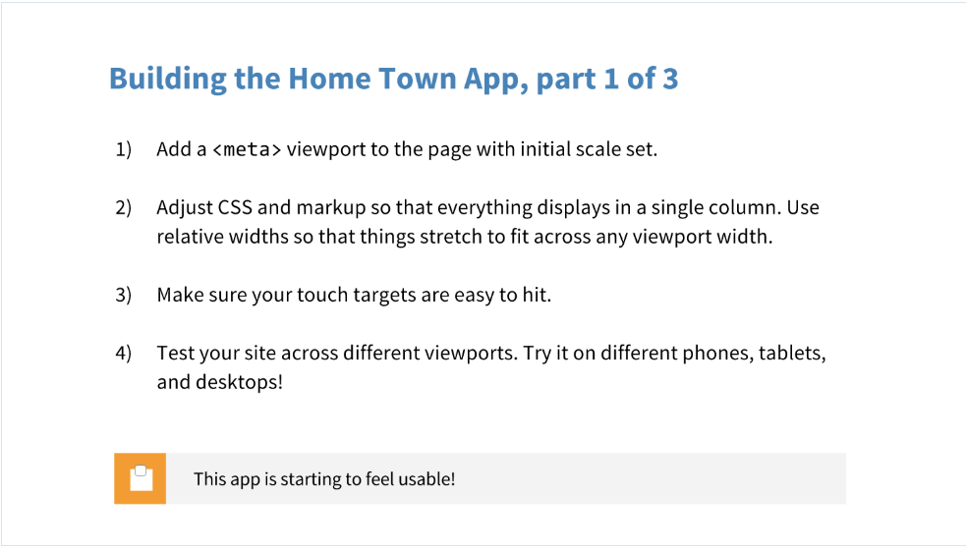

Download the RWDF_L2_Start.zip file below.

Here's the <meta> tag for easy copy/pasting:

<meta name="viewport" content="width=device-width, initial-scale=1.0">

Download the RWDF_L2_Solution.zip file below.