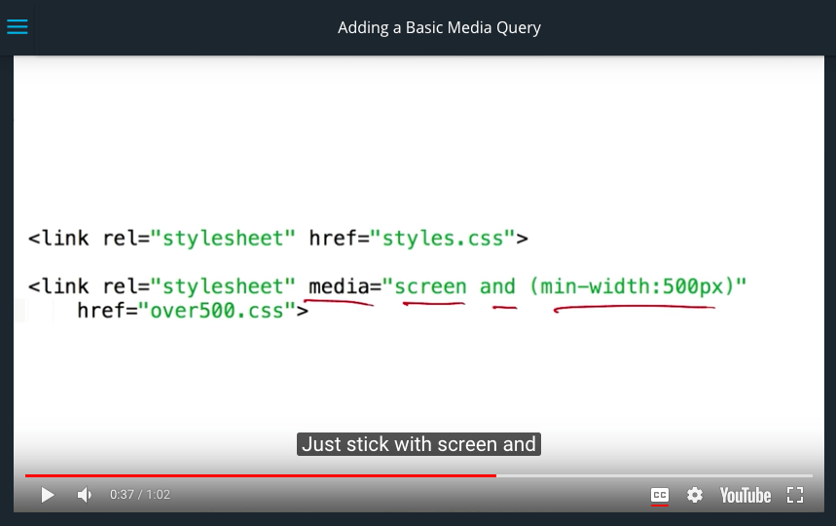

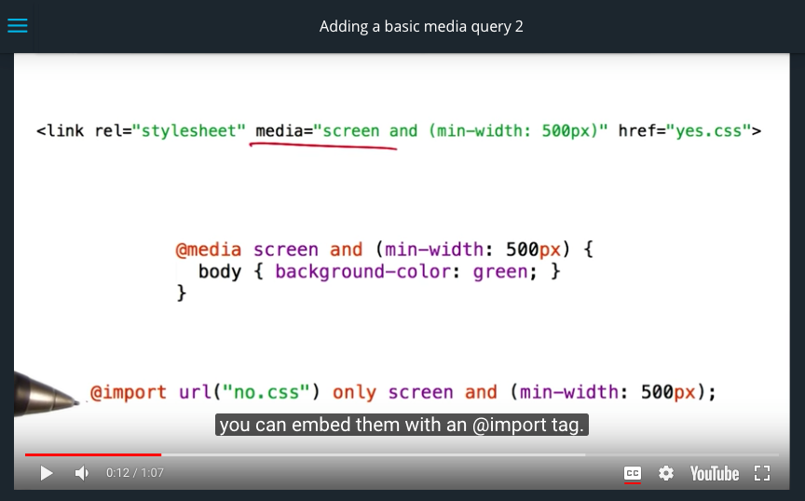

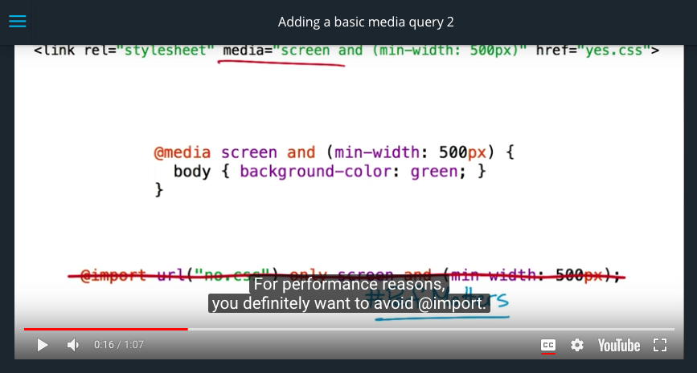

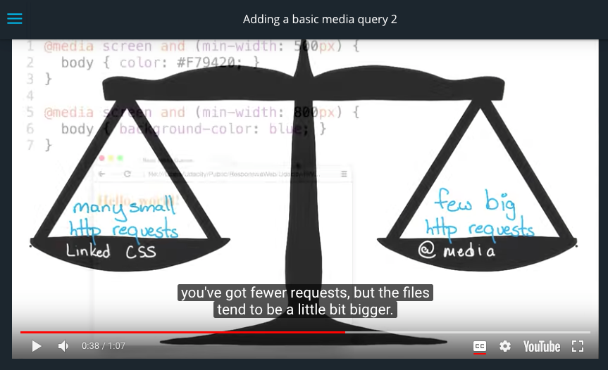

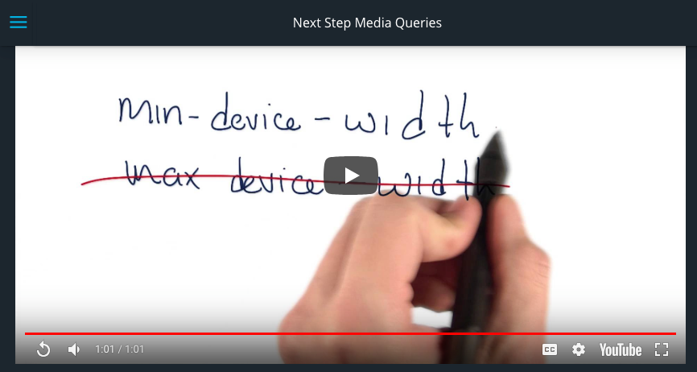

**Quiz: Which Styles Are Applied?**

Check out the sample site (index.html) in the Workspace. Your goal is to set the following media queries:

* Between 0 and 400 pixels, set the background color to **red**
* Between 401 and 599 pixels, set the background color to **green**
* 600 pixels or wider, set the background color to **blue**

Feel free to write your code in a text editor as well. You may open the page in your browser to test various viewport widths.

After completing this quiz, check out our own implementation (solution.html)!

index.html

solution.html

Here's a link to the course example: [**http://udacity.github.io/RWDF-samples/Lesson3/media-queries/min-max-width.html**](http://udacity.github.io/RWDF-samples/Lesson3/media-queries/min-max-width.html)

**Errata:** The layout of medium.com has changed since this video was created. Take a look at how it behaves in the video.

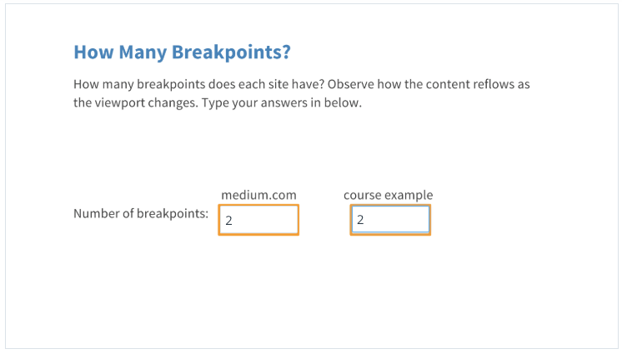

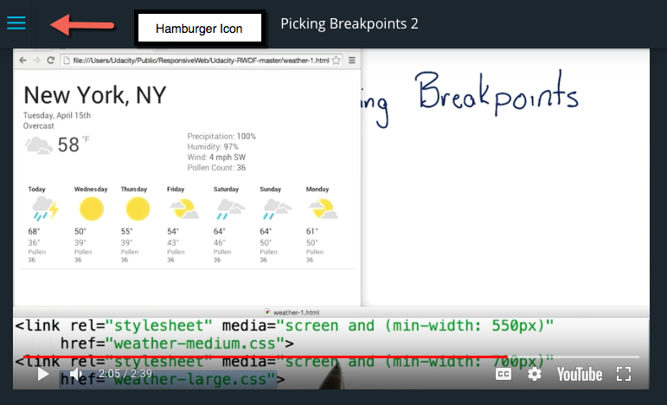

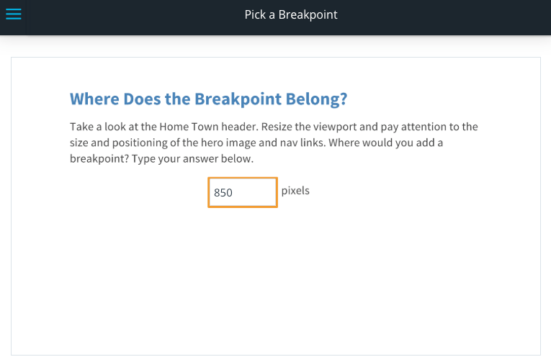

Here's a link to the [**site**](http://udacity.github.io/RWDF-samples/Lesson4/Project/Start/index.html).

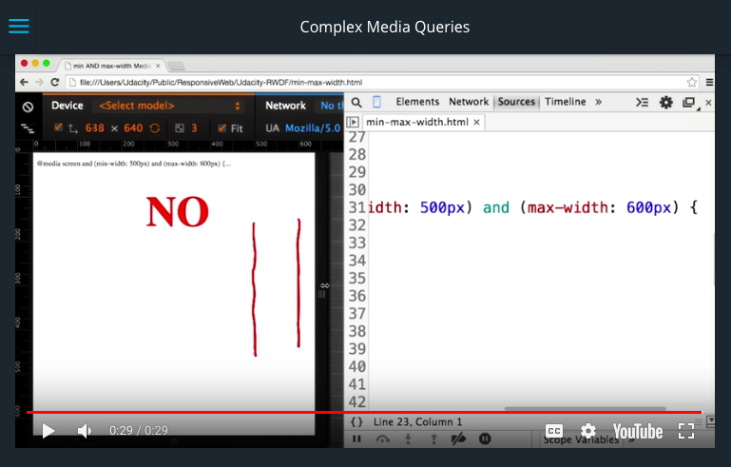

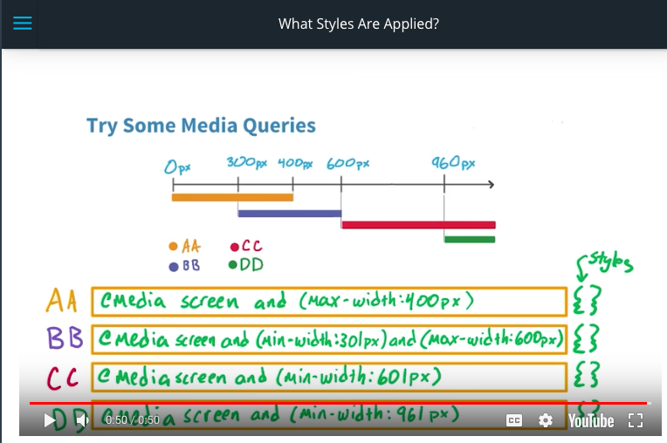

Want some help with media queries? Check out [**this guide on MDN.**](https://developer.mozilla.org/en-US/docs/Web/Guide/CSS/Media_queries)

Cameron makes a reference here to the Intro to HTML and CSS course, which has since been replaced with newer content. If you'd like to learn more about grids, we encourage you to check out [**MDN's introduction to grid layout.**](https://developer.mozilla.org/en-US/docs/Web/CSS/CSS_Grid_Layout/Basic_Concepts_of_Grid_Layout)

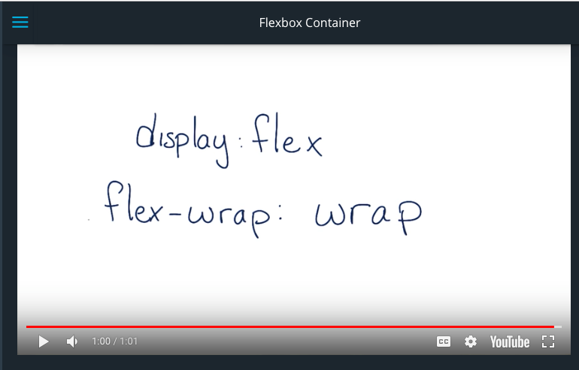

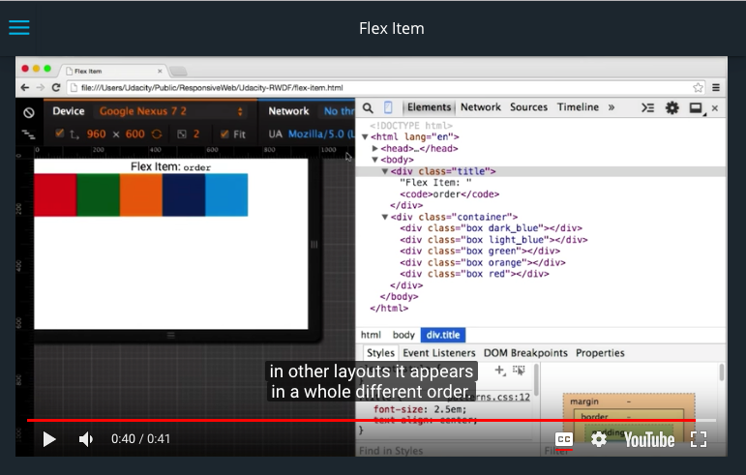



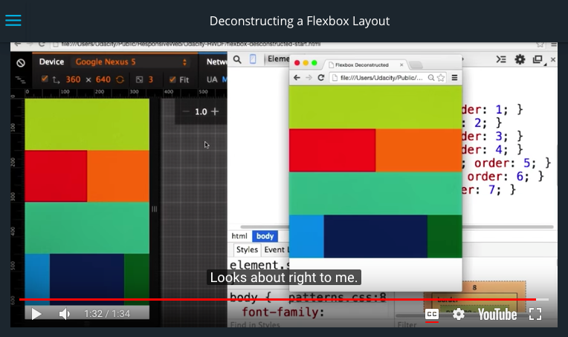

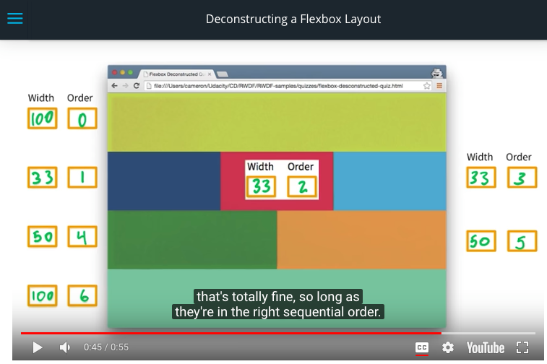

**Hint**: you **don't** need to include % in your **width** answers.