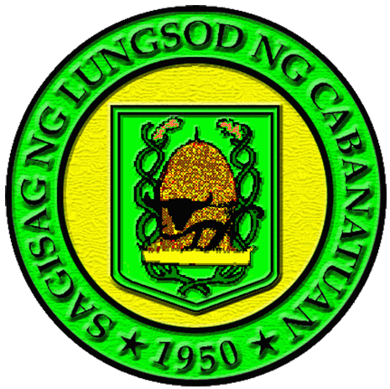
REPUBLIC OF THE PHILIPPINES
PROVINCE OF NUEVA ECIJA
CITY GOVERNMENT OF CABANATUAN
A Web-Based AI-Assisted Ordinance
Information System for Cabanatuan City
Comprehensive Multi-Role User & Administrative Manual
End-User Citizen • Barangay Administrator • LGU Super Administrator
BSIT Capstone Project Final Defense Edition
Document Version 2.0 • October 2026
Capstone Research Proponents:
Chris Karl M. Lacanilao • John Carlo DG. Lemence
Manny N. Agulto • Reyven B. Calara
Degree Program:
Bachelor of Science in Information Technology (BSIT)
College of Information and Communications Technology
Cabanatuan City, Nueva Ecija, Philippines

Table of Contents
Manual Section | Covered Workflows & Architectural Topics
1. Executive Summary & System Overview | 1.1 Background & Innovation, 1.2 System Scope & Objectives, 1.3 Key Innovation Matrix
2. System Architecture & Role-Based Access Control | 2.1 Technical Stack, 2.2 Security Architecture, 2.3 Role Permissions Matrix
3. System Access & Multi-Role Authentication | 3.1 Zero-Barrier Public Access, 3.2 Secure Login Procedure, 3.3 Session Management
4. Citizen & Public End-User Guide (7 Workflows) | 4.1 Homepage & 3D Archive, 4.2 Ordinance Explorer, 4.3 Split-Screen Detail View, 4.4 Official Scanned PDF Viewer, 4.5 AI Civic Assistant, 4.6 Incident Reporting, 4.7 Civic News Feed
5. Barangay Administrator Operations Guide (7 Workflows) | 5.1 Barangay Governance Dashboard, 5.2 Local Ordinance Repository, 5.3 Ordinance Proposal & Drafting, 5.4 AI Multimodal OCR Extraction, 5.5 Resident Incident Triage, 5.6 Case Status Updates, 5.7 Barangay Legislative Reports
6. LGU Super Administrator Executive Guide (10 Workflows) | 6.1 Executive City Hall Dashboard, 6.2 Central Ordinance Repository, 6.3 Reviewing Barangay Submissions, 6.4 AI Ordinance Extraction, 6.5 User & Official Management, 6.6 Barangay Directory, 6.7 City-Wide Reports Monitoring, 6.8 Civic News Broadcast, 6.9 Legislative Report Generator, 6.10 Governance Analytics & Visualizations
7. Multi-Tenant Data Isolation & Security Guidelines | 7.1 Multi-Tenant Integrity, 7.2 Salted bcrypt Encryption, 7.3 Audit Trails & Traceability
8. Troubleshooting, System Prerequisites & FAQ | 8.1 System Requirements, 8.2 Common Operational Issues, 8.3 Defense Panel Technical FAQ
📌 NOTE: HOW TO USE THIS OPERATIONAL MANUAL
This user manual is formatted on a per-user-role basis. To perform tasks specific to your official capacity, navigate directly to your designated chapter:
• Public Citizens: Chapter 4 (Workflows 4.1 to 4.7)
• Barangay Captains & Secretaries: Chapter 5 (Workflows 5.1 to 5.7)
• City Hall & LGU Super Administrators: Chapter 6 (Workflows 6.1 to 6.10)
Each section contains high-resolution genuine application screenshots with numbered callout circles corresponding exactly to the step-by-step instructions.

Chapter 1: Executive Summary & System Overview
The Cabanatuan City Ordinance Portal is an integrated web-based civic technology platform engineered to modernise, centralise, and automate municipal and barangay ordinance governance across the City of Cabanatuan, Nueva Ecija. Operating across eighty-nine (89) administrative barangays, local government units historically faced fragmented physical records, cumbersome paper drafting procedures, manual OCR encoding bottlenecks, and limited public visibility into enacted local laws.
To decisively overcome these governance challenges, this project introduces a unified, multi-tiered legislative ecosystem combining zero-barrier civic transparency for citizens, localized jurisdictional autonomy for barangay councils, and comprehensive executive oversight for City Hall.

1.1 Core Innovation Matrix
System Innovation | Technical Implementation & Impact
Multimodal AI Document Extractor | Powered by Google Gemini multimodal vision processing. Government clerks upload scanned PDF copies or smartphone photos of signed physical ordinances. The engine performs high-precision OCR, strips bureaucratic legal preambles, and populates resolution numbers, series years, categories, coverage, and tiered fine schedules with human-in-the-loop review in under 5 seconds.
Bilingual Gemini AI Civic Assistant (RAG) | A conversational Retrieval-Augmented Generation assistant embedded on the public portal. Citizens inquire in English, Tagalog, or Taglish (e.g., 'Ano ang parusa sa illegal dumping sa Camp Tinio?'). The pipeline injects verified local database legislation into the LLM context window to provide grounded, citation-rich answers while strictly refusing to give out-of-scope legal advice.
Multi-Tenant Barangay Isolation | Complete data partitioning and RBAC enforcement. Barangay administrators can only draft, view, and modify legislative records and community incident reports within their assigned jurisdiction, while City Hall LGU Super Admins retain consolidated city-wide oversight.
End-to-End Incident Traceability | A closed-loop community reporting mechanism. Residents submit violation complaints with automatic location landmarking and draft auto-save persistence. The system routes the report to the local Barangay Tanod desk, provides an audit reference tracking code to the citizen, and updates resolution statuses in real time.

Chapter 2: System Architecture & Role Permissions
The application is engineered on Next.js 16 (App Router & Turbopack), React 19, Tailwind CSS v4, Prisma ORM 7 with SQLite, and the Google GenAI SDK. Authentication is enforced through cryptographically signed JSON Web Tokens (jose) stored in Secure HTTP-only cookies, eliminating client-side token interception risks.
User permissions adhere strictly to the principle of least privilege through three dedicated roles:

2.1 Role-Based Access Control (RBAC) Matrix
System Module / Capability | Citizen / Public | Barangay Admin | LGU Super Admin
Public Landing Page & 3D Archive | Full Access (No Login) | Full Access | Full Access
Ordinance Explorer & PDF Viewer | Full Access (No Login) | Full Access | Full Access
AI Civic Assistant (Chatbot RAG) | Full Access (No Login) | Full Access | Full Access
Community Incident Report Submission | Full Access (Draft Persistence) | Full Access | Full Access
Barangay Governance Dashboard | No Access (Denied) | Full Access (Scoped to Barangay) | Supervisory View
Drafting Local Barangay Ordinances | No Access (Denied) | Full Access (Save Draft / Submit) | Full Access (City Enactments)
AI Document OCR Extraction Tool | No Access (Denied) | Local Extraction & Upload | Full City Hall Extraction
Review & Approve/Reject Submissions | No Access (Denied) | No Access (Barangay is Submitter) | Full Legislative Authority
User & Personnel Account Management | No Access (Denied) | No Access (Barangay Level) | Full Admin User Provisioning
Barangay Directory & Coverage | View Public Directory | View Local Barangay | Full 89 Barangay Management
Incident Report Resolution Triage | No Access (Resident View) | Triage Local Reports (Tanod Desk) | City-Wide Oversight & Auditing
Civic News Publishing & Broadcast | View Public Feed | Propose Local Advisories | Publish, Edit, Pin City Bulletins
Official Legislative Report Generator | No Access | Barangay Local Summary PDF | Full Municipal PDF Generator
Executive Governance Analytics | No Access | Barangay Resolution Rates | Comprehensive Recharts Analytics
💡 PRO-TIP: SECURITY ARCHITECTURE COMPLIANCE
The system complies with Section II of the BSIT Capstone Defense Guide. Passwords are never stored in plaintext and are hashed using bcrypt with 10 salt rounds. Multi-tenant database queries enforce WHERE barangayId = session.barangayId on all mutation endpoints, preventing unauthorized cross-jurisdiction access.

Chapter 3: System Access & Multi-Role Authentication
Access to the Cabanatuan City Ordinance Portal is structured into two tiers: zero-barrier public exploration (requiring zero registration or login) and secure administrative access for city and barangay officials.

3.1 Public Portal Landing & Civic Navigation
Step 1: Accessing the Portal — Open any modern web browser (Google Chrome, Microsoft Edge, Mozilla Firefox, or Safari) and navigate to the official portal domain (or http://localhost:3000 for local administrative installations).
Step 2: Public Portal Navigation — Inspect the civic navigation bar (Badge 2) containing direct links to Ordinances, Community Reports, AI Assistant, Civic News, and Administrative Sign-in.
Step 3: Keyword Quick Search — Locate the prominent Hero Search input (Badge 3). Type in any keyword such as 'Traffic', 'Basura', or 'Curfew' to execute immediate full-text search across all municipal legislation.
Step 4: Category Discovery — Click any of the quick discovery category chips (Badge 4) to instantly filter ordinances by municipal interest areas.
Step 5: Interactive 3D Archive Exploration — Interact with the Three.js 3D Ordinance Archive Canvas (Badge 5) using mouse drag or touch gestures to rotate the cylindrical archive.
Step 6: Toggling Accessibility Themes — Click the Theme Toggle button (Badge 6) in the upper right header to switch between Light and Dark mode.
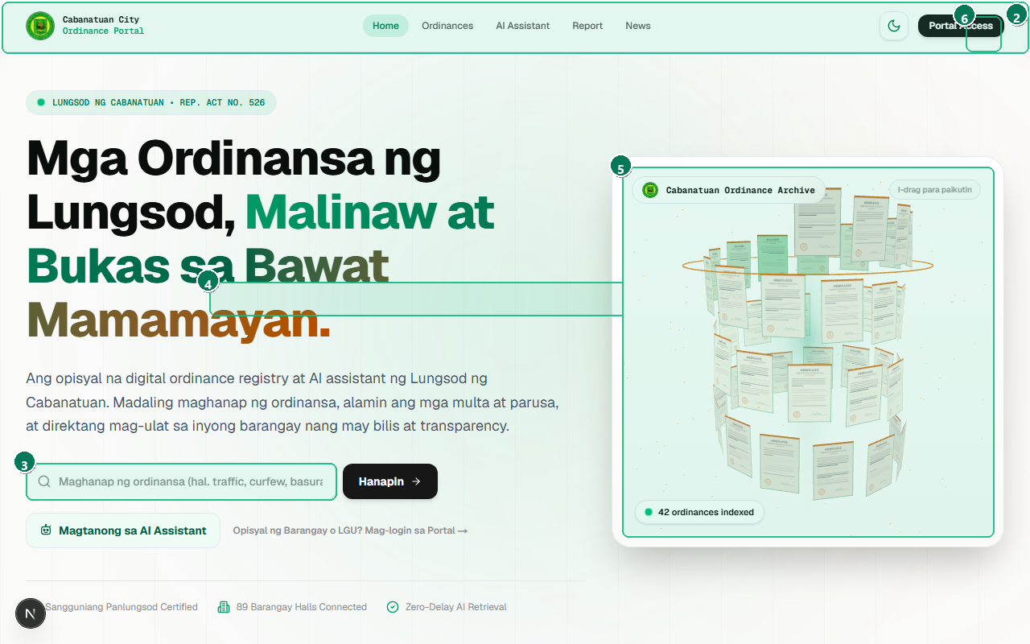
Figure 3.1: The public homepage provides zero-barrier access to city ordinances, quick search, interactive 3D archive, and civic links.
# | Interface Element / Control | Operational Purpose & Usage
1 | Cabanatuan City Seal & Portal Branding | Official seal of the City Government of Cabanatuan, linking back to the root landing interface.
2 | Main Navigation Bar | Top persistent navigation bar hosting direct links to Ordinances, Report, AI Assistant, News, and Login.
3 | Hero Search Bar | Primary full-text query bar supporting real-time keywords, resolution numbers, and Tagalog terms.
4 | Quick Category Discovery Chips | Quick-discovery filter chips enabling 1-click access to common legal categories (#Basura, #Trapiko, #Kalusugan).
5 | Interactive 3D Ordinance Archive Canvas | Interactive WebGL Three.js 3D cylindrical visualization displaying active municipal legislation.
6 | Portal Theme Toggle (Dark/Light) | Accessibility theme toggle allowing instant switching between high-contrast Dark Mode and crisp Light Mode.

3.2 Multi-Role Authentication Procedure
Step 1: Navigating to Authentication — Click the 'Mag-log In' button on the navigation bar, or navigate directly to /login.
Step 2: Entering Official Email — In the Email field (Badge 2), enter your verified administrative email address (e.g., admin@cabanatuan.gov.ph for LGU Super Admin or kapitan@cabanatuan.gov.ph for Barangay Admin).
Step 3: Entering Password — In the Password field (Badge 3), input your secure password. The interface masks characters for shoulder-surfing protection.
Step 4: Submitting Credentials — Click the 'Pumasok sa Portal' button (Badge 4). Upon verification, the system creates an HTTP-only JWT session cookie and redirects you automatically to your designated dashboard.
Step 5: Demo Preset Quick-Fill — For defense demonstrations or training, click any of the preset role chips (Badge 5) to auto-fill verified demonstration credentials.
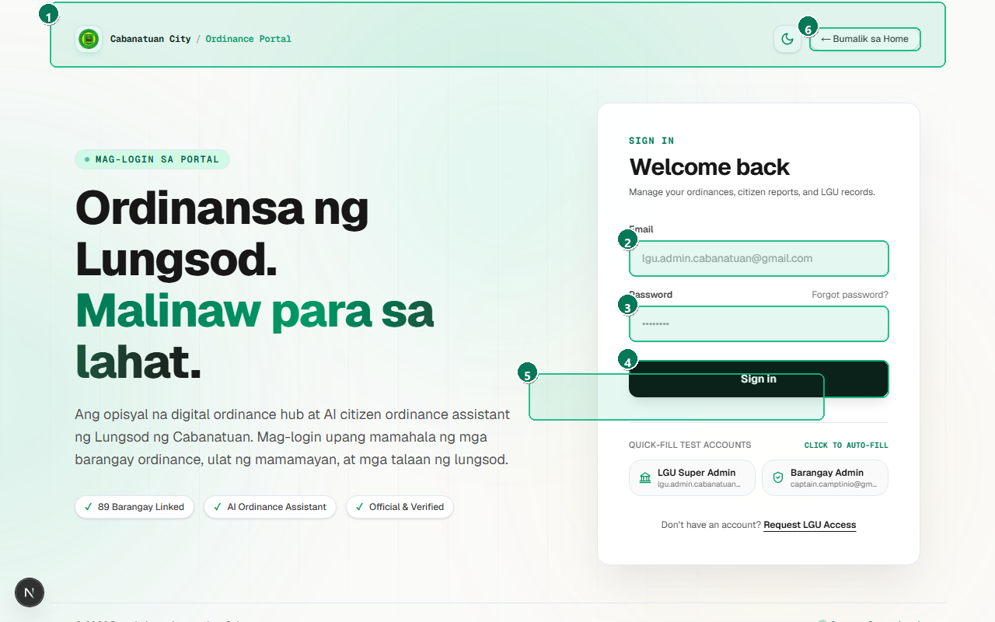
Figure 3.2: Secure sign-in interface supporting Role-Based Access Control (RBAC) for LGU Super Administrators, Barangay Officials, and Citizens.
# | Interface Element / Control | Operational Purpose & Usage
1 | Official Portal Authentication Header | Official civic authentication branding with municipal security badges and credential encryption notice.
2 | Official Email Address Input Field | Email entry field accepting registered administrative credentials (e.g., admin@cabanatuan.gov.ph).
3 | Password Input Field | Masked password field authenticated via salted bcrypt hashing and HTTP-only session tokens.
4 | Sign In / Submit Button (Pumasok sa Portal) | Primary authentication submission button triggering server-side role evaluation and session dispatch.
5 | Quick Role Preset Access Chips | Rapid test-credential selector enabling instant sign-in for demonstration and testing purposes.
6 | Return to Public Portal Homepage Link | Public redirect anchor allowing users to exit the authentication boundary and return to public browsing.

3.3 High-Contrast Dark Mode & Accessibility
Step 1: Engaging Dark Theme — Click the Theme Toggle icon (Badge 2). The application dynamically swaps CSS design tokens across backgrounds, borders, and typography.
Step 2: Reviewing High Contrast — Inspect the high-contrast dark header and search bar (Badges 1 and 3) designed with muted emerald accents for night viewing.
Step 3: Visualizing 3D Elements in Dark Mode — The WebGL canvas (Badge 4) automatically adapts its lighting shaders and particle background to dark aesthetics.
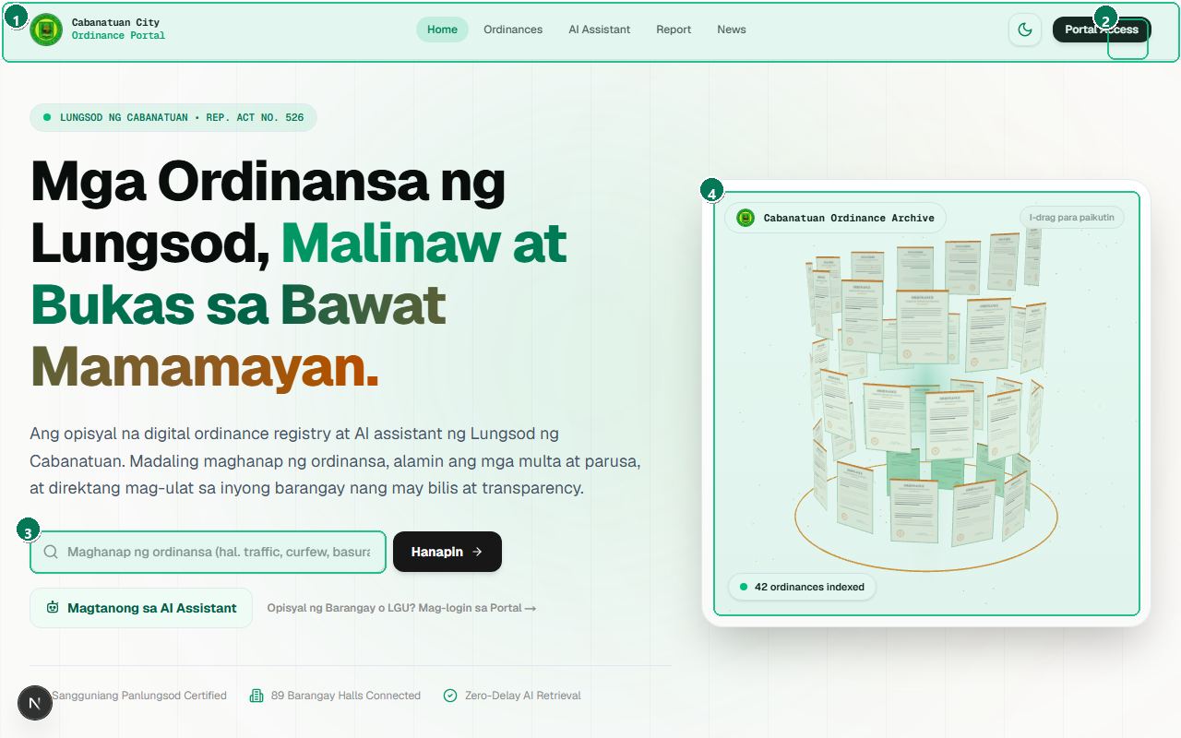
Figure 3.3: Zero-flicker dark aesthetic compliant with WCAG accessibility standards, designed for comfortable nighttime civic reading.
# | Interface Element / Control | Operational Purpose & Usage
1 | Dark High-Contrast Civic Header | Dark-optimized civic header with emerald branding maintaining AAA contrast standards.
2 | Active Dark Mode Theme Toggle | Active state theme switch reflecting dark mode engagement across the entire application shell.
3 | Dark Glassmorphic Search & Suggestion Bar | Glassmorphic high-contrast search input designed for glare-free nighttime legibility.
4 | Interactive 3D Cylinder Archive (Dark Scheme) | Three.js canvas dynamically re-rendered with ambient emerald glow and dark cylindrical facets.

💡 PRO-TIP: OFFICIAL DEMONSTRATION CREDENTIALS REFERENCE
For defense evaluation, the system is seeded with three primary verified accounts:
• LGU Super Admin: admin@cabanatuan.gov.ph | Password: admin123 (Redirects to /admin/lgu)
• Barangay Admin (Camp Tinio): kapitan@cabanatuan.gov.ph | Password: kapitan123 (Redirects to /admin/barangay)
• Resident / Citizen: juan@cabanatuan.gov.ph | Password: citizen123 (Public exploration & report filing)

Chapter 4: Citizen & Public End-User Guide
A cornerstone of the Cabanatuan City Ordinance Portal is zero-barrier public civic transparency. Cabanatuan residents, students, business owners, and legal researchers can browse enacted municipal regulations, examine certified PDF copies, consult the bilingual Gemini AI Civic Assistant, and submit incident reports without mandatory account creation.

4.1 Public Ordinance Explorer & Multi-Filtering
Step 1: Navigating to Explorer — Click 'Mga Ordinansa' in the navigation bar or visit /ordinances.
Step 2: Instant Keyword Filtering — Enter terms into the Full-Text Search box (Badge 1). The interface filters records instantly with zero page reloads.
Step 3: Selecting Policy Categories — Click any category button (Badge 2) such as 'Kapayapaan at Kaayusan', 'Kalusugan', or 'Kapaligiran' to narrow results.
Step 4: Adjusting Year Slider — Drag the Year Range Slider (Badge 3) to isolate legislation enacted within specific legislative calendar terms.
Step 5: Filtering by Jurisdiction — Use the Jurisdiction Scope buttons (Badge 4) to toggle between City-Wide Ordinances and Barangay Regulations.
Step 6: Browsing Results — Click any ordinance card in the responsive grid (Badge 5) to inspect its full legal text.
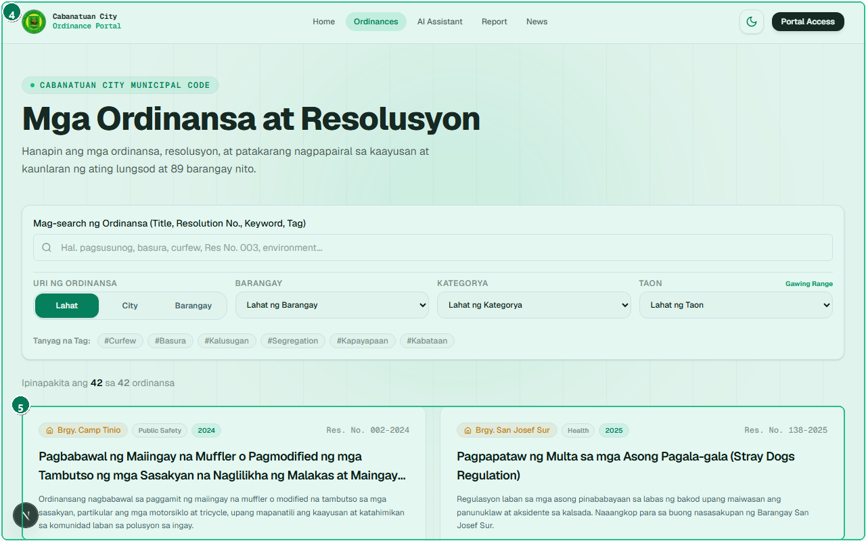
Figure 4.1: Comprehensive search and multi-filtering system enabling citizens to find city and barangay ordinances by keyword, year, and category.
# | Interface Element / Control | Operational Purpose & Usage
1 | Full-Text Keyword Search Input | Real-time debounce search input filtering ordinances across title, resolution number, and content.
2 | Policy Category Filter Chips | Interactive category pill selectors filtering records by municipal jurisdiction areas.
3 | Dynamic Year Range Filter Slider | Dynamic double-ended year slider isolating ordinances enacted between 2018 and 2026.
4 | Jurisdiction Scope Filter (City vs Barangay) | Jurisdiction filter segmented buttons toggling between City-wide and Barangay-level ordinances.
5 | Ordinance Card Grid with Status & Category Tags | Responsive card grid displaying approved ordinances with title, category, year, and read-more actions.

4.2 Split-Screen Legal Text & Sanctions View
Step 1: Reviewing Heading & Resolution Number — Verify the official ordinance title and unique legislative resolution number at the top of the view (Badge 1).
Step 2: Inspecting Legislative Metadata — Check the enacting date, year series, and authorizing body (Badge 2).
Step 3: Reading Legal Provisions — Read through the structured legal articles and prohibited acts on the split-screen left pane (Badge 3).
Step 4: Inspecting Sanctions & Penalties — Examine the dedicated Sanctions Card on the right sidebar (Badge 4) for tiered monetary fines and community service provisions.
Step 5: Accessing Certified PDF Document — Click the 'Buksan ang Opisyal na PDF' button (Badge 5) to open the verified scanned original document.
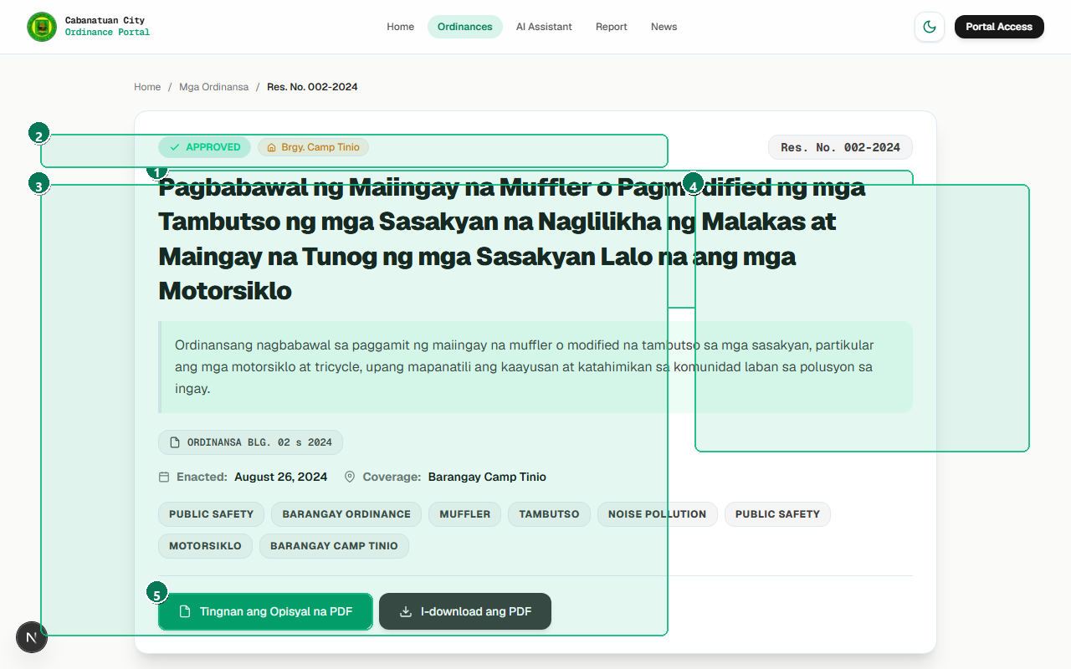
Figure 4.2: Structured presentation of ordinance text, breaking complex legislation into readable articles, penalties, and enforcement mechanisms.
# | Interface Element / Control | Operational Purpose & Usage
1 | Official Ordinance Title & Resolution Number | Official ordinance heading and enacted resolution identifier formatted for civic clarity.
2 | Legislative Metadata (Date, Series Year, Enacting Body) | Comprehensive enactment metadata including date passed, series year, and presiding legislative body.
3 | Structured Legal Articles & Provisions (Split-Screen Left) | Structured legal provisions broken down into numbered articles, sections, and prohibited acts.
4 | Summary, Sanctions & Tiered Penalties Card (Right) | Prominent sanctions sidebar detailing tiered monetary fines and community service consequences.
5 | Open Official PDF Document Viewer Button | High-priority action button launching the interactive scanned PDF document modal dialog.

4.3 Official Scanned PDF Viewer Modal
Step 1: Inspecting Scanned Resolution Copy — The embedded viewer (Badge 2) loads the scanned physical document complete with official dry seals and physical signatures.
Step 2: Using Interactive Zoom Controls — Use the Zoom In (+) and Zoom Out (-) buttons (Badge 3) to inspect fine print, signatures, and legal annotations.
Step 3: Downloading the PDF File — Click the 'I-download ang Dokumento' button (Badge 4) to save a certified copy to your computer or mobile device.
Step 4: Closing the Modal Dialog — Click the Close button (Badge 5) or press the Escape key to return to the ordinance overview.
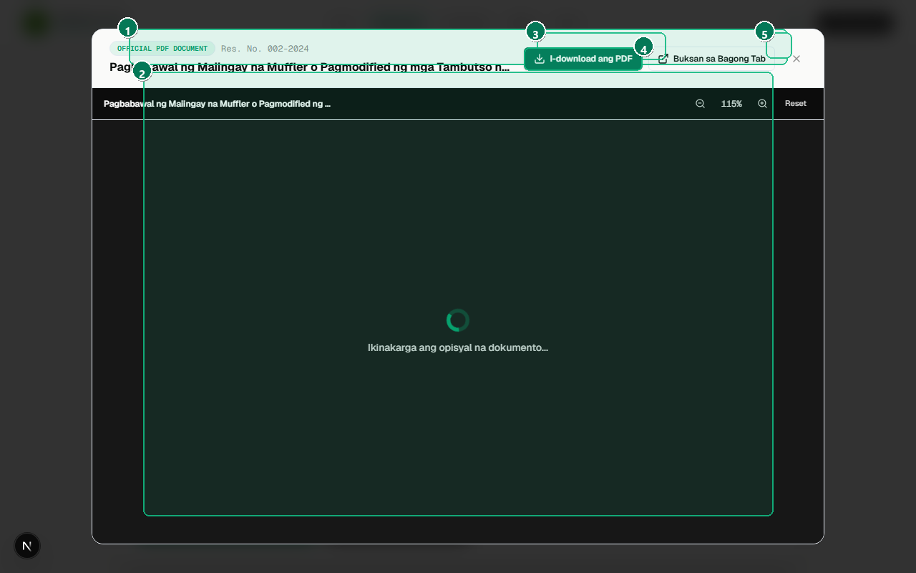
Figure 4.3: Integrated in-browser document viewer allowing residents to examine official stamped ordinances, zoom into signatures, and download verified copies.
# | Interface Element / Control | Operational Purpose & Usage
1 | Official Document Modal Dialog Header | Accessible modal container with resolution identification and WCAG-compliant dialog focus lock.
2 | Embedded Digital PDF Document Canvas | Embedded document renderer presenting the original certified scanned paper copy with official seals.
3 | Interactive Zoom & Pagination Controls | Interactive magnification controls (+ / - / Reset) for inspecting physical signatures and dry seals.
4 | Direct PDF File Download Action Button | Direct download button retrieving the official PDF file to the resident's local storage.
5 | Modal Dismiss / Close Action (Esc) | Accessible dismissal control triggering clean modal close (also supports keyboard Escape key).

4.4 AI Civic Assistant (Bilingual Gemini RAG)
Step 1: Navigating to AI Assistant — Click 'AI Assistant' in the header navigation or open /chatbot.
Step 2: Noting the Civic Safety Disclaimer — Read the informational notice at the top (Badge 1) clarifying that the assistant provides informational citations and not legal advice.
Step 3: Using Preset Action Inquiries — Click any of the quick prompt chips (Badge 2) to explore common questions regarding curfew hours, waste burning, or traffic rules.
Step 4: Typing Natural Language Inquiries — Type your question into the chat input field (Badge 5) in English, Tagalog, or Taglish, then click Send (Badge 6).
Step 5: Reviewing Citation-Grounded Responses — The Gemini RAG pipeline queries local municipal ordinances and streams an answer citing specific resolution numbers and fine schedules (Badge 4).
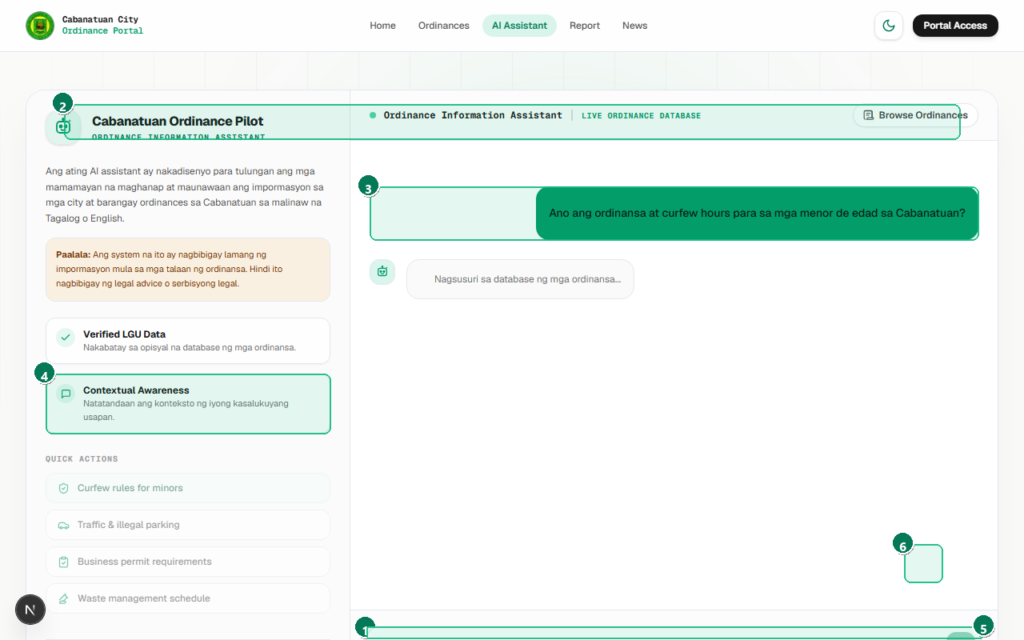
Figure 4.4: Retrieval-Augmented Generation (RAG) assistant powered by Google Gemini, answering citizen inquiries with official ordinance citations.
# | Interface Element / Control | Operational Purpose & Usage
1 | Civic Safety & Informational Disclaimer Banner | Prominent civic advisory banner stating AI outputs are informational and do not constitute formal legal counsel.
2 | Quick Common Inquiry Action Buttons | Preset citizen inquiry chips launching common questions regarding curfew, traffic, and waste management.
3 | Citizen Inquiry Message Bubble | Citizen message bubble reflecting natural English, Tagalog, or Taglish inquiry phrasing.
4 | Gemini RAG Assistant Answer with Ordinance Citations | Gemini RAG assistant response citing exact resolution numbers, article clauses, and tiered penalty schedules.
5 | Bilingual Question Input Field | Bilingual prompt input supporting conversational inquiries with debounced token streaming.
6 | Send Message Action Button | Message dispatch button transmitting prompt to the Gemini 3.5 Flash Lite retrieval pipeline.

4.5 Submitting a Community Incident Report
Step 1: Reviewing Emergency Hotline Notice — Inspect the prominent red emergency banner (Badge 1). If an incident involves an ongoing fire, medical emergency, or crime in progress, call the listed hotlines immediately (e.g., CDRRMO Rescue at 044-940-0161).
Step 2: Selecting Assigned Barangay — Open the Barangay selector (Badge 2) and select the specific barangay where the violation occurred (e.g., Camp Tinio).
Step 3: Choosing Violation Category — Select the category from the dropdown (Badge 3), such as 'Sanitation / Basura', 'Ingay / Loud Exhausts', or 'Obstruction'.
Step 4: Entering Subject & Details — Provide a brief summary in the Subject line (Badge 4) and full narrative details in the Textarea (Badge 5), including landmarks.
Step 5: Client-Side Draft Persistence — The form automatically saves typed content to browser local storage. If your page reloads accidentally, all typed information is instantly restored.
Step 6: Submitting the Report — Choose whether to remain anonymous (Badge 6) and click 'I-sumite ang Ulat sa Barangay' (Badge 7).
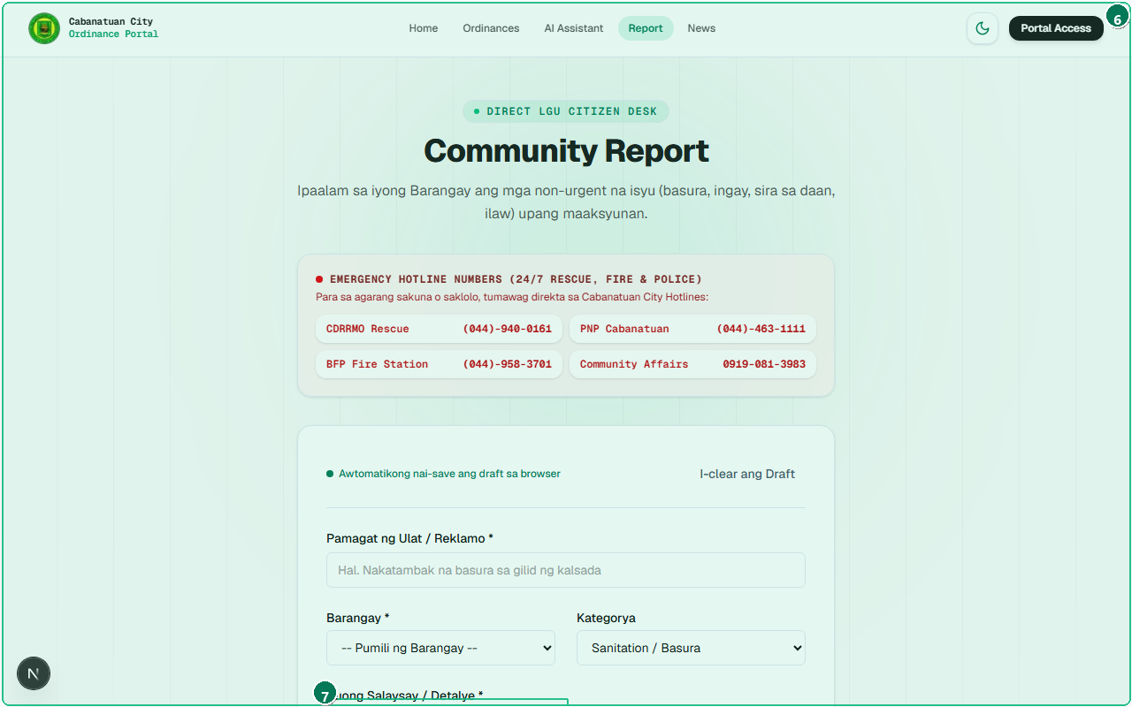
Figure 4.5: Citizen incident submission interface equipped with client-side draft auto-save persistence and direct routing to barangay halls.
# | Interface Element / Control | Operational Purpose & Usage
1 | 24/7 City Emergency Hotline Numbers Banner | Emergency numbers bulletin emphasizing that urgent rescue, fire, and police matters must call 911 / CDRRMO.
2 | Assigned Barangay Jurisdiction Dropdown | Participating barangay dropdown routing the incident directly to the designated barangay hall.
3 | Incident Category Selector | Standardized incident category selector (Open Burning, Noise Disturbance, Road Obstruction, etc.).
4 | Incident Subject / Summary Input Field | Location landmark input capturing precise neighborhood coordinates (purok, street, corner).
5 | Incident Narrative & Location Details Textarea | Narrative details textarea capturing factual descriptions of the observed ordinance violation.
6 | Anonymous Reporting Toggle & Contact Fields | Anonymous submission checkbox protecting resident identity with optional follow-up phone entry.
7 | Submit Incident Report Action Button | Formal report submission trigger validating required fields and committing to the database.

4.6 Submission Feedback & Tracking Reference
Step 1: Reviewing Confirmation Alert — Upon submission, a prominent green confirmation alert banner appears on screen (Badge 1).
Step 2: Verifying Destination Routing — The banner confirms that the incident has been officially routed to the target barangay hall (Badge 2).
Step 3: Recording Tracking Code — Copy or screenshot the generated unique Transaction Reference Code (Badge 3) for future follow-up with barangay officials.
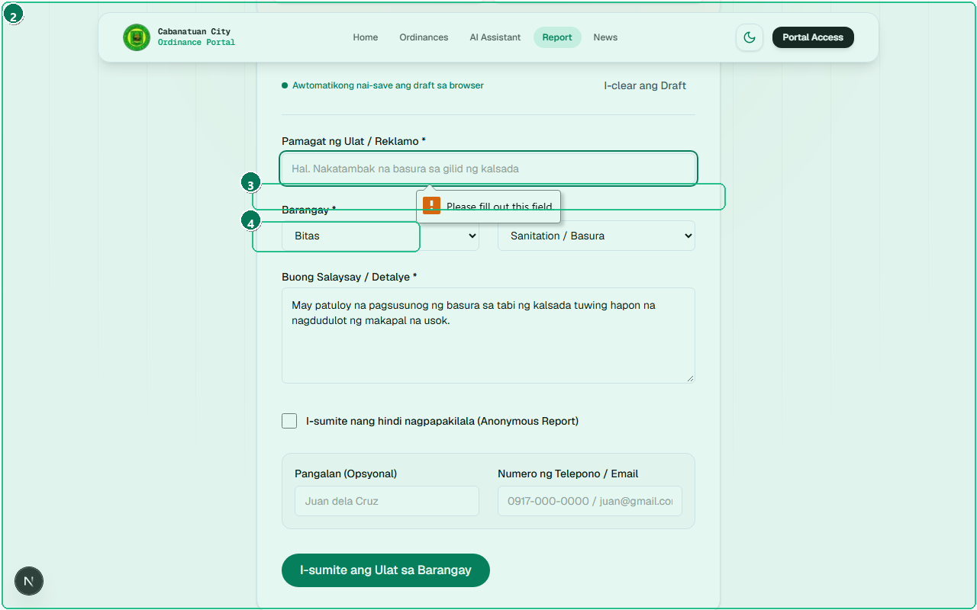
Figure 4.6: Confirmation alert providing a unique tracking code for citizen verification, seamlessly connecting to barangay admin triage.
# | Interface Element / Control | Operational Purpose & Usage
1 | Official Submission Confirmation Alert Banner | Role-alert confirmation banner signaling successful transmission to local barangay authorities.
2 | Target Barangay Hall Routing Notification | Designated destination barangay hall confirmation verifying operational jurisdiction routing.
3 | Official Tracking Reference Code | Cryptographic unique tracking code allowing residents to verify follow-up action with officials.
4 | File Another Report / Return Option | Form reset action button allowing residents to submit another report or navigate back home.

4.7 Civic News & Public Advisories Feed
Step 1: Accessing Newsroom — Click 'Balita' in the navigation bar or visit /news.
Step 2: Filtering by Category — Toggle between 'Lahat', 'Lungsod', and 'Barangay' filters (Badge 2).
Step 3: Reading Pinned Urgent Directives — Inspect high-priority executive directives marked with the Pinned tag (Badge 3) at the top of the feed.
Step 4: Browsing Community Articles — Read chronological updates, cleanup drives, and municipal council session summaries (Badge 4).
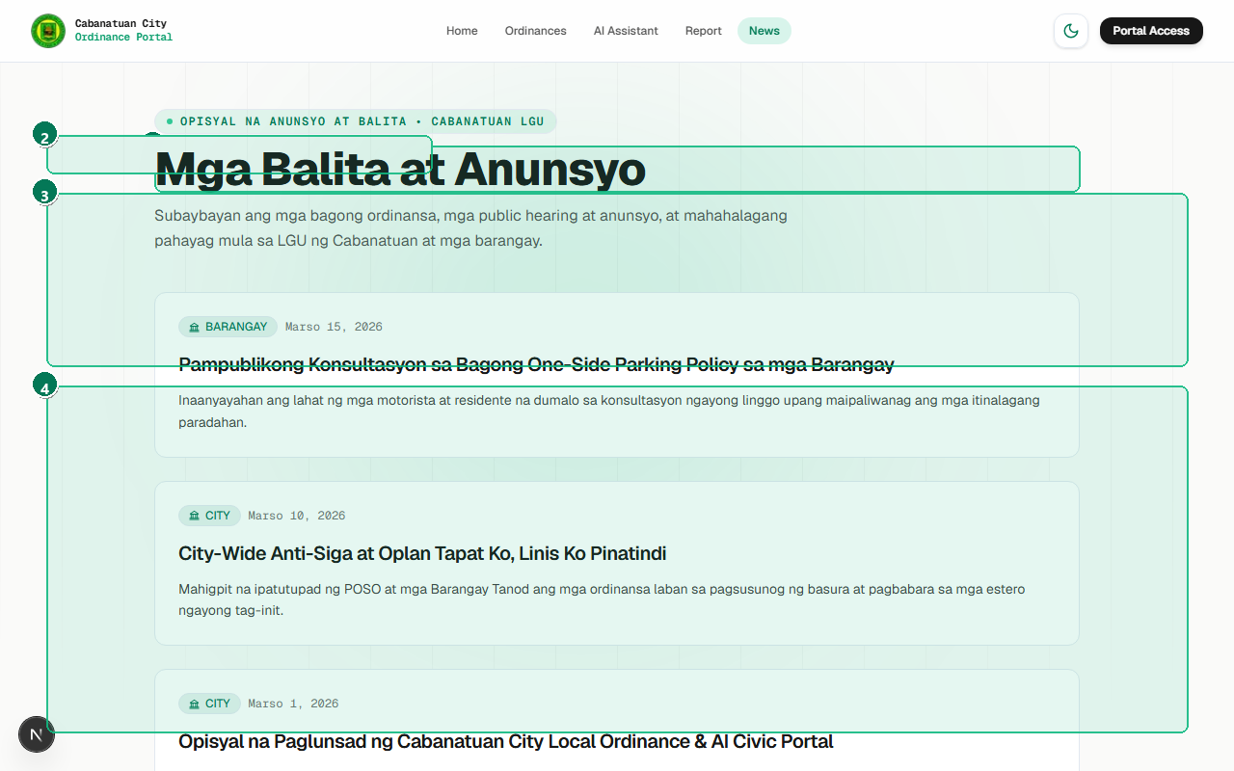
Figure 4.7: Public information broadcast feed synchronizing official legislative reminders and community announcements across Cabanatuan City.
# | Interface Element / Control | Operational Purpose & Usage
1 | Civic News & Legislative Advisories Header | Civic newsroom header displaying verified announcements from City Hall and participating barangays.
2 | News Category Filter Tabs (Lahat, Lungsod, Barangay) | Category filter tabs toggling between city-wide advisories and localized barangay updates.
3 | Pinned Official Executive Advisory Card | Prominent pinned announcement card displaying urgent public notices and executive directives.
4 | Chronological Community News Feed | Chronological advisory stream with publication timestamps, authoring agency, and read-more modals.

Chapter 5: Barangay Administrator Operations Guide
Barangay Administrators (Punong Barangays, Barangay Secretaries, and Sangguniang Barangay Members) possess dedicated administrative privileges scoped strictly to their registered barangay. Officials can draft local ordinances, parse scanned documents via Google Gemini multimodal OCR, transmit legislation to City Hall for legal review, triage community incident reports, and generate formal legislative reports.

5.1 Local Governance Dashboard Overview
Step 1: Signing In — Sign in using your verified barangay credentials (e.g., kapitan@cabanatuan.gov.ph / kapitan123).
Step 2: Verifying Jurisdiction Header — Confirm the header reads 'Barangay Governance Dashboard — Camp Tinio' (Badge 1). Data isolation prevents visibility of unrelated barangays.
Step 3: Inspecting Local KPI Cards — Monitor active local ordinances (Badge 2), pending proposals awaiting Sangguniang Panlungsod approval (Badge 3), and citizen reports (Badge 4).
Step 4: Triage Overview Feed — Examine incoming incident reports from constituents in the central activity table (Badge 5).
Step 5: Navigating Modules — Use the dedicated sidebar (Badge 6) to transition between Ordinances, Reports, and Analytics.
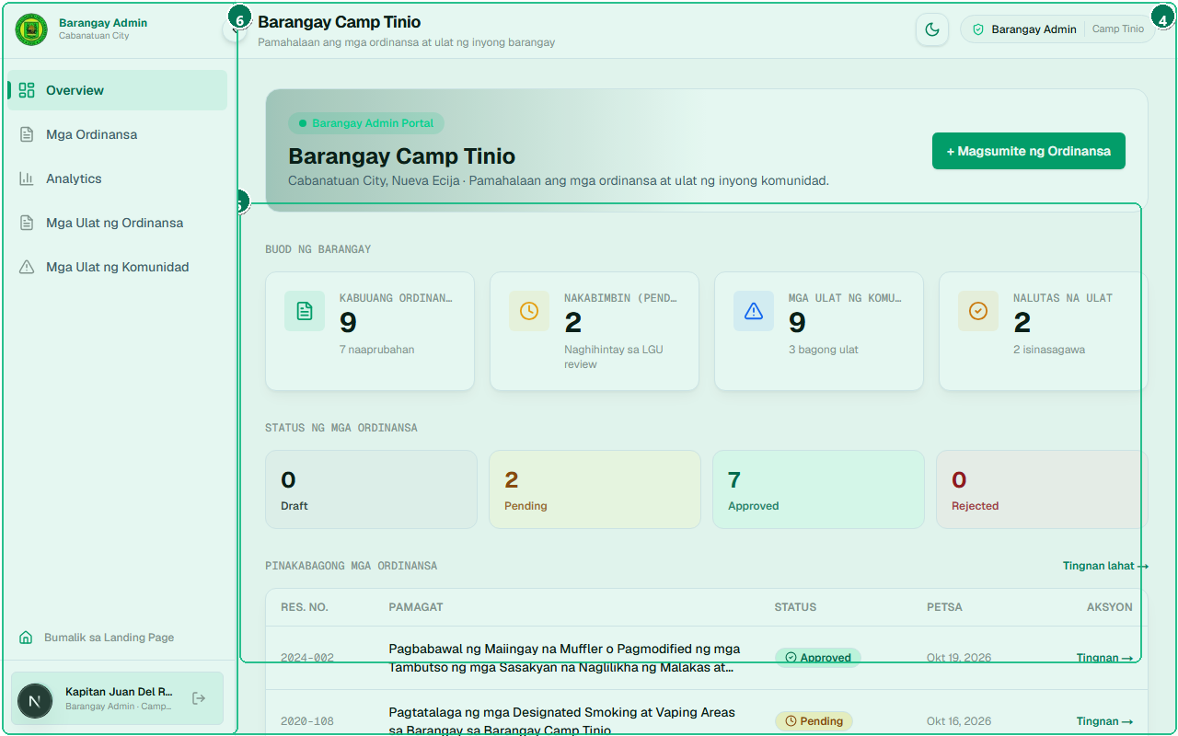
Figure 5.1: Localized dashboard scoped exclusively to Barangay Camp Tinio, displaying local ordinance counts, pending approvals, and constituent reports.
# | Interface Element / Control | Operational Purpose & Usage
1 | Barangay-Scoped Header ('Barangay Governance Dashboard — Camp Tinio') | Scoped header confirming administrative session for Barangay Camp Tinio with localized authority.
2 | Local Enacted Ordinances Metric Card | Active local ordinances counter tracking enacted barangay resolutions within the jurisdiction.
3 | Pending Legislative Proposals Metric Card | Pending proposals counter monitoring legislation submitted to City Hall awaiting LGU approval.
4 | Active Community Incident Reports Metric Card | Community reports KPI displaying incoming violation reports filed by barangay residents.
5 | Recent Community Incident Triage Feed | Real-time constituent incident report stream displaying recent submissions needing inspection.
6 | Barangay Admin Dedicated Navigation Sidebar | Barangay navigation sidebar providing rapid access to Ordinances, Community Reports, and Analytics.

5.2 Barangay Ordinance Management & Status Tabs
Step 1: Navigating to Repository — Click 'Mga Ordinansa' on the sidebar or visit /admin/barangay/ordinances.
Step 2: Triage by Status Tabs — Use the accessible status tabs (Badge 1) to inspect All, Pending, Approved, Draft, and Rejected ordinances.
Step 3: Searching Local Records — Type resolution numbers or keywords into the local search bar (Badge 3).
Step 4: Initiating New Enactment — Click the 'Magdagdag ng Ordinansa' button (Badge 2) to launch the proposal modal.
Step 5: Managing Legislative Records — Click action buttons (Badge 5) on any row to view, edit drafts, or resubmit rejected items.
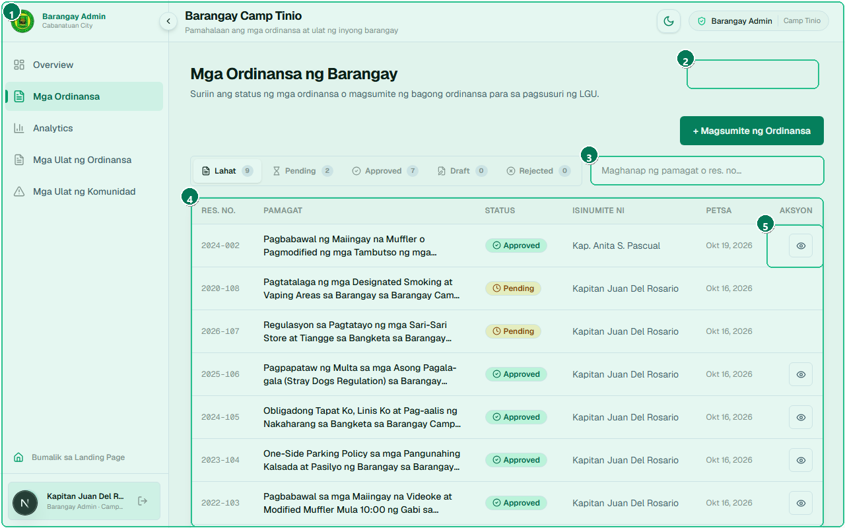
Figure 5.2: Administrative table for managing local resolutions across their complete lifecycle: Drafts, Pending LGU Submissions, and Approved laws.
# | Interface Element / Control | Operational Purpose & Usage
1 | Legislative Status Tabs (Lahat, Pending, Approved, Draft, Rejected) | Accessible status tabs filtering local records by All, Pending, Approved, Draft, and Rejected.
2 | Create / Propose New Ordinance Action Button | Primary enactment button opening the multi-stage ordinance proposal and drafting modal dialog.
3 | Local Ordinance Keyword Search Input | Search input enabling quick lookup of local barangay resolutions by keyword or series number.
4 | Barangay Ordinance Records Table with Status Badges | Comprehensive barangay ordinance data table displaying resolution numbers, titles, and dates.
5 | Item Action Controls (View, Edit Draft, Resubmit) | Action controls allowing officials to edit drafts, inspect rejected feedback, and resubmit items.

5.3 Drafting & Transmitting Local Ordinances
Step 1: Filling Legislative Metadata — Enter the proposed title and resolution number (Badge 2), followed by the policy category and year series (Badge 3).
Step 2: Drafting Legal Text & Sanctions — Enter legal provisions, prohibited acts, and fine schedules in the description and content inputs (Badge 4).
Step 3: Saving as Draft (Internal Staging) — Click 'I-save bilang Draft' (Badge 5). The record is stored with status DRAFT. City Hall cannot see or approve drafts until transmitted.
Step 4: Official Transmittal to LGU — Once approved by the Barangay Council, click 'Isumite sa LGU para sa Pagsusuri' (Badge 6). Status changes to PENDING and appears on the City Hall docket.
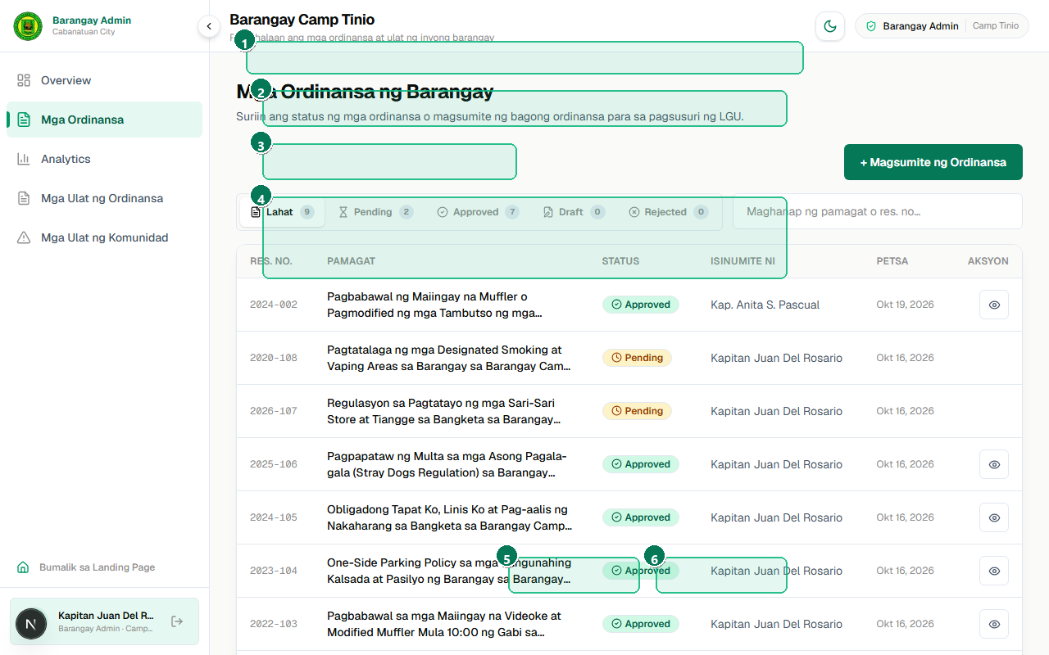
Figure 5.3: Multi-stage proposal form enabling officials to prepare local legislation, save works-in-progress as drafts, or transmit them directly to City Hall.
# | Interface Element / Control | Operational Purpose & Usage
1 | New Ordinance Proposal Modal Dialog Header | Ordinance drafting modal header indicating proposal preparation for barangay council consideration.
2 | Proposed Title & Resolution Number Input Fields | Title and resolution numbering inputs adhering to standard barangay legislative naming conventions.
3 | Legislative Category & Year Series Dropdowns | Categorization and enactment series selectors mapping the ordinance to city governance domains.
4 | Legal Summary & Prohibited Acts Content Fields | Legislative narrative fields for encoding background rationale, prohibited acts, and local coverage.
5 | Save as Draft Action Button (Internal Staging) | Draft saving action button persisting work-in-progress to the database without alerting City Hall.
6 | Submit to LGU for Approval Button (Official Transmittal) | Official transmittal button submitting the finalized ordinance to the LGU Super Admin for legal review.

5.4 Multimodal AI Document Extraction (Barangay)
Step 1: Activating AI Extractor — In the ordinance creation modal, locate the 'AI Auto-Extraction' section (Badge 1).
Step 2: Uploading Scanned Document — Drag and drop a scanned PDF or smartphone photograph of the signed paper ordinance into the dropzone (Badge 2).
Step 3: Executing AI Extraction — Click 'I-Extract gamit ang AI' (Badge 3). The system dispatches the file to the Google Gemini multimodal model.
Step 4: Monitoring Multi-Stage Progress — Watch the animated progress indicator (Badge 4) as the model parses OCR text, resolution numbers, and penalty clauses.
Step 5: Human-in-the-Loop Review — Inspect the automatically populated fields (Badge 5). Make minor adjustments if necessary, then click Save.
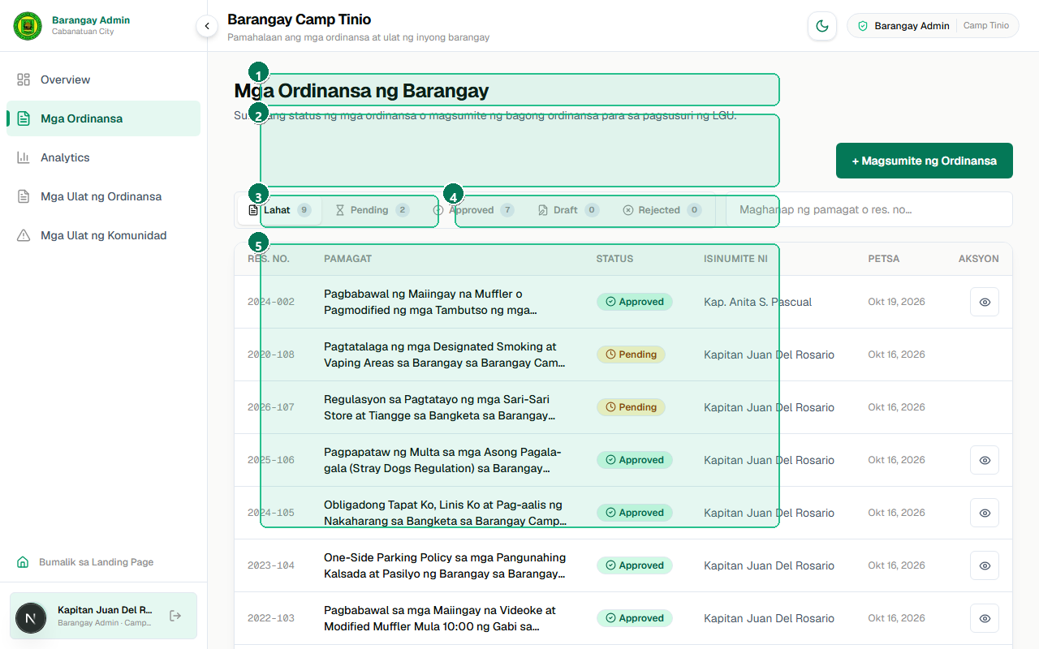
Figure 5.4: Automated extraction tool utilizing Google Gemini to convert scanned physical paper ordinances into structured database records in seconds.
# | Interface Element / Control | Operational Purpose & Usage
1 | AI Auto-Extraction Section Header & Gemini Sparkle Badge | AI extraction module header featuring Google Gemini multimodal OCR integration badge.
2 | Scanned Document PDF / Image File Dropzone | Drag-and-drop file upload zone accepting scanned PDF documents or multi-page high-resolution images.
3 | Execute Multimodal AI Parsing Button ('I-Extract gamit ang AI') | Extraction execution trigger initiating automated text recognition and semantic clause extraction.
4 | Multimodal OCR Status & Parsing Sequence | Multi-stage animated progress indicator displaying OCR analysis, metadata parsing, and penalty structuring.
5 | Auto-Populated Form Inputs with Human Verification | Auto-populated form fields allowing the official to perform human-in-the-loop review before saving.

5.5 Constituent Incident Reports Desk
Step 1: Navigating to Reports Desk — Click 'Mga Ulat ng Residente' on the sidebar or visit /admin/barangay/reports.
Step 2: Filtering by Status — Click status filter buttons (Badge 2) to display New complaints, In Progress investigations, or Resolved incidents.
Step 3: Inspecting Incident Rows — Examine violation categories, landmark locations, and narrative testimonies submitted by residents (Badge 3).
Step 4: Verifying Anonymity Badges — Check whether the citizen filed anonymously or attached verified contact details (Badge 4).
Step 5: Launching Triage Dialog — Click the action button (Badge 5) on any row to open the case management modal.
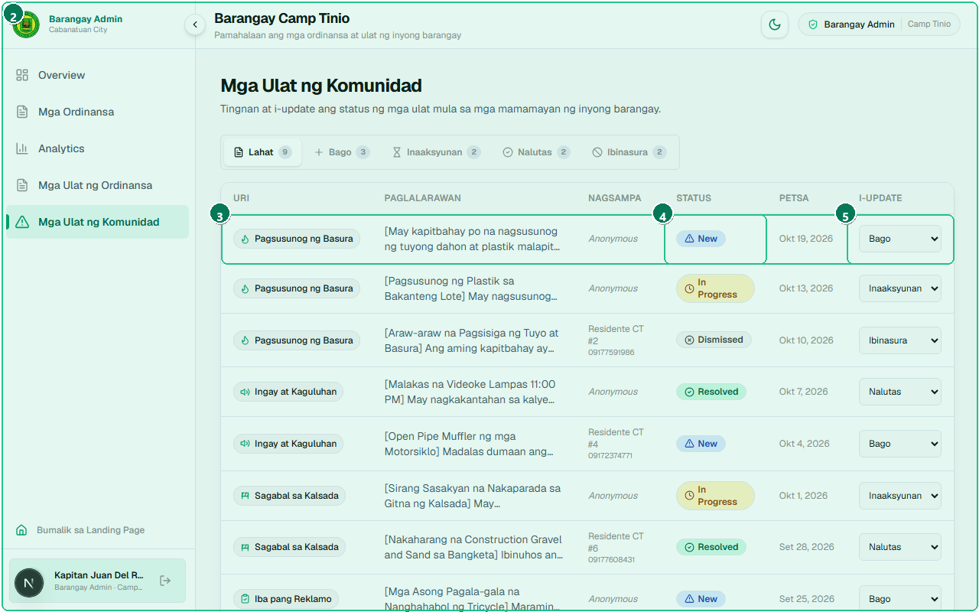
Figure 5.5: Triage desk where barangay officials monitor, inspect, and process violation reports submitted by local residents.
# | Interface Element / Control | Operational Purpose & Usage
1 | Barangay Community Incident Reports Header | Barangay reports desk header confirming oversight of citizen incident submissions in Camp Tinio.
2 | Status Filter Chips (Lahat, Bago, Inaaksyunan, Naresolba) | Status filter buttons (All, New, In Progress, Resolved) segregating reports by operational triage stage.
3 | Incident Report Record Row with Timestamp & Category | Incident record row detailing category, landmark location, narrative summary, and submission timestamp.
4 | Constituent Anonymity / Contact Verification Badge | Resident confidentiality badge indicating whether the submission is anonymous or carries contact info.
5 | Triage & Status Action Control | Triage action button opening the case management dialog for status update and officer dispatch notes.

5.6 Incident Case Triage & Status Resolution
Step 1: Reviewing Testimony & Evidence — Inspect the citizen's incident testimony, landmark coordinates, and timestamp (Badge 2).
Step 2: Updating Operational Status — Select the new status from the dropdown (Badge 3): change from 'Bago' (New) to 'Inaaksyunan' (In Progress) or 'Naresolba' (Resolved).
Step 3: Attaching Official Action Notes — In the Remarks field (Badge 4), enter official dispatch notes (e.g., 'Dispatched Barangay Tanod Team B for site inspection and mediation').
Step 4: Saving Updates — Click 'I-update ang Status' (Badge 5) to commit changes and log an audit timestamp.
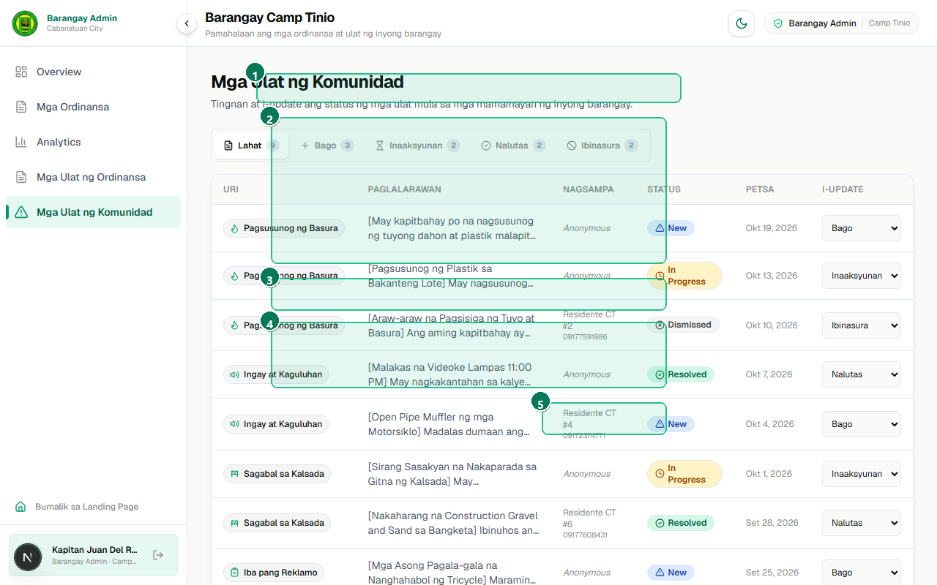
Figure 5.6: Action dialog enabling barangay leaders to dispatch officers, record findings, and transition complaints to 'In Progress' or 'Resolved'.
# | Interface Element / Control | Operational Purpose & Usage
1 | Incident Case Triage Dialog Header | Incident case overview modal displaying full resident testimony and timestamped submission details.
2 | Constituent Incident Details & Evidence Overview | Incident evidence review area allowing inspection of citizen descriptions and uploaded photo proofs.
3 | Resolution Status Selector (Bago -> Inaaksyunan -> Naresolba) | Operational status selector transitioning cases from 'New' to 'In Progress' and finally 'Resolved'.
4 | Barangay Official Action Remarks & Findings Field | Action remarks textarea where officials document barangay tanod dispatch and resolution measures taken.
5 | Confirm Status Update Action Button | Confirmation button committing status updates, creating an audit log, and notifying the resident.

5.7 Barangay Legislative Reporting & Export
Step 1: Navigating to Reporting Desk — Navigate to /admin/barangay/ordinance-reports or click 'Analytics & Reports'.
Step 2: Setting Report Parameters — Select report criteria, year ranges, and policy categories (Badge 2).
Step 3: Generating Summary Layout — Click 'I-generate ang Ulat' (Badge 3) to render the certified tabular layout.
Step 4: Exporting Formal PDF Documentation — Click 'I-download bilang PDF' (Badge 4) to compile a certified legislative record for the Barangay Hall physical archives.
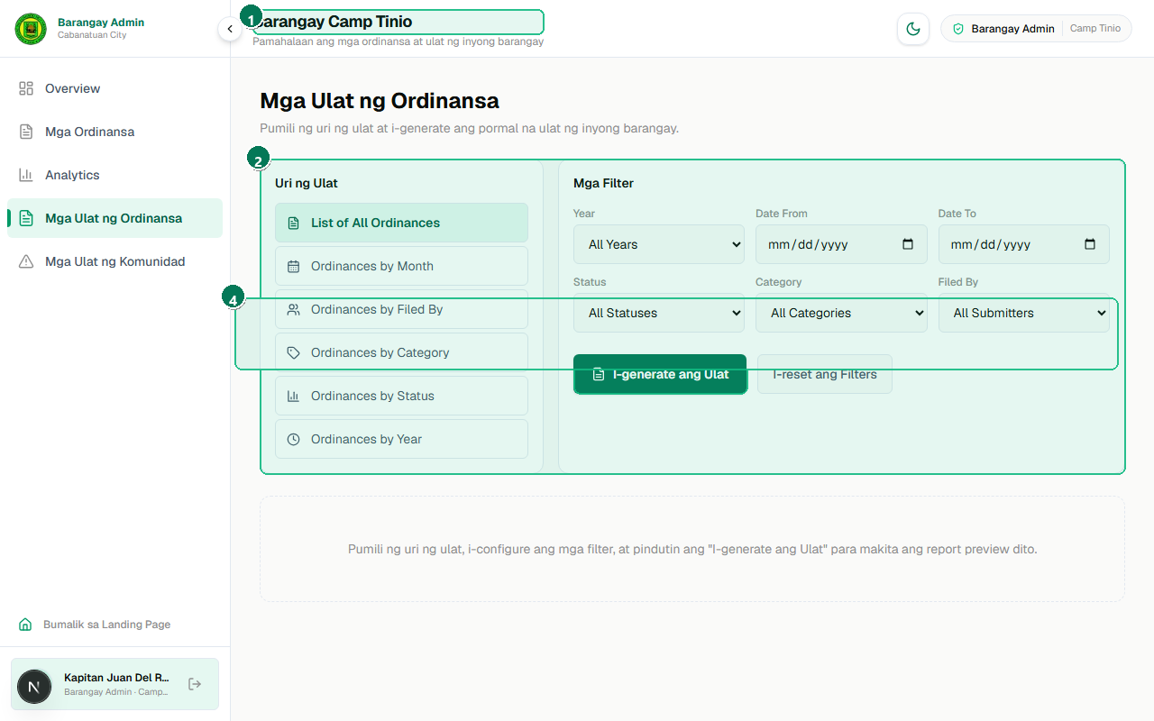
Figure 5.7: Reporting module allowing barangay officials to generate formatted summaries of local legislation for barangay hall records.
# | Interface Element / Control | Operational Purpose & Usage
1 | Barangay-Scoped Legislative Reports Header | Barangay legislative report generator header displaying localized documentation tools.
2 | Report Criteria & Category Selector | Report type and filter selector defining parameters for generating formal barangay council reports.
3 | Generate Localized Report Button | Execution trigger generating certified legislative summaries for local archiving and review.
4 | Official Export & PDF Download Toolbar | Official export toolbar enabling instant download of formal PDF documentation with barangay headers.

Chapter 6: LGU Super Administrator Executive Guide
LGU Super Administrators (City Mayor, City Legal Council, Sangguniang Panlungsod Secretariat, and System Administrators) exercise full city-wide governance over all 89 barangays. Capabilities include managing the central municipal repository, reviewing and legally approving/rejecting barangay submissions, high-throughput AI document parsing, official account provisioning, city-wide incident auditing, civic broadcast publishing, and certified legislative PDF report generation.

6.1 Executive Governance Dashboard & City KPIs
Step 1: Executive Sign-In — Sign in with City Hall credentials (admin@cabanatuan.gov.ph / admin123) and navigate to /admin/lgu.
Step 2: Inspecting City-Wide KPI Cards — Examine live indicators (Badge 2): Total Ordinances (56), Approved Laws (43), Pending Barangay Proposals (6), Drafts (6), and Registered Barangays (14).
Step 3: Using Governance Quick Actions — Use direct action shortcuts (Badge 3) to enact city ordinances, generate certified reports, or jump directly to pending submissions.
Step 4: Auditing Real-Time Legislative Activity — Review the activity stream (Badge 4) for recent transmittals, approvals, and citizen report updates.
Step 5: Accessing Navigation Modules — The left sidebar (Badge 5) grants direct access to all eight administrative desks.
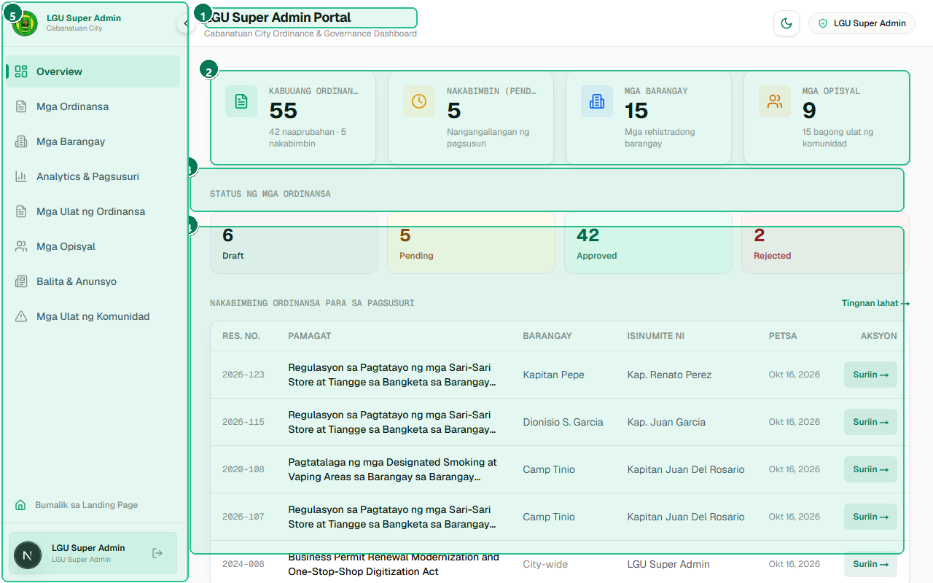
Figure 6.1: Executive overview displaying city-wide legislative health metrics, pending barangay proposals, and real-time activity stream.
# | Interface Element / Control | Operational Purpose & Usage
1 | Executive Dashboard Header & City Hall Governance Scope | City Government Executive Governance Dashboard header confirming City Hall Super Admin privileges.
2 | City-Wide KPI Cards (Total Ordinances, Approved, Pending, Drafts, Barangays) | Consolidated city-wide KPI cards showing Total Ordinances, Approved, Pending, Drafts, and Barangays.
3 | Quick Governance Action Shortcuts (Add Ordinance, Export, Reviews) | Executive quick-action shortcuts for rapid ordinance enactment, report generation, and pending reviews.
4 | Recent City-Wide Legislative Activity Log | Recent legislative activity stream recording real-time enactment, submissions, and status mutations.
5 | Full Executive Navigation Sidebar (8 Integrated Administrative Modules) | Full administrative sidebar providing direct routing across all eight executive management modules.

6.2 Central Ordinance Repository & Status Triage
Step 1: Navigating to Repository — Click 'Mga Ordinansa' on the sidebar or visit /admin/lgu/ordinances.
Step 2: Filtering by Status Tabs — Click accessible tabs with live record counters (Badge 1): All (56), Pending (6), Approved (43), Draft (6), Rejected.
Step 3: Performing Instant Search — Type search terms into the input box (Badge 2) for immediate client-side table filtering.
Step 4: Enacting City Legislation — Click 'Magdagdag ng Ordinansa' (Badge 3) to enact a new city-wide regulation or launch AI document parsing.
Step 5: Verifying Jurisdiction Badges — Inspect the origin badges (Badge 4) distinguishing municipal City ordinances from local Barangay submissions.
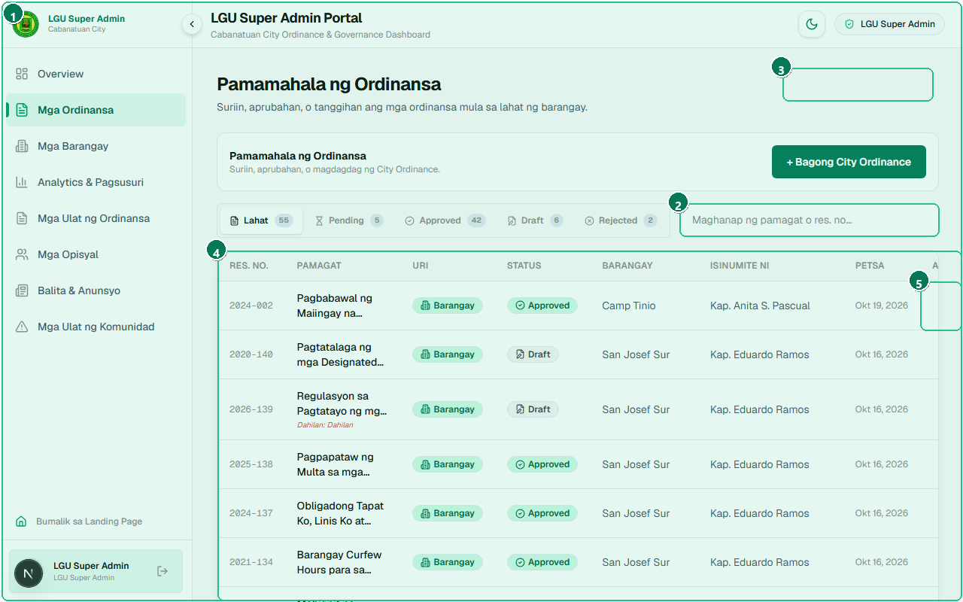
Figure 6.2: Central repository managing all official city ordinances and legislative proposals submitted by eighty-nine administrative barangays.
# | Interface Element / Control | Operational Purpose & Usage
1 | Accessible Status Filter Tabs with Live Record Counters | Status tabs with live record badges categorizing the complete municipal archive (56 total records).
2 | Instant City Ordinance Repository Search Input | Client-side instant search input filtering city and barangay ordinances without network latency.
3 | Add City Ordinance / AI Document Parsing Action Button | New Ordinance enactment button launching the City Hall legislative creation and AI extraction modal.
4 | City-Wide Ordinance Repository Table with Jurisdiction Badges | Consolidated repository table with jurisdiction badges distinguishing City vs Barangay resolutions.
5 | Legislative Oversight Action Controls (Review, Enact, Delete) | Administrative actions column providing review triggers, status overrides, and deletion safeguards.

6.3 Reviewing & Processing Barangay Submissions
Step 1: Selecting Pending Submissions Tab — Click the 'Pending' tab on /admin/lgu/ordinances.
Step 2: Launching Review Modal — Locate a pending proposal (e.g., from Barangay Camp Tinio) and click 'Suriin / Review'.
Step 3: Evaluating Legal Provisions — Read the submitted title, background rationale, and proposed fine schedules (Badge 2).
Step 4: Attaching Legal Council Remarks — In the Remarks field (Badge 3), enter formal feedback (e.g., 'Reviewed and approved pursuant to City Council Session No. 14').
Step 5: Granting Enactment Approval — Click 'Aprubahan' (Badge 4). Status transitions immediately to APPROVED and the ordinance is published to the public portal.
Step 6: Requesting Revisions / Denying — Alternatively, enter required corrective actions and click 'Tanggihan' (Badge 5) to return the item to the barangay with attached notes.
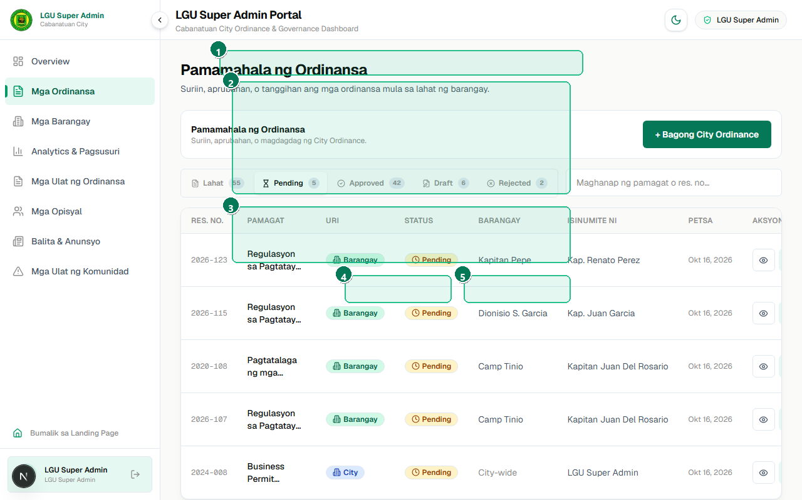
Figure 6.3: Sangguniang Panlungsod review interface for evaluating proposed barangay ordinances, attaching official comments, and granting legal approval.
# | Interface Element / Control | Operational Purpose & Usage
1 | Sangguniang Panlungsod Legislative Review Dialog Header | Sangguniang Panlungsod Legislative Review modal displaying pending barangay proposal details.
2 | Barangay Proposal Summary & Enactment Metadata | Barangay transmittal overview showing proposed resolution provisions, penalties, and signatories.
3 | City Legal Review Comments & Observation Remarks | City Legal Council observations and review remarks input field for formal feedback transmission.
4 | Official Enactment / Approval Action Button ('Aprubahan') | Approval action button updating record status to 'APPROVED' and immediately publishing to the public.
5 | Request Revision / Deny Submission Button ('Tanggihan') | Revision / Rejection action button returning proposal to the barangay with attached corrective guidance.

6.4 Multimodal OCR Ordinance Extractor (Powered by Gemini)
Step 1: Opening City Ordinance Modal — Click 'Magdagdag ng Ordinansa' on /admin/lgu/ordinances.
Step 2: Uploading Official Scanned PDF — Drag and drop the scanned resolution file into the upload zone (Badge 2).
Step 3: Executing AI Multimodal Parsing — Click 'I-Extract gamit ang AI' (Badge 3). Google Gemini analyzes text and visual document structure.
Step 4: Inspecting Extracted Metadata — Verify auto-populated fields (Badge 4): Resolution Number, Series Year, Enacted Date, and Title.
Step 5: Validating Sanctions Breakdown — Verify structured first, second, and third offense fines (Badge 5), make minor text adjustments, and save.
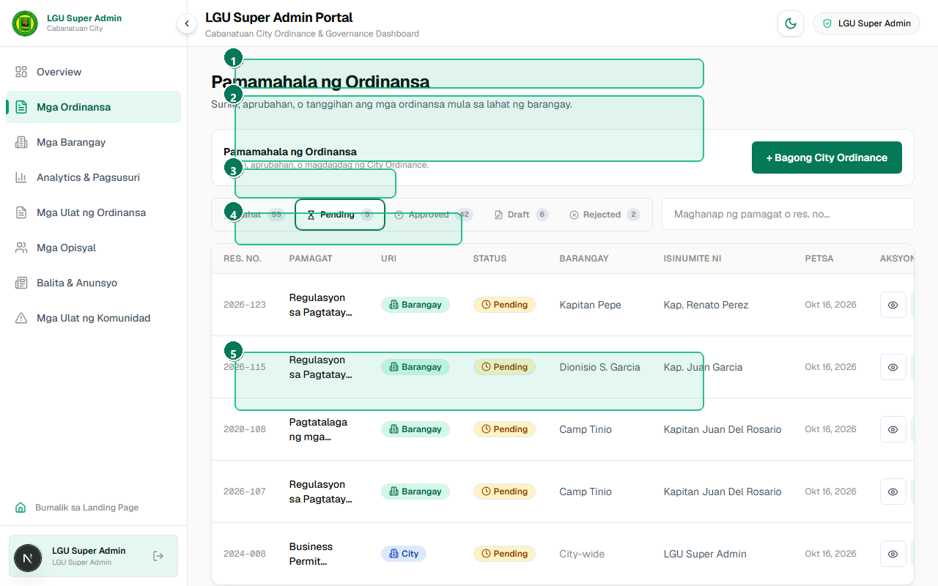
Figure 6.4: High-throughput AI parser transforming scanned multi-page paper ordinances into verified digital records with tiered fine extraction.
# | Interface Element / Control | Operational Purpose & Usage
1 | AI-Powered Multimodal OCR Ordinance Extractor Header | LGU multimodal AI extraction tool powered by Google Gemini for scanning physical paper ordinances.
2 | Official Scanned Resolution Upload Dropzone | Certified resolution document upload dropzone supporting multi-page PDF documents and high-res scans.
3 | Multimodal AI Parsing Execution Button | AI extraction execution trigger initiating automated OCR, preamble stripping, and penalty categorization.
4 | Auto-Populated Resolution Number, Series & Enactment Date | Auto-populated legislative fields displaying parsed resolution number, year series, and cleaned title.
5 | Auto-Extracted Tiered Sanctions & Fines Breakdown | Structured sanctions editor displaying parsed first, second, and third offense fine schedules.

6.5 Administrative Accounts & Official Directory
Step 1: Navigating to Official Directory — Click 'Mga Opisyal / Users' on the sidebar or visit /admin/lgu/users.
Step 2: Registering a New Official — Click 'Magrehistro ng Opisyal' (Badge 2) to open the account provisioning dialog.
Step 3: Assigning Roles & Barangays — Select the role (LGU_ADMIN vs BARANGAY_ADMIN) and bind the account to their specific barangay jurisdiction (Badge 5).
Step 4: Security & Password Protection — Passwords are encrypted using salted bcrypt hashing before storage (Badge 3).
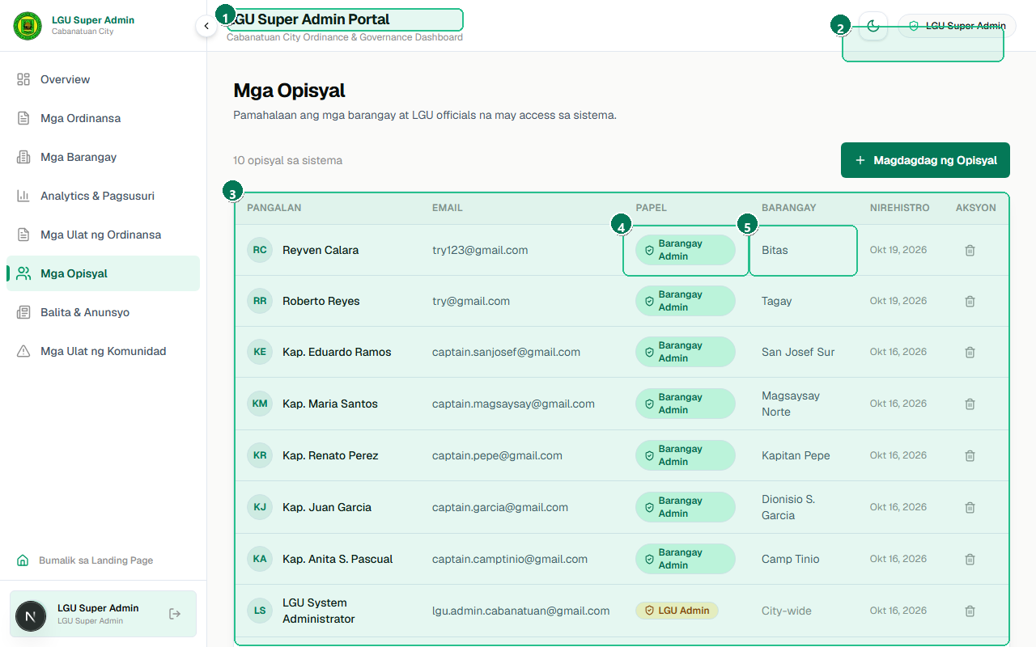
Figure 6.5: Administrative user directory for provisioning barangay captains and city personnel with cryptographically secure role-based access control.
# | Interface Element / Control | Operational Purpose & Usage
1 | City Government Official Personnel Roster Header | Official personnel directory header displaying registered administrative accounts across Cabanatuan.
2 | Register New Official Action Button ('Magrehistro ng Opisyal') | Provisioning action button opening the modal for registering new barangay captains and secretaries.
3 | Official Directory Table with Security Badges | User directory data table showing full names, official emails, assigned roles, and creation dates.
4 | Role-Based Privilege Badges (LGU Admin vs Barangay Admin) | Role privilege badges distinguishing LGU Super Admin permissions from scoped Barangay Admin rights.
5 | Assigned Territorial Barangay Jurisdiction Tag | Territorial assignment badge ensuring barangay officials are strictly mapped to their local jurisdiction.

6.6 Barangay Directory & Territorial Coverage
Step 1: Navigating to Barangay Directory — Click 'Direktoryo ng Barangay' or visit /admin/lgu/barangays.
Step 2: Inspecting Participation Indicators — Examine active participation badges across the 14 registered barangays (Badge 2).
Step 3: Monitoring Enacted Legislation Counts — Inspect individual barangay cards (Badge 3) showing local resolution counts and active captains.
Step 4: Direct Barangay Archive Navigation — Click the view link on any card (Badge 4) to inspect that barangay's local archive.
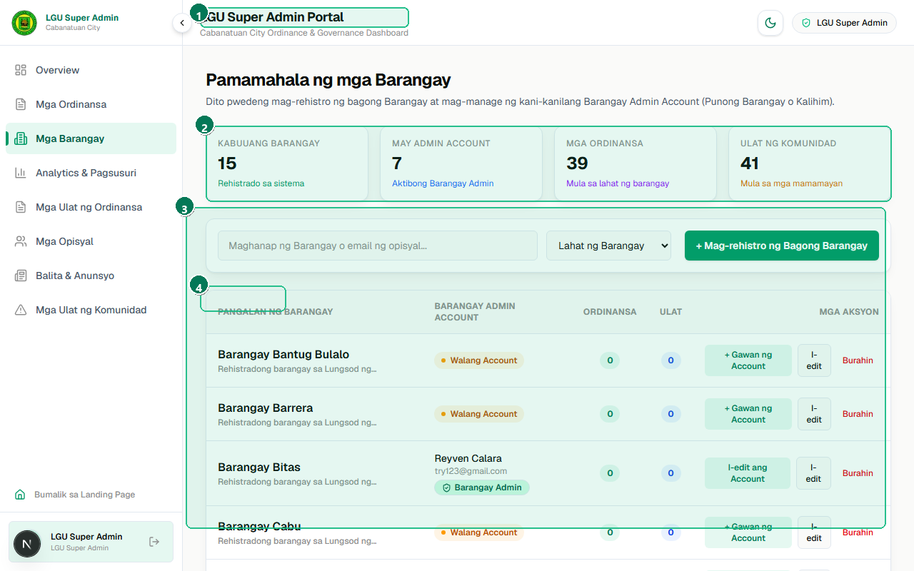
Figure 6.6: Directory tracking participation, enacted local resolutions, and administrative contacts across all eighty-nine barangays of Cabanatuan City.
# | Interface Element / Control | Operational Purpose & Usage
1 | Cabanatuan City Barangay Directory Header | Cabanatuan City Barangay Directory header tracking administrative coverage across all eighty-nine barangays.
2 | Active Participation & Onboarding Indicators | Active portal participation indicator cards distinguishing active pilot barangays from pending ones.
3 | Registered Barangay Directory Cards with Ordinance Counters | Barangay card grid displaying registered barangays with active local ordinance counts.
4 | Local Jurisdiction Contact & Profile Shortcuts | Direct navigation shortcuts for inspecting localized legislative archives for specific barangays.

6.7 City-Wide Community Incident Reports Desk
Step 1: Navigating to Reports Desk — Click 'Mga Ulat ng Komunidad' on the sidebar or visit /admin/lgu/reports.
Step 2: Filtering by Barangay Jurisdiction — Use the Barangay Dropdown (Badge 2) to filter complaints across any of Cabanatuan's barangays.
Step 3: Auditing Resolution Performance — Toggle status filter tabs (Badge 3) to identify unaddressed citizen reports.
Step 4: Inspecting Consolidated Evidence — Review violation categories, descriptions, and photographic evidence (Badge 4).
Step 5: Executive Override & Intervention — Click the status action control (Badge 5) to update status or assign city-level enforcement.
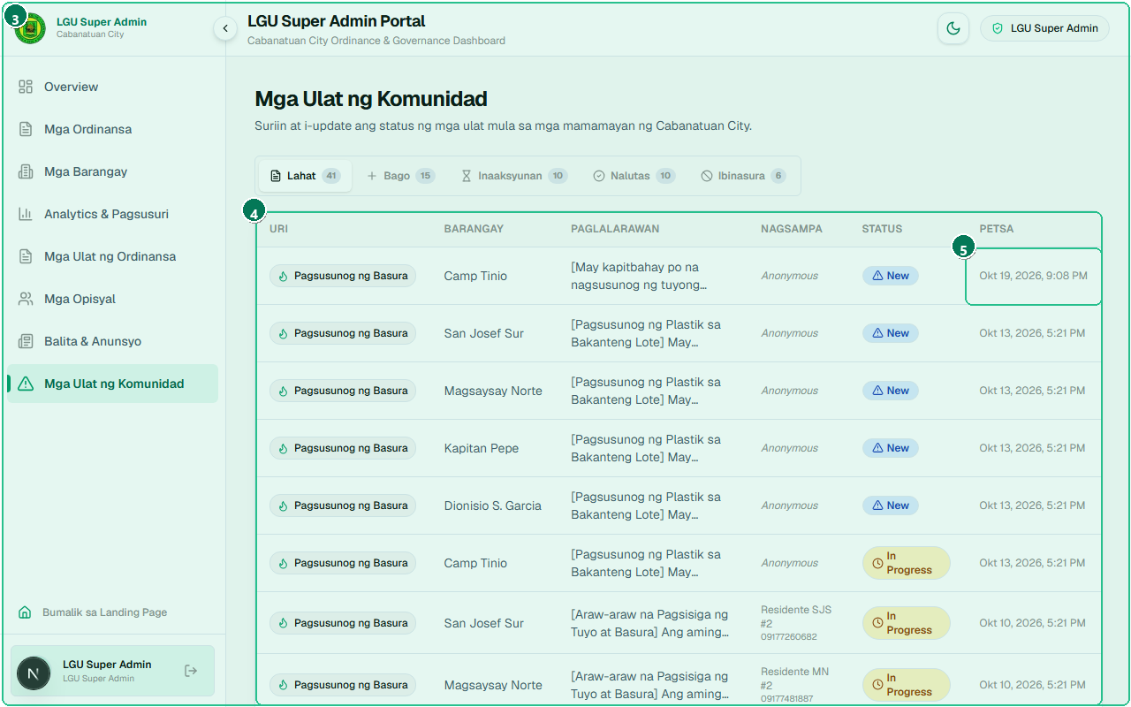
Figure 6.7: Centralized supervisory desk enabling city hall administrators to monitor resident concerns and audit barangay action resolution times.
# | Interface Element / Control | Operational Purpose & Usage
1 | City-Wide Community Reports Monitoring Header | City-wide community incident monitoring desk header providing executive oversight of citizen reports.
2 | Territorial Barangay Filter Dropdown (All 89 Barangays) | Territorial barangay dropdown filter allowing city administrators to inspect any of the 89 barangays.
3 | Resolution Status Filter Tabs (Lahat, Bago, Inaaksyunan, Naresolba) | Consolidated status tabs segregating reports across New, In Progress, Resolved, and Dismissed stages.
4 | Consolidated City-Wide Incident Records Table | Comprehensive incident records table displaying violation categories, locations, and barangay assignments.
5 | Executive Incident Oversight & Status Update Action | Supervisory action button allowing City Hall to update report statuses or assign direct city escalations.

6.8 Civic News & Public Advisories Broadcast Desk
Step 1: Navigating to News Desk — Click 'Mga Balita at Anunsyo' on the sidebar or visit /admin/lgu/news.
Step 2: Drafting New Public Advisory — Click 'Maglathala ng Anunsyo' (Badge 2) to open the announcement composer.
Step 3: Composing Title, Category & Content — Enter an informative title, select category (City or Barangay), and type announcement details.
Step 4: Pinning Urgent Public Advisories — Toggle the 'Pinned' switch (Badge 4) for critical weather, curfew, or public health directives.
Step 5: Publishing to Citizen Portal — Click Publish. The announcement synchronizes immediately with the public citizen portal (/news).
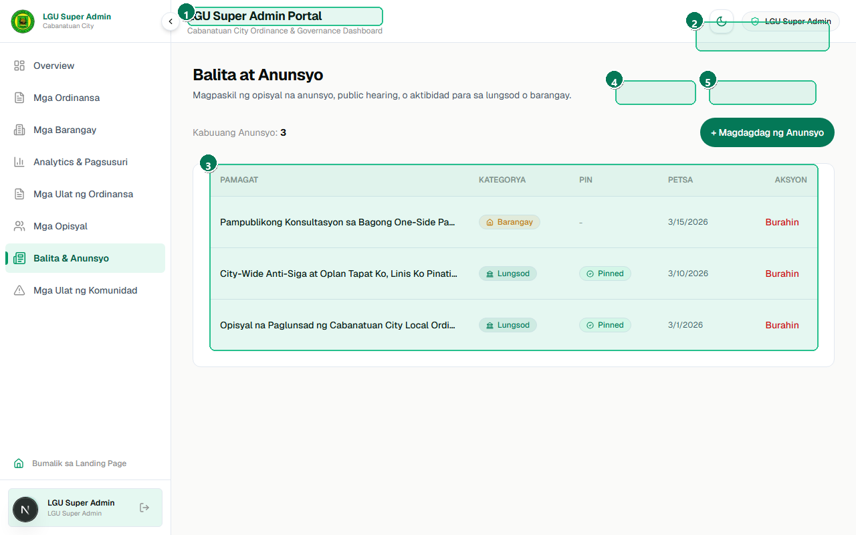
Figure 6.8: Communication center for publishing legislative alerts, curfew reminders, and public health directives to the citizen-facing portal.
# | Interface Element / Control | Operational Purpose & Usage
1 | Civic News & Legislative Broadcasts Desk Header | Civic news and public broadcast management desk header for City Hall legislative announcements.
2 | Publish New Advisory Action Button ('Maglathala ng Anunsyo') | Advisory publishing button opening the rich news composer dialog with category and pinning options.
3 | Published Public News & Emergency Advisories List | Active public advisories stream displaying published executive notices, reminders, and press releases.
4 | Priority Pinning Toggle for Urgent Civic Directives | Urgent priority pinning toggle highlighting critical public advisories at the top of the citizen portal.
5 | Advisory Management Controls (Edit, Delete, Sync to Public Feed) | Advisory management controls allowing city personnel to modify announcement content or archive items.

6.9 Legislative Report Generator & PDF Exporter
Step 1: Navigating to Report Generator — Click 'Mga Ulat at Dokumento' on the sidebar or visit /admin/lgu/ordinance-reports.
Step 2: Selecting Report Structure — Choose from eight specialized report structures (Badge 1): List of All Ordinances, by Month, Barangay, Filer, Category, Status, Type, or Year.
Step 3: Applying Criteria Filters — Set parameters in the filter panel (Badge 2) for Year, Status, Category, and Barangay origin.
Step 4: Executing Report Generation — Click 'I-generate ang Ulat' (Badge 3) to execute database aggregation and render the official preview.
Step 5: Inspecting Certified Document Preview — Verify the official Republic of the Philippines heading, Cabanatuan seal, and tabular format (Badge 4).
Step 6: Exporting Certified PDF Document — Click 'I-download bilang PDF' (Badge 5) to compile a certified legislative summary document.
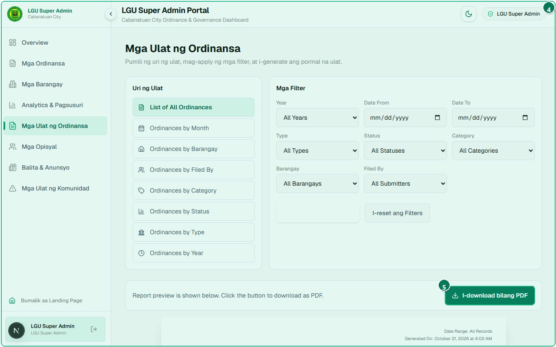
Figure 6.9: Formal reporting tool generating certified legislative summaries with official headers, serial codes, and tabular PDF document generation.
# | Interface Element / Control | Operational Purpose & Usage
1 | Legislative Report Structure Selector (All, by Month, Barangay, Category, Status) | Report type selector offering 8 specialized structures (All, by Month, Barangay, Filer, Category, Status).
2 | Multi-Criteria Filter Parameters (Year, Status, Category, Origin) | Multi-criteria filter panel with dropdowns for year series, status, category, and barangay scoping.
3 | Execute Report Generation Action Button | Report generation execution button querying the database and rendering the formal print-ready layout.
4 | Official Government Header Preview with Cabanatuan City Seal | Official document preview complete with the Republic of the Philippines header and Cabanatuan seal.
5 | Export Formal PDF Document Action Button ('I-download bilang PDF') | Direct PDF download button generating a certified legislative summary document with pagination.

6.10 Governance Analytics & Policy Trend Visualizations
Step 1: Navigating to Analytics — Click 'Analytics' on the sidebar or visit /admin/lgu/analytics.
Step 2: Analyzing Enactment Velocity — Inspect the interactive line chart (Badge 2) tracking municipal ordinance enactment velocity over time.
Step 3: Examining Policy Distributions — Review the Category Distribution chart (Badge 3) showing thematic allocations (Health, Environment, Peace & Order).
Step 4: Auditing Barangay Participation — Inspect the Barangay Participation ranking (Badge 4) identifying top-contributing local councils.
Step 5: Tracking Community Resolution Efficiency — Analyze the Report Resolution Rate gauge (Badge 5) measuring average turnaround times for citizen complaints.
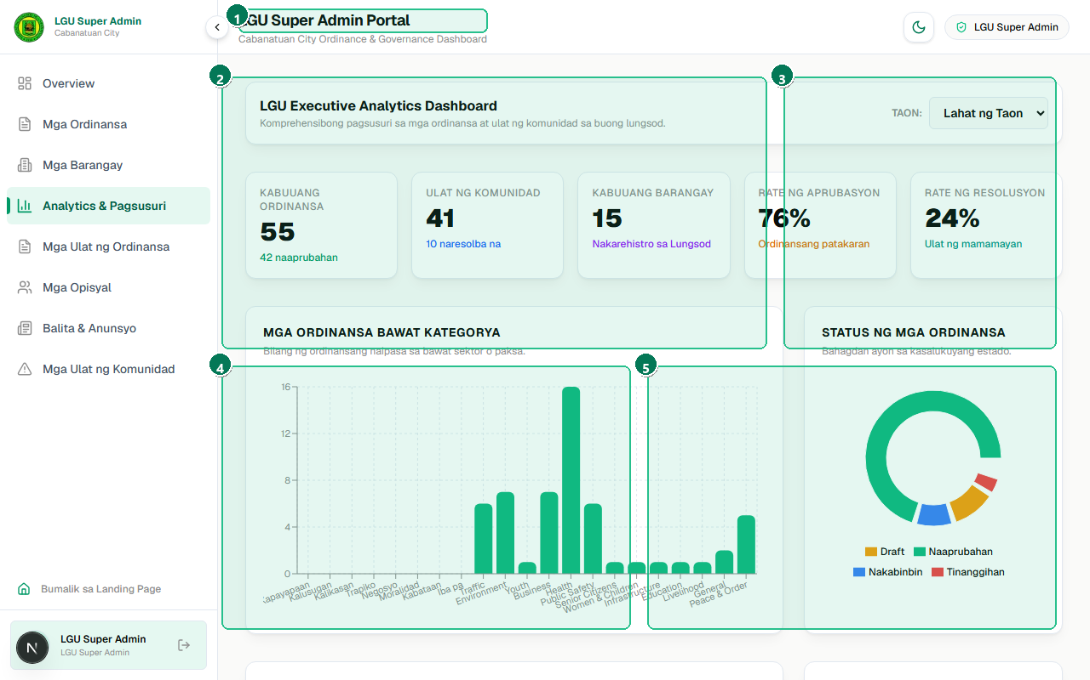
Figure 6.10: Interactive data visualization suite tracking legislative velocity, thematic distributions, and civic report resolution performance.
# | Interface Element / Control | Operational Purpose & Usage
1 | Governance Analytics & Policy Intelligence Header | Governance analytics and policy intelligence header providing data-driven legislative insights.
2 | Legislative Enactment Velocity Trend Chart (Yearly Trajectory) | Interactive legislative enactment velocity line chart tracking annual policy adoption trends.
3 | Policy Category Distribution Breakdown Chart | Policy category distribution chart illustrating legislative focus across health, safety, and environment.
4 | Barangay Legislative Participation & Enactment Ranking | Barangay legislative participation ranking highlighting top contributing barangays across the city.
5 | Citizen Report Resolution Rate & Efficiency Metrics | Citizen report resolution performance metric tracking the average response and closure rate.

Chapter 7: Data Isolation & Security Guidelines
To guarantee administrative integrity, operational privacy, and compliance with the Philippine Data Privacy Act of 2012 (RA 10173), the Cabanatuan City Ordinance Portal implements multi-tiered security protocols:
1. Multi-Tenant Jurisdictional Isolation:
Every database mutation (creation, status update, deletion) verifies that the authenticated user's session barangayId matches the target record's barangayId. Barangay Captains cannot view drafts or modify citizen reports belonging to neighboring barangays.
2. Cryptographic Token Protection:
Authentication tokens are signed with HMAC-SHA256 and transmitted exclusively in HTTP-only, SameSite=Lax cookies with path-level route guards in Next.js middleware, mitigating cross-site scripting (XSS) and CSRF vectors.
3. Salted Password Hashing:
User credentials are encrypted using salted bcrypt hashing with a work factor of 10. No plaintext credentials ever touch persistent storage or server log files.
4. Audit Logging & Legislative Traceability:
All ordinance approvals, rejections, and citizen report status updates record an immutable audit trail capturing the actor's user ID, timestamp, and review remarks for complete civic accountability.
💡 PRO-TIP: IMMUTABLE LEGISLATIVE AUDIT TRAILS
When an LGU Super Administrator approves or denies a proposed ordinance, the system records: (1) reviewedById foreign key reference, (2) approvedAt timestamp, and (3) rejectedReason text notes. This audit record is preserved permanently in the database and visible in formal legislative PDF exports.

Chapter 8: Troubleshooting, Prerequisites & FAQ

8.1 System Requirements & Browser Compatibility
System Component | Technical Specification
Supported Browsers | Google Chrome 110+, Microsoft Edge 110+, Mozilla Firefox 115+, Safari 16+
Display Resolution | Responsive: 360px mobile viewport up to 1920x1080 Full HD desktop
Server Runtime | Node.js 20+ LTS or Node.js 22+, SQLite 3.40+, Better-SQLite3
Hardware Requirements | Minimum 4 GB RAM, 2 GHz dual-core processor, 500 MB disk space
Network Connectivity | Broadband internet connection required for Google Gemini API inference; offline database exploration supported locally

8.2 Common Operational Issues & Troubleshooting
⚠️ CAUTION: ISSUE 1: AI MULTIMODAL EXTRACTION TIMEOUT OR ERROR
Symptom: Uploading a large scanned PDF results in an error message or spinning wheel.
Resolution: Ensure the uploaded PDF or image is under 15 MB and clearly legible. Verify that your GEMINI_API_KEY environment variable is configured in .env and that the server has an active internet connection to access the Google GenAI endpoints.

⚠️ CAUTION: ISSUE 2: FORBIDDEN / REDIRECT LOOP DURING LOGIN
Symptom: Attempting to access /admin/lgu redirects back to /login.
Resolution: Clear your browser session cookies for localhost:3000. Re-authenticate using the exact LGU Super Admin credentials (admin@cabanatuan.gov.ph / admin123). Ensure that caps lock is off.

📌 NOTE: ISSUE 3: SUBMITTED ORDINANCE NOT APPEARING ON PUBLIC EXPLORER
Symptom: A barangay official submitted an ordinance, but citizens cannot find it in /ordinances.
Resolution: Newly submitted barangay ordinances carry the status 'PENDING'. They only appear publicly once an LGU Super Administrator reviews and officially APPROVES the proposal pursuant to Sangguniang Panlungsod procedures.

8.3 Defense Panel Technical FAQ
Q1: Why was Google Gemini chosen over OpenAI or self-hosted models?
Answer: Google Gemini provides superior multimodal vision for analyzing scanned physical documents with stamps and signatures, low inference latency, and excellent bilingual Tagalog/English comprehension. In our RAG architecture, all city data remains securely on our local database, invoking Gemini solely for context synthesis.
Q2: How does the system prevent AI hallucinations and unauthorized legal advice?
Answer: The AI Civic Assistant utilizes strict prompt grounding with local retrieval injection. It only answers questions based on retrieved municipal ordinances and refuses to answer out-of-scope national legal questions. A prominent civic disclaimer informs residents that outputs are informational only.
Q3: How is multi-tenant security handled across eighty-nine barangays?
Answer: We enforce multi-tenant role-based access control using Prisma ORM and JWT tokens. Each barangay session is strictly bound to its assigned barangayId, preventing unauthorized cross-jurisdiction access or modification.

