Main Structures
Setup: includes all values to input into GPOPS including functions, bounds, guess, mesh, auxdata, etc.
Output: All resultant values of GPOPS calculation where main structure is result but also includes meshhistory,meshcounts,totaltime,defaults,and conflicts

Setup:
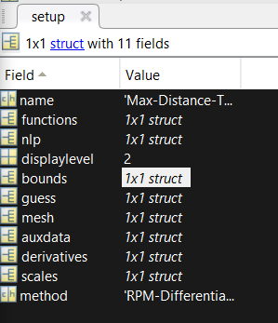
functions: list the endpoint and continuous function name
nlp: pick which nonlinear programming solver to use with options
displaylevel: Define what outputs are presented (0,1, or a max 2)
bounds: upper and lower bounds on initialtime, finaltime,initialstate,active state,final state, and the control
guess: initial guess for time, states, and control
mesh: defines mesh method, options, and tolerances
auxdata: variables to be passed between main, continuous, and endpoint functions
derivatives: Describes "derivative supplier" (adigator) and the derivative order (1 or 2)
scales: capable of doing automactic bounds but for this problem not applied
method: Version of collocation to be used (RPM-differentiation or RPM-integration)

Output:
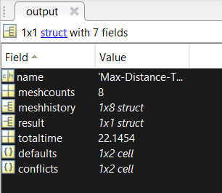
meshcounts: number of mesh refinement iterations taken
meshhistory: Solution and error of each mesh
result: complete solution organized by time vector, states matrix, control matrix, costate matrix?,and time/control Radau.

Setup.functions.continuous
Phaseout = function(input)
Input = input.auxdata and input.phase
Input.phase includes an array of values describing certain initial and final conditions for each phase (initialtime,finaltime,initialstate,finalstate,integral,static parameters)

Phaseout = .dynamics list of differential equations for problem & .path which list the number of collocation points and the number of path constraints in phase p = 1,...,P;

Code Changes Made

To MaxDistanceToDescendMain:
- Added “x0 = 0” initial boundary condition
- Added “tf = 62” final boundary condition
- Added “xmin” and “xmax” limits on variables along with adjusting “tfmin” down to 10 and added “qmin” and “qmax”
- Changed bounds.phase.finaltime.upper = “tf”.
- Changed entire block starting with “bounds.phase(iphase).initialstate.lower = [h0, v0, fpa0. x0];” and going through “bounds.phase(iphase).path.upper = [qmax];
- Changed all boundary conditions

To MaxDistanceToDescendContinous
- Added “x = input.phase.state(:,4);
- Added “xdot = v.*cos(fpa)”
- Commented out old and added “phaseout(1).dynamics = [hdot, vdot, fpadot, xdot];
- Added “phaseout(1).path = q/S

To MaxDistanceToDescendEndpoint
- Commented out “tf = input.phase(1).finaltime; output.objective = tf;”
- Changed to “xf = input.phase(1).finalstate(4); output.objective = -xf;”

