Data Engineering Notebook
Course: Data Engineering (2026SP-DSCI-6313-A)
Author: Scott Person
Date: March 08, 2026

Table of Contents
Introduction 4
Docker Install 4
Why use Docker? 4
Docker Installation 4
Prerequisites 4
Instructions 4
PostgreSQL Install 6
Why Use Postgres? 6
Postgres Installation 6
Docker Execution Script 6
Script Instructions 7
PostgreSQL Data Import 9
Anaconda Install 11
Deployment Architecture 11
Anaconda Docker Configuration 11
Docker Execution Script 11
Script Instructions 12
Docker Network Configuration 12
VS Code Install and Configuration 15
VS Code Installation 15
Python Data Pipeline Setup 16
Apache Nifi Install (Ravi, 2023) 18
Nifi Docker Configuration 18
Docker Execution Script 18
Apache Nifi Usage (Ravi, 2023) 21
Flow Configuration 21
Apache Nifi Flow Operations 22
Apache Nifi Rest API Pipeline 24
Setup Postgres IOT 24
Apache Nifi Initial Configuration 25
Apache Nifi Flow Configuration 27
Validate Data Flow 29
Make it Better 29
aviationstack.com Registration 31
Airbyte/dbt/Dagster Project 31
Source Video 31
Configure the Environment 32
Python Run Environment 32
Database Container Configuration 33
Setup Google Cloud Data Warehouse (BigQuery) 35
Setup Airbyte 36
Configure Airbyte Source 37
Create Airbyte Connection 38
Run Airbyte Sync 38
dbt Project 39
Setup dbt Source 39
Create dbt Model 41
Dagster Implementation 45
Sources 48
Appendix A: Code Listings 48
Create Tables SQL (Postsgres SQL Data Import) 48
Insert Data SQL (Postgres SQL Data Import) 50
Extract Script Python 51
IOT Database Table Creation 52
Flight Data Fields 53
Flight Data Insert Statement 54

Introduction
This document provides instructions for installing and configuring PostgreSQL (AKA Postgres) on MacOS using Docker Desktop. Web sites are somewhat fickle. They will change. The instructions below are accurate at the time of writing this document. Regardless of the changes, even if the exact instructions no longer work, it is highly likely that very similar steps will be appropriate for the foreseeable future. Be flexible and follow the spirit of this guide.

Docker Install

Why use Docker?
Docker Desktop provides virtual environments in the form of lightweight containers. It allows us to isolate each component to avoid conflicts and ease maintenance and operations. An additional benefit is that we avoid installing software directly on the host computer. This simplifies cleanup. As mentioned above these instructions will cover MacOS but the installation on Windows is quite similar.

Docker Installation

Prerequisites
Docker requires 4GB of RAM. Generally any machine with 8GB of total RAM will be able to run Docker successfully. MacOS is supported for the current version and two versions back. This is rolling support and moves as new versions of MacOS are released.
Basic familiarity with MacOS is assumed.

Instructions
- Navigate to the Docker home page (https://www.docker.com).
- Hover over the Download Docker Desktop button and select the version of Docker Desktop that is appropriate for your machine as shown in Figure 1: Docker Homepage Download Link below. This will place a copy of the DMG install archive in your Downloads folder.
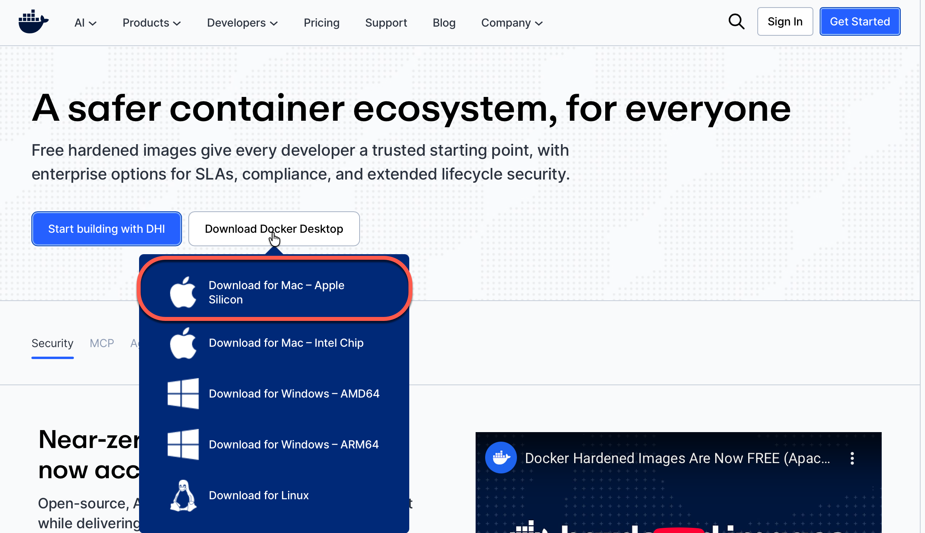
Figure 1: Docker Homepage Download Link
- Open your Downloads folder and launch Docker.dmg.
- Follow the instructions in the dialog (see Figure 2: Install Docker into Applications) to copy Docker to Applications. Once copied close the dialog.
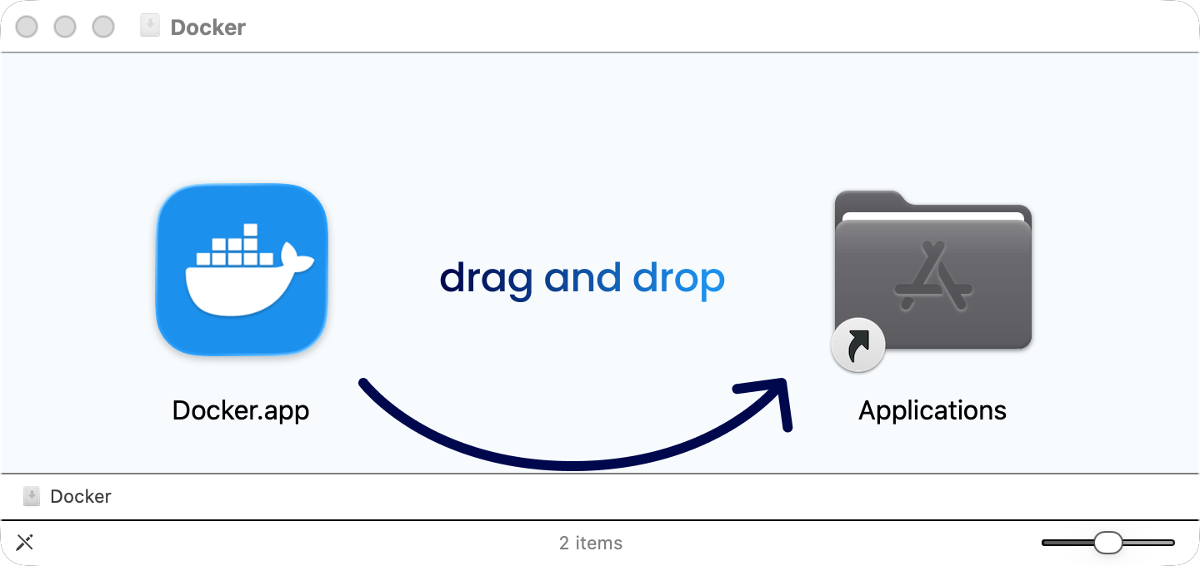
Figure 2: Install Docker into Applications
- Launch Docker from Applications and you’ll see a dialog similar to Figure 3: docker.desktop Dashboard. Note that the author uses Docker extensively for work and side projects so the screenshot shows several existing containers. We’ll create our own in the instructions below.
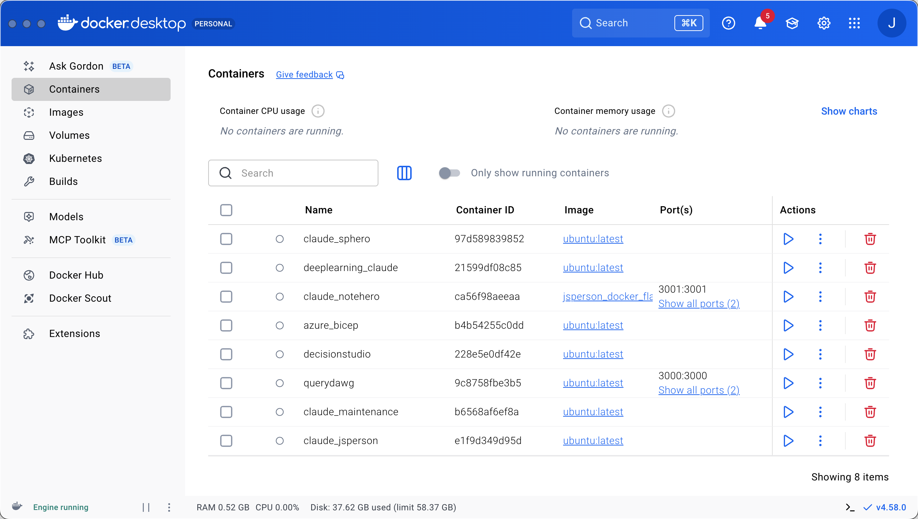
Figure 3: docker.desktop Dashboard

PostgreSQL Install

Why Use Postgres?
Postgres is an open source well supported database engine that runs on most general purpose computing platforms. It works very well as a production database and is widely used in industry. Similarly it is often used in education environments because of its low cost (free) and general applicability to commercial implementations. We will utilizing a pre-built image and running it in Docker.

Postgres Installation

Docker Execution Script
I have a script that I like to use that performs the image download (if necessary), container creation (again if necessary), container startup, and finally opening an interactive shell to the container. This script can be used for starting the container in the future. The script is pasted below and explained in the included comments.
#!/bin/bash

# Variables
CONTAINER_NAME="postgres_data_engineering"
IMAGE_NAME="postgres:latest"
POSTGRES_USER="admin"
POSTGRES_PW="admin"
POSTGRES_DB="salestracker"
POSTGRES_PORT="5432"
#MOUNT_PATH_ON_HOST="/Users/jsperson"
#MOUNT_PATH_IN_CONTAINER="/home/jsperson/host"

# Check if the container exists
CONTAINER_ID=$(docker ps -a -q -f name=$CONTAINER_NAME)

# If the container does not exist, create and run it
if [ -z "$CONTAINER_ID" ]; then
echo "Container does not exist. Creating and starting..."
docker run -d \
--name $CONTAINER_NAME \
-e POSTGRES_USER=$POSTGRES_USER \
-e POSTGRES_PASSWORD=$POSTGRES_PW \
-e POSTGRES_DB=$POSTGRES_DB \
-p $POSTGRES_PORT:$POSTGRES_PORT \
$IMAGE_NAME
else
# Check if the container is running
RUNNING_CONTAINER_ID=$(docker ps -q -f name=$CONTAINER_NAME)
if [ -z "$RUNNING_CONTAINER_ID" ]; then
echo "Container exists but is stopped. Starting..."
docker start $CONTAINER_NAME
else
echo "Container is already running."
fi
fi

# Connect to the container
echo "Connecting to container..."
docker exec -it $CONTAINER_NAME /bin/bash

Script Instructions
- If you have not already, create a working directory where you will be storing files for this module.
- Using a test editor copy the contents of the script in its entirety into a file. I named my file run_docker_postgres.sh.
- At the command prompt in your working directory change permissions of the script created above to allow execution. Use something like: chmod 700 <script name>
- Execute the script by typing: ./<script name>
- During execution the script:
  - Downloads the Postgres image – see Figure 4: Postgres Image
  - Creates a container using the image – see Figure 5: Running Postgres Container
  - Starts the container
  - Connects to the container in a shell environment
- In the future your script can be used to restart the container or you can use the Docker Desktop GUI. The GUI can also be used to delete the container (note: complete loss of the container data) and the image.
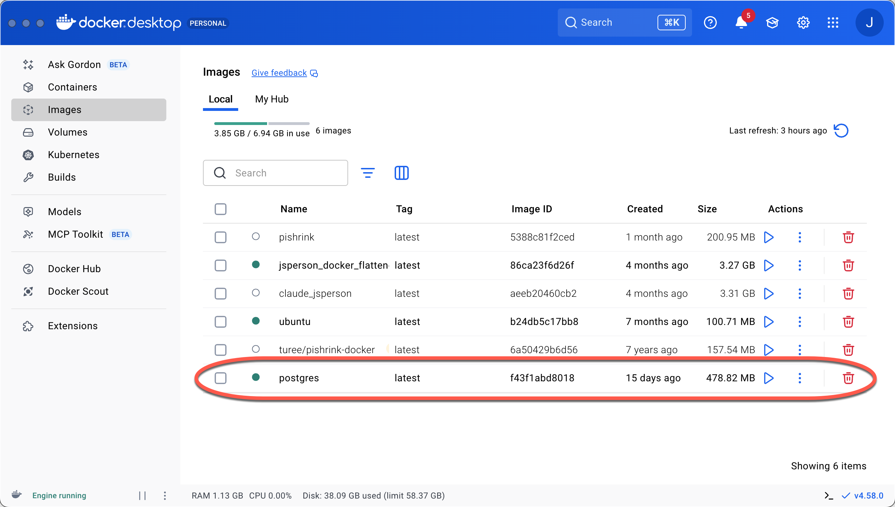
Figure 4: Postgres Image

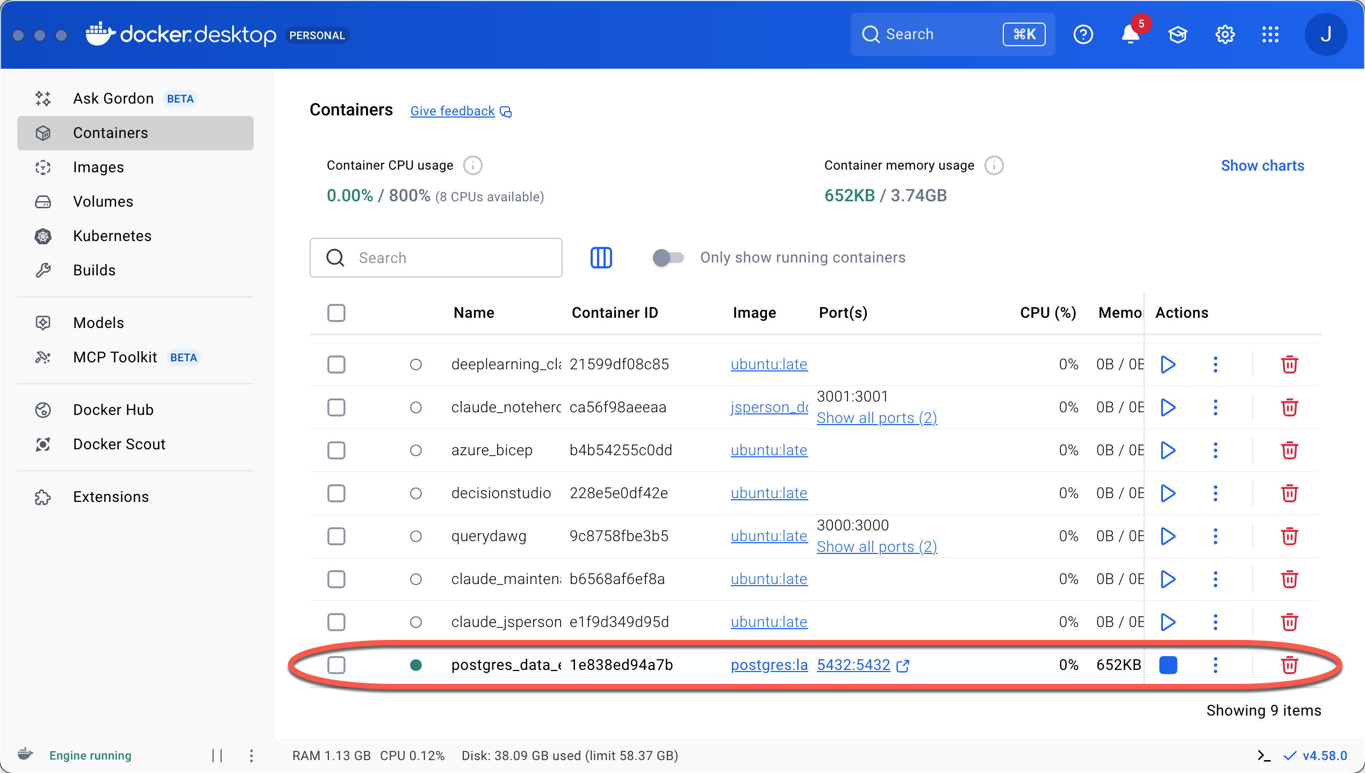
Figure 5: Running Postgres Container
- From the command line of the container (you drop in there after running the above script in the terminal), execute: psql -U admin -d salestracker
If you have been successful you’ll be in the Postgres command environment with a prompt similar to salestracker=#

PostgreSQL Data Import
Now we’re going to populate our database with some sample data using a couple of scripts.
- In the terminal execute the script you created above. This will start the Postgres container if it’s not running and drop you into a shell inside of the container.
- Enter psql -U admin -d salestracker to get into the Postgres terminal client. You should be sitting at a prompt similar to what is displayed in Figure 6: Database Running.
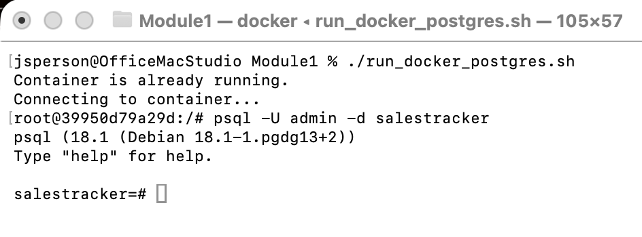
Figure 6: Database Running
- Execute the Create Tables SQL and Insert Data SQL below. You can copy the entirety of both or either list or execute them one at a time in the terminal. You should see four tables with 15 records each. Code is available in Appendix A: Code Listings.
- Validate that the tables exist and are populated with the following queries:
select table_name
from information_schema.tables
where table_schema = 'public'
and table_catalog = 'salestracker';
select count(*) from <table_name>;
You should see four tables each with 15 records.
- A listing of the entire contents of the tables is available in Figure 7: Full Data Listing
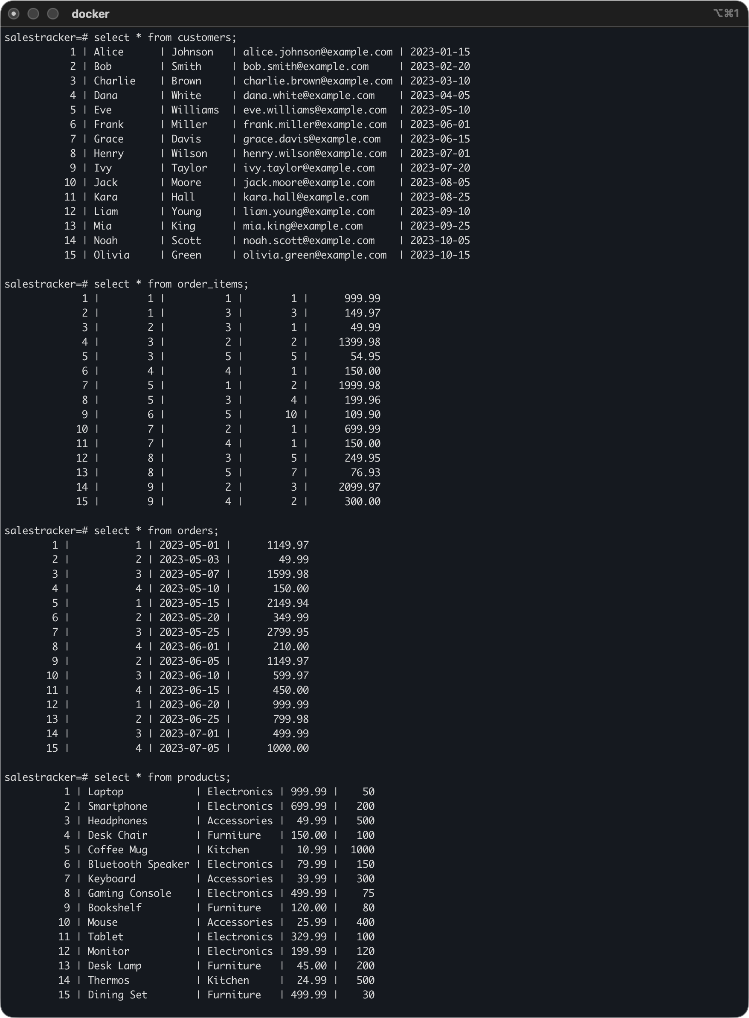
Figure 7: Full Data Listing

Anaconda Install

Deployment Architecture
I’m going to use a Docker container to house the Python execution environment. This simplifies the configuration – no polluting the host environment or virtual environment complexities. We’ll connect to the Anaconda container with Visual Studio’s container development extensions (see below).

Anaconda Docker Configuration
See Postgres Installation above for more information about Docker. We’re going to use a similar procedure here.

Docker Execution Script
As with Postgres above, I have a script that downloads an image, configures a container, and starts the container.
#!/bin/bash

# Variables
CONTAINER_NAME="anaconda_data_engineering"
IMAGE_NAME="continuumio/anaconda3:latest"
MOUNT_PATH_ON_HOST="/Users/jsperson"
MOUNT_PATH_IN_CONTAINER="/home/jsperson/host"

# Check if the container exists
CONTAINER_ID=$(docker ps -a -q -f name=$CONTAINER_NAME)

# If the container does not exist, create and run it
if [ -z "$CONTAINER_ID" ]; then
echo "Container does not exist. Creating and starting..."
docker run -d \
--name $CONTAINER_NAME \
-v $MOUNT_PATH_ON_HOST:$MOUNT_PATH_IN_CONTAINER \
$IMAGE_NAME \
tail -f /dev/null
else
# Check if the container is running
RUNNING_CONTAINER_ID=$(docker ps -q -f name=$CONTAINER_NAME)
if [ -z "$RUNNING_CONTAINER_ID" ]; then
echo "Container exists but is stopped. Starting..."
docker start $CONTAINER_NAME
else
echo "Container is already running."
fi
fi

# Connect to the container
echo "Connecting to container..."
docker exec -it $CONTAINER_NAME bash

Script Instructions
- Use the same working directory created for the project in the Postgres install to store this script.
- Using a text editor copy the contents of the script in its entirety into a file. I named my file run_docker_anaconda.sh.
- Modify the mount points as appropriate for your environment (most likely changing the name from jsperson to your login name).
- At the command prompt in your working directory change permissions of the script created above to allow execution. Use something like: chmod 700 <script name>
- Execute the script by typing: ./<script name>
- During execution the script:
  - Downloads the Anaconda image – see Figure 4: Postgres Image
  - Creates a container using the image – see Figure 5: Running Postgres Container
  - Adds a mount path from the container to my host home directory
  - Starts the container
  - Connects to the container in a shell environment
- After running the script you’ll be at the command prompt inside of the container. Validate proper installation by running anaconda --version at the command line. The output should be similar to Figure 8: Anaconda version confirmation.
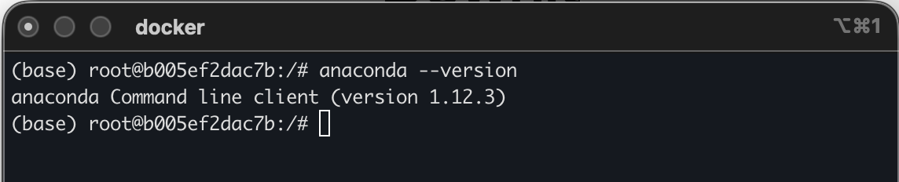
Figure 8: Anaconda version confirmation

Docker Network Configuration
We’re running a couple of Docker containers here. One of the cool things about Docker is that we can join them into their own network. This will allow the two to talk directly without relying on the host’s network.
In a local terminal window Enter the following commands:
docker network create <network name>
docker network connect <network name> <postgres container name>
docker network connect <network name> <anaconda container name>

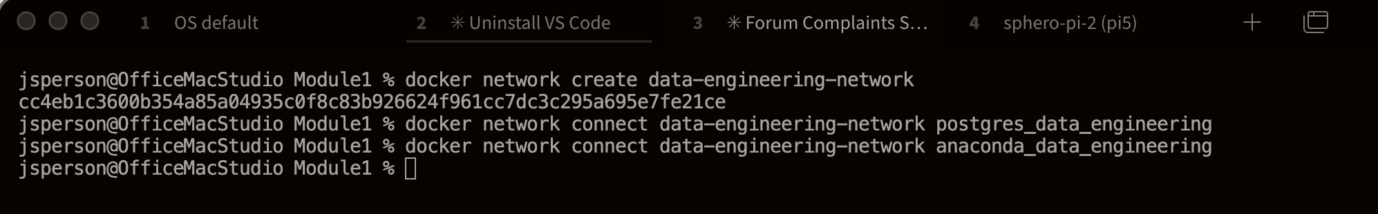
Figure 9:Docker Network Setup
Use the command docker network inspect <network name> to see the configuration of the network. Note that containers must be running in order to show up in the network. They do not need to be running to be added.
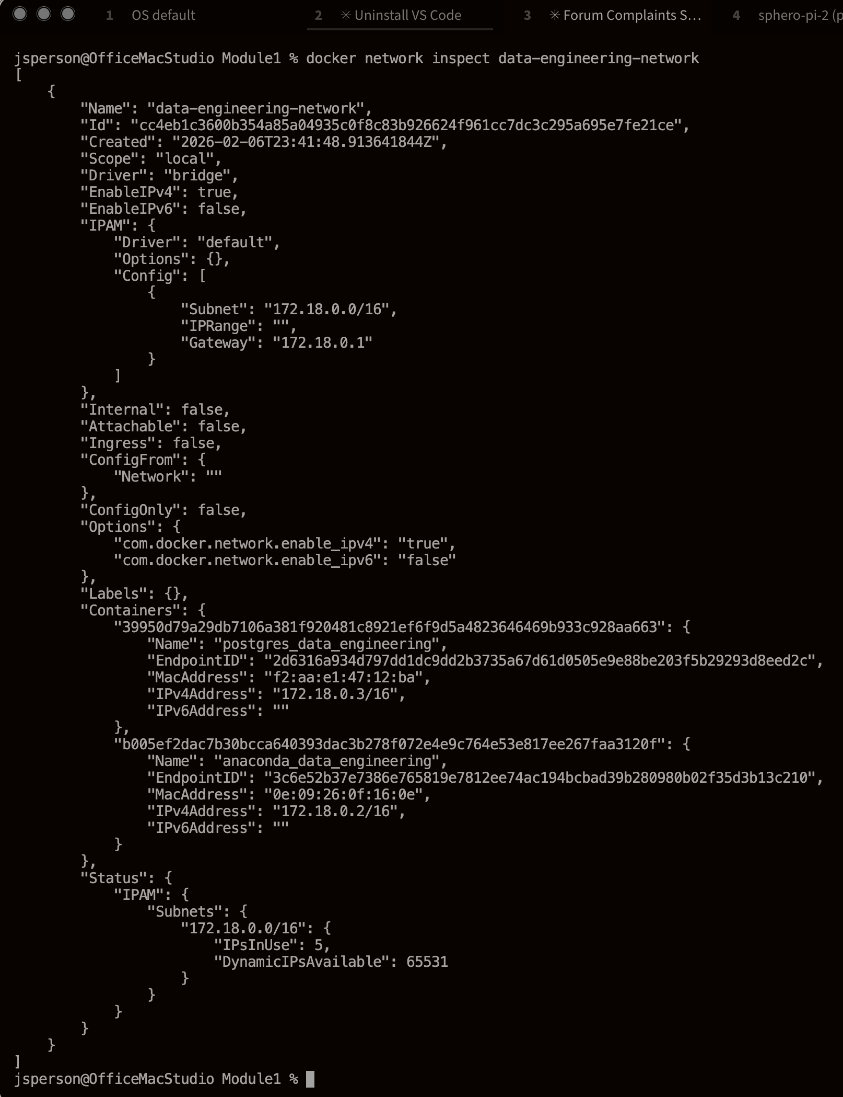
Figure 10: Sample Docker Network Inspect Output – Note two containers

VS Code Install and Configuration

VS Code Installation
These steps are specifically for MacOS but other operating systems installations should be quite similar.
- In a web browser navigate to https://code.visualstudio.com/download
- Select the link for the appropriate install. This could be an in-depth discussion depending on what Mac you have. I’m using the Apple Silicon dmg.
- Assuming downloaded the dmg, find it in the Downloads folder and click on it. You’ll see a window like Figure 11: VS Code Install Screen. Drag Visual Studio Code over to the Applications folder.
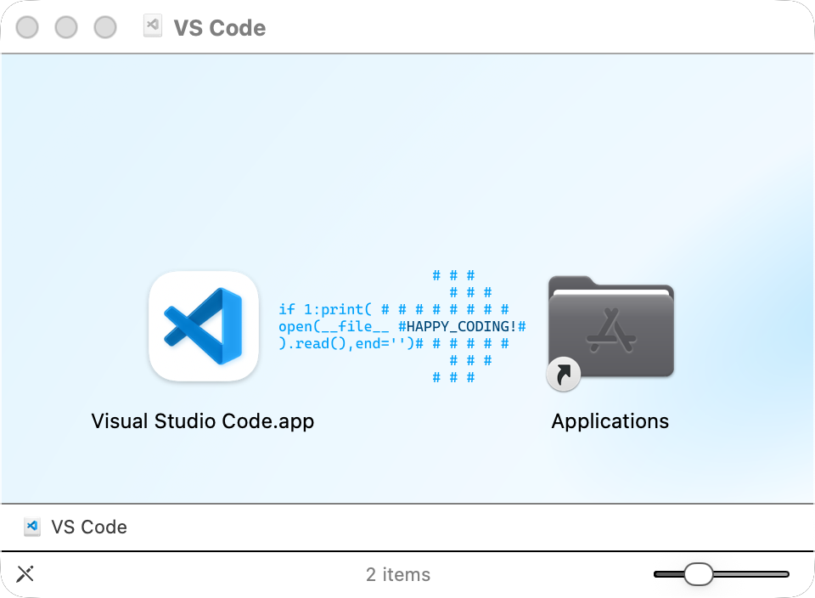
Figure 11: VS Code Install Screen
- Start VS Code from the Applications folder.
- In VS Code, on the left-hand side of VS Code, Select the Extensions icon (see Figure 12.
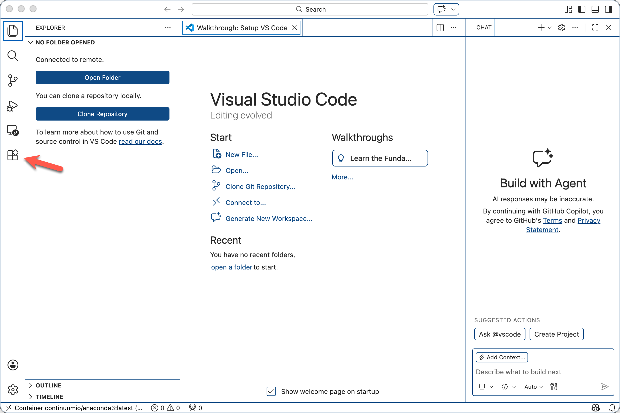
Figure 12: Extension icon indicated by arrow
- Install the following Extensions:
  - Python (Python debugger comes with it)
  - Dev Containers

Python Data Pipeline Setup
These steps are a bit sparser than the above. My assumption is that anyone doing development in containers knows at least a bit about VS Code. Since I believe the goal here is to prove knowledge and to provide a reference in the future I think this is sufficient.
- If it’s not already running, start Docker Desktop
- Start both the Postgres and the Anaconda containers
- Open VS Code
- Click on the remote explorer in VS Code (it’s the icon right above the Extensions icon)
- Click on the “Attach in Current Window” arrow as indicated by the red box and finger pointer in Figure 13.
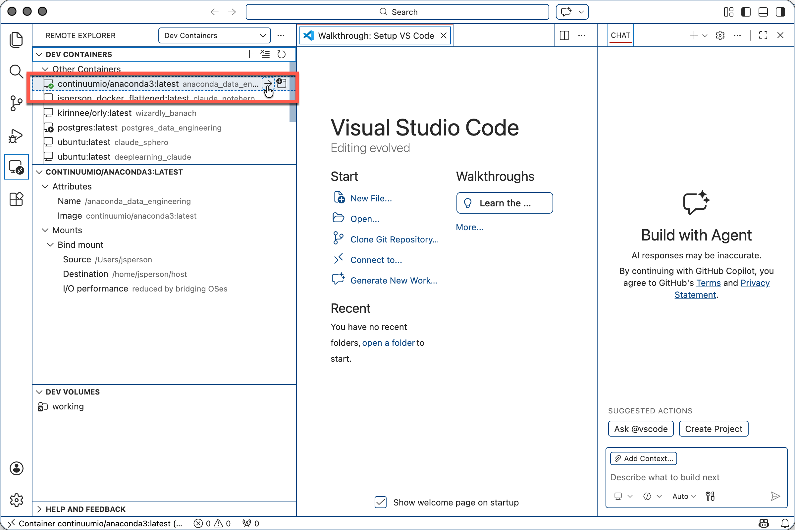
Figure 13: Attaching to the Anaconda container
- Open a folder of your choice. I’m using a folder on the host via the mounted directory that is a github repo.
- Create a new python file in that folder.
- Make sure you’re running with the conda python3.
- pip install psycopg2-binary
- Grab the script from the Canvas page (See Appendix A: Code Listings) and copy it to your file.
- On line 52 change the host name to the name of your Postgres Docker container. See Figure 14: Extract Script Executed for a screenshot of the modified and executed script. The extracted data files can be seen in the left hand file explorer pane. Data files and scripts are available here: https://github.com/jsperson/newman_data_engineering (Extract script and data files are in the “extract” folder at the top of the repo.
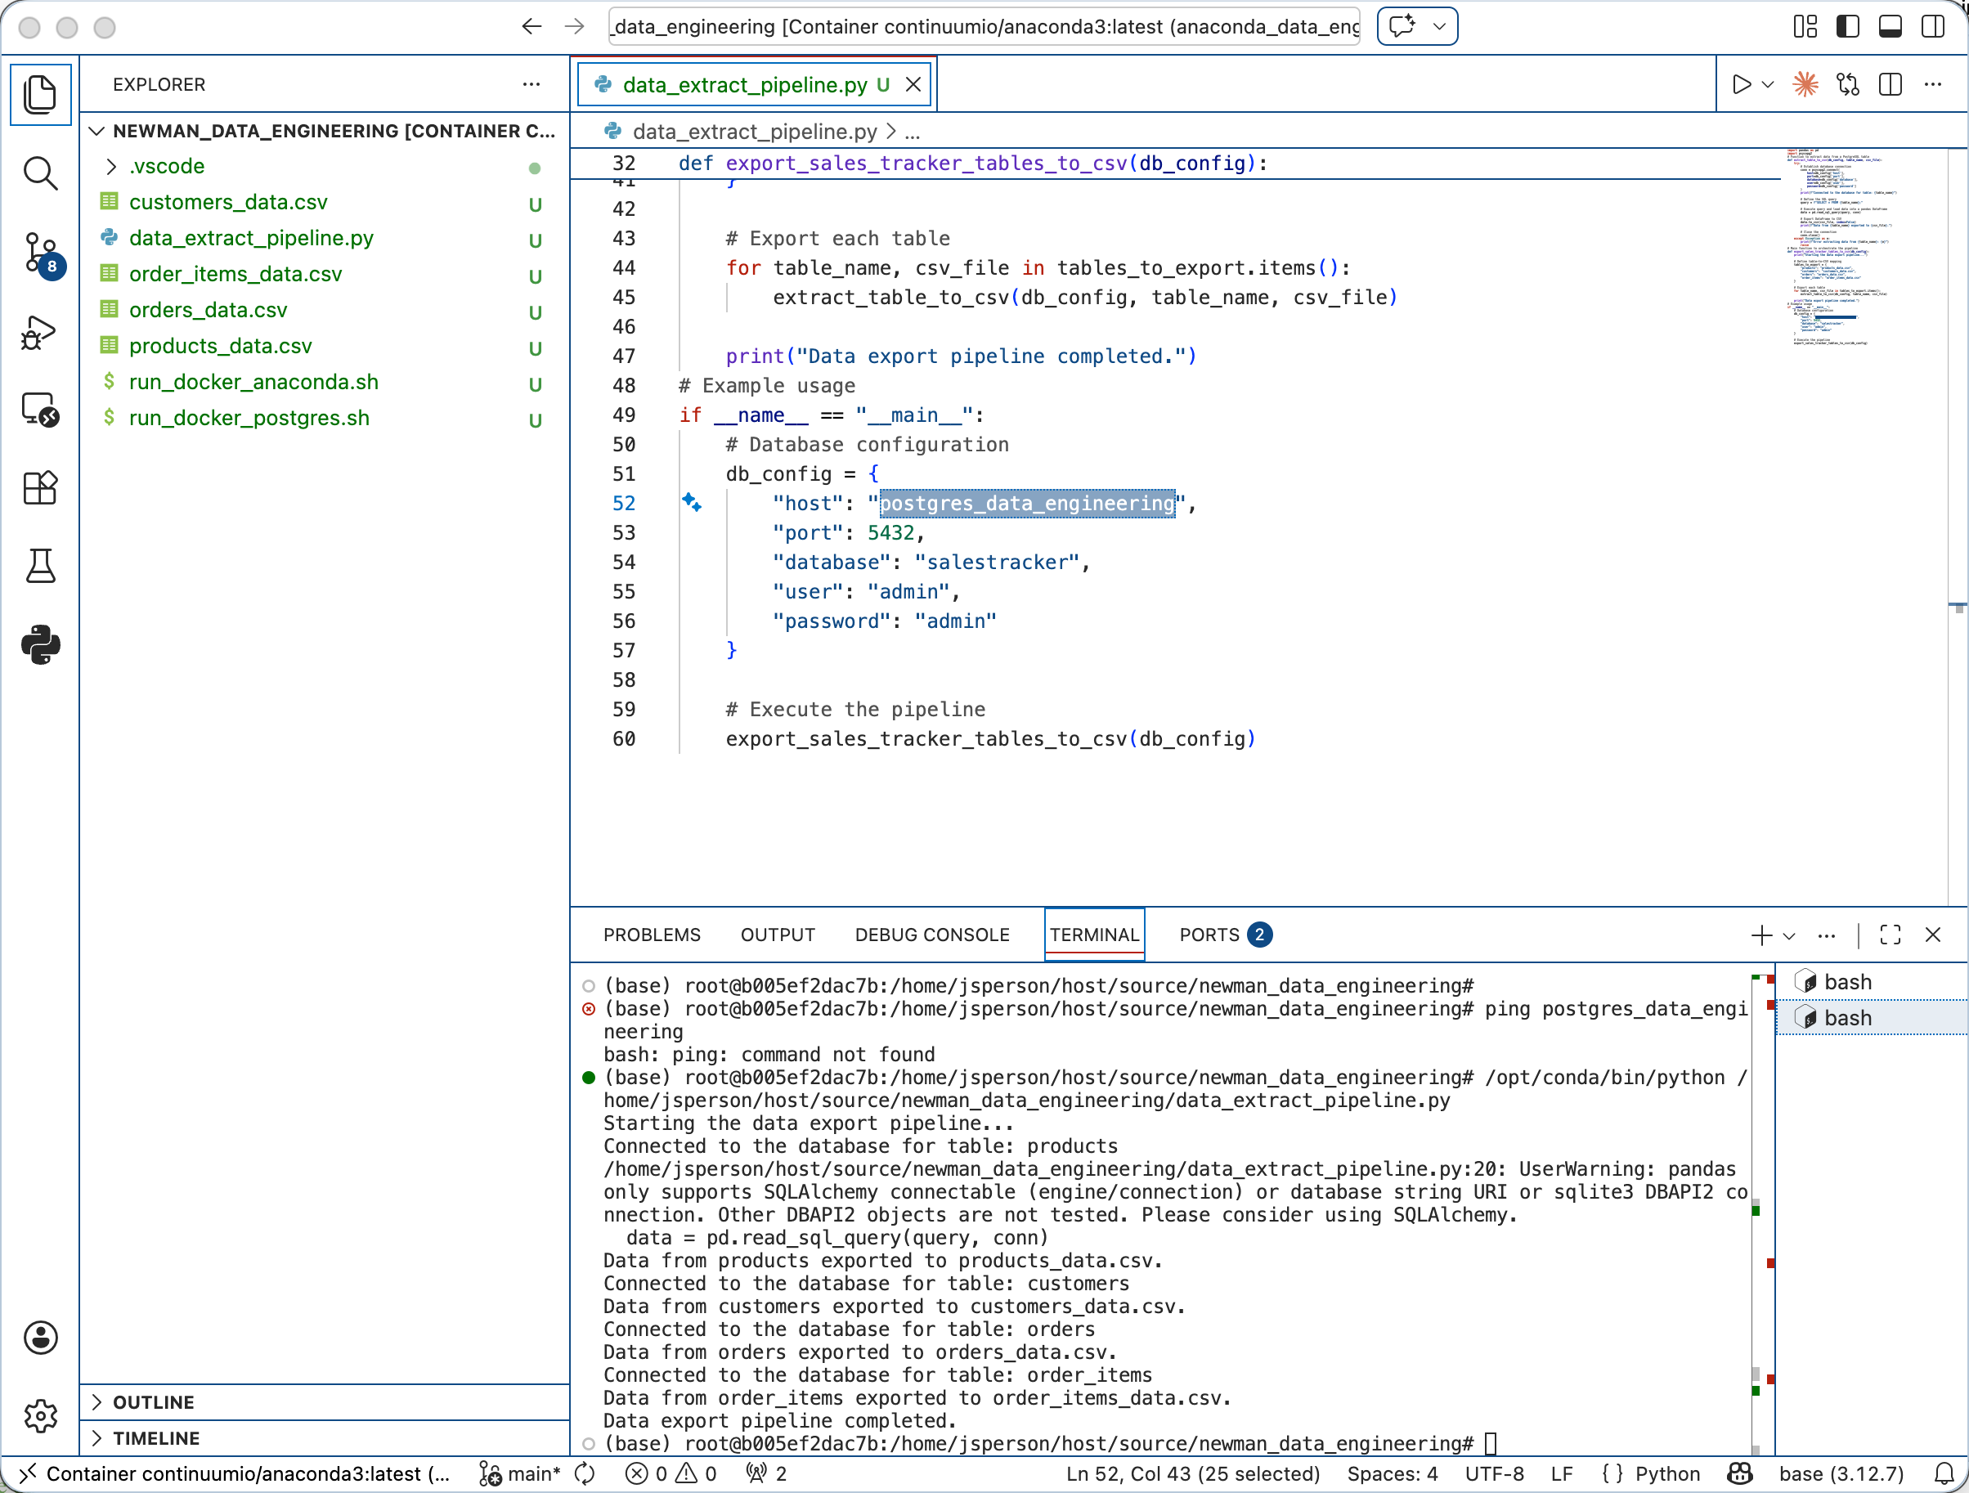
Figure 14: Extract Script Executed

Apache Nifi Install (Ravi, 2023)
These steps are specifically for MacOS but other operating systems installations should be quite similar.

Nifi Docker Configuration
See Postgres Installation above for more information about Docker. We’re going to use a similar procedure here.

Docker Execution Script
As with Postgres above, I have a script that downloads an image, configures a container, and starts the container.
#!/bin/bash

# Variables
CONTAINER_NAME="nifi_data_engineering"
IMAGE_NAME="apache/nifi:latest"
PORT="8443"
#MOUNT_PATH_ON_HOST="/Users/jsperson"
#MOUNT_PATH_IN_CONTAINER="/home/jsperson/host"

# Check if the container exists
CONTAINER_ID=$(docker ps -a -q -f name=$CONTAINER_NAME)

# If the container does not exist, create and run it
if [ -z "$CONTAINER_ID" ]; then
echo "Container does not exist. Creating and starting..."
docker run -d \
--name $CONTAINER_NAME \
-p $PORT:$PORT \
$IMAGE_NAME
else
# Check if the container is running
RUNNING_CONTAINER_ID=$(docker ps -q -f name=$CONTAINER_NAME)
if [ -z "$RUNNING_CONTAINER_ID" ]; then
echo "Container exists but is stopped. Starting..."
docker start $CONTAINER_NAME
else
echo "Container is already running."
fi
fi

# Connect to the container
echo "Connecting to container..."
docker exec -it $CONTAINER_NAME /bin/bash

- See the Postgres and Anaconda instructions for background in Docker and the related Docker scripting.
- Use the script above as an example. As with previous scripts it downloads an image, creates a container, and starts the container. It is intended for normal use of the Nifi container.

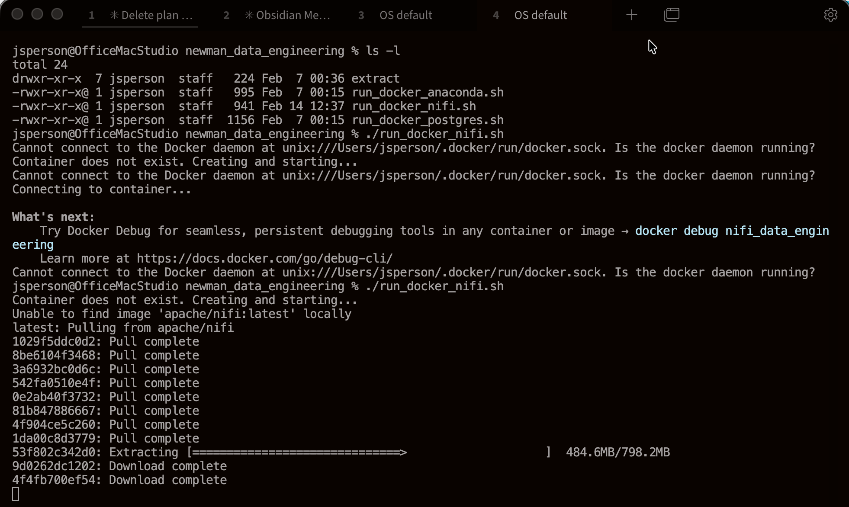
Figure 15: Initial failure to start (Docker not running) then success downloading image
- Add the Nifi container to the Docker network:
docker network connect <network name> <nfie container name>
- Point your web browser to https://localhost:8443/nifi
- Accept any warnings (these are due to self-signed https certs)
- A web page prompting for username and password indicates success.
- Retrieve the Nifi username and password:
docker logs -f <nifi container name> 2>&1 | grep -A 1 "Generated"
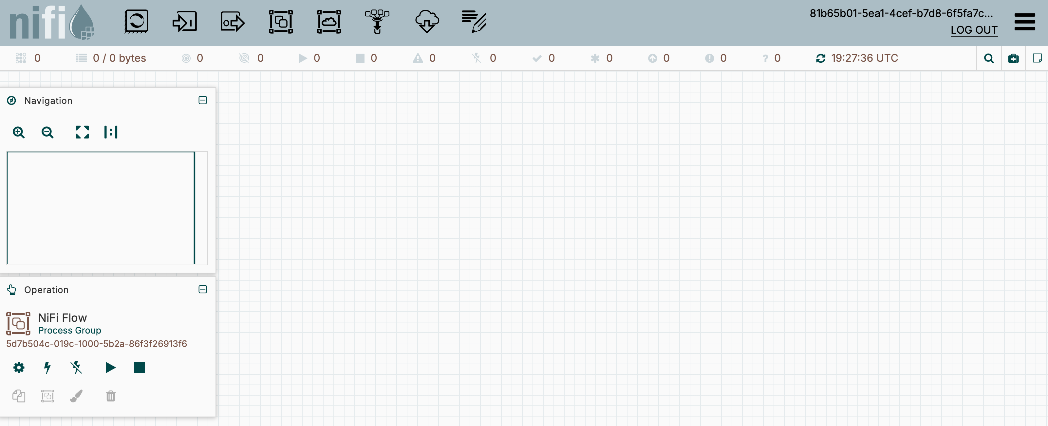
Figure 16: Successful Nifi Login

Apache Nifi Usage (Ravi, 2023)

Flow Configuration
In this section we walk through configuring our first Nifi flow. This flow consists of a static file generator and a file writer process called GenerateFlowFile and PutFile respectively. This flow will generate a single file every minute it is running.
- Start the Nifi container.
- Navigate to https://localhost:8443/nifi
- Login using the Nifi credentials. You’ll land on page similar to that shown in Figure 16: Successful Nifi Login.
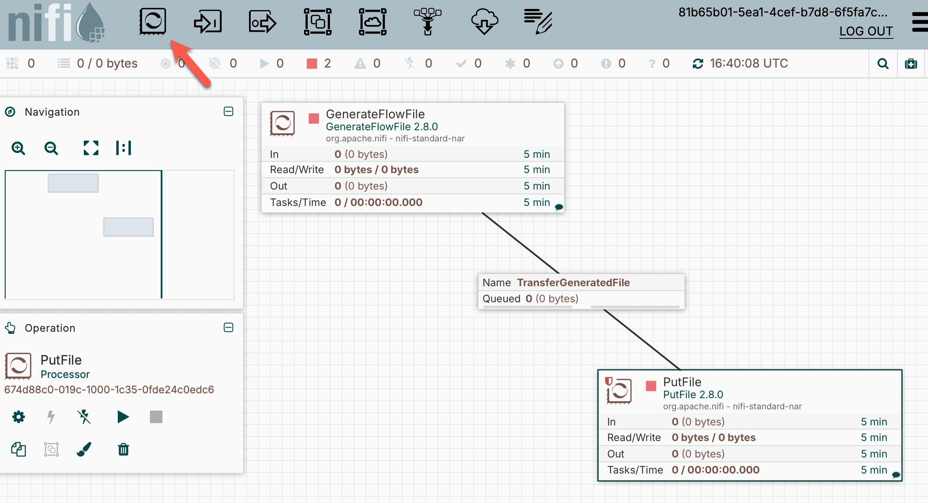
Figure 17: Nifi canvas with Processor icon indicated
- Using the Processor icon indicated in Figure 17, add a GenerateFlowFile and a PutFile processor onto the canvas.
- Configure the GenerateFlowFile (double click on the respective box):
  - Settings/Name: <Name the processor something reasonable>
  - Scheduling: No changes but note CRON and Timer driven options.
  - Properties/File Size: I believe that these are informative to the orchestrator.
  - Properties/Custom Text: Change to contain some text that will be inserted into each output file.
  - Relationships: No changes or notes
  - Comments: Add a comment describing this processor
  - Click Apply
- Create a connection between GenerateFlowFile and PutFile by hovering over the former, putting the pointer on the connector icon that appears, and then dragging to the PutFile box. Figure 17 shows the connector between the two processors.
- Configure PutFile (double click on the respective box):
  - Settings/Name: <Name the processor something reasonable>
  - Scheduling/Concurrent Tasks: This allows parallel execution when the setting is greater than one and there is available input. Leave at 1 for now.
  - Properties/Directory: Give this a path location on the Nifi container where it can write files.
  - Properties/Create Missing Directories: I set this to false and created the folder myself. This way if Nifi can’t write to the folder or it tries to write in an unexpected location an error is likely. This minimizes the chance of silent failure.
  - Relationships: Set both options to terminate. The PutFile is the last processor in the flow so it is reasonable to terminate on either failure or success.
  - Comments: Add a comment describing this processor
  - Click Apply

Apache Nifi Flow Operations
Once the flow is configured, we can walk through some of the operational capabilities of the Nifi interface.
- To start a flow, click on the canvas to ensure that the Operation panel indicates “Nifi Flow” then click the start button indicated by the arrow in Figure 18. Note that this screenshot shows the flow partially stopped. We discuss this state below.
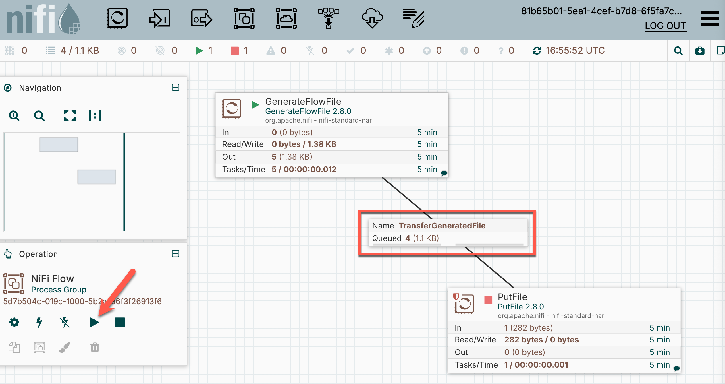
Figure 18: Flow with PutFile Stopped
- Right clicking on a component provides access to “View Status History”. This exposes various selectable metrics and timeframes presented in a graph (See Figure 19).
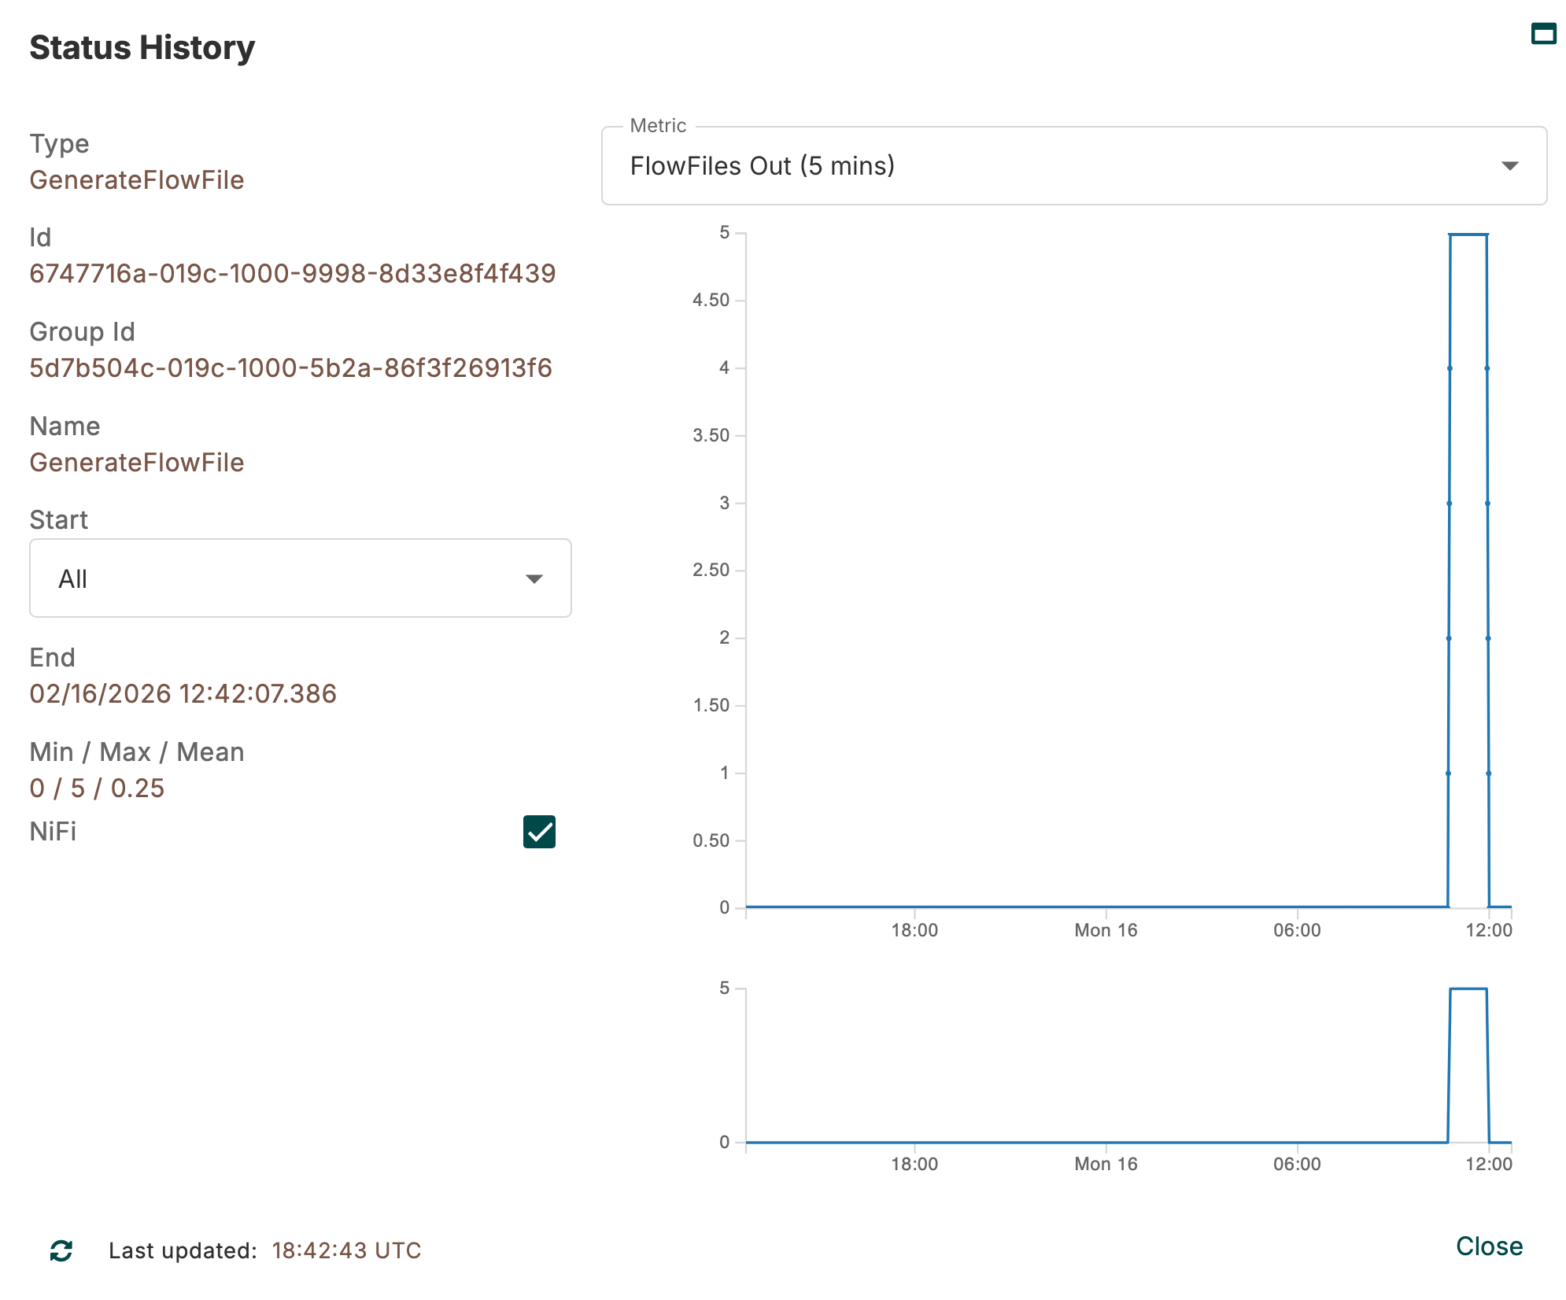
Figure 19: Metric View

- A rather unique (in my experience) feature of Nifi is the ability to stop individual flow components. In Figure 18 you can see how the PutFile is stopped (indicated by the stop icon in the processor box. While PutFile is stopped, GenerateFlowFile remains running and its output is queued in the connection TransferGeneratedFile. The figure calls out the connection with a red box where you can observe four files are queued. Restarting the PutFile causes the queue to be rapidly emptied as the PutFile processor writes the files to the filesystem. Figure 20 shows the file output before and after the partial stop. Observe files written every minute up to 1651 where there was a five minute PutFile stop then five files written at 1656 the subsequent return to the one per minute cadence.
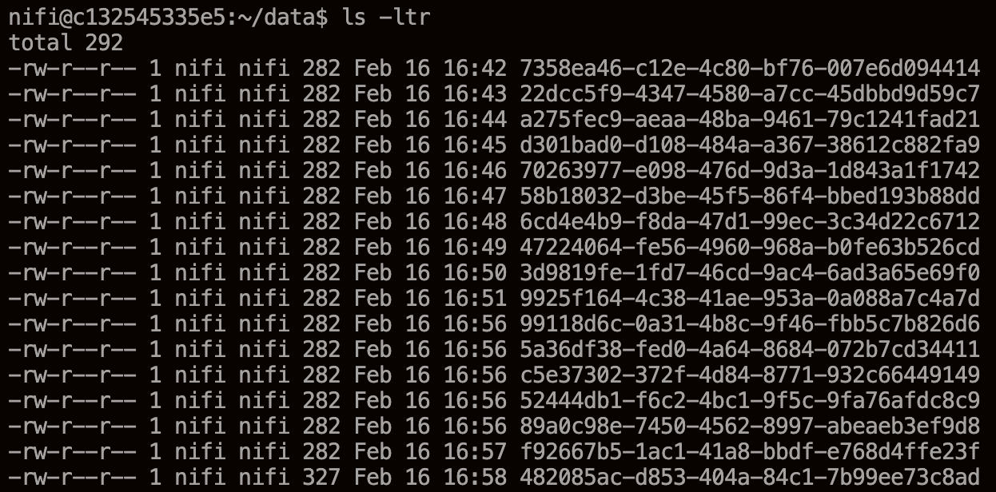
Figure 20: File listing of flow output

Apache Nifi Rest API Pipeline
We are going to be pulling data from a Rest endpoint and inserting the data into a Postgres database. This section will walk through the steps.

Setup Postgres IOT
We need a target database for our data. We’ll setup a new container to do this.
- Create a copy of your original Postgres startup script.
- In the new startup script, modify lines 4-8 to read as follows:
CONTAINER_NAME="postgresIOT"
IMAGE_NAME="postgres:latest"
POSTGRES_USER="iot_user"
POSTGRES_PW="secretpassword"
POSTGRES_DB="iot_data_db"
- Execute the script – this will create and start the new postgresIOT container and drop you into a command line inside of it.
- Enter: psql -U iot_user -d iot_data_db to enter the database CLI.
- Use the \l (backslash lower case L) to lsit databases. You should see iot_data_db in the list.
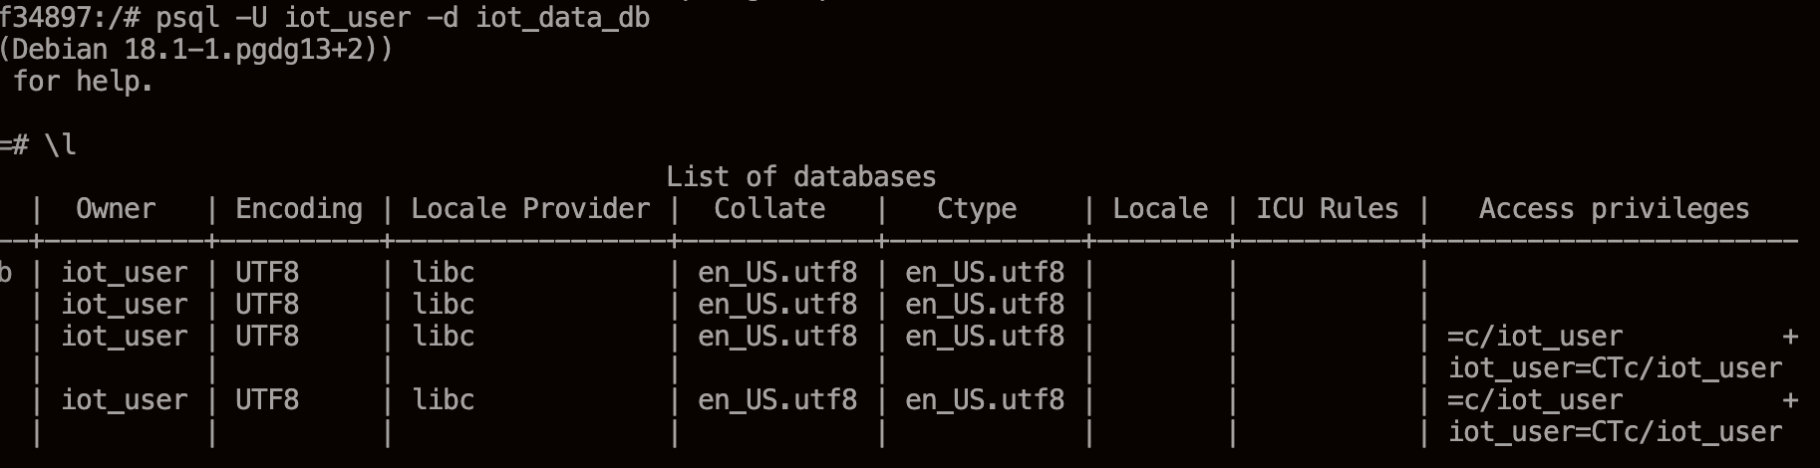
Figure 21: Starting psql and listing databases
- Use the SQL script listed below in IOT Database Table Creation to create the table to store the Rest data.
- Enter \d flight_data (backslash lower case D) to describe the newly created table.

Apache Nifi Initial Configuration
- Start the Nifi container. Note: Nifi instructions are above.
- Connect to Nifi.
- If there’s anything on the canvas from previous work, delete it.
- On the canvas click hamburger/Controller Settings/Management Controller Services
- Click the + (plus) icon in the upper right
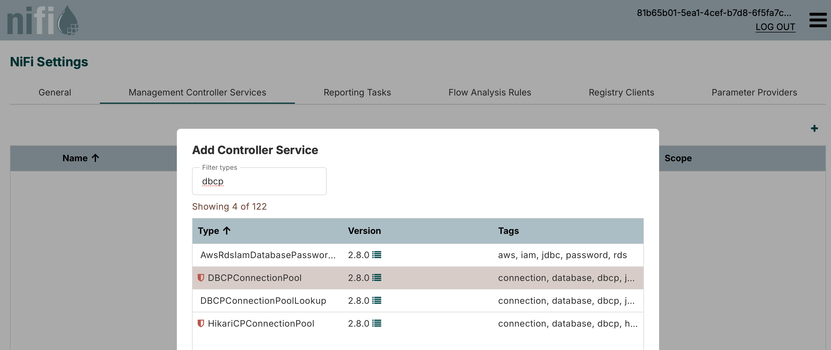
Figure 22: Add DBCPConnectionPool
- Click the Add button
- Edit the newly added connection pool
  - Properties/Database Connection URL: jdbc:postgresql://host.docker.internal:5432/iot_data_db
  - Properties/Database Driver Class Name: org.postgresql.Driver
  - Properties/Database User: iot_user
  - Properties/Password: secretpassword
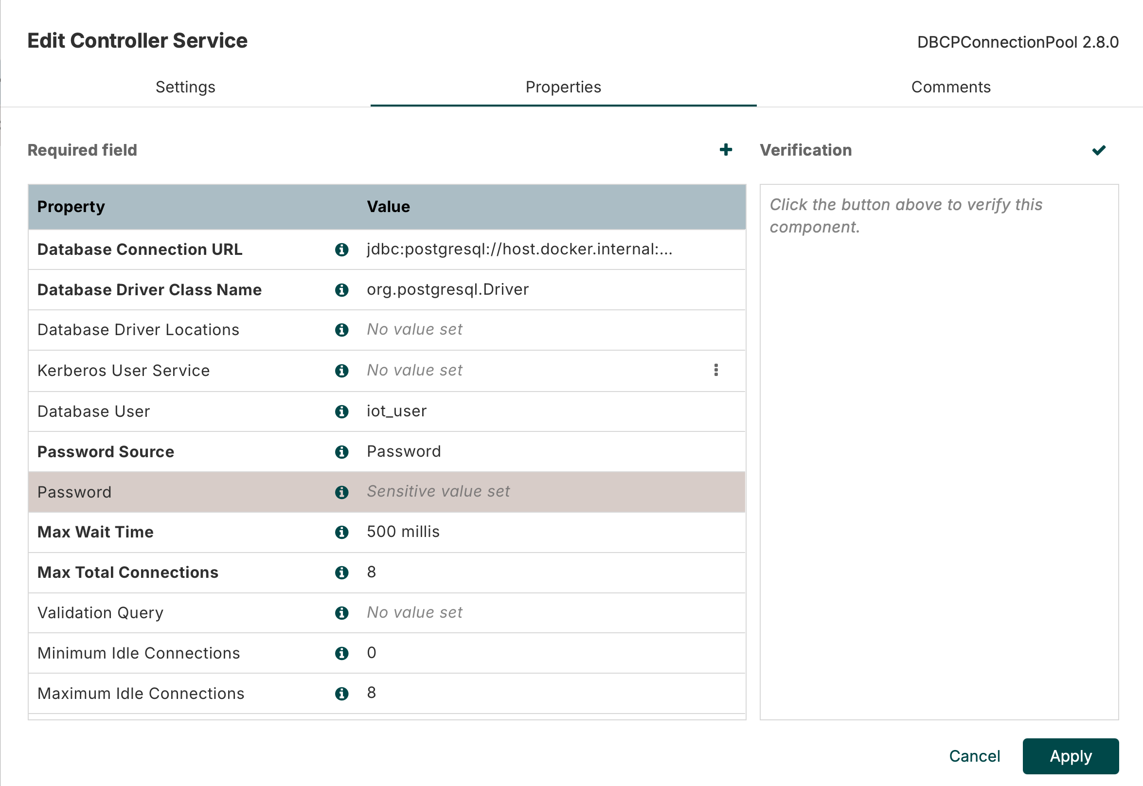
Figure 23: Connection Pool configuration
- Download and install the JDBC driver
  - Go to https://jdbc.postgresql.org/download/
  - Download the latest version of the driver
  - Copy driver to your nifi opt/lib directory (see screenshot below) – validate target directory and driver name using your CLI skills. Note my mixup the first two times.
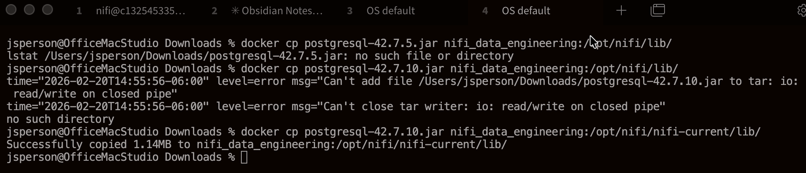
Figure 24: Copying the JDBC driver - third time worked
  - Enable the connection using three dots/Enable. It won’t fully start (red icon on the left) but will be enabled next Nifi restart.
  - We appear to have a classloader issue that is throwing a warning for the Connection Pool. It will probably work but we need to be aware in case of issues later.

Apache Nifi Flow Configuration
- Add a GnerateFlowFile processor to the canvas.
- Configure just added processor
  - Scheduling/Run Schedule: 3 min
  - Properties/+/access_key: <aviationstack.com key>
  - Properties/+/flight_status: active
  - Properties/+/limit: 5
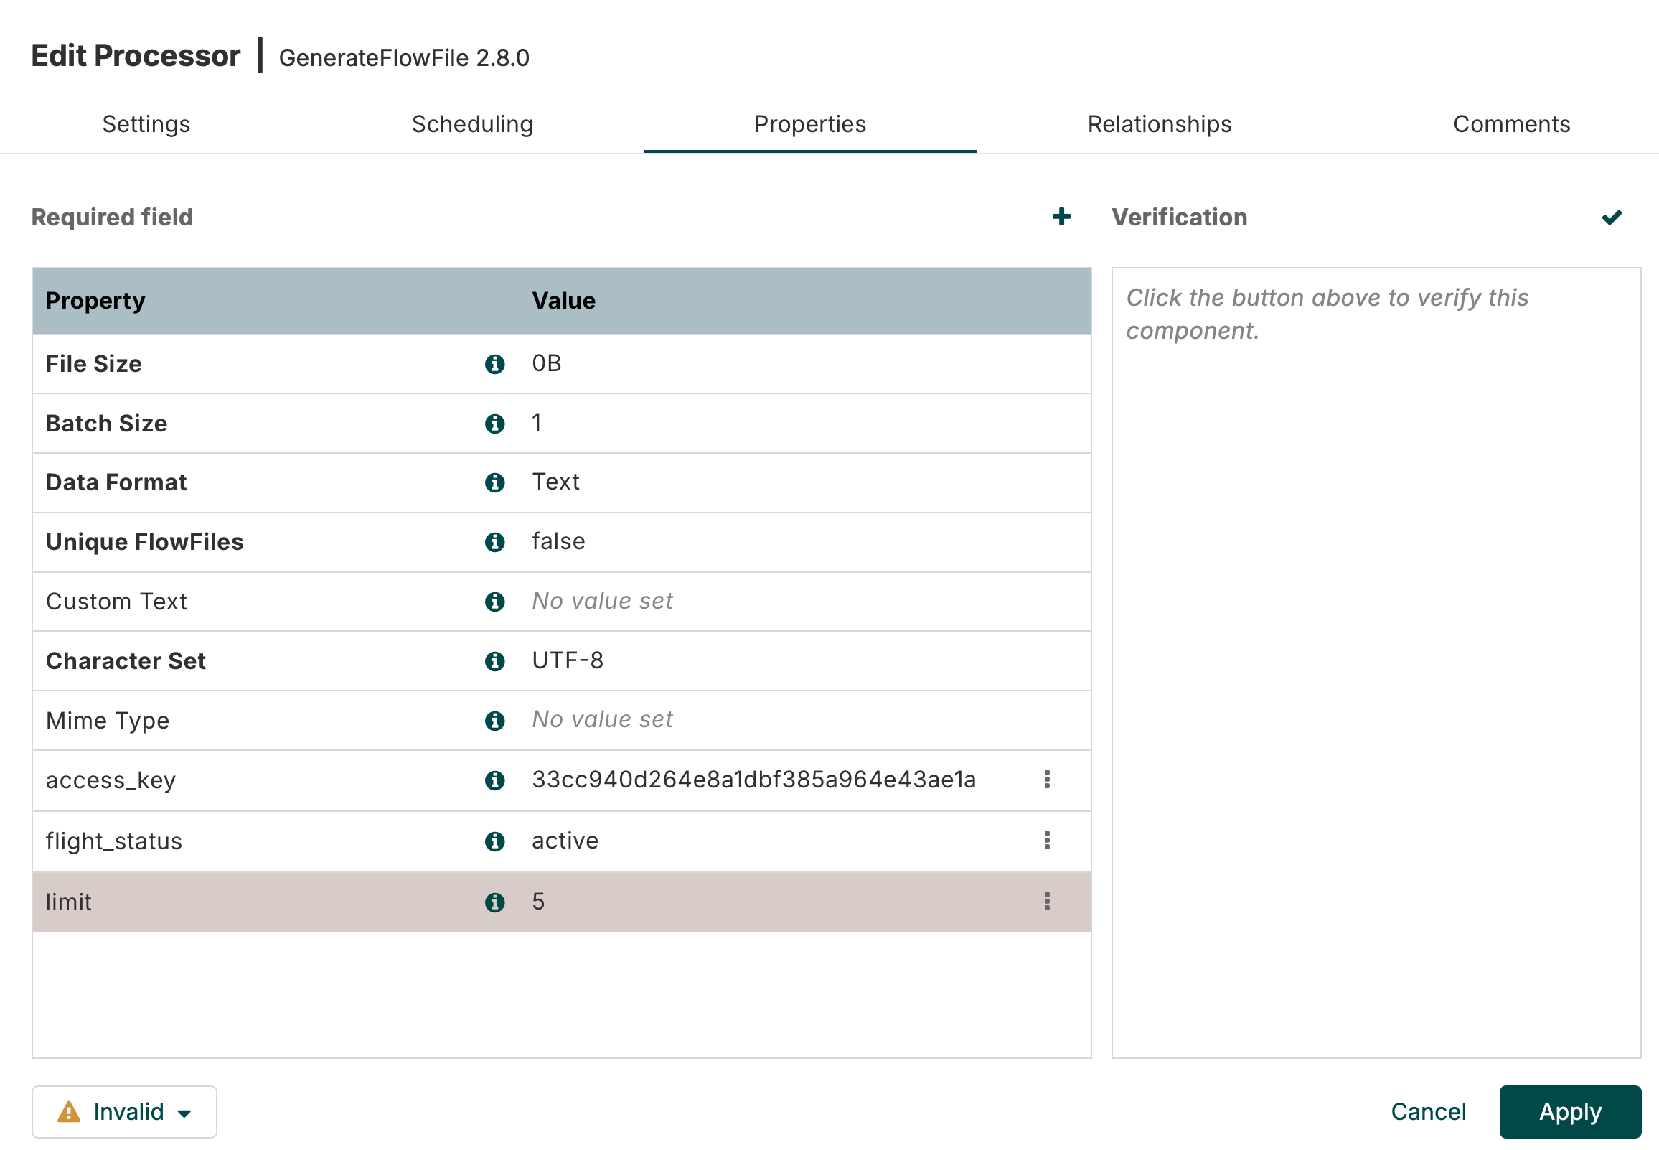
Figure 25: First processor configuration
- Add and configure InvokeHTTP Processor
  - Scheduling/Run Schedule: 3 min
  - Properties/HTTP URL (was Remote URL): http://api.aviationstack.com/v1/flights?access_key=${access_key}
- Add and configure EvaluateJsonPath Processor
  - Properties/Destination: flowfile-attribute
  - Add all fields found in Flight Data Fields as Property/Value in the Properties tab.
- Add and configure PutSQL Processor
  - Properties/JDBC Connection Pool: DBCPConnectionPool (Note that I had to actually add another one from this dialog as it wouldn’t pick up the one we configured above.)
  - Properties/SQL Statement: Text from Flight Data Insert Statement below.
- Connect the Processors in the following order:
GenerateFlowFile -> InvokeHTTP -> (response) EvaluateJsonPath -> (matched) PutSQL
- We need to add connectors for the rest of the relationships…
- Add and configure a Wait Processor
  - Leave all settings as default
- From InvokeHTTP join to Wait for Failure, No Retry, and Retry
- Set InvokeHTTP/Relationships/original to terminate (checked)
- From EvaluateJsonPath join to Wait for failure and unmatched
- Set PutSQL/Relationships/success to terminate (checked)
- Connect PutSQL to itself for retry
- From PutSQL join to Wait for failure
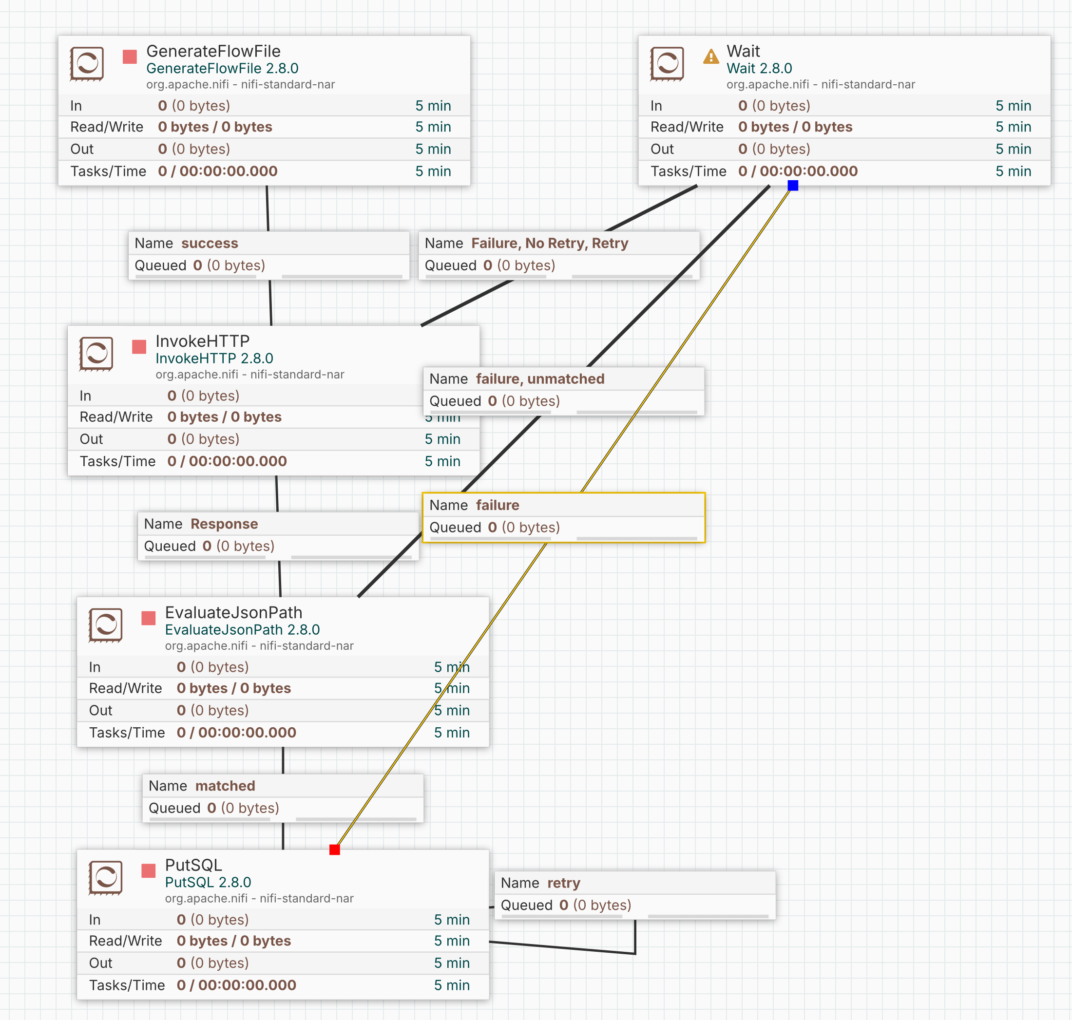
Figure 26: Completed Apache Nifi Flow
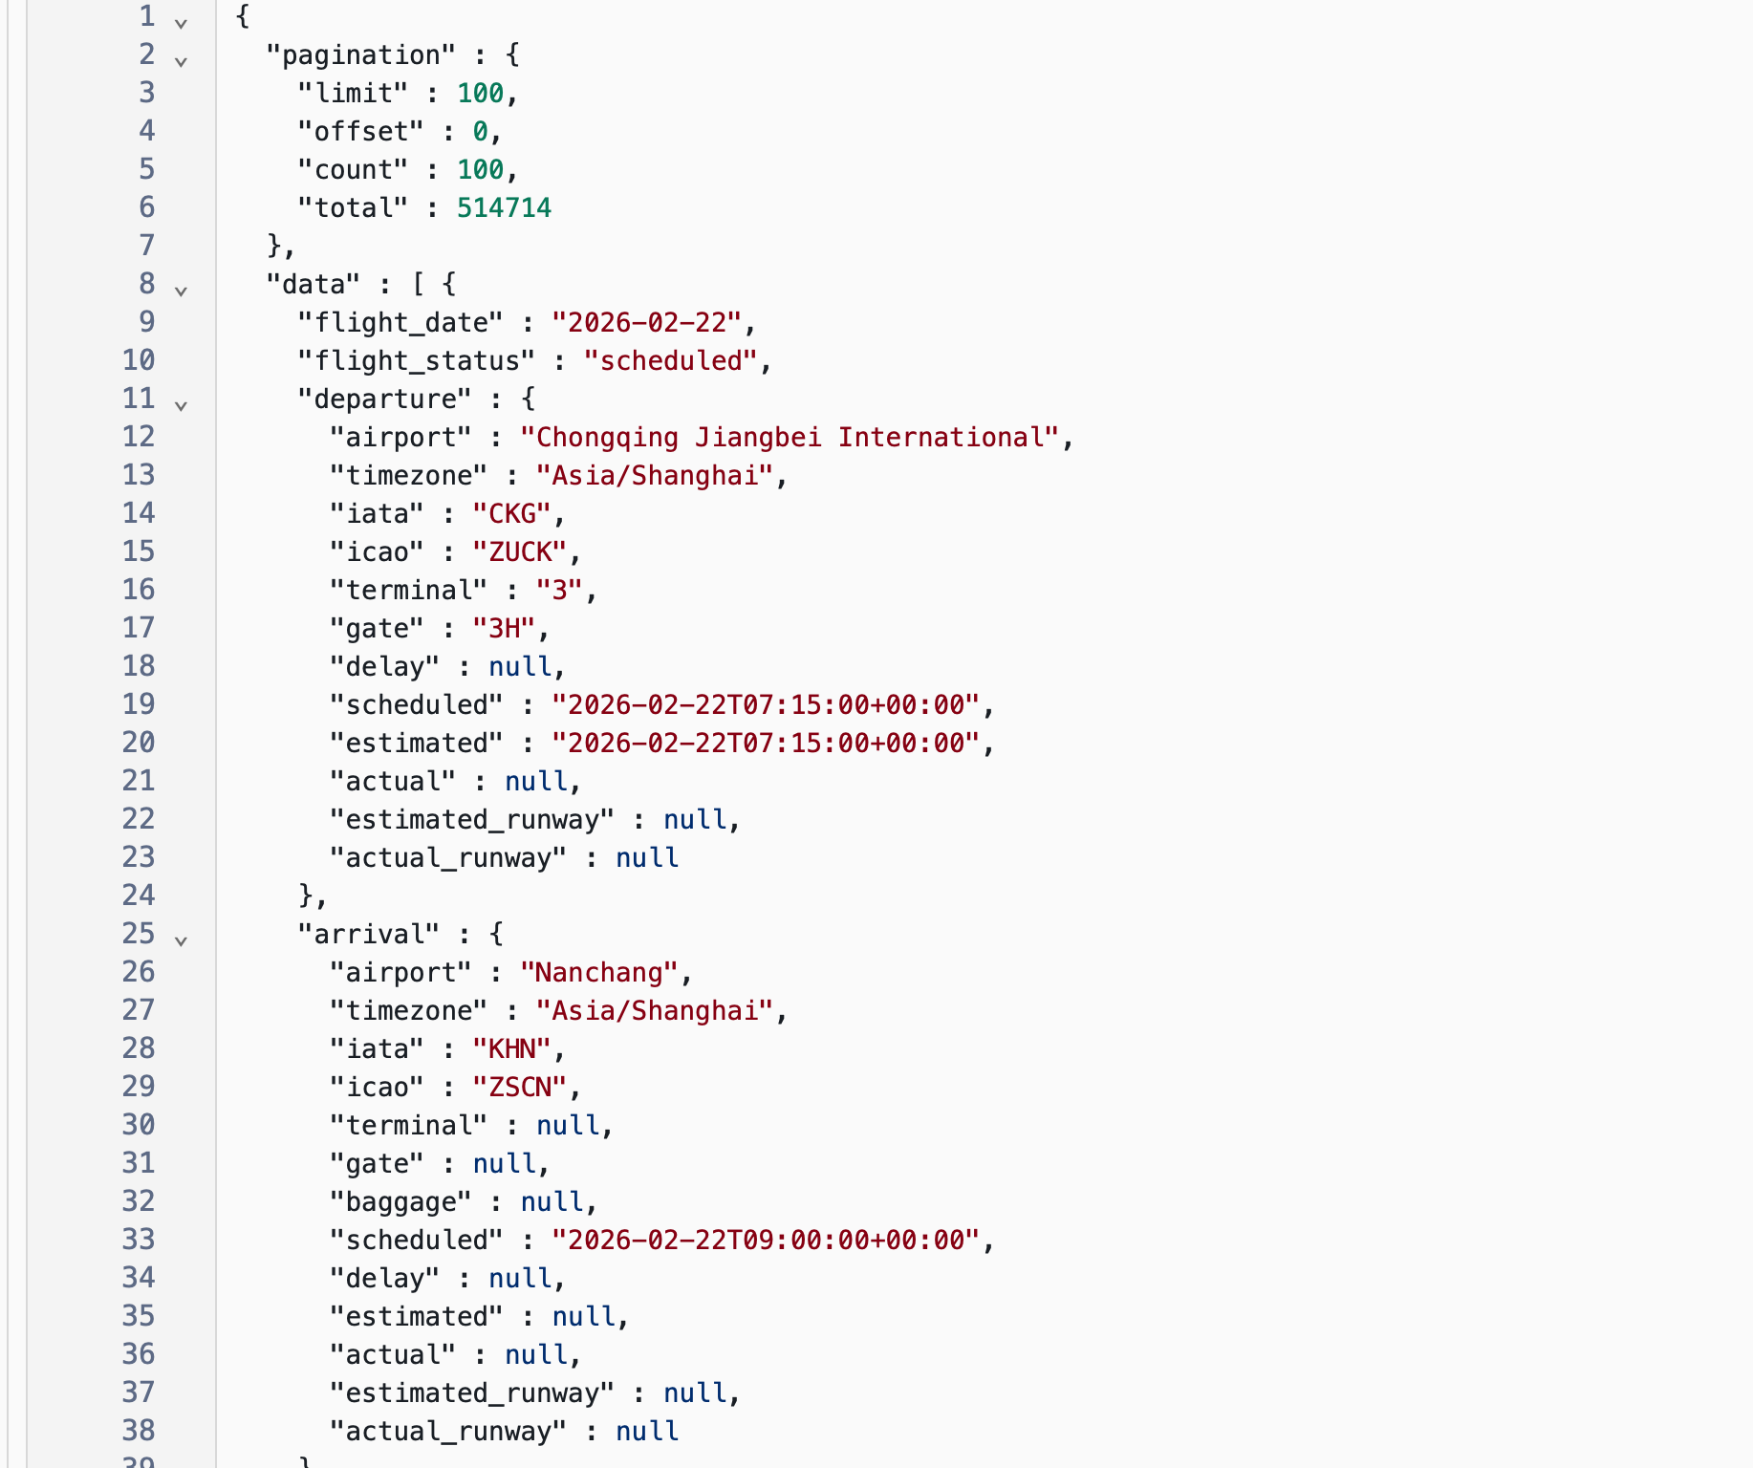
Figure 27:JSON Output from SplitJson

Validate Data Flow
- Execute the Apache Nifi Flow
- Open a terminal on the PostgresIOT container
- psql -U iot_user -d iot_data_db
- SELECT * FROM flight_data;
- See records

Make it Better
The above didn’t do what I wanted or expected it to do. I was only getting one record per pass. I wanted 100 records per call and immediate commits after each 100 record chunk. So I did the following:
- Add a Split Json Processor between InvokeHTTP and EvaluateJsonPath
  - Properties/JsonPathExpression: $.data
- Change EvaluateJsonPath to set the field values to remove .data[0] so that they look like $.airline.iata and not .data[0].airline.iata
- PutSQL/Properties/Support Fragmented Transactions: false
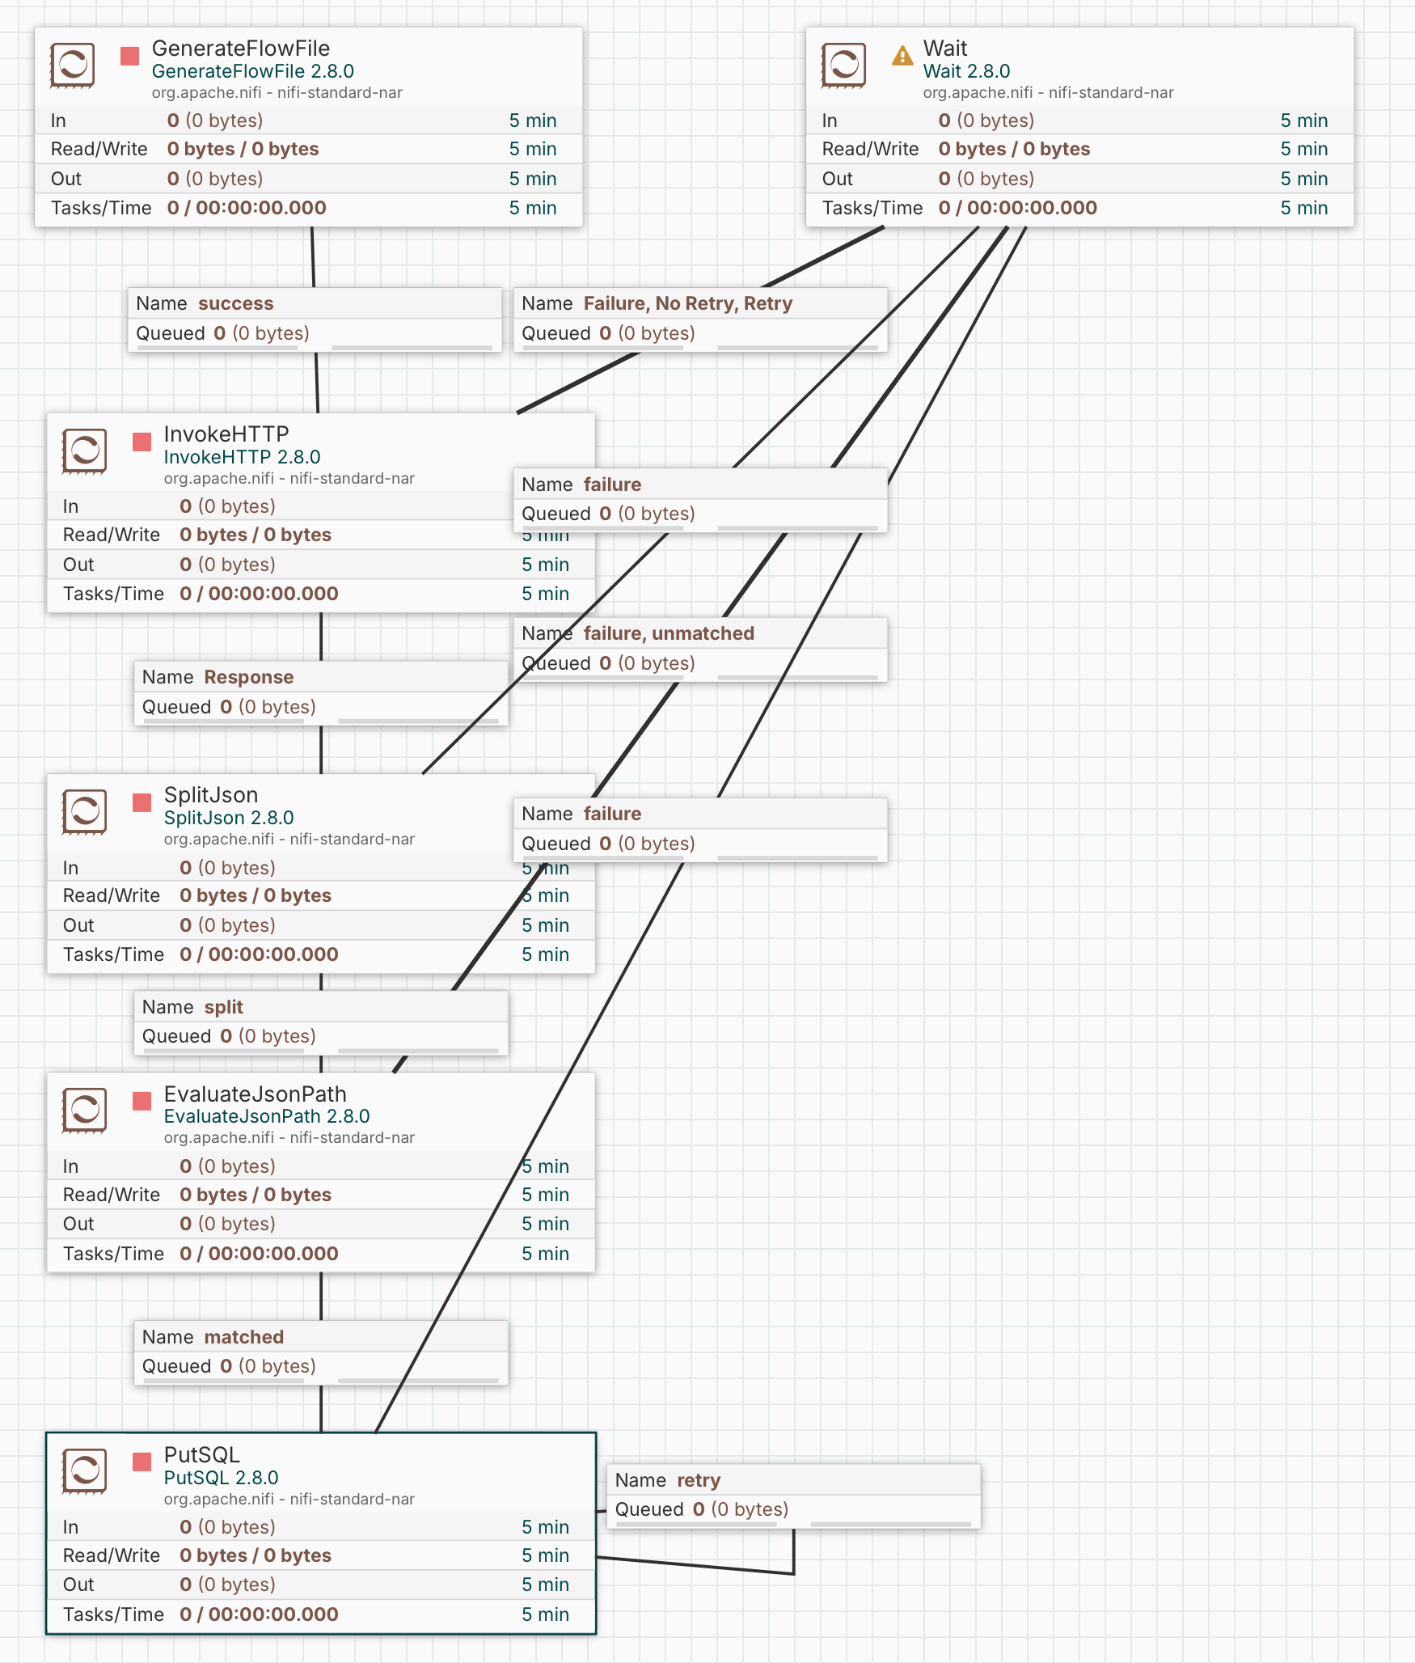
Figure 28: Enhanced Flow
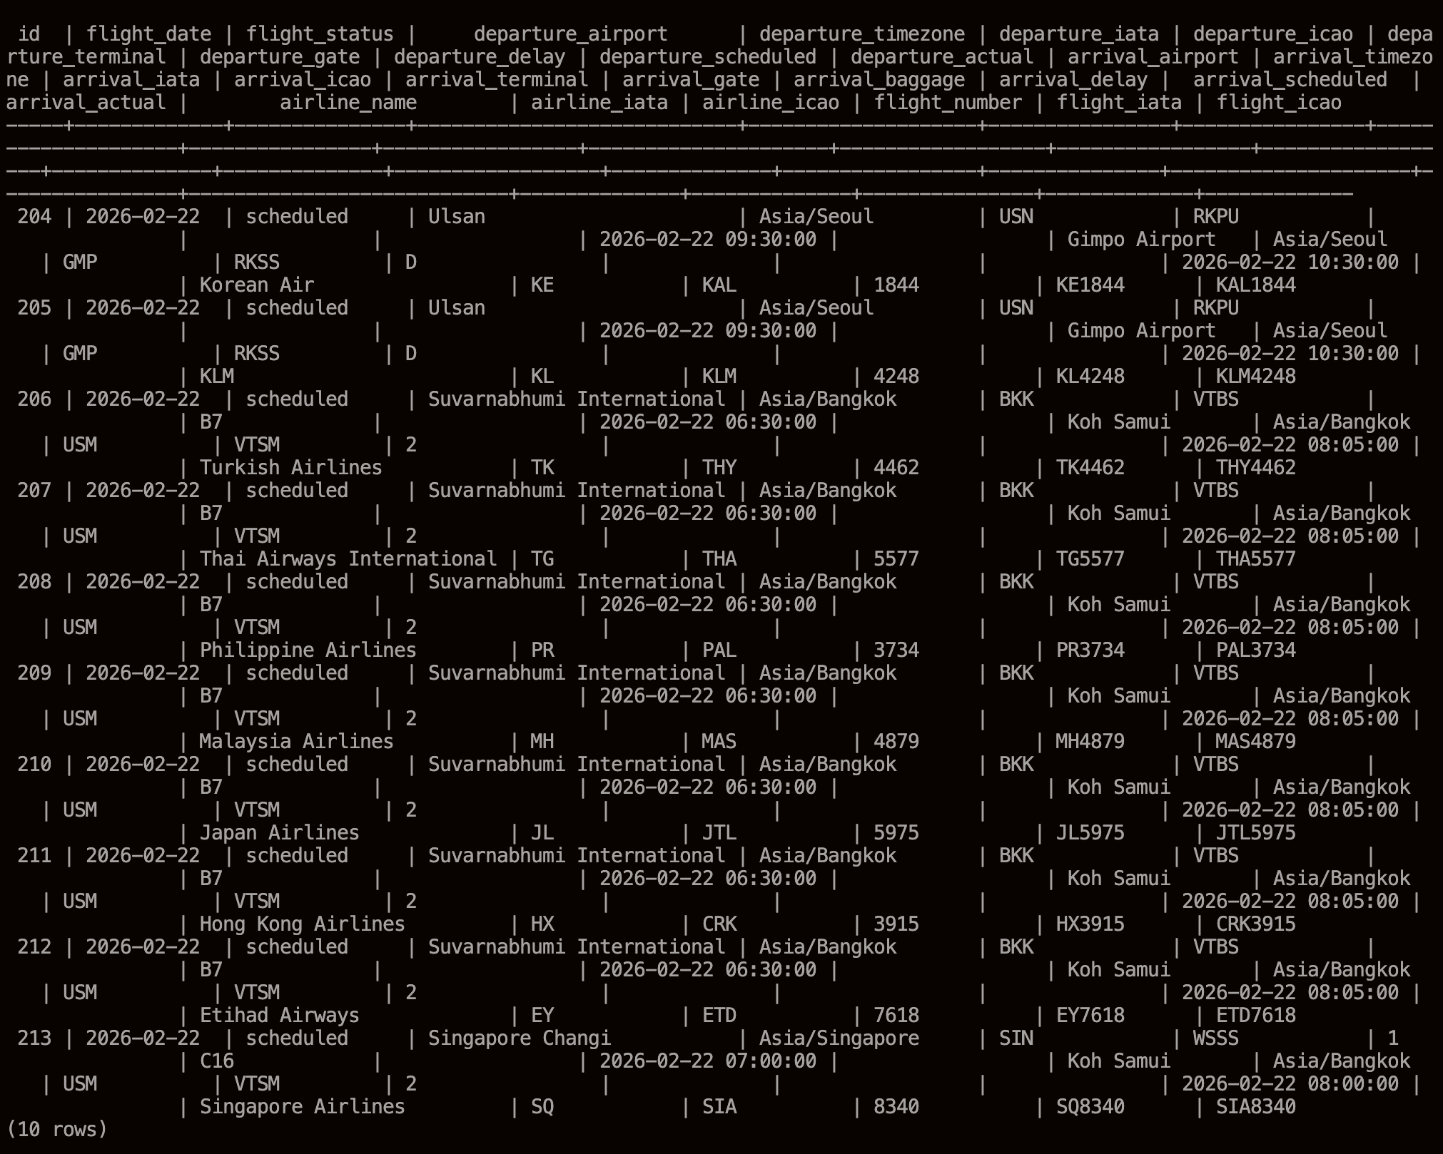
Figure 29: Ten Records of the 200 Inserted (two pulls)

aviationstack.com Registration
- Open a free account on at https://aviationstack.com
- Once account is verified, capture the API key on the Dashboard and keep it for configuring the Nifi flow.

Airbyte/dbt/Dagster Project
This one is going to be relatively sparse. I’ll make it at the level that Scott Person or another relatively experienced data engineer could follow given no specific prior knowledge but with a good general understanding of MacOS, Docker, and database stuff.

Source Video
I’m using the LinkedIn Learning End to End Data Engineering Project Class video as a guide. It’s somewhat old but uses Airbyte. The age will make it interesting to get working.

Configure the Environment

Python Run Environment
- In keeping with my principle to try to not screw up python on MacOS, I setup a Docker image with python. This is modeled after my standard Docker startup script.
#!/bin/bash

# Variables
CONTAINER_NAME="end-to-end-data-engineering"
IMAGE_NAME="python:3.12-slim"
MOUNT_PATH_ON_HOST="/Users/jsperson"
MOUNT_PATH_IN_CONTAINER="/home/jsperson/host"

# Check if the container exists
CONTAINER_ID=$(docker ps -a -q -f name=$CONTAINER_NAME)

# If the container does not exist, create and run it
if [ -z "$CONTAINER_ID" ]; then
echo "Container does not exist. Creating and starting..."
docker run -d \
--name $CONTAINER_NAME \
-v $MOUNT_PATH_ON_HOST:$MOUNT_PATH_IN_CONTAINER \
$IMAGE_NAME \
tail -f /dev/null
else
# Check if the container is running
RUNNING_CONTAINER_ID=$(docker ps -q -f name=$CONTAINER_NAME)
if [ -z "$RUNNING_CONTAINER_ID" ]; then
echo "Container exists but is stopped. Starting..."
docker start $CONTAINER_NAME
else
echo "Container is already running."
fi
fi

# Connect to the container
echo "Connecting to container..."
docker exec -it $CONTAINER_NAME bash

- Inside the python image I created my normal “source” folder and cloned the https://github.com/jsperson/end-to-end-data-engineering-project.git github repo. This is a fork of https://github.com/LinkedInLearning/end-to-end-data-engineering-project-4413618, which I hope works. The original repo for this class appears to be removed.
- Inside the repo I then ran pip install -e ".[dev]" as instructed in the video. This installed a lot of stuff – at least dbt but I believe more.
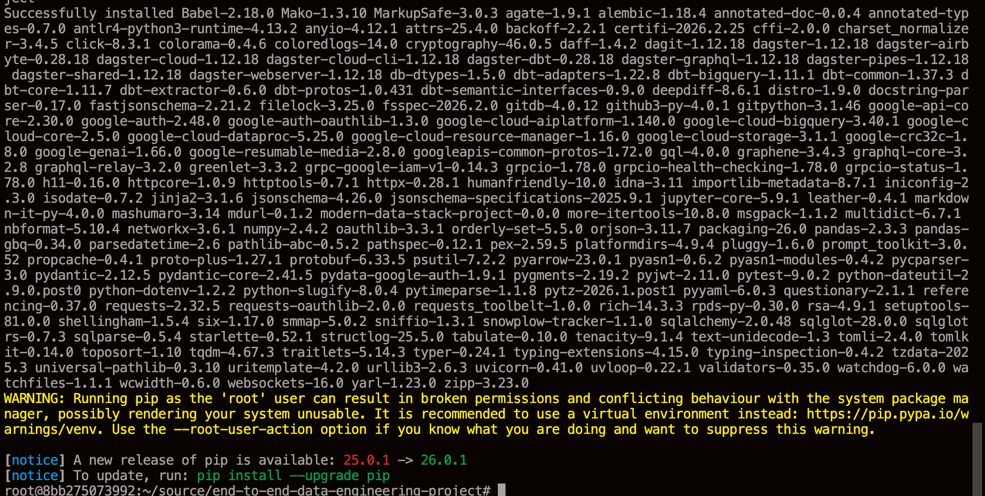
Figure 30: Python Container Config Proof of Work

Database Container Configuration
I’m using this Docker script:
#!/bin/bash

# Variables
CONTAINER_NAME="big-star-container"
IMAGE_NAME="lilearningproject/big-star-postgres"
#POSTGRES_USER="admin"
#POSTGRES_PW="admin"
#POSTGRES_DB="salestracker"
POSTGRES_PORT="5432"
#MOUNT_PATH_ON_HOST="/Users/jsperson"
#MOUNT_PATH_IN_CONTAINER="/home/jsperson/host"

# Check if the container exists
CONTAINER_ID=$(docker ps -a -q -f name=$CONTAINER_NAME)

# If the container does not exist, create and run it
if [ -z "$CONTAINER_ID" ]; then
echo "Container does not exist. Creating and starting..."
docker run -d \
--name $CONTAINER_NAME \
-p $POSTGRES_PORT:$POSTGRES_PORT \
$IMAGE_NAME \
-c "wal_level=logical"
else
# Check if the container is running
RUNNING_CONTAINER_ID=$(docker ps -q -f name=$CONTAINER_NAME)
if [ -z "$RUNNING_CONTAINER_ID" ]; then
echo "Container exists but is stopped. Starting..."
docker start $CONTAINER_NAME
else
echo "Container is already running."
fi
fi

# Connect to the container
echo "Connecting to container..."
docker exec -it $CONTAINER_NAME /bin/bash

- Access the database using SQL:
psql -U postgres -d big-star-db

- Set a replica identity:
ALTER TABLE customers REPLICA IDENTITY DEFAULT;
ALTER TABLE order_items REPLICA IDENTITY DEFAULT;
ALTER TABLE orders REPLICA IDENTITY DEFAULT;
ALTER TABLE products REPLICA IDENTITY DEFAULT;

- Create a replication slot:
SELECT pg_create_logical_replication_slot('airbyte_slot', 'pgoutput');
- Create a publication:
CREATE PUBLICATION airbyte_publication FOR TABLE customers, order_items, orders, products;
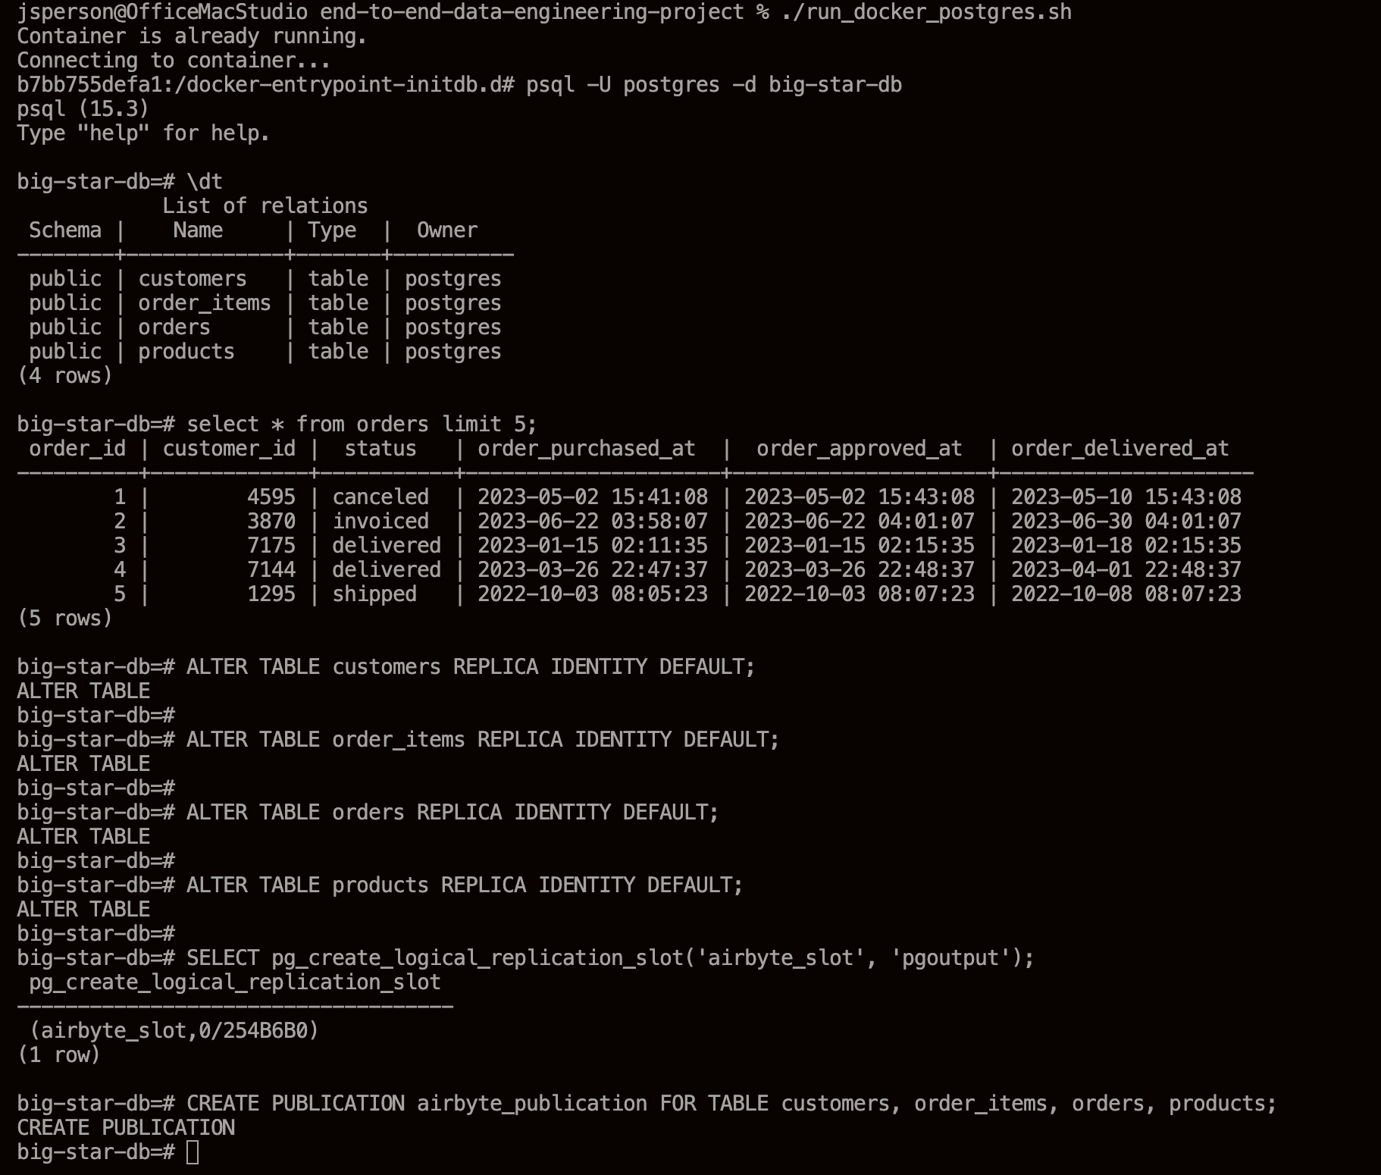
Figure 31: Database Configuration Inside Container

Setup Google Cloud Data Warehouse (BigQuery)
- Login to Google and create/activate a Google Cloud Service account.
- Create a new project. I’m calling it Big Star Collectibles to be consistent with the class videos.
- Select the project on the Overview window
- Go to BigQuery
- Create a “raw_data” dataset
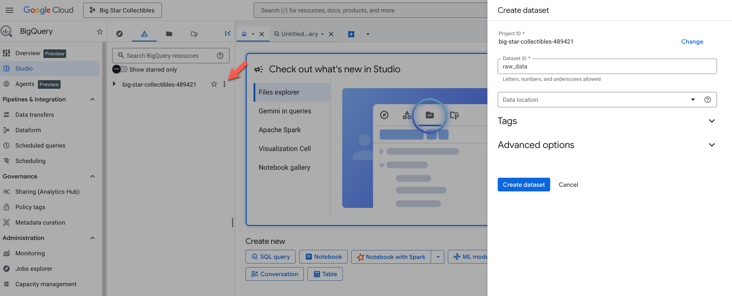
Figure 32: Creating "raw_data" dataset
- Create a “transformed_data” dataset as well.
- Using the hamburger menu (top left) Navigate to IAM & Admin/Service Accounts
- Click Create Service Account
- Name the account “Airbyte” and the hit Create and Continue.
- Assign the roles “Big Query Data Editor” and “Big Query Job User”
- Click Done
- Repeat for service account “dbt”
- For each account click on the three dot action button and create a JSON key.
- Save off the JSON files for future use.

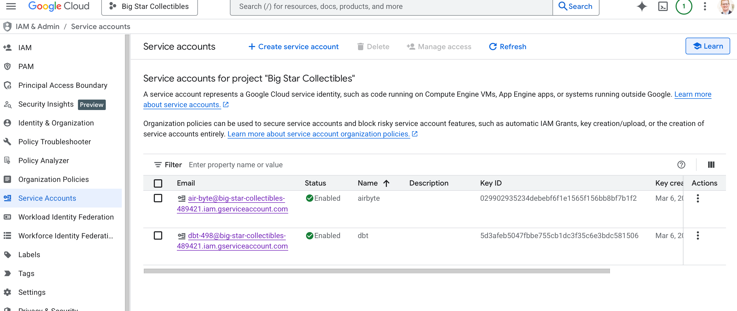
Figure 33: Two Completed Service Accounts

Setup Airbyte
The instructions for the course have us run airbyte with ./run-ab-platform.sh but that script no longer exists. Apparently the install procedure updated several years ago.
- git clone https://github.com/airbytehq/airbyte.git
- brew tap airbytehq/tap
- brew install abctl
- I ended up doing this on the second try (after nuking Docker). This pre-pulls the images.
docker pull airbyte/bootloader:2.0.1
docker pull airbyte/server:2.0.1
docker pull airbyte/worker:2.0.1
docker pull airbyte/cron:2.0.1
docker pull airbyte/connector-builder-server:2.0.1
docker pull airbyte/connector-sidecar:2.0.1
docker pull airbyte/container-orchestrator:2.0.1
docker pull airbyte/workload-api-server:2.0.1
docker pull airbyte/workload-launcher:2.0.1
docker pull airbyte/workload-init-container:2.0.1
docker pull airbyte/db:1.7.0-17
docker pull temporalio/auto-setup:1.27.2
- abctl local install --insecure-cookies
Note: added the insecure cookies thing on the third pass. F*** me.
- <wait a long time – 5 min or more>
- Use abctl local credentials to get the random password.
- Control airbyte running: docker [start|stop] airbyte-abctl-control-plane
Note: while trying to get airbyte running it errored out. Due to some unfortunate commands I nuked my entire docker install. Big oops. I rebuilt for this project and am currently trying to get airbyte running again.

Configure Airbyte Source
Connector: Postgres
Port: 5432
Host: host.docker.internal
Database Name: big-star-db
Username: postgres
Password: mysecretpassword
Replication Slot: airbyte_slot
Publication: airbyte_publication
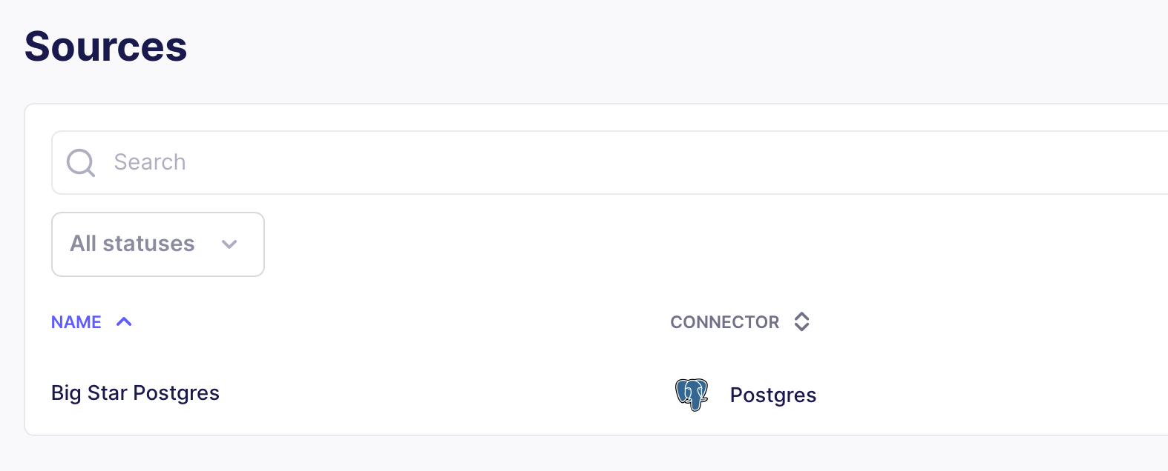
Figure 34: Source Configured
Configure Airbyte Destination
Connector: Big Query
Project ID: <from Google Cloud>
Dataset Location: US or whatever you selected when setting up the dataset
Dataset ID: <dataset name from Google Cloud>
Loading Method: Batched Standard Inserts
Service Account Key JSON: <JSON for Airbyte service account downloaded earlier>
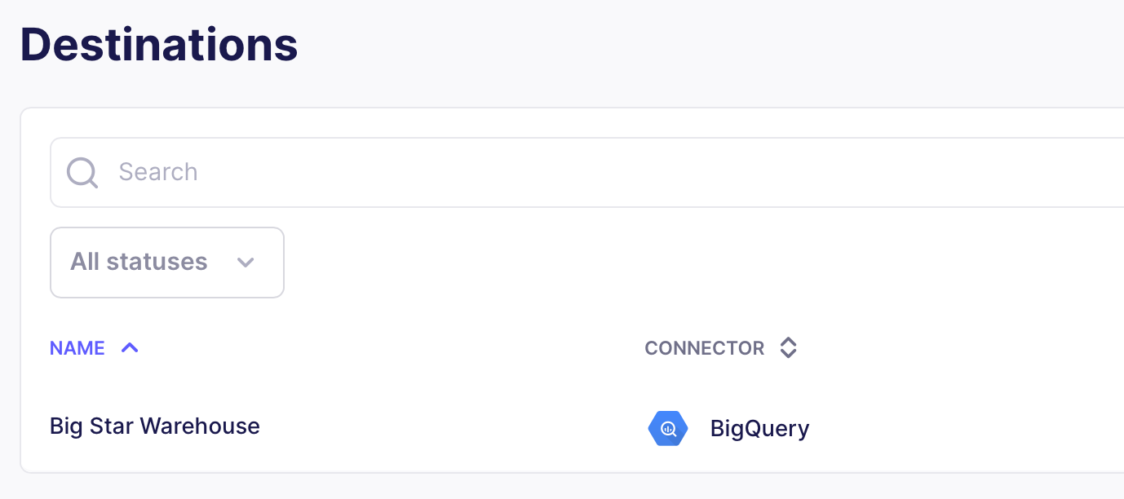
Figure 35: Destination Configured

Create Airbyte Connection
- Click on Connections
- Create First Connection
- Select Source and Destination
- Let Airbyte fetch the source schema
- Select sync mode: Replicate Source
- Select the streams (Pick all of them for most configurations)
- Sync mode for each table: Incremental | Append + Deduped Incremental | Append
- Configure connection: leave defaults

Run Airbyte Sync
Hit the sync now button in the connection to initiate a sync event.
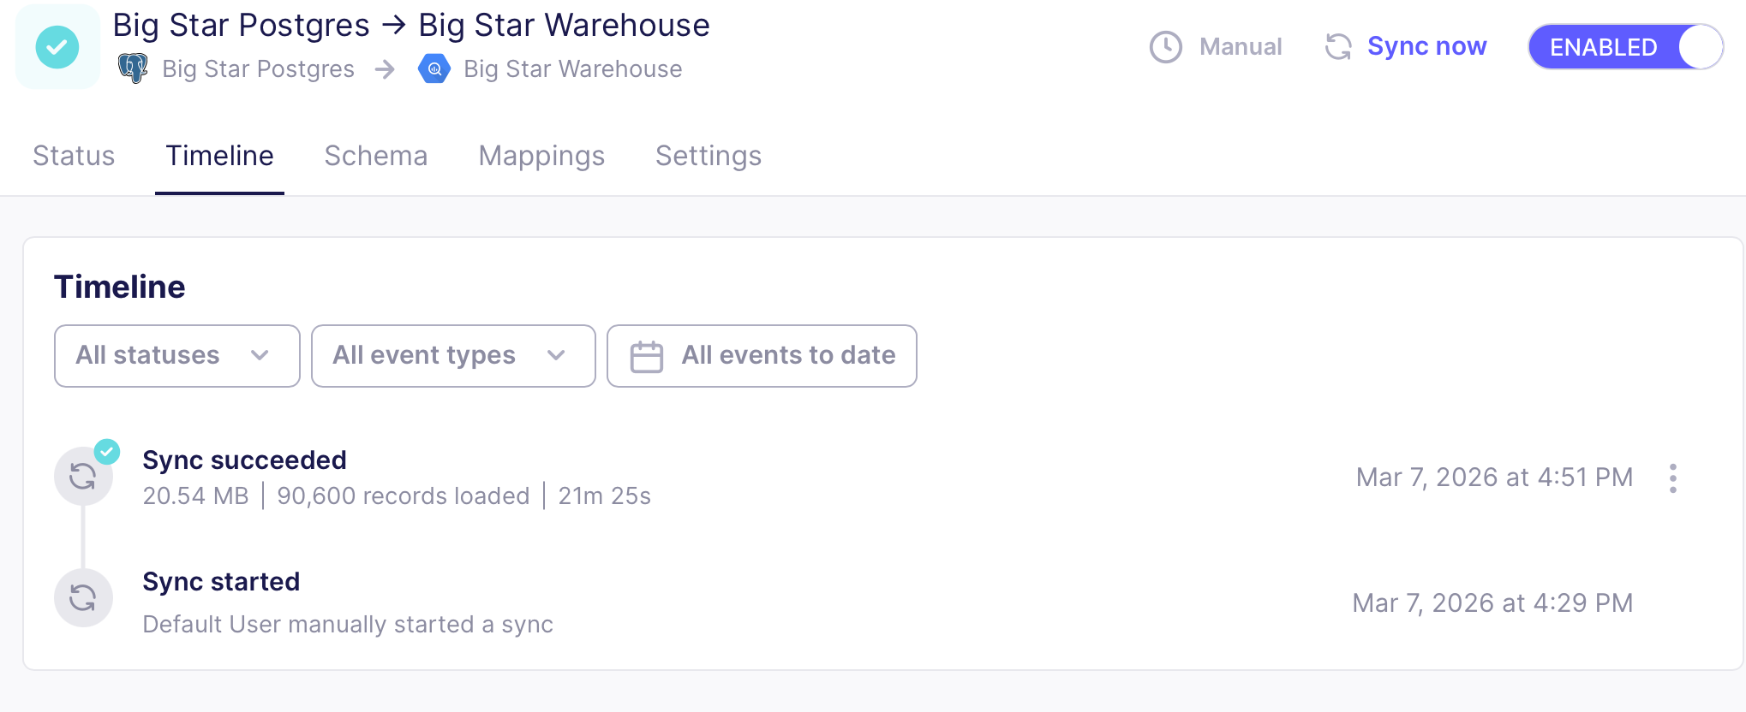
Figure 36: Successful Sync Postgres to BigQuery
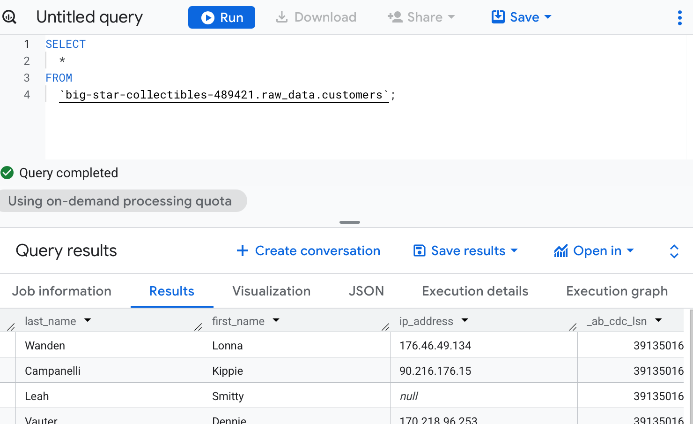
Figure 37: Customer Information Copied to BigQuery

dbt Project
I’m walking through the class setting u

Setup dbt Source
- Start VS Code and the Python development container (end-to-end-data-engineering) created above.
- Attach to the container in VS Code.
- Open the end-to-end-data-engineering-project folder
- Goto the config directory.
- Create a script that sets the appropriate environment variables:
#!/bin/bash
export DBT_BIGQUERY_DATASET=transformed_data
export DBT_BIGQUERY_KEYFILE_PATH=/source/end-to-end-data-engineering-project/dbt_transformation/config/service_account.json
export DBT_BIGQUERY_LOCATION=US
export DBT_BIGQUERY_PROJECT=big-star-collectibles-489421
export DBT_PROFILES_DIR=/source/end-to-end-data-engineering-project/dbt_transformation/config

- Put the service account json credentials in the same folder. (Exclude this one from source control).
- Open a terminal window and source the script.
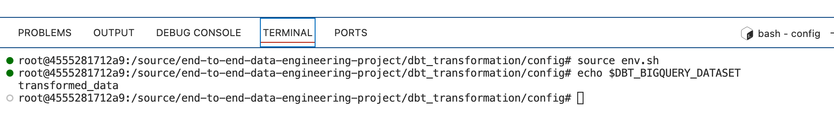
Figure 38: Script Worked
- Go to the project root and run the command below. This will test dbt’s connection to BigQuery.
dbt debug
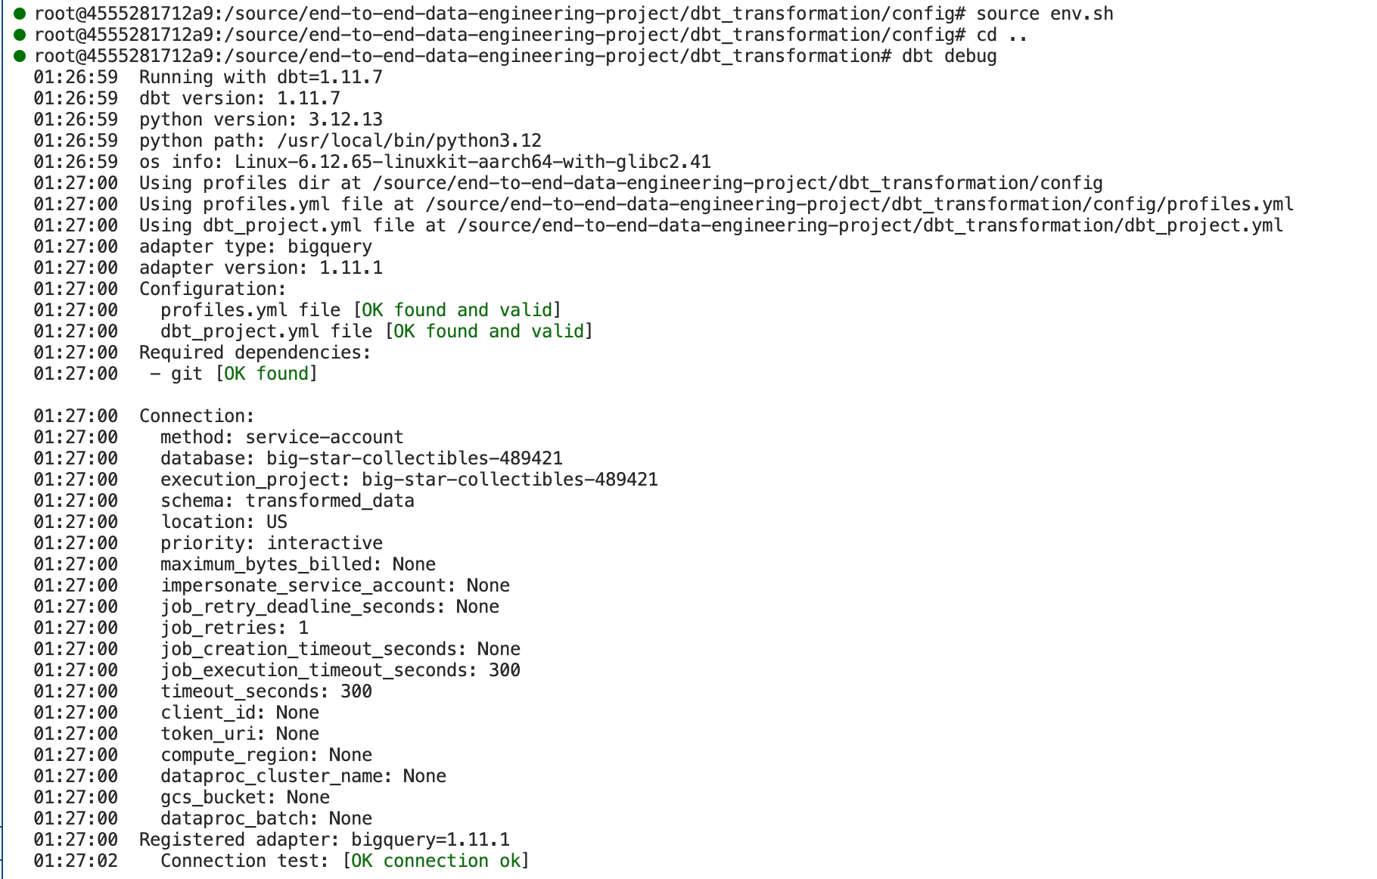
Figure 39: Successful dbt Connection to BigQuery
- In the “models” folder of the repo create a “staging” folder.
- Inside of the staging folder create a new file “src_big_star_db.yml”.
sources:
- name: raw_data
database: big-star-collectibles-489421
schema: raw_data
freshness:
warn_after:
count: 24
period: hour
loaded_at_field: "_airbyte_extracted_at"
tables:
- name: customers
- name: orders
- name: products
- name: order_items

- Use this command to run the freshness check: dbt source freshness
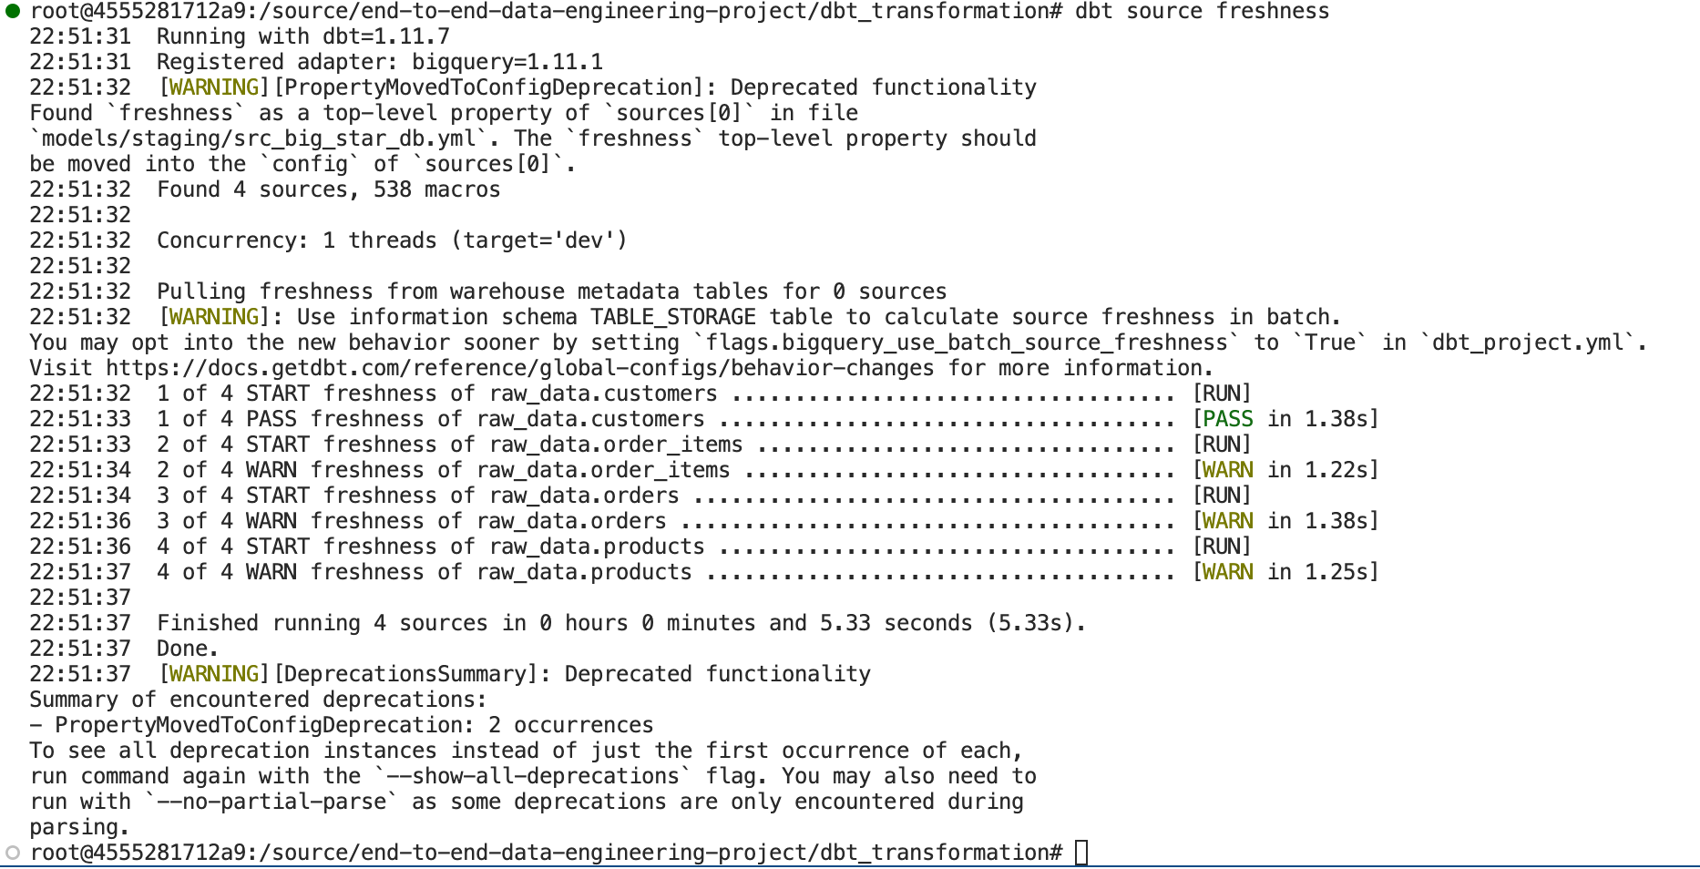
Figure 40: Successful Execution of the Freshness Test

Create dbt Model
This section defines the operations that will create our database objects using dbt.

- File 1:
# dbt_transformation/models/staging/stg_customers.sql

select customer_id, email, gender, city, country
from {{ source("raw_data", "customers") }}

- File 2:
# dbt_transformation/models/staging/stg_orders.sql

select
order_id,
customer_id,
status as order_status,
order_approved_at,
order_purchased_at
from {{ source("raw_data", "orders") }}

- File 3:
# dbt_transformation/models/marts/dim_customers.sql

with
customers as (select * from {{ ref("stg_customers") }}),
orders as (select * from {{ ref("stg_orders") }}),
customer_orders as (
select
c.customer_id,
c.email,
c.country,
c.city,
min(o.order_approved_at) as first_order_date,
max(o.order_approved_at) as most_recent_order_date,
count(o.order_id) as number_of_orders
from orders o
inner join customers c using (customer_id)
group by c.customer_id, c.email, c.country, c.city
)
select *
from customer_orders

- Add these lines to dbt_project.yml:
models:
dbt_transformation:
# Config indicated by +.and applies to all files under models/example
staging:
+materialized: view
marts:
+materialized: table
- Execute a dbt run
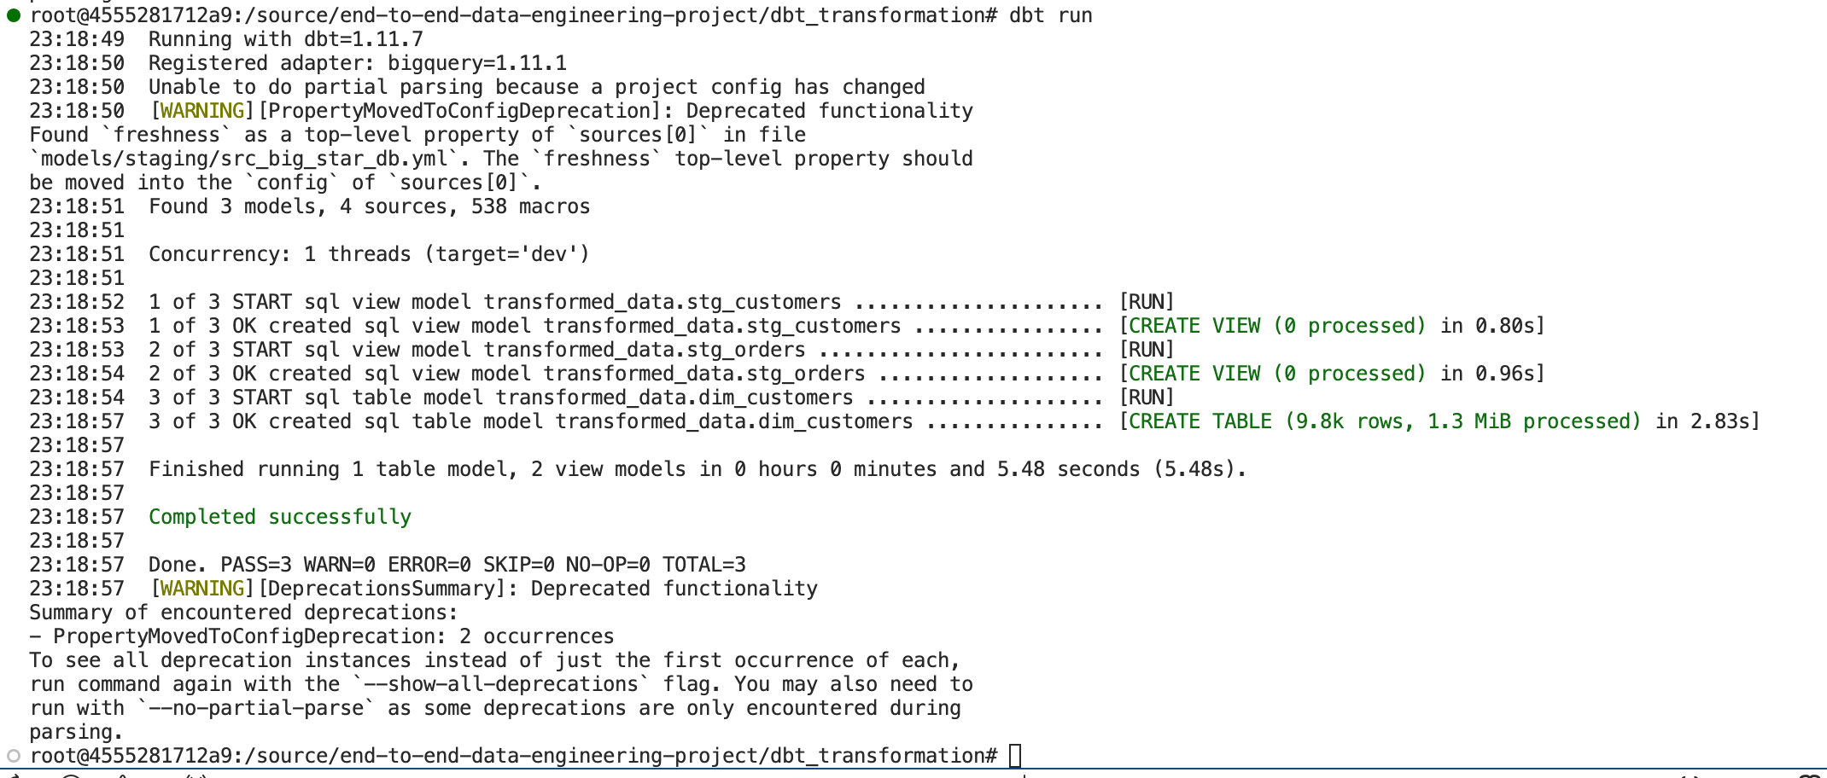
Figure 41: dbt run Output
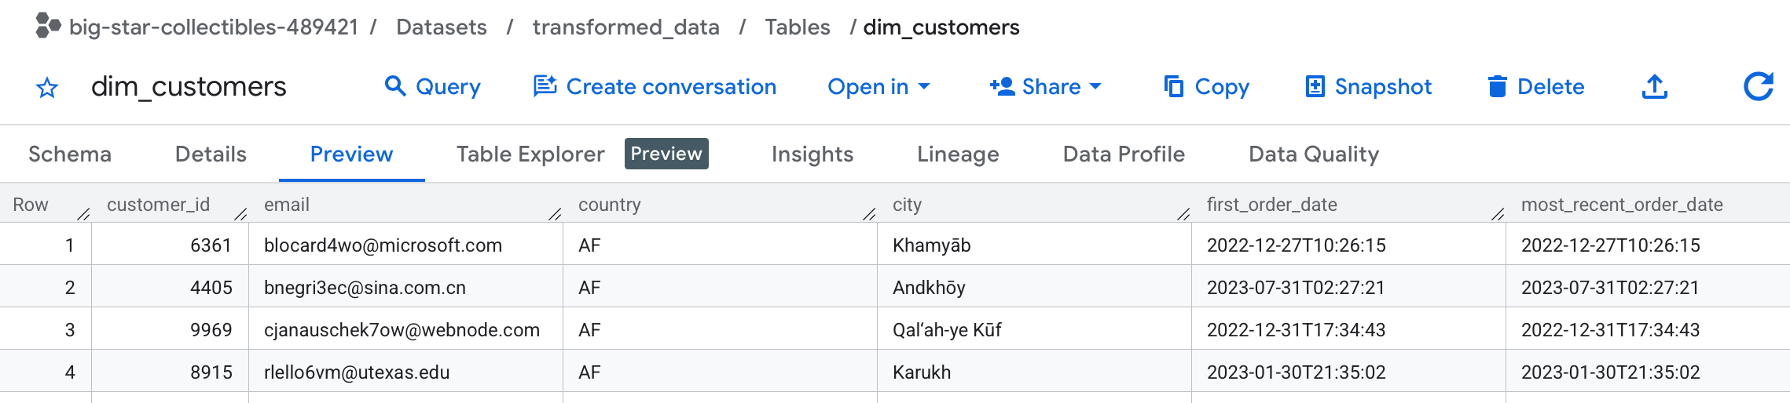
Figure 42: Data in our new dim_customers table

- Create a few data tests:
# dbt_transformation/models/staging/stg_big_star_db.yml

models:
- name: stg_customers
columns:
- name: customer_id
tests:
- unique
- not_null
- name: stg_orders
columns:
- name: order_id
tests:
- unique
- not_null
- name: order_status
tests:
- accepted_values:
values:
- created
- shipped
- approved
- canceled
- invoiced
- delivered
- processing
- unavailable
- name: customer_id
tests:
- relationships:
to: ref('stg_customers')
field: customer_id

# dbt_transformation/models/marts/marts_big_star_db.yml

models:
- name: dim_customers
columns:
- name: customer_id
tests:
- unique
- not_null
- name: email
tests:
- not_null
- name: city
tests:
- not_null
- name: country
tests:
- not_null

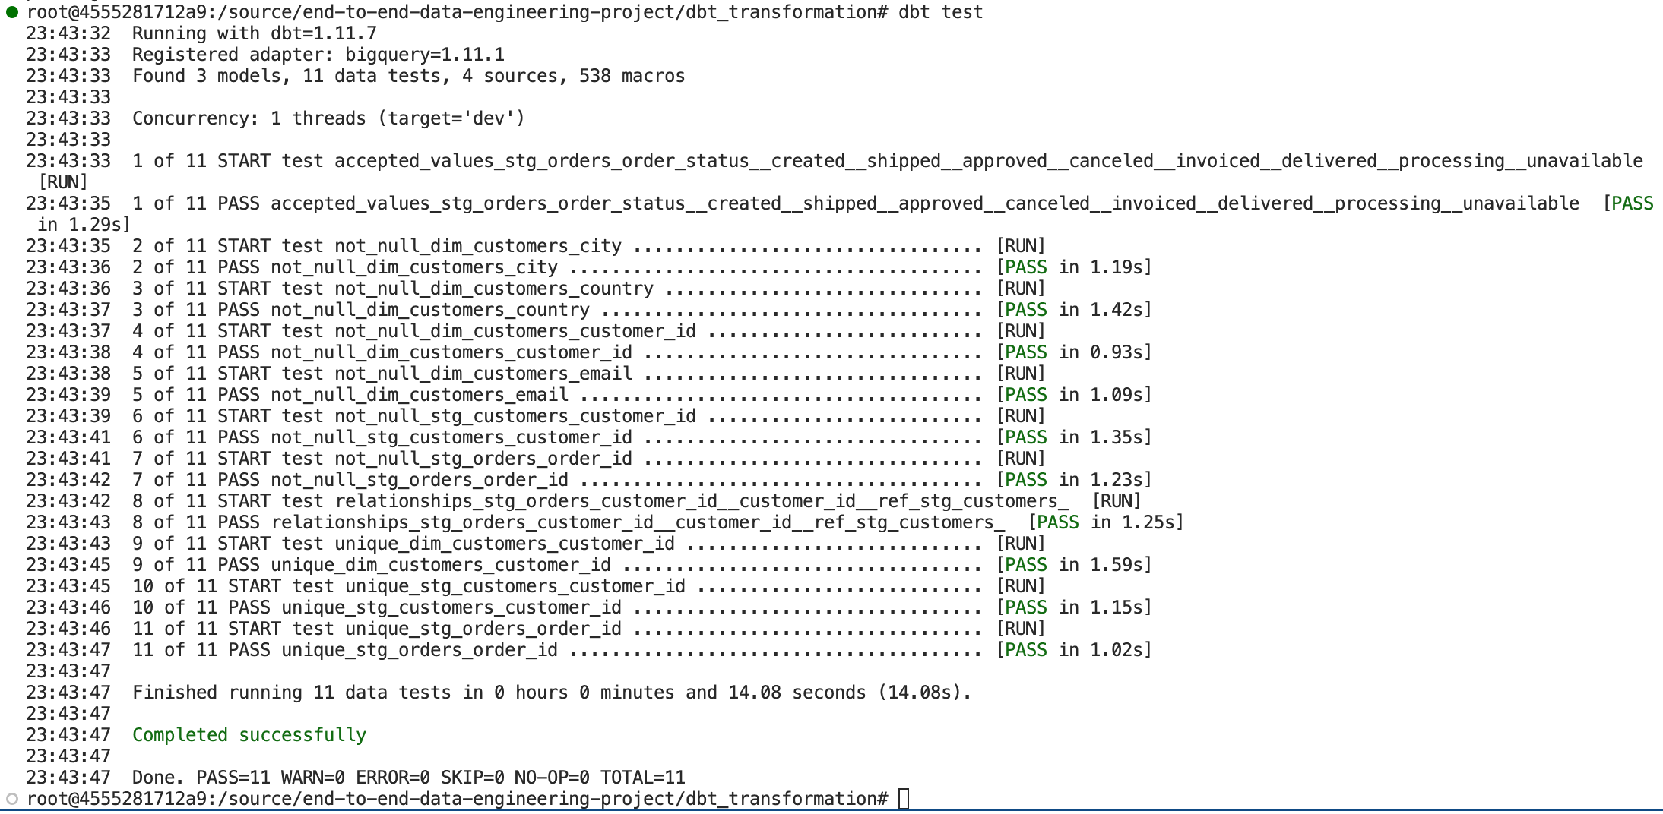
Figure 43: dbt test Output
- Use dbt docs generate and dbt docs serve to generate and start the documentation web server respectively.

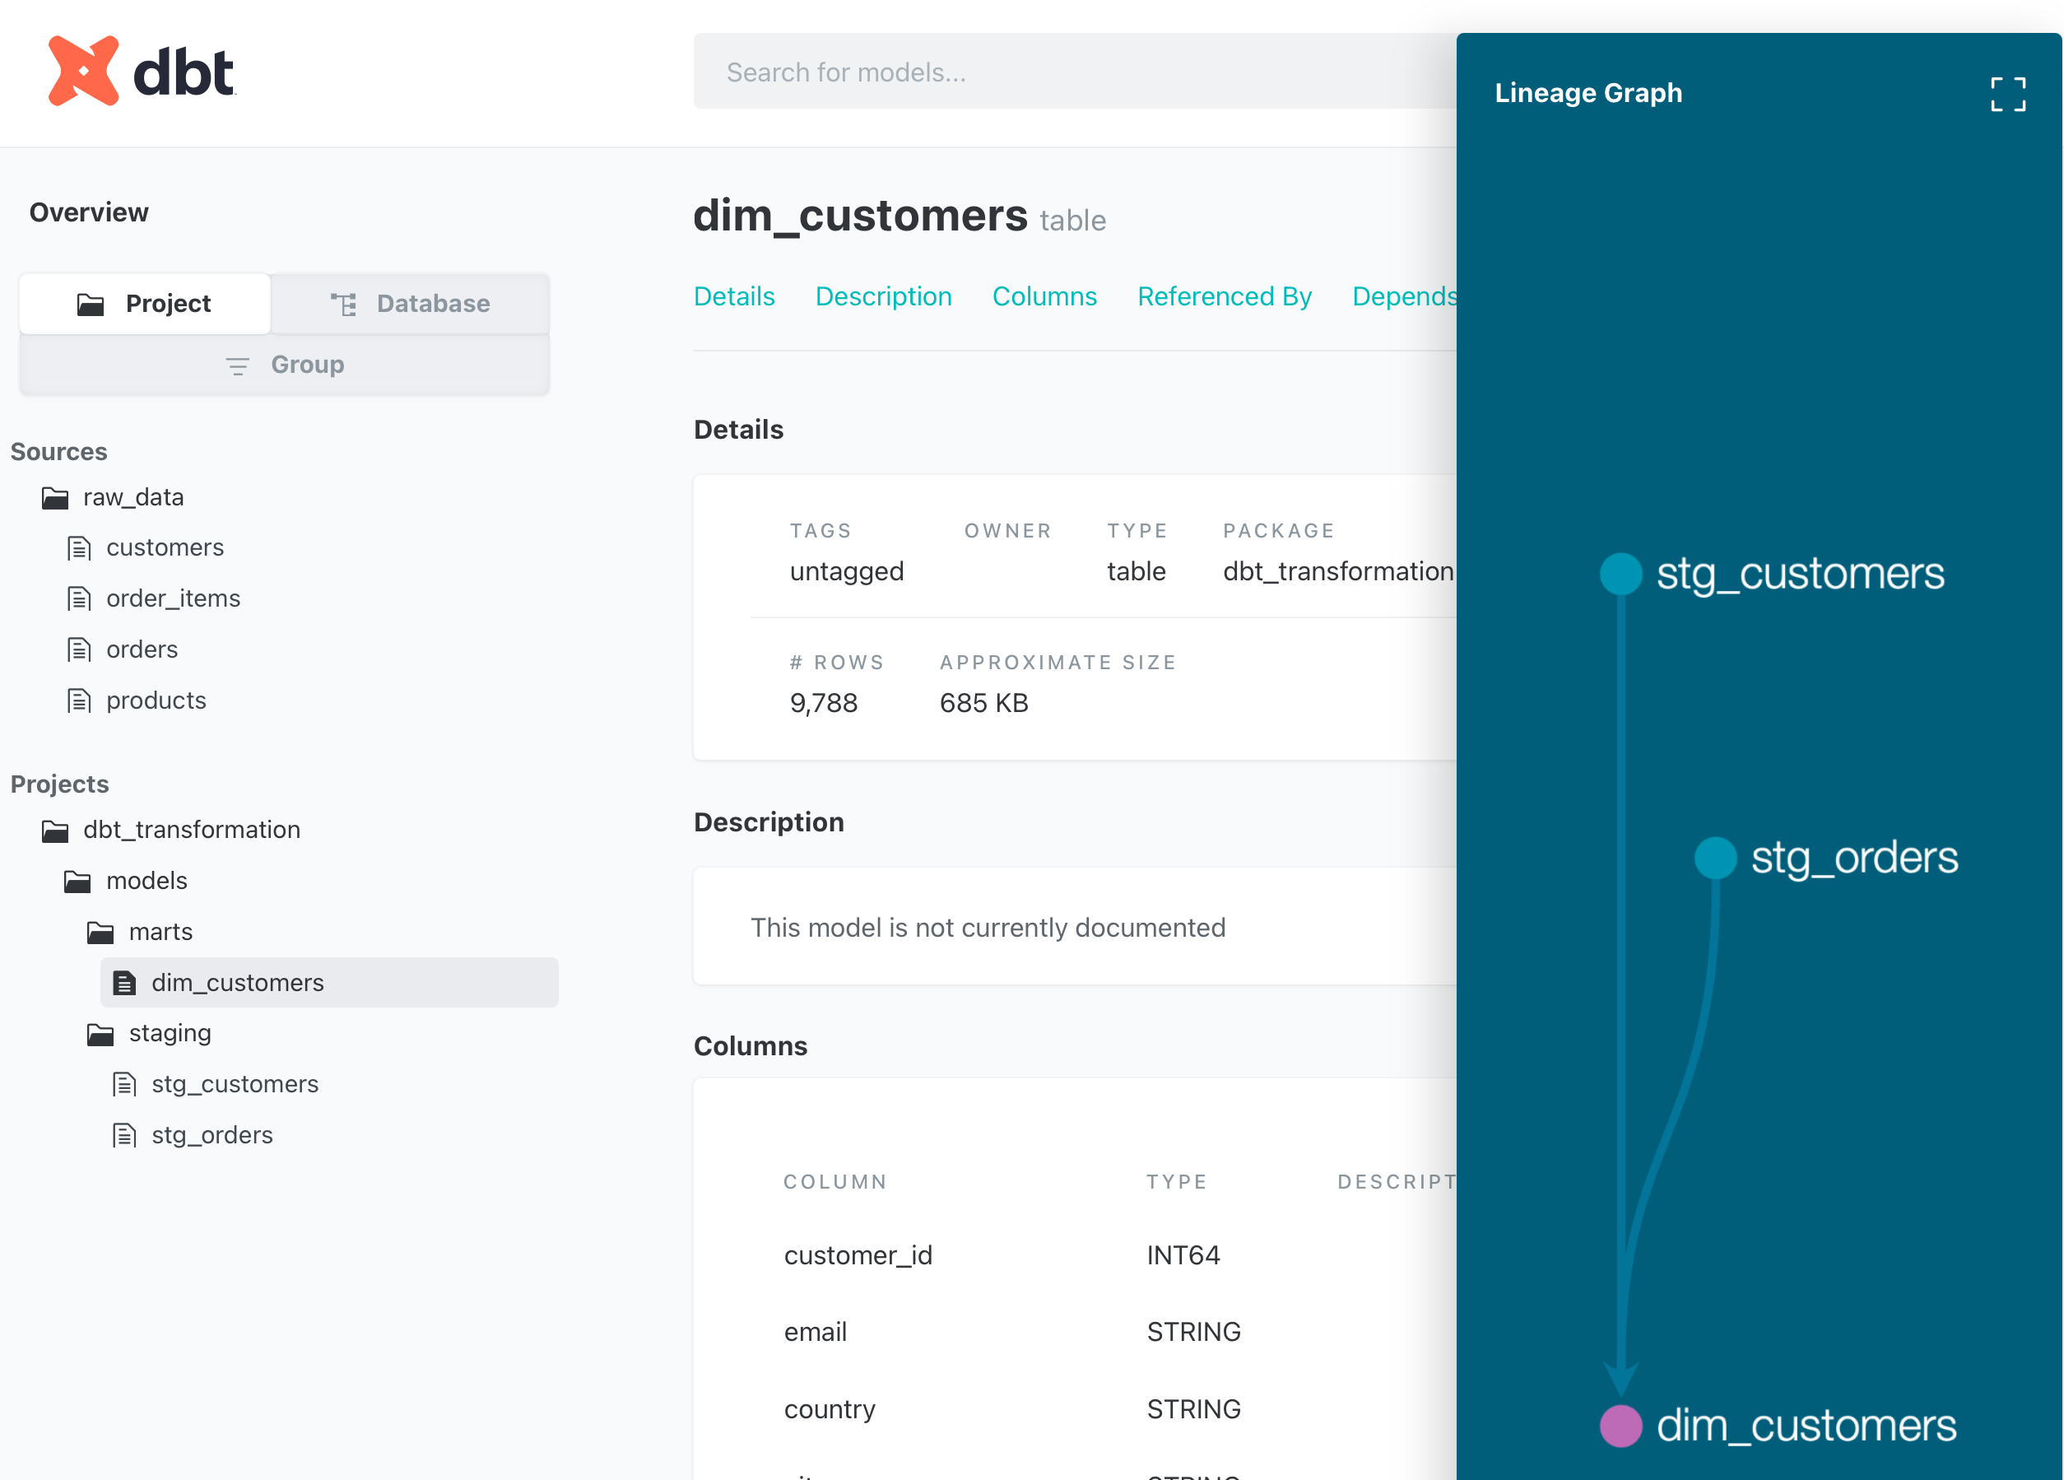
Figure 44: dbt Generated Documentation Showing Lineage
- Use dbt build to execute the run and test code.

Dagster Implementation
- File 1:
# dagster_orchestration/dagster_orchestration/assets/__init__.py

import os
from dagster import AssetExecutionContext
from dagster_dbt import DbtCliResource, DbtProject, dbt_assets

dbt_project = DbtProject(
project_dir=os.getenv("DBT_PROJECT_DIR"),
)

@dbt_assets(manifest=dbt_project.manifest_path)
def my_dbt_assets(context: AssetExecutionContext, dbt: DbtCliResource):
yield from dbt.cli(["build"], context=context).stream()

resources = {
"dbt": DbtCliResource(
project_dir=os.getenv("DBT_PROJECT_DIR"),
profiles_dir=os.getenv("DBT_PROFILES_DIR"),
),
}

- File 2:
# dagster_orchestration/dagster_orchestration/__init__.py

from dagster import Definitions, load_assets_from_modules

from .assets import resources

defs = Definitions(assets=load_assets_from_modules(
[assets]), resources=resources)

- File 3 (env.sh file to source):
#!/bin/bash
export DBT_PROJECT_DIR=/source/end-to-end-data-engineering-project/dbt_transformation
export AIRBYTE_PASSWORD=<password>

- Use dagster dev to start the Dagster GUI.
Note: I had lots of issues with Python errors here. I leaned on Claude to help me update the init.py files to current versions of the packages. Those changes are reflected above. Also needed to run dbt parse and dbt compile.

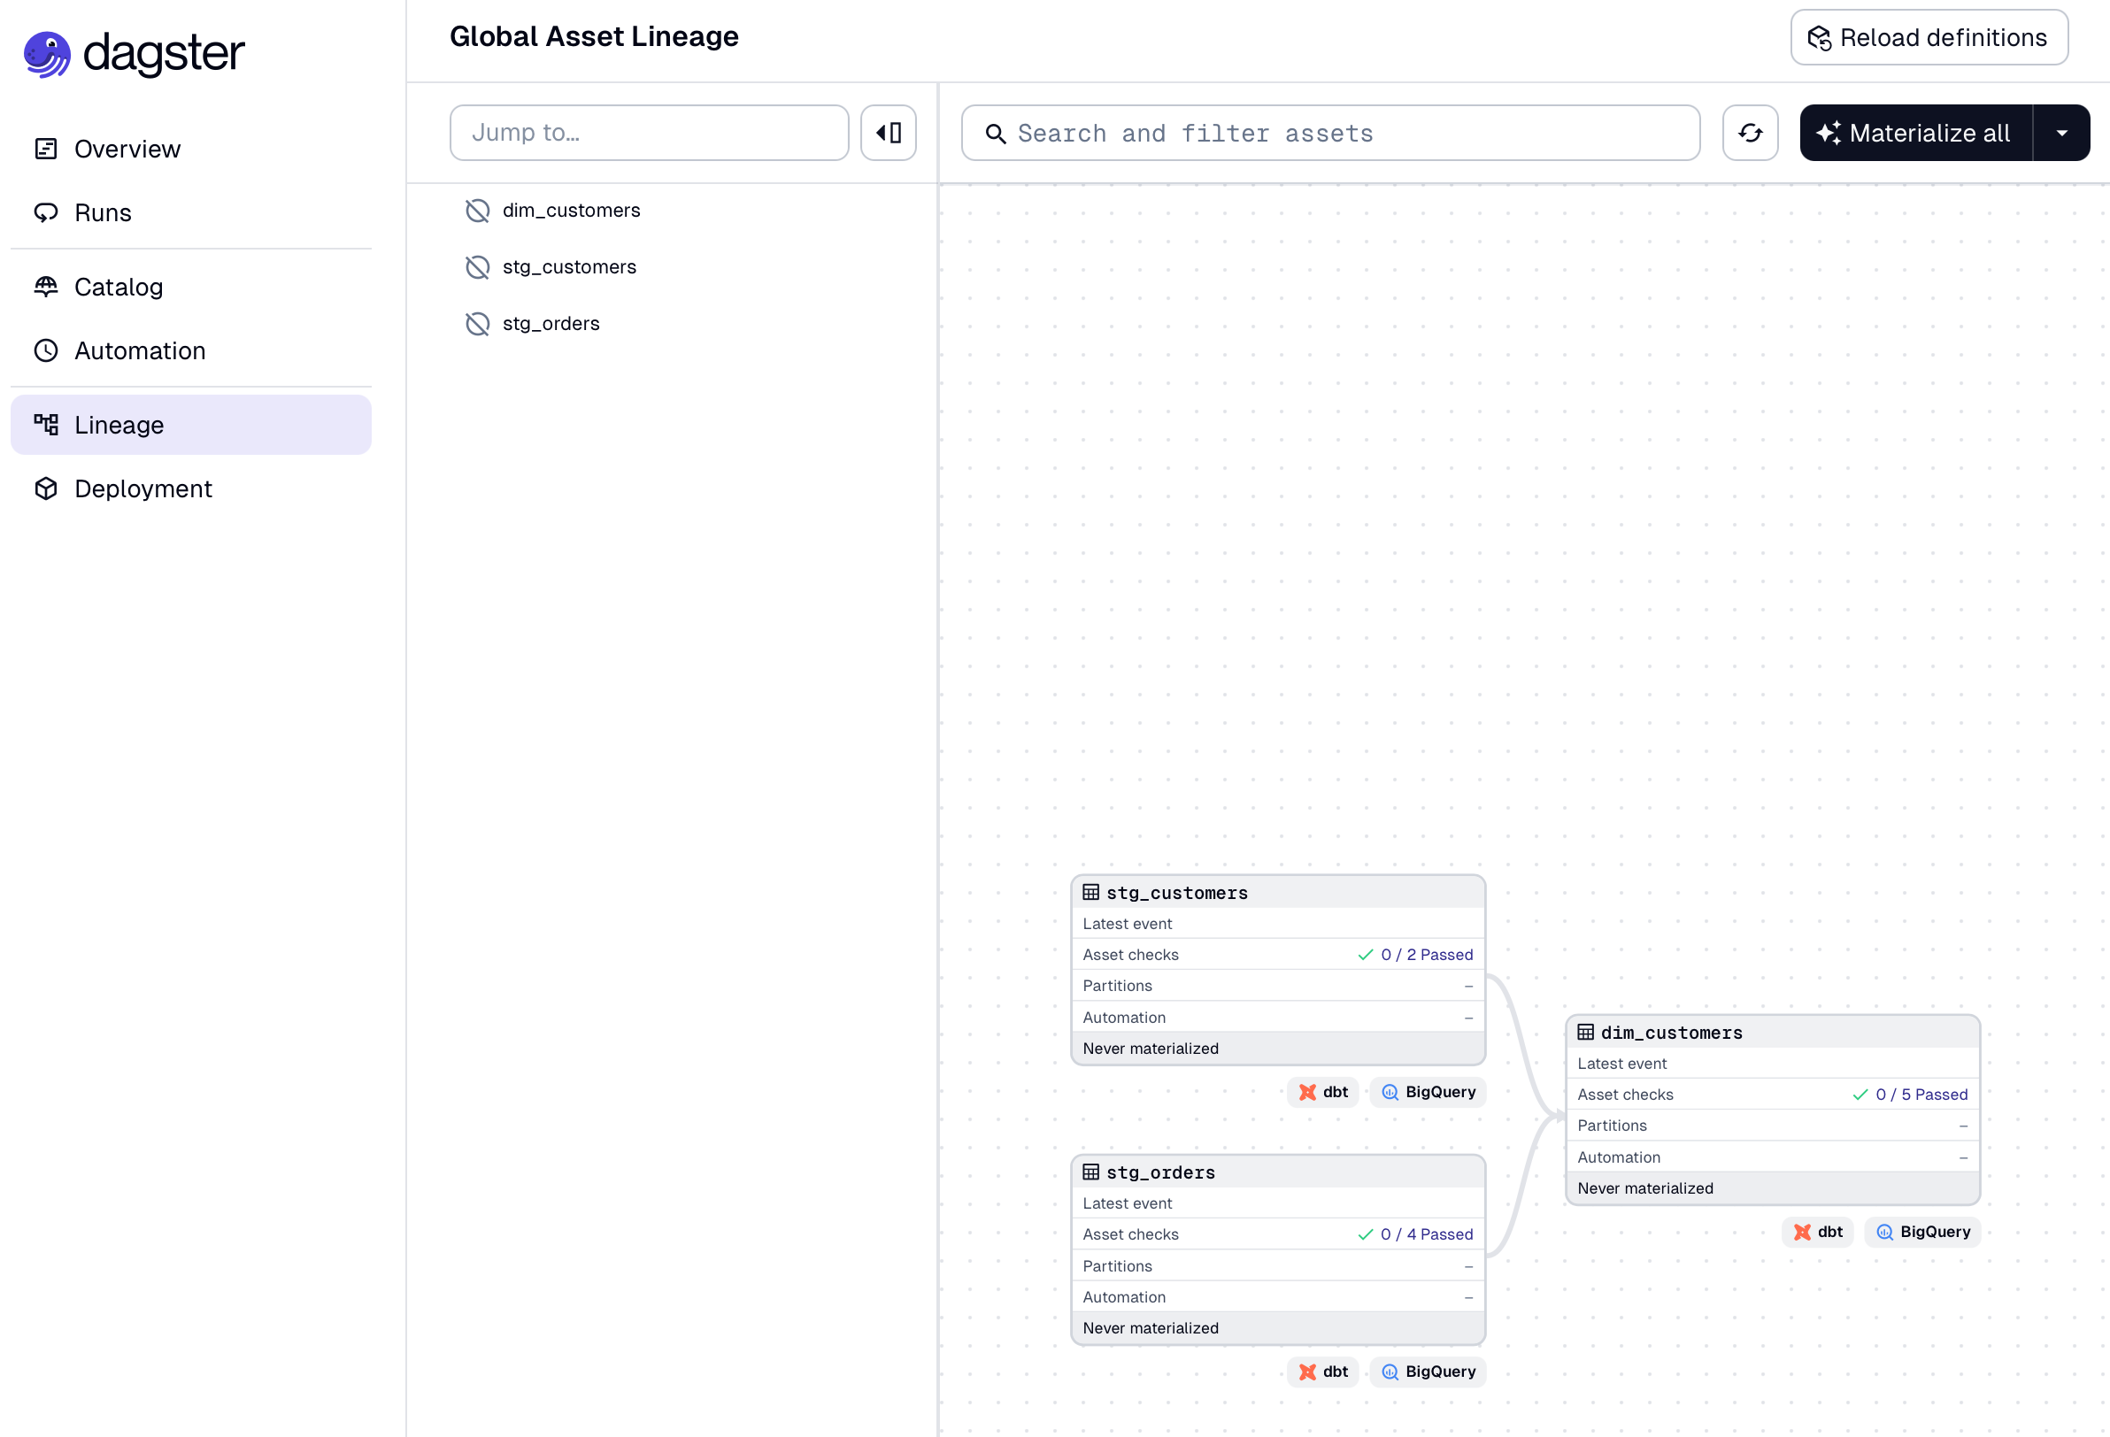
Figure 45: dagster GUI showing our dbt model
- Add Airbyte to the init file (this is the new complete file listing):
Note: this file took a ton of work to get it going. It took several pulls and research on the airbyte side to get the right credentials. Not fun. Disclosure: I had to rely very heavily on Claude to get this working. I’m dealing with newer versions of all products than used in the class and also with several beta features. Would have taken several more days (I’m three hard days into this now) to get it working.

# dagster_orchestration/dagster_orchestration/assets/__init__.py

import os
from dagster import AssetKey, AssetExecutionContext, EnvVar
from dagster_dbt import DagsterDbtTranslator, DbtCliResource, DbtProject, dbt_assets
from dagster_airbyte import AirbyteWorkspace, build_airbyte_assets_definitions

dbt_project = DbtProject(
project_dir=os.getenv("DBT_PROJECT_DIR"),
)

class CustomDbtTranslator(DagsterDbtTranslator):
def get_asset_key(self, dbt_resource_props):
if dbt_resource_props["resource_type"] == "source":
return AssetKey(dbt_resource_props["name"])
return super().get_asset_key(dbt_resource_props)

@dbt_assets(
manifest=dbt_project.manifest_path,
dagster_dbt_translator=CustomDbtTranslator(),
)
def my_dbt_assets(context: AssetExecutionContext, dbt: DbtCliResource):
yield from dbt.cli(["build"], context=context).stream()

airbyte_workspace = AirbyteWorkspace(
rest_api_base_url="http://host.docker.internal:8000/api/public/v1",
configuration_api_base_url="http://host.docker.internal:8000/api/v1",
workspace_id="a0d0989e-5bca-49ba-9c6c-4f2759d9086e",
username="jsperson@gmail.com",
password=EnvVar("AIRBYTE_PASSWORD"),
)

airbyte_assets = build_airbyte_assets_definitions(workspace=airbyte_workspace)

resources = {
"dbt": DbtCliResource(
project_dir=os.getenv("DBT_PROJECT_DIR"),
profiles_dir=os.getenv("DBT_PROFILES_DIR"),
),
"airbyte": airbyte_workspace,
}

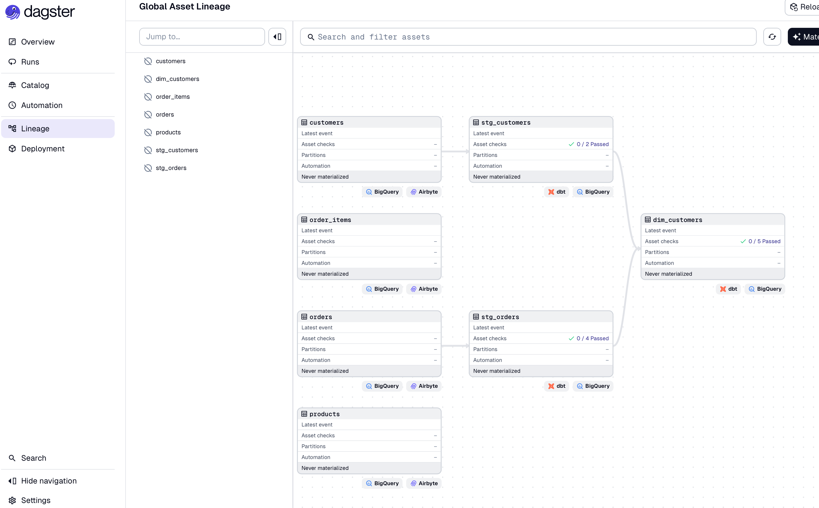
Figure 46: dagster now with Airbyte resources

- Change the base init.py file to add every hour schedule:
# dagster_orchestration/dagster_orchestration/__init__.py

from dagster import Definitions, AssetSelection, ScheduleDefinition, load_assets_from_modules, define_asset_job
from .assets import resources

big_star_job = define_asset_job("big_star_job", selection=AssetSelection.all())

big_star_schedule = ScheduleDefinition(
job=big_star_job,
cron_schedule="0 * * * *", # every hour
)

defs = Definitions(assets=load_assets_from_modules(
[assets]), resources=resources, jobs=[big_star_job], schedules=[big_star_schedule])

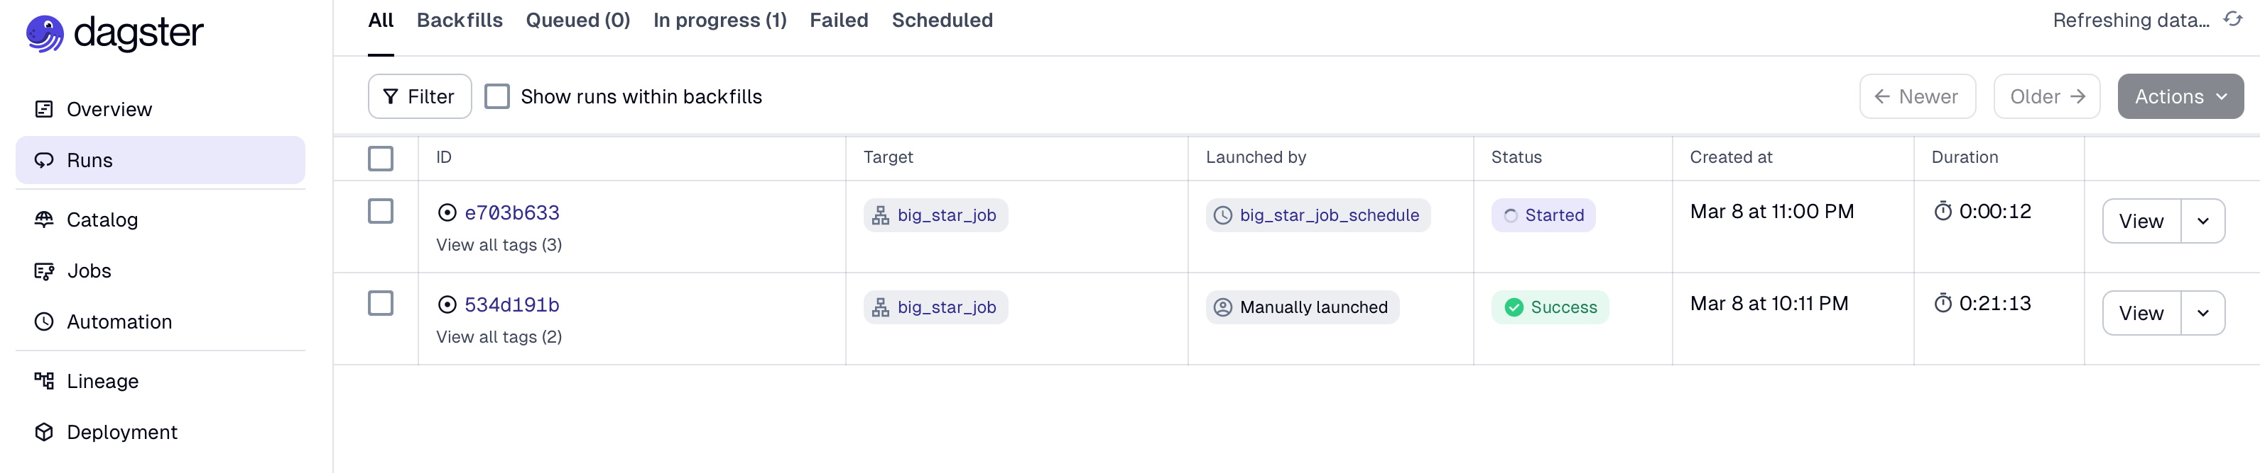
Figure 47: dagster running the whole pipeline on a schedule

Sources
Ravi, J. (2023). Data management with Apache NiFi [Online course]. LinkedIn Learning. https://www.linkedin.com/learning/data-management-with-apache-nifi

Appendix A: Code Listings

Create Tables SQL (Postsgres SQL Data Import)
-- Create the products table
CREATE TABLE products (
product_id SERIAL PRIMARY KEY,
product_name VARCHAR(100) NOT NULL,
category VARCHAR(50),
price DECIMAL(10, 2) NOT NULL,
stock INT NOT NULL
);
-- Create the customers table
CREATE TABLE customers (
customer_id SERIAL PRIMARY KEY,
first_name VARCHAR(50),
last_name VARCHAR(50),
email VARCHAR(100) UNIQUE NOT NULL,
join_date DATE NOT NULL
);
-- Create the orders table
CREATE TABLE orders (
order_id SERIAL PRIMARY KEY,
customer_id INT NOT NULL,
order_date DATE NOT NULL,
total_amount DECIMAL(10, 2) NOT NULL,
FOREIGN KEY (customer_id) REFERENCES customers(customer_id)
);
-- Create the order_items table
CREATE TABLE order_items (
order_item_id SERIAL PRIMARY KEY,
order_id INT NOT NULL,
product_id INT NOT NULL,
quantity INT NOT NULL,
total_price DECIMAL(10, 2) NOT NULL,
FOREIGN KEY (order_id) REFERENCES orders(order_id),
FOREIGN KEY (product_id) REFERENCES products(product_id)
);

Insert Data SQL (Postgres SQL Data Import)
-- Insert sample products
INSERT INTO products (product_name, category, price, stock) VALUES
('Laptop', 'Electronics', 999.99, 50),
('Smartphone', 'Electronics', 699.99, 200),
('Headphones', 'Accessories', 49.99, 500),
('Desk Chair', 'Furniture', 150.00, 100),
('Coffee Mug', 'Kitchen', 10.99, 1000),
('Bluetooth Speaker', 'Electronics', 79.99, 150),
('Keyboard', 'Accessories', 39.99, 300),
('Gaming Console', 'Electronics', 499.99, 75),
('Bookshelf', 'Furniture', 120.00, 80),
('Mouse', 'Accessories', 25.99, 400),
('Tablet', 'Electronics', 329.99, 100),
('Monitor', 'Electronics', 199.99, 120),
('Desk Lamp', 'Furniture', 45.00, 200),
('Thermos', 'Kitchen', 24.99, 500),
('Dining Set', 'Furniture', 499.99, 30);
-- Insert sample customers
INSERT INTO customers (first_name, last_name, email, join_date) VALUES
('Alice', 'Johnson', 'alice.johnson@example.com', '2023-01-15'),
('Bob', 'Smith', 'bob.smith@example.com', '2023-02-20'),
('Charlie', 'Brown', 'charlie.brown@example.com', '2023-03-10'),
('Dana', 'White', 'dana.white@example.com', '2023-04-05'),
('Eve', 'Williams', 'eve.williams@example.com', '2023-05-10'),
('Frank', 'Miller', 'frank.miller@example.com', '2023-06-01'),
('Grace', 'Davis', 'grace.davis@example.com', '2023-06-15'),
('Henry', 'Wilson', 'henry.wilson@example.com', '2023-07-01'),
('Ivy', 'Taylor', 'ivy.taylor@example.com', '2023-07-20'),
('Jack', 'Moore', 'jack.moore@example.com', '2023-08-05'),
('Kara', 'Hall', 'kara.hall@example.com', '2023-08-25'),
('Liam', 'Young', 'liam.young@example.com', '2023-09-10'),
('Mia', 'King', 'mia.king@example.com', '2023-09-25'),
('Noah', 'Scott', 'noah.scott@example.com', '2023-10-05'),
('Olivia', 'Green', 'olivia.green@example.com', '2023-10-15');
-- Insert expanded sample orders
INSERT INTO orders (customer_id, order_date, total_amount) VALUES
(1, '2023-05-01', 1149.97), -- Customer 1
(2, '2023-05-03', 49.99), -- Customer 2
(3, '2023-05-07', 1599.98), -- Customer 3
(4, '2023-05-10', 150.00), -- Customer 4
(1, '2023-05-15', 2149.94), -- Customer 1
(2, '2023-05-20', 349.99), -- Customer 2
(3, '2023-05-25', 2799.95), -- Customer 3
(4, '2023-06-01', 210.00), -- Customer 4
(2, '2023-06-05', 1149.97), -- Customer 2
(3, '2023-06-10', 599.97), -- Customer 3
(4, '2023-06-15', 450.00), -- Customer 4
(1, '2023-06-20', 999.99), -- Customer 1
(2, '2023-06-25', 799.98), -- Customer 2
(3, '2023-07-01', 499.99), -- Customer 3
(4, '2023-07-05', 1000.00); -- Customer 4
-- Insert expanded sample order items
INSERT INTO order_items (order_id, product_id, quantity, total_price) VALUES
(1, 1, 1, 999.99), -- Order 1: Laptop
(1, 3, 3, 149.97), -- Order 1: Headphones
(2, 3, 1, 49.99), -- Order 2: Headphones
(3, 2, 2, 1399.98), -- Order 3: Smartphone
(3, 5, 5, 54.95), -- Order 3: Coffee Mug
(4, 4, 1, 150.00), -- Order 4: Desk Chair
(5, 1, 2, 1999.98), -- Order 5: Laptop
(5, 3, 4, 199.96), -- Order 5: Headphones
(6, 5, 10, 109.90), -- Order 6: Coffee Mug
(7, 2, 1, 699.99), -- Order 7: Smartphone
(7, 4, 1, 150.00), -- Order 7: Desk Chair
(8, 3, 5, 249.95), -- Order 8: Headphones
(8, 5, 7, 76.93), -- Order 8: Coffee Mug
(9, 2, 3, 2099.97), -- Order 9: Smartphone
(9, 4, 2, 300.00); -- Order 9: Desk Chair

Extract Script Python
import pandas as pd
import psycopg2
# Function to extract data from a PostgreSQL table
def extract_table_to_csv(db_config, table_name, csv_file):
try:
# Establish database connection
conn = psycopg2.connect(
host=db_config['host'],
port=db_config['port'],
database=db_config['database'],
user=db_config['user'],
password=db_config['password']
)
print(f"Connected to the database for table: {table_name}")

# Define the SQL query
query = f"SELECT * FROM {table_name};"

# Execute query and load data into a pandas DataFrame
data = pd.read_sql_query(query, conn)

# Export DataFrame to CSV
data.to_csv(csv_file, index=False)
print(f"Data from {table_name} exported to {csv_file}.")

# Close the connection
conn.close()
except Exception as e:
print(f"Error extracting data from {table_name}: {e}")
raise
# Main function to orchestrate the pipeline
def export_sales_tracker_tables_to_csv(db_config):
print("Starting the data export pipeline...")

# Define table-to-CSV mapping
tables_to_export = {
"products": "products_data.csv",
"customers": "customers_data.csv",
"orders": "orders_data.csv",
"order_items": "order_items_data.csv"
}

# Export each table
for table_name, csv_file in tables_to_export.items():
extract_table_to_csv(db_config, table_name, csv_file)

print("Data export pipeline completed.")
# Example usage
if __name__ == "__main__":
# Database configuration
db_config = {
"host": "postgres_data_engineering",
"port": 5432,
"database": "salestracker",
"user": "admin",
"password": "admin"
}

# Execute the pipeline
export_sales_tracker_tables_to_csv(db_config)

IOT Database Table Creation
CREATE TABLE flight_data (
id SERIAL PRIMARY KEY,
flight_date DATE,
flight_status TEXT,
departure_airport TEXT,
departure_timezone TEXT,
departure_iata TEXT,
departure_icao TEXT,
departure_terminal TEXT,
departure_gate TEXT,
departure_delay INT,
departure_scheduled TIMESTAMP,
departure_actual TIMESTAMP,
arrival_airport TEXT,
arrival_timezone TEXT,
arrival_iata TEXT,
arrival_icao TEXT,
arrival_terminal TEXT,
arrival_gate TEXT,
arrival_baggage TEXT,
arrival_delay INT,
arrival_scheduled TIMESTAMP,
arrival_actual TIMESTAMP,
airline_name TEXT,
airline_iata TEXT,
airline_icao TEXT,
flight_number TEXT,
flight_iata TEXT,
flight_icao TEXT
);

Flight Data Fields
flight_date $.data[0].flight_date
flight_status $.data[0].flight_status
departure_airport $.data[0].departure.airport
departure_timezone $.data[0].departure.timezone
departure_iata $.data[0].departure.iata
departure_icao $.data[0].departure.icao
departure_terminal $.data[0].departure.terminal
departure_gate $.data[0].departure.gate
departure_delay $.data[0].departure.delay
departure_scheduled $.data[0].departure.scheduled
departure_actual $.data[0].departure.actual
arrival_airport $.data[0].arrival.airport
arrival_timezone $.data[0].arrival.timezone
arrival_iata $.data[0].arrival.iata
arrival_icao $.data[0].arrival.icao
arrival_terminal $.data[0].arrival.terminal
arrival_gate $.data[0].arrival.gate
arrival_baggage $.data[0].arrival.baggage
arrival_delay $.data[0].arrival.delay
arrival_scheduled $.data[0].arrival.scheduled
arrival_actual $.data[0].arrival.actual
airline_name $.data[0].airline.name
airline_iata $.data[0].airline.iata
airline_icao $.data[0].airline.icao
flight_number $.data[0].flight.number
flight_iata $.data[0].flight.iata
flight_icao $.data[0].flight.icao

Flight Data Insert Statement
INSERT INTO flight_data (
flight_date,
flight_status,
departure_airport,
departure_timezone,
departure_iata,
departure_icao,
departure_terminal,
departure_gate,
departure_scheduled,
departure_actual,
arrival_airport,
arrival_timezone,
arrival_iata,
arrival_icao,
arrival_terminal,
arrival_gate,
arrival_baggage,
arrival_scheduled,
arrival_actual,
airline_name,
airline_iata,
airline_icao,
flight_number,
flight_iata,
flight_icao
) VALUES (
'${flight_date}',
'${flight_status}',
'${departure_airport}',
'${departure_timezone}',
'${departure_iata}',
'${departure_icao}',
'${departure_terminal}',
'${departure_gate}',
NULLIF('${departure_scheduled}', '')::TIMESTAMP,
NULLIF('${departure_actual}', '')::TIMESTAMP,
'${arrival_airport}',
'${arrival_timezone}',
'${arrival_iata}',
'${arrival_icao}',
'${arrival_terminal}',
'${arrival_gate}',
'${arrival_baggage}',
NULLIF('${arrival_scheduled}', '')::TIMESTAMP,
NULLIF('${arrival_actual}', '')::TIMESTAMP,
'${airline_name}',
'${airline_iata}',
'${airline_icao}',
'${flight_number}',
'${flight_iata}',
'${flight_icao}'
);

