Company Database Creation

Create the Database
create database company;
use company;
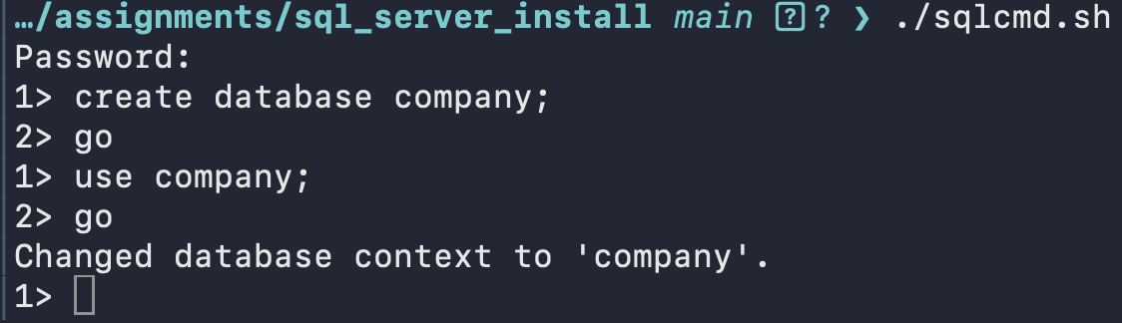
Figure 1: Create the database company

Create Products Table
Due to the pain of using the line based editor in sqlcmd, I created a SQL file to create the products table.
SQL Listing:
…/assignments/sql_server_install main  ? ❯ cat create_table_products.sql
create table products(
product_id int identity(1,1),
name varchar(100),
description varchar(max),
price decimal(12,2),
in_stock bit,
release_date date
);

Note, I deviated from the video by using varchar(max) for the description datatype in preference over the deprecated text type. I also used the standard all lower snake case for the table and column names.
I had a bit of a bother trying to run the script from within sqlcmd. sqlcmd repeatedly could not find the file despite a me using the full explicit path. After a few tries it occurred to me that sqlcmd is running inside of a container.
This command copies the file from host storage to the container’s tmp directory:
docker cp insert_products.sql mssql1:/tmp/
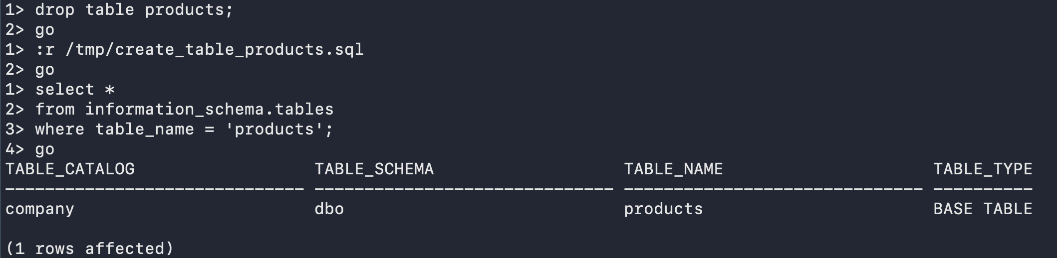
Figure 2: Create table company.dbo.products

Insert Records Into company.dbo.products
As with creating the table, I also created a script to populate the company.dbo.products table. File listing:
insert into products (name, description, price, in_stock, release_date)
values
('Magic Beans', 'Grows a beanstalk overnight',5.00, 1, '2023-05-01'),
('Golden Goose', 'Lays one golden egg per day', 1999.99, 0, '2022-11-15'),
('Singing Harp', 'Plays itself, may call for help', 349.50, 1, '2024-02-29'),
('Giant Boots', 'Size 90, extra stompy', 129.00, 1, '2021-07-04'),
('Englishman Grinder', 'Makes bread, batteries not included', 79.95, 0, '2020-10-31');
go

Note: because “go” is at the end of the SQL file it does not need to be issued after loading – it’s automatic.
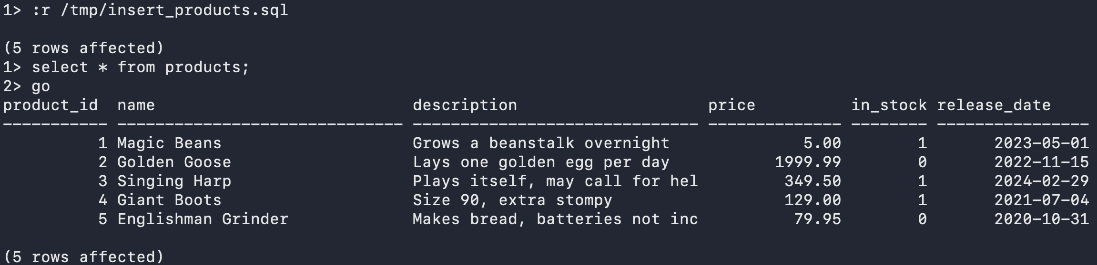
Figure 3:Insert records into company.dbo.products
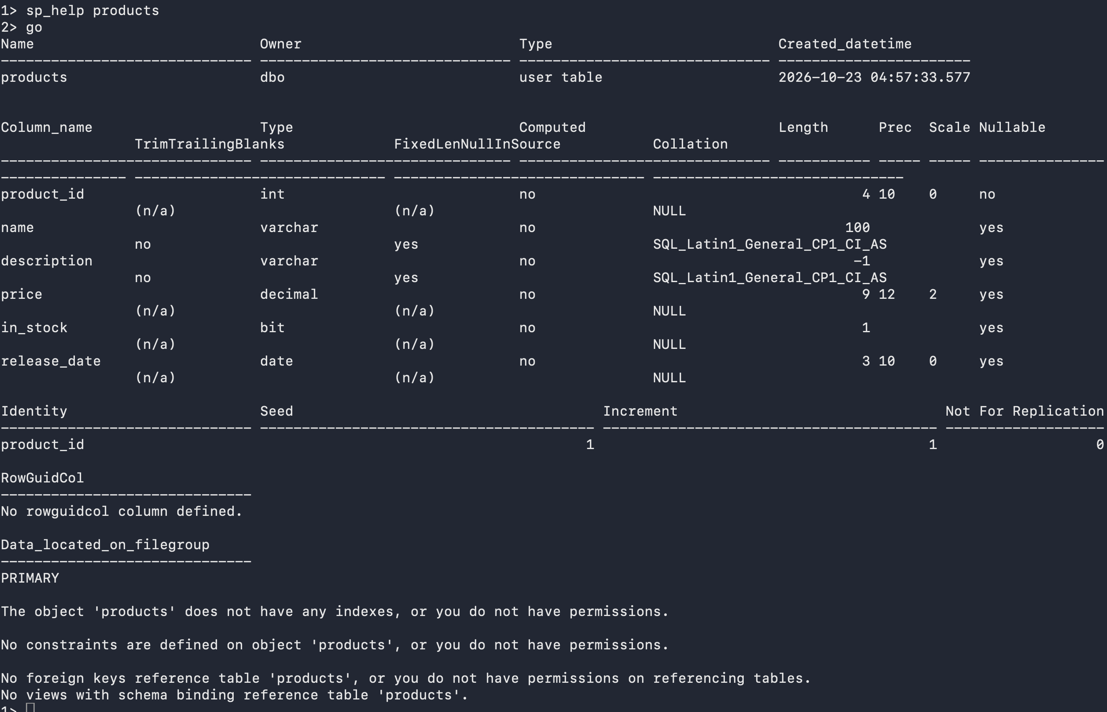
Figure 4: sp_help for company.dbo.products

