System F

Weaknesses of Simply Typed Lambda Calculus
In the simply typed lambda calculus:
we can take in an expression, check if its well typed, and give it a type. It has some nice properties; it can take in an expression, do some simplifications, reach some stage and stop.
The simply typed lambda calculus is not Turing complete. In general its impossible to predict what a Turing-complete program will do over an arbitrarily long time. Its decidable whether a simply typed lambda calculus program halts, and it will always halt at some stage, so therefore its not Turing complete.
The simply typed lambda calculus has some other annoying aspects:

The identity function in simply typed lambda calculus:
We have to give ?, the specific type (e.g. , where could be R, or char, or anything like that, like ).
But you have to put in some specific type! It would be easier if you could be more general about it, like for example say that the output type is the same as the input type. But you can’t, you have to be specific.
Another example, the compose function:
In this example we could replace the ?s with many different types and it would still work. One example is:
But we have to do it manually! The problem is, there’s no polymorphism.

There’s no (proper) polymorphism in C either:
int max(x:int, y:int)
{
if(x>y)
return x;
else
return y;
}
My code structure wouldn’t change if I wanted to use floats instead of ints. But I can’t just send in floats as inputs and expect a float as my output as C isn’t polymorphic. I’d have to explicitly define another function that takes floats as inputs and output, give it the same internal code structure, and use that instead. This is clearly annoying.

Extending the Simply Typed Lambda Calculus
To sort out this problem, lets extend the simply typed lambda calculus, to include some foralls:

Extending the identity function:
i.e. for all types goes to

Extending the compose function:

This sorts out our polymorphism problem.

Our definitions of T and E have to be extended:

We can fiddle with this a bit more to create a system where we can have foralls, but they have to be on the outside.

This is the basis of System F.

You create a lattice of types, where one type can be more general than another (i.e. greater: >)
i.e. is a type
is a type too
and
i.e. the first is more general than the second.
and is more general than the first.

We can come up with some properties for this system:
also,
This is a lot like set theory. In fact you can think of it like a more specific type is a subset of a more general type. One type can be a subset of another.

So the types form a lattice:

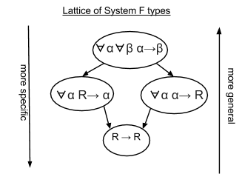

It has a least upper bound and a greatest lower bound → allows it to form a lattice.

Greatest Lower Bound

Of all the types that are more specific than both T1 and T2, there is one that is the most general. This is the greatest lower bound.

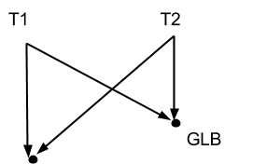

So its the least specific type that is more specific than all your input types.

Least Upper Bound

Of all the types that are more general than both T1 and T2, there is one that is the least general. The is the least upper bound.

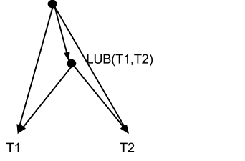

Its the most specific type that is less specific than the input types.

We need these for type inference in System F. e.g. if we need a type thats at least as specific as T1 and T2, we use the GLB. Or if we want to give it as specific a type as we can but still works for T1 and T2, we use the LUB.

Example:
negate: takes in a number and gives you minus that number. What type is negate?
Takes in any as long as its a number, and goes from type to .
We would usually just write . Any free variable has a forall on the outside. They’re implied so we don’t write them.

Curry-Howard Isomorphism

Curry-Howard isomorphism is the direct relationship between mathematical proofs and computer programs.

If we have a constant C :
We can assume that T1 implies T2 (predicate logic)

predicate logic
predicate calculus
In the simple lambda calculus
Can conclude
where
and

