**DIGITAL SYSTEM DESIGN APPLICATIONS**

**(CRN: 11275)**

**THE REPORT OF EXPERIMENT – 6**



Faculty of Electrical and Electronics Engineering

Electronics and Communication Engineering

Yusuf Tekin – 040200043

1. **Clock Generation**

Clock Generation Verilog Code

`timescale 1ns **/** 1ps

**module** top_module**(**

**input** clk**,**

**input** rst**,**

**output** **reg** **[**6**:**0**]** cnt100**,**

**output** **reg** **[**6**:**0**]** cnt80**,**

**output** **reg** **[**6**:**0**]** cnt60

**);**

**wire** clk80**,** clk60**;**

// Clocking Wizard instantiation

clk_wiz_0 clknetwork **(**

**.**clk_out1**(**clk80**),**

**.**clk_out2**(**clk60**),**

**.**reset**(**rst**),**

**.**locked**(),**

**.**clk_in1**(**clk**)**

**);**

// Counter for 100 MHz clock

**always** **@(posedge** clk **or** **posedge** rst**)** **begin**

**if** **(**rst**)** **begin**

cnt100 **<=** 7'b0**;**

**end** **else** **if** **(**cnt100 **<** 100**)** **begin**

cnt100 **<=** cnt100 **+** 1**;**

**end**

**end**

// Counter for 80 MHz clock

**always** **@(posedge** clk80 **or** **posedge** rst**)** **begin**

**if** **(**rst**)** **begin**

cnt80 **<=** 7'b0**;**

**end** **else** **if** **(**cnt80 **<** 80**)** **begin**

cnt80 **<=** cnt80 **+** 1**;**

**end**

**end**

// Counter for 60 MHz clock

**always** **@(posedge** clk60 **or** **posedge** rst**)** **begin**

**if** **(**rst**)** **begin**

cnt60 **<=** 7'b0**;**

**end** **else** **if** **(**cnt60 **<** 60**)** **begin**

cnt60 **<=** cnt60 **+** 1**;**

**end**

**end**

**endmodule**

Clock Generation Testbench Code

`timescale 1ns **/** 1ps

**module** top_module_tb**;**

**reg** clk**,** rst**;**

**wire** **[**6**:**0**]** cnt100**,** cnt80**,** cnt60**;**

top_module dut **(**

**.**clk**(**clk**),**

**.**rst**(**rst**),**

**.**cnt100**(**cnt100**),**

**.**cnt80**(**cnt80**),**

**.**cnt60**(**cnt60**)**

**);**

**always** **#**5 clk **=** **~**clk**;**

**initial** **begin**

clk **=** 0**;** rst **=** 1**;** **#**15**;**

rst **=** 0**;** **#**10**;** rst **=** 1**;**

**#**10**;** rst **=** 0**;**

**#**4200**;**

$finish**();**

**end**

**endmodule**

Clock Generation Behavioral Simulation

Clock Generation Primitive Usage

Clock Generation Clock Networks Report

1. **Clock Gating**

Clock Gating Verilog Code

`timescale 1ns **/** 1ps

**module** clock_gating**(**

**input** clk**,**

**input** rst**,**

**output** **reg** **[**6**:**0**]** cnt50**,**

**output** **reg** **[**6**:**0**]** cnt25

**);**

**reg** clk50_en**,** clk25_en**;**

**wire** clk50**,** clk25**;**

**integer** i**;**

BUFR **#(**

**.**BUFR_DIVIDE**(**"2"**),**

**.**SIM_DEVICE**(**"7SERIES"**)**

**)**

BUFR_ins_1 **(**

**.**O**(**clk50**),**

**.**CE**(**clk50_en**),**

**.**CLR**(**1'b0**),**

**.**I**(**clk**)**

**);**

BUFR **#(**

**.**BUFR_DIVIDE**(**"4"**),**

**.**SIM_DEVICE**(**"7SERIES"**)**

**)**

BUFR_inst_2 **(**

**.**O**(**clk25**),**

**.**CE**(**clk25_en**),**

**.**CLR**(**1'b0**),**

**.**I**(**clk**)**

**);**

**always** **@(posedge** clk50 **or** **posedge** rst**)** **begin**

**if(**rst**)** **begin**

cnt50 **<=** 7'b0**;**

**end** **else** **if(**cnt50 **<** 50**)** **begin**

cnt50 **<=** cnt50 **+** 1**;**

**end**

**end**

**always** **@(posedge** clk25 **or** **posedge** rst**)** **begin**

**if(**rst**)** **begin**

cnt25 **<=** 7'b0**;**

**end** **else** **if(**cnt25 **<** 25**)** **begin**

cnt25 **<=** cnt25 **+** 1**;**

**end**

**end**

**always** **@(posedge** clk **or** **posedge** rst**)** **begin**

**if** **(**rst**)** **begin**

clk50_en **<=** 1'b0**;**

clk25_en **<=** 1'b0**;**

**end** **else** **begin**

**if** **(**cnt50 **<** 50**)**

clk50_en **<=** 1'b1**;**

**else**

clk50_en **<=** 1'b0**;**

**if** **(**cnt25 **<** 25**)**

clk25_en **<=** 1'b1**;**

**else**

clk25_en **<=** 1'b0**;**

**end**

**end**

**endmodule**

Clock Gating Testbench Code

`timescale 1ns **/** 1ps

**module** clock_gating_tb**;**

**wire** **[**6**:**0**]** cnt50**,** cnt25**;**

**reg** clk**,** rst**;**

clock_gating dut**(**

**.**clk**(**clk**),**

**.**rst**(**rst**),**

**.**cnt50**(**cnt50**),**

**.**cnt25**(**cnt25**)**

**);**

**always** **#**5 clk **=** **~**clk**;**

**initial** **begin**

clk **=** 1'b0**;** rst **=** 1'b0**;** **#**100**;**

rst **=** 1'b1**;** **#**10**;** rst **=** 1'b0**;**

**#**4200**;**

$finish**();**

**end**

**endmodule**

Clock Gating Behavioral Simulation

Clock Gatin Primitive Usage

Clock Gating Clock Network Report

1. **Block RAM**

Block RAM Verilog Code

//Copyright 1986-2022 Xilinx, Inc. All Rights Reserved.

//Copyright 2022-2024 Advanced Micro Devices, Inc. All Rights Reserved.

//--------------------------------------------------------------------------------

//Tool Version: Vivado v.2024.1 (win64) Build 5076996 Wed May 22 18:37:14 MDT 2024

//Date : Mon Dec 9 11:36:38 2024

//Host : DESKTOP-KMJ9JAC running 64-bit major release (build 9200)

//Command : generate_target block_ram_50MHz_wrapper.bd

//Design : block_ram_50MHz_wrapper

//Purpose : IP block netlist

//--------------------------------------------------------------------------------

`timescale 1 ps **/** 1 ps

**module** block_ram_50MHz_wrapper

**(**addra_0**,**

clk_100MHz**,**

dina_0**,**

douta_0**,**

wea_0**);**

**input** **[**3**:**0**]**addra_0**;**

**input** clk_100MHz**;**

**input** **[**7**:**0**]**dina_0**;**

**output** **[**7**:**0**]**douta_0**;**

**input** **[**0**:**0**]**wea_0**;**

**wire** **[**3**:**0**]**addra_0**;**

**wire** clk_100MHz**;**

**wire** **[**7**:**0**]**dina_0**;**

**wire** **[**7**:**0**]**douta_0**;**

**wire** **[**0**:**0**]**wea_0**;**

block_ram_50MHz block_ram_50MHz_i

**(.**addra_0**(**addra_0**),**

**.**clk_100MHz**(**clk_100MHz**),**

**.**dina_0**(**dina_0**),**

**.**douta_0**(**douta_0**),**

**.**wea_0**(**wea_0**));**

**endmodule**

Block RAM Testbench Code

`timescale 1ns **/** 1ps

**module** block_ram_50MHz_wrapper_tb**;**

**wire** **[**7**:**0**]** douta_0**;**

**reg** clk_100MHz**,** wea_0**;**

**reg** **[**3**:**0**]** addra_0**;**

**reg** **[**7**:**0**]** dina_0**;**

**integer** i**;**

block_ram_50MHz_wrapper dut**(**

**.**addra_0**(**addra_0**),**

**.**clk_100MHz**(**clk_100MHz**),**

**.**dina_0**(**dina_0**),**

**.**douta_0**(**douta_0**),**

**.**wea_0**(**wea_0**)**

**);**

**always** **#**5 clk_100MHz **=** **~**clk_100MHz**;**

**initial** **begin**

clk_100MHz **=** 1'b0**;** wea_0 **=** 1'b0**;** **#**500**;**

$display**(**"\n--- Reading Initial Data ---"**);**

**for** **(**i **=** 0**;** i **<** 16**;** i **=** i **+** 1**)** **begin**

addra_0 **=** i**;**

**#**40**;**

$display**(**"Address %0d: Data = %0d"**,** addra_0**,** douta_0**);**

**end**

$display**(**"\n--- Writing School Number in reverse to the RAM ---"**);**

wea_0 **=** 1'b1**;** **#**90**;**

addra_0 **=** 4'b0000**;** dina_0 **=** 8'b00000011**;** **#**60**;**

addra_0 **=** 4'b0001**;** dina_0 **=** 8'b00000100**;** **#**60**;**

addra_0 **=** 4'b0010**;** dina_0 **=** 8'b00000000**;** **#**60**;**

addra_0 **=** 4'b0011**;** dina_0 **=** 8'b00000000**;** **#**60**;**

addra_0 **=** 4'b0100**;** dina_0 **=** 8'b00000000**;** **#**60**;**

addra_0 **=** 4'b0101**;** dina_0 **=** 8'b00000010**;** **#**60**;**

addra_0 **=** 4'b0110**;** dina_0 **=** 8'b00000000**;** **#**60**;**

addra_0 **=** 4'b0111**;** dina_0 **=** 8'b00000100**;** **#**60**;**

addra_0 **=** 4'b1000**;** dina_0 **=** 8'b00000011**;** **#**60**;**

addra_0 **=** 4'b1001**;** dina_0 **=** 8'b00000100**;** **#**60**;**

addra_0 **=** 4'b1010**;** dina_0 **=** 8'b00000000**;** **#**60**;**

addra_0 **=** 4'b1011**;** dina_0 **=** 8'b00000000**;** **#**60**;**

addra_0 **=** 4'b1100**;** dina_0 **=** 8'b00000000**;** **#**60**;**

addra_0 **=** 4'b1101**;** dina_0 **=** 8'b00000010**;** **#**60**;**

addra_0 **=** 4'b1110**;** dina_0 **=** 8'b00000000**;** **#**60**;**

addra_0 **=** 4'b1111**;** dina_0 **=** 8'b00000100**;** **#**60**;**

wea_0 **=** 1'b0**;** **#**90**;**

addra_0 **=** 4'b0000**;** **#**80**;**

addra_0 **=** 4'b0001**;** **#**80**;**

addra_0 **=** 4'b0010**;** **#**80**;**

addra_0 **=** 4'b0011**;** **#**80**;**

addra_0 **=** 4'b0100**;** **#**80**;**

addra_0 **=** 4'b0101**;** **#**80**;**

addra_0 **=** 4'b0110**;** **#**80**;**

addra_0 **=** 4'b0111**;** **#**80**;**

addra_0 **=** 4'b1000**;** **#**80**;**

addra_0 **=** 4'b1001**;** **#**80**;**

addra_0 **=** 4'b1010**;** **#**80**;**

addra_0 **=** 4'b1011**;** **#**80**;**

addra_0 **=** 4'b1100**;** **#**80**;**

addra_0 **=** 4'b1101**;** **#**80**;**

addra_0 **=** 4'b1110**;** **#**80**;**

addra_0 **=** 4'b1111**;** **#**80**;**

$display**(**"\n--- Writing Complete ---"**);**

$display**(**"\n--- Reading data from RAM ---"**);**

**for** **(**i **=** 0**;** i **<** 16**;** i **=** i **+** 1**)** **begin**

addra_0 **=** i**;**

**#**40**;**

$display**(**"Address %0d: Data = %0d"**,** addra_0**,** douta_0**);**

**end**

$display**(**"\nBenchmark finished.\n"**);**

$finish**();**

**end**

**endmodule**

Block RAM Simulation TCL Console Log

Block RAM Behavioral Simulation

Block RAM Primitive Usage

Block RAM Block Design

1. **FIFO for Clock Domain Crossing**

FIFO Verilog Code

`timescale 1ns **/** 1ps

**module** top_module**(**

**input** clk**,**

**input** rst**,**

**input** wr_en**,**

**input** rd_en**,**

**input** **[**7**:**0**]** din**,**

**output** **[**7**:**0**]** dout**,**

**output** empty**,**

**output** full**,**

**output** overflow**,**

**output** underflow

**);**

**reg** **[**2**:**0**]** counter **=** 3'b0**;**

**wire** wr_clk**,** rd_clk**;**

**assign** wr_clk **=** counter**[**0**];**

**assign** rd_clk **=** counter**[**1**];**

**always** **@(posedge** clk **or** **posedge** rst**)** **begin**

**if(**rst**)** counter **<=** 3'b0**;**

**else** counter **<=** counter **+** 1**;**

**end**

fifo_generator_0 memory1**(**

**.**wr_clk**(**wr_clk**),**

**.**wr_rst **(**rst**),**

**.**rd_clk**(**rd_clk**),**

**.**rd_rst**(**rst**),**

**.**din**(**din**),**

**.**wr_en**(**wr_en**),**

**.**rd_en**(**rd_en**),**

**.**dout**(**dout**),**

**.**full**(**full**),**

**.**overflow**(**overflow**),**

**.**empty**(**empty**),**

**.**underflow**(**underflow**));**

**endmodule**

FIFO Testbench Code

`timescale 1ns **/** 1ps

**module** top_module_tb**;**

**wire** full**,** overflow**,** underflow**,** empty**;**

**wire** **[**7**:**0**]** dout**;**

**reg** **[**7**:**0**]** din**;**

**reg** clk**,** rst**,** wr_en**,** rd_en**;**

**integer** i**;**

top_module dut**(**

**.**clk**(**clk**),**

**.**rst**(**rst**),**

**.**wr_en**(**wr_en**),**

**.**rd_en**(**rd_en**),**

**.**din**(**din**),**

**.**dout**(**dout**),**

**.**empty**(**empty**),**

**.**full**(**full**),**

**.**overflow**(**overlow**),**

**.**underflow**(**underflow**));**

**always** **#**5 clk **=** **~**clk**;**

**initial** **begin**

clk **=** 1'b0**;** rst **=** 1'b1**;** wr_en **=** 1'b0**;** rd_en **=** 1'b0**;** **#**40**;**

rst **=** 1'b0**;** wr_en **=** 1'b1**;** rd_en **=** 1'b1**;** **#**80**;**

**for** **(**i **=** 0**;** i **<** 64**;** i **=** i **+** 1**)** **begin**

din **<=** i**;** **#**40**;**

**end**

**#**1200**;**

$finish**();**

**end**

**endmodule**

FIFO Behavioral Simulation

FIFO Primitive Usage

Clock Network Reports

Clock Interaction Report

FIFO Post-Implementation Timing Simulation

1. **Research**

**Clock Tree Synthesis (CTS)** aims to distribute the clock signal from a single clock source to all clocked elements in a design while minimizing skew and maintaining signal integrity.

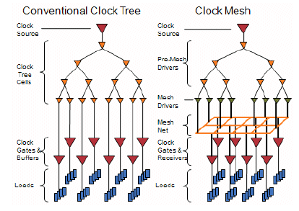

CTS Figure1

A clock tree is a hierarchical network of buffers, inverters, and interconnect wires that distribute the clock signal. It starts at the clock source and branches out to clock sinks. The topology can be:

* H-Tree: Balanced tree structure for equal latency.
* Spine or Mesh: Grid-based clock distribution, typically used in high-frequency designs.
* Buffered Tree: Uses buffers at branching points to strengthen the clock signal.

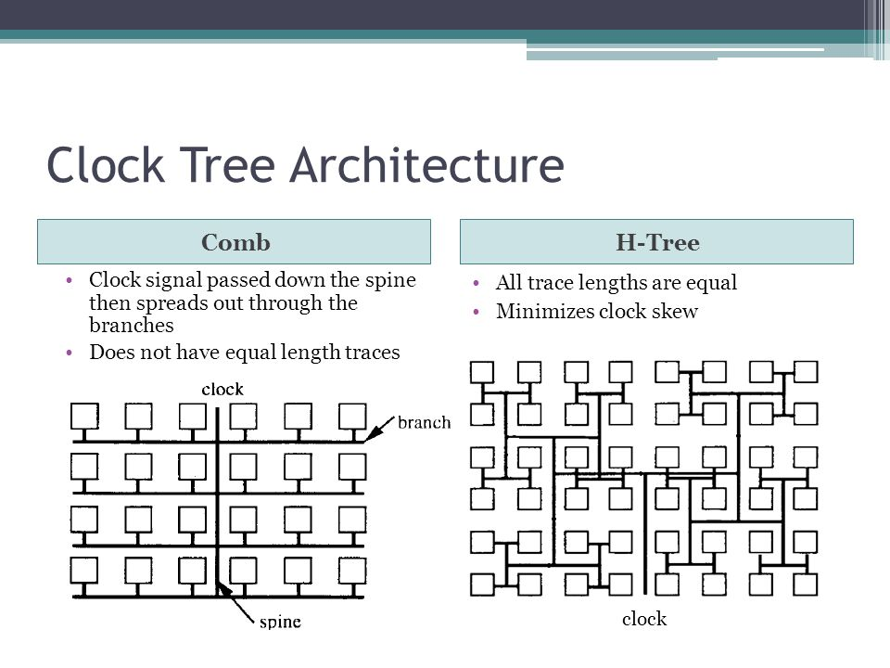

Clock Tree Architecture2

**Dual FF Synchronizer:**

Clock Domain Crossing (CDC) occurs when signals pass from one clock domain to another domain with a different clock frequency or phase relationship. CDC introduces the risk of metastability, where a flip-flop enters an unstable state and delays the signal propagation. The **dual flip-flop synchronizer** is a common technique used to address metastability. It ensures that data crossing clock domains stabilizes before it is used in the new clock domain.

Dual FF Figure with Clocks & Outputs3

* **First Flip-Flop:** Captures the signal from the source clock domain and allows metastability to resolve over one clock cycle.
* **Second Flip-Flop:** Further stabilizes the signal, ensuring that it is safe to use in the destination clock domain.
* The two flip-flops act as a buffer, allowing metastability to settle while ensuring signal integrity.

**References**

1. <https://www.design-reuse.com/articles/21019/clock-mesh-benefits-analysis.html>
2. <https://slideplayer.com/slide/4442868/>
3. <https://commons.wikimedia.org/wiki/File:2FF_synchronizer.gif>