John Spicer
CS334
Final Exam Review

I pledge my honor that I have abided by the Stevens Honor System.

1.) Q = { qs, q1, q2, q3 }

Σ = { 0, 1 }

ẟ =
 | 0 | 1
qs | q1 | q2
q1 | qs | q3
q2 | q3 | qs
q3 | q3 | q3

q0 = qs
F = { qs, q3 }

00, 11, 100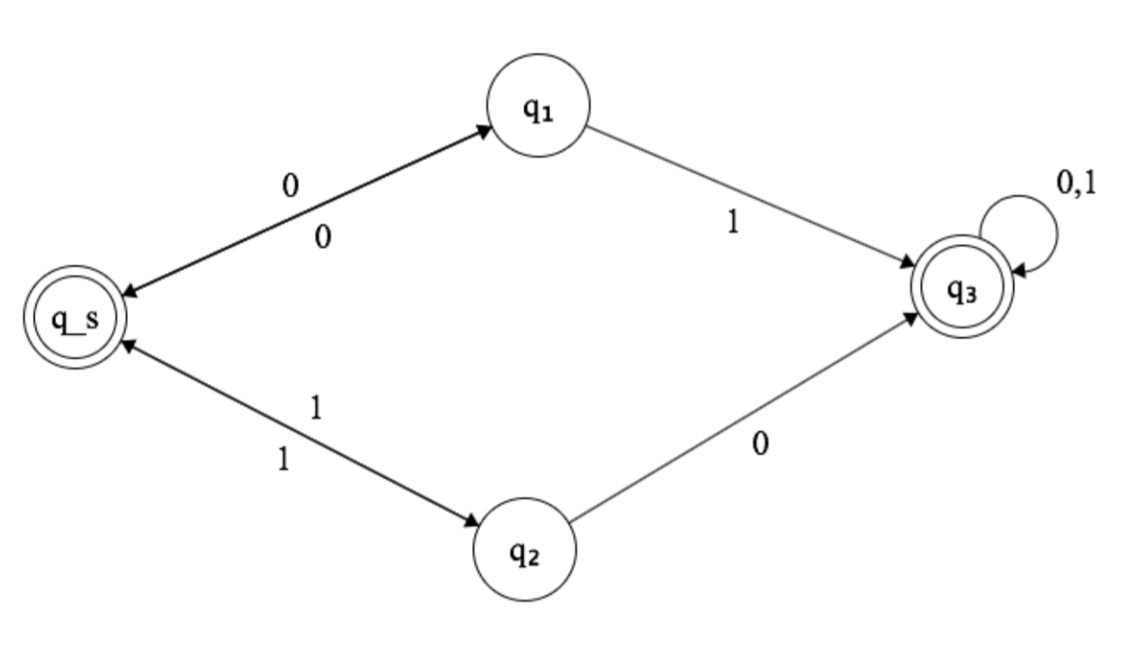

2. Q = { qs, q1, q2, q3 }

Σ = { 0, 1}

ẟ =

 | 0 | 1
qs | q1 | q2
q1 | qs, q3 | q3
q2 | q3 | qs, q3
q3 | q3

q0 = qs
F = { q3 }

11, 00, 010

3. ( 0 ( 0 U 1 ( 0 U 1 ) * ) * ) * U ( 1 ( 1 U 0 ( 0 U 1 ) * ) * ) *

4. For a language to be co-Turing recognizable is for its context to be Turing-recognizable

Trivial: L = { w | w ε Σ }
Simple: L = { 0i | i > 0 }
Complex: L = { 0i 1n | i > 0 < n }

5. {0^{K}1^{K}0^{2K} | K >= 0}
Assume L = {0^{K}1^{K}0^{2K} | K >= 0} is context free.
If P is the pumping length of L, 0P1P02P must be in L. S = uvxyz ε L so s_{i} = uv^{i}xy^{i}z ∀ I >= 0, |vy| > 0, and |xyz| <= P. Since xyz is less than or equal to the pumping length and we know vy is greater than 0 (it gets pumped), we know any substring p-long in L can be pumped. For example, 0^{P}1^{P+K}0^{2P} is in L. Wherever L is pumped, there will not be a correct number of zeros and ones (there won't be an equal number of beginning 0's and 1's or twice as many trailing 0's as beginning 0's). These would cause the pumped string to not be in L. This is a contradiction, so L cannot be context free.

6.
a. First the TM reads the first bit. If it is a 0, an x is placed to mark it. It then enteres a state where it looks for +. If the TM reads a 1 as the first bit, it marks it with an x and enters a state looking for a +.
b. The TM then after finding the +, searches for the next 0 or 1. In the found zero state, place a Y for a zero and an N for a one. In the found one state, place a Y for a zero and an N for a one.
c. The TM will then go back until it finds an x. Then it will repeat steps a-c.
d. After all 0's and 1's have been replaced, the TM should move to the end of the tape. The TM should then begin to move left. Every Y should be replaced by a zero and every N should be replaced by a one. Everything else gets replaced by |_|. Once the TM reads the end, go back to format correctly and accept.

7. A Staqueue automaton is computationally equivalent to a q queue automaton, as a staqueue automaton justs has one extra ability, the ability to read and write on the right end. A queue automaton can simulate a TM by using special markers for the head and the end of the tape. A queue automaton simulates a TM by using reads and writes to simulate transitions. Thus, a staqueue automata is computationally equivalent to a TM.

8. Taking the diagonalilzation gives you:
Trout, Trout, Eel, Mackerel, Trout, Eel, Mackerel, Eel
This sequence is never found in any of the given sequences, so all the possibilities must be uncountably infinite

9. There exists a TM L such that the TM will check w against any string found in the two DFA's. If it exists in D₁ or D₂ accept, otherwise L will reject. So U_{DFA} is decidable.

10. DISJOINT_{TM} is the language that is not decided because either TM M or TM N. There does not exist a TM to show that this is decidable. If a TM works on M, it would have to not work on N. This would however cause a contradiction. So, DISJOINT_{TM} is undecidable.

