John Spicer
CS383
9/23/15
I pledge my honor that I have abided by the Stevens Honor System

Exercise 1:
1. In client-server architecture, client computers have to request services from a remote server running a specific program. Peer-to-peer systems share resources with all computers on the network.

2. The purpose of the OS is to connect the user to the hardware of the computer.

3. When building a system, decomposition and abstraction are necessary. Decomposition is dividing the system into separate components to be used by abstraction. Abstractions are models of these parts of the system, and using these it is easier to analyze each individual part, as opposed to looking at the system as a whole.

4. Primary storage (RAM) hold data for access by the CPU. Secondary storage is any external storage devices not directly accessible by the CPU.

5. Bitmaps are large files used for images with a great amount of detail. Object images are created by geometrically defined shapes/lines. The size of object images depends on the complexity of the geometry of the image, but still requires less storage space than bitmap images.

6. BCD is Binary Coded Decimal. The range of BCD is an entire decimal digit less than that of binary. In addition calculations in BCD are more stressful on the CPU as the CPU must convert base 10 numbers into binary before actually carrying out any calculations.
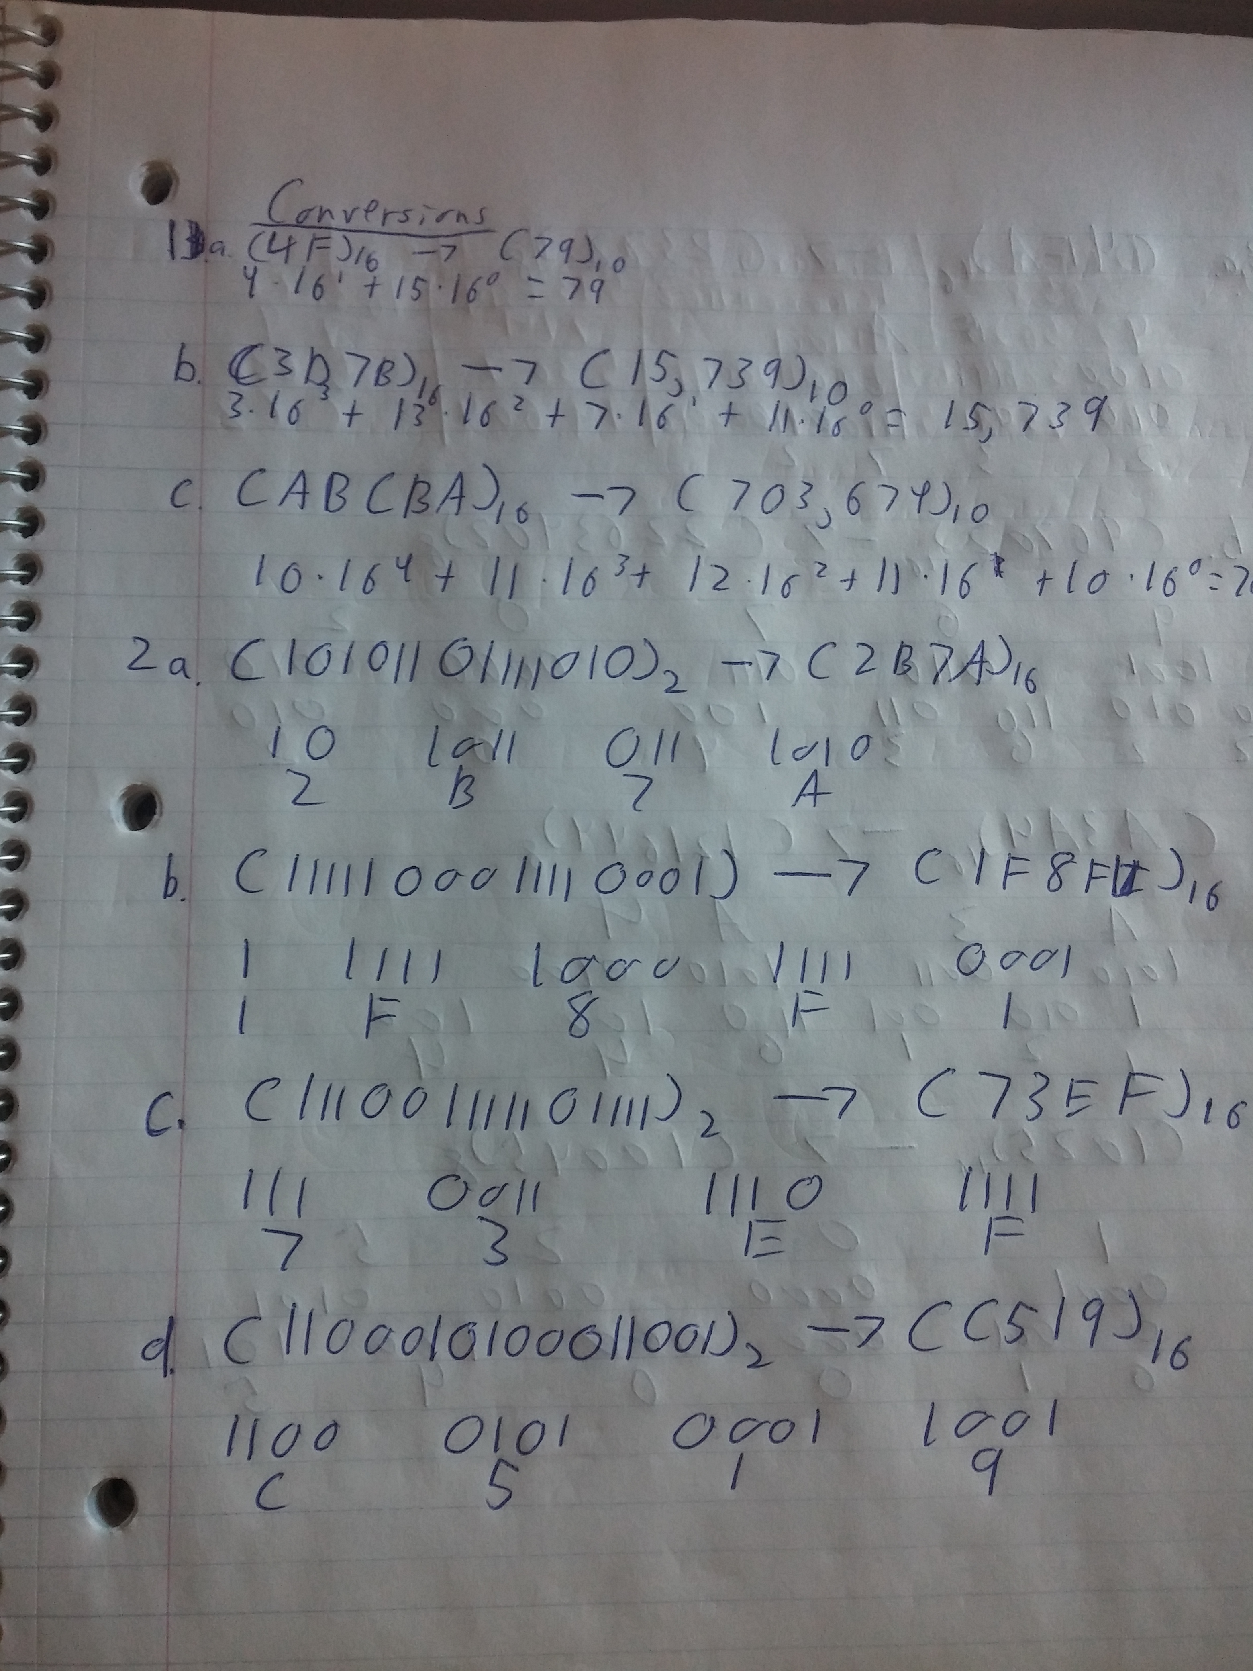

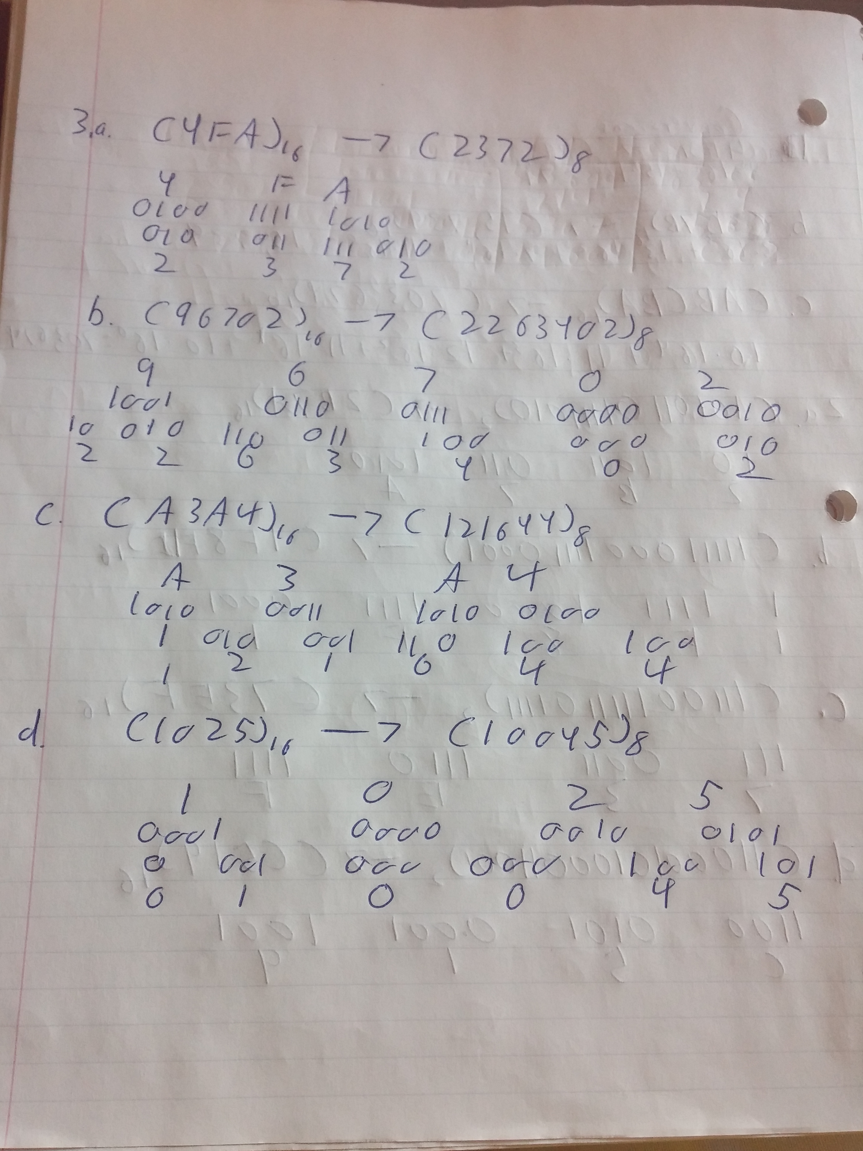

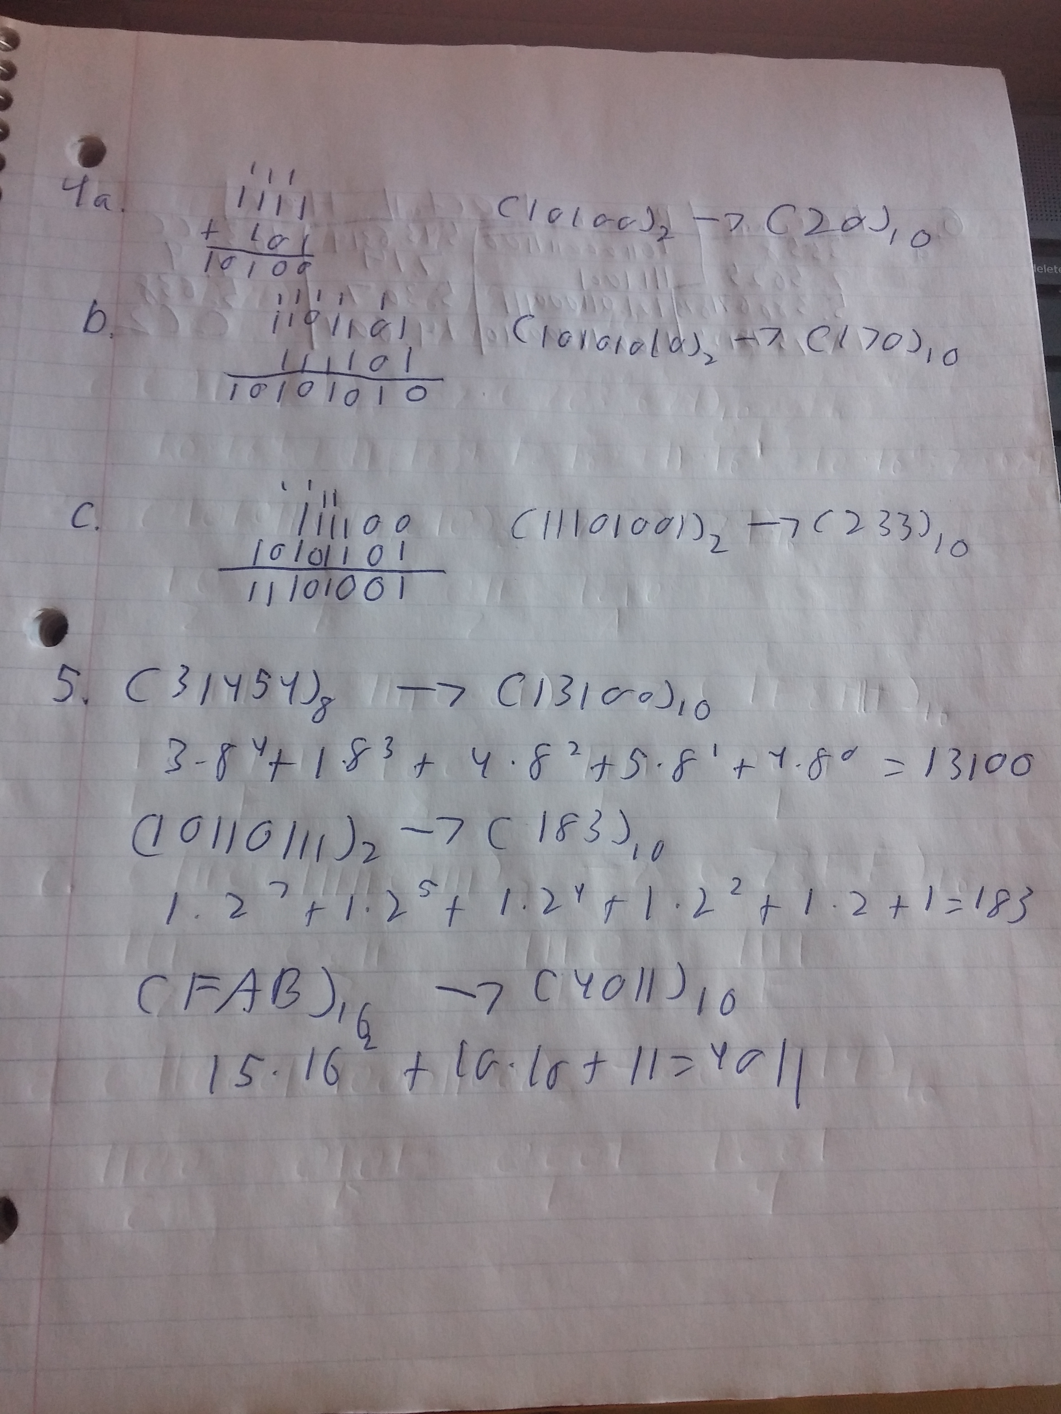

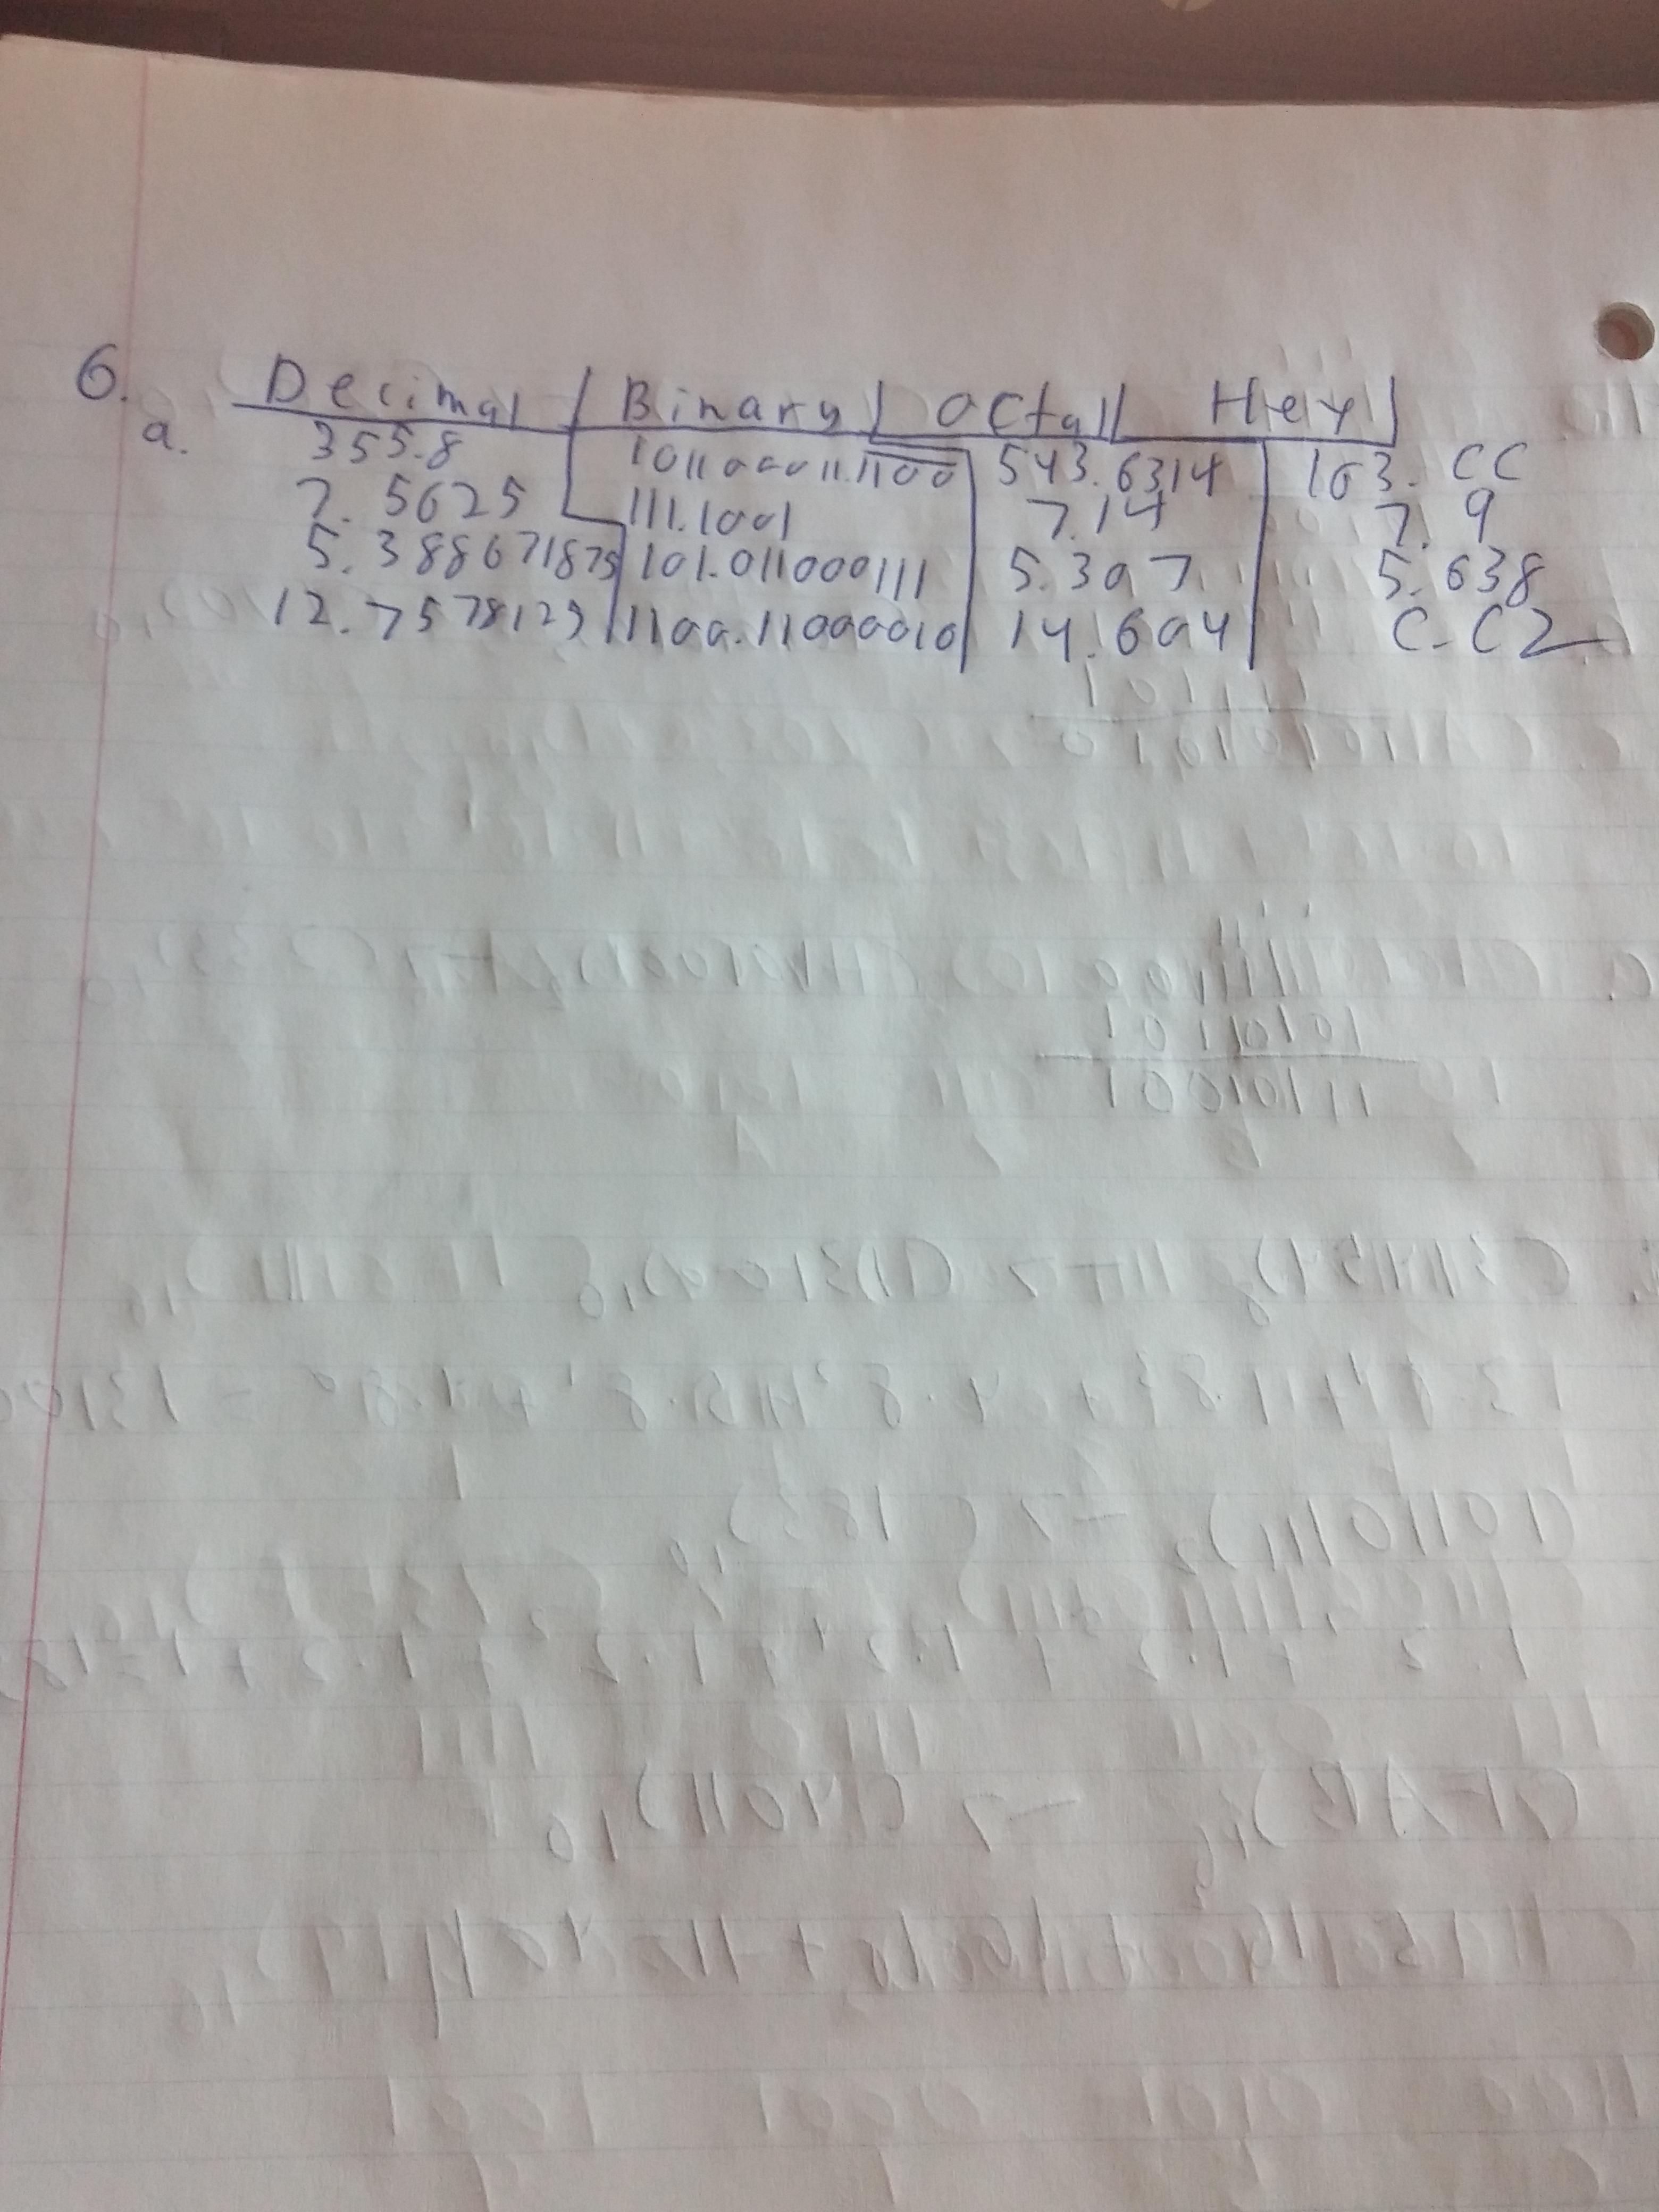

Exercise 3
1.
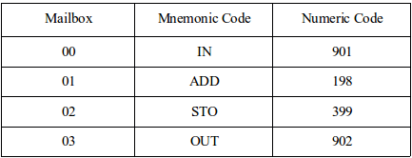

2. The program produces the wrong output. Instead of subtracting the second and third inputs from the first, the program subtracts the first from the second, and then that from the third input.



