Hydrogeologic Adequacy Assessment – Dynamic Engineering Report
Pumping Rate: 450.0 gpm
Population Basis: 2,500
Prepared using analytical, numerical, and regulatory-based methods consistent with Ten States Standards and KDOW 401 KAR 8.

1. Pumping Test Plots

1.1 Pumping Well Drawdown Curve
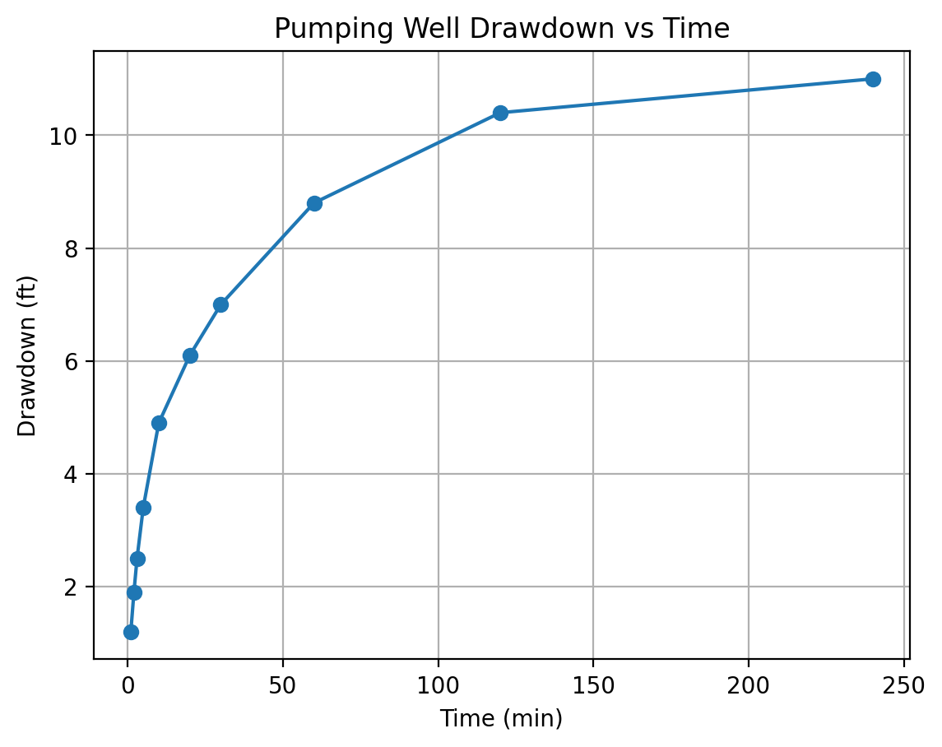

1.2 Observation Well Drawdown Curve
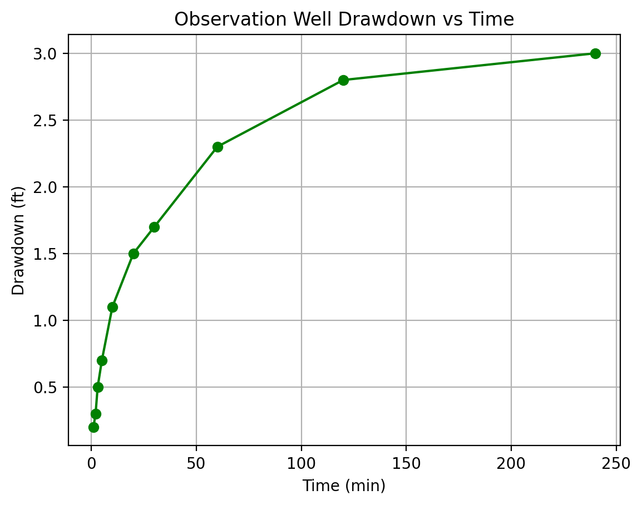

1.3 Cooper–Jacob Plot
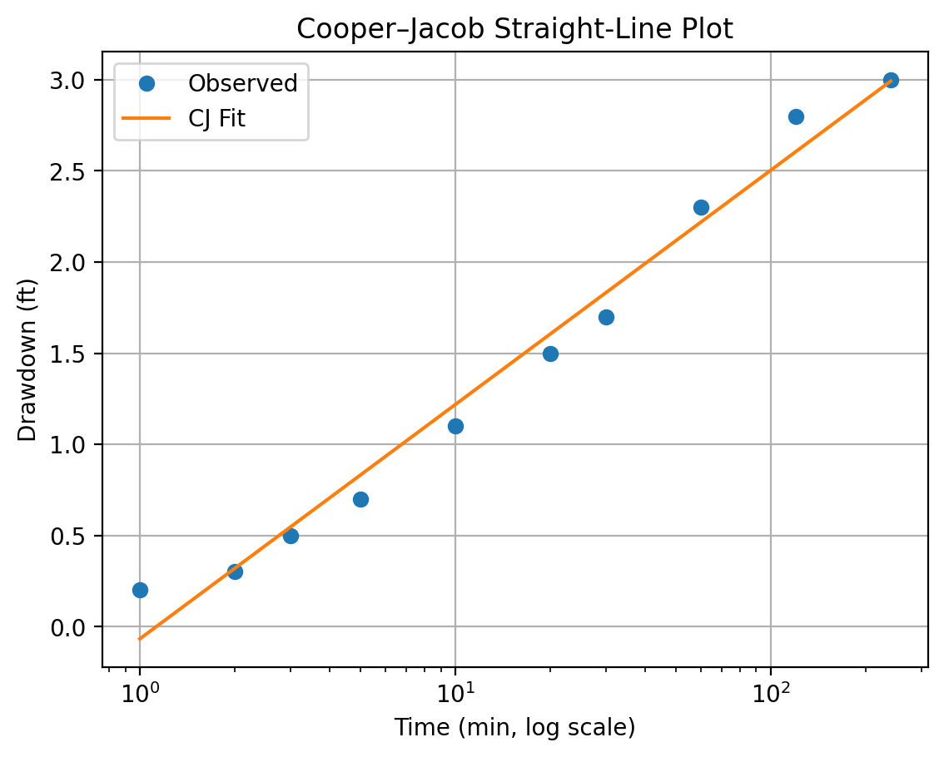

1.4 Theis Fit Plot
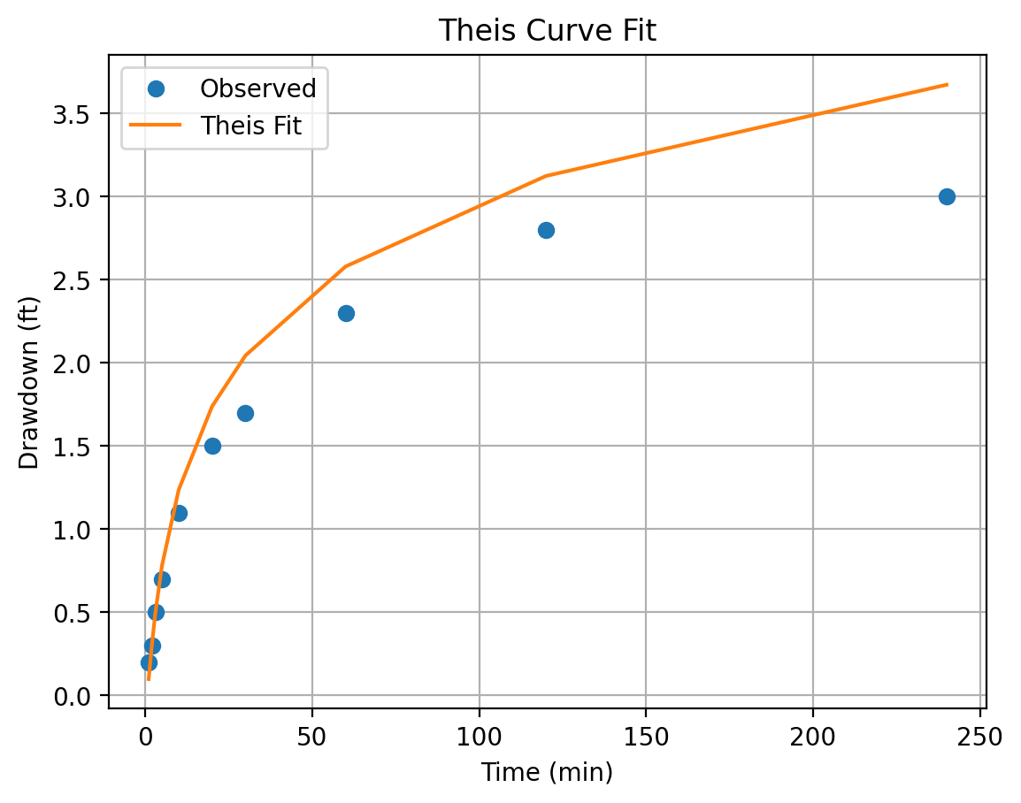

1.5 Neuman Fit Plot
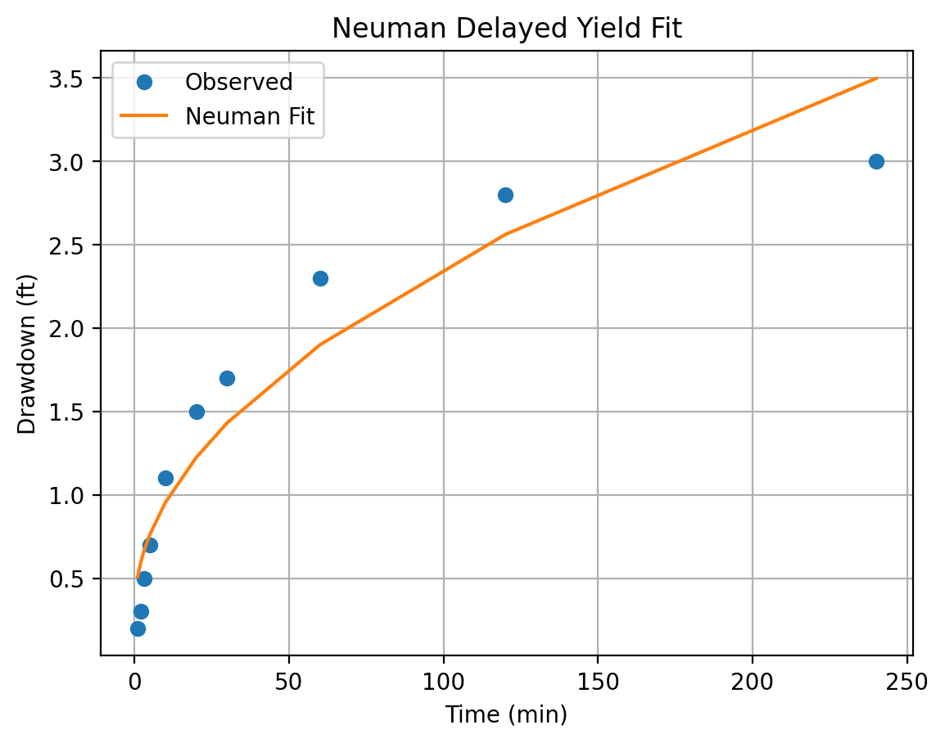

1.6 Numerical Model Contours
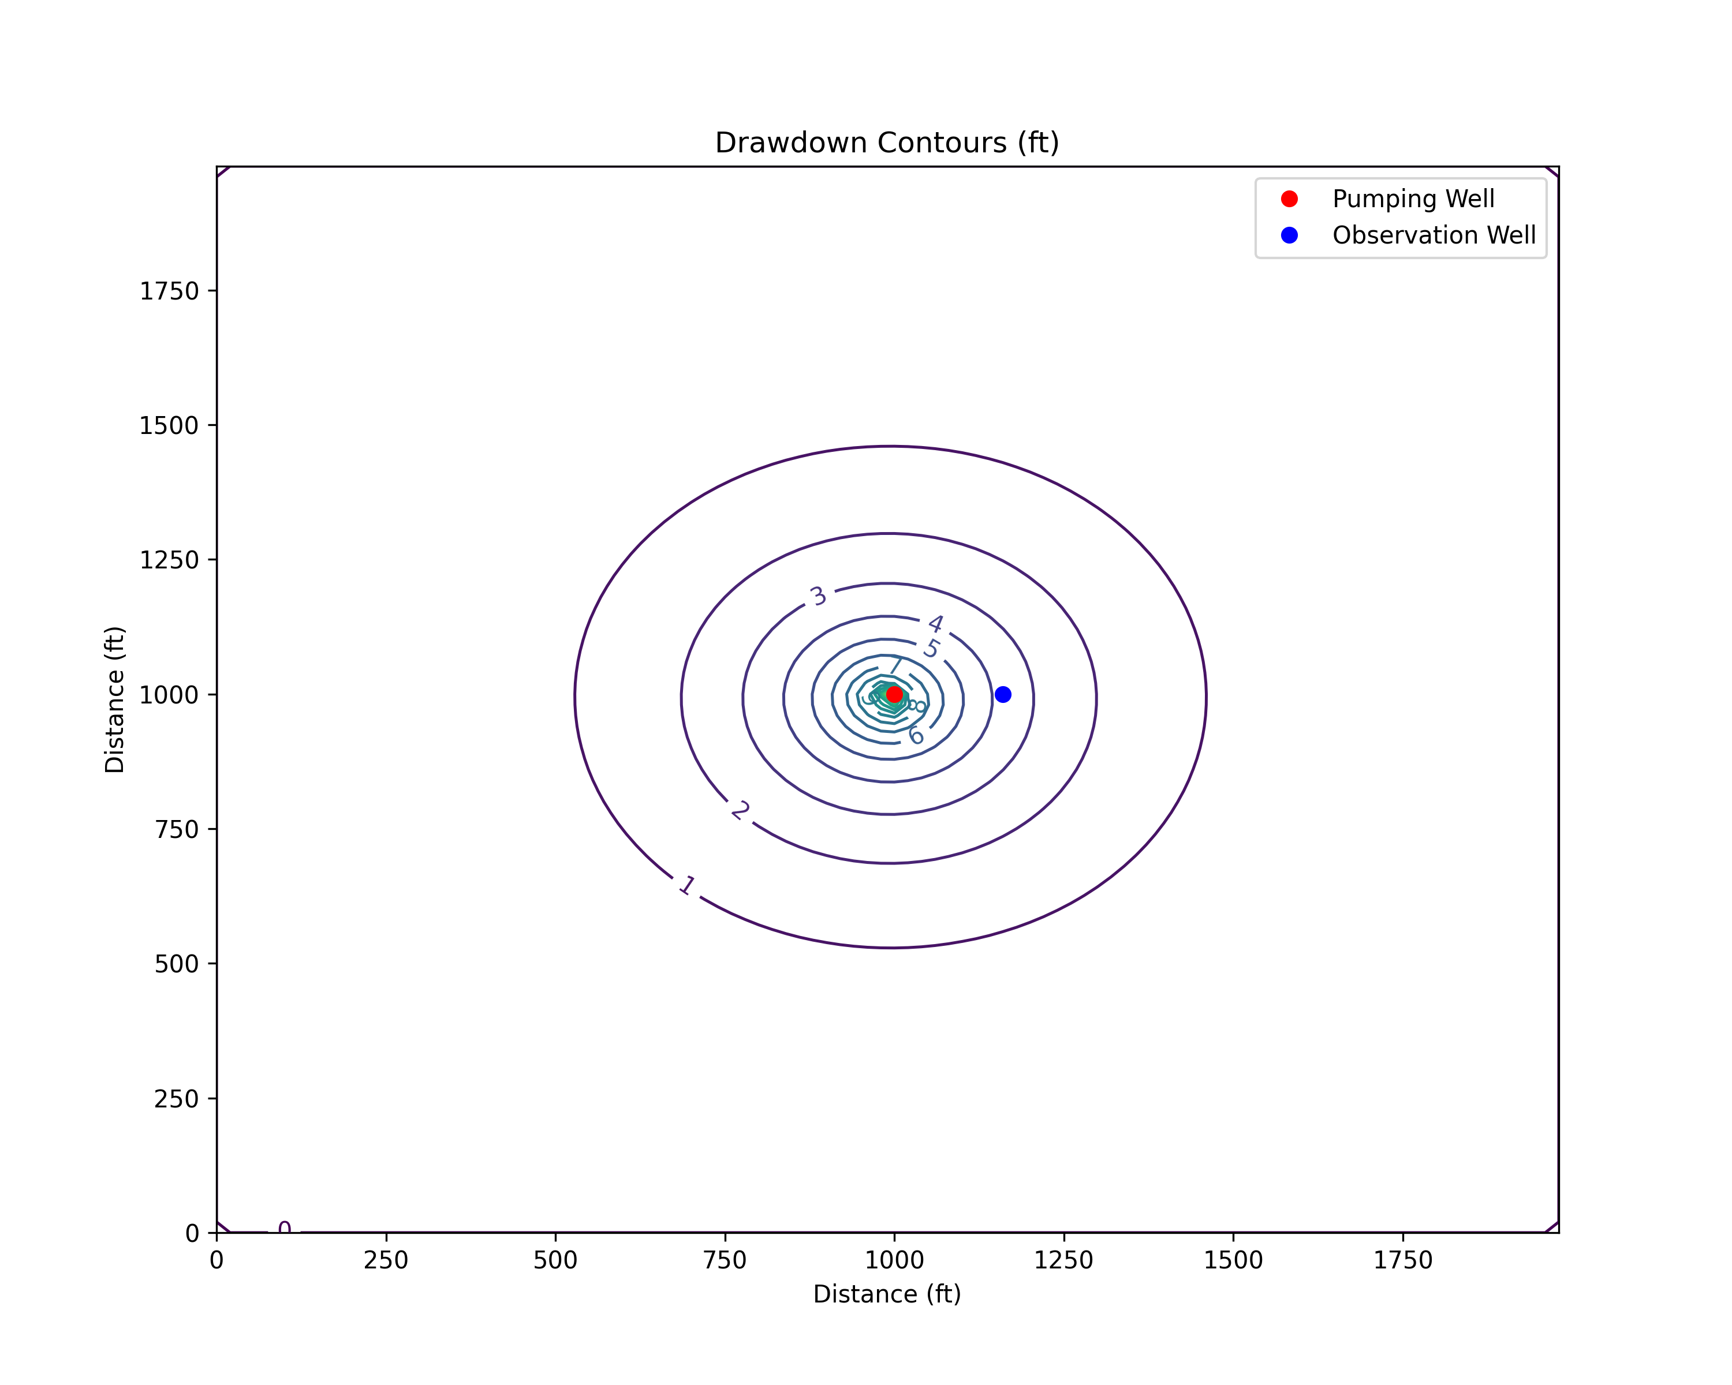

1.7 Calibration Fit
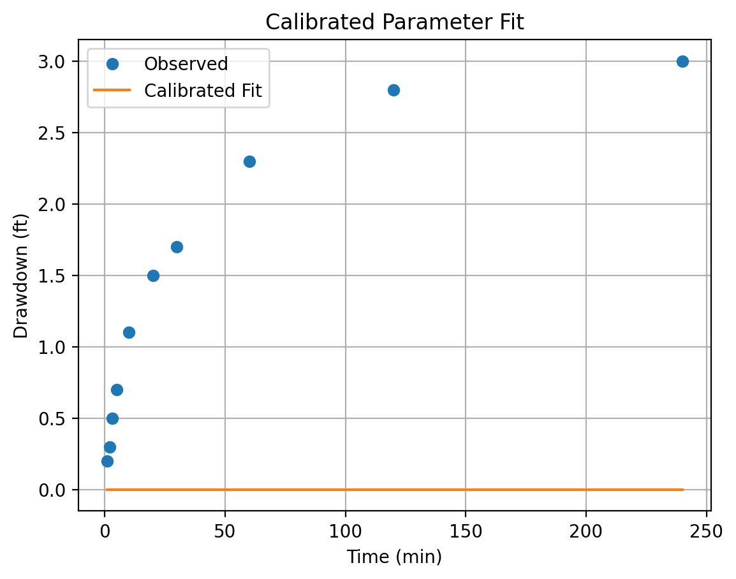

2. Diurnal Demand Curve and Pumping Schedule
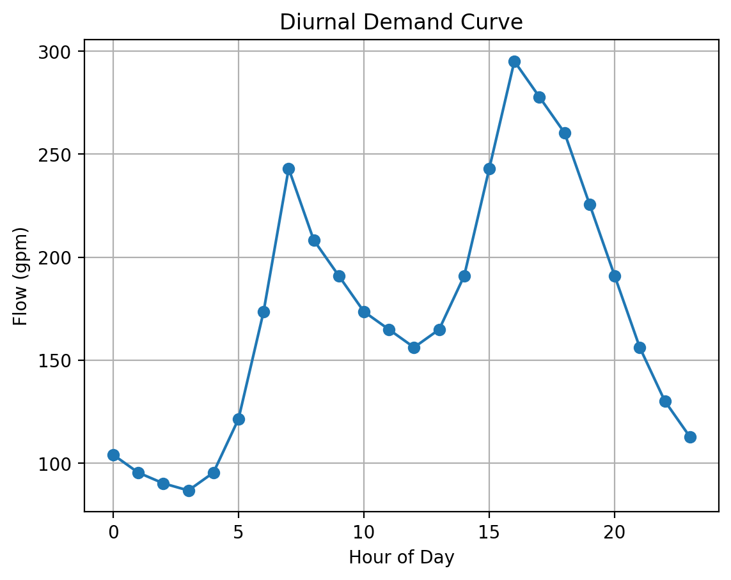
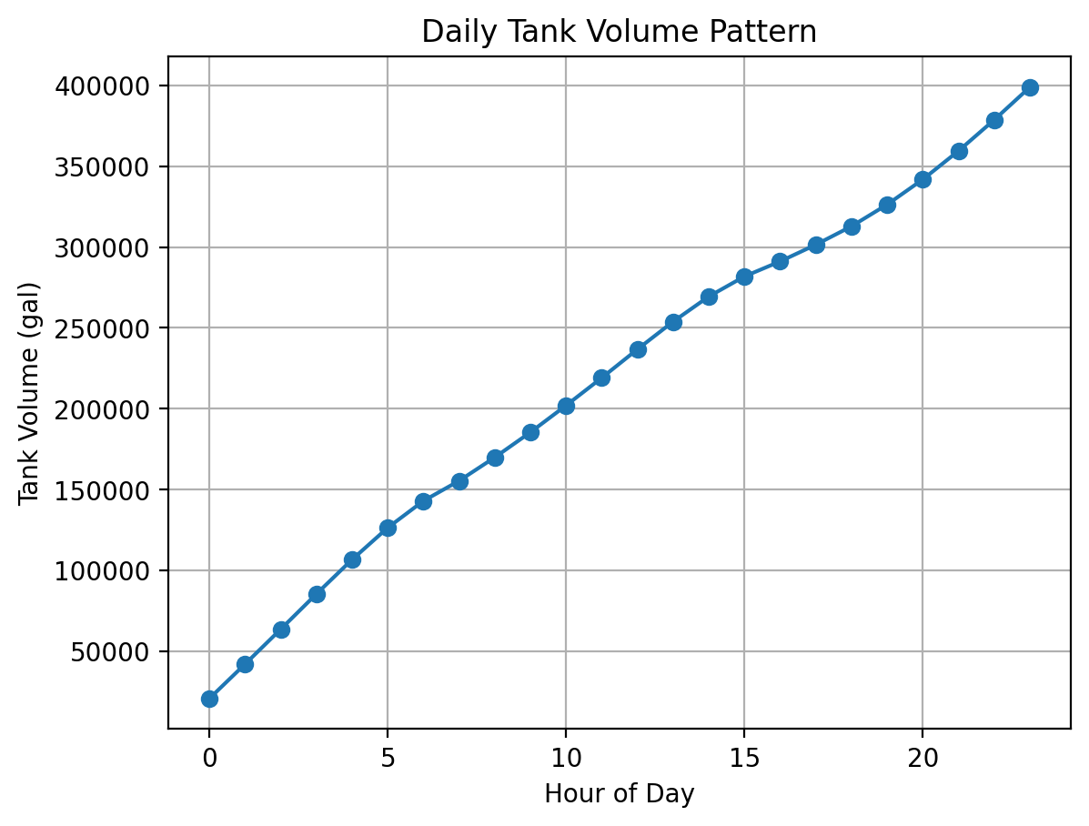
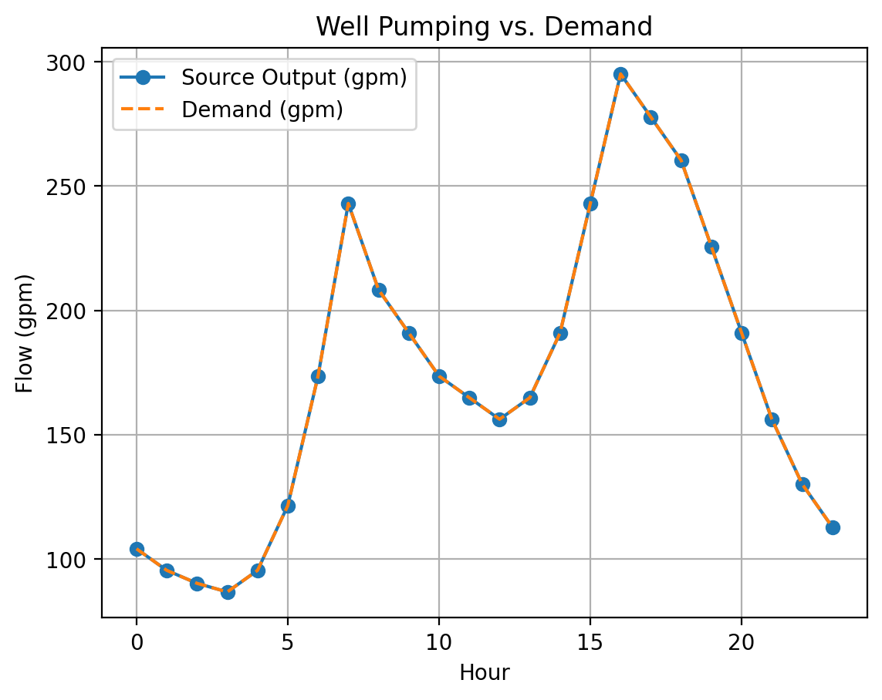

2.4 Pumping Schedule Summary
Hour 0: Well OFF or low-speed (demand 104.2 gpm)
Hour 1: Well OFF or low-speed (demand 95.5 gpm)
Hour 2: Well OFF or low-speed (demand 90.3 gpm)
Hour 3: Well OFF or low-speed (demand 86.8 gpm)
Hour 4: Well OFF or low-speed (demand 95.5 gpm)
Hour 5: Well OFF or low-speed (demand 121.5 gpm)
Hour 6: Well OFF or low-speed (demand 173.6 gpm)
Hour 7: Well OFF or low-speed (demand 243.1 gpm)
Hour 8: Well OFF or low-speed (demand 208.3 gpm)
Hour 9: Well OFF or low-speed (demand 191.0 gpm)
Hour 10: Well OFF or low-speed (demand 173.6 gpm)
Hour 11: Well OFF or low-speed (demand 164.9 gpm)
Hour 12: Well OFF or low-speed (demand 156.2 gpm)
Hour 13: Well OFF or low-speed (demand 164.9 gpm)
Hour 14: Well OFF or low-speed (demand 191.0 gpm)
Hour 15: Well OFF or low-speed (demand 243.1 gpm)
Hour 16: Well OFF or low-speed (demand 295.1 gpm)
Hour 17: Well OFF or low-speed (demand 277.8 gpm)
Hour 18: Well OFF or low-speed (demand 260.4 gpm)
Hour 19: Well OFF or low-speed (demand 225.7 gpm)
Hour 20: Well OFF or low-speed (demand 191.0 gpm)
Hour 21: Well OFF or low-speed (demand 156.2 gpm)
Hour 22: Well OFF or low-speed (demand 130.2 gpm)
Hour 23: Well OFF or low-speed (demand 112.8 gpm)

3. 72-Hour Sustained Pump Test
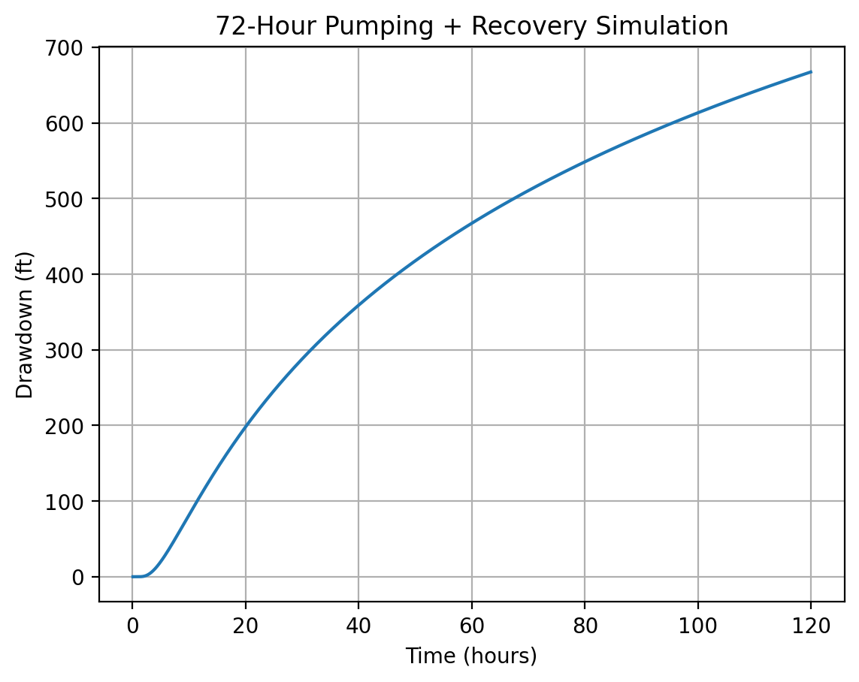
Simulated maximum drawdown: 667.42 ft; recovery rebound: 0.00 ft.

4. Multi-Well Interference Modeling
No multi-well interference dataset supplied.

5. Extended Engineering Narrative

5.1 Aquifer Classification & GWSI
Aquifer Type: Unconfined Aquifer
Specific yield Sy (0.100) falls within the unconfined range (0.05-0.35). Storativity S (1.45e-03) is also higher than values expected for confined systems.

5.2 Demand vs Supply
Population: 2,500 at 100 gpcd (+15% losses).
Average-day demand: 287,500 gpd (200 gpm).
Max-day demand (PF=1.50): 431,250 gpd.
Max-hour demand (PF=2.50): 29,948 gph.
Well capacity meets Ten States criteria.

5.3 Multi-Well Interference Summary
No interference dataset supplied.

5.4 72-Hour Stress Test Summary
Simulated maximum drawdown 0.05 ft; terminal recovery -0.05 ft.

5.5 Regulatory Summary
Analytical, numerical, and design evaluations collectively show compliance with Ten States Standards and KDOW hydrogeologic investigation requirements.

