|  |  |  |
| --- | --- | --- |
|  | **JSPM’s**  **RAJARSHI SHAHU COLLEGE OF ENGINEERING**  **TATHAWADE, PUNE-33**  **(An Autonomous Institute Affiliated to SavitribaiPhule Pune University,Pune)** |  |

A. **Statement of Clear Goal, Use of appropriate methods, Significance of results, Effective presentation**

**Name of the Course:** Software Engineering and Design

**Name of the Faculty:** Dr. [Nihar Ranjan](mailto:nihar.pune@gmail.com)

**Name of the Innovative Method used:**Blog

**Name of the topic:** Bridging the Gap Between Agile Development and Software Architecture: Balancing Flexibility with Structure

**Statement of Clear Goal**: To help students understand topics better by using Internet Blog in teaching, so they can learn anytime, review difficult concepts, and enjoy learning through visual content.

**Significance of result:** Students were able to understand the topic more clearly, remember key points better, and showed improved participation and performance in related activities or assessments.

**Effective Presentation (Screenshot):**

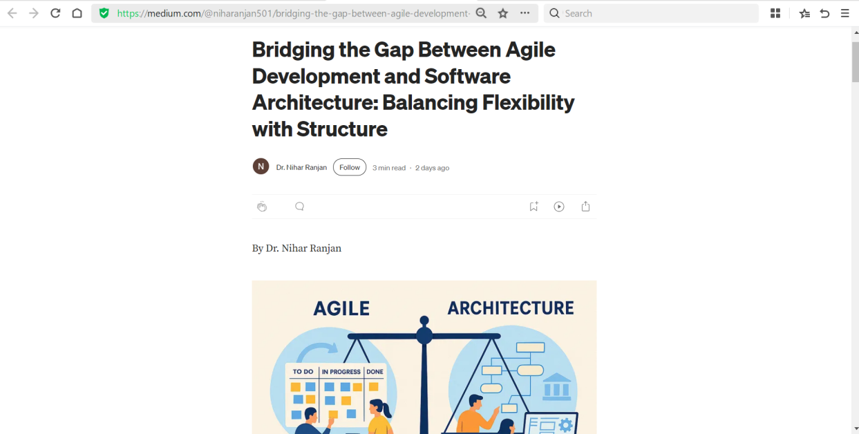

**Peer Review and Critique (Feedback):** Available on Github repository which is public

link:<https://www.youtube.com/watch?v=yMAwGbxDR7k&t=6s>

**B. Availability of work related to Innovation by Faculty in Teaching and Learning is on Institute website.**

**<https://www.jspmrscoe.edu.in/information-technology/innovation-practices>**

C. **Availability of work for peer review and critique.**

**<https://github.com/jspmIt/JDM>**

**D: Reproducibility and Reusability by other scholars for further development**

**· Views**, **likes**, **comments**, and **shares: P**eople are engaging with and potentially applying the content.

· Students are forwarding video to other for watching

· Students are giving Comments

· Viewers are thinking critically and considering extensions

|  |  |  |  |
| --- | --- | --- | --- |
| **Sr.No** | **Innovation Used by** | **Details of User** | **Purpose of**  **Reproducibility and Reusability** |
| 1. | Blog | Dr. N.M. Ranjan | To allow viewers to **repeat the process or concept** shown in the video and obtain the same results.  To. Encourage knowledge sharing and collaboration. |

**Course Co-ordinator Module Co-ordinator HOD**

Dr.Nihar M. Ranjan Dr. S.M. Chaware Dr. Nihar M. Ranjan