**JSPM’s**

**RAJARSHI SHAHU COLLEGE OF ENGINEERING**

**TATHAWADE, PUNE-33**

**(An Autonomous Institute Affiliated to Savitribai Phule Pune University, Pune)**

1. **Statement of Clear Goal, Use of appropriate methods, Significance of results, Effective presentation**

**Name of the Course:** Software Testing And Quality Assurance

**Name of the Faculty:** Rashmi M. Papalkar

**Name of the Innovative Method used:** Flipped Classroom **Name of the topic:** Testing Techniques and Levels of Testing

**Class**:- BTech B Div

**Statement of Clear Goal**:

The goal of the Flipped Classroom is to empower students to take ownership of their learning by accessing instructional content at their own pace, which create understanding of topics and promote active engagement.

The Flipped Classroom aims to cultivate lifelong learning skills by encouraging students to develop self-discipline, time management, and self-directed study habits through pre-class preparation, while fostering critical thinking and communication skills during interactive in- class activities.

**Significance of result:**

**Improved Student Engagement:** Students actively participate during class time, leading to higher motivation and interest.

**Personalized Learning:** Teachers can provide targeted support and differentiate instruction based on individual student needs.

**Development of Self-Regulation:** Students build skills in time management, responsibility, and independent learning.

**Integration of Technology Skills:** Students become more proficient in using digital tools and online resources essential for modern learning.

**Effective Presentation (Screenshot):**

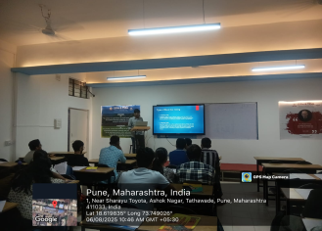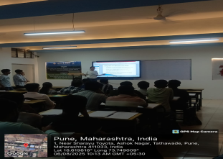

**Peer Review and Critique (Feedback):**

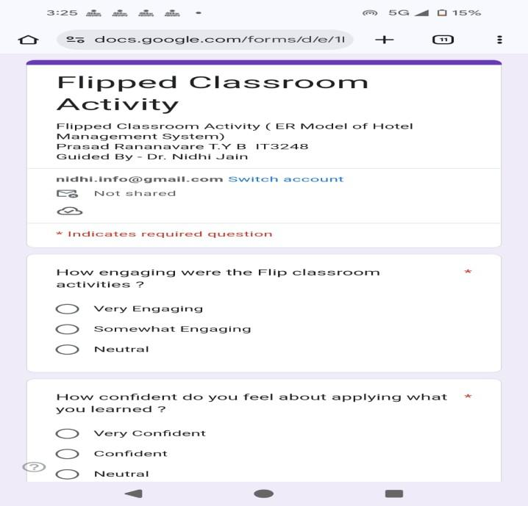

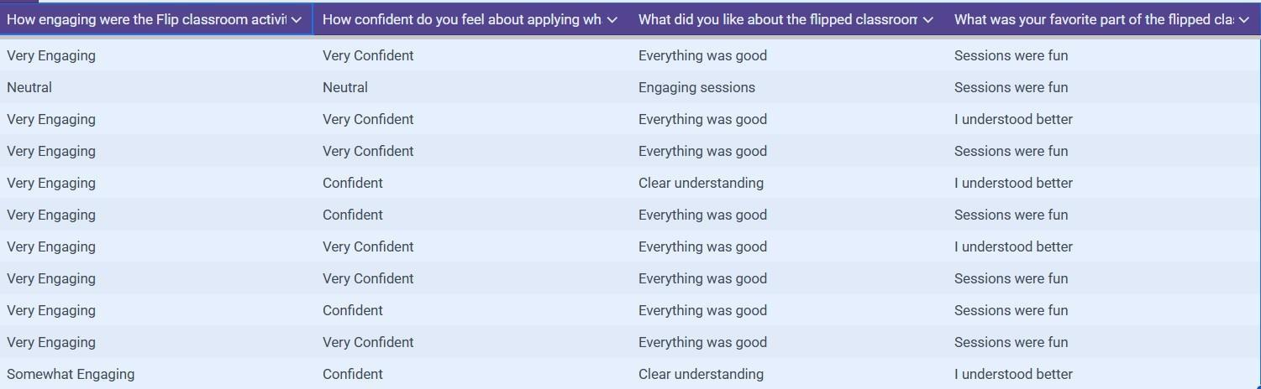

**B.Availability of work related to Innovation by Faculty in Teaching and Learning**

**is on Institute website.**

[**https://www.jspmrscoe.edu.in/information-technology/innovation-practices**](https://www.jspmrscoe.edu.in/information-technology/innovation-practices)

**C. Availability of work for peer review and critique.**

[**https://github.com/jspmIt/RMP**](https://github.com/jspmIt/RMP)