Introduction to Data Visualization with R

Scott McCain

Today we will go into some basic introductions to R, but mostly to a data visualization package ggplot2. This is also a first-run at the R notebook, the format that you see here. It allows a mix of plots, code, and text. This is in constrast with an R script by itself, which is just code (hopefully also with comments!)

Data visualization in R can be done in two main avenues: ggplot2, and "base" R graphics. I will demonstrate the use of ggplot2, but base R graphics can be very useful as well. I would argue that ggplot2 is significantly better at exploratory plots, and base R graphics are slightly better for publication level plots (but this is just my humble opinion!). Base R gives you ultimate control over every aspect of your plots.

We will use a dataset that is automatically uploaded to R known as iris. So let's take a look at this dataset!

#First we need to upload all the necessary packages into the working space.  
#You'll notice that these need to be downloaded first, eg:  
#install.packages("ggplot2")  
library(ggplot2)

## Warning: package 'ggplot2' was built under R version 3.3.2

library(magrittr)

These are some useful functions for when you've got your data uploaded into R. Uploading data into R can be a challenge by itself. I tend to use mostly ".csv" files, and the read.csv() function. We can cover that on another time!

#What does top of the dataset look like?  
head(iris)#Check out the function tail() also!

## Sepal.Length Sepal.Width Petal.Length Petal.Width Species  
## 1 5.1 3.5 1.4 0.2 setosa  
## 2 4.9 3.0 1.4 0.2 setosa  
## 3 4.7 3.2 1.3 0.2 setosa  
## 4 4.6 3.1 1.5 0.2 setosa  
## 5 5.0 3.6 1.4 0.2 setosa  
## 6 5.4 3.9 1.7 0.4 setosa

#What is the structure? (str function)  
str(iris)

## 'data.frame': 150 obs. of 5 variables:  
## $ Sepal.Length: num 5.1 4.9 4.7 4.6 5 5.4 4.6 5 4.4 4.9 ...  
## $ Sepal.Width : num 3.5 3 3.2 3.1 3.6 3.9 3.4 3.4 2.9 3.1 ...  
## $ Petal.Length: num 1.4 1.4 1.3 1.5 1.4 1.7 1.4 1.5 1.4 1.5 ...  
## $ Petal.Width : num 0.2 0.2 0.2 0.2 0.2 0.4 0.3 0.2 0.2 0.1 ...  
## $ Species : Factor w/ 3 levels "setosa","versicolor",..: 1 1 1 1 1 1 1 1 1 1 ...

#What are the dimensions?  
dim(iris)

## [1] 150 5

I don't like writing capital letters, so lets change these names...

names(iris) <- tolower(names(iris))

There are many ways to do the same thing in R. Do you find the above code statement hard to read? I do! That's because we sort of have to read it inside out - that can get very confusing when you have a lot of functions in one line! Here is a neater alternative:

names(iris) <- iris %>% names() %>% tolower()

We are using the pipe command, %>%. You can read this as "then". So we take the dataframe "iris" *then* get the names, *then* converting to lower case.

### "Plot the data, plot the data, plot the data" - R.A. Myers

What does it **look** like!

Start off with the base function ggplot(). What are the key arguments? You tell me! (?ggplot)

names(iris)

## [1] "sepal.length" "sepal.width" "petal.length" "petal.width"   
## [5] "species"

ggplot(data = iris, aes(x = sepal.length, y = sepal.width)) +   
 geom_point()

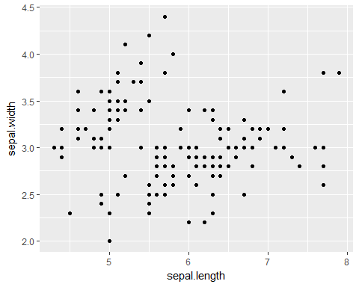

This is a pretty great plot already! But I want to colour code by species.

ggplot(data = iris, aes(x = sepal.width, y = sepal.length)) +   
 geom_point(aes(colour = species))

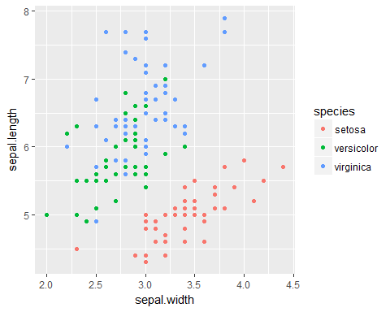 Great! But I don't want to rewrite that code chunk every time. Let's assign this plot to an object:

plot_1 <- ggplot(data = iris, aes(x = sepal.width, y = sepal.length)) +   
 geom_point(aes(colour = species))  
print(plot_1)



plot_1 + geom_point(aes(colour = species), size = 3)

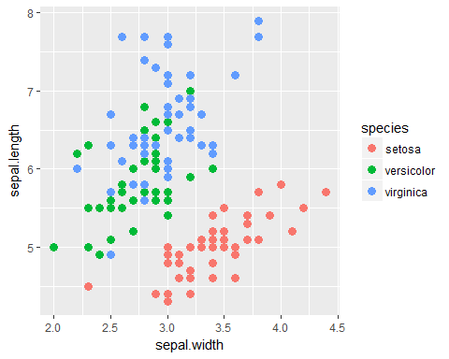

Note what happens when I put the size argument outside of aes(). It applies to all of the observations, it's not mapped to a variable.

What if we want to look at the distribution of these by species?

plot_2 <- ggplot(iris, aes(species, sepal.width)) + geom_boxplot()   
print(plot_2)

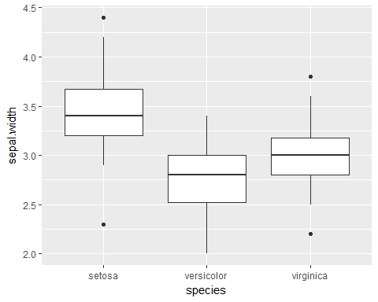

plot_2 + theme_bw() + geom_jitter()

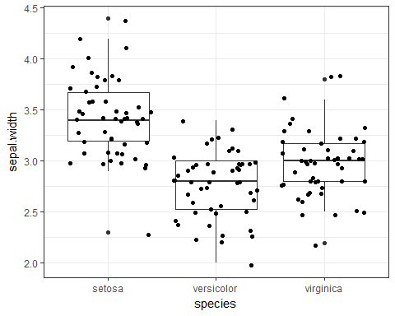

ggplot(iris, aes(species, sepal.width)) + geom_violin()

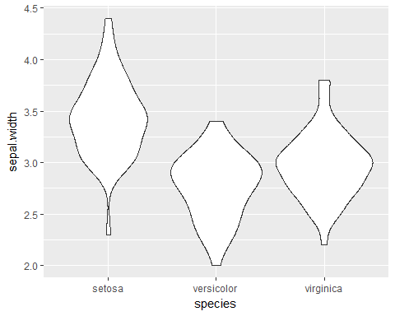

What if we want to look at the relationship between two variables, but separate it by each species?

ggplot(data = iris, mapping = aes(sepal.width, sepal.length)) +   
 geom_point() +   
 facet_grid(~species)

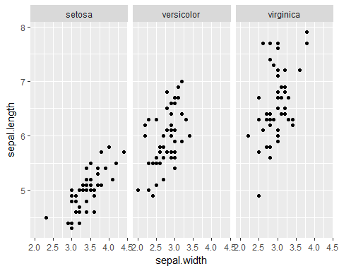

This is just scraping the surface of ggplot2, you go from idea to visualization with just a few lines of code. It's extremely effective for exploratory data visualization. To get to a publication level plot, it's debatable which is better: ggplot2 or base graphics.

There many options for visualizing your data with ggplot2. [This](http://docs.ggplot2.org/current/) website is amazing for exploring the different types!