**Exercise on SQLite and Firebase**

**SQLite**

We consider a table *student* with 2 attributes *id* and *name.* **We consider the *query* and *insert* methods of the class *SQLiteDatabase*** (<https://developer.android.com/reference/android/database/sqlite/SQLiteDatabase.html>).

Rename this file into LastNameFirstNameAndroidSQLiteExercise.docx and push it (with the answers) at the root of your GitHub repository for the course.

*IN THE QUESTIONS BELOW, DO NOT USE SQL BUT USE THE PARSE METHOD THAT IS PROVIDED IN JAVA.*

1. How do you write select * from student using the provided *query* method?

StudentDatabaseHelper dbHelper = new StudentDatabaseHelper(this.getActivity());

SQLiteDatabase db = dbHelper.getWritableDatabase();

**db.query(“student”,null,null,null,null,null,null,null);**

1. How do you write select name from student using the provided *query* method?

StudentDatabaseHelper dbHelper = new StudentDatabaseHelper(this.getActivity());

SQLiteDatabase db = dbHelper.getWritableDatabase();

**db.query(“student”,name,null,null,null,null,null,null);**

1. How do you write select * from student where name = ‘Smith’ using the provided *query* method?

StudentDatabaseHelper dbHelper = new StudentDatabaseHelper(this.getActivity());

SQLiteDatabase db = dbHelper.getWritableDatabase();

**db.query(“student”,null,”name=’Smith’”,null,null,null,nullc);**

1. How do you write insert into student(id,name) values (10,’John’)?

StudentDatabaseHelper dbHelper = new StudentDatabaseHelper(this.getActivity());

SQLiteDatabase db = dbHelper.getWritableDatabase();

**db.insert(“student”,null,insertValues);**

**Firebase**

Create an application called *FirebaseStudent* that will save the id and first name of a person in a Firebase database when we press *Submit.*

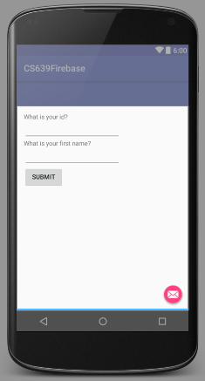

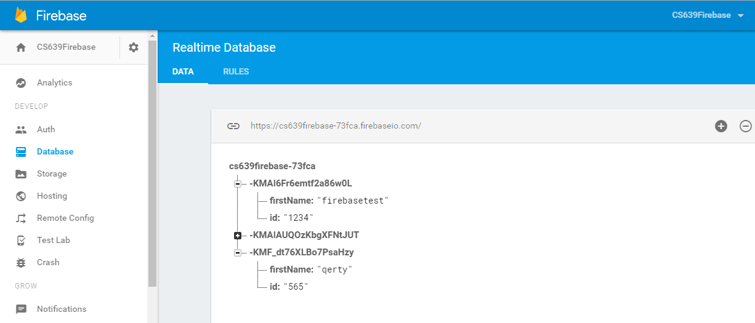

In addition to the project to be pushed in GitHub, push a screenshot of the real time database with data related to your name (see above). We want to be able to see the name of the database and the data.