Standard Operating Procedure

Recital and Form Automation Tool (RFAT)

# Purpose:

To reduce recital scheduling times by >75% and increase consistency in event programming.

# Requirements From You:

You are required to follow this Standard Operating Procedure (SOP) to ensure the designed tools function effectively. This includes mandatory instructions (tasks you are required to do) and prohibitive instructions (actions which can disrupt the process).

**Below are key does and don’t to make the tools work as designed:**

**NEVER** rename form fields, without contacting Justin Powley.

**NEVER** rename the top row on excel files, without contacting Justin. These unique identifiers allow the computer to recognize which columns are which when they are loaded into the next stage of the process.

**NEVER make changes within spreadsheets, unless in an area that is specifically marked for changes in this SOP**

**Contact Justin** if you intend to make changes to the form’s fields. Reconfiguration will likely be required.

**When making changes to data**, make the changes on the Master_Input sheet of the scheduling template. This allows any updates to by pushed through to downstream stages of the process.

**Contact Justin:**

587-590-4107

powleyjustin@gmail.com

# Overview:

Data for recital scheduling is currently collected through multiline forms on Activity Messenger (AM). Multiline tables provide the flexibility for teachers to add any number of performers to the list of students attending recital. See below:

Multi-line forms are not without their limitations, however. An entry from a single teacher for this table initially looks like this:

|  |
| --- |
| 1: First Name: Joseph, Last Name: Ward, Song1 Title: Man In The Mirror, Song1 Length (minutes): 2, Song1 Composer/Arr.: Michael Jackson, Song2 Title: Water Lilies, Song2 Length (minutes): 3, Song2 Composer/Arr.: Debussy, Song3 Title: Blips and Bloops, Song3 Length (minutes): 1:30, Song3 Composer/Arr.: Faber, 2: First Name: Eric, Last Name: Butch, Song1 Title: Never Gonna Be Alone, Song1 Length (minutes): 3, Song1 Composer/Arr.: Jacob Collier |

Note that this is for 2 students only! Imaging 20 students for 1 teacher, how long it would take to get all information out correctly. Fortunately, there are tools in place that can automatically pull this information into a scheduling template, and then once scheduled break it apart into recital programs, stage tech sheets, and award information sheets.

**Here’s the bigger picture of steps required:**

-Getting the data from Activity Messenger (AM).

-Converting the form data into a scheduling sheet.

-Scheduling the recital.

-Converting the schedule into recital program sheets, tech sheets, and award sheets.

-Using the final output to prepare recital materials, and updating and reconciling the final output with program materials as required.

## Step 1. Activity Messenger:

Make a copy of the “Recital Registration for Teachers” form. You can do this under the “manage forms” section on AM, searching for “Recital Registration for Teachers”. Click the 3 dots icon and select duplicate. You can now select the name for this years recital registration for teachers.

Then, prepare a sequence of messages for teachers on AM, which sends them the form.

When the form is filled by all teachers, return to the form, by going to “manage forms” and searching for the name you created. Then, click to access the form details.

Select the respondents tab and click the Excel icon in green (bottom right):

Then, ensure all fields are checked before exporting:

You should now have the form data in your downloads folder! You’re ready for step 2.

## Step 2. Converting to Scheduling Template:

Open the folder where the recital automation tool is stored. Alternatively, download the download repository of the tool can be found here: <https://github.com/jspowley/Recital-Automation>.

Copy and paste the AM excel file into the folder. Rename it “Input”. If an Input file is present from previous years, replace the file by deleting, moving or renaming the old one:

If a “Scheduling_Sheet” file is currently in the folder, delete or move it elsewhere for the studios records. The program currently can’t overwrite “Scheduling_Sheet” to prevent accidental data loss:

Double click “Form Conversion” to run the form conversion. A black box should pop up briefly, and then disappear. A “Scheduling_Sheet” excel file should have been created, containing 4 sheets when opened. Open Scheduling sheet to see your converted and clean data!

## Step 3. Scheduling:

#### Part 1: Information Changes:

The scheduling template is where all major program changes occur. It is the one designated area for making ordinary adjustments to the program schedule and performance entries. Changes to program entries occur on the *“Master_Input”* Sheet, show below:



Changes can be made to all information contained in the table. 2 rules need to be followed when doing so:

1. **When adding a new entry, always add a unique primary key in the PK column** (first column on the left. When adding a row, this is usually the next consecutive number.
2. **Never make changes to the title of columns, in the top row.** These are unique identifiers used to convert data later.

#### Part 2: Scheduling:

To schedule the program, first enter the time slots available in the *“Time Slots”* sheet. Enter them in the box, and ensure each entry is unique:

Then, go to the *“Scheduling”* sheet. Here you can select each student’s time slot from the drop-down menus:

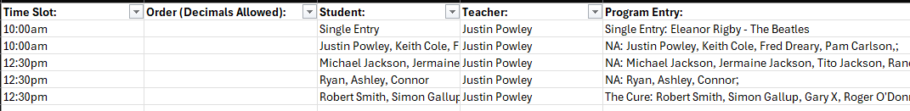

Then, determine the program order by adding numbers to the order column. Lower numbers go first and higher numbers go last:

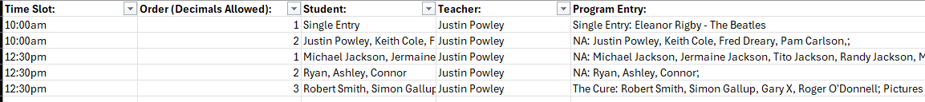

**Quick Tip to Save 30+ minutes of time:**

This page is already set up to use filters. You can access a filter by clicking on the downward arrow box to at the top right of the column you want to filter:

This makes scheduling time slots by teacher much easier. Make sure the teacher you want to filter for is the only one selected, and click Ok. Just make sure you unfilter later by clicking the filter icon on the column, and clicking “select all”:

Filters are also useful for choosing the program order. Once time slots are selected, filter for an individual timeslot, for example 10:00am:



Then, select the filter for “Order”, and click “Sort Smallest to Largest”. This will show you the current program order, allowing changes to be made easier.

Finally, you can use decimals in the “Order” column to insert a performance between two existing entries. This brings a greater level of ease to last minute changes:



You’re now ready to pull all 3 related sheets from the schedule.

## Step 4: Pulling Program Sheets:

1. Go to the recital automation tool folder.
2. Click “Pull Lists”

A black box should appear, and shortly after the files “tech_sheet”, “award_list”, and “program_list”, will either appear, or be overwritten with new data. These are ready to be formatted into a printable document for stage techs, the master of ceremony for giving awards, and to be moved into the recital programs printed for guests.

## Step 5: Pulling Program Sheets:

*Note, you can delay preparing the “tech_sheet” and “award_list” data into a printable document, until all relevant changes are made. This is because although the recital program needs to be prepared for one final round of confirmation, the tech sheets and award lists can be prepared after the review is complete.*

Once you have used any or all of the 3 files to make the initial recital documents, the procedure to make changes as updates arise is quite important. We recommend you update the final documents **Once Only** in the following fashion:

1. First, make all changes as they arise on the *“Master_Input”* sheet on the *“Scheduling”* workbook.
2. Update the program_entry column in the workbook accordingly. This is slightly tricky due to when the recital program entry is automatically formatted, so take care to format it carefully with slashes, colons and dashes.
3. Rerun the “Pull Lists” as in Step 4.
4. Compare and replace the information in all 3 output files with the program materials they are related to.

Once these documents are finalized with final round revisions, you’re ready to go!