
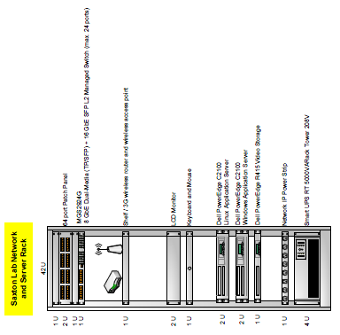
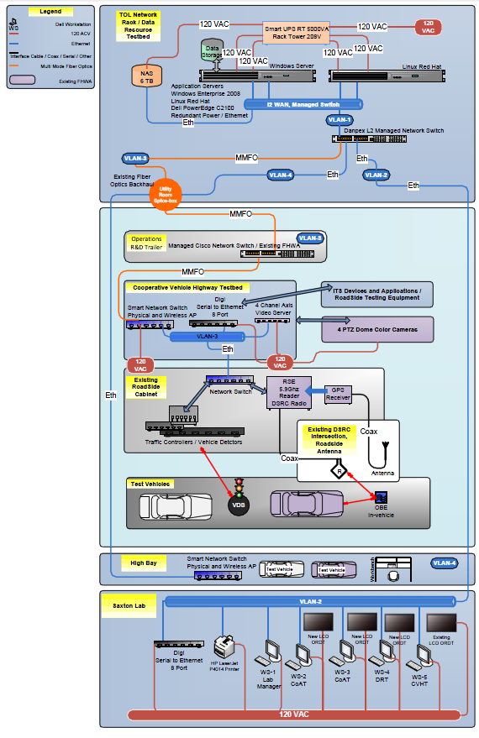
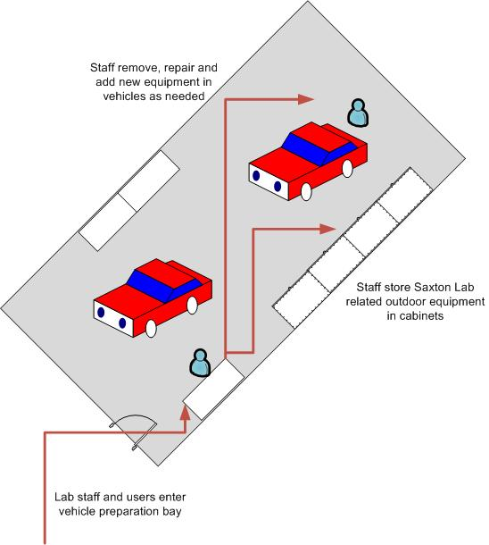
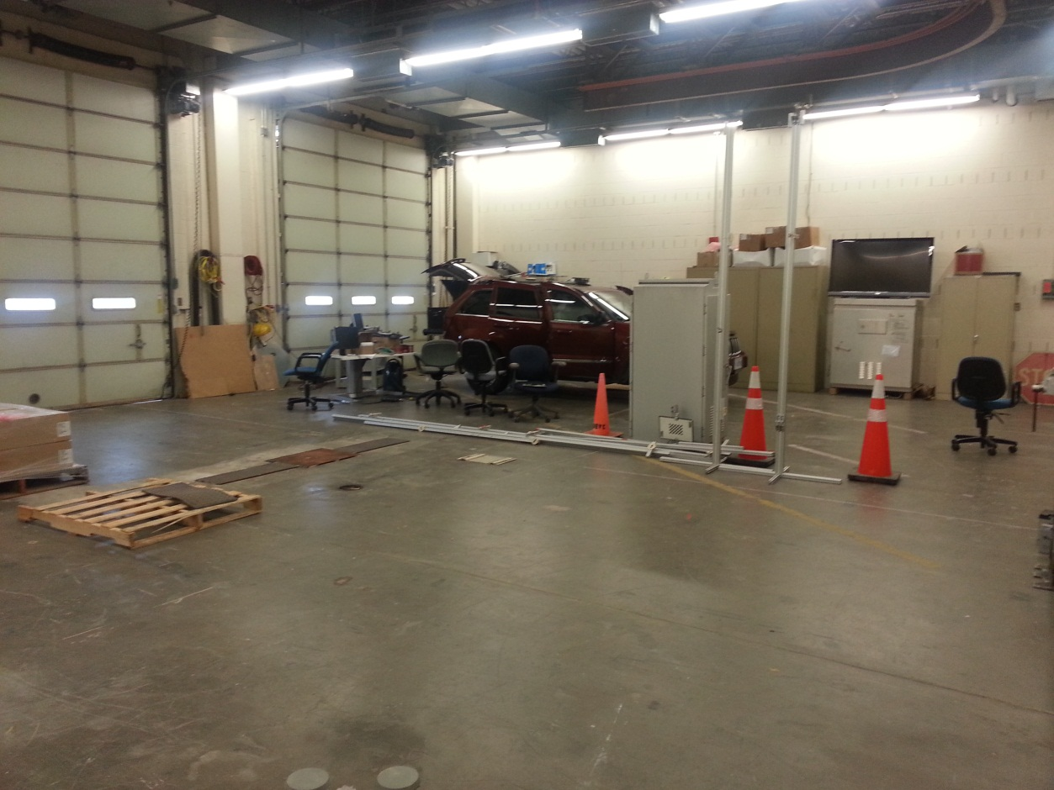
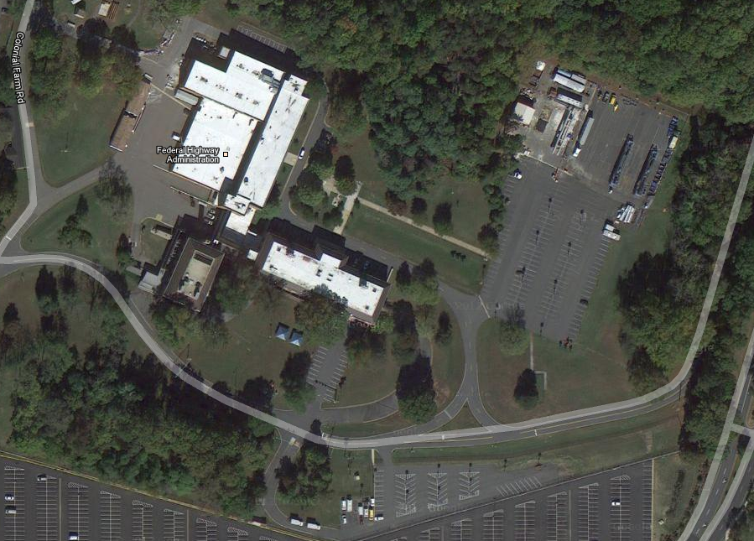
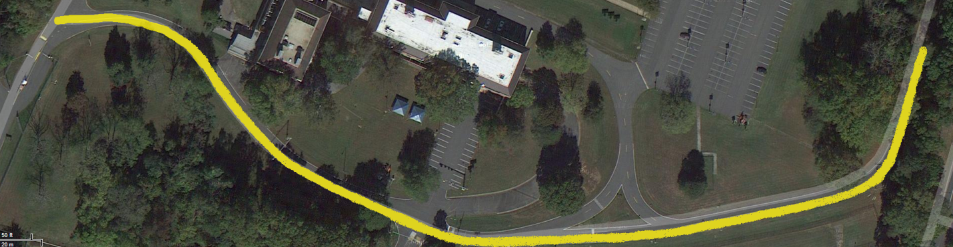
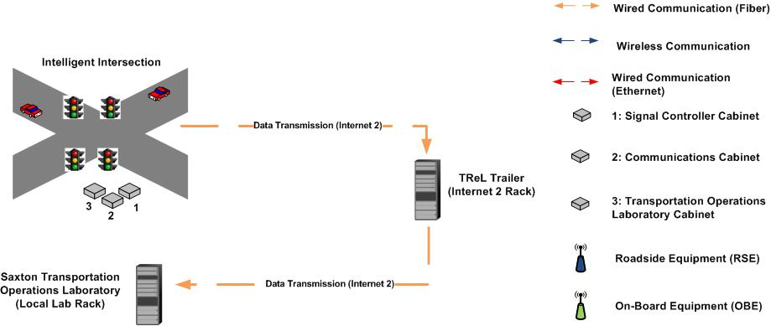

Task 2.4A Report – Test Plan for Low-Speed Vehicle Platooning at TFHRC

Authors: Tony Ahmad and Julie Evans
Project Number: DTFH61-12-D-00020
Submitted: February 13, 2013
Version: 1

Table of Contents
Introduction 3
Test Site Description 3
Physical Infrastructure 3
Phase One – Remotely Controlled DMS and DSRC Messaging 4
Test Plan 4
Equipment Requirements 4
Phase Two – Vehicle Platooning Capability 5
Phase Three – DSRC Initiated Speed Change for Vehicle Platoon 5
List of Figures

List of Tables

Introduction
This document defines the requirements for low-speed vehicle platooning tests to be conducted at the Turner Fairbank Highway Research Center (TFHRC) to analyze Multi-Vehicle Cooperative Adaptive Cruise Control (CACC) and Infrastructure System Operations as a prototype for later deployment along the selected living laboratory corridor. The purpose of these tests is to thoroughly evaluate the cooperative vehicle-infrastructure applications in a protected environment before they are deployed on public roadways.
These tests will enable local support staff to troubleshoot and debug any malfunctions without risking interference with live traffic or requiring travel to and from remote sites. The Saxton Lab’s Intelligent Intersection will be equipped with a 5.9 GHz Dedicated Short-Range Communication (DSRC) Roadside Equipment device (RSE) to support Infrastructure-to-Vehicle (I2V) communication. Additionally, a Dynamic Message Sign (DMS) will be deployed to validate its response to remotely communicated speed limit changes.
Due to the short approach distances and significant road curvature and grade changes, testing at TFHRC is limited to low-speed operations. To accommodate this constraint, the vehicles will have to be equipped with Full Speed Range Adaptive Cruise Control (FSRA) systems which are capable of operating at speeds below 25mph.
Testing will be conducted in three phases to ensure each component of the Variable Speed Limit (VSL) Application functions properly. The first phase of testing will be to validate that the DMS and DSRC after-market safety device (ASD) can respond to remotely transmitted messages to advise a new recommended speed. The second phase of testing will validate that the vehicles equipped with automated brake and throttle capability can operate in a platoon based on vehicle-to-vehicle (V2V) communication broadcast over DSRC or a cellular network. The third and final phase will evaluate whether the VSL Application can be implemented by the vehicle platoon over DSRC or a cellular network in place of a DMS installation.
The first version of this document defines the requirements for phase one of testing and will be subsequently updated to include requirements for phases two and three upon completion of the vehicle design and infrastructure instrumentation report (Task 2.4B).

Test Site Description
The following section describes the equipment configuration for the indoor and outdoor facilities at TFHRC that are dedicated for operations research.

Physical Infrastructure
The Saxton Laboratory consists of two indoor spaces, a laboratory and vehicle preparation area, as well as an intelligent intersection on the TFHRC campus. The following sections depict the network setup of the research lab, highbay and intelligent intersection.

Indoor Lab
The indoor research lab is centered around a conference table and test bench and is equipped with a number of desktops for staff and visitors to connect to several different networks; the U.S. Department of Transportation Common Operating Environment (COE) network, the Internet-2 research network, the public domain network (Internet), and the local area network (LAN) with connectivity to lab equipment. The desktops stationed around the lab are configured to support five independent workstations and the conference table is wired to support additional workstations for visitors. The configuration of server equipment contained in the lab is depicted in Figure 1, which provides access management capabilities, as well as connectivity to the Vehicle Preparation Area and Intelligent Intersection.
Figure . Configuration of Equipment in Saxton Lab Server Rack.

Figure 2, below, illustrates the overall network architecture and additional documentation is available in the Saxton Laboratory Operation and Maintenance Manual.
Figure . Saxton Laboratory Network Architecture Diagram.
The lab also houses a variety of DSRC equipment that has been configured for use in different settings, including outdoor deployment for application testing. The equipment includes both vehicle-based and roadside radio equipment, in addition to the necessary cables for power and back-end connectivity.

Vehicle Preparation Area
The vehicle preparation area (“highbay”) is used to store vehicles during equipment installation and maintenance, and for longer term storage between research activities. Two bays are available for use during these testing activities and can fit two vehicles per bay, such that as many as four vehicles can be parked for maintenance access at once. The highbay is connected to the lab’s local network and houses much of the standard equipment necessary to maintain vehicles. Below, Figure 3 depicts a schematic diagram of one bay and Figure 4 is a photograph of the available spaces.
Figure . Schematic Diagram of Vehicle Preparation Area

Figure . Photograph of Available Space for Vehicle Storage and Maintenance.
Figure . Aerial Photograph of TFHRC Grounds.

Testing Roadway and Intelligent Intersection
The grounds of TFHRC are depicted in Figure 5, and the roadway available for testing is highlighted below in Figure 6. As is evident in the photographs, TFHRC is a small site and the curvature of the roadway is not suitable for high speed testing. In Figure 6, the location of the Intelligent Intersection that will be used for the first phase of testing is depicted by a circled red “X” and the section of the roadway that will be used in the second and third phases of testing is highlighted in yellow. The test segment of the roadway measures approximately 1500 feet (~450m) in length and will be suitable for low-speed testing of the functionality of automated vehicle platoons.
Along the mid-section of the roadway, safe speeds up to 35mph are possible, but around the curved sections at each end, which are also characterized by slight grade changes, vehicles must slow down to about 20mph to safely navigate the roadway.
Determination of equipment positioning for all phases of testing will be based upon the availability of sufficient line-of-sight along the roadway, which will be an important component of testing with both the DMS and the DSRC radio equipment. Additionally, availability of mounting infrastructure along the roadway may affect the location of various equipment; however, temporary mounting equipment can be installed in the case that no available infrastructure will be conducive to establishing sufficient line-of-sight.

Figure . Intelligent Intersection and Available Test Roadway at TFHRC.
Figure 7 presents a functional diagram that depicts the data collection process at the Intelligent Intersection for transmission to the Indoor Laboratory. Data collected using devices at the intersection are then transmitted via a fiber-link connection to the lab via an intermediary rack in the Transportation Research Laboratory (TReL).
Figure . Functional Diagram of Data Collection Process at Intelligent Intersection.

Phase One – Remotely Controlled DMS and DSRC Messaging
The purpose of phase one of testing is to validate that the DMS and DSRC after-market safety device (ASD) can respond to remotely transmitted messages to provide a speed advisory. The following section outlines the test plan, procedures and equipment requirements for this sub-task.

Test Plan
Phase One of testing will begin on the Indoor Laboratory Test Bench, where a system prototype will be developed to verify basic functionality of the DMS and DSRC equipment, as well as to establish connectivity to the backend server before deployment at the Intelligent Intersection. Lab staff will use the Windows and Linux based high performance servers in the lab to run the VSL application during its development phase, and assist developers with the application interface handler to the speed advisory devices. The equipment will be configured within the architecture depicted in Figure 2, which will provide the capability to test the application between multiple interfaces required to verify overall functionality of the application and to identify any technical constraints.
Once the functionality of the equipment and application have been confirmed, the prototype will be deployed at the Intelligent Intersection, maintaining connectivity to the backend server in the lab via an existing fiber link between the lab and the intersection.
Throughout testing, the team will maintain a configuration management matrix to help the development team with version control and regression testing.

Equipment Requirements

Vehicle Requirements
To support Phase One of testing, lab staff will use the test vehicles, equipped with a DSRC After-Market Safety Device (ASD) that is capable of broadcasting a Basic Safety Message (BSM) and receiving and displaying messages from the roadside on a display that will be installed on the front console of the vehicle. A magnetically mounted GPS antenna will be affixed to the roof of the vehicle and connected to the ASD, which will be operated from a dual-boot Windows/Linux based laptop.

Infrastructure Requirements
Access to a power source and network switch will be the main components of the infrastructure configuration, which will be used to operate both the Dynamic Message Sign (DMS) and DSRC Roadside Equipment device (RSE).
DSRC Roadside Equipment Device

Application Requirements
These requirements will be provided by the application developers.

Phase Two – Vehicle Platooning Capability
The second phase of testing aims to validate that platooning, based on vehicle-to-vehicle (V2V) communication broadcast over the DSRC or a cellular network, is possible using vehicles equipped with automated brake and throttle capability. The specifications for Phase Two will be developed in a later version of this document upon completion of the Report for Task 2.4B.

Phase Three – DSRC Initiated Speed Change for Vehicle Platoon
The final phase of testing is dependent upon the success of Phases One and Two, and combines the outcomes to evaluate whether the VSL application can be implemented by the vehicle platoon over DSRC or a cellular network in place of a DMS installation. The specifications for Phase Three will be developed in a later version of this document upon completion of the Report for Task 2.4B.

