**TSCP Quick Installation Guide**

To install the TSCP program to the 2070 controller:

1. transfer the "tscp220b107.tar" file and "restore_tscp220b107.ba_" file to the 2070 controller's /r2 directory
2. run the installation “restore_tscp220b105.ba_” script file from the OS-9 shell command prompt with the command: $/r2/restore_tscp220b107.ba_
3. Once the installation is completed, the screen with HyperTerminal should look similar to the screen shown below:

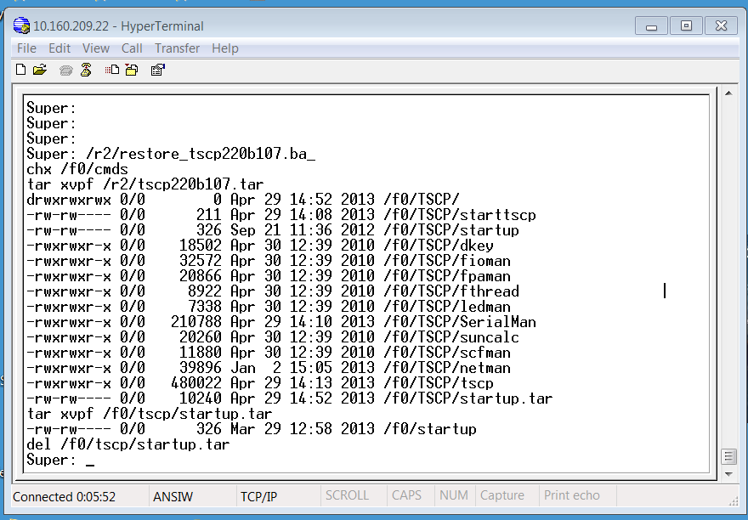

1. After the installation is completed, reboot the 2070 controller
2. After the TSCP v2.20 has been loaded onto the 2070 controller, initialize the 2070 controller with the following keystrokes:

* Press 9 (utilities)
* Press 3 (RAM Initialization)
* Press 1 (Caltrans 332)
* Press * (press * to initialize controller)

1. Follow the keystrokes below to access the network menu through the controller’s front panel:

* Press 6 (Comm/Logic)
* Press 4 (Network Parameters)
* After make changed to IP address, press * to update IP address
* Changes of the TCP Port# will take effect after the 2070 controller restart.
* By pressing the key 1 5 5 will bring you to the network communication status display screen. This screen display the following information:
* Current controller address
* Current IP address
* Current TCP Port number