**Coordination of Freeway Ramp Metering and Arterial Traffic Signals Phase IIB**

**Field Test Plan (Draft)**

1. **Introduction**

This document is a proposed test pan for the Coordination of Freeway Ramp Metering and Arterial Traffic Signal Control. It contains the following: items:

* Test site and scope
* Data Requirement
* ConOps – the concept of operations
* Progressive field test schedule

The field test consists of two phases. At the beginning of the field test, the freeway ramp metering algorithm for I-680 will remain unchanged. The initial phase will adopt the existing local-responsive ramp metering algorithm. During the initial phase, the arterial traffic signal will interface with the freeway ramp metering controller to test the proposed signal timing plan. Then, the subsequent phase will implement the coordinated ramp metering algorithm in addition to testing the proposed signal timing plan.

1. **The System – Test Site**

To coordinate Freeway Ramp Metering (RM) and the arterial intersection traffic signals, the overall structure of the system is the foundation. There are several possibilities for field implementation. As Sean stated, for the RM side, it would depend on what data/info is necessary for RM control and how the Coordinated Ramp Metering (CRM) control signals

Road Section: I-680/Capitol Ave. (Northbound AM peak, Capitol Expy. To Berryessa Rd.)

Onramps involved for metering: Alum Rock Ave. (loop), Alum Rock Ave. (diagonal), McKee Rd., Berryessa Rd.; data collection will need one onramp upstream.

Arterial intersections involved for signal timing: Capitol Ave. at Wilbur Ave., Capitol Ave. at Florence Ave., Capitol Ave. at Alum Rock Ave., Capitol Ave. at Madden Ave., Capitol Ave. at Gay Ave., Capitol Ave. at McKee Rd., Capitol Ave. at Capitol Square Mall, Capitol Ave. at Giannotta Way, Capitol Ave. at Rainfield Dr., Capitol Ave. at Mabury Rd., Capitol Ave. at Gilchrist Dr., Capitol Ave. at Penitencia Creek Dr., and Capitol Ave. at Berryessa Rd. Alum Rock Ave. at Alexander Ave., Alum Rock Ave. at I-680 Northbound off-ramp.

1. **Data Requirements:**

*Freeway Corridor:*

* traffic detection and state parameter estimation:
  + mainline range: needs to have traffic detection one section further upstream near the interchange with SR101 as shown in Fig. 0.
  + Mainline traffic detection data:
    - flow
    - occupancy
    - speed (as accurate as possible – better to be estimated in 2070 controller using high frequency dual loop detector data); based on flow and point speed, we need to estimation of density for each section, which is required by the Cell Transmission Model; the CRM algorithm is based this model
  + onramps
    - queue detector: vehicle count and occupancy, or queue length estimation
    - departure detector (after meter): vehicle count and occupancy
  + off-ramps
    - good to have vehicle count and occupancy, but not critical
* CRM control activation
  + CRM rate is calculated in real-time based on current traffic situation;
  + CRM rate need to be executed every 30[s]; it cannot be implemented as fixed plan; in Caltrans D3, this has been implemented in URMS with 2070 controller

*Arterial Corridor:*

* All traffic detection data and state parameter estimation (movements and lanes) including advance loop stations:
  + vehicle count
  + occupancy
* green distribution of all phases
* real-time green time distribution of all phases to be sent to 2070 controller for execution
  + all phases

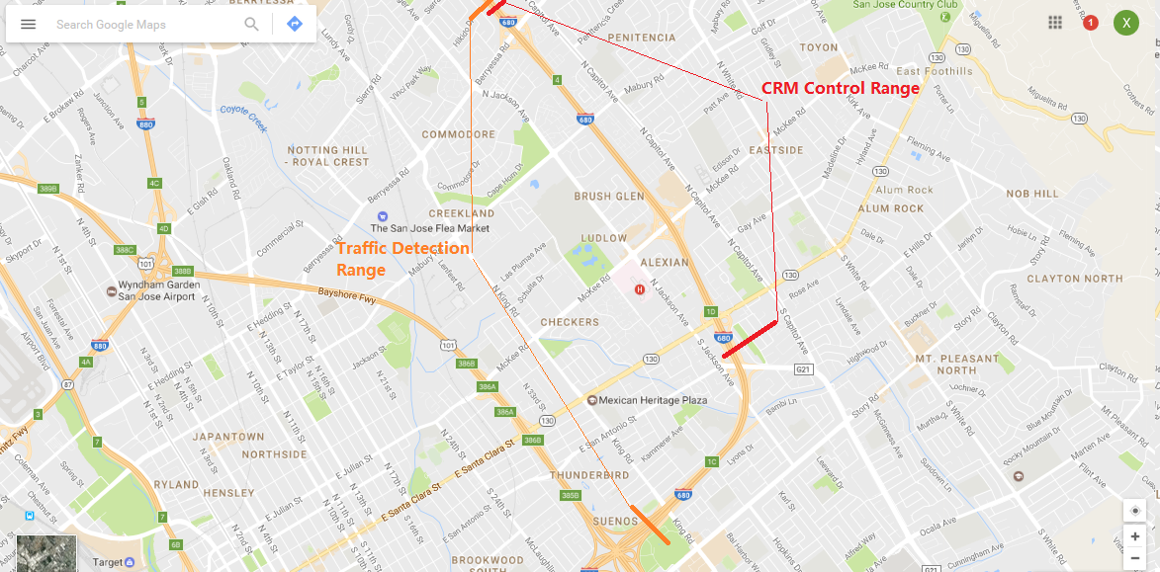

**Figure 1.** Freeway CRM control and traffic detection range

1. **ConOps (to be finalized)**

As shown in Figure 2: PATH arterial traffic control computer interfaces with SJ TMC computer instead of directly linking with controllers in the field; PATH freeway RM control computer will directly link with controllers in the field through wireless modem; this may require that all the RM controllers need to be changed into 2070 controllers which is more convenient in interface for data acquisition and direct control; Caltrans D4 TMC ATM computer will act as a monitor and a supervisor; in case there is any problem, it should be able to disable the CRM signal such that the system returns to its default RM control strategy.

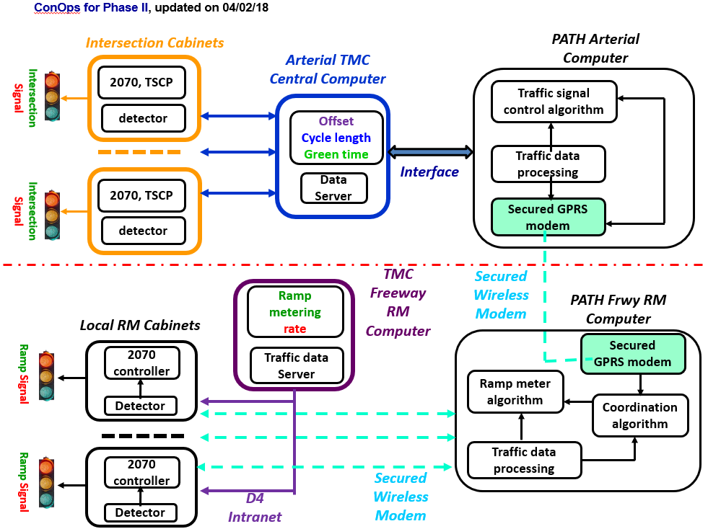

**Figure 2** Draft ConOps for field test

The following Figure 3 depicts the functionality of each block in Figure 3.

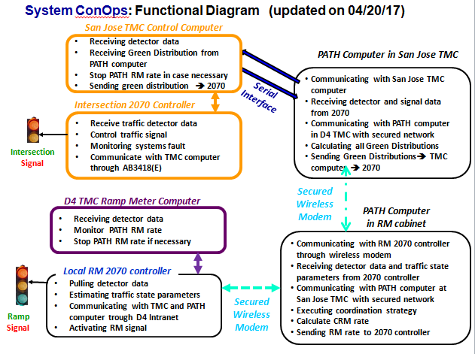

**Figure 3**. Functional diagram of ConOps

1. **Progressive Field Test Schedule**

A progressive field test will be conducted in two phases: Phase 1 will focus on data collection from freeway detector stations and arterial intersection detector station and traffic signal controllers, and the test of arterial traffic signal control; Phase II will test Coordinated Ramp Metering (CRM) for freeway corridor, and the coordination of the two sub-systems, i.e. CRM and arterial traffic signal control system.

***Phase 1: Data Collection and Arterial Traffic Signal Control and Coordination (Ramp Metering Algorithm Remains Local-Responsive)***

*Step 1-1:* Establish a PATH computer link with field 2070 Ramp Metering controller: interface with Caltrans Distract 4 TMC (Traffic Management Center) or through modem;

*Step 1-2:* Collect real-time freeway detector data, on-ramp queue detector data, and ramp metering rates for the morning peak hours. Then send the data to the corresponding freeway operation engineer for review, to ensure that the freeway ramp metering controller are functioning properly.

*Step 1-3:* Freeway data analysis and processing: Check freeway data health and develop the data processing module for traffic state parameters (i.e. occupancy, flow, and time-mean speed) run correctly.

*Step 1-4*: Establish a PATH computer interface with the San Jose TMC computer to link with 2070 controller of arterial corridor.

*Step 1-5*: Collect arterial data from the loop detectors that belong to the traffic signals. Look for the following parameters: green time, yellow time, red time, gap out, max out, force off, and all red time. Then send the data to relevant signal operations engineer for review, to ensure that the arterial traffic signals are functioning properly.

*Step 1-6*: Arterial data analysis and processing: Check that the traffic data processing module can estimate traffic state parameters robustly, even in case of detector and/or data error.

*Step 1-7*: Dry-Run of arterial traffic signal control and coordination: Run the proposed signal control strategy that coordinates with the freeway ramp metering on the PATH computer. Do not activate this control to alter the real-world signal timing but run it in parallel with the existing actuated signal timing plan on the arterial. Then check the data output to ensure that the proposed control runs properly. For example, the cycle length does not become too short and the pedestrian actuation requests are guaranteed. This requires data inputs (ramp metering rate and flow from queue detectors) from the freeway ramp metering controllers.

Continue running the PATH computer during the AM peaks without altering the real-world signal timing plan. Check for errors and modify the algorithm if necessary. Observe the impact of the new control on minimum pedestrian crossing times and transit signal priority for light rail vehicles on Capitol Ave. Expected duration: 2-3 weeks.

Test the transition modules to ensure that there will be a smooth transition between proposed signal timing plan and the existing signal timing plan for actuated signals.

*Step 1-8:* Activate the proposed arterial signal control plan (coordinated with freeway ramp metering) in the PATH computer. This will be an initial test conducted for 2 days during the AM peak hours, to ensure that the PATH computer generates reasonable signal timing in the real world. This initial test will be conducted on Friday and the following Monday, since both days typically have lower than usual traffic demand during the morning peak hours.

*Step 1-9:* Arterial Traffic Signal Control for System Tuning: Continue operating the proposed arterial signal control plan for tuning for a week before August to detect any other issues with field implementation.

*Step 1-10:* Extend the testing period for 6-8 weeks: During this testing period, traffic conditions will be closely monitored and the signal timing plan will return to the existing plan if errors were detected.

***Phase 2: Integration of Arterial Traffic Signal Control with Coordinated Freeway Ramp Metering***

Following the successful test of the proposed signal timing plan (coordinated with freeway ramp metering), the freeway ramp metering will no longer adopt the existing local responsive algorithm. During this phase of the field test, the proposed signal control will continue to be in place while the freeway ramp metering algorithm switches to coordinated traffic responsive ramp metering.

*Step 2-1*: Dry-run the proposed coordinated ramp metering (CRM): run the CRM algorithm on the PATH computer but do not implement it in the real world. This will run simultaneously with the existing local-responsive ramp metering algorithm. Then check the ramp metering rate outputs from both algorithms to make sure that the coordinated ramp metering algorithm does not generate unreasonably high or low ramp metering rates, in comparison with the existing ramp metering rates.

Run the two transition modules without activation to make sure transition between the existing local-responsive and the coordinated ramp metering algorithms can be done smoothly.

*Step 2-2*: Activating the coordinated ramp metering (CRM) algorithm via the PATH computer as an initial test. This will take place for 2 days during the AM peak hours, to ensure that the PATH computer generates reasonable ramp metering rates in the real world. This initial test will be conducted on Friday and the following Monday, since both days typically have lower than usual traffic demand during the morning peak hours. The proposed arterial traffic signal control keeps running.

*Step 2-3*: Integrated System Tuning: Continue activating the coordinated ramp metering algorithm on the PATH computer for a week during the morning peak hours. Observe and correct any issues that may arise during this week. The proposed arterial traffic signal control keeps running.

*Step 2-4*: Extend the testing period for 8-10 weeks for integrated system. During this testing period, traffic conditions will be closely monitored and the ramp metering algorithm will return to the existing local-responsive algorithm if errors were detected.

The following Table 1 is a proposed progressive test schedule.

**Table 1:** Proposed Progressive Field Test Schedule

