EE445L Lab Report 7

Github link: <https://github.com/jspspike/balance>   
All our files are there. Stuff specific to this report is in the lab7 deliverables folder.

Requirements Doc

1. Overview
   1. Objectives
      1. We are doing this for the purpose of designing our own embedded system with the concepts that we have learned in class
   2. Roles
      1. Not sure yet
      2. Also this…. EE445L students are the engineers and the TA is the client. Students are expected to make minor modifications to this document in order to clarify exactly what they plan to build. Students are allowed to divide responsibilities of the project however they wish, but, at the time of demonstration, both students are expected to understand all aspects of the design.
2. Function Description
   1. This system will balance a ball on a plate, allowing the user to move the ball using the plate center the ball as well as cause the ball to follow some patterns all by changing the plates orientation using servos. At first, we will just have buttons. One button when pressed will cause the ball to be centered, another when pressed can cause the ball to do a certain pattern. If this goal is reached, then we will try and control the plate remotely from our phones.
   2. We have three main goals as stated above. The user can move the ball, center the ball, and cause the ball to follow a predefined pattern. Quantitative measurements for all three goals could be how accurate the system is at moving to the position it is expected to go. For example, for centering the ball, we can see how far the ball ends up from the true center of the plate.
   3. There will be three switch inputs. The tm4c will interfaced with two servos and a resistive touch plate
3. Deliverables
   1. Lab 7 and Lab 11 stuff

Hardware Design

SCH  
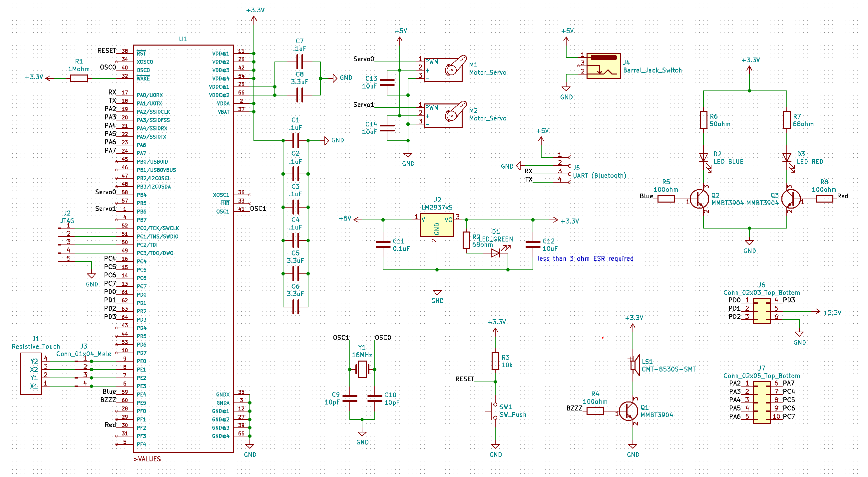

PCB  
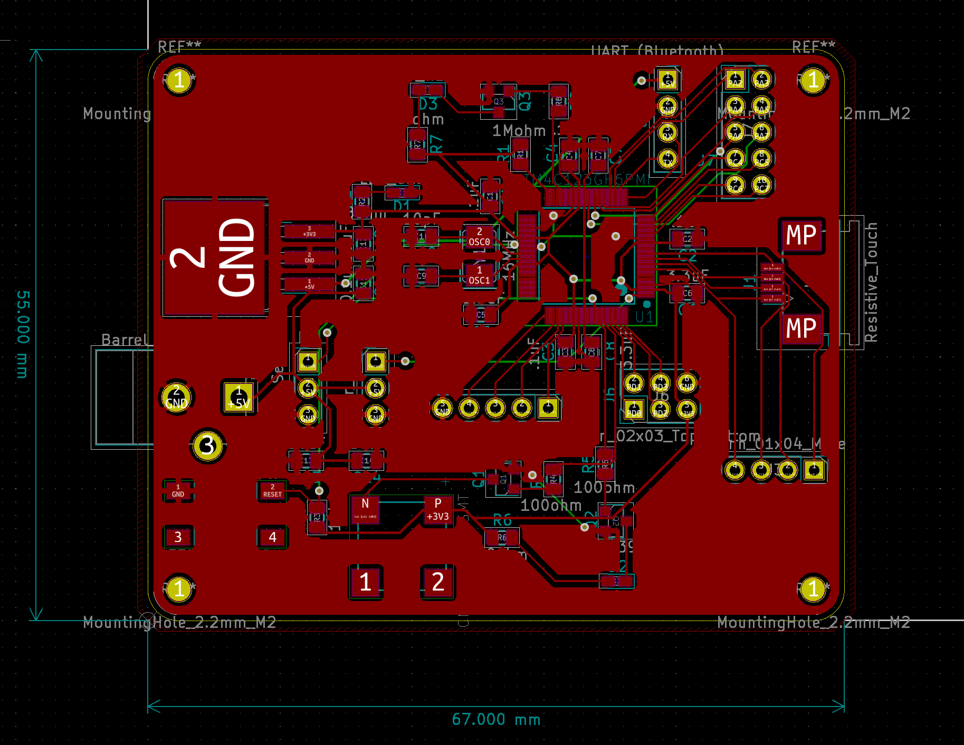

We only have stuff on one side of the PCB

Measurement Data  
PCB Components Estimated Cost: $29.01 (Located in the BOM file in the deliverables folder).  
Cost of servos: minimum $20  
Cost of Resistive Touch Screen: Not sure about our choice yet.