**Console/ASCII Version**

This document covers the console only, test playable lite version of the JTacticalSim.

* .NET 4.5 – C#
* System.Console environment/No graphics engine/no 3rd party libraries
* XML data store

The JTactical Battle Simulator is intended to be a dynamic environment for localized combat scenarios. Rather than restricting the players to a pre-determined geography and victory conditions, JTS allows for a multitude of different options for multiple players playing opposing factions each with multiple countries, at any scale.

The game is won when either faction reaches the victory conditions outlined for that side. 3 types of conditions are supported:

* Enemy Units Remaining – Battle of attrition where the opposing faction meets a condition where a maximum number of units are still in play.
* Victory Points Held – Battle of resources and geography where a faction holds a minimum number of victory points as determined by the board setup
* Flag Captured – Battle of protection where a designated opponent HQ is the specific target.

**Game Environment**

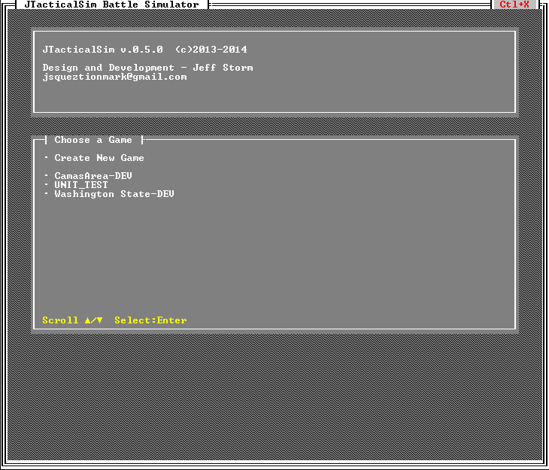

**Title Screen:**

Choose an existing game previously created from any of the installed scenarios or create a new game based on an installed scenario.

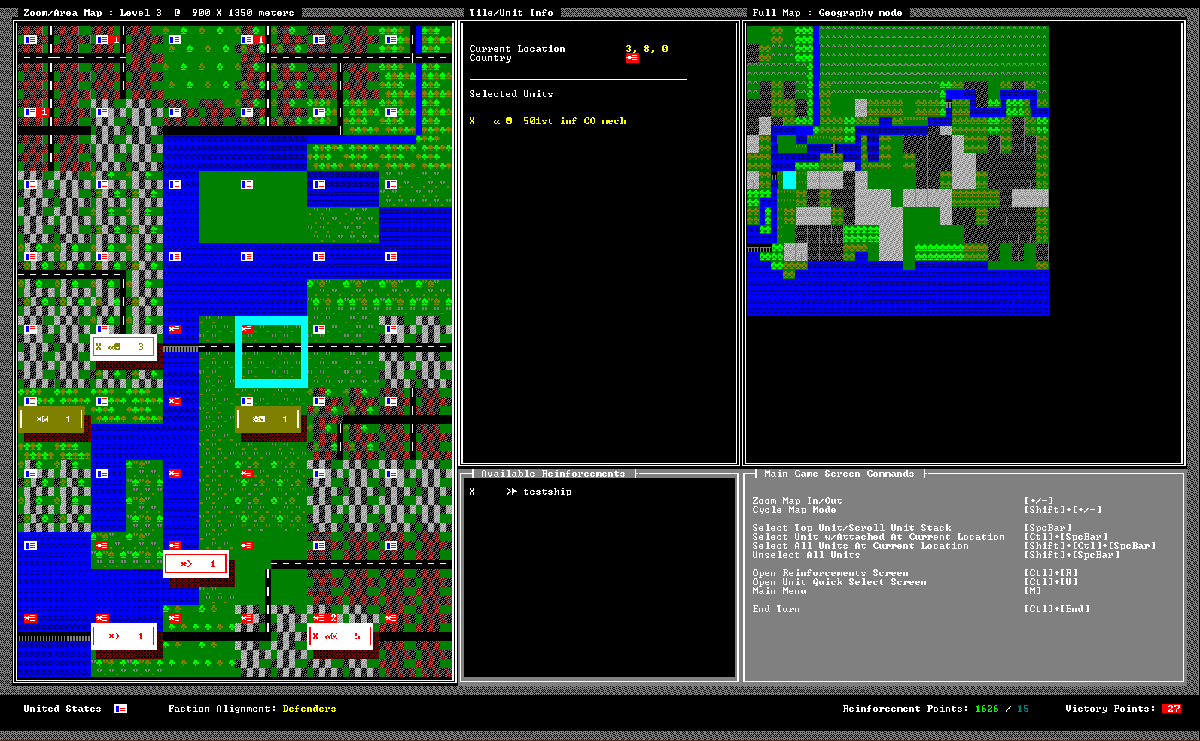

**Main Screen:**

The main screen is where most of the game play occurs. There are two maps, the area or ‘Zoom’ Map and the Full Map. For the console version of the game, the full map is kept to the maximum size displayable in the frame and represents the entire play area. The zoom map shows a specific area and has 3 zoom levels. The real world dimensions of the area are shown. There are 3 map modes to assist in interpreting the play area: *Geographic*, *Political* and *High Contrast*.

The Tile/Unit Info area shows information related to the currently selected space. This includes:

* Infrastructure feature names
* Coordinate location
* Country of claim
* All units
* Selected Units

More detailed information regarding the tile and units can be found in the menus on the map itself and the **Unit Quick Select Screen.**

The Battle area shows any current battle action occurring.

The Available Reinforcements area lists all unplaced reinforcements acquired on the **Reinforcements Screen**.

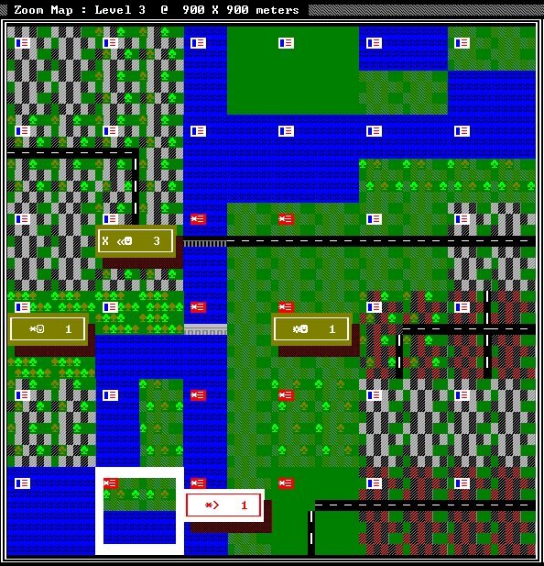

‘Zoom’ (Area) Map

Movement around the map is conducted by using the numpad keys as direction keys (in cases where a numpad is not available, the *Arrow Keys* can be used – diagonal is not available). Using a combination of *Shift+[Arrow Keys]* scrolls the map by one full area in the selected direction. Otherwise, the map scrolls one space at a time when the selection cursor reaches the edge.

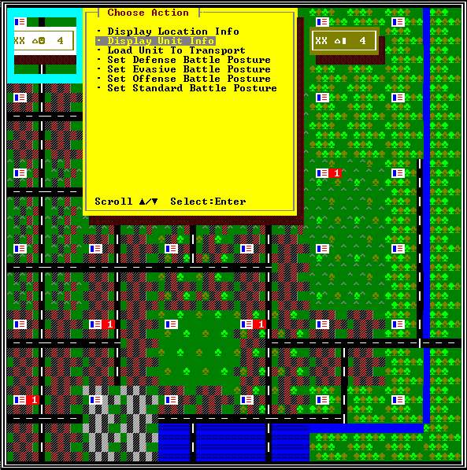 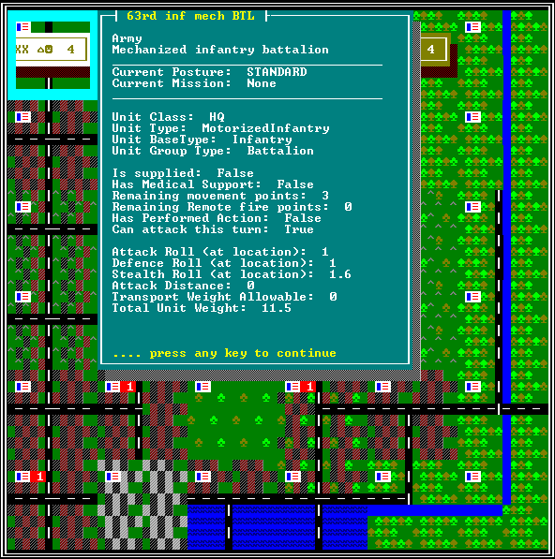

All actions in the JTacticalSim are either context menu or keyboard shortcut driven with the majority in the menu system. Menus are activated and canceled by pressing the *numpad 5 Key* (*Enter Key* if the numpad is not available). You can scroll through select lists with the *Arrow Keys* and select by pressing *Enter*.

Keyboard shortcuts to know:

* [+/-] Zoom Map In/Out
* [Shift]+[+/-] Cycle Map Mode
* [SpcBar] Select Top Unit/Scroll Unit Stack
* [Ctl]+[SpcBar] Select Unit w/Attached At Current Location
* [Shift]+[Ctl]+[SpcBar] Select All Units At Current Location
* [Shift]+[SpcBar] Unselect All Units
* [Ctl]+[R] Open Reinforcements Screen
* [Ctl]+[U] Open Unit Quick Select Screen
* [M] Main Menu
* [Ctl]+[End] End Turn

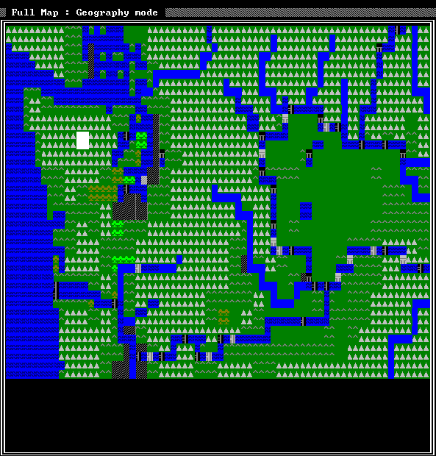

Full Board Map

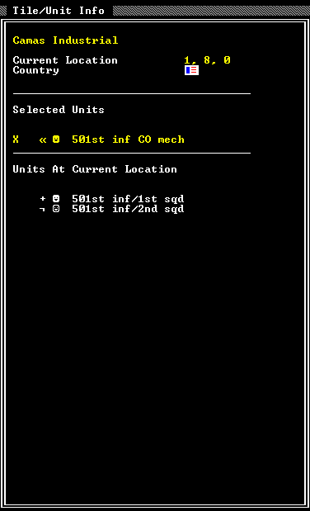

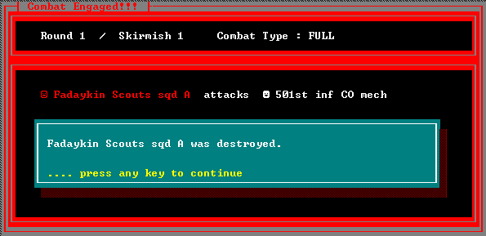

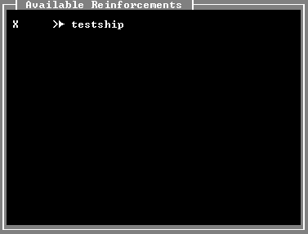

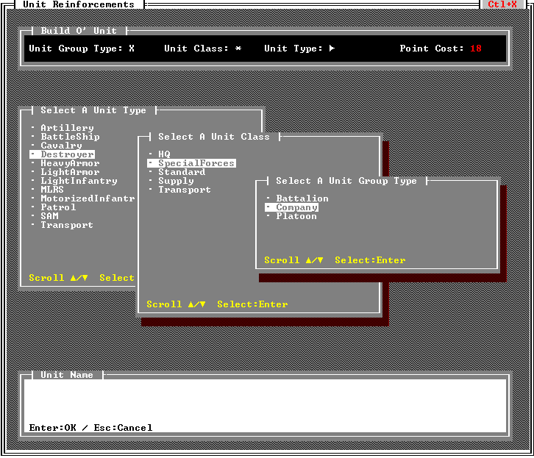

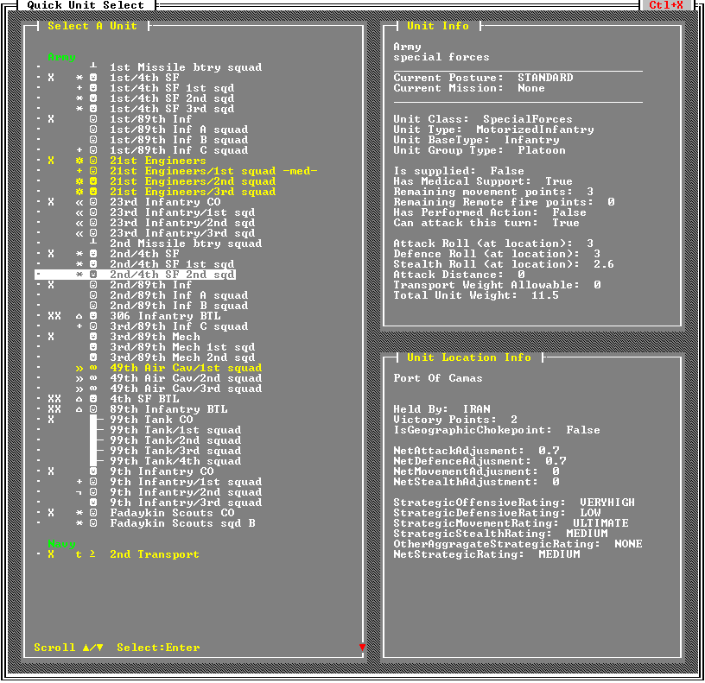

Player turn

Play is restricted only by the unit turn stats for each unit per turn. Stats are updated at the end of each turn, but victory conditions are checked in real time. These stats include:

Units outline