Apache Solr

Guide for Installation and Configuration

# Overview

This document details the steps needed for the initial installation and configuration of an Apache Solr instance for use as a product search engine on a virtual machine for use in the local development environment. For the purposes of this document, the steps and screenshots provided assume that the installation is taking place on a Windows Server host.

The following conventions are used within this document:

* Information to be entered or read from installation dialogs or configuration files will be denoted using a fixed with font and a red color. For example, “At the prompt, type key=value then press the enter key.” Under normal circumstances, these items will not be in quotations.
* Installation paths and other configurable items which may vary based on user choices will be denoted using the style noted above, and enclosed in [[ ]] blocks. For example, “Navigate to the [[Product Installation Path]].” Unless otherwise noted, all paths should be fully-qualified and not relative.

# Installation Components

The Solr stack is comprised of a Java Runtime Environment (JRE), Java Servlet Container, Web Server, and the Solr engine. The installation procedures described are based on the following products. All versions used were the latest at the time that this guide was authored. Download locations for each can be found in the resources section at the end of this document.

* ***Java Runtime Environment –*** Oracle Java Development Kit Standard Edition, version 7u2.
* ***Java Servlet Container*** – Apache Tomcat, version 7.0.23.
* ***Web Server*** – Apache Tomcat, version 7.0.23.
* ***Solr Engine*** – Apache Solr, version 3.5.0.

# Installation Steps

### Java Runtime Environment

1. Download or locate the installer for the Java Development Kit (JDK) which contains both the development kit and Java Runtime Environment (JRE.) If the server is a 32-bit environment, only the 32-bit installer is needed. If the server is a 64-bit environment, then both the 32 and 64-bit installers will need to be run. It is advised that the 32-bit installer be run first. For the purposes of path selection and other related configuration, the 64-bit environment should be considered the primary option on 64-bit systems.
2. Launch the installer and click Next to view the installation options.
3. From the dialog, deselect the Source Code item, while accepting the remaining defaults. Take note of the installation path for the primary server architecture (32 or 64-bit) as it will be referenced later.  
   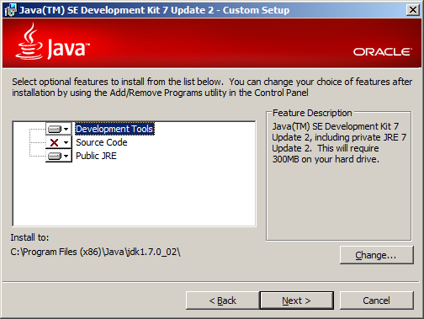
4. Once the JDK installation has been completed, the dialog for installation of the runtime environment will be presented. Click Next to accept the default parameters and begin the installation. Take note of the installation path for the primary server architecture (32 or 64-bit) as it will be referenced later.

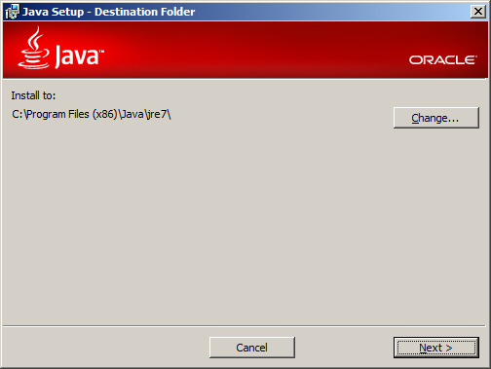

1. Once the JRE installation has been successfully completed, a dialog to that effect will be displayed. Click the Continue button which will launch the installer for the JavaFX SDK.

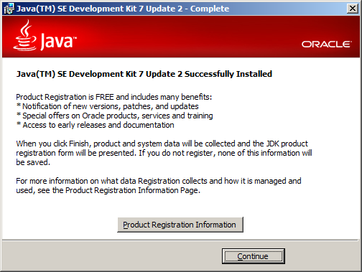

1. Cancel the JavaFX SDK, which will cause the default browser to open with the prompt to register the JDK. Close the browser without registering.

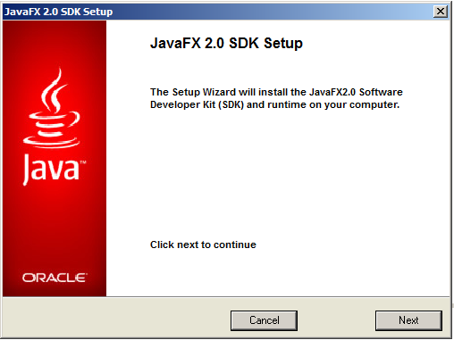

1. If installing on a 64-bit environment, perform steps 1-6 again for the 64-bit JDK. Otherwise, proceed to the next step.
2. Once the Java environment has been installed, it needs to be integrated into the system-level environment variables. Begin by clicking Start, locate the Computer item from the menu, right-click to bring up a context menu, and click on the Properties item.

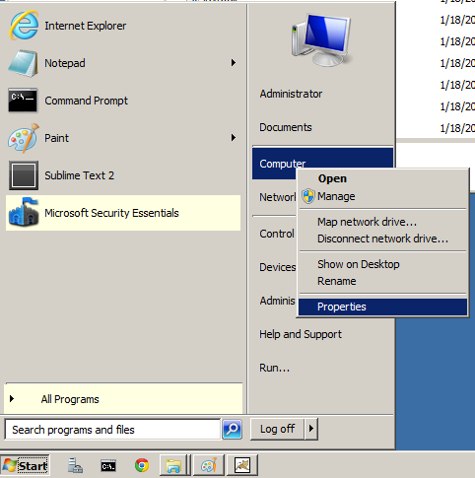

1. From the resulting dialog click Advanced System Settings from the left column.

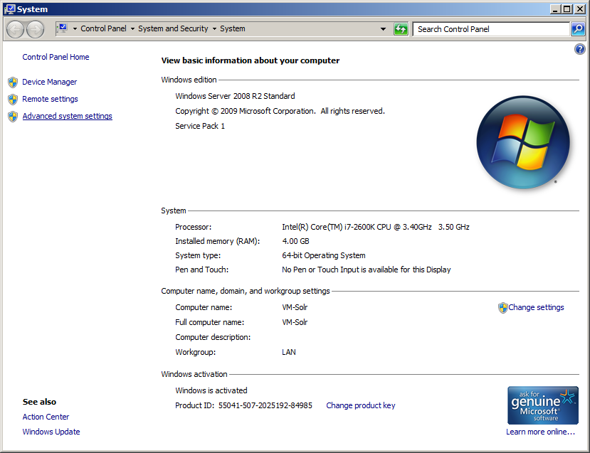

1. From the resulting dialog click the button for Environment Variables from the bottom.

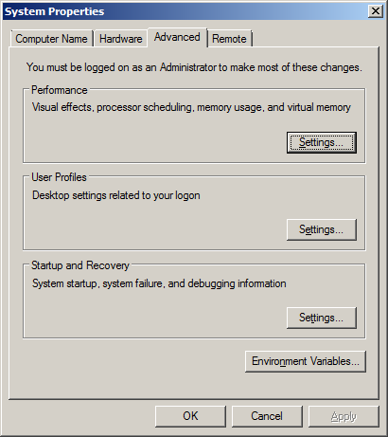

1. In the lower pane for System Variables, click the New button and fill out the dialog, using JAVA_HOME as the name and the [[JDK Installation Path]] from step 3 as the value.

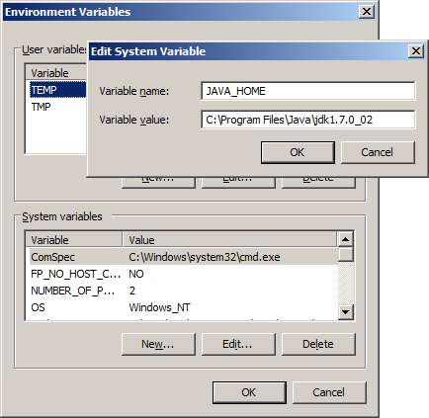

1. In the lower pane for System Variables, select Path from the list box, click the Edit button and append ;%JAVA_HOME%\bin to the value.

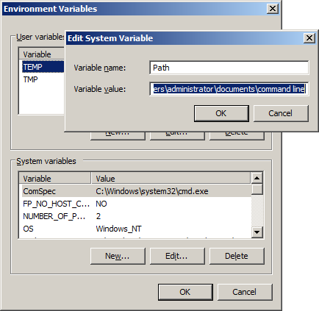

1. The Java environment is now installed and configured. To verify, launch a command prompt and enter the command java –version followed by the Enter key. You should see a message detailing the Java Runtime Environment. Next, enter the command javac –version followed by the Enter key. You should see a message detailing the Java compiler.

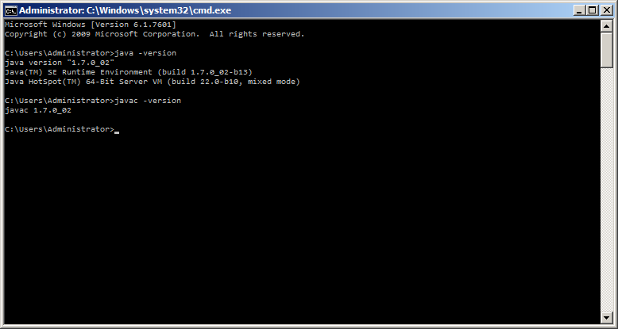

### Apache Tomcat

1. Download or locate the 32/64-bit Windows Service installer, which provides a self-contained experience for inclusion of Tomcat as a service under Windows.
2. Launch the installer and select the option Full from the drop down then click Next.

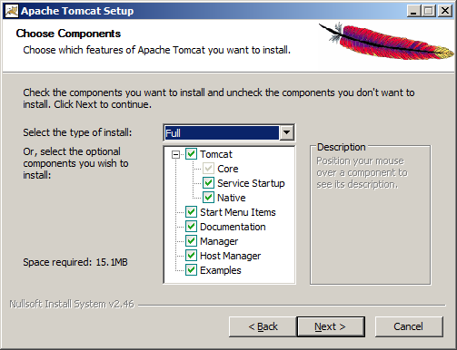

1. Configure the ports, service name, and login options. Unless there is reason to do otherwise, it is recommended that the defaults be used. When the desired values have been entered, click Next.

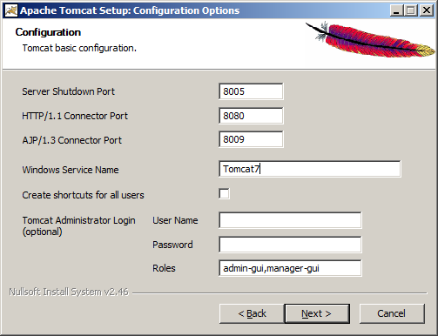

1. Verify that the location of the JRE is correct. This value is auto-populated and under normal circumstances should not require adjustment. Once verified, click Next.

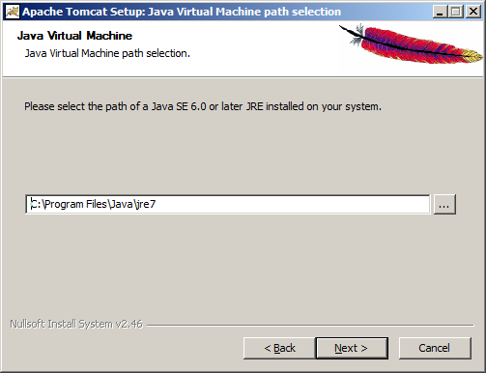

1. Select the path for installation. In order to simplify configuration later, it is recommended that a simple path be chosen. Take note of the selected path, as it will be referenced later and during the installation of Solr. Once the desired path has been entered, click Install.

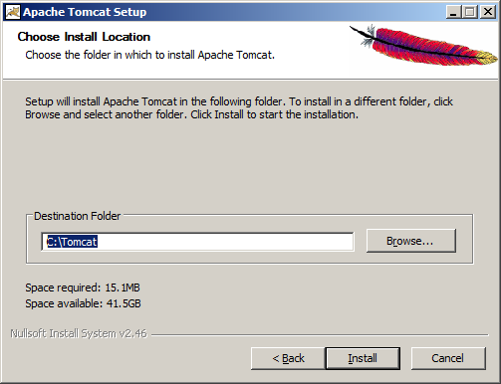

1. When the installation is complete, click Finish. The Tomcat service will be started causing both the web server and Java servlet container functionality to be active on the ports specified earlier.

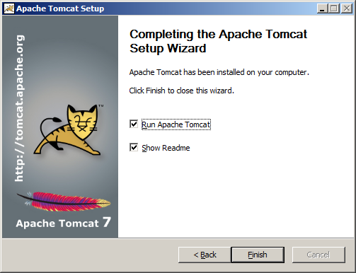

1. Navigate to the Tomcat configuration directory, located at [[Tomcat Installation Path]]\conf and open the file server.xml in a text editor.

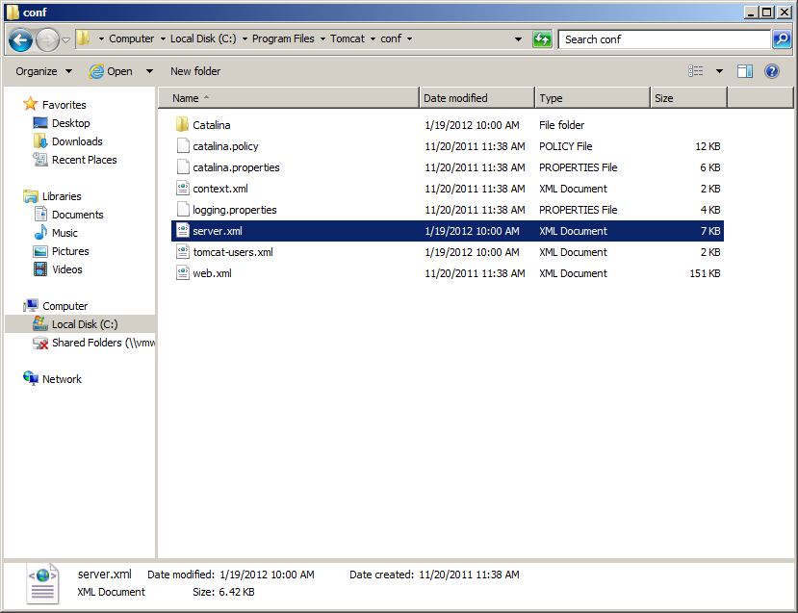

1. Locate the XML element that defines the HTTP connector, as illustrated in the screenshot below. To that element, add the attribute URIEncoding=”UTF-8”, using the capitalization depicted. All other attributes should remain unchanged.

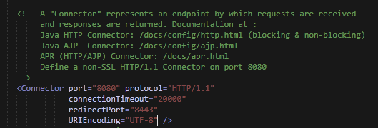

1. Tomcat is now installed and configured. The installation may be verified by opening a web browser and navigating to <http://localhost:8080>, if the default port was accepted or substituting the HTTP/1.1 Connector Port chosen during installation. The default Tomcat splash screen should be displayed.

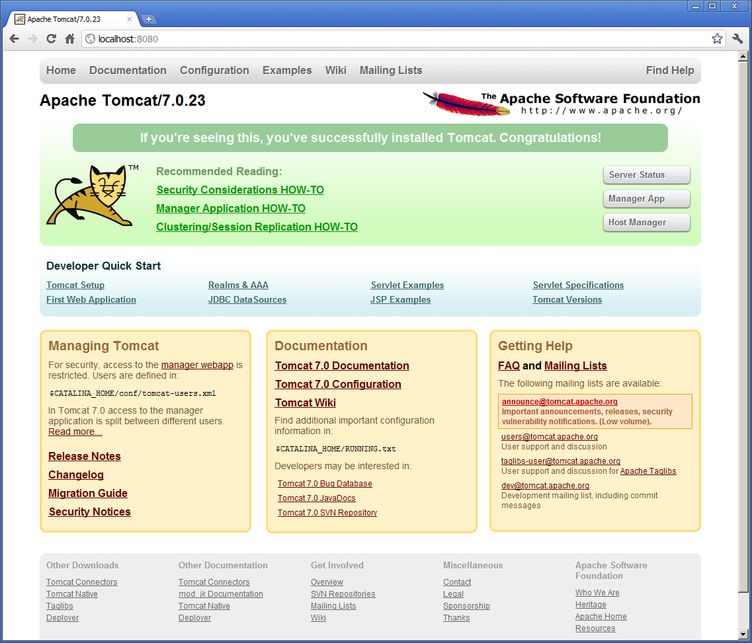

### Apache Solr

1. Download or locate the Solr archive, which provides the Solr application and related resources.
2. Extract the archive into a working directory and take note. The directory contained within the archive itself will be referenced later.
3. Create a directory to serve as the root for the Solr application. It is recommended that a short path without spaces be used, such as c:\Solr. Take note of this path, it will be referenced later.
4. Under the [[Solr Root Path]] directory, create a directory to serve as the Solr application home directory. It is recommended that a simple name without space be used, such as home.
5. Copy the directory [[Solr Archive Path]]\contrib to [[Solr Root Path]]\contrib.
6. Copy the directory [[Solr Archive Path]]\dist to [[Solr Root Path]]\dist.
7. The [[Solr Root Path]] should now look similar to the following screenshot.

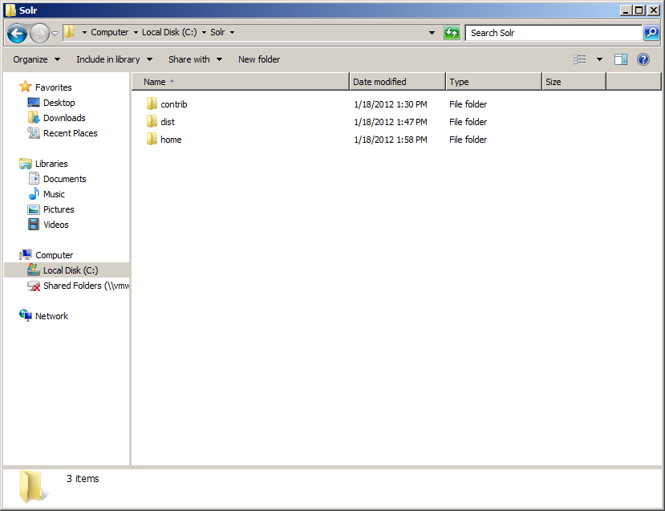

1. Stop the Tomcat service by locating the icon in the system tray, right-clicking it, and choosing Stop Service.

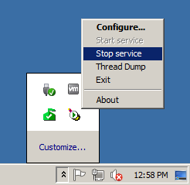

1. Configure the Tomcat service by locating the icon in the system tray, right-clicking it, and choosing Configure.
2. Select the Java tab from the dialog and then locate the Java Options section at the bottom. Into the Java Options, append –Dsolr.solr.home=[[Solr Home Path]].

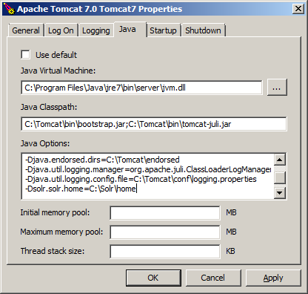

1. Copy [[Solr Archive Path]]\dist\apache-solr-#.#.#.war to [[Tomcat Installation Path]]\webapps\solr.war, replacing #.#.# with the version of Solr being installed.

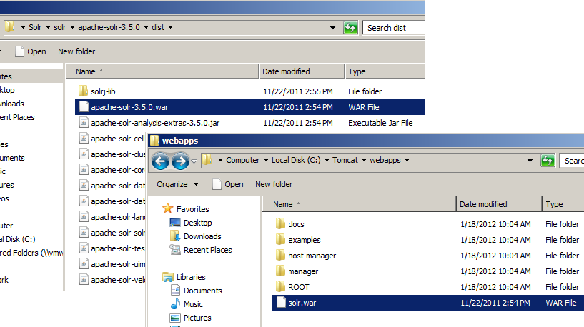

1. Copy [[Solr Archive Path]]\example\solr\* to [[Solr Home Path]].

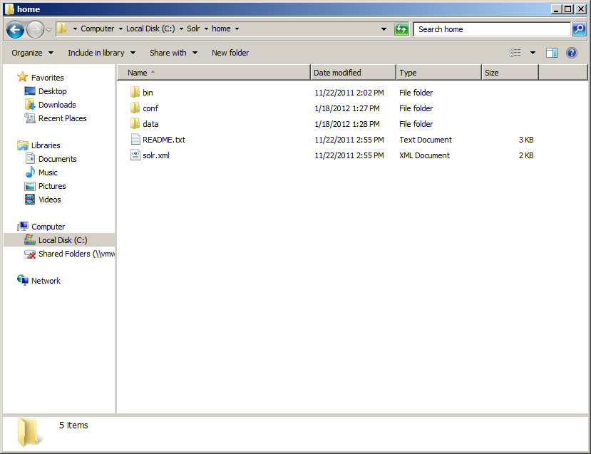

1. Navigate to the Solr configuration path, located at [[Solr Home Path]]\conf. Open the file solrconfig.xml in a text editor. Search for ../../contrib, replacing with ../contrib. Search for ../../dist, replacing with ../dist. These paths should be clustered in one area of the configuration, and the resulting paths should look similar to the snippet shown in the bottom right.

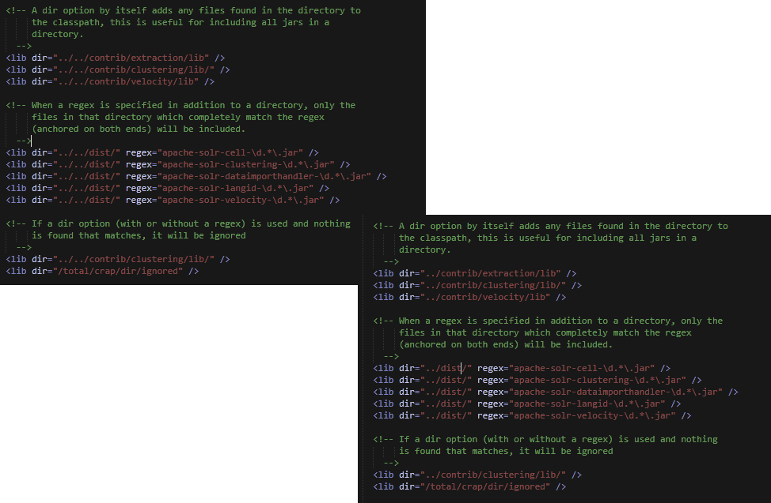

1. Restart the Tomcat service by locating the icon in the system tray, right-clicking it, and choosing Start Service.

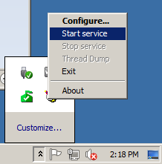

1. Solr is now installed and configured. The installation may be verified by opening a web browser and navigating to http://localhost:8080/solr/admin, if the default port was accepted during Tomcat installation or substituting the HTTP/1.1 Connector Port chosen during Tomcat installation. The default Solr administration screen should be displayed.

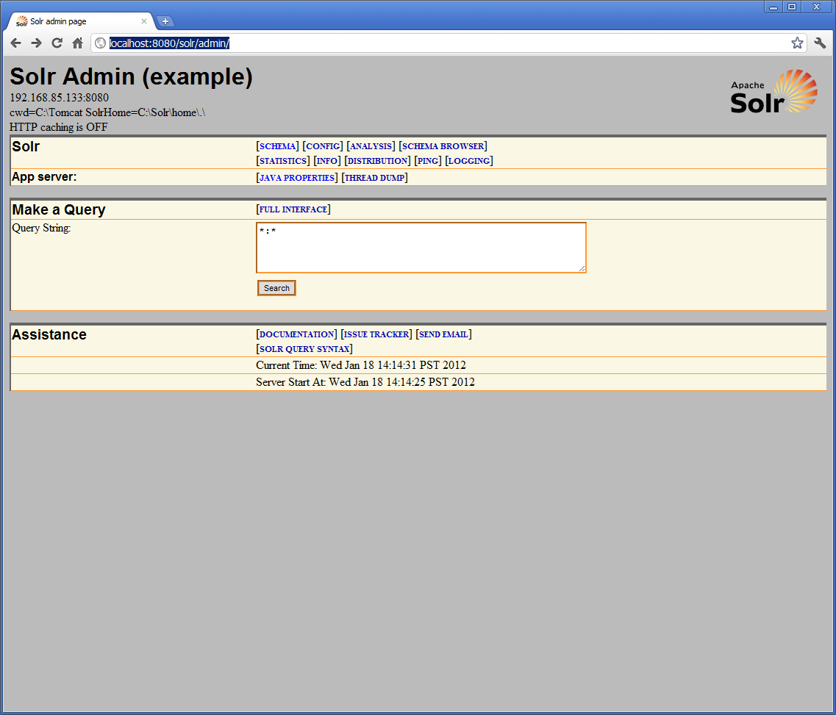

# Resources

Solr

* [Home](http://lucene.apache.org/solr/)
* [Downloads](http://apache.mirrors.pair.com/lucene/solr/)
* [Installation FAQ](http://wiki.apache.org/solr/SolrInstall)
* [Tutorial](http://lucene.apache.org/solr/tutorial.html)
* [Wiki](http://wiki.apache.org/solr/FrontPage)

Java

* [Java Downloads](http://www.oracle.com/technetwork/java/javase/downloads/index.html)

Tomcat

* [Home](http://tomcat.apache.org/)
* [Documentation](http://tomcat.apache.org/tomcat-7.0-doc/index.html)
* [FAQ](http://wiki.apache.org/tomcat/FAQ)
* [Common Windows Questions](http://wiki.apache.org/tomcat/FAQ/Windows)