**Certificate**

This is to certify that the topic entitled on superconductor is here with work done by Ms. Manjari of class XII-R has successfully completed the research on the above mentioned project under the guidance of Mrs. Anushya during the academic year 2015-16 partial fulfillment of physics practical examination conducted by CBSE.

Internal External

Teacher’s sign Teacher’s sign

**ACKNOWLEDGEMENT**

We express our deep sense of gratitude to Mrs. Mary shanthi, Principal, Blossom Public School, Thanjavur, for her invaluable advice and guidance during our work.

We are grateful to Mrs. Anushya, our Physics mentor, for their constant inspiration and suggestions provided for us during the project work.

We immensely thank all our teachers for their support rendered throughout our project. We are deeply indebted to our dear parents, friends and classmates, for their love and encouragement

LIST OF CONTENTS

* **Introduction**
* **Transition temperature or Critical Temperature**
* **Occurrence**
* **Properties**
* **Types of Superconductors**
* **Application Of Superconductors**
* **Advantages**
* **Conclusion**
* **Bibliography**

**Superconductivity**–**Introduction**

* The research about superconductors began when KamerlinghOnnes found that the resistivity of Hg suddenly dropped to zero at 4.2K (liquid He Temperature).
* At very low temperatures normal conductors retain some resistivity but the resistivity of superconductors suddenly drop to zero.
* A normal conductor can be brought into superconducting state by increasing its pressure.

**Transition Temperature**

**OR**

**Critical Temperature**

**Temperature at which a normal conductor loses its resistivity and becomes a superconductor.**

* Definite for a material
* Superconducting transition reversible
* Good electrical conductors like Cu, Ag, Au are not superconductors and good superconducting materials are not good electrical conductors.

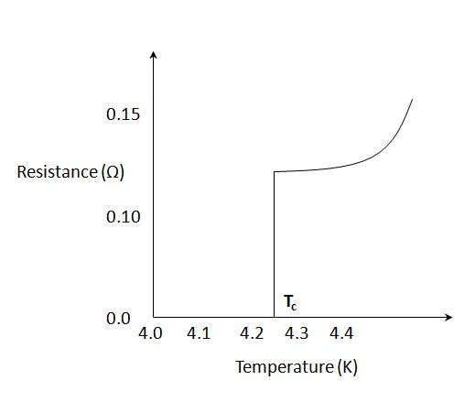

**Occurrence of Superconductivity**

|  |  |
| --- | --- |
| **Superconducting Elements** | **TC (K)** |
| Sn (Tin) | 3.72 |
| Hg (Mercury) | 4.15 |
| Pb (Lead) | 7.19 |
| **Superconducting Compounds** |  |
| NbTi (Niobium Titanium) | 10 |
| Nb3Sn (Niobium Tin) | 18.1 |

**Superconductivity**–**Properties**

1.**ElectricalResistance**

* Zero electrical resistance
* Ratio of resistance of material in superconducting state to the same material in normal state is less than 10-5.



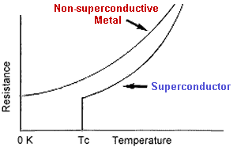

**2. Effect of magnetic field**

* When the superconducting materials are subjected to large value of magnetic field, it’s superconducting property gets destroyed.
* Critical magnetic field (HC) – Minimum magnetic field required to destroy the superconducting property at any temperature

H0 – Critical field at 0K

T - Temperature below TC

TC  - Transition Temperature

|  |  |
| --- | --- |
| **Element** | **HC at 0K**  **(mT)** |
| Nb | 198 |
| Pb | 80.3 |
| Sn | 30.9 |

Examples of critical fields of some superconducting materials

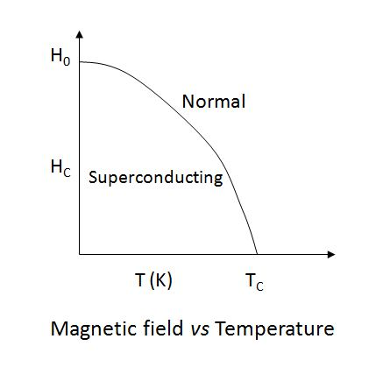

3. Effect of Electric Current

* The application of large value of electric current to a superconducting material induces a magnetic field in the material and thus destroys its superconducting property.
* Induced Critical Current iC = 2πrHC

Where Hc is the critical magnetic field required and r is the radius of superconductor.

**4. Effect of Entropy**

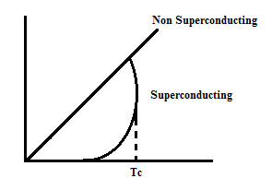

**5. Specific Heat**

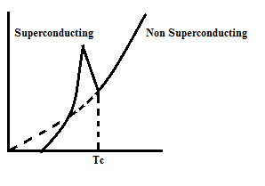

**6. Thermal Conductivity**

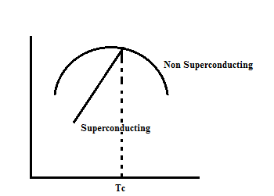

7. **Diamagnetic property: -Meissner Effect**

* Magnetic Lines of force penetrate through a normal conducting material when placed in a magnetic field of flux density B.
* Whereas, a superconducting material repels the magnetic field & thus behaves as a diamagnetic material.
* A superconducting material also ejects magnetic lines of force when cooled for superconductivity.

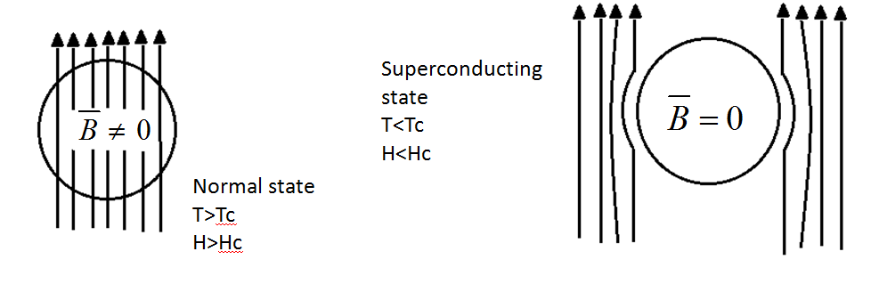

**Types of Superconductors**

**Type I**

* Exhibit Meissner Effect
* Behave as a prefect diamagnetic material
* There is only one Hc
* No mixed state is present
* Sudden loss of magnetisation
* Soft superconductor
* Eg. – Pb, Sn, Hg

**Type II**

* Does not exhibit complete Meissner Effect
* Does not behave as a perfect diamagnetic material
* There are two HCs – HC1 & HC2
* Mixed state present
* Gradual loss of magnetisation
* Hard superconductor
* Eg. – Nb-Sn, Nb-Ti

**High-Temperature Superconductors**

* High Temperature superconductors have high Tc values.
* They are not metal or intermetallic compounds but oxides of copper in combination with other elements.
* In 1983, 1987 & 1988, materials with Tc up to 40K, 93K and 125K have been discovered respevtively.
* The HTSC compounds are represented by simplified notations as 1212, 1234, etc. These notations are based on number of atoms in each metal element.
* They are brittle and easy to form wires and tapes.
* HTSC wires/tapes provide transmission of electrical power over a long distance without any resistive loss.

**High Temperature Semiconductors**

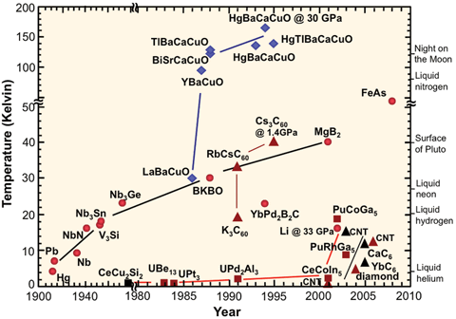

**Application of Superconductors**

1. **Josephson Effect**

In 1962, Brain Josephson predicted the flow of current in insulator sandwiched between two superconductors on the application of a D.C. Voltage

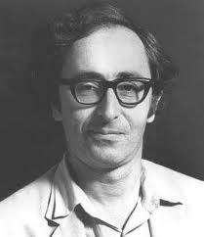

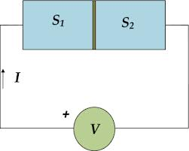

**Components of Current**

* D.C. Component of Current – This component of current exists even after the applied voltage is removed.
* A.C. Component of Current – This component of current exists only during the existence of applied voltage.

The frequency of A.C. components is



**Uses of Josephson devices**

* Magnetic Sensors
* Gradiometers
* Oscilloscopes
* Decoders
* Analogue to Digital converters
* Oscillators
* Microwave amplifiers
* Sensors for biomedical, scientific and defence purposes
* Digital circuit development for Integrated circuits
* Microprocessors
* Random Access Memories (RAMs)

**Application of Superconductors**

**2. SQUID**

(Superconducting Quantum Interface Device)

* SQUID is a type of magnetometer.
* It is the most sensitive type of detector known to science.
* Low Temperature superconductors are used for fabricating SQUID.
* It consists of a superconducting loop of two Josephson junctions.

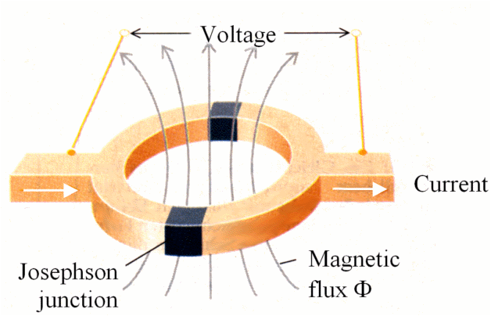

**Discovery:**

* The DC SQUID was invented in 1964 by Robert Jaklevic, John Lambe, Arnold Silver and James Mercereau of Ford Research Labs

**Principle :**

* Small change in magnetic field, produces variation in the flux quantum.

**Uses :**

* Storage device for magnetic flux
* Study of earthquakes
* Removing paramagnetic impurities
* Detection of magnetic signals from brain, heart etc.

**Application of Superconductors**

**3. Cryotron**

The cryotron is a switch that operates using superconductivity. The cryotron works on the principle that magnetic fields destroy superconductivity.

* Hca&Hcb are critical fields of material A & B respectively &Hca<Hcb.
* The current ‘i’ induces some magnetic field ‘H’ in both materials. If ‘H’ lies between Hca&Hcb, then the induced field will destroy the superconductivity of material A & hence contact will be broken due to increase in resistivity.

**Application of Superconductors**

1. **Maglev (Magnetic Leviation)**

* **Principle**: Electro-magnetic induction
* **Magnetic levitation transport**, or **maglev**, is a form of transportation that suspends guides and propels vehicles via electromagnetic force. This method can be faster than wheeled mass transit systems, potentially reaching velocities comparable to turboprop and jet aircraft (500 to 580 km/h).

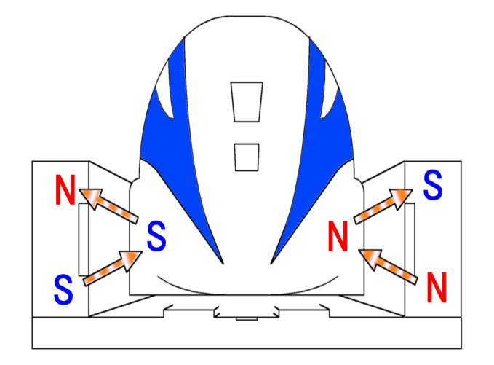

**Advantages**

* No need of initial energy in case of magnets for low speeds
* One litre of Liquid nitrogen costs less than one litre of mineral water
* Onboard magnets and large margin between rail and train enable highest recorded train speeds (581 km/h) and heavy load capacity. Successful operations using high temperature superconductors in its onboard magnets, cooled with inexpensive liquid nitrogen
* Magnetic fields inside and outside the vehicle are insignificant; proven, commercially available technology that can attain very high speeds (500 km/h); no wheels or secondary propulsion system needed
* Free of friction as it is “Levitating”

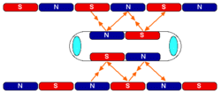

**Bibliography**

**Books referred:**

* Introduction to solid state(physics)-Kittel
* Superconductivity,superfluids and condensates-Annet
* Introduction to superconductivity-Tinkham

**Website:**

[**www.superconductors.org**](http://www.superconductors.org)

**en.wikipedia.org**

[**www.superconductorweek.com**](http://www.superconductorweek.com)

PHYSICS

INVESTIGATORY PROJECT

ON

SUPERCONDUCTORS

