**CHEMISTRY   
PROJECT**



**"Topic-Study of Adulterants in Food Stuffs"**

**Certificate**



This is to certify that Mr. J. Sanjay Raju , a student of class XII-R has successfully completed the research on the above mentioned project under the guidance of Mrs. Anita Shirley as prescribed by the CBSE during the academic year 2015-2016

**External examiner Internal examiner**

**ACKNOWLEDGEMENT**

I would like to express my sincere gratitude to my chemistry mentor **Mrs. K.Anita Sheirly**, for her vital support, guidanceand encouragement - without which this project would not have come forth.

I would like to extend my gratitude to the principal**Mrs.S.Mary Shanthi** for providing me with all the facility that was required.

**LISTOF CONTENTS**

* **Aim**
* **Introduction**
* **Theoretical background**
* **Common adulterated food items**
* **Experiments 1 & 2**
* **Observation & Result**
* **Adulterants & Diseases**
* **Precautions**
* **Government Measures**
* **Conclusion**
* **Bibliography**

**AIM :**

**To study some of the common adulterants in**

**different food stuffs**

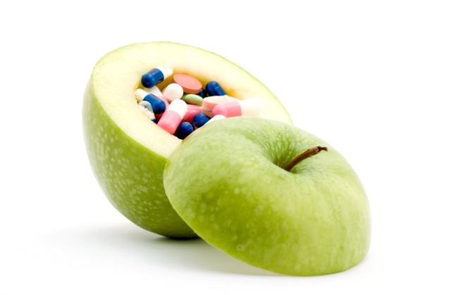

**INTRODUCTION**

**A**dulteration is the act of intentionally debasing the quality of food offered for sale either by mixture or substitution of inferior substances or by the removal of some valuable ingredient. In past few decades adulteration of food has become one of the most serious problems.

Consumption of adulterated food causes diseases like cancer, asthma, ulcer, etc. Majority of adulterants used by the shopkeepers are cheap substitutes which are easily available.

In order to prevent adulteration of food products by dishonest traders,  the government has issued ‘The Prevention of Food Adulteration Act’.

The Bureau of Indian Standards is the agency in India that provides the certificate of reliability to food  manufacturers in India.

**THEORITICAL BACKGROUND**

**W**e are very fortunate to be born a country which is blessed with rich soil, diversified climate, many rivers and the great Himalayas where almost all varieties of fruits, vegetables and cereals, etc. can be grown. In ancient times, the land was in abundance, the supply of food was more than the demand and people used fresh food materials in most natural form. The population spurt in our country has given rise to unemployment and  poverty.

The demand for food has increased & our country has to import food  grains, oil etc. from other countries. This shortage of food and ignorance of consumers is the main cause for adulteration of foodstuffs by the unscrupulous traders. It has become so common that the consumers have to run from pillars to pillars to get a foodstuff which is not adulterated. The consumers are not aware of hazards of adulteration and pay heavily for consuming adulterated food. If the consumer knows the ways and means to check the commodities of daily use, they can save themselves and their families from this mind-boggling problem.**SOME OF THE COMMON FOOD ADULTERANTS IN FOOD ITEMS ARE:**

|  |  |
| --- | --- |
| FOOD ITEMS | ADULTERANTS |
| Desi ghee & Butter | **Vanaspati ghee** |
| Vegetable ghee | **Paraffin wax** |
| Mustard oil | **Argemone oil** |
| Sugar | **Chalk powder, washing powder** |
| Chilli | **Red lead, Brick powder** |
| Turmeric powder | **Yellow salts of lead, yellow chalk powder** |

**EXPERIMENT 1 :**

**AIM:**

To test the presence of adulterant in Fats, Butter & Oils.

**APPARATUS:**

Test-tubes, beakers, test-tube stand, filter paper, dropper etc.

**CHEMICALS REQUIRED:**

**For desi ghee & butter –** conc. HCl, sugar, small amounts of vanaspati ghee or butter.

**For vegetable ghee –** conc. Acetic anhydride, small amounts of vegetable ghee.

**For oil –** conc. Nitric acid, small amounts of edible oil.

**PROCEDURE:**

In case of ordinary test for fats, butter & oils, put a small amount of these separately on a filter paper. Fold it &press, then unfold it. The presence of translucent spot indicates the presence of oil or fat. Hold the filter paper over flame, the spot grows larger.

**Test for oils:**

Take 1 ml of mustard oil in a test tube & add few drops of conc. HCl solution to it. Shake the mixture well. Appearance of red colour in the acid layer indicates the presence of argemone oil in mustard oil.

**CONCLUSION:**

Appearance of certain colours in the mixture detects the presence of adulterants.

**EXPERIMENT 2:**

**AIM:**

To test the presence of adulterants in Sugar, Chilli powder, Turmeric powder & Pepper.

**APPARATUS:**

Test-tubes, beakers, test-tube stand, dropper, glass rod etc.

**CHEMICALS REQUIRED:**

**For sugar –** dil. H2SO4, water, sample of sugar.

**For chilli powder –** dil. HNO3, KI solution, sample of chilli powder.

**For turmeric powder –** conc. HCl, sample of turmeric powder.

**For pepper –** water, sample of pepper.

**PROCEDURE:**

**1)Tests for Sugar:**

**(a)** Take a small amount of sugar in a beaker & add some amount of water to it. Stir the solution with a glass rod. Pure sugar dissolves in the water whereas the insoluble particles (chilli powder, washing powder etc.) floats on the surface indicates the presence of adulterants.

**(b)** Take 1 g of sugar in a test-tube & add few drops of dil. HCl to it. A brisk effervescence due to the formation of CO2 indicates chalk powder or washing soda in the given sample of sugar.

**2) Tests for Chilli powder:**

**(a)** Take a small amount of chilli powder in a test-tube & add few drops of dil. HNO3 to the test-tube. Shake the mixture well & filter the solution. To the filtrate, add 2-3 drops, of 10% KI solution. The presence of yellow coloured precipitate indicates the presence of lead salts in chilli powder.

**(b)** Take a small amount of given red chilli powder in a beaker & add water to it. The pure chilli powder floats over the surface of water whereas brick powder settles at the bottom.

**3) Tests for Turmeric powder:**

Take a small amount of turmeric powder in a test-tube & to this add few drops of conc. HCl. The colour changes from yellow to violet or magenta indicates the presence of lead salts in turmeric powder.

**4) Tests for Pepper:**

Take a small amount of pepper in a beaker & add water to it. Stir the mixture with a glass rod. Dried papaya seeds float over water & pepper settles at the bottom.

**OBSERVATIONS & RESULTS:**

|  |  |  |  |
| --- | --- | --- | --- |
| S.No | FOOD PARTICLE | COMMON ADULTERANT | TEST |
| 1. | Desi Ghee & Butter | Vanspati ghee starch & Potato | 1. Add a little sugar &HCl to melt sample of ghee or butter, shake it for 5 minutes presence of pink colour in aqueous layer indicate vanaspati ghee. 2. Add 2 ml of water in ghee or butter boil, add few drops of iodine solution to it , appearance of blue colour indicate the presence of starch in the sample. |
| 2. | Mustard oil | Argemone oil | 5ml oil + conc. HNO3 orange/red colour indicate the presence of argemone oil. |
| 3. | Sugar | Washing soda or Chalk powder | Sample of sugar add dil. HCl – brisk effervescence indicates presence of washing soda or chalks powder. |
| 4. | Salt | Chalk powder | Salt + Water = white ppt indicate adulteration of chalk powder. |
| 5. | Red chilli powder | Brick powder or dyes | Red chilli powder in a beaker + distilled powder, Brick powder settle down in the bottom, appearance of redcolour indicate the presence of dyes. |
| 6. | Pepper | Dried papaya seeds | Sample + water = dried papaya, seed floats over the surface of water, pure pepper settle down. |
| 7. | Tea | Used tea leaves or wooden chip coloured | Sample + moist white clothes rubbed = coloured indicate used tea leaves or coloured wooden chips. |
| 8. | Turmeric powder | Yellow chalk powder. | Sample Turmeric powder + 2 ml HCl = brisk effervescences indicate presence of chalk powder. |
| 9. | Rice | Stone chips | Rice in water, stone chip sink down in the bottom. |
| 10. | Arhar + Gram Dal | Khesari dal | Sample + HCl (conc.) on the presence of heat gives Pink colour, indicates the presence of Khesari dal. |

|  |  |  |  |
| --- | --- | --- | --- |
| S.NO. | FOOD PRODUCT | COMMON ADULTERANT | DISEASES CAUSED |
| 1. | Black pepper | Dried papaya seeds | Stomach irritation, liver damage, cancer. |
| 2. | Butter & pure desi ghee | Starch, Vanaspati ghee | Food poisoning. |
| 3. | Chilli powder | Brick powder, artificial colour | Liver damage, stomach irritation. |
| 4. | Sugar | Fine white sand, chalk powder, rawa | Stomach disorder. |

**ADULTERANTS & DISEASES**

**PRECAUTIONS**

By taking a few precautions, we can escape from consuming adulterated  products:

1. Take only packed items of well known companies.

2. Buy items from reliable retail shops and recognized outlets.

3. Check the ISI mark or Ag mark.

4. Buy products of only air tight popular brands.

5. Avoid craziness for artificially colored sweets and buy only from reputed shops.

6. Do not buy sweets or snacks kept in open.

7. Avoid buying things from street side vendors.

**GOVERNMENT MEASURES**

**T**o check the suppliers of food from doing so, the government has passed astringent act which is known as preservation of food Adulteration Act. They have been implemented with the objective of providing safety to human beings in the supply of food. It covers safety from risks involved due to contamination of poisonous elements.

The specification laid down of various foods under the provisions of PFA Act covers minimum basic characteristics of the Products Below which it is deemed to be adulterated and also covers the maximum limit of contaminant not considered being safe for human beings beyond a certain level.

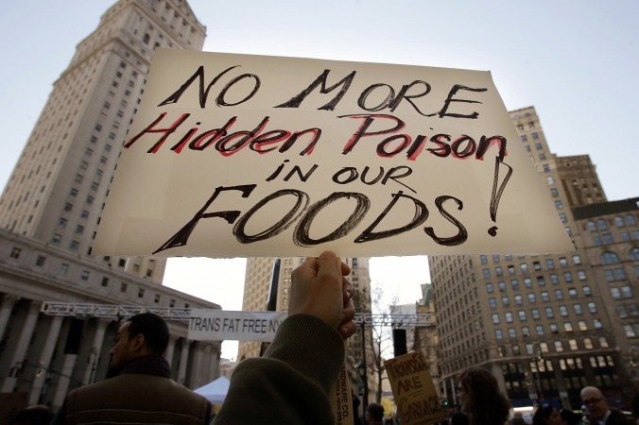

**CONCLUSION**

**T**he increasing number of food producers and the outstanding amounts of imported food stuffs enables the producers to mislead and cheat consumers. To differentiate of those who take advantage of legal rules from the once who commit food adulteration is very difficult. The consciousness of consumers has become very crucial.

However, how can we expect consequent behavior from them regarding controversial issues emerging day by day? In addition, ignorance and unfair market behaviors is endangering consumer health. So we need sanctions and judicial penalties with adequate restraining force to halt this process.

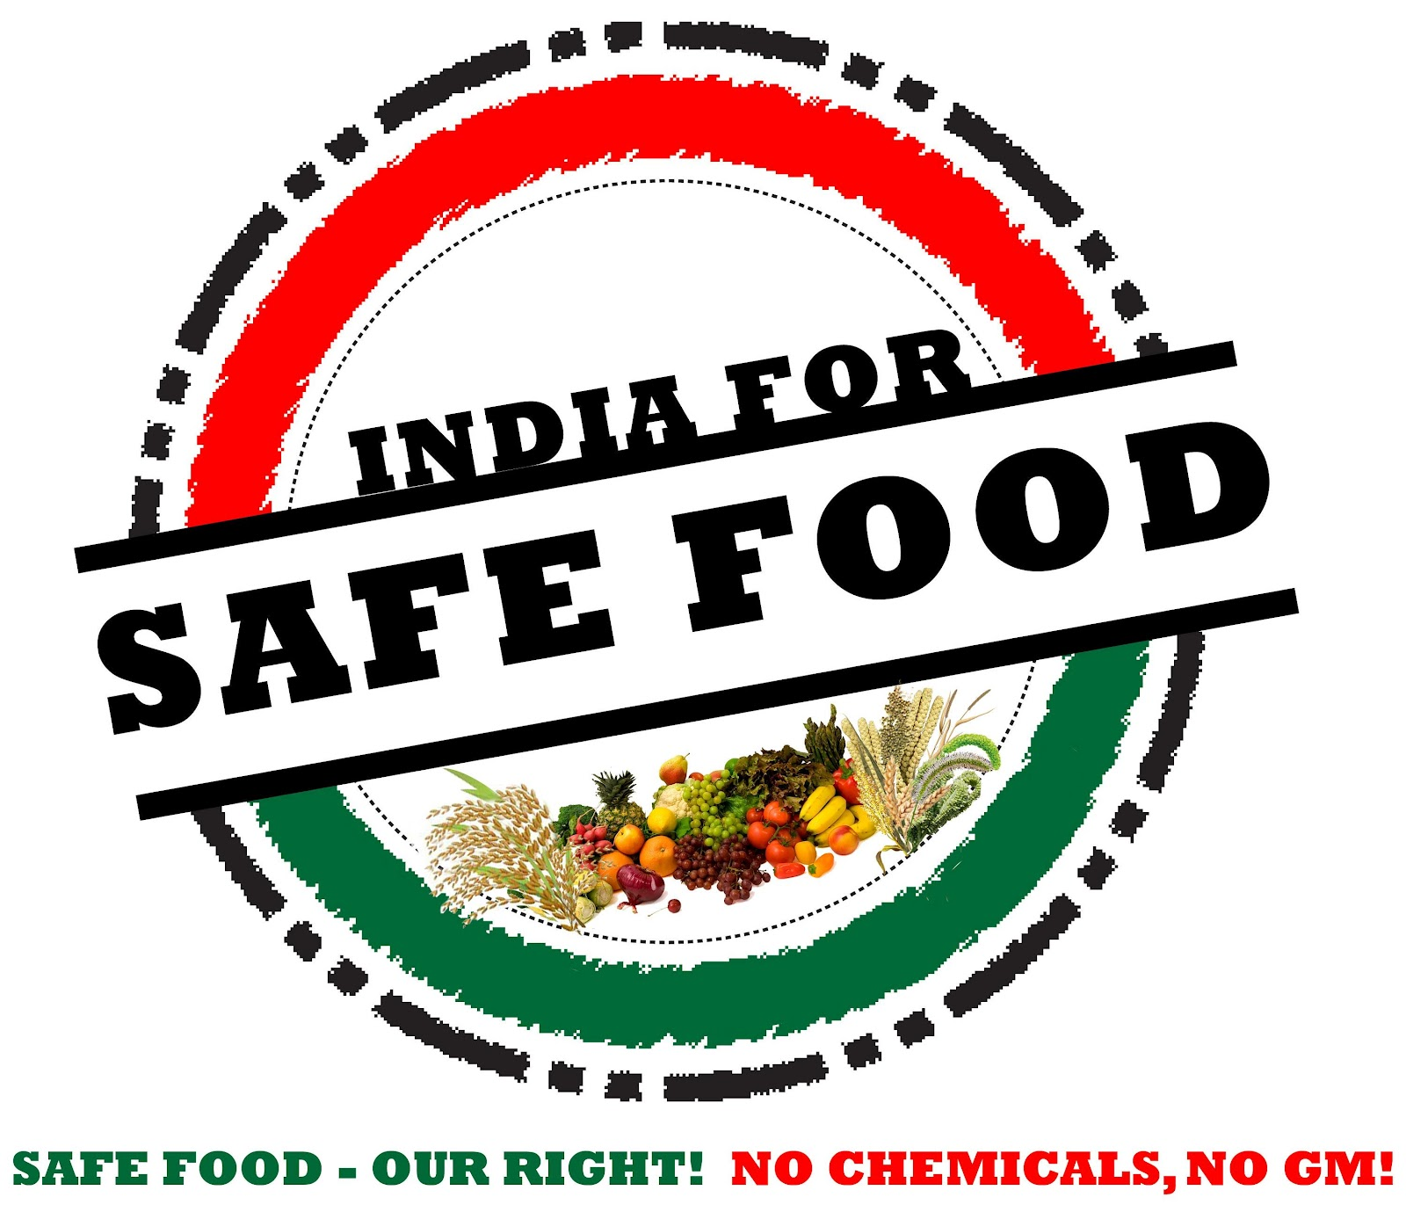

**BIBLIOGRAPHY**

**Book referred:**

* **Food adulteration and its detection  
  -Jesse Park Battershall**
* **A treatise on adulterations of food particles  
  -Friedrich Christian Accum**
* **CBSE text books**

**Websites referred:**

* **www.wikipedia.com**
* **http://agmarknet.nic.in/adulterants.html**