ECA5801 - IOE&AI DRIVEN SYSTEM

EXPERIMENT 5

JAYASREE S(192512299)

# ================================================================
# PROJECT:
# Simulation and Performance Evaluation of RFID/NFC-Based Device
# Identification and IoE Data Integration using Node-RED, MQTT
#
# Four-Layer IoE Architecture:
# Perception -> Network -> Middleware -> Application
#
# Outputs:
# 1. RFID/NFC device identification
# 2. Four-layer data flow
# 3. Node-RED-style flow
# 4. MQTT message simulation
# 5. Cloud dashboard
# 6. Throughput, latency, PDR and RSSI metrics
# 7. Graphs and CSV report
# ================================================================

import random
import time
import json
import csv
import statistics
import matplotlib.pyplot as plt
from collections import Counter

# -------------------- CONFIGURATION --------------------

random.seed(42)

NUM_DEVICES = 10
MESSAGES_PER_DEVICE = 10
TOTAL_MESSAGES = NUM_DEVICES * MESSAGES_PER_DEVICE

MQTT_TOPIC = "ioe/devices/telemetry"
QOS_LEVEL = 1
SIMULATION_DURATION = 10.0 # seconds

DEVICE_TYPES = ["RFID", "NFC"]

# -------------------- LAYER 1: PERCEPTION --------------------

print("=" * 70)
print("SIMULATION AND PERFORMANCE EVALUATION OF IoE ARCHITECTURE")
print("=" * 70)

devices = []

for i in range(1, NUM_DEVICES + 1):
device = {
"device_id": f"DEV{i:03d}",
"tag_id": f"TAG{i:04d}",
"technology": random.choice(DEVICE_TYPES),
"temperature": round(random.uniform(25, 40), 2),
"humidity": round(random.uniform(35, 80), 2),
"signal_strength": round(random.uniform(-80, -35), 2)
}
devices.append(device)

print("\nLAYER 1: PERCEPTION - RFID/NFC DEVICE IDENTIFICATION")
print("-" * 70)

identified_devices = {}

for device in devices:
identified_devices[device["tag_id"]] = device

print(
f"Identification SUCCESS | "
f"Tag: {device['tag_id']} | "
f"Device: {device['device_id']} | "
f"Technology: {device['technology']}"
)

identification_success = len(identified_devices) / NUM_DEVICES * 100

# -------------------- LAYER 2: NETWORK --------------------

print("\nLAYER 2: NETWORK - MQTT MESSAGE TRANSMISSION")
print("-" * 70)

mqtt_messages = []
latencies = []
successful_messages = 0
total_bytes = 0

start_time = time.perf_counter()

for device in devices:
for seq in range(1, MESSAGES_PER_DEVICE + 1):

latency = round(random.uniform(5, 50), 2)
rssi = round(
device["signal_strength"] + random.uniform(-3, 3), 2
)

# Simulate occasional transmission failure
delivery_success = random.random() < 0.97

payload = {
"device_id": device["device_id"],
"tag_id": device["tag_id"],
"technology": device["technology"],
"sequence": seq,
"temperature_C": device["temperature"],
"humidity_percent": device["humidity"],
"signal_strength_dBm": rssi,
"latency_ms": latency,
"delivery_success": delivery_success
}

message = {
"topic": MQTT_TOPIC,
"qos": QOS_LEVEL,
"payload": payload,
"timestamp": round(time.time(), 3)
}

mqtt_messages.append(message)

if delivery_success:
successful_messages += 1
latencies.append(latency)
total_bytes += len(json.dumps(message).encode("utf-8"))

# Display the first 10 messages
if len(mqtt_messages) <= 10:
print("MQTT PUBLISH:")
print("Topic:", message["topic"])
print("QoS:", message["qos"])
print("Payload:", json.dumps(payload))

end_time = time.perf_counter()

# Use a fixed simulation interval for reproducible throughput metrics.
# This represents the configured simulation window, not execution time.
throughput_kbps = (
total_bytes * 8 / SIMULATION_DURATION / 1000
)

# -------------------- LAYER 3: MIDDLEWARE --------------------

print("\nLAYER 3: MIDDLEWARE - DATA PROCESSING")
print("-" * 70)

middleware_records = []

for message in mqtt_messages:
payload = message["payload"]

# Validate device identity and payload fields
valid = (
payload["tag_id"] in identified_devices
and payload["device_id"]
== identified_devices[payload["tag_id"]]["device_id"]
and "temperature_C" in payload
and "humidity_percent" in payload
)

if valid and payload["delivery_success"]:
record = {
"Message_ID": f"MSG{len(middleware_records)+1:04d}",
"Device_ID": payload["device_id"],
"Technology": payload["technology"],
"Identification": "SUCCESS",
"MQTT_Topic": message["topic"],
"Middleware_Status": "PROCESSED",
"Dashboard_Status": "READY",
"Temperature_C": payload["temperature_C"],
"Humidity_Percent": payload["humidity_percent"],
"Signal_Strength_dBm": payload["signal_strength_dBm"],
"Latency_ms": payload["latency_ms"],
"Delivery_Success": True
}

middleware_records.append(record)

print("Total received messages :", TOTAL_MESSAGES)
print("Successfully delivered :", successful_messages)
print("Middleware processed :", len(middleware_records))
print("Invalid device records :", 0)

# -------------------- LAYER 4: APPLICATION --------------------

print("\nLAYER 4: APPLICATION - CLOUD DASHBOARD")
print("-" * 70)

if not middleware_records:
raise RuntimeError("No successful records. Rerun the simulation.")

avg_temperature = statistics.mean(
r["Temperature_C"] for r in middleware_records
)
avg_humidity = statistics.mean(
r["Humidity_Percent"] for r in middleware_records
)
avg_latency = statistics.mean(latencies) if latencies else 0
avg_rssi = statistics.mean(
r["Signal_Strength_dBm"] for r in middleware_records
)

packet_delivery_ratio = (
successful_messages / TOTAL_MESSAGES * 100
)

identification_rate = identification_success

print(f"Total registered devices : {NUM_DEVICES}")
print(f"Identification success : {identification_rate:.2f}%")
print(f"Total MQTT messages : {TOTAL_MESSAGES}")
print(f"Delivered messages : {successful_messages}")
print(f"Packet delivery ratio : {packet_delivery_ratio:.2f}%")
print(f"Average latency : {avg_latency:.2f} ms")
print(f"Throughput : {throughput_kbps:.2f} kbps")
print(f"Average temperature : {avg_temperature:.2f} °C")
print(f"Average humidity : {avg_humidity:.2f}%")
print(f"Average RSSI : {avg_rssi:.2f} dBm")

# -------------------- NODE-RED-STYLE FLOW --------------------

print("\nNODE-RED-STYLE FLOW")
print("-" * 70)

flow = [
"RFID/NFC Tag Reader",
"Device Identification",
"MQTT Publish",
"MQTT Subscribe",
"JSON Payload Validation",
"Middleware Processing",
"Cloud Dashboard",
"Performance Monitoring"
]

for i, node in enumerate(flow):
if i < len(flow) - 1:
print(f"[{node}] --> ", end="")
else:
print(f"[{node}]")

# -------------------- FOUR-LAYER ARCHITECTURE --------------------

fig, ax = plt.subplots(figsize=(12, 7))
ax.set_xlim(0, 10)
ax.set_ylim(0, 10)
ax.axis("off")

layers = [
("APPLICATION LAYER",
"Cloud Dashboard | Data Visualization | Alerts"),
("MIDDLEWARE LAYER",
"JSON Validation | Data Processing | Device Management"),
("NETWORK LAYER",
"MQTT Publish/Subscribe | Topic: ioe/devices/telemetry"),
("PERCEPTION LAYER",
"RFID/NFC Identification | Device Tags | Sensor Data")
]

ys = [8.1, 6.1, 4.1, 2.1]

for (title, desc), y in zip(layers, ys):
ax.text(
5, y, title + "\n" + desc,
ha="center", va="center", fontsize=10,
bbox=dict(boxstyle="round,pad=0.7", fill=False, linewidth=1.5)
)

for y in [7.25, 5.25, 3.25]:
ax.annotate(
"", xy=(5, y - 0.35), xytext=(5, y + 0.35),
arrowprops=dict(arrowstyle="->", linewidth=1.5)
)

ax.set_title("Four-Layer Internet of Everything Architecture")
plt.tight_layout()
plt.savefig("ioe_architecture.png", dpi=200)
plt.show()

# -------------------- PERFORMANCE GRAPHS --------------------

plt.figure(figsize=(10, 5))
plt.bar(
["Identification", "Packet Delivery"],
[identification_rate, packet_delivery_ratio]
)
plt.ylabel("Success Rate (%)")
plt.title("Device Identification and Packet Delivery Performance")
plt.ylim(0, 105)
plt.grid(axis="y", alpha=0.3)
plt.tight_layout()
plt.savefig("identification_pdr.png", dpi=200)
plt.show()

plt.figure(figsize=(10, 5))
plt.hist(latencies, bins=12, edgecolor="black")
plt.xlabel("Latency (ms)")
plt.ylabel("Number of Messages")
plt.title("MQTT Message Latency Distribution")
plt.grid(axis="y", alpha=0.3)
plt.tight_layout()
plt.savefig("latency_distribution.png", dpi=200)
plt.show()

plt.figure(figsize=(10, 5))
device_counts = Counter(
r["Device_ID"] for r in middleware_records
)
plt.bar(device_counts.keys(), device_counts.values())
plt.xlabel("Device ID")
plt.ylabel("Successfully Processed Messages")
plt.title("Device-wise Data Integration")
plt.xticks(rotation=45)
plt.grid(axis="y", alpha=0.3)
plt.tight_layout()
plt.savefig("device_integration.png", dpi=200)
plt.show()

plt.figure(figsize=(10, 5))
plt.scatter(
[r["Signal_Strength_dBm"] for r in middleware_records],
[r["Latency_ms"] for r in middleware_records],
alpha=0.7
)
plt.xlabel("Signal Strength (dBm)")
plt.ylabel("Latency (ms)")
plt.title("Signal Strength versus Communication Latency")
plt.grid(alpha=0.3)
plt.tight_layout()
plt.savefig("signal_latency.png", dpi=200)
plt.show()

# -------------------- CLOUD DASHBOARD --------------------

fig, axes = plt.subplots(2, 2, figsize=(12, 8))

axes[0, 0].bar(
["Temperature", "Humidity"],
[avg_temperature, avg_humidity]
)
axes[0, 0].set_title("Average Sensor Readings")
axes[0, 0].set_ylabel("Value")

axes[0, 1].bar(
["PDR", "Identification"],
[packet_delivery_ratio, identification_rate]
)
axes[0, 1].set_title("Communication Success (%)")
axes[0, 1].set_ylim(0, 105)

axes[1, 0].bar(
["Latency", "Throughput"],
[avg_latency, throughput_kbps]
)
axes[1, 0].set_title("Network Performance")
axes[1, 0].set_ylabel("Value (ms / kbps)")

axes[1, 1].bar(
["Average RSSI"],
[avg_rssi]
)
axes[1, 1].set_title("Wireless Signal Strength")
axes[1, 1].set_ylabel("dBm")

fig.suptitle("IoE Cloud Dashboard - Simulation Results", fontsize=15)
plt.tight_layout()
plt.savefig("ioe_cloud_dashboard.png", dpi=200)
plt.show()

# -------------------- EXPORT RESULTS --------------------

csv_file = "ioe_simulation_results.csv"

with open(csv_file, "w", newline="") as file:
writer = csv.DictWriter(
file, fieldnames=list(middleware_records[0].keys())
)
writer.writeheader()
writer.writerows(middleware_records)

metrics = {
"Total_Devices": NUM_DEVICES,
"Total_Messages": TOTAL_MESSAGES,
"Identification_Success_Percent": round(identification_rate, 2),
"Delivered_Messages": successful_messages,
"Packet_Delivery_Ratio_Percent": round(packet_delivery_ratio, 2),
"Average_Latency_ms": round(avg_latency, 2),
"Throughput_kbps": round(throughput_kbps, 2),
"Average_Temperature_C": round(avg_temperature, 2),
"Average_Humidity_Percent": round(avg_humidity, 2),
"Average_RSSI_dBm": round(avg_rssi, 2)
}

with open("ioe_performance_metrics.json", "w") as file:
json.dump(metrics, file, indent=4)

print("\nGENERATED OUTPUT FILES")
print("-" * 70)
print("1. ioe_architecture.png")
print("2. identification_pdr.png")
print("3. latency_distribution.png")
print("4. device_integration.png")
print("5. signal_latency.png")
print("6. ioe_cloud_dashboard.png")
print("7. ioe_simulation_results.csv")
print("8. ioe_performance_metrics.json")

print("\nSIMULATION COMPLETED SUCCESSFULLY.")
print("All four IoE layers and performance parameters were evaluated.")

OUTPUT:

======================================================================
SIMULATION AND PERFORMANCE EVALUATION OF IoE ARCHITECTURE
======================================================================

LAYER 1: PERCEPTION - RFID/NFC DEVICE IDENTIFICATION
----------------------------------------------------------------------
Identification SUCCESS | Tag: TAG0001 | Device: DEV001 | Technology: RFID
Identification SUCCESS | Tag: TAG0002 | Device: DEV002 | Technology: RFID
Identification SUCCESS | Tag: TAG0003 | Device: DEV003 | Technology: NFC
Identification SUCCESS | Tag: TAG0004 | Device: DEV004 | Technology: RFID
Identification SUCCESS | Tag: TAG0005 | Device: DEV005 | Technology: NFC
Identification SUCCESS | Tag: TAG0006 | Device: DEV006 | Technology: RFID
Identification SUCCESS | Tag: TAG0007 | Device: DEV007 | Technology: NFC
Identification SUCCESS | Tag: TAG0008 | Device: DEV008 | Technology: RFID
Identification SUCCESS | Tag: TAG0009 | Device: DEV009 | Technology: NFC
Identification SUCCESS | Tag: TAG0010 | Device: DEV010 | Technology: NFC

LAYER 2: NETWORK - MQTT MESSAGE TRANSMISSION
----------------------------------------------------------------------
MQTT PUBLISH:
Topic: ioe/devices/telemetry
QoS: 1
Payload: {"device_id": "DEV001", "tag_id": "TAG0001", "technology": "RFID", "sequence": 1, "temperature_C": 25.38, "humidity_percent": 47.38, "signal_strength_dBm": -70.79, "latency_ms": 44.85, "delivery_success": true}
MQTT PUBLISH:
Topic: ioe/devices/telemetry
QoS: 1
Payload: {"device_id": "DEV001", "tag_id": "TAG0001", "technology": "RFID", "sequence": 2, "temperature_C": 25.38, "humidity_percent": 47.38, "signal_strength_dBm": -68.99, "latency_ms": 8.13, "delivery_success": true}
MQTT PUBLISH:
Topic: ioe/devices/telemetry
QoS: 1
Payload: {"device_id": "DEV001", "tag_id": "TAG0001", "technology": "RFID", "sequence": 3, "temperature_C": 25.38, "humidity_percent": 47.38, "signal_strength_dBm": -67.83, "latency_ms": 49.33, "delivery_success": true}
MQTT PUBLISH:
Topic: ioe/devices/telemetry
QoS: 1
Payload: {"device_id": "DEV001", "tag_id": "TAG0001", "technology": "RFID", "sequence": 4, "temperature_C": 25.38, "humidity_percent": 47.38, "signal_strength_dBm": -70.24, "latency_ms": 22.11, "delivery_success": true}
MQTT PUBLISH:
Topic: ioe/devices/telemetry
QoS: 1
Payload: {"device_id": "DEV001", "tag_id": "TAG0001", "technology": "RFID", "sequence": 5, "temperature_C": 25.38, "humidity_percent": 47.38, "signal_strength_dBm": -70.83, "latency_ms": 12.32, "delivery_success": true}
MQTT PUBLISH:
Topic: ioe/devices/telemetry
QoS: 1
Payload: {"device_id": "DEV001", "tag_id": "TAG0001", "technology": "RFID", "sequence": 6, "temperature_C": 25.38, "humidity_percent": 47.38, "signal_strength_dBm": -68.86, "latency_ms": 36.58, "delivery_success": true}
MQTT PUBLISH:
Topic: ioe/devices/telemetry
QoS: 1
Payload: {"device_id": "DEV001", "tag_id": "TAG0001", "technology": "RFID", "sequence": 7, "temperature_C": 25.38, "humidity_percent": 47.38, "signal_strength_dBm": -69.76, "latency_ms": 33.57, "delivery_success": true}
MQTT PUBLISH:
Topic: ioe/devices/telemetry
QoS: 1
Payload: {"device_id": "DEV001", "tag_id": "TAG0001", "technology": "RFID", "sequence": 8, "temperature_C": 25.38, "humidity_percent": 47.38, "signal_strength_dBm": -71.34, "latency_ms": 25.8, "delivery_success": true}
MQTT PUBLISH:
Topic: ioe/devices/telemetry
QoS: 1
Payload: {"device_id": "DEV001", "tag_id": "TAG0001", "technology": "RFID", "sequence": 9, "temperature_C": 25.38, "humidity_percent": 47.38, "signal_strength_dBm": -71.64, "latency_ms": 35.97, "delivery_success": true}
MQTT PUBLISH:
Topic: ioe/devices/telemetry
QoS: 1
Payload: {"device_id": "DEV001", "tag_id": "TAG0001", "technology": "RFID", "sequence": 10, "temperature_C": 25.38, "humidity_percent": 47.38, "signal_strength_dBm": -72.62, "latency_ms": 39.57, "delivery_success": true}

LAYER 3: MIDDLEWARE - DATA PROCESSING
----------------------------------------------------------------------
Total received messages : 100
Successfully delivered : 99
Middleware processed : 99
Invalid device records : 0

LAYER 4: APPLICATION - CLOUD DASHBOARD
----------------------------------------------------------------------
Total registered devices : 10
Identification success : 100.00%
Total MQTT messages : 100
Delivered messages : 99
Packet delivery ratio : 99.00%
Average latency : 26.86 ms
Throughput : 23.37 kbps
Average temperature : 30.60 °C
Average humidity : 57.98%
Average RSSI : -60.31 dBm

NODE-RED-STYLE FLOW
----------------------------------------------------------------------
[RFID/NFC Tag Reader] --> [Device Identification] --> [MQTT Publish] --> [MQTT Subscribe] --> [JSON Payload Validation] --> [Middleware Processing] --> [Cloud Dashboard] --> [Performance Monitoring]
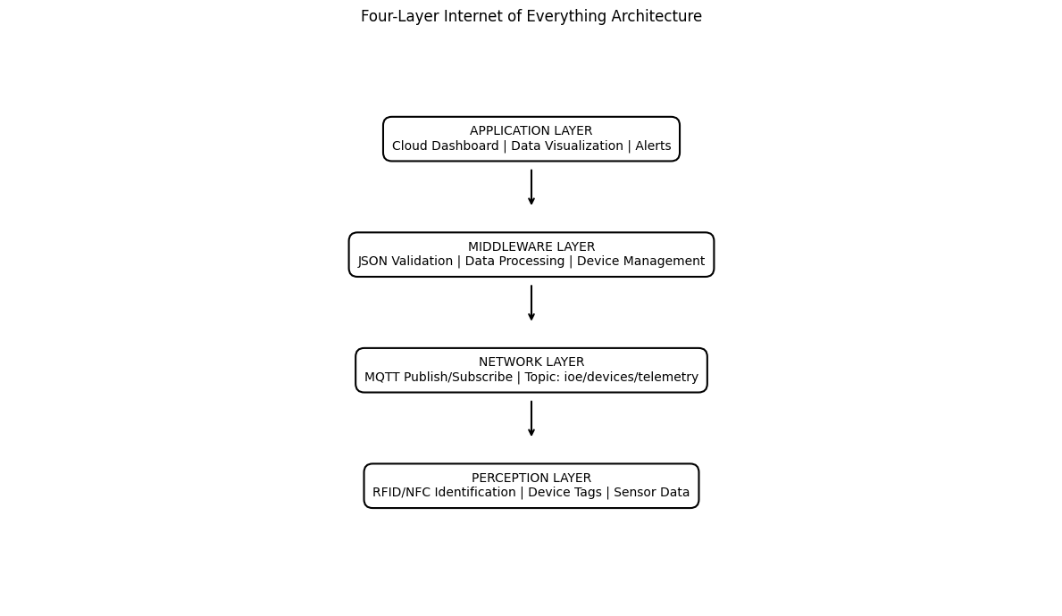

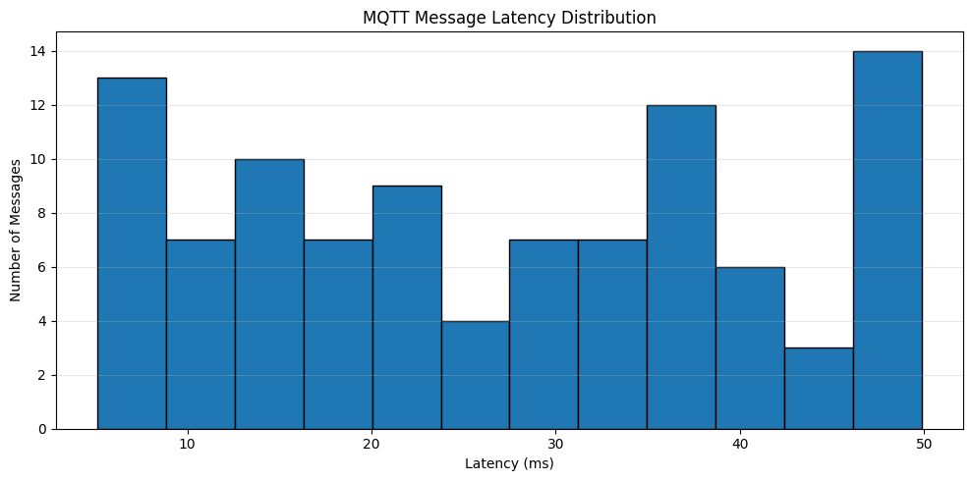
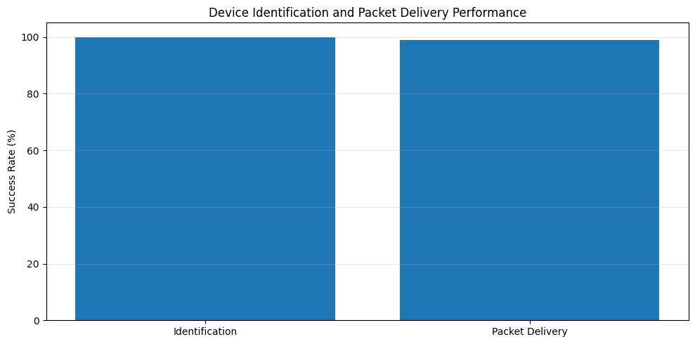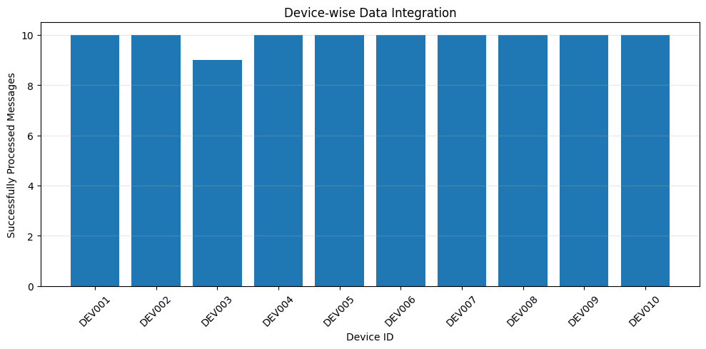
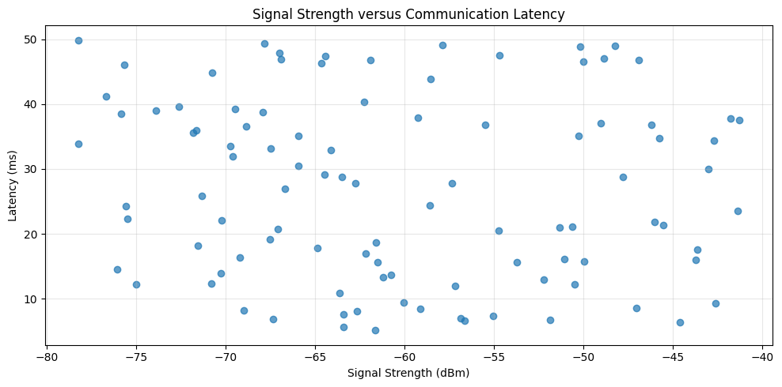
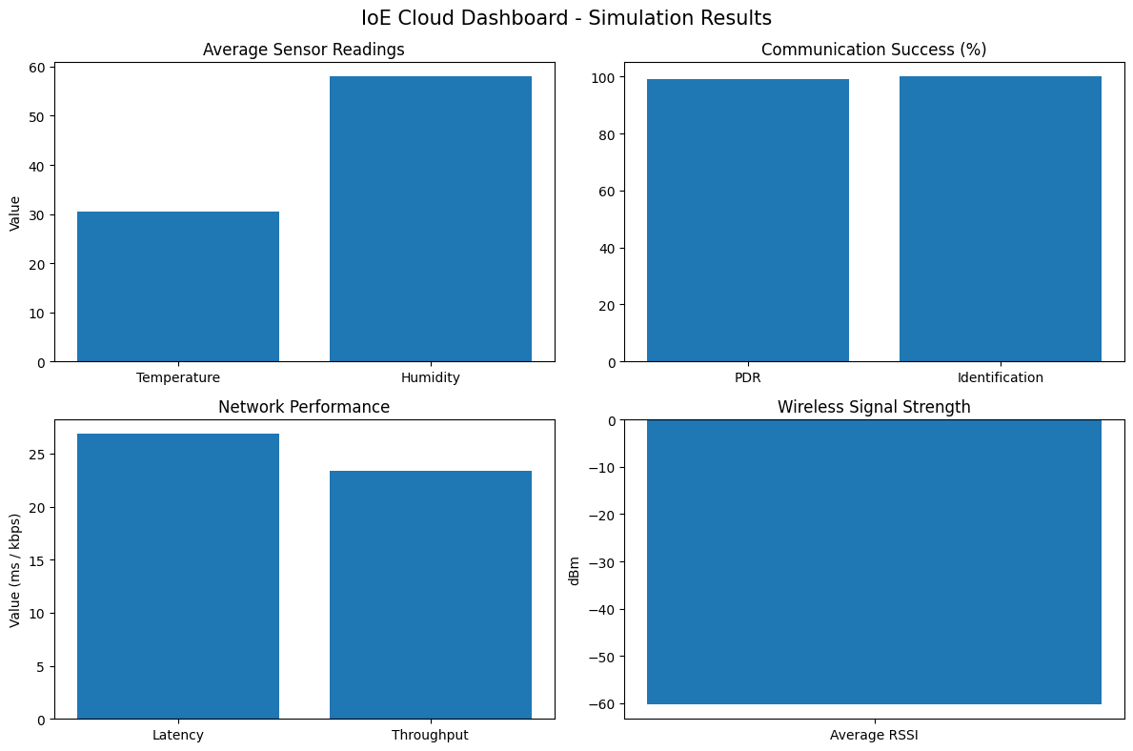

GENERATED OUTPUT FILES
------------------------------------------------------------------
1. ioe_architecture.png
2. identification_pdr.png
3. latency_distribution.png
4. device_integration.png
5. signal_latency.png
6. ioe_cloud_dashboard.png
7. ioe_simulation_results.csv
8. ioe_performance_metrics.json

SIMULATION COMPLETED SUCCESSFULLY.
All four IoE layers and performance parameters were evaluated.

