ECA5801 - IOE&AI DRIVEN SYSTEM

EXPERIMENT 6

JAYASREE S(192512299)

PROGRAM:

# ================================================================
# PROJECT:
# a. Simulation and Performance Evaluation of People-Process-Data-
# Things IoE Framework using Edge/Fog-to-Cloud Pipeline with
# MQTT, Node-RED.
# b. Benchmarking of 5G/6G Communication for IoE Applications
# based on Throughput, Latency, Reliability and Energy Efficiency.
#
# Environment: Google Colab / Python
# Outputs: P-P-D-T flow, Edge/Fog/Cloud metrics, 5G/6G graphs,
# MQTT messages, CSV reports and architecture diagram.
#
# NOTE: This is a model-based simulation, not a live 5G/6G test.
# ================================================================

import random
import json
import csv
import numpy as np
import pandas as pd
import matplotlib.pyplot as plt
from collections import Counter

# -------------------- 1. SIMULATION SETTINGS --------------------

random.seed(42)
np.random.seed(42)

NUM_PEOPLE = 20
NUM_THINGS = 20
MESSAGES_PER_THING = 50
NUM_MESSAGES = NUM_THINGS * MESSAGES_PER_THING

MQTT_TOPIC = "ioe/ppdt/telemetry"
SIMULATION_TIME_S = 10
PACKET_SIZE_BYTES = 1024

print("=" * 75)
print("IoE P-P-D-T FRAMEWORK AND 5G/6G PERFORMANCE BENCHMARK")
print("=" * 75)

# -------------------- 2. PEOPLE-PROCESS-DATA-THINGS --------------------

people = [
{"person_id": f"P{i:03d}", "role": random.choice(
["Operator", "Engineer", "Supervisor"]
)}
for i in range(1, NUM_PEOPLE + 1)
]

things = [
{
"thing_id": f"T{i:03d}",
"temperature_C": round(random.uniform(20, 40), 2),
"humidity_percent": round(random.uniform(30, 80), 2),
"status": "ACTIVE"
}
for i in range(1, NUM_THINGS + 1)
]

print("\nLAYER 1: PEOPLE")
print("People registered:", len(people))
print("Sample:", people[:5])

print("\nLAYER 2: THINGS")
print("IoE devices registered:", len(things))
print("Sample:", things[:5])

# Process layer: rules for processing sensor information
def process_data(record):
record = record.copy()
record["temperature_alert"] = (
record["temperature_C"] >= 35
)
record["humidity_alert"] = (
record["humidity_percent"] >= 70
)
record["processing_status"] = "PROCESSED"
return record

# Data layer: JSON payload creation
raw_records = []
processed_records = []

for thing in things:
for sequence in range(1, MESSAGES_PER_THING + 1):
raw = {
"person_id": people[
(sequence - 1) % len(people)
]["person_id"],
"thing_id": thing["thing_id"],
"sequence": sequence,
"temperature_C": round(
np.clip(
thing["temperature_C"] + np.random.normal(0, 1),
10, 50
), 2
),
"humidity_percent": round(
np.clip(
thing["humidity_percent"] + np.random.normal(0, 2),
10, 100
), 2
)
}

raw_records.append(raw)
processed_records.append(process_data(raw))

print("\nLAYER 3: PROCESS")
print("Total processed records:", len(processed_records))
print("Temperature alerts:", sum(
r["temperature_alert"] for r in processed_records
))
print("Humidity alerts:", sum(
r["humidity_alert"] for r in processed_records
))

print("\nLAYER 4: DATA")
print("Data format: JSON")
print("MQTT topic:", MQTT_TOPIC)
print("Sample JSON:")
print(json.dumps(processed_records[0], indent=2))

# -------------------- 3. MQTT MESSAGE SIMULATION --------------------

mqtt_messages = []

for record in processed_records:
mqtt_messages.append({
"topic": MQTT_TOPIC,
"qos": 1,
"payload": json.dumps(record)
})

print("\nMQTT MESSAGE SIMULATION")
print("Total messages:", len(mqtt_messages))
print("QoS level: 1")
for message in mqtt_messages[:3]:
print("Topic:", message["topic"])
print("QoS:", message["qos"])
print("Payload:", message["payload"])

# -------------------- 4. NODE-RED-STYLE DATA FLOW --------------------

flow = [
"People / IoE Devices",
"Sensor Data Acquisition",
"MQTT Publish",
"Edge Processing",
"Fog Aggregation",
"Cloud Storage / Analytics",
"Dashboard and Alerts"
]

print("\nNODE-RED-STYLE FLOW")
print(" -> ".join(flow))

# -------------------- 5. EDGE / FOG / CLOUD COMPARISON --------------------
# Assumed model parameters, in milliseconds.
# These are illustrative simulation assumptions, not measured values.

pipeline_parameters = {
"Edge": {
"network_delay_ms": 2,
"processing_delay_ms": 3,
"cloud_transfer_delay_ms": 0,
"energy_per_packet_mJ": 0.8
},
"Fog": {
"network_delay_ms": 8,
"processing_delay_ms": 5,
"cloud_transfer_delay_ms": 0,
"energy_per_packet_mJ": 1.5
},
"Cloud": {
"network_delay_ms": 25,
"processing_delay_ms": 12,
"cloud_transfer_delay_ms": 10,
"energy_per_packet_mJ": 2.5
}
}

pipeline_results = []

for layer, params in pipeline_parameters.items():
latencies = np.maximum(
0.1,
np.random.normal(
params["network_delay_ms"]
+ params["processing_delay_ms"]
+ params["cloud_transfer_delay_ms"],
max(0.5, params["network_delay_ms"] * 0.15),
NUM_MESSAGES
)
)

delivery_rate = {
"Edge": 0.995,
"Fog": 0.990,
"Cloud": 0.980
}[layer]

delivered = np.random.random(NUM_MESSAGES) < delivery_rate
pdr = np.mean(delivered) * 100

delivered_bytes = int(
np.sum(delivered) * PACKET_SIZE_BYTES
)

throughput_mbps = (
delivered_bytes * 8 / SIMULATION_TIME_S / 1_000_000
)

# Energy efficiency: successfully delivered bits / energy in joules
energy_joules = (
np.sum(delivered) * params["energy_per_packet_mJ"] / 1000
)

energy_efficiency = (
delivered_bytes * 8 / energy_joules / 1_000_000
if energy_joules > 0 else 0
)

pipeline_results.append({
"Pipeline": layer,
"Average_Latency_ms": round(np.mean(latencies), 2),
"P95_Latency_ms": round(np.percentile(latencies, 95), 2),
"Throughput_Mbps": round(throughput_mbps, 4),
"Reliability_Percent": round(pdr, 2),
"Energy_Efficiency_Mbit_per_J": round(
energy_efficiency, 4
)
})

pipeline_df = pd.DataFrame(pipeline_results)

print("\nEDGE / FOG / CLOUD PERFORMANCE")
print(pipeline_df.to_string(index=False))

# -------------------- 6. 5G / 6G BENCHMARK --------------------
# Illustrative assumptions for an idealized comparison.
# Energy is modeled as radio/network energy per delivered packet.

network_parameters = {
"5G": {
"mean_latency_ms": 10,
"latency_std_ms": 2.5,
"capacity_mbps": 100,
"reliability": 0.990,
"energy_per_packet_mJ": 1.5
},
"6G": {
"mean_latency_ms": 1,
"latency_std_ms": 0.3,
"capacity_mbps": 1000,
"reliability": 0.999,
"energy_per_packet_mJ": 1.0
}
}

network_results = []
network_latency_samples = {}

for network, params in network_parameters.items():

# Generate packet latency samples.
latency = np.maximum(
0.05,
np.random.normal(
params["mean_latency_ms"],
params["latency_std_ms"],
NUM_MESSAGES
)
)

# Simulate communication reliability.
delivered = np.random.random(NUM_MESSAGES) < params["reliability"]
successful_packets = int(np.sum(delivered))
reliability_percent = successful_packets / NUM_MESSAGES * 100

# Delivered traffic, bounded by the assumed network capacity.
offered_mbps = (
successful_packets * PACKET_SIZE_BYTES * 8
/ SIMULATION_TIME_S / 1_000_000
)

throughput_mbps = min(
offered_mbps, params["capacity_mbps"]
)

# Estimate energy from successfully delivered packets.
energy_joules = (
successful_packets * params["energy_per_packet_mJ"] / 1000
)

total_delivered_bits = (
successful_packets * PACKET_SIZE_BYTES * 8
)

energy_efficiency = (
total_delivered_bits / energy_joules / 1_000_000
if energy_joules > 0 else 0
)

network_latency_samples[network] = latency

network_results.append({
"Network": network,
"Throughput_Mbps": round(throughput_mbps, 4),
"Average_Latency_ms": round(np.mean(latency), 3),
"P95_Latency_ms": round(np.percentile(latency, 95), 3),
"Reliability_Percent": round(reliability_percent, 3),
"Energy_Efficiency_Mbit_per_J": round(
energy_efficiency, 3
)
})

network_df = pd.DataFrame(network_results)

print("\n5G / 6G BENCHMARK RESULTS")
print(network_df.to_string(index=False))

# -------------------- 7. P-P-D-T ARCHITECTURE DIAGRAM --------------------

fig, ax = plt.subplots(figsize=(12, 8))
ax.set_xlim(0, 10)
ax.set_ylim(0, 12)
ax.axis("off")

architecture = [
(10, "PEOPLE", "Operators | Engineers | Supervisors"),
(8, "PROCESS", "Rules | Analytics | Alerts"),
(6, "DATA", "JSON | MQTT | Sensor Measurements"),
(4, "THINGS", "IoE Devices | Sensors | Actuators")
]

for y, title, description in architecture:
ax.text(
5, y, title + "\n" + description,
ha="center", va="center", fontsize=11,
bbox=dict(boxstyle="round,pad=0.7", fill=False, linewidth=1.5)
)

for y1, y2 in [(9.2, 8.8), (7.2, 6.8), (5.2, 4.8)]:
ax.annotate(
"", xy=(5, y2), xytext=(5, y1),
arrowprops=dict(arrowstyle="<->", linewidth=1.5)
)

ax.text(
5, 2,
"Edge Processing -> Fog Aggregation -> Cloud Analytics\n"
"MQTT Communication | Node-RED-Style Flow | Dashboard",
ha="center", va="center", fontsize=10
)

ax.set_title("People-Process-Data-Things IoE Framework")
plt.tight_layout()
plt.savefig("ppdt_architecture.png", dpi=200)
plt.show()

# -------------------- 8. EDGE / FOG / CLOUD GRAPHS --------------------

pipeline_metrics = [
("Average_Latency_ms", "Average Latency (ms)"),
("Throughput_Mbps", "Throughput (Mbps)"),
("Reliability_Percent", "Reliability (%)"),
("Energy_Efficiency_Mbit_per_J", "Energy Efficiency (Mbit/J)")
]

for metric, title in pipeline_metrics:
plt.figure(figsize=(8, 5))
plt.bar(pipeline_df["Pipeline"], pipeline_df[metric])
plt.title("Edge / Fog / Cloud: " + title)
plt.ylabel(title)
plt.xlabel("Processing Pipeline")
plt.grid(axis="y", alpha=0.3)
plt.tight_layout()
plt.savefig(
"pipeline_" + metric.lower() + ".png", dpi=200
)
plt.show()

# -------------------- 9. 5G / 6G COMPARISON GRAPHS --------------------

network_metrics = [
("Throughput_Mbps", "Throughput (Mbps)"),
("Average_Latency_ms", "Average Latency (ms)"),
("Reliability_Percent", "Reliability (%)"),
("Energy_Efficiency_Mbit_per_J", "Energy Efficiency (Mbit/J)")
]

for metric, title in network_metrics:
plt.figure(figsize=(8, 5))
plt.bar(network_df["Network"], network_df[metric])
plt.title("5G vs 6G: " + title)
plt.xlabel("Communication Network")
plt.ylabel(title)
plt.grid(axis="y", alpha=0.3)
plt.tight_layout()
plt.savefig(
"network_" + metric.lower() + ".png", dpi=200
)
plt.show()

# -------------------- 10. LATENCY DISTRIBUTION --------------------

plt.figure(figsize=(9, 5))

for network, samples in network_latency_samples.items():
plt.hist(
samples, bins=25, alpha=0.55,
label=network
)

plt.title("5G / 6G Latency Distribution")
plt.xlabel("Latency (ms)")
plt.ylabel("Packet Count")
plt.legend()
plt.grid(alpha=0.3)
plt.tight_layout()
plt.savefig("5g_6g_latency_distribution.png", dpi=200)
plt.show()

# -------------------- 11. RESULTS TABLE EXPORT --------------------

pipeline_df.to_csv("edge_fog_cloud_results.csv", index=False)
network_df.to_csv("5g_6g_benchmark_results.csv", index=False)

pd.DataFrame(processed_records).to_csv(
"ppdt_processed_data.csv", index=False
)

with open("mqtt_sample_messages.json", "w") as f:
json.dump(mqtt_messages[:20], f, indent=2)

summary = {
"project": "P-P-D-T IoE and 5G/6G Benchmark",
"people_registered": NUM_PEOPLE,
"things_registered": NUM_THINGS,
"messages_generated": NUM_MESSAGES,
"mqtt_topic": MQTT_TOPIC,
"pipeline_results": pipeline_results,
"network_results": network_results,
"simulation_time_seconds": SIMULATION_TIME_S,
"packet_size_bytes": PACKET_SIZE_BYTES,
"model_based_simulation": True
}

with open("ioe_benchmark_summary.json", "w") as f:
json.dump(summary, f, indent=2)

print("\n" + "=" * 75)
print("SIMULATION COMPLETED SUCCESSFULLY")
print("=" * 75)

print("\nOUTPUT FILES")
print("1. ppdt_architecture.png")
print("2. pipeline_average_latency_ms.png")
print("3. pipeline_throughput_mbps.png")
print("4. pipeline_reliability_percent.png")
print("5. pipeline_energy_efficiency_mbit_per_j.png")
print("6. network_throughput_mbps.png")
print("7. network_average_latency_ms.png")
print("8. network_reliability_percent.png")
print("9. network_energy_efficiency_mbit_per_j.png")
print("10. 5g_6g_latency_distribution.png")
print("11. edge_fog_cloud_results.csv")
print("12. 5g_6g_benchmark_results.csv")
print("13. ppdt_processed_data.csv")
print("14. mqtt_sample_messages.json")
print("15. ioe_benchmark_summary.json")

OUTPUT:

===========================================================================
IoE P-P-D-T FRAMEWORK AND 5G/6G PERFORMANCE BENCHMARK
===========================================================================

LAYER 1: PEOPLE
People registered: 20
Sample: [{'person_id': 'P001', 'role': 'Supervisor'}, {'person_id': 'P002', 'role': 'Operator'}, {'person_id': 'P003', 'role': 'Operator'}, {'person_id': 'P004', 'role': 'Supervisor'}, {'person_id': 'P005', 'role': 'Engineer'}]

LAYER 2: THINGS
IoE devices registered: 20
Sample: [{'thing_id': 'T001', 'temperature_C': 24.65, 'humidity_percent': 60.1, 'status': 'ACTIVE'}, {'thing_id': 'T002', 'temperature_C': 31.22, 'humidity_percent': 65.8, 'status': 'ACTIVE'}, {'thing_id': 'T003', 'temperature_C': 34.03, 'humidity_percent': 50.98, 'status': 'ACTIVE'}, {'thing_id': 'T004', 'temperature_C': 28.98, 'humidity_percent': 43.91, 'status': 'ACTIVE'}, {'thing_id': 'T005', 'temperature_C': 37.39, 'humidity_percent': 67.94, 'status': 'ACTIVE'}]

LAYER 3: PROCESS
Total processed records: 1000
Temperature alerts: 223
Humidity alerts: 207

LAYER 4: DATA
Data format: JSON
MQTT topic: ioe/ppdt/telemetry
Sample JSON:
{
"person_id": "P001",
"thing_id": "T001",
"sequence": 1,
"temperature_C": 25.15,
"humidity_percent": 59.82,
"temperature_alert": false,
"humidity_alert": false,
"processing_status": "PROCESSED"
}

MQTT MESSAGE SIMULATION
Total messages: 1000
QoS level: 1
Topic: ioe/ppdt/telemetry
QoS: 1
Payload: {"person_id": "P001", "thing_id": "T001", "sequence": 1, "temperature_C": 25.15, "humidity_percent": 59.82, "temperature_alert": false, "humidity_alert": false, "processing_status": "PROCESSED"}
Topic: ioe/ppdt/telemetry
QoS: 1
Payload: {"person_id": "P002", "thing_id": "T001", "sequence": 2, "temperature_C": 25.3, "humidity_percent": 63.15, "temperature_alert": false, "humidity_alert": false, "processing_status": "PROCESSED"}
Topic: ioe/ppdt/telemetry
QoS: 1
Payload: {"person_id": "P003", "thing_id": "T001", "sequence": 3, "temperature_C": 24.42, "humidity_percent": 59.63, "temperature_alert": false, "humidity_alert": false, "processing_status": "PROCESSED"}

NODE-RED-STYLE FLOW
People / IoE Devices -> Sensor Data Acquisition -> MQTT Publish -> Edge Processing -> Fog Aggregation -> Cloud Storage / Analytics -> Dashboard and Alerts

EDGE / FOG / CLOUD PERFORMANCE
Pipeline Average_Latency_ms P95_Latency_ms Throughput_Mbps Reliability_Percent Energy_Efficiency_Mbit_per_J
Edge 5.00 5.81 0.8151 99.5 10.2400
Fog 12.93 14.77 0.8135 99.3 5.4613
Cloud 46.85 52.92 0.8077 98.6 3.2768

5G / 6G BENCHMARK RESULTS
Network Throughput_Mbps Average_Latency_ms P95_Latency_ms Reliability_Percent Energy_Efficiency_Mbit_per_J
5G 0.8143 10.029 14.308 99.4 5.461
6G 0.8192 0.989 1.464 100.0 8.192
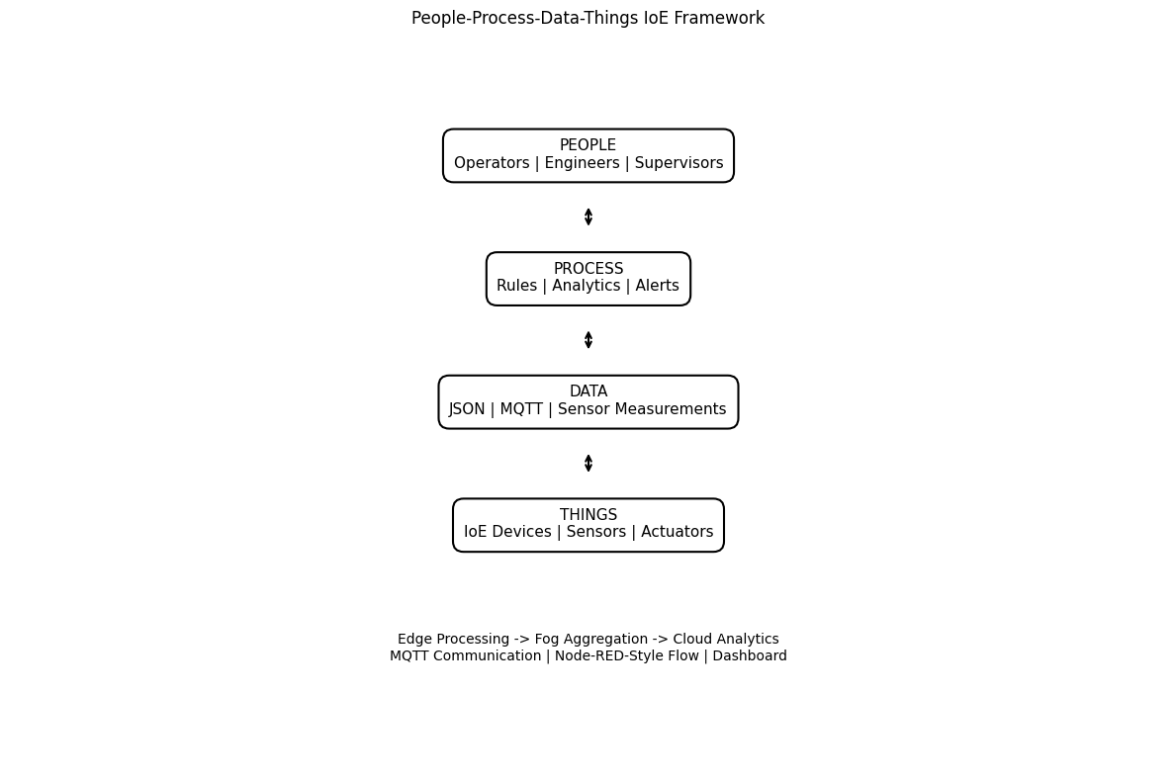
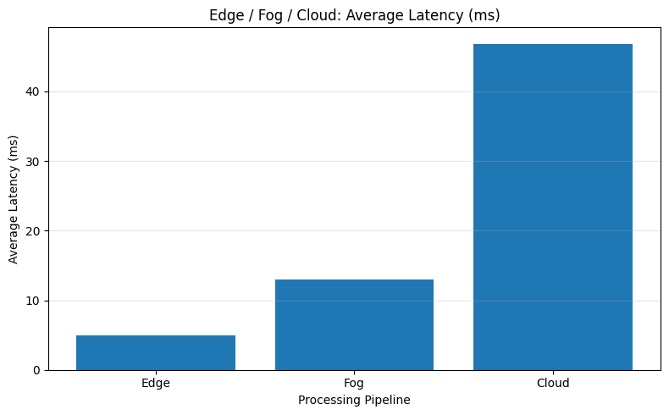
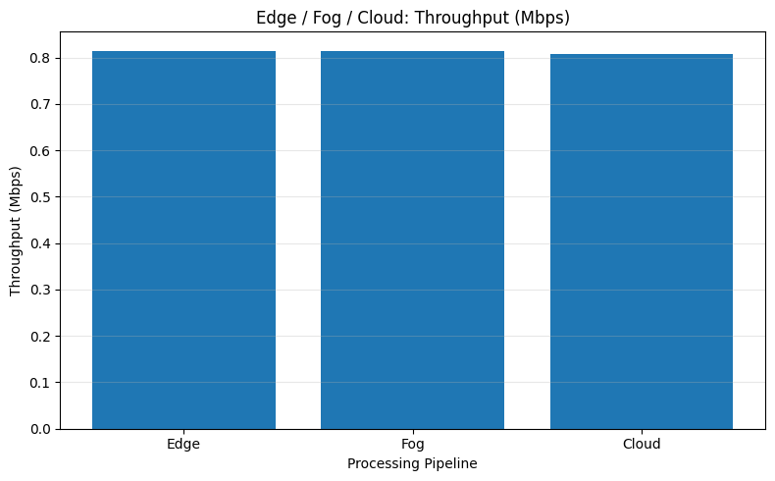
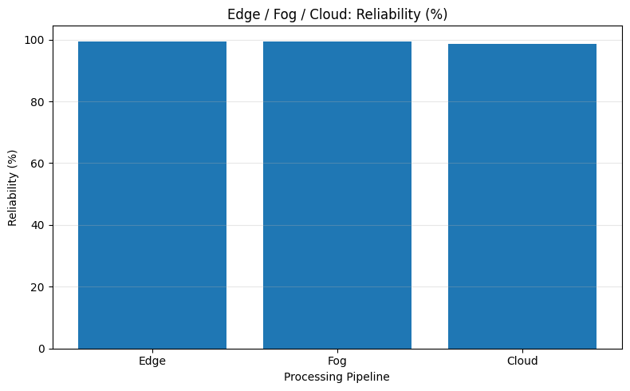
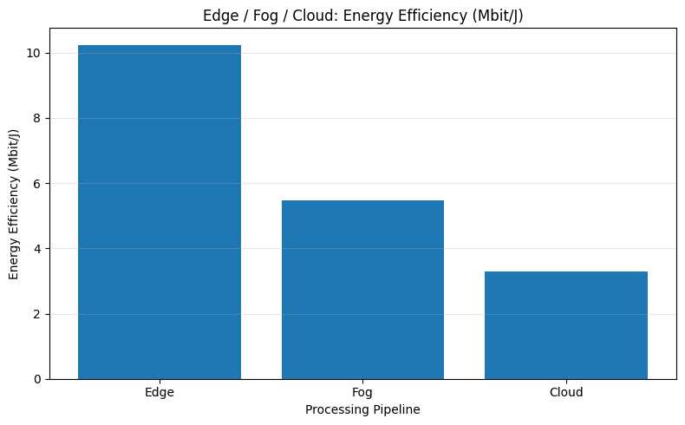
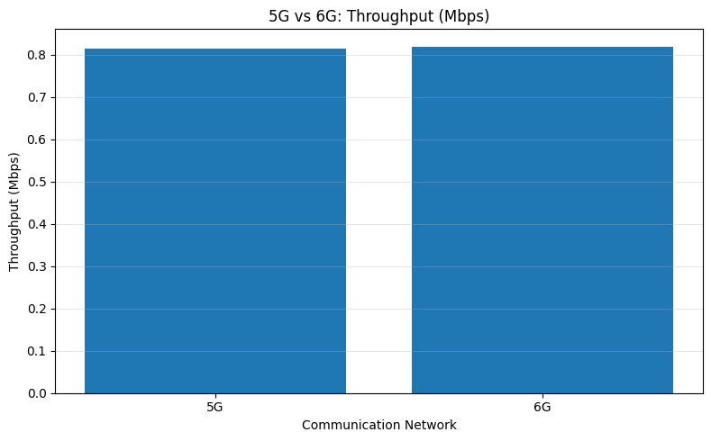
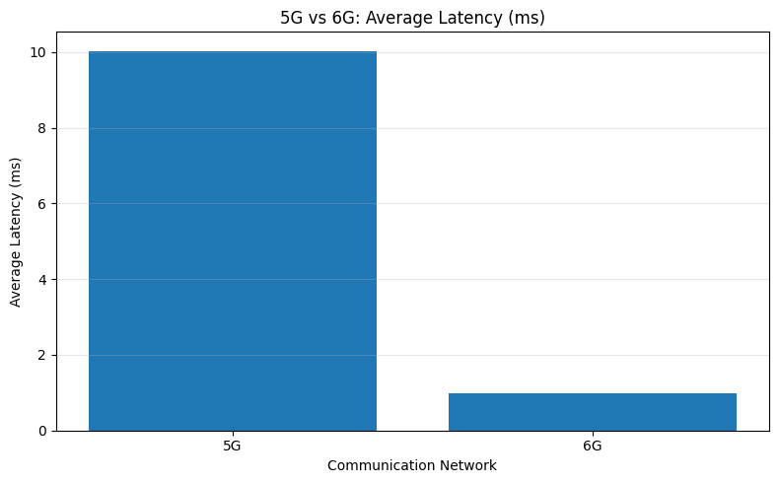
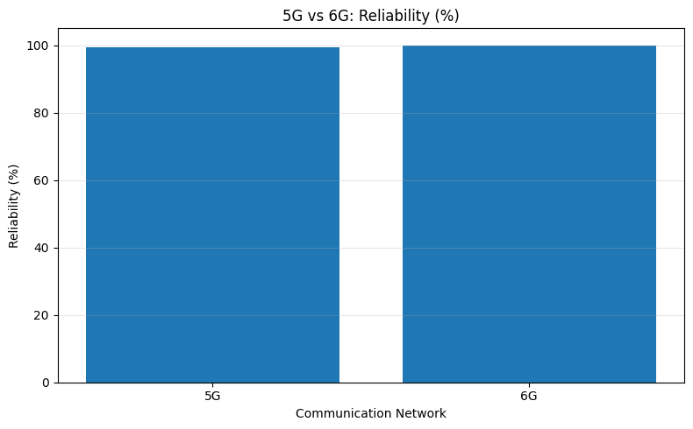
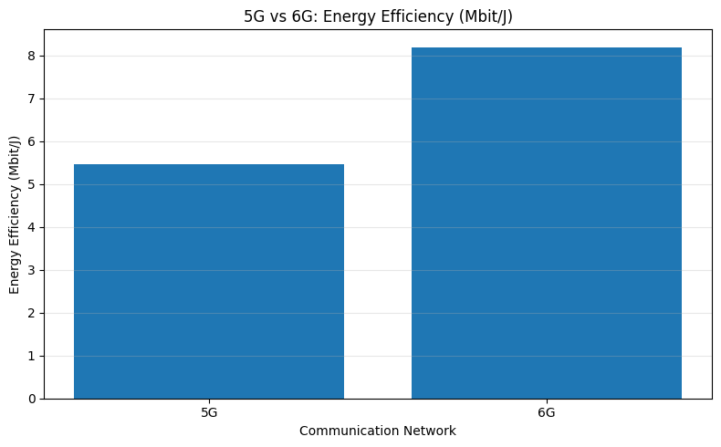
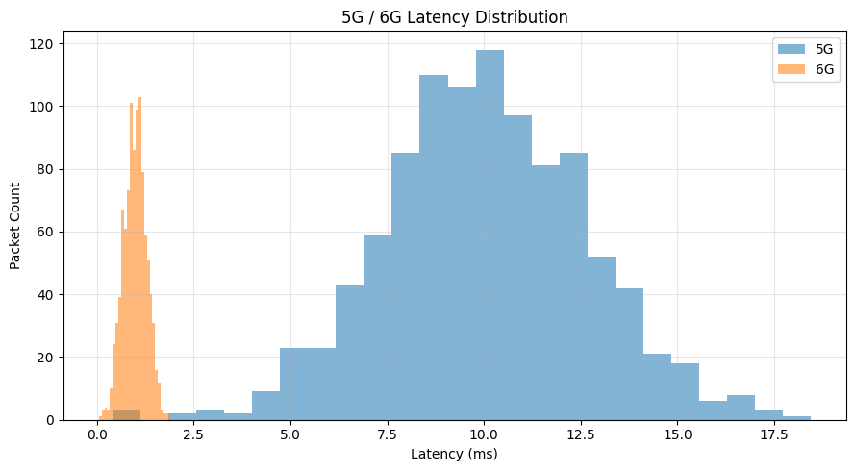

==========================================================================
SIMULATION COMPLETED SUCCESSFULLY
===========================================================================

