ECA5801 - IOE&AI DRIVEN SYSTEM

EXPERIMENT 9

JAYASREE S(192512299)

# ================================================================
# PROJECT:
# Simulation of Telemetry Data Ingestion to Time-Series Database
# and Visualization using Grafana, Power BI and Tableau
#
# Major: IoE Data Analytics and Visualization
# Minor: Telemetry, Time-Series Data, Dashboards, Visualization
#
# RUN: Google Colab - paste the complete code into one cell
# ================================================================

import sys
import subprocess
import importlib.util

# Install required Python packages
for package, module in [
("plotly", "plotly"),
("pandas", "pandas"),
("numpy", "numpy")
]:
if importlib.util.find_spec(module) is None:
subprocess.check_call([
sys.executable, "-m", "pip", "install", "-q", package
])

import os
import json
import sqlite3
import random
import numpy as np
import pandas as pd
import plotly.express as px
import plotly.graph_objects as go
from plotly.subplots import make_subplots
from datetime import datetime, timedelta, timezone

random.seed(42)
np.random.seed(42)

# -------------------- CONFIGURATION --------------------

PROJECT_NAME = "IoE Telemetry Analytics"
DB_FILE = "telemetry_timeseries.db"
CSV_FILE = "telemetry_data.csv"
GRAFANA_FILE = "grafana_dashboard.json"
HTML_FILE = "telemetry_dashboard.html"

NUM_DEVICES = 5
READINGS_PER_DEVICE = 120
INTERVAL_SECONDS = 10

# Optional InfluxDB v2 integration:
# Set these environment variables in your Colab session if you
# have an InfluxDB instance and want to send real stored points.
INFLUX_URL = os.getenv("INFLUX_URL", "")
INFLUX_TOKEN = os.getenv("INFLUX_TOKEN", "")
INFLUX_ORG = os.getenv("INFLUX_ORG", "")
INFLUX_BUCKET = os.getenv("INFLUX_BUCKET", "telemetry")

print("=" * 70)
print("TELEMETRY INGESTION AND VISUALIZATION SYSTEM")
print("=" * 70)

# -------------------- 1. TELEMETRY DATA GENERATION --------------------

print("\n1. GENERATING TIMESTAMPED TELEMETRY DATA")

now = datetime.now(timezone.utc)
rows = []

for device_num in range(1, NUM_DEVICES + 1):
device_id = f"DEVICE_{device_num:03d}"

base_temp = random.uniform(25, 32)
base_humidity = random.uniform(40, 65)
base_pressure = random.uniform(990, 1020)

for i in range(READINGS_PER_DEVICE):
timestamp = now - timedelta(
seconds=(READINGS_PER_DEVICE - 1 - i)
* INTERVAL_SECONDS
)

temperature = (
base_temp
+ 2 * np.sin(i / 10)
+ np.random.normal(0, 0.35)
)

humidity = (
base_humidity
+ 5 * np.sin(i / 15)
+ np.random.normal(0, 1.2)
)

pressure = (
base_pressure
+ 1.5 * np.sin(i / 20)
+ np.random.normal(0, 0.4)
)

rows.append({
"timestamp": timestamp.isoformat(),
"device_id": device_id,
"temperature_c": round(float(temperature), 2),
"humidity_percent": round(
float(np.clip(humidity, 0, 100)), 2
),
"pressure_hpa": round(float(pressure), 2),
"status": "NORMAL" if temperature < 35 else "WARNING"
})

df = pd.DataFrame(rows)
df["timestamp"] = pd.to_datetime(df["timestamp"], utc=True)
df = df.sort_values(["timestamp", "device_id"]).reset_index(drop=True)

print("Devices:", NUM_DEVICES)
print("Readings per device:", READINGS_PER_DEVICE)
print("Total telemetry records:", len(df))
print("\nSample telemetry records:")
print(df.head(10).to_string(index=False))

# -------------------- 2. TIME-SERIES DATABASE --------------------
# SQLite provides a persistent local database file.
# The timestamp column supports historical time-series queries.

print("\n2. STORING DATA IN THE TIME-SERIES DATABASE")

conn = sqlite3.connect(DB_FILE)

df.to_sql(
"telemetry",
conn,
if_exists="replace",
index=False
)

conn.execute("""
CREATE INDEX IF NOT EXISTS idx_telemetry_timestamp
ON telemetry(timestamp)
""")

conn.execute("""
CREATE INDEX IF NOT EXISTS idx_telemetry_device
ON telemetry(device_id)
""")

conn.commit()

stored_df = pd.read_sql_query("""
SELECT timestamp, device_id, temperature_c,
humidity_percent, pressure_hpa, status
FROM telemetry
ORDER BY timestamp
""", conn)

stored_df["timestamp"] = pd.to_datetime(
stored_df["timestamp"], utc=True
)

database_count = pd.read_sql_query(
"SELECT COUNT(*) AS total FROM telemetry",
conn
)["total"][0]

print("Database:", DB_FILE)
print("Records stored:", database_count)
print("Time-series storage verification: SUCCESS")

# -------------------- 3. HISTORICAL QUERY --------------------

print("\n3. HISTORICAL TELEMETRY QUERY")

historical = pd.read_sql_query("""
SELECT
device_id,
COUNT(*) AS readings,
ROUND(AVG(temperature_c), 2) AS avg_temperature_c,
ROUND(MIN(temperature_c), 2) AS min_temperature_c,
ROUND(MAX(temperature_c), 2) AS max_temperature_c,
ROUND(AVG(humidity_percent), 2) AS avg_humidity_percent,
ROUND(AVG(pressure_hpa), 2) AS avg_pressure_hpa
FROM telemetry
GROUP BY device_id
ORDER BY device_id
""", conn)

print(historical.to_string(index=False))
historical.to_csv("historical_summary.csv", index=False)

# -------------------- 4. KPI CALCULATIONS --------------------

avg_temp = stored_df["temperature_c"].mean()
avg_humidity = stored_df["humidity_percent"].mean()
avg_pressure = stored_df["pressure_hpa"].mean()
min_temp = stored_df["temperature_c"].min()
max_temp = stored_df["temperature_c"].max()
warning_count = int((stored_df["status"] == "WARNING").sum())

print("\n4. TELEMETRY KEY PERFORMANCE INDICATORS")
print(f"Total records : {len(stored_df)}")
print(f"Active devices : {stored_df['device_id'].nunique()}")
print(f"Average temperature : {avg_temp:.2f} °C")
print(f"Average humidity : {avg_humidity:.2f} %")
print(f"Average pressure : {avg_pressure:.2f} hPa")
print(f"Minimum temperature : {min_temp:.2f} °C")
print(f"Maximum temperature : {max_temp:.2f} °C")
print(f"Warning records : {warning_count}")

# -------------------- 5. INTERACTIVE DASHBOARD --------------------

print("\n5. BUILDING INTERACTIVE TELEMETRY DASHBOARD")

fig = make_subplots(
rows=2,
cols=2,
subplot_titles=(
"Temperature History",
"Humidity History",
"Pressure History",
"Device-wise Average Temperature"
),
specs=[
[{"type": "scatter"}, {"type": "scatter"}],
[{"type": "scatter"}, {"type": "bar"}]
]
)

# Temperature time series
for device_id, group in stored_df.groupby("device_id"):
fig.add_trace(
go.Scatter(
x=group["timestamp"],
y=group["temperature_c"],
mode="lines",
name=device_id,
legendgroup=device_id,
hovertemplate=(
"Device: " + device_id +
"<br>Time: %{x}<br>Temperature: %{y:.2f} °C"
"<extra></extra>"
)
),
row=1, col=1
)

# Humidity time series
for device_id, group in stored_df.groupby("device_id"):
fig.add_trace(
go.Scatter(
x=group["timestamp"],
y=group["humidity_percent"],
mode="lines",
name=device_id,
legendgroup=device_id,
showlegend=False
),
row=1, col=2
)

# Pressure time series
for device_id, group in stored_df.groupby("device_id"):
fig.add_trace(
go.Scatter(
x=group["timestamp"],
y=group["pressure_hpa"],
mode="lines",
name=device_id,
legendgroup=device_id,
showlegend=False
),
row=2, col=1
)

# Device-wise comparison
device_avg = (
stored_df.groupby("device_id")["temperature_c"]
.mean()
.reset_index()
)

fig.add_trace(
go.Bar(
x=device_avg["device_id"],
y=device_avg["temperature_c"],
name="Average temperature",
showlegend=False
),
row=2, col=2
)

fig.update_xaxes(title_text="Timestamp", row=1, col=1)
fig.update_xaxes(title_text="Timestamp", row=1, col=2)
fig.update_xaxes(title_text="Timestamp", row=2, col=1)
fig.update_yaxes(title_text="Temperature (°C)", row=1, col=1)
fig.update_yaxes(title_text="Humidity (%)", row=1, col=2)
fig.update_yaxes(title_text="Pressure (hPa)", row=2, col=1)
fig.update_yaxes(title_text="Temperature (°C)", row=2, col=2)

fig.update_layout(
title="IoE Telemetry Time-Series Analytics Dashboard",
height=850,
template="plotly_white",
hovermode="x unified"
)

fig.write_html(HTML_FILE, include_plotlyjs=True)
fig.show()

print("Interactive dashboard saved:", HTML_FILE)

# -------------------- 6. COMPARATIVE VISUALIZATION --------------------

print("\n6. CREATING COMPARATIVE VISUALIZATION")

comparison = stored_df.groupby("device_id").agg(
Average_Temperature_C=("temperature_c", "mean"),
Average_Humidity_Percent=("humidity_percent", "mean"),
Average_Pressure_hPa=("pressure_hpa", "mean")
).reset_index()

comparison.to_csv("device_comparison.csv", index=False)

comparison_fig = px.bar(
comparison,
x="device_id",
y=[
"Average_Temperature_C",
"Average_Humidity_Percent",
"Average_Pressure_hPa"
],
barmode="group",
title="Comparative Telemetry Metrics by Device"
)

comparison_fig.write_html(
"telemetry_comparison.html",
include_plotlyjs=True
)
comparison_fig.show()

# -------------------- 7. EXPORT DATA FOR POWER BI / TABLEAU --------------------

print("\n7. EXPORTING POWER BI / TABLEAU DATA")

# Include an ISO timestamp and separate numeric columns.
export_df = stored_df.copy()
export_df["timestamp"] = export_df["timestamp"].astype(str)
export_df.to_csv(CSV_FILE, index=False)

print("CSV exported:", CSV_FILE)
print("Power BI / Tableau import dataset created.")

# -------------------- 8. GRAFANA DASHBOARD JSON TEMPLATE --------------------
# This dashboard expects a configured InfluxDB v2 datasource.
# The datasource UID must be replaced with the UID in your Grafana.
# The optional InfluxDB upload section below sends the same data.

grafana_dashboard = {
"annotations": {"list": []},
"editable": True,
"panels": [
{
"id": 1,
"title": "Temperature History",
"type": "timeseries",
"datasource": {
"type": "influxdb",
"uid": "INFLUXDB_UID"
},
"gridPos": {"h": 9, "w": 12, "x": 0, "y": 0},
"targets": [{
"refId": "A",
"query": (
'from(bucket: "telemetry") '
'|> range(start: -24h) '
'|> filter(fn: (r) => '
'r._measurement == "telemetry" and '
'r._field == "temperature_c")'
),
"queryType": "flux"
}],
"fieldConfig": {
"defaults": {"unit": "celsius"},
"overrides": []
},
"options": {}
},
{
"id": 2,
"title": "Humidity History",
"type": "timeseries",
"datasource": {
"type": "influxdb",
"uid": "INFLUXDB_UID"
},
"gridPos": {"h": 9, "w": 12, "x": 12, "y": 0},
"targets": [{
"refId": "A",
"query": (
'from(bucket: "telemetry") '
'|> range(start: -24h) '
'|> filter(fn: (r) => '
'r._measurement == "telemetry" and '
'r._field == "humidity_percent")'
),
"queryType": "flux"
}],
"fieldConfig": {
"defaults": {"unit": "percent"},
"overrides": []
},
"options": {}
},
{
"id": 3,
"title": "Pressure History",
"type": "timeseries",
"datasource": {
"type": "influxdb",
"uid": "INFLUXDB_UID"
},
"gridPos": {"h": 9, "w": 12, "x": 0, "y": 9},
"targets": [{
"refId": "A",
"query": (
'from(bucket: "telemetry") '
'|> range(start: -24h) '
'|> filter(fn: (r) => '
'r._measurement == "telemetry" and '
'r._field == "pressure_hpa")'
),
"queryType": "flux"
}],
"fieldConfig": {
"defaults": {"unit": "hPa"},
"overrides": []
},
"options": {}
}
],
"schemaVersion": 39,
"tags": ["IoE", "Telemetry", "Time-Series"],
"time": {"from": "now-24h", "to": "now"},
"title": "IoE Telemetry Analytics",
"version": 1
}

with open(GRAFANA_FILE, "w") as f:
json.dump(grafana_dashboard, f, indent=2)

print("Grafana dashboard template saved:", GRAFANA_FILE)

# -------------------- 9. OPTIONAL REAL INFLUXDB INGESTION --------------------

if INFLUX_URL and INFLUX_TOKEN and INFLUX_ORG and INFLUX_BUCKET:
try:
subprocess.check_call([
sys.executable, "-m", "pip", "install", "-q",
"influxdb-client"
])

from influxdb_client import InfluxDBClient, Point
from influxdb_client.client.write_api import SYNCHRONOUS

with InfluxDBClient(
url=INFLUX_URL,
token=INFLUX_TOKEN,
org=INFLUX_ORG
) as client:

with client.write_api(
write_options=SYNCHRONOUS
) as write_api:

points = []
for _, r in stored_df.iterrows():
point = (
Point("telemetry")
.tag("device_id", str(r["device_id"]))
.field("temperature_c", float(r["temperature_c"]))
.field("humidity_percent", float(r["humidity_percent"]))
.field("pressure_hpa", float(r["pressure_hpa"]))
.time(r["timestamp"].to_pydatetime()
)
points.append(point)

write_api.write(
bucket=INFLUX_BUCKET,
org=INFLUX_ORG,
record=points
)

print("InfluxDB upload: SUCCESS")
print("Bucket:", INFLUX_BUCKET)

except Exception as e:
print("InfluxDB upload failed:", str(e))
print("Check your URL, token, organization and bucket.")
else:
print("\nInfluxDB upload skipped.")
print("Local SQLite database and CSV files are ready.")
print("Set INFLUX_URL, INFLUX_TOKEN, INFLUX_ORG and")
print("INFLUX_BUCKET to enable external InfluxDB ingestion.")

# -------------------- 10. FINAL REPORT --------------------

report = {
"project": PROJECT_NAME,
"database": DB_FILE,
"total_records": int(len(stored_df)),
"device_count": int(stored_df["device_id"].nunique()),
"average_temperature_c": round(float(avg_temp), 2),
"average_humidity_percent": round(float(avg_humidity), 2),
"average_pressure_hpa": round(float(avg_pressure), 2),
"warning_records": warning_count,
"outputs": [
DB_FILE,
CSV_FILE,
"historical_summary.csv",
"device_comparison.csv",
HTML_FILE,
"telemetry_comparison.html",
GRAFANA_FILE
]
}

with open("telemetry_report.json", "w") as f:
json.dump(report, f, indent=2)

conn.close()

print("\n" + "=" * 70)
print("SIMULATION COMPLETED SUCCESSFULLY")
print("=" * 70)
print(json.dumps(report, indent=2))

OUTPUT:
======================================================================
TELEMETRY INGESTION AND VISUALIZATION SYSTEM
======================================================================

1. GENERATING TIMESTAMPED TELEMETRY DATA
Devices: 5
Readings per device: 120
Total telemetry records: 600

Sample telemetry records:
Timestamp Device_id temperature humidity pressure_hpa
2026-10-20 07:32:30.351010+00:00 DEVICE_001 29.65 40.46 998.51 NORMAL
2026-10-20 07:32:30.351010+00:00 DEVICE_002 26.74 60.25 1010.26 NORMAL
2026-10-20 07:32:30.351010+00:00 DEVICE_003 31.35 40.12 1002.12 NORMAL
2026-10-20 07:32:30.351010+00:00 DEVICE_004 25.09 45.05 1005.03 NORMAL
2026-10-20 07:32:30.351010+00:00 DEVICE_005 25.42 46.38 1009.57 NORMAL
2026-10-20 07:32:40.351010+00:00 DEVICE_001 30.21 40.68 998.23 NORMAL
2026-10-20 07:32:40.351010+00:00 DEVICE_002 26.90 59.57 1010.22 NORMAL
2026-10-20 07:32:40.351010+00:00 DEVICE_003 31.71 42.71 1002.66 NORMAL
2026-10-20 07:32:40.351010+00:00 DEVICE_004 26.14 46.26 1005.41 NORMAL
2026-10-20 07:32:40.351010+00:00 DEVICE_005 24.93 45.78 1009.31 NORMAL

2. STORING DATA IN THE TIME-SERIES DATABASE
Database: telemetry_timeseries.db
Records stored: 600
Time-series storage verification: SUCCESS

3. HISTORICAL TELEMETRY QUERY
device_id readings avg_temperature_c min_temperature_c max_temperature_c avg_humidity_percent avg_pressure_hpa
DEVICE_001 120 29.54 27.05 32.22 41.09 998.31
DEVICE_002 120 26.60 24.17 29.10 59.02 1010.31
DEVICE_003 120 31.30 28.70 34.11 43.06 1002.70
DEVICE_004 120 25.33 22.77 27.91 46.07 1005.19
DEVICE_005 120 25.27 22.82 28.06 45.70 1009.53

4. TELEMETRY KEY PERFORMANCE INDICATORS
Total records : 600
Active devices : 5
Average temperature : 27.61 °C
Average humidity : 46.99 %
Average pressure : 1005.21 hPa
Minimum temperature : 22.77 °C
Maximum temperature : 34.11 °C
Warning records : 0

- BUILDING INTERACTIVE TELEMETRY DASHBOARD
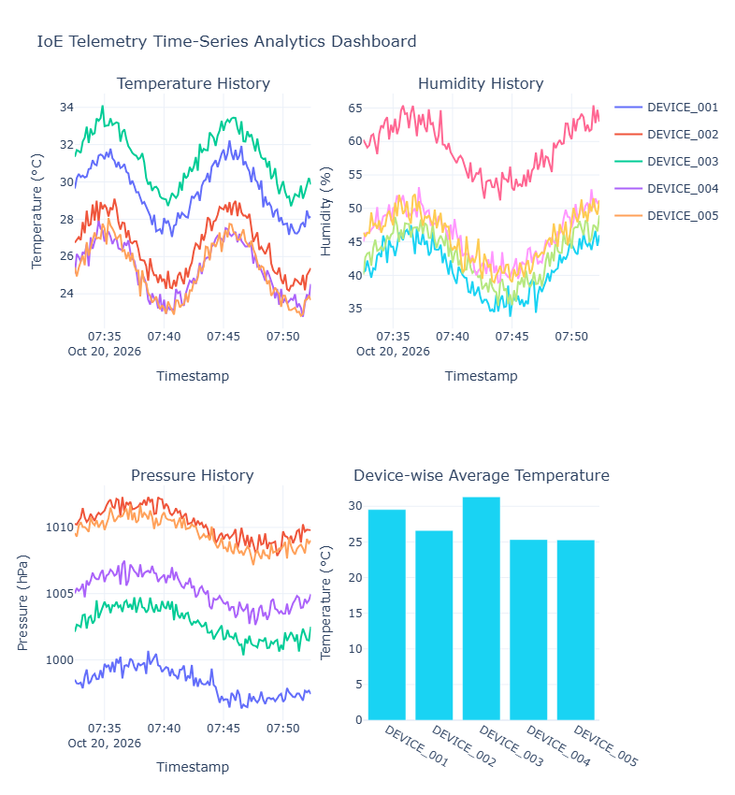

6.CREATING COMPARATIVE VISUALIZATION
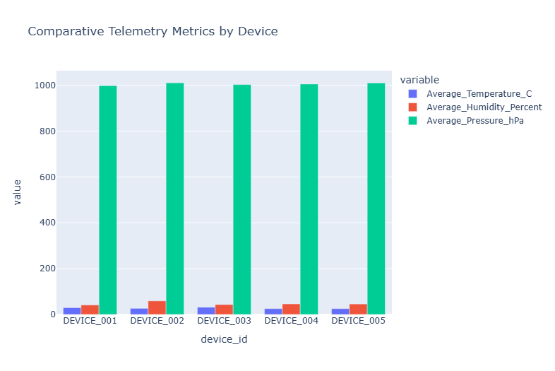
7.EXPORTING POWER BI / TABLEAU DATA
CSV exported: telemetry_data.csv
Power BI / Tableau import dataset created.
Grafana dashboard template saved: grafana_dashboard.json

InfluxDB upload skipped.
Local SQLite database and CSV files are ready.
Set INFLUX_URL, INFLUX_TOKEN, INFLUX_ORG and
INFLUX_BUCKET to enable external InfluxDB ingestion.

======================================================================
SIMULATION COMPLETED SUCCESSFULLY
======================================================================

