{{#each photos}}

[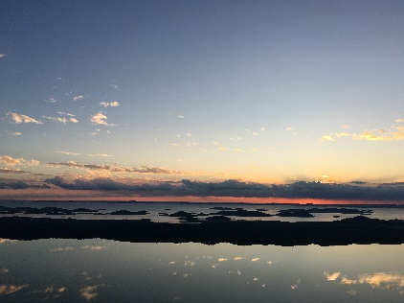](%7B%7Burl%7D%7D)

{{/each}}