**KUBERNETS INSTALLATION INSTRUCTION (On Windows)**

Step 1: Install kubectl.exe using this link: <https://storage.googleapis.com/kubernetes-release/release/v1.9.0/bin/windows/amd64/kubectl.exe>

Step 2 : Install Google cloud SDK using<https://cloud.google.com/sdk/docs/quickstart-windows>

Step 3: Set system variable to gcloud

Step 4: Go to kuberctl exe download path and Open cmd using Run as admin

Step 5: Run command “**gcloud components install kubectl**”

Step 6: Run **kubectl version** to verify that the version you’ve installed is sufficiently up-to-date.

Step 7 : Download and Install Minikube from following link <https://github.com/kubernetes/minikube/releases>

Step 8: Create one new folder (Name: Minikube) on C drive, Move Kubectl.exe and Minikube.exe file to that folder.

Step 9 : Download and install Oracle Virtual box or Hyper V(For windows 10 users) and set environment variable to the path where Virtual box gets installed.

Step 10: Open command prompt/Powershell using run as admin, Move to the Minikube folder

Step 11: Enter a command “**minikube start**”

Step 12: we’ll call the deployment webserver and use the nginx:alpine image using following command “**kubectl run webserver --image=nginx:alpine**”

Step 13 : Take the deployment & pod using the kubectl get command “**kubectl get deployments**”

Step 14: To see the Pods from kubernets using command “**kubectl get pods**”

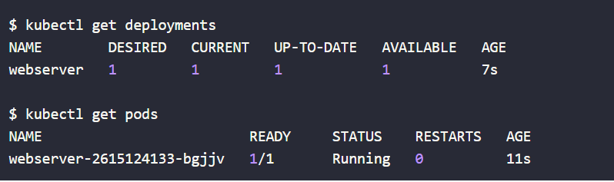

Step 15 : Kubectl Service we will use the kubectl delete command like “**kubectl delete pod webserver-2615124133-bgjjv**” (Use name of the webserver)

Step 16: We’ll create a service for our “webserver” deployment by using the kubectl exposecommand, “**kubectl expose deployment webserver --type=LoadBalancer --port=80**”

Step 17: To get service list which already exposed in kubectl using “**kubectl get services**”

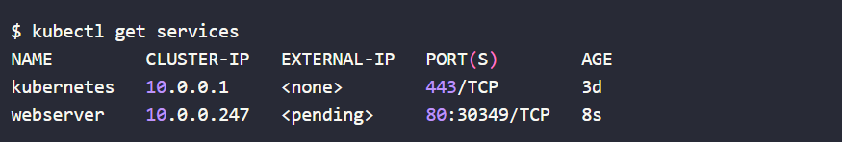

Step 18: Viewing the URL that the command gave from our browser will show the default nginx landing page using “**minikube service webserver --url**” It give us like this <http://192.168.99.101:30349> (We no need any external IP for running minikube)

Step 19: Kubernetes can be visualized through dashboards and minikube comes with one baked right in. You can launch the dashboard using this command “**minikube dashboard**”, Following image shows the kubernets dashboard.

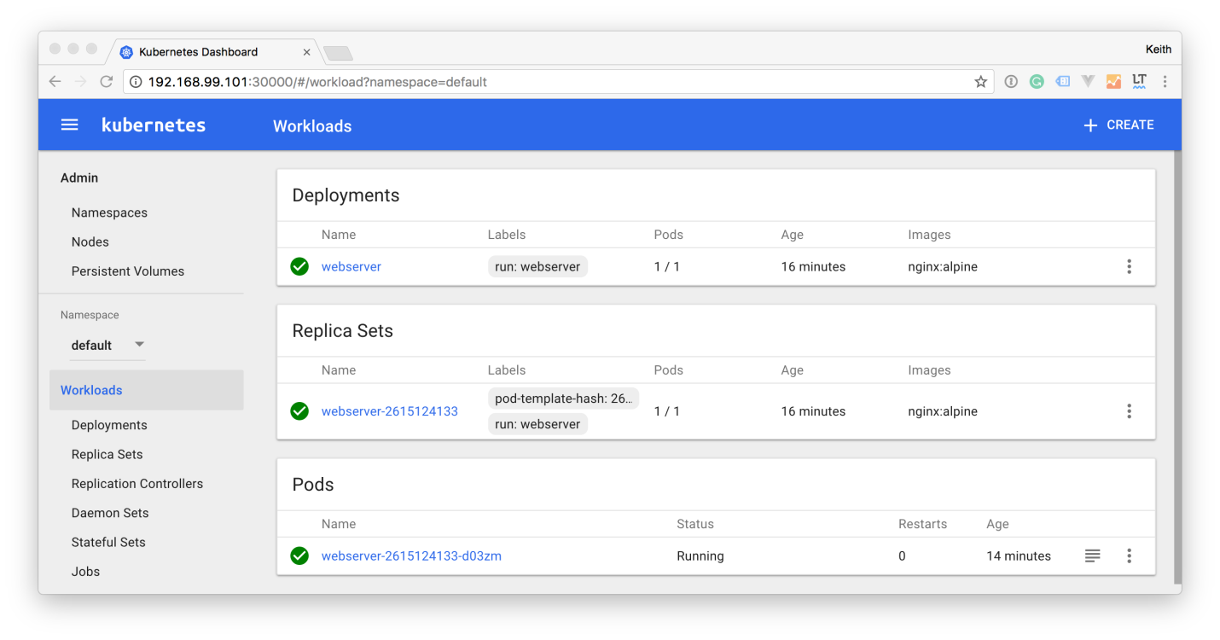

Note: This instruction will work perfectly in No proxy machine. If we are using proxy system we should give the following command in every cmd to set proxy.

* set HTTP_PROXY=http://host:port
* set HTTPS_PROXY=https://host:port