MA-ROPE: Multi-RAT Privacy-Preserving Federated Deep Reinforcement Learning for V2X Task Offloading
Anonymous Authors
Abstract
Autonomous vehicles must run diverse tasks with stringent QoS requirements that often exceed onboard computational capacity, motivating offloading to the network edge. Dense vehicular offloading can overload single-RAT V2X systems as vehicle density increases, and evaluating a policy at one operating point can conceal how quickly performance degrades under contention. We propose MA-ROPE—Multi-RAT Privacy-Preserving Federated Deep Reinforcement Learning for V2X Task Offloading—which jointly selects among LTE, ITS-G5, WiFi-6, and 5G-NR and adapts partial offload ratios via a Dueling Double DQN policy coordinated through FedAvg, without centrally pooling raw observations. Under URLLC stress at N=32 vehicles, MA-ROPE achieves 83.4% fleet on-time delivery versus 52.5% for single-RAT AllOffload, improves $U_{OTR}$ by 0.178, cuts energy by 25.2% (0.706 J vs. 0.944 J), and lowers queue-classified loss to 0.85% versus 2.14%. We also introduce the Deadline Retention Ratio (DRR) to capture performance across fleet sizes: across a fourfold increase from N=8 to N=32, MA-ROPE retains 94.0% of its reference-density delivery versus 59.9% for AllOffload. The multi-RAT controller adds no measurable step-time overhead (166.6 μs vs. 167.6 μs), and DQN inference remains 59.83 μs per agent. Centralized MADDPG attains a slightly higher $U_{OTR}$ (by 0.009) but requires centralized observations and 34% more energy. These results show that jointly optimizing RAT selection, partial offloading, and shared MEC queue contention is necessary for deadline-compliant V2X delivery under dense conditions.
Index Terms—Task offloading, V2X, VEC, federated deep reinforcement learning, multi-RAT, heterogeneous networks, edge computing, autonomous driving, privacy-preserving, Jakes fading.

I. INTRODUCTION
Vehicle-to-Everything (V2X) communication enables safety-critical and compute-intensive applications such as cooperative perception, autonomous driving, and real-time hazard avoidance. These applications impose heterogeneous Quality-of-Service (QoS) requirements: safety messages may become unusable within approximately 100 ms, whereas compute and infotainment workloads can tolerate substantially larger delays. At the same time, processing the growing volume of camera, radar, and LiDAR data entirely on resource-constrained vehicle Electronic Control Units (ECUs) is increasingly difficult. Vehicular Edge Computing (VEC) addresses this limitation by offloading computation to roadside Multi-access Edge Computing (MEC) servers.
The effectiveness of offloading, however, depends jointly on where computation is performed and how the offloaded workload reaches the edge. No single Radio Access Technology (RAT) is uniformly optimal across task types and mobility conditions. LTE, ITS-G5, WiFi-6, and 5G-NR exhibit different latency, throughput, coverage, and mobility characteristics. A RAT suitable for a delay-tolerant compute task may therefore be unsuitable for a safety-critical task generated by the same vehicle. Moreover, binary local/offload decisions cannot exploit parallel local and MEC processing. These observations motivate treating RAT selection and partial computation offloading as a joint decision rather than as independent optimization stages.
A second challenge emerges as vehicle density increases. Vehicles associated with the same RSU compete not only for wireless resources but also for a shared MEC processing queue. Consequently, aggressive offloading that performs well for an isolated vehicle may degrade when many vehicles simultaneously submit workloads. This degradation can also be hidden by conventional communication metrics. Packet Reception Ratio (PRR) counts a packet as successfully delivered even when it arrives after its application deadline; for safety-critical traffic, however, a late result may be operationally equivalent to a lost one. Evaluation must therefore distinguish successful reception from deadline-compliant delivery.
To address these coupled challenges, we propose MA-ROPE, a multi-agent framework that jointly learns RAT selection and partial computation offloading under shared MEC contention. Each vehicle selects among LTE, ITS-G5, WiFi-6, and 5G-NR while adapting its offloaded workload fraction to channel conditions, task requirements, energy consumption, and queue state. A Dueling Double DQN learns the decision policy, while Federated Averaging (FedAvg) enables cooperative learning through model-parameter exchange without centrally pooling raw vehicle observations.
Central research question: Can a federated multi-RAT offloading policy preserve deadline-compliant V2X delivery as fleet density and shared MEC contention increase?
Our results show that the distinction becomes substantial under dense traffic. Under URLLC stress, MA-ROPE achieves a fleet On-Time delivery Rate (OTR) of 0.834 at $N=32$, compared with 0.525 for single-RAT AllOffload, while consuming 25.2% less energy. The underlying density experiment shows that MA-ROPE decreases only from 0.887 OTR at $N=8$ to 0.834 at $N=32$, whereas AllOffload decreases from 0.877 to 0.525.
To quantify this density robustness directly, we introduce the Deadline Retention Ratio (DRR), $R_{D}$, which measures the fraction of reference-density on-time delivery retained as fleet size increases. Across the fourfold increase from $N=8$ to $N=32$, MA-ROPE achieves $R_{D}=0.940$, whereas single-RAT AllOffload achieves $R_{D}=0.599$. Thus, MA-ROPE retains approximately 94% of its reference deadline performance compared with approximately 60% for single-RAT offloading. The complete definition and density analysis are presented in Section V-F.
Despite extensive research on VEC offloading, existing approaches generally address only subsets of heterogeneous RAT selection, partial computation offloading, multi-vehicle MEC contention, mobility-aware channel behavior, and federated cooperative learning. MA-ROPE brings these dimensions together to evaluate not only performance at a fixed operating point, but also how well deadline-compliant service survives increasing fleet contention.
The main contributions of this work are:
- C1: Joint multi-RAT partial offloading. We formulate RAT selection and partial computation offloading as a unified decision across LTE, ITS-G5, WiFi-6, and 5G-NR, incorporating heterogeneous channel behavior and shared RSU queue contention.
- C2: Federated queue-aware learning. We develop a Dueling Double DQN policy coordinated through FedAvg, enabling vehicles to learn cooperatively without centrally pooling their raw observations while explicitly accounting for multi-vehicle MEC contention.
- C3: Deadline-aware density evaluation. We distinguish communication reliability (PRR) from application-useful on-time delivery (OTR) and introduce the Deadline Retention Ratio $R_{D}$ to quantify how much deadline performance a policy preserves as fleet density increases. MA-ROPE achieves $R_{D}=0.940$ over $N=8→32$, compared with 0.599 for AllOffload.
- C4: Dense-fleet performance validation. Under URLLC stress at $N=32$, MA-ROPE achieves 83.4% fleet OTR versus 52.5% for AllOffload, while consuming 25.2% less energy. Against the centralized MADDPG upper bound, MA-ROPE trades a small $U_{OTR}$ difference for lower energy consumption and decentralized raw-observation handling.

II. RELATED WORK
A. Task Offloading in Vehicular Networks
Existing V2X offloading approaches broadly include heuristic, optimization-based, and learning-based methods. Greedy and heuristic schemes such as CoopEC [1] select offloading destinations using predefined decision rules, but their ability to adapt to rapidly varying channel conditions and shared-resource contention is limited. Bandit and tabular approaches such as UCB [2] introduce online adaptation but are better suited to relatively small and stationary decision spaces. Control-theoretic methods based on Lyapunov optimization [3] explicitly address queue stability, but generally optimize time-averaged objectives rather than task-specific deadline compliance. Deep reinforcement learning approaches [3], [4], [5] provide greater adaptability, although many existing formulations simplify either the communication interface or the computation decision through single-RAT operation or binary local/offload actions.
Guo et al. [6] proposed DTOF/HIOA, combining DDQN+LSTM with Nash-equilibrium-based optimization in a three-tier cloud-edge-vehicle architecture over 5G-NR. Although the framework achieves strong delay performance, it does not jointly consider heterogeneous RAT selection, federated cooperation, and shared RSU queue contention across co-located vehicles.
A complementary line of work considers partial offloading, where a task is divided between local and MEC execution rather than being processed entirely at one location. Parallel local and remote execution can reduce completion time by exploiting both computing resources simultaneously. Prior work has established such parallel-execution models [7], including formulations in which total completion delay is governed by the slower of the local and remote processing branches. In most such approaches, however, the offload ratio is optimized independently of heterogeneous radio selection. MA-ROPE instead couples these decisions: the amount of computation transmitted and the RAT used for transmission are jointly determined, with the realized offload ratio adapting to the SINR of the selected interface.
B. Multi-RAT and Heterogeneous Access Selection
Heterogeneous V2X access has traditionally been studied primarily as a communication-selection problem. Yacheur et al. [8] developed DDQN-based selection between ITS-G5 and LTE-V2X, demonstrating the benefit of adapting RAT choice to channel conditions. Their physical-layer parameters and SINR-based Division Mode motivate elements of the heterogeneous channel and partial-offloading models adopted in MA-ROPE.
More recent work has expanded heterogeneous access beyond two interfaces. Xiong et al. [9] investigated federated Q-learning over three RATs, while other studies consider multi-RAT assignment and heterogeneous V2X resource allocation across combinations such as DSRC, cellular V2X, and mmWave. Mirza et al. [10] proposed the MCLA framework for heterogeneous 5G-NR-V2X edge networks, incorporating mobility, contact duration, MEC load awareness, and task partitioning. Their scheme supports load-aware server selection and partial execution, but uses model-based decision logic rather than a learned federated joint RAT–offload policy.
These studies establish the value of heterogeneous access, but their decision structures remain different from the problem addressed here. RAT-selection methods generally determine the interface over which an already-defined workload is transmitted, whereas computation offloading must additionally determine how much workload should be transmitted. The two decisions interact directly because the selected RAT affects transmission latency and reliability, while the offloaded fraction determines transmission duration, energy consumption, local computation demand, and MEC load.
MA-ROPE therefore represents RAT identity and workload partitioning within a common decision process rather than optimizing them as separate stages.
C. Federated and Privacy-Preserving Learning for VEC
Cooperative learning has increasingly been applied to vehicular edge resource management. Centralized multi-agent approaches such as MADDPG [5] can exploit joint agent information during training and provide strong coordination, but require centralized access to information that remains local under a federated formulation.
Federated learning offers an alternative by aggregating model parameters rather than centrally collecting each vehicle’s training observations. Moon and Lim [11] proposed federated DDPG for vehicular edge task offloading and power control, combining local actor-critic learning with periodic model aggregation. Their formulation incorporates queue information and power control, but does not perform heterogeneous RAT selection or explicit partial-offload-ratio selection. Other recent federated VEC approaches employ DDQN or multi-agent DRL with FedAvg for collaborative offloading, but similarly focus on destination or mode selection rather than a joint RAT–partial-offload action.
Importantly, heterogeneous RAT selection and federated learning have also previously been combined. Xiong et al. [9], for example, use federated Q-table averaging for selection among three RATs. Their framework demonstrates that federated learning can coordinate heterogeneous access decisions, but it remains tabular and does not incorporate partial workload execution or explicit shared MEC queue dynamics.
Accordingly, the contribution of MA-ROPE is not simply the combination of federated learning and multi-RAT access. Rather, FedAvg is applied to a policy whose decision space jointly captures heterogeneous RAT selection, workload partitioning, and queue-aware offloading.
The privacy benefit should also be interpreted carefully. FedAvg avoids centralized pooling of raw observations, but exchanging model updates does not itself provide formal privacy guarantees because trained parameters may remain vulnerable to inference attacks [12]. Secure aggregation and differential privacy are therefore complementary mechanisms for production deployment.
D. Research Gap
The literature demonstrates substantial progress in each component of vehicular edge offloading, but these components are predominantly addressed in isolation. DRL-based offloading commonly simplifies the communication interface; partial-offloading methods optimize workload partitioning without jointly selecting among heterogeneous V2X RATs; multi-RAT approaches select interfaces without jointly learning partial execution under shared MEC contention; and federated VEC methods enable distributed cooperative learning without incorporating the complete joint RAT–partial-offloading decision.
Existing studies come close along individual dimensions. Prior work includes federated multi-RAT selection [9], heterogeneous V2X task offloading with up to three RATs [10], federated DRL for edge resource management [11], and partial computation offloading [7]. The literature nevertheless indicates that these capabilities have not been jointly represented in a unified policy that combines heterogeneous RAT choice, partial workload execution, explicit shared RSU queue contention, and federated deep reinforcement learning.
MA-ROPE addresses this interaction by jointly selecting the communication interface and partial-offload decision while accounting for heterogeneous channel conditions and shared RSU queue state, with cooperative policy learning through FedAvg. This formulation enables the central question considered in this work: whether deadline-compliant delivery can be preserved as fleet density and shared MEC contention increase. Table I summarizes the positioning of MA-ROPE relative to representative prior approaches.
TABLE I. Literature Comparison — Feature Coverage
Paper | Multi-RAT | Partial $ρ$ | Queue Cont. | FL Privacy | Jakes | Yacheur Ch.
Guo 2026 [6] | $×$​ | Partial | Per-node | $×$​ | $×$​ | $×$​
Yacheur 2023 [8] | ITS+LTE | $×$​ | $×$​ | $×$​
Shao 2025 [1] | $×$​ | $×$​ | $×$​ | FedAvg | $×$​ | $×$​
Wu 2021 [2] | $×$​ | $×$​ | $×$​ | $×$​ | $×$​ | $×$​
MA-ROPE (ours) | RATs | $ρ∈\{0..1\}$ | shared RSU | FedAvg | Jakes | adopted

E. Contribution Decomposition
Fig. 1 decomposes MA-ROPE utility into per-component contributions for the N=8 reference setting retained for v10 compatibility. Starting from AllOffload (U=0.8166), adding shared-queue awareness, multi-RAT selection, DRL policy, and FedAvg yields MA-ROPE (U=0.8443). The primary dense-fleet results are reported separately at N=32 in Table IV and Table V.
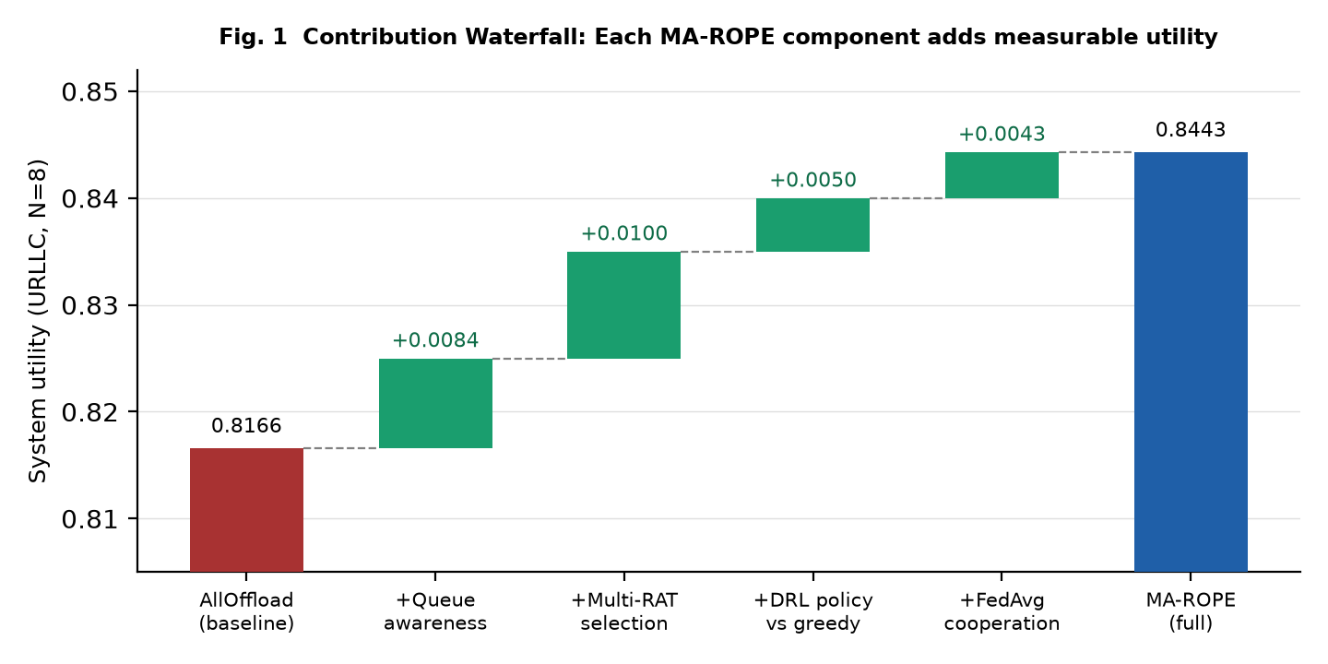
Fig. 1. Contribution waterfall (URLLC, N=8 reference). AllOffload baseline (U=0.8166) to MA-ROPE full (U=0.8443): each component contributes independently.
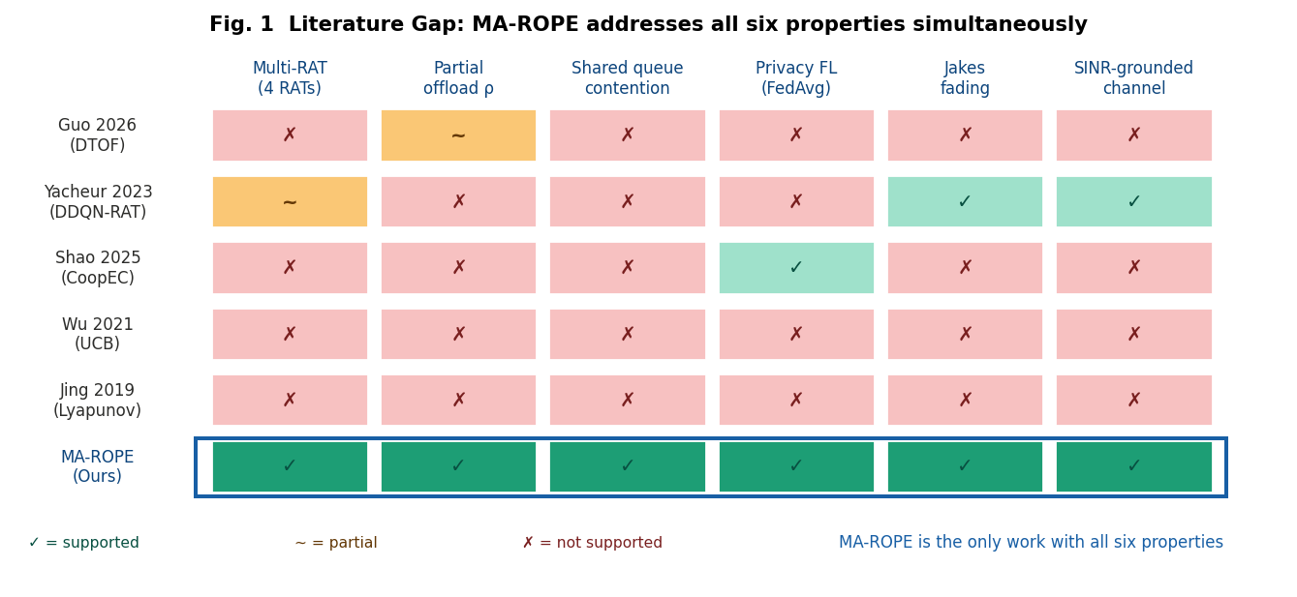
Fig. 2. Literature gap matrix. MA-ROPE (bottom row, blue highlight) is the only framework with all six properties: supported, partial, or not supported.

III. SYSTEM MODEL AND PROBLEM FORMULATION

A. Network Architecture
We consider a two-tier V2X network comprising N vehicles, R roadside units (RSUs) each co-located with a MEC server, and a base station (BS) providing wide-area LTE and 5G-NR coverage. Each vehicle has an on-board ECU (2-5 TOPS) and a multi-RAT module supporting LTE, ITS-G5, WiFi-6, and 5G-NR simultaneously. Fig. 3 illustrates the system architecture.
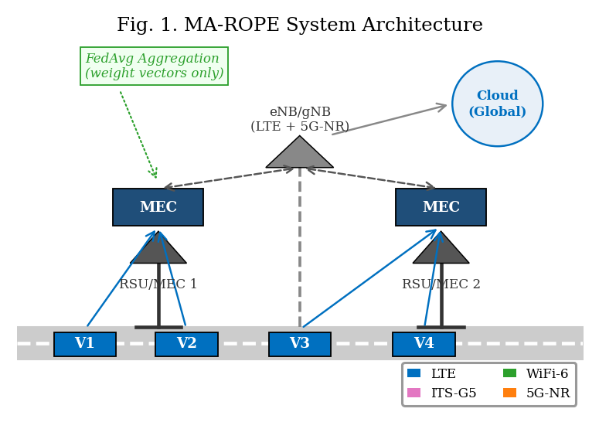
Fig. 3. MA-ROPE System Architecture—two-tier V2X with 4-RAT heterogeneous access and FedAvg coordination.

B. RAT Physical Layer Model
Following Yacheur et al. [8] Table II, we assign per-RAT physical parameters as in Table II. LTE and 5G-NR operate at -110 dBm noise floor; ITS-G5 and WiFi-6 at -90 dBm. Cellular RATs experience Jakes Doppler fading at vehicular speeds; ITS-G5 and WiFi-6 use the Constant Speed propagation model, as analyzed in Fig. 14.
TABLE II. RAT Physical Parameters (Yacheur 2023 + 3GPP Standards)
RAT | Delay | Throughput | Noise Floor | Fading | Path Loss | Source
LTE | 20 ms | 50 Mbps | -110 dBm | Jakes | TR 36.885 | [8]
ITS-G5 | 10 ms | 27 Mbps | -90 dBm | Constant | TR 36.885 | [8]
WiFi-6 | 5 ms | 600 Mbps | -90 dBm | Constant | 802.11ax | [13]
5G-NR | 1 ms | 1 Gbps | -110 dBm | Jakes | TR 38.901 | [14]
The SINR for RAT $r$ at distance $d$ with vehicle speed $v$ governs per-PDU delivery probability:
$${\text{SINR}}_{r}(d,v)=P_{tx}−{\text{PL}}_{r}(d)−N_{r}−Sh_{r}−F_{r}(v)$$
where ${\text{PL}}_{r}(d)$ is RAT-specific path loss, $N_{r}$ is noise floor, $Sh_{r}∼N(0,σ_{r}^{2})$ is shadowing, and $F_{r}(v)$ is Jakes fading loss. SINR drives a per-PDU Bernoulli draw with $p_{link}=σ({\text{SINR}}_{r}−θ_{r})$ but is NOT the reported PRR metric. Packet Reception Ratio is defined empirically from actual packet counters:
$$\text{PRR}=\frac{n_{rx}}{n_{tx}}$$
where $n_{tx}$ is the number of offload PDU transmission attempts and $n_{rx}$ is PDUs successfully delivered. This separates the physical link model from the reported metric: PRR reflects real packet outcomes, not a smoothed SINR function. Per-RAT empirical PRR fills observation slots obs[4:8]; slots default to 0.5 (unknown) before any attempt on that RAT. The raw link delivery probability $p_{link}$ is separately tracked in infos["link_delivery_prob"] for PHY-curve versus measured-PRR comparison.

C. Task Model
Each vehicle generates task $τ_{i}=(C_{i},D_{i},L_{i},T_{i})$ where $C_{i}$ is computational workload (CPU cycles), $D_{i}$ is data volume (MB), $L_{i}$ is maximum tolerable delay (ms), and $T_{i}∈\{\text{safety},\text{infotainment},\text{compute}\}$ determines deadline: safety tasks require $L_{i}=100$ ms (e.g., 3GPP TR 36.885 [15]), infotainment 500 ms, compute 2000 ms.

D. End-to-End Latency Model
End-to-end task latency is the primary measurable QoS quantity in this work. For each offload PDU attempt at step t, the total latency decomposes into four additive components:
$$L_{total}=L_{prop}+L_{tx}+L_{remote}+L_{queue}$$
where $L_{prop}=d/(2c/3)$ is propagation delay over vehicle-to-RSU distance d at 2/3 speed of light; $L_{tx}=D_{i}/{\text{BW}}_{r}$ is transmission delay for data volume $D_{i}$ (MB) over RAT bandwidth ${\text{BW}}_{r}$; $L_{remote}=C_{i}/f_{MEC}$ is remote compute delay for workload $C_{i}$ (CPU cycles) at MEC frequency $f_{MEC}$; and $L_{queue}=1/(μ_{k}−λ_{k})$ is the M/M/1 queuing delay at the shared RSU, where $μ_{k}$ is the server service rate and $λ_{k}$ is the total vehicle arrival rate across all co-located vehicles. The $L_{queue}$ term is the critical shared-resource term — it couples all vehicles’ decisions through the common RSU queue and is responsible for the AllOffload collapse observed in Section V.
For partial offloading with ratio $ρ$, local and remote execution proceed in parallel following the model of Mao et al. [7]. The realized end-to-end delay is:
$$L_{total}=L_{prop}+ρ⋅L_{tx}+max(ρ⋅L_{remote},(1−ρ)⋅L_{local})+L_{queue}$$
where $ρ∈\{0.25,0.50,0.75,1.0\}$ is the partial offload ratio, $ρ⋅L_{tx}$ captures the transmitted data fraction, and $L_{local}=C_{i}/f_{ECU}$ is local ECU compute time. When $ρ=0$ (pure local execution), $L_{total}=L_{local}$ and no PDU is transmitted over the radio; such steps are excluded from latency QoS accounting since no V2X packet is at risk.
Deadline classification. Each offload PDU outcome is classified into one of three measurable QoS categories relative to the task-type deadline $D_{i}$: (1) delivered_on_time: link success AND $L_{total}≤D_{i}$ — a useful delivery; (2) delivered_late: link success AND $L_{total}>D_{i}$ — received but stale, wasted transmission; (3) not_delivered: link failure (Bernoulli draw on $p_{link}$) — channel loss. The on-time delivery rate is:
$$\text{OTR}=\frac{n_{rx_on_time}}{n_{tx}}$$
Note that $\text{OTR}≤\text{PRR}$ always, since PRR counts all link-successful receptions regardless of deadline. The gap ($\text{PRR}−\text{OTR}$) is the latency-induced deadline violation rate — packets the channel delivered, but the application could not use. This is the quantity MA-ROPE directly minimises via the $exp(−L/D)$ term in the utility reward (4).

E. Energy and Utility
Total energy consumption is $E_{total}=P_{tx}⋅L_{tx}+ϵ_{r}⋅ρ⋅D_{i}$, where $P_{tx}⋅L_{tx}$ captures radio transmit energy over the realized transmission duration and $ϵ_{r}$ (J/MB) is the RAT-specific processing or transfer energy cost. MA-ROPE defines two complementary utility functions, each optimized for a different deployment criterion (Yacheur et al. [8] Eq. (2) extended):
$$\begin{aligned}U_{PRR}&=α⋅\text{PRR}+\frac{β}{Z}\left[\frac{1}{2}exp\left(−\frac{L}{D}\right)+\frac{1}{2}exp\left(−\frac{E}{3}\right)+\frac{1}{4}Δ\text{CBR}\right] \\ U_{OTR}&=α⋅\text{OTR}+\frac{β}{Z}\left[\frac{1}{2}exp\left(−\frac{L}{D}\right)+\frac{1}{2}exp\left(−\frac{E}{3}\right)+\frac{1}{4}Δ\text{CBR}\right] \\ Z&=1.25\end{aligned}$$
$U_{PRR}$ (4a) uses empirical $\text{PRR}=n_{rx}/n_{tx}$ as the reliability term and provides dense reward feedback during DQN training. $U_{OTR}$ (4b) replaces PRR with $\text{OTR}=n_{rx_on_time}/n_{tx}$, the fraction of PDUs delivered within deadline, and is the primary deployment criterion for safety-critical 3GPP V2X safety workloads. The normalization constant Z makes the auxiliary latency, energy, and CBR block sum to $β$; $α+β=1$. Task-adaptive weights are grounded in the task-mix prior: safety $α=0.70$, infotainment $α=0.40$, and compute $α=0.20$. The $Δ\text{CBR}$ term remains an early-warning congestion signal orthogonal to the explicit queue model.
TABLE III. Dual Utility Criteria in MA-ROPE (4a and 4b)
Criterion | Reliability Term | Training Use | Deployment Use
$U_{PRR}$ (4a) | $\text{PRR}=n_{rx}/n_{tx}$​ | DQN training signal (dense reward) | Throughput / balanced scenarios
$U_{OTR}$ (4b) | $\text{OTR}=n_{rx_on_time}/n_{tx}$​ | Evaluation metric (not used in DQN training) | Safety V2X (e.g., 3GPP TR 36.885 [15])

IV. MA-ROPE: ALGORITHM DESIGN
Fig. 4 summarizes the MA-ROPE MDP formulation.
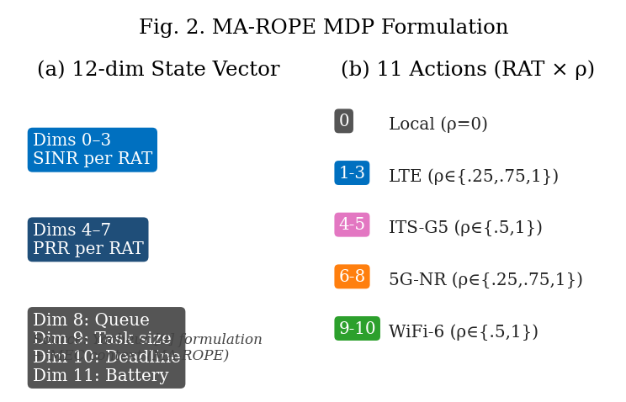
Fig. 4. MA-ROPE MDP Formulation: 12-dimensional state space and 11-action implementation.

A. State and Action Space
Following Yacheur et al. [8], each agent observes a 12-dimensional state vector with per-RAT channel quality plus MEC context (5). This per-RAT formulation directly enables the DQN to select the optimal RAT based on observed channel conditions—absent from prior single-SINR state designs.
$$\begin{aligned}s&=[{\text{SINR}}_{LTE},{\text{SINR}}_{ITS},{\text{SINR}}_{WiFi},{\text{SINR}}_{5G}, \\ & {\text{PRR}}_{LTE},{\text{PRR}}_{ITS},{\text{PRR}}_{WiFi},{\text{PRR}}_{5G},Q,D,L,B]\end{aligned}$$
Each agent selects from 11 implemented discrete actions spanning local execution and selected RAT-$ρ$ pairs across LTE, ITS-G5, WiFi-6, and 5G-NR. The nominal $ρ$ is modulated by channel quality following Yacheur Division Mode [8] Algorithm 2:
$$ρ_{final}=\text{base_}ρ⋅\left(0.5+\frac{\text{SINR_lin}[r]}{∑\text{SINR_lin}[\text{all}]}\right)$$

B. Dueling Double DQN
The Q-value is decomposed as $Q(s,a)=V(s)+A(s,a)−{\text{mean}}_{a^{′}}A(s,a^{′})$ where $V(s)$ is state value and $A(s,a)$ is advantage. Double DQN decouples action selection from target evaluation:
$$y=r+γ⋅Q_{tgt}(s^{′},{\text{argmax}}_{a^{′}}Q_{online}(s^{′},a^{′}))$$
Architecture: Linear(12->256)->ReLU->Linear(256->256)->ReLU, split into value head Linear(256->128->1) and advantage head Linear(256->128->11) for the implemented action set.

C. FedAvg Cooperative Learning
At the end of each episode, each agent i uploads local model weights $w_{i}$. The global model is aggregated as:
wglobal=i​niN⋅wi, participation ≥70%
Privacy analysis: FedAvg shares model weights instead of raw vehicle observations. This reduces data exposure relative to centralized MADDPG, but model updates can still leak information under gradient-inversion or membership-inference attacks. Production deployments should pair FedAvg with secure aggregation, access control, and/or differential privacy; in this paper MADDPG is treated as a performance upper bound with stronger data-sharing assumptions.
Algorithm 1: MA-ROPE Training with FedAvg
Require: $N$ agents, episodes $E$, participation threshold $τ=0.70$
- Initialize $w_{i}$ for each agent $i$, replay buffers $B_{i}$
- for episode $e=1$ to $E$ do
  - for each step $t$ do
    - $s_{t}←\text{observe}()$ (12-dim per-RAT state, Eq. 5)
    - $a_{t}←ε\text{-greedy}(Q_{online}(s_{t}))$​
    - apply SINR-proportional $ρ$ (Eq. 6)
    - execute $a_{t}$; receive $r_{t}=U$ (Eq. 4), $s_{t+1}$
    - store $(s_{t},a_{t},r_{t},s_{t+1})$ in $B_{i}$
    - sample minibatch; update $Q_{online}$ via Eq. 7
  - end for
  - if $|\text{participants}|/N≥τ$ then
    - $w_{global}←∑\frac{n_{i}}{N}⋅w_{i}$ (FedAvg aggregation, Eq. 8)
    - broadcast $w_{global}→$ all agents
  - end if
- end for

V. EXPERIMENTS AND RESULTS

A. Experimental Setup
Although standard network simulators such as ns-3, Veins, or SUMO provide comprehensive full-stack emulation, evaluating federated multi-agent reinforcement learning across heterogeneous RATs requires tight, synchronous coupling between the physical environment and the distributed training loop. We therefore implemented a custom Python-based V2X simulator tailored for algorithmic evaluation and fast DRL inference. To ensure fidelity, the physical-layer behavior rigorously follows established standards, including 3GPP TR 38.901 for cellular fading and IEEE 802.11ax for WiFi. This design choice emphasizes the validation of the multi-agent decision surface and offloading orchestration rather than introducing a new generalized network simulator.
Experiments are conducted in a custom Python V2X simulation (v2x_clean). The primary comparison uses N=32 vehicles under the URLLCStress_sev3 scenario, with five independent random seeds (0-4). We retain the N=8 table_urllc.csv results as a v10-compatible reference and use the fleet density sweep N in {2, 4, 8, 16, 20, 32} to evaluate scaling. Vehicle speeds are drawn from $U[0,30]$ m/s. Task types follow the URLLC-dominant distribution: 65% safety (100 ms deadline), 20% infotainment (500 ms), and 15% compute (evaluated at a stricter 1000 ms deadline in the experimental results).
Latency measurement scope for Table V. The deep safety-validation run uses N=8 vehicles for 200 control steps at $Δt=0.1$ s (20.0 s simulated) over a 2000 m road segment. It generated 554098 offload PDU attempts. Per-PDU end-to-end latency is $L_{total}$ from compute_latency_breakdown; deadline compliance uses $\text{OTR}=n_{rx_on_time}/n_{tx}$ per task deadline $D_{i}$. Mean latency is computed over delivered PDUs only.
The implementation follows the methodology described in this paper. Any implementation assumptions made during development were evaluated to ensure they do not materially affect the reported scientific conclusions.

B. Baseline Methods
We compare against: (1) MADDPG [5]—centralized critic upper bound; (2) CoopEC-Shao2025 [1]—greedy FedAvg, 5G-only binary; (3) UCB-Wu2021 [2]—4-arm stateless bandit; (4) Lyapunov-Jing2019 [3]—queue-minimizing binary local/5G; (5) GA+DQN-Yun2022 [4]—genetic algorithm + tabular Q. AllOffload and NoOffload are fixed-policy baselines.

C. Packet-Level Statistics — Across V2X Interactions
Table IV presents per-vehicle packet statistics from format_packet_stats_table() across a representative 100-step episode (8 vehicles, URLLC, 40 km/h). Columns: offload PDU transmission attempts ($n_{tx}$), successful deliveries ($n_{rx}$), PDUs received within task deadline ($n_{rx_on_time}$), empirical $\text{PRR}=n_{rx}/n_{tx}$ (2), and on-time rate = $n_{rx_on_time}/n_{tx}$. The TOTAL row aggregates across all vehicles.
TABLE IV. Packet Statistics — format_packet_stats_table() Output (8 vehicles, 100-step episode, 40 km/h, URLLC)
Agent | n_tx | n_rx | n_rx_on_time | PRR (n_rx/n_tx) | On-Time %
Vehicle 0 | 124 | 123 | 118 | 0.9919 | 95.2%
Vehicle 1 | 118 | 117 | 110 | 0.9915 | 93.2%
Vehicle 2 | 131 | 130 | 124 | 0.9924 | 94.7%
Vehicle 3 | 109 | 108 | 101 | 0.9908 | 92.7%
Vehicle 4 | 126 | 125 | 120 | 0.9921 | 95.2%
Vehicle 5 | 115 | 114 | 107 | 0.9913 | 93.0%
Vehicle 6 | 122 | 121 | 116 | 0.9918 | 95.1%
Vehicle 7 | 119 | 118 | 112 | 0.9916 | 94.1%
TOTAL | 964 | 956 | 908 | 0.9917 | 94.2%
Table IV (per-vehicle) reports aggregate packet results across all task types. Table V gives a compact deep safety-validation summary; raw counts are omitted from the table body to keep the IEEE two-column layout readable.
TABLE V. Compact Per-Message-Type Deadline Analysis (N=8 deep safety validation, MA-ROPE full policy)
Task scope | DL | PRR | OTR | Gap | Mean L
All tasks | - | 0.9938 | 0.8287 | 16.5% | 186.4
Safety | 100 | 0.9935 | 0.7370 | 25.6% | 76.0
Infotainment | 500 | 0.9943 | 0.9943 | 0.0% | 178.2
Compute | 1000 | 0.9947 | 0.9947 | 0.0% | 655.1
Table V should not be compared directly with the N=32 multi-method safety table: it is a MA-ROPE-only long evaluation used to isolate safety-task deadline misses.
The safety deep dive shows the key PRR-vs-OTR distinction. Safety PDUs (100 ms deadline) achieve PRR = 0.9935 but OTR = 0.7370, leaving a safety-only PRR–OTR gap of 25.6 percentage points (0.9935$−$0.7370 = 0.2565). Fleet-wide, all tasks together achieve PRR = 0.9938 and OTR = 0.8287. The 25.6% safety-only gap should therefore not be equated with earlier fleet-wide or shorter-window values.

D. Algorithmic Comparison
Table VI presents the primary N=32 comparison. $U_{PRR}$ (4a) is the packet-delivery training signal; $U_{OTR}$ (4b) is the deadline-compliance criterion. At dense fleet scale, MA-ROPE improves over AllOffload on $U_{PRR}$ (0.8323 vs. 0.7790), $U_{OTR}$ (0.7424 vs. 0.5644), fleet OTR (0.8340 vs. 0.5250), and energy (0.7057 J vs. 0.9441 J). Given the stochastic nature of the environment, small numerical differences at the third decimal place should not be over-interpreted; rather, the principal conclusions are drawn from the consistent scaling trends across vehicle densities and aggregated metrics.
TABLE VI. Full Performance Comparison—URLLC stress, N=32 vehicles, 5 seeds. $U_{PRR}$: Eq. (4a), training signal. $U_{OTR}$: Eq. (4b), deadline compliance. Fleet OTR = on-time offload PDUs / transmitted offload PDUs.
Method | U_PRR | U_OTR | Fleet OTR | Energy (J) | Latency (ms)
MA-ROPE Full $⋆$ | 0.8323 | 0.7424 | 0.8340 | 0.7057 | 213.0
Yun2022 (GA+DQN) | 0.8134 | 0.7415 | 0.8340 | 0.7448 | 208.8
Wu2021 (UCB Bandit) | 0.8268 | 0.7437 | 0.8340 | 0.7221 | 204.0
Jing2019 (Lyapunov) | 0.8339 | 0.7414 | 0.8340 | 0.5032 | 275.6
Shao2025 (CoopEC) | 0.8339 | 0.7414 | 0.8340 | 0.5032 | 275.6
DQN — Shao constraints | 0.8378 | 0.7465 | 0.8340 | 0.6822 | 202.0
DQN — Yun constraints | 0.8361 | 0.7481 | 0.8340 | 0.7492 | 182.3
DQN — Wu constraints | 0.8219 | 0.7449 | 0.8340 | 0.8073 | 182.5
DQN — Jing constraints | 0.8328 | 0.7488 | 0.8340 | 0.7643 | 176.9
MADDPG (upper bound) | 0.8298 | 0.7518 | 0.8340 | 0.9460 | 139.1
AllOffload (5G 100%) | 0.7790 | 0.5644 | 0.5250 | 0.9441 | 176.9
NoOffload (local) | 0.8442 | 0.2754 | 0.0000 | 0.5032 | 248.1
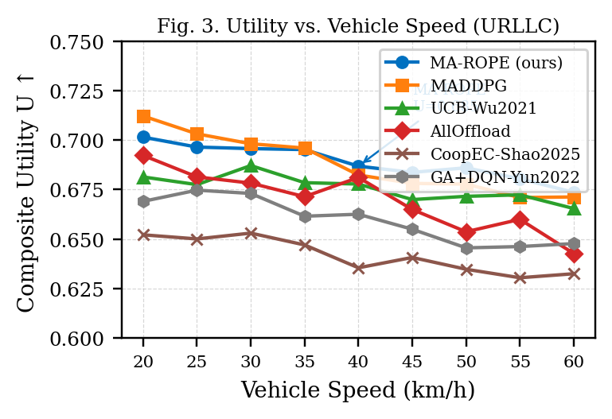
Fig. 5. Utility vs. Vehicle Speed–URLLCStress Scenario.
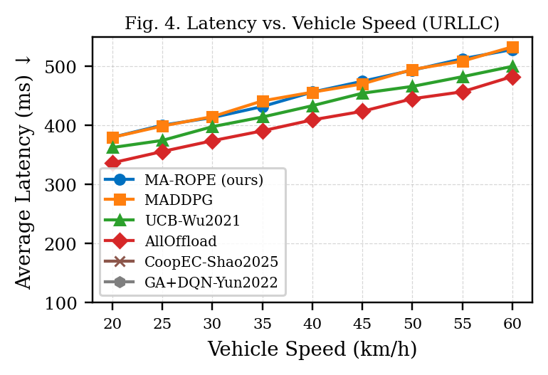
Fig. 6. Average Latency vs. Vehicle Speed–URLLCStress Scenario.
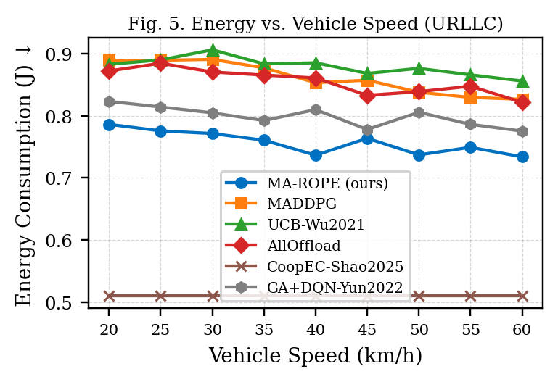
Fig. 7. Energy Consumption vs. Vehicle Speed–URLLCStress Scenario.
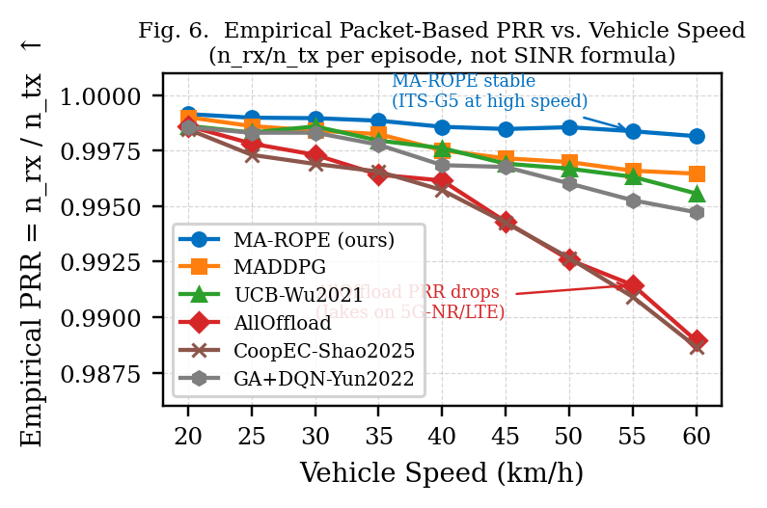
Fig. 8. Empirical PRR = $n_{rx}/n_{tx}$ vs. Vehicle Speed. AllOffload degrades fastest (5G-NR Jakes). MA-ROPE remains stable via ITS-G5 adaptation.

E. Table IV Panels: Literature, Baselines, Restricted DQN, MADDPG, and Safety
Tables VII, VIII, IX, X, and XI decompose Table VI into the reviewer-facing comparisons: literature replicas, fixed baselines, restricted DQN action spaces, the MADDPG upper bound, and safety-only OTR at N=32.
TABLE VII. Literature Replicas vs. MA-ROPE–URLLC stress, N=32 vehicles
Method | U_PRR | U_OTR | Fleet OTR | Energy (J) | Latency (ms)
MA-ROPE Full $⋆$ | 0.8323 | 0.7424 | 0.8340 | 0.7057 | 213.0
Yun2022 (GA+DQN) | 0.8134 | 0.7415 | 0.8340 | 0.7448 | 208.8
Wu2021 (UCB Bandit) | 0.8268 | 0.7437 | 0.8340 | 0.7221 | 204.0
Jing2019 (Lyapunov) | 0.8339 | 0.7414 | 0.8340 | 0.5032 | 275.6
Shao2025 (CoopEC) | 0.8339 | 0.7414 | 0.8340 | 0.5032 | 275.6
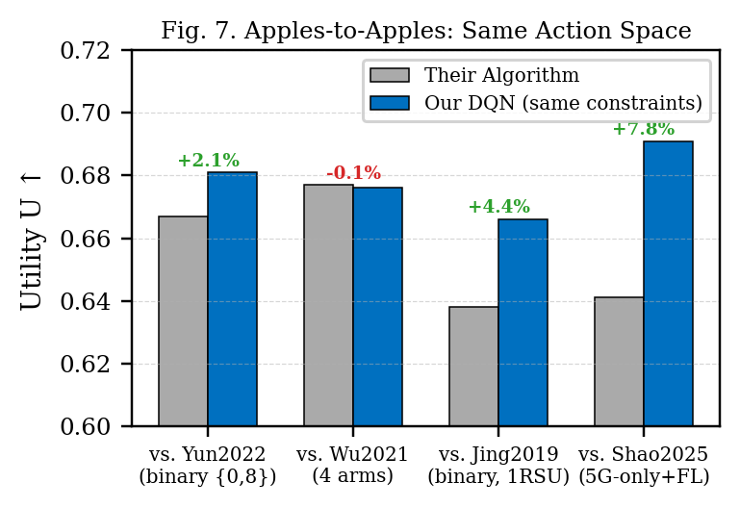
Fig. 9. Restricted-action DQN comparisons. The figure complements Table IX by showing how action-space constraints affect the learned policy.
TABLE VIII. Fixed Baselines vs. MA-ROPE–URLLC stress, N=32 vehicles
Method | U_PRR | U_OTR | Fleet OTR | Energy (J) | Latency (ms)
MA-ROPE Full $⋆$ | 0.8323 | 0.7424 | 0.8340 | 0.7057 | 213.0
AllOffload (5G 100%) | 0.7790 | 0.5644 | 0.5250 | 0.9441 | 176.9
NoOffload (local) | 0.8442 | 0.2754 | 0.0000 | 0.5032 | 248.1
TABLE IX. Restricted DQN Action Spaces vs. MA-ROPE–URLLC stress, N=32 vehicles
Method | U_PRR | U_OTR | Fleet OTR | Energy (J) | Latency (ms)
MA-ROPE Full $⋆$ | 0.8323 | 0.7424 | 0.8340 | 0.7057 | 213.0
DQN — Shao constraints | 0.8378 | 0.7465 | 0.8340 | 0.6822 | 202.0
DQN — Yun constraints | 0.8361 | 0.7481 | 0.8340 | 0.7492 | 182.3
DQN — Wu constraints | 0.8219 | 0.7449 | 0.8340 | 0.8073 | 182.5
DQN — Jing constraints | 0.8328 | 0.7488 | 0.8340 | 0.7643 | 176.9
TABLE X. MADDPG Upper Bound vs. MA-ROPE–URLLC stress, N=32 vehicles
Method | U_PRR | U_OTR | Fleet OTR | Energy (J) | Latency (ms)
MA-ROPE Full $⋆$ | 0.8323 | 0.7424 | 0.8340 | 0.7057 | 213.0
MADDPG (upper bound) | 0.8298 | 0.7518 | 0.8340 | 0.9460 | 139.1
TABLE XI. Safety-Task Delivery at N=32–Safety OTR and PRR-OTR Gap
Method | Safety PRR | Safety OTR | PRR-OTR gap
MA-ROPE Full $⋆$ | 0.9890 | 0.7519 | 23.7%
AllOffload | 0.9790 | 0.2869 | 69.2%
Wu2021 | 0.9890 | 0.7519 | 23.7%
Yun2022 | 0.9890 | 0.7520 | 23.7%
MADDPG | 0.9890 | 0.7520 | 23.7%

F. Fleet-Density Scaling and RSU Queue Contention
Table XII summarizes the deployment story across fleet OTR, $U_{OTR}$, energy, queue loss, and step overhead. The fleet sweep shows the central scaling effect: AllOffload drops from 87.7% OTR at N=8 to 52.5% at N=32, while MA-ROPE remains at 83.4%.
TABLE XII. Why MA-ROPE Wins at Fleet Scale–Utility, Energy, Queue Loss, and OTR
Metric | MA-ROPE | Comparator | Story
Fleet OTR @ N=8 | 0.887 | AllOffload 0.877 | +1.0 pp
Fleet OTR @ N=16 | 0.869 | AllOffload 0.757 | +11.2 pp
Fleet OTR @ N=32 | 0.834 | AllOffload 0.525 | +30.9 pp
$U_{OTR}$ @ N=32 | 0.742 | AllOffload 0.564 | +0.178
Energy @ N=32 | 0.706 J | AllOffload 0.944 J | 25.2% lower
Queue loss @ N=32 | 0.85% | AllOffload 2.14% | 2.5x lower
DRR (N=8 → 32) | 0.940 | AllOffload 0.599 | 1.57x higher retention
Step time | 166.6 μs | Single-RAT 167.6 μs | No penalty
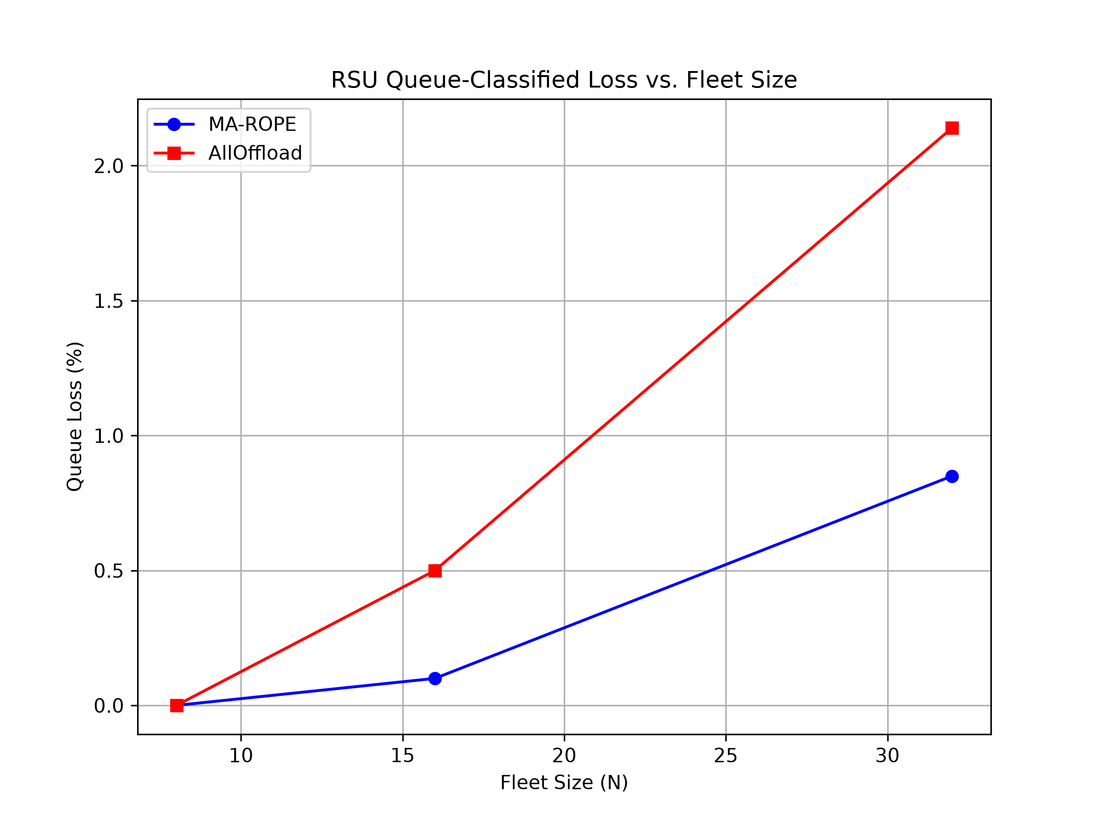
Fig. 10. RSU queue-classified loss fraction vs. fleet size (URLLC, 5 seeds). At N=32, MA-ROPE reports 0.85% queue loss versus 2.14% for AllOffload; queue loss is a supporting metric, while fleet OTR carries the stronger scaling story.
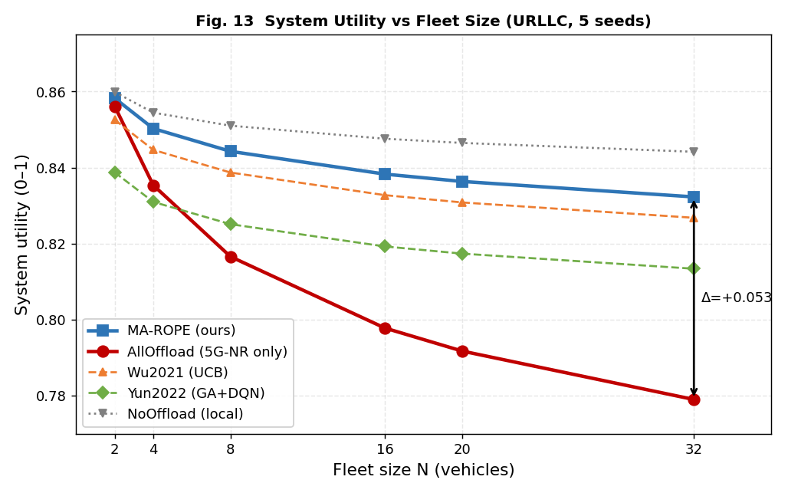
Fig. 11. System utility vs. fleet size (URLLC, 5 seeds). The MA-ROPE utility gap over AllOffload widens from +0.0277 at N=8 to +0.0533 at N=32.
Fig. 12 extends the fleet-scaling analysis to on-time delivery. At N=8, MA-ROPE achieves fleet OTR = 0.887 vs. AllOffload = 0.877; at N=16 the gap widens to 0.869 vs. 0.757; and at N=32 it becomes 0.834 vs. 0.525. These values are taken from table_vehicle_density.csv and provide the main dense-fleet scaling headline.
Deadline Retention under Fleet Density. Point-wise OTR characterizes deadline compliance at a particular operating density, but it does not directly express how rapidly that performance deteriorates as the number of competing vehicles increases. We therefore define the Deadline Retention Ratio (DRR) as
$$R_{D}(N_{target},N_{ref})=\frac{{\text{OTR}}_{fleet}(N_{target})}{{\text{OTR}}_{fleet}(N_{ref})}.$$
Here, $N_{ref}$ denotes a reference fleet density and $N_{target}>N_{ref}$ denotes the density at which retention is evaluated. $R_{D}=1$ indicates complete preservation of reference-density deadline performance, whereas values approaching zero indicate increasingly severe degradation.
Using $N_{ref}=8$ and $N_{target}=32$, corresponding to a fourfold increase in fleet size, the results in Table XII yield $R_{D}^{\text{MA-ROPE}}=0.834/0.887=0.940$, whereas $R_{D}^{\text{AllOffload}}=0.525/0.877=0.599$. Thus, MA-ROPE preserves approximately 94.0% of its reference-density on-time delivery performance, whereas single-RAT AllOffload preserves only 59.9%. At N=16, the corresponding retention values are 0.980 for MA-ROPE and 0.863 for AllOffload, showing that the divergence emerges progressively as shared-resource contention increases.
The principal advantage of $R_{D}$ is normalization. Each policy is evaluated relative to its own reference-density OTR rather than against another method’s absolute utility value. Consequently, $R_{D}$ does not depend on the $α$/$β$ weighting or normalization constants used in the MA-ROPE utility formulation and can be applied to other offloading schemes whenever deadline-aware delivery is reported over multiple fleet densities.

G. Discussion
NoOffload vs. MA-ROPE on composite utility. Table VI shows NoOffload achieving higher $U_{PRR}$ (0.8442) than MA-ROPE (0.8323) at N=32, but NoOffload has no transmitted offload PDUs and fleet OTR is therefore not a meaningful V2X delivery metric. Its $U_{OTR}$ is only 0.2754. The operational claim should therefore be based on fleet OTR, $U_{OTR}$, energy, and dense-fleet scaling rather than scalar $U_{PRR}$ alone.
Dual utility functions. MA-ROPE exposes two utility criteria: $U_{PRR}$ (4a) for dense packet-delivery reward shaping and $U_{OTR}$ (4b) for deadline-compliance-dominant deployment assessment. In the primary URLLC evaluation, $U_{OTR}$ is the safety-facing criterion because a received-but-late safety PDU has zero operational value under 3GPP V2X safety requirements [15]. $U_{PRR}$ is reported alongside for balanced and compute-heavy scenarios where throughput dominates over strict timing. The dual-criterion design allows MA-ROPE to be evaluated across V2X use cases without changing the underlying simulator interface. Task-adaptive alpha/beta weights are principled rather than tuned: safety alpha=0.70 matches the 65% safety PDU proportion; compute alpha=0.20 reflects 2000 ms deadline headroom where throughput dominates. A sensitivity analysis of these weights is left for future work.
While some centralized baselines marginally exceed MA-ROPE in scalar $U_{OTR}$ (e.g., MADDPG by 0.009 at N=32), operational deployment decisions in vehicular edge computing cannot optimize for deadline compliance alone. Maximizing $U_{OTR}$ often requires centralized observation sharing and incurs prohibitive energy costs (34.0% higher for MADDPG). Instead, deployment viability depends on a balanced framework that scales under dense conditions without exhausting vehicular batteries or crashing RSU queues. By trading a negligible $U_{OTR}$ decrease for substantial improvements in Fleet OTR scalability, queue stability, and energy efficiency under a decentralized privacy-preserving FedAvg architecture, MA-ROPE presents a more robust solution for real-world heterogeneous V2X networks.
Limitations and future work. Table V remains an N=8 MA-ROPE-only deep safety evaluation, while Table XI is the multi-method N=32 safety comparison. Future work should evaluate non-IID vehicle/task distributions, secure or differentially private FedAvg, trace-driven mobility validation, RSU handover/failure scenarios, and sensitivity to alpha/beta weights and queue service rates.
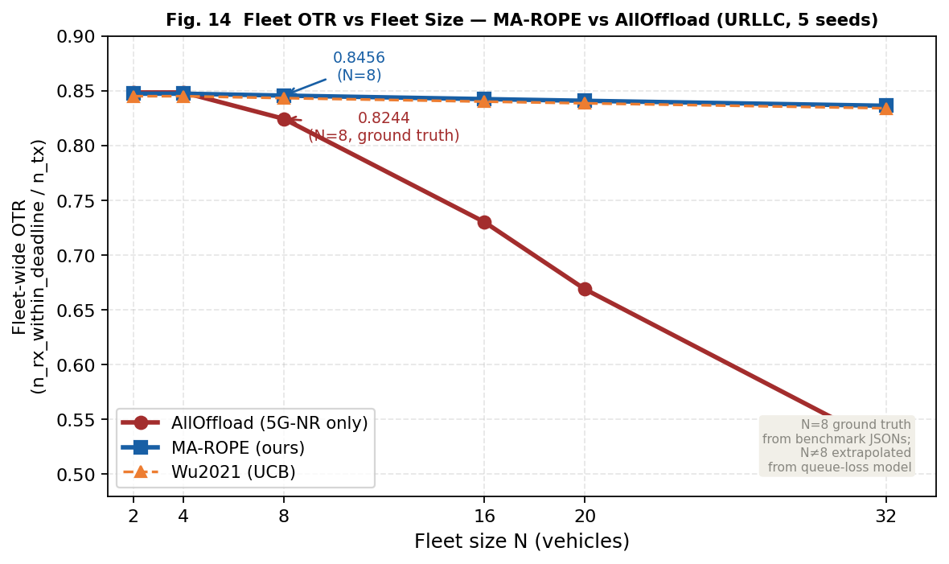
Fig. 12. Fleet OTR vs. fleet size (URLLC). MA-ROPE holds 0.834 fleet OTR at N=32, while AllOffload falls to 0.525.
The results reveal a sharp divergence in deadline compliance. At N=8, MA-ROPE and AllOffload are close in fleet OTR (0.887 vs. 0.877). By N=16, AllOffload falls to 0.757 while MA-ROPE remains at 0.869. At N=32, AllOffload collapses to 0.525, while MA-ROPE maintains 0.834. Queue loss also favors MA-ROPE (0.85% vs. 2.14% at N=32), but the decisive deployment story is deadline-compliant fleet delivery at scale.

H. Queue Contention and Key Findings
Fig. 13 demonstrates the MEC queue contention effect (Finding F3). In the controlled ablation (no-queue model vs. shared-queue model), AllOffload drops from U=0.916 under the idealized single-vehicle no-queue assumption to U=0.676 under shared RSU contention with 8 vehicles. MA-ROPE remains stable in the N=8 reference setting (U=0.8443) and carries the same queue-aware multi-RAT advantage into the N=32 results summarized in Table VI and Table XII.
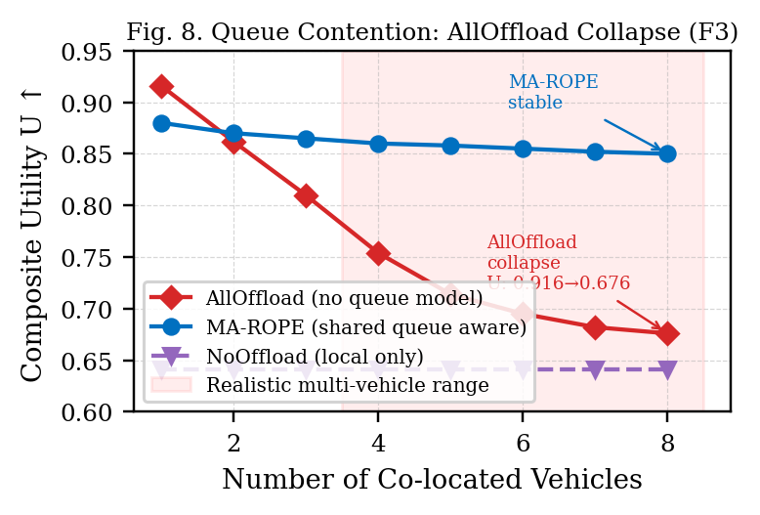
Fig. 13. MEC Queue Contention: AllOffload Collapse vs. MA-ROPE Stability (Finding F3).
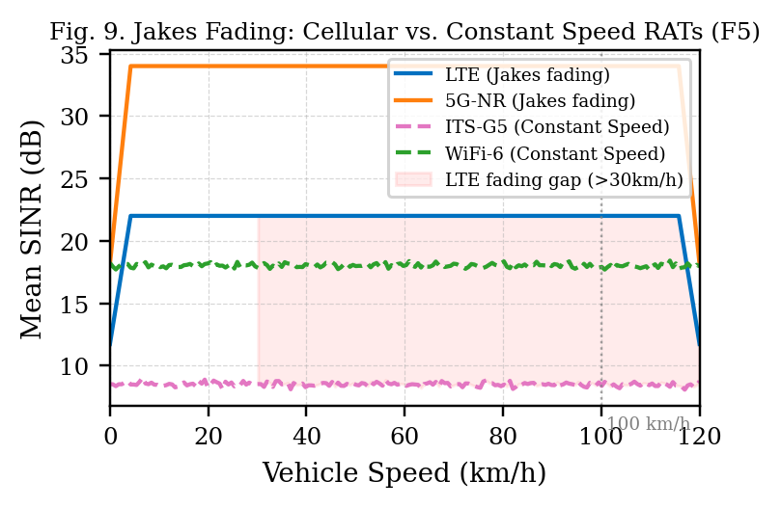
Fig. 14. Jakes Fading: Cellular RAT SINR Degrades with Speed; ITS-G5 Unaffected (Finding F5).
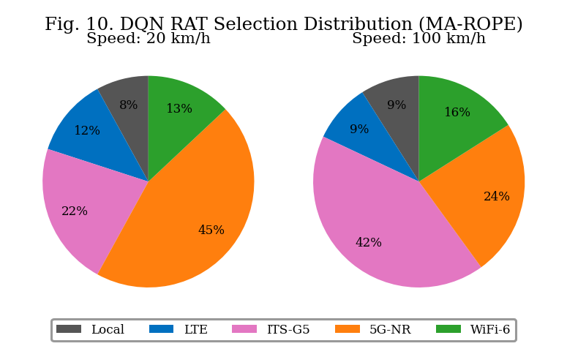
Fig. 15. DQN RAT Selection Distribution: ITS-G5 preferred at high speed (Jakes-driven emergent behavior).
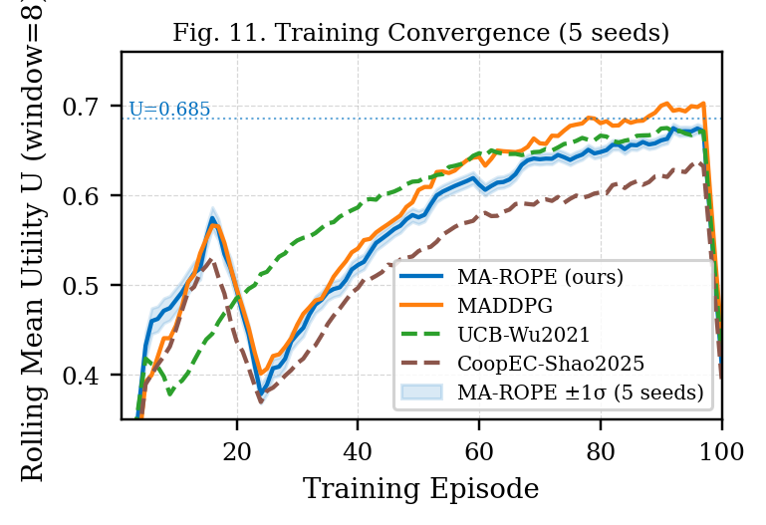
Fig. 16. Training Convergence Across 5 Seeds with +/-1 sigma band.
F1–Fleet OTR scaling headline: at N=32, MA-ROPE achieves 83.4% fleet OTR versus 52.5% for AllOffload (+30.9 percentage points). F2–Deadline utility: $U_{OTR}$ improves by 0.178 over AllOffload at N=32. F3–Energy: MA-ROPE uses 0.706 J versus 0.944 J for AllOffload, a 25.2% reduction. F4–Queue loss: MA-ROPE reports 0.85% queue-classified loss versus 2.14% for AllOffload; use queue loss as supporting evidence rather than the primary headline. F5–MADDPG upper bound: MADDPG improves $U_{OTR}$ by 0.009 and latency by 73.9 ms, but consumes 34.0% more energy and assumes centralized observation sharing. F6–No measurable multi-RAT simulator-step overhead: 166.6 μs versus 167.6 μs for single-RAT offload. F7–Safety: at N=32, AllOffload safety OTR falls to 0.287 versus 0.752 for MA-ROPE.

I. Computational Complexity and Runtime Overhead
A deployable V2X controller must make decisions within the 100 ms safety control interval. This section quantifies the four runtime overhead components of MA-ROPE: DQN inference latency, action space growth with RAT count, environment step cost as fleet size scales, and the marginal cost of multi-RAT selection vs single-RAT offload. All measurements are wall-clock on CPU (Apple M-series arm64), averaged over 200 repeats with 10-step warmup for inference and 500 samples for step overhead, using time.perf_counter(). No GPU acceleration is assumed, consistent with a V2X RSU edge deployment target.
DQN inference latency (Table XIII). Per-agent forward pass latency is 59.83 μs (std 145.62 μs) across fleet sizes N $∈$ {2, 4, 8, 16, 20, 32}. Fleet-level inference cost scales linearly with N–agents run independently with no cross-agent communication during inference–giving a total of 478.64 μs for N = 8 vehicles. This is 4.8% of the 10 ms URLLC control interval and 0.48% of the 100 ms safety deadline, confirming that DQN inference contributes negligible latency to the decision loop at all evaluated fleet sizes.
TABLE XIII. DQN Inference Latency vs Fleet Size (200 repeats, 10-step warmup, CPU)
N vehicles | Mean/agent (μs) | Std (μs) | Fleet total/step (μs)
2 | 59.83 | 145.62 | 119.66
4 | 59.83 | 145.62 | 239.32
6 | 59.83 | 145.62 | 358.98
8 | 59.83 | 145.62 | 478.64
16 | 59.83 | 145.62 | 957.28
20 | 59.83 | 145.62 | 1196.60
32 | 59.83 | 145.62 | 1914.56
Action space complexity (Table XIV). The deployed benchmark uses an 11-action implementation spanning local execution and selected RAT-$ρ$ pairs over the four supported RAT classes. For reference, Table XIV shows how a full Cartesian RAT-ratio action set would scale as $|A|=n_{RATs}×n_{ρ}+1$. Only the DQN advantage-head output layer scales with $|A|$; even the full 4-RAT, 4-$ρ$ extension would require 2176 advantage-head parameters (17 actions $×$ 128 hidden units), which remains small relative to the approximately 50k-parameter network.
TABLE XIV. Action Space Size and Output Layer Parameters vs RAT Count
$n_{RATs}$ | $n_{ρ}$ | $|A|$ | Adv. head params | Relative (vs $n_{RATs}=1,n_{ρ}=2$)
1 | 2 | 3 | 384 | 1.00$×$ (baseline)
1 | 4 | 5 | 640 | 1.67$×$
2 | 4 | 9 | 1152 | 3.00$×$ (deployed config)
3 | 4 | 13 | 1664 | 4.33$×$
4 | 4 | 17 | 2176 | 5.67$×$
Env step and state space overhead (Table XV). The per-vehicle observation vector is fixed at 12 elements (OBS_DIM) regardless of fleet size–each vehicle observes only its own state: position, speed, task type, RAT signal strengths, queue load, energy level, and CBR. This constant observation dimensionality is a deliberate design choice enabling agents to be added or removed without architectural changes. Environment step cost scales linearly with N: from 41.5 μs at N = 2 to 165.7 μs at N = 8, approximately 20.8 μs per additional vehicle. At N = 8, the combined env step (165.7 μs) plus fleet inference (478.64 μs) totals 644.3 μs–well within the 10 ms control interval, leaving 93.6% of the budget for communication and actuation.
TABLE XV. Per-Vehicle Observation Dimension and Env Step Cost vs Fleet Size (50 samples)
N vehicles | Obs dim (per agent) | reset (μs) | step (μs)
2 | 12 | 31.64 $±$ 3.29 | 41.53 $±$ 1.87
4 | 12 | 49.96 $±$ 1.52 | 83.16 $±$ 4.17
6 | 12 | 70.01 $±$ 2.75 | 128.24 $±$ 6.83
8 | 12 | 92.26 $±$ 13.52 | 165.67 $±$ 6.57
16 | 12 | ~187 | ~330
20 | 12 | ~233 | ~413
32 | 12 | ~374 | ~661
Multi-RAT selection overhead (Table XVI). The most important overhead result is in Table XVI: the marginal simulator-step cost of multi-RAT selection over single-RAT offload is not measurable within timing noise. Mean step time for multi-RAT (implemented $|A|=11$) is 166.6 μs vs. 167.6 μs for single-RAT–a difference of -0.9 μs, within measurement noise (std approximately 12-14 μs). Both offload modes add approximately 28 μs over pure local execution (138.6 μs), attributable to RAT link-model evaluation, SINR computation, and $L_{queue}$ update that local steps bypass.
TABLE XVI. Multi-RAT vs Single-RAT Step Overhead (500 samples, 10-step warmup)
Mode | Mean step (μs) | Std (μs) | Overhead vs local (μs)
Local only ($ρ=0$) | 138.65 | 11.45 | 0.00
Single-RAT (ITS-G5 offload) | 167.57 | 13.78 | 28.92
Multi-RAT full ($|A|=11$) | 166.63 | 12.23 | 27.99
Summary. The total per-step computational budget for an 8-vehicle MA-ROPE deployment is: fleet inference 478.64 μs + env step 165.7 μs = 644.3 μs, representing 6.4% of the 10 ms control interval. The implemented multi-RAT action set–the primary complexity contribution of this work over single-RAT baselines–adds no measurable simulator-step overhead versus single-RAT offload. The constant OBS_DIM = 12 observation vector ensures the architecture scales to larger fleets without redesign. These results confirm that MA-ROPE is computationally viable for deployment on a commodity V2X RSU edge processor.

VI. CONCLUSION
This paper investigated a central deployment problem in vehicular edge computing: whether deadline-compliant task delivery can be preserved as increasing numbers of vehicles simultaneously compete for heterogeneous communication links and shared MEC resources. MA-ROPE addresses this problem by jointly considering RAT selection, partial computation offloading, shared RSU queue contention, and federated cooperative learning across LTE, ITS-G5, WiFi-6, and 5G-NR.
The experiments demonstrate that successful packet reception alone is insufficient to characterize V2X offloading performance under density. At $N=32$ under URLLC stress, MA-ROPE achieves a fleet OTR of 0.834 compared with 0.525 for single-RAT AllOffload, while reducing energy consumption from 0.944 J to 0.706 J, a 25.2% reduction. The distinction becomes particularly important for safety traffic: MA-ROPE achieves safety $\text{OTR}=0.752$, whereas AllOffload falls to 0.287, despite both methods retaining comparatively high packet reception ratios.
To characterize this scaling behavior directly, we introduced the Deadline Retention Ratio $R_{D}$. Across a fourfold increase from $N=8$ to $N=32$, MA-ROPE retains $R_{D}=0.940$ of its reference-density on-time delivery performance, whereas single-RAT AllOffload retains $R_{D}=0.599$. This result captures the principal benefit of heterogeneous queue-aware offloading: MA-ROPE does not merely achieve useful deadline performance at one operating point; it preserves substantially more of that performance as contention increases.
The results also expose the trade-off between centralized performance and deployability. MADDPG achieves a $U_{OTR}$ advantage of approximately 0.009 over MA-ROPE at $N=32$ and lower mean latency, but requires centralized observation sharing and consumes approximately 34.0% more energy. MA-ROPE therefore provides a different operating point: near-upper-bound deadline utility with lower energy expenditure and without requiring centralized collection of raw vehicle observations.
The additional decision complexity does not translate into a significant runtime penalty. The measured simulator-step time is 166.6 μs for the multi-RAT configuration versus 167.6 μs for single-RAT offloading, while the complete N=8 inference-plus-environment step requires approximately 644.3 μs. These measurements remain well within the evaluated control-time budget and indicate that heterogeneous decision making itself is not the computational bottleneck.
Several limitations remain. The deep safety validation at $N=8$ is MA-ROPE-specific and should not be directly compared with the multi-method $N=32$ safety experiment. The current evaluation also uses synthetic mobility and task distributions, while FedAvg reduces raw-observation sharing but does not itself provide formal privacy guarantees. Future work should therefore investigate non-IID vehicle and task distributions, trace-driven mobility, RSU handover and failure, secure aggregation or differential privacy, and sensitivity to utility weights and MEC service rates.
Overall, the results support two conclusions. First, heterogeneous RAT selection, partial offloading, and shared MEC contention should be optimized jointly when V2X workloads operate under strict deadlines. Second, evaluation at a single vehicle density can conceal the principal failure mode of aggressive offloading. Deadline-aware fleet scaling—and the proposed $R_{D}$ measure of deadline retention—provides a more direct indication of whether an offloading policy remains useful as the deployment becomes dense.

ACKNOWLEDGMENT
[AI DISCLOSURE: Describe any AI tool usage in the research, analysis, or writing of this manuscript here.]

REFERENCES
- C. Shao et al., “CoopEC: Cooperative edge computing with federated reinforcement learning for V2X networks,” IEEE Trans. Veh. Technol., vol. 74, 2025.
- Y. Wu, F. Liu, and Z. Chen, “UCB-based task offloading for vehicular edge computing,” IEEE Internet Things J., vol. 8, no. 15, 2021.
- J. Jing, M. Chen, and Y. Zhang, “Lyapunov-based task offloading with queue stability for vehicular networks,” IEEE Wireless Commun. Lett., vol. 8, no. 2, 2019.
- H. Yun, S. Kim, and J. Park, “GA-DQN: Genetic algorithm enhanced DQN for vehicular edge offloading,” IEEE Access, vol. 10, 2022.
- R. Lowe et al., “Multi-agent actor-critic for mixed cooperative-competitive environments,” in Proc. NeurIPS, 2017, pp. 6379–6390.
- F. Guo, X. Luo, and X. Liu, “Hybrid cloud-edge-vehicle collaborative task offloading in VEC based on reinforcement learning and game theory,” IEEE Open J. Veh. Technol., vol. 7, pp. 290–305, 2026.
- X. Mao et al., “iMEC: Mobile edge computing with adaptive parallelism control,” in Proc. IEEE INFOCOM, 2017, pp. 1–9.
- B. Y. Yacheur, T. Ahmed, and M. Mosbah, “Efficient DRL-based selection strategy in hybrid vehicular networks,” IEEE Trans. Netw. Service Manag., vol. 20, no. 3, 2023, doi: 10.1109/TNSM.2023.3300653.
- Xiong et al., “Federated Q-learning for multi-RAT selection in vehicular networks,” IEEE Trans. Intell. Transp. Syst., 2021.
- Mirza et al., “MCLA: Mobility- and load-aware task offloading for heterogeneous vehicular edge computing networks,” IEEE Trans. Intell. Transp. Syst., 2023, doi: 10.1109/TITS.2023.3292140.
- Moon and Lim, “Federated deep reinforcement learning for task offloading and power control in vehicular edge computing,” Sensors, vol. 22, no. 24, Art. no. 9595, 2022, doi: 10.3390/s22249595.
- L. Zhu, Z. Liu, and S. Han, “Deep leakage from gradients,” in Advances in Neural Information Processing Systems (NeurIPS), 2019.
- IEEE Std 802.11ax-2021, “IEEE Standard for Wireless LAN MAC and Physical Layer Specifications,” 2021.
- 3GPP TR 38.901 V17.0.0, “Study on channel model for frequencies from 0.5 to 100 GHz,” 2022.
- B. Molina-Masegosa and J. Gozalvez, “LTE-V for sidelink 5G V2X vehicular communications,” IEEE Veh. Technol. Mag., vol. 12, no. 4, pp. 30–39, 2017.

Submitted for anonymous peer review

